Sex differences between model-based and model-free behavior
Supplemental Information

S-1: Recruitment and inclusion/exclusion criteria:
A randomized sample of participants ages 20-40 years and gender balanced was selected from the registration data of the city and asked to participate in the study. A total of 1383 participants replied to the invitation and proceeded to screening. Exclusion criteria during screening included safety concerns for the fMRI scan (metallic implants, cardiac pacemakers, pregnancy etc.), corrected binocular visus lower than 0.8, psychiatric disorder requiring medical treatment within the last year, life time history of a psychiatric disorder with ICD code F0, F2, F3 and consuming medication affecting the central nervous system.
Additionally, participants who failed to present sober or did not tolerate the mixture were excluded. Smokers were included in the study, however, they were asked to refrain from smoking one hour before the fMRI session.
For the behavioral analyses, five participants needed to be excluded due to task unresponsiveness (>30 trials missed during one session), two due to technical issues while obtaining data, two because of intervention randomization errors. This left a final sample size of 98 participants.
For the fMRI analyses, it was necessary to exclude another 10 participants, because of insufficient data quality, leaving a final sample size of 88 participants. Upon visual inspection of the data, 5 data sets presenting with either ghosting, spiking or cut off brains were removed. The remaining fMRI images were corrected with the ArtRepair toolbox. Four individuals with >30% repaired slices, as well as one individual with high scan-to-scan motion, were additionally excluded for analyses.
For more details on recruitment and inclusion/exclusion criteria see supplement of original manuscript.

S-2: Sample characteristics:
Behavioral parameters were compared between 61 males (62.2 %) and 37 females (37.8%), ages 20-42 years (mean: 32.2 years, SD = 6.1 years). No statistically significant difference in age (t=0.826, p=.411, η_{p}² = 5.93) could be detected between genders (See Figure S1). Participants were weighed at the baseline visit and weights ranged between 50-139kg (mean BMI = 24.2 kg/m2, mean male BMI =25, mean female =23). It was necessary to determine the original weight of each subject, as the amount of tryptophan administered to a subject in the original study plot was body-weighed adjusted (mean male weight = 81.2 kg, SD = 15.7 kg; mean female weight = 65 kg, SD = 9.8 kg). An overview of education can be found in tables S1 and S2, 53 participants (54%) (70%male /30% female) held an academic degree or higher. 76% of the sample were non-smokers or ex-smokers (nicotine abstinence for at least three months prior to baseline).
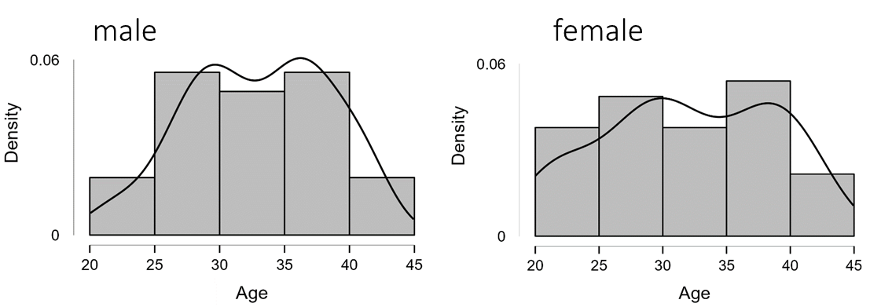
Figure S1. Histogram portraying age distribution of men (left) and women (right) of the sample.

 | Sex
 | Male (N, %) | Female (N, %) | Total
Vocational training | 12 (20.3%) | 15 (40.5%) | 27 (28.1%)
Technical diploma | 10 (16.9%) | 6 (16.2%) | 16 (16.7%)
Academic degree | 26 (44.1%) | 10 (27.0%) | 36 (37.5%)
PhD | 11 (18.6%) | 6 (16.2%) | 17 (17.7%)
Total | 59 (100.00%) | 37 (100.00%) | 96 (100.00%)
Table S1. Highest achieved or targeted degree. Data on two male participants is missing. X² test showed no statistically relevant difference in education degree between both sexes (X²(3)=5.32; p=.15).

 | Sex
 | Male (N,%) | Female (N,%) | Total
Volks-Hauptschulabschluss | 3 (5%) | 1 (2.8%) | 4 (4.2%)
Realschule Mittlere Reife | 7 (11.9%) | 3 (8.3%) | 10 (10.5%)
Polytechnische Oberschule | 1 (1.7%) | 3 (8.3%) | 4 (4.2%)
Abitur | 48 (81.4%) | 29 (80.6%) | 77 (81.1%)
Total | 59 (100.0%) | 36 (100.0%) | 95 (100.0%)
Table S2. Highest obtained secondary education degree. Data on two male participants and one female participant is missing. No statistically significant difference (X²=(3)2.89; p=.41) in secondary education was detected between both sexes.
In addition to education and degree we also compared RAVENS scores between both sexes. The RAVENS serves as a measure of cognitive ability and participants were asked to try and complete 12 designs within 5 minutes. Mann Whitney U test could detect no difference (U=895.5, Z=-1.607, p=.108) in RAVENS scores between men and women. (See Figure S2)
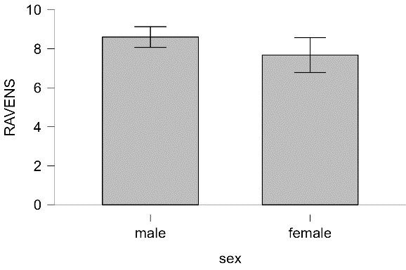
Figure S2. Barplot showing RAVENS distribution for men (left) and women (right)

We additionally obtained an overview of consumption patterns for caffeine, alcohol and nicotine (see table S3). We compared whether caffeinated drinks were consumed prior to the first session, if a person drank alcohol within the last 48h prior to session one and nicotine consumption on the first day of assessment.
 | Sex
 | Male (N,%) | Female (N,%) | Total
Caffeine | 8 (13.1) | 10 (27) | 18 (40.1)
Alcohol | 14 (23) | 15 (40.5) | 29 (63.5)
Nicotine | 5 (8.2) | 2 (5.4) | 7 (13.6)
Total | 27 (44.3) | 27 (72.9) | 54 (117.2)
Table S3. Consumption patterns of Caffeine, Alcohol and Nicotine are compared between both genders.
Imaging analyses included 52 males (59%) and 36 females (41%), aged 20-42 years (mean 31.8 years, SD = 6.1 years). 50 participants (57%) held an academic degree.
S-3: Assessment: Procedure and intervention
The study consisted of four appointments: a baseline session for genotyping and behavioral testing and three fMRI sessions, in which different amounts of tryptophan were administered. During the three fMRI appointments, participants received equal amounts of large neutral amino acids (LNAAs) and intervention dependent amounts of tryptophan. The amount of tryptophan was adjusted according to body-weight (see scheme S1). For detailed information on genotyping, tryptophan administration and etc. see supplement original manuscript.

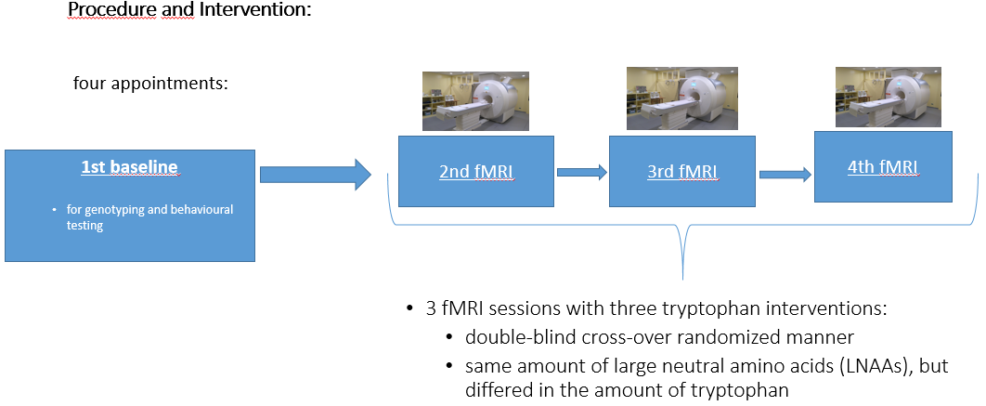
Scheme S1. Procedure and intervention.

S-4: fMRI data acquisition and preprocessing
The imaging data was acquired with a Siemens 3-Tesla MRI scanner (Magnetom Trio, Siemens, Erlangen, Germany). Echo-planar imaging (EPI) sequence (TR=2410ms; TE=25ms; flip angle=80°; voxel size=3.0x3.0x2.0 mm with a 1mm gap; FOV=192x192 mm²; in-plane resolution: 64x64 pixels) consisted of 42 transverse slices and was acquired in a top-down manner rotated at -25° to the anterior commissure-posterior commissure line. A structural T1-weighted image was also acquired (TR=1900ms; TE=2.52ms; flip angle=9°; voxel size=1.0x1.0x1.0 mm³; FOV=256x256mm²).
fMRI data was preprocessed using Nipype ¹. The EPI images were corrected for slice time, motion and spatial distortion. Each individual structural image was segmented and normalized to MNI space in a 2x2x2 mm³ voxel dimension. Finally, the images were smoothed with an isotropic Gaussian kernel (full width at half maximum: 8mm). For first-level fMRI analysis a high-pass filter with a width of 128s was applied.

S-5: Computational Model
Our model follows the set-up of the original study by Daw et. Al.². The paradigm contains three states: one first stage (grey boxes, indicated by S) and two second-stages (pair of colored boxes, indicated by S’₁ and S’₂). Within each stage, an agent can execute two actions, selecting either the left or right option (indicated by a₁ and a₂). Transition contingencies between the first-stage S and second-stage S’ are fixed throughout the task and defined accordingly:
P(S’₁|S,a₁)=0.7, P(S’₂|S,a₂)=0.7 (common transitions) or
P(S’₂|S,a₁)=0.3, P(S’₁|S,a₂)=0.3 (rare transitions)
After the second step the diffusive probability of receiving a reward lies between 0.25 and 0.75 and varies throughout the task according to random Gaussian walks.
The model is constructed as a hybrid reinforcement learning model with weighted components for model-free (MF) and model-based (MB) controls. The MF system follows temporal difference learning; in comparison, the model-based system additionally considers transition contingencies. Reward after first stage is always zero, as rewards are exclusively obtained after the second stage.
The second stage consist only of a model free component, as both MB and MF provide the same state-action value in the second stage (${Q=Q}_{MB}= Q_{MF})$. After the second stage a reward (indicated by r_{t} ) is either awarded or not. We can describe the second-stage state-action value accordingly:
$Q_{MF}$(S’_{t+1},a)=$Q_{MF}$(S’_{t}, a) + α₂$δ$
The reward prediction error (RPE) is defined by $δ$ and α₂ describes the second stage learning rate, respectively. For the second stage RPE the following is defined as $δ=$r_{t}-$Q_{MF}$(S’_{t},a). In the first stage value updating is similar, but with a different learning rate (α₁) and an additional eligibility parameter (λ) for stage skipping. The first stage RPE is defined as $δ=$r_{t}+$Q_{MF}$(S’_{t}, a)-$Q_{MF}$(S_{t},a). The first stage state-action value is described accordingly:
Q_{MF}(S_{t+1},a)=Q_{MF}(S_{t},a)+ α₁ λ$δ$
The model based component takes into consideration the transition probability and the maximum model-free state action value an agent had received in the past. Given action j is selected ($a_{j}$) the model based state action value is described as followed:
Q_{MB}(S_{t},$a_{j}$)=P(S’₁|S,$a_{j}$)maxQ_{MF}(S’_{1,t},a)+P(S’₂|S,$a_{j}$)maxQ_{MF}(S’_{2,t},a)
The hybrid model brings together model-free and model-based decision values in the first stage. The parameter $ω$ weights the influence of model-based and model-free values. In the specific case of a pure model-based learner $ω$=1, for a pure model-free learner $ω=0$ would be the case. The total state action value (Q_{net}) is defined as followed:
$Q\text{net}\text{(S,}{\text{a}}_{\text{j}}\text{)=ω}{\text{Q}}_{\text{MB}}\text{(S,}{\text{a}}_{\text{j}}\text{)+(1-ω)}{\text{Q}}_{\text{MF}}\text{(S}\text{,}{\text{a}}_{\text{j}}$)
The total state action value (Q_{net}) can be integrated into the softmax function, thereby assigning probabilities to different actions. The inverse temperature parameter $ß_{i}$tells us how deterministic the choices are, $ß_{1}$ and $ß_{2}$ refer to the first and second stage, respectively. The perseveration parameter π describes the propensity of repeating the previous first stage option (p>0) or switching (p<0). In case the previous first stage was repeated rep(a) equals 1, if not rep(a) equals 0. The sum of all available actions is described as a’. The following function provides action probabilities given the agent finds himself in state $S_{t}$.
$$\text{P}\left({\text{a}}_{\text{i,t}}\text{=a} | {\text{S}}_{\text{i,t}}\right)\text{=}\frac{\text{exp}\left({\text{ß}}_{\text{i}}\left[{\text{Q}}_{\text{net}}\left({\text{s}}_{\text{i,t}}\text{,a}\right)\text{+π*rep(a)}\right]\right)}{\sum_{\text{a'}}{\text{exp}\text{⁡}\text{(}{\text{ß}}_{\text{i}}\text{[}{\text{Q}}_{\text{net}}\left({\text{s}}_{\text{i,t}}\text{,}{\text{a}}^{\text{'}}\right)\text{+π*rep}\left({\text{a}}^{\text{'}}\right)\text{]}}}$$

S-6: fMRI first-level model and ROI definition
The first-level statistics general linear model (GLM) described stay-switch behaviour of the participants ³. Two first stage onset parametric modulators – namely, model-free and model-based – were our regressors of main interest. For the model-free parameter we looked into the effect of previous reward (unrewarded/rewarded coded as -0.5/0.5) on the neural response during first stage presentation. For the model-based parameter we investigated the interaction of previous transition (rare/common as -0.5/0.5) and reward on neural response in the first stage. Regressors that were included, but of no further relevance for the study included a first stage onset regressor for transition and two second stage onset regressors (for transition and reward, respectively).
The same ROI masks were used as in Gilger et al. The vmPFC mask (Figure S3; top left) was extracted from the Neurosynth database (https://www.neurosynth.org/) and the anterior cingulate cortex was additionally removed. The VS (Figure S3; bottom left) and dlPFC masks (Figure S3; top right) were taken from the BrainMap database ⁴. All maps were smoothed.

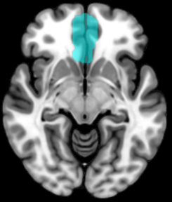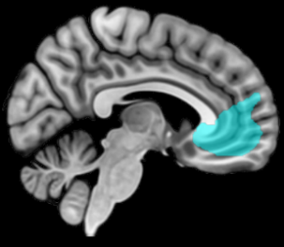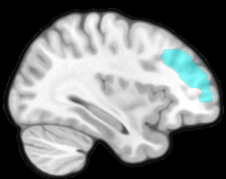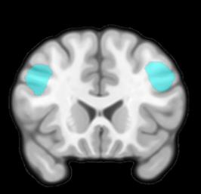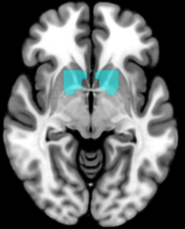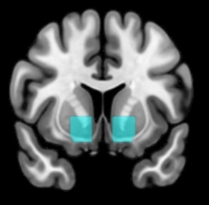
vmPFC mask
z = -8
x = 5
dlPFC mask
y = 21
x = 34
ventral striatum mask
y = 12
z = -6
Figure S3: ROI masksRegion of interest (ROI) analyses:
As they have previously been correlated with MF and MB signals the ventral striatum, vmPFC and dlPFC are the three regions of interest determined to be of importance for our study ⁵⁻⁷. The mean BOLD signal in the ROIs was extracted for each session and four contrasts of interest (first-stage reward presentation, first-stage onset interaction reward and transition, second stage onset difference in transition, second stage onset difference in reward) were looked into. We then compared the values of the extracted ROIs between men and women with a t-test or Mann-Whitney test. All values p<0.05 (two-tailed) were considered statistically significant.

Exploratory whole-brain analyses:
To conclude the imaging analyses, an exploratory second-level statistics was performed building on to the original analysis from Gilger et. Al. where the effect of the tryptophan intervention had been evaluated as a repeated measures factor. We added sex as a covariate to the primary analysis and looked for the association between averaged effect across the sessions and sex through a t-test, similar to the behavioural analysis. A voxel-based threshold of p (uncorr) < 0.001 was selected.

References supplementary material
1 Gorgolewski, K. et al. Nipype: a flexible, lightweight and extensible neuroimaging data processing framework in python. Frontiers in neuroinformatics 5, 13 (2011). https://doi.org/10.3389/fninf.2011.00013
2 Daw, N. D., Gershman, S. J., Seymour, B., Dayan, P. & Dolan, R. J. Model-based influences on humans' choices and striatal prediction errors. Neuron 69, 1204-1215 (2011). https://doi.org/10.1016/j.neuron.2011.02.027
3 Kroemer, N. B. et al. L-DOPA reduces model-free control of behavior by attenuating the transfer of value to action. NeuroImage 186, 113-125 (2019). https://doi.org/10.1016/j.neuroimage.2018.10.075
4 Hansen, F. A. N. L. K. Automatic anatomical labeling of Talairach coordinates and generation of volumes of interest via the BrainMap database. Neuroimag 16, 2-6 (2002).
5 Nee, D. E. et al. A meta-analysis of executive components of working memory. Cerebral cortex (New York, N.Y. : 1991) 23, 264-282 (2013). https://doi.org/10.1093/cercor/bhs007
6 Smittenaar, P., FitzGerald, T. H., Romei, V., Wright, N. D. & Dolan, R. J. Disruption of dorsolateral prefrontal cortex decreases model-based in favor of model-free control in humans. Neuron 80, 914-919 (2013). https://doi.org/10.1016/j.neuron.2013.08.009
7 Wager, T. D., Jonides, J. & Reading, S. Neuroimaging studies of shifting attention: a meta-analysis. NeuroImage 22, 1679-1693 (2004). https://doi.org/10.1016/j.neuroimage.2004.03.052

