SUPPLEMENTARY MATERIAL

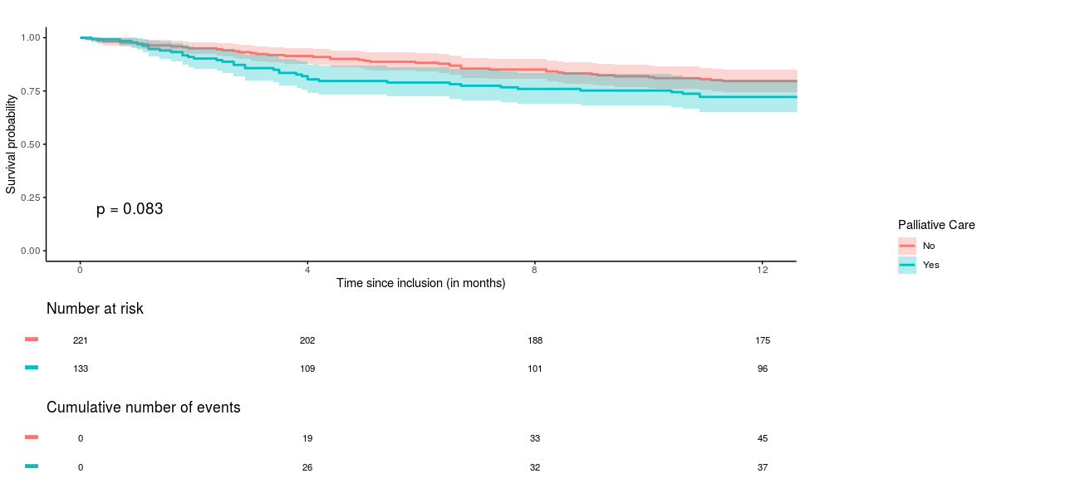
Figure 1- Comparison of one-year survival between patients who had met or not a palliative care team at inclusion.

