Supplemental Information
Zinc Ion Thermogalvanic Cell: A New Strategy for Low-Grade Heat Conversion and Energy Storage
Zhiwei Li,¹ Yinghong Xu,¹ Langyuan Wu,¹ Yufeng An,¹ Yao Sun,¹ Tingting Meng,² Hui Dou,¹ Yimin Xuan,^{2∗} Xiaogang Zhang^{1∗}
¹Jiangsu Key Laboratory of Electrochemical Energy Storage Technologies, College of Material Science and Engineering, Nanjing University of Aeronautics and Astronautics, Nanjing 211106, China
²School of Energy and Power Engineering, Nanjing University of Aeronautics and Astronautics, Nanjing 210016, P. R. China

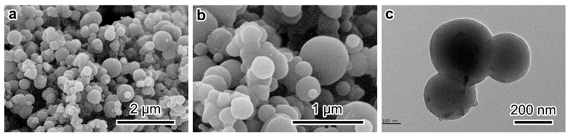
Fig. S1 SEM and TEM images of PC.

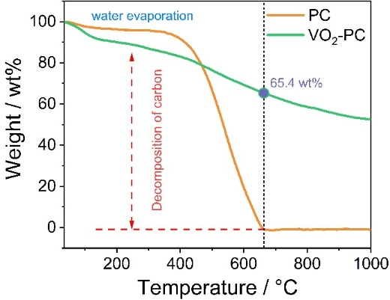
Fig. S2 TGA curves of PC and VO₂-PC.

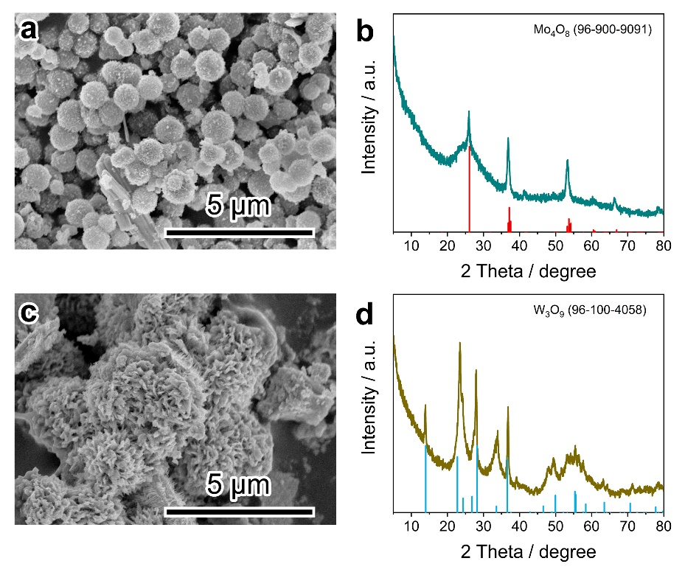
Fig. S3 The SEM image and XRD pattern for a,b Mo₄O₈ and c,d W₃O₉, respectively.

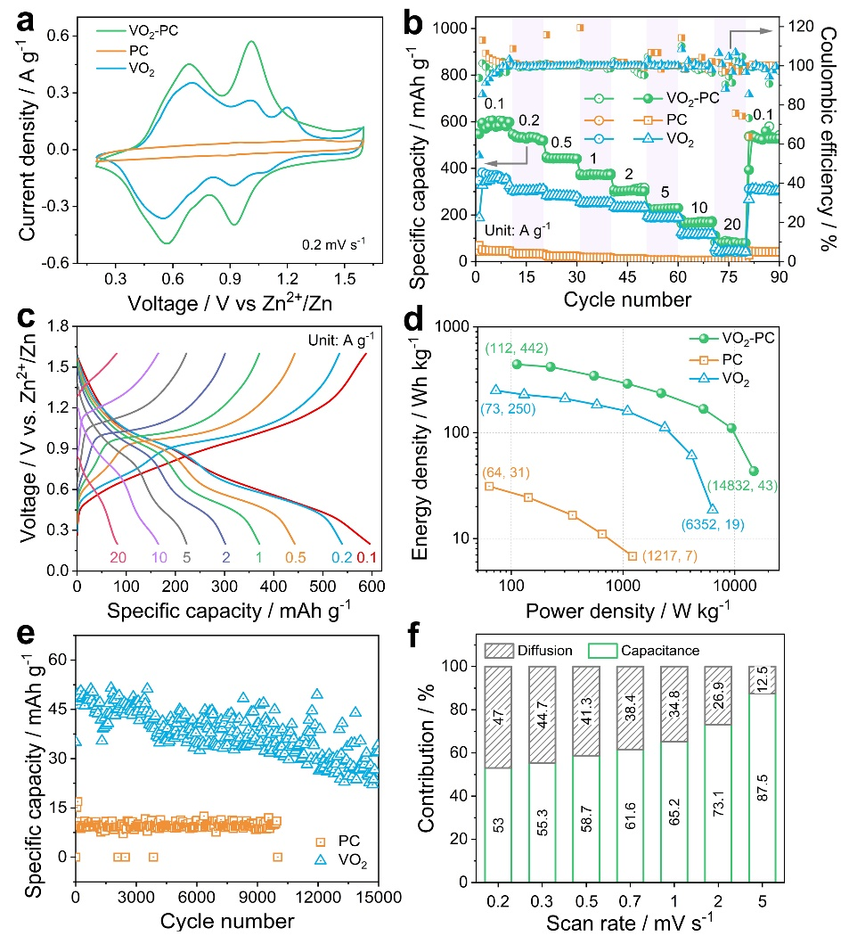
Fig. S4 a CV curves at 0.2 mV s⁻¹ and b rate performance of VO₂-PC, VO₂, and PC. c GCD curves of VO2-PC at various current densities. d Ragone plots. e Cycling stability at 10 A g⁻¹. f Capacitive contributions at different scan rates.

∗Corresponding author E-mail: azhangxg@nuaa.edu.cn
∗Corresponding author E-mail: ymxuan@nuaa.edu.cn

