Figure S1 Differential colonization efficiency of bacterial isolates in adult Nematostella polyps at 2 days post recolonization (2dpr). Boxplot showing bacterial colonization levels expressed as log10 colony-forming units (CFU) per polyp after recolonization with isolates NJ1, NJ33, NA11 (blue), and Hal025, Hal281 (red). N=5 polyps each, Kruskal-Wallis ANOVA revealed significant differences between recolonization succession of native (blue) and foreign (red) isolates, * p<=0,05 ** p<=0,01 *** p<=0,001.

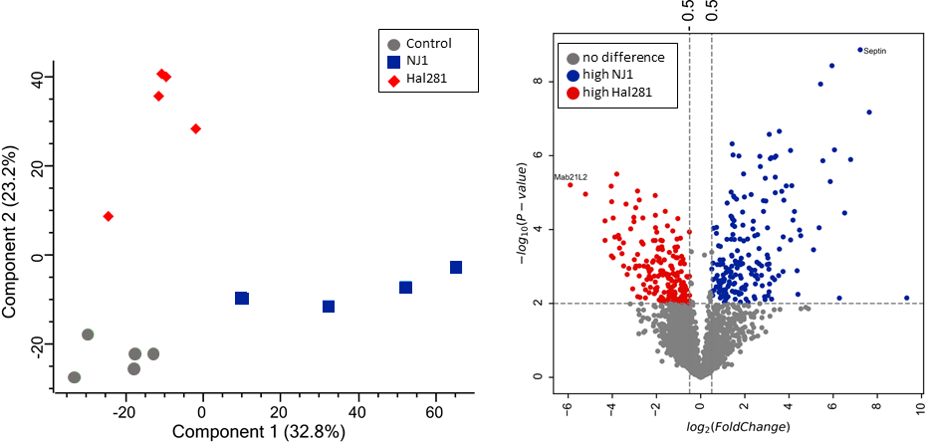
Figure S2 Proteomic response of nematosomes following treatment with bacterial isolates NJ1 and Hal281. A) Principal component analysis (PCA) of proteomic profiles showing distinct clustering patterns among nematosomes treated with isolates NJ1 (blue), Hal281 (red), and control nematosomes without bacterial challenge (grey). Percentages indicate the explained variance for each principal component. B) Volcano plot illustrating differentially abundant proteins identified between NJ1- and Hal281-treated nematosomes. Proteins significantly enriched (p<0.05, log₂ fold-change > 0.5) in NJ1-treated nematosomes are shown in blue, those enriched in Hal281-treated nematosomes are in red, and proteins with no significant difference are represented in grey. Selected proteins with strong differential expression are labeled explicitly on the plot.
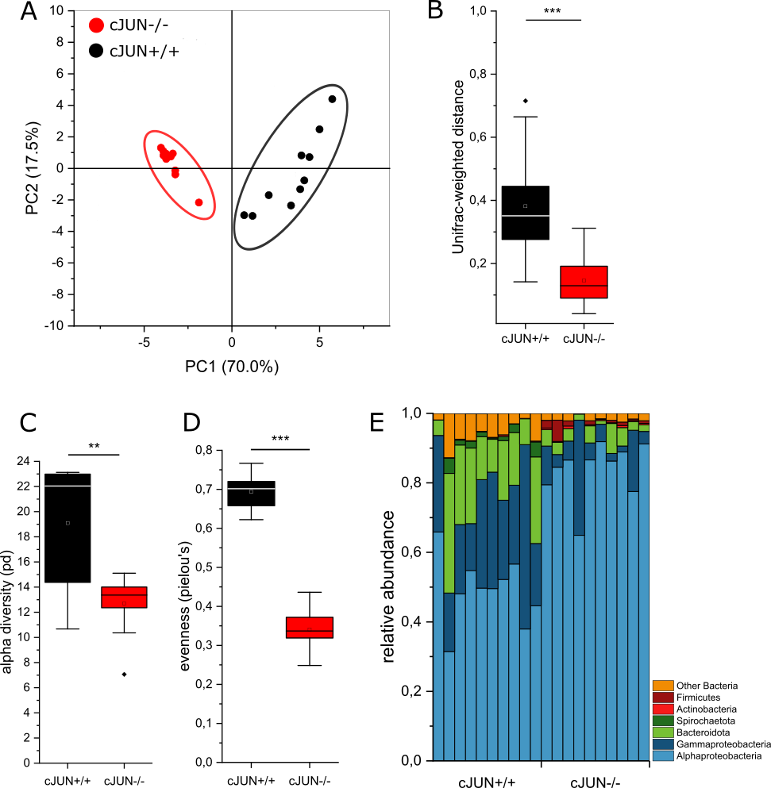
Figure S3 Impact of cJUN KO on microbial diversity and abundance of specific taxa in Nematostella polyps. A) Principal Coordinate Analysis (PCoA) plot based on weighted UniFrac distances, comparing the microbial communities of cJUN^{+/+} and cJUN^{-/-} polyps. The two groups form distinct clusters, indicating significant differences in microbial community composition. B) Weighted UniFrac distance demonstrates distinct microbial community composition in cJUN^{-/-} versus cJUN^{+/+} polyps. C) Alpha diversity analysis using Faith’s Phylogenetic Diversity (PD) index revealed a significant reduction in microbiome richness in cJUN^{-/-} polyps compared to cJUN^{+/+} polyps. N=20/genotype, two-sample t-test, * p<=0,05 ** p<=0,01 *** p<=0,001. D) Microbial community evenness (Pielou’s evenness index) significantly decreases in cJUN mutant polyps compared to wildtype control. E) Bar plots representing the relative abundance of bacterial taxa in cJUN^{+/+} and cJUN^{-/-} animals. Each bar shows the mean relative abundance of taxa, including Alphaproteobacteria, Gammaproteobacteria, Bacteroidota, Spirochaetota, Actinobacteria, and Firmicutes, across samples for each genotype, highlighting differences in the microbial community composition between the two groups.
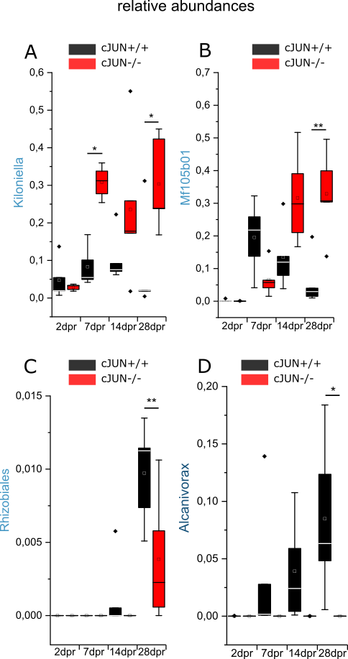
Figure S4 Temporal dynamics of differentially abundant bacterial taxa in cJUN^{-/-} and cJUN^{+/+} polyps. Relative abundances of specific bacterial taxa over time (2, 7, 14, and 28 days post-recolonization [dpr]) in cJUN knockout (red) and wildtype (black) polyps. (A) Kiloniella (Alphaproteobacteria), (B) Mf105b01 (Alphaproteobacteria), (C) Rhizobiales (Alphaproteobacteria), and (D) Alcanivorax (Gammaproteobacteria) show distinct colonization patterns between genotypes. Significant differences between groups at specific time points are indicated (*p<0.05, **p<0.01, ***p<0.001; ANCOM).

