Starch-Based Hydrogel Development and Its Impact on Seed Coating Performance

Raikhan Rakhmetullayeva¹, Botakoz Khavilkhairat¹, Assel Toktabayeva¹, Nurzhan Mukhamadiyev², Elmira Nurgaziyeva³*, Munziya Abutalip³*
¹Department of Chemistry and Chemical Technology, Al-Farabi Kazakh National University, Almaty, 050040, Kazakhstan
²Kazakh Research Institute of Plant Protection and Quarantine Named After Zh. Zhiyembayev, Almaty 050070, Kazakhstan
³National Laboratory Astana, Nazarbayev University, Astana, 010000, Kazakhstan
*corresponding author's email: munziya.abutalip@nu.edu.kz, elmira.nurgaziyeva@nu.edu.kz

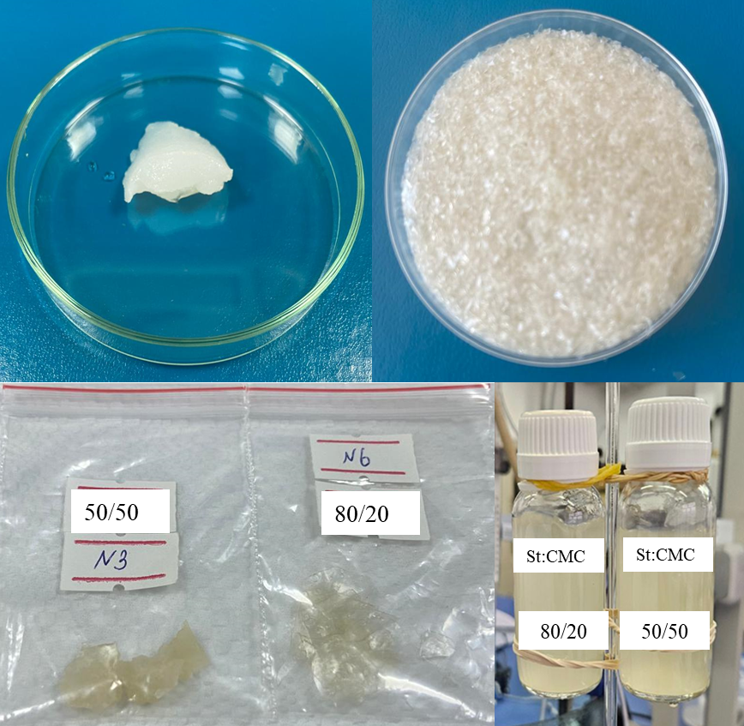
S1 – Synthesized hydrogels in swollen and dried forms
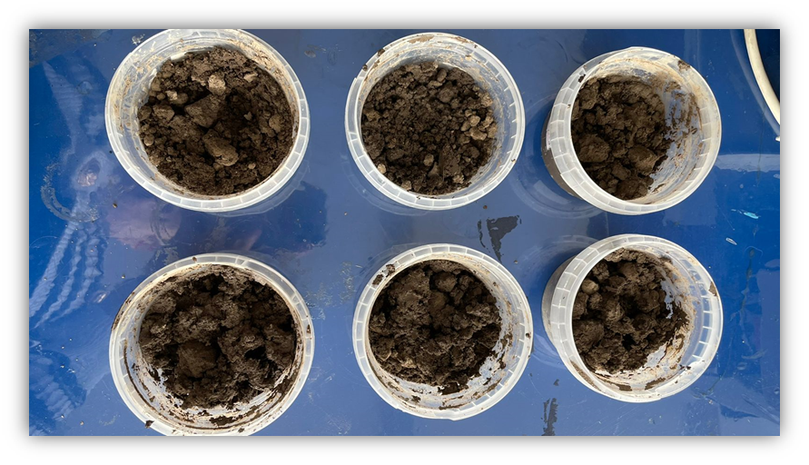
S2 – Biodegradability test performance

