SUPPLEMENTARY TABLES
Table 1. Sex-Specific Heritability and Genetic Correlation Results for all 733 Traits
Sex-specific heritability estimates for 733 traits were obtained from sex-stratified GWAS summary statistics using LDSC. Sex-differences in heritability were tested using a two-sided z-statistic constructed from the heritability estimates and their standard errors, and false discovery rate was controlled at 5% using the Benjamini-Hochberg procedure. All 733 trait phenotype codes, descriptions, male and female heritability estimates and standard errors, computed heritability difference score, BH-adjusted p-value, and computed genetic correlation between males and females are displayed in the table below. Due to uncertainties in the LDSC genetic correlation estimates, genetic correlations between sexes could not be calculated in some traits.
Table 2. Primary and Replication Analysis Results for All Loci (A-E)
Significant loci for each trait group were identified using PLINK on aggregated summary statistics. Candidate significant loci were then tested in a replication set, yielding 649 significant loci for FM traits, 381 significant loci for BP traits, 14 for creatinine levels, 8 for snoring, and 64 for birth weight. Sex-specific loci were identified through a two-stage procedure, where candidate sex-specific loci in the discovery set were tested for sex-specificity in the replication set. After replication, 47 loci were identified as sex-specific, of which 31 were not previously reported to be sex-specific. All identified sex-specific loci are provided in the tables attached, with columns denoting the locus, locus chromosome, the range of the locus, and the lead SNP. In addition, the identified locus type, male and female p-values, beta estimates, and standard errors are also included for both the primary and replication study, as well as combined meta values. Nearby genes and QTL-associated genes are also provided for each locus.
Table 3. Review of Previous Literature on the Identified Sex-Specific Loci
To better interpret the identified sex-specific loci, all 47 loci were subject to a literature review conducted using the Data Integrator tool from the UCSC genome browser, where we searched for previous association in the trait or identification of sex-specificity. All identified loci were previously associated with either their respective or related traits in the literature, but 31 loci had not been previously identified in sex-specific analyses. Previous studies identifying each locus are provided in Supplementary Table 3 for both FM and BP traits, with the chromosome, genetic position, locus name, author of the study identifying the locus, the date of publication, name of the study, the trait analyzed, the primary and replication samples, the locus band, nearby genes, and a description of the population the locus was found to be associated in.
Table 4. Results of Pathway Enrichment Analysis
Genes with known QTL associations to the identified sex-specific loci were further explored with pathway enrichment analysis using g:Profiler. Five gene sets were constructed per trait group using QTL-associated genes: a sex-agnostic gene set containing all associated QTL genes, male and female-specific gene sets containing the union of non-SSE loci and the respective SSE loci, and male and female-specific gene sets containing only the corresponding SSE loci. Enrichment analysis was conducted on gene sets from Gene Ontology (GO), the Kyoto Encyclopedia of Genes and Genomes (KEGG), and the Reactome database, and FDR was controlled at 5%. The source, name, ID, and term size are listed for each pathway, as well as the respective adjusted p-values in each gene set. Pathways with sex-specific significance (either significant in only one sex-specific gene set or significant in one sex and the sex-agnostic gene set, but not in the other) are highlighted in yellow for ease of identification, and significant p-values at FDR 5% are highlighted in green.
Table 5. Sex-Specific and Sex-Agnostic Polygenic Risk Score Analysis Results
Both sex-specific and sex-agnostic PRSs were generated using pruning + thresholding and PRScs, with the sex-agnostic PRSs trained on the entire discovery dataset and the sex-specific PRSs trained on the male and female subsets of the discovery dataset. PRS accuracies for all methods was then evaluated on the male and female subsets of the replication dataset. Predictive performance was then compared between the sex-specific PRSs to test for significant differences in performance. The performance of all models, as well as the test statistics and p-values for the performance comparison, are included in Supplementary Table 5.

SUPPLEMENTARY FIGURES
Figure 1. Comparison of Male and Female Heritabilities for all Traits
Male and female heritability estimates for a range of complex traits and diseases were calculated and compared using a two-sided z-score approach. In many traits, there seemed to be a large difference between male and female heritability estimates, but the high standard errors of the estimates lowered the significance of these difference.
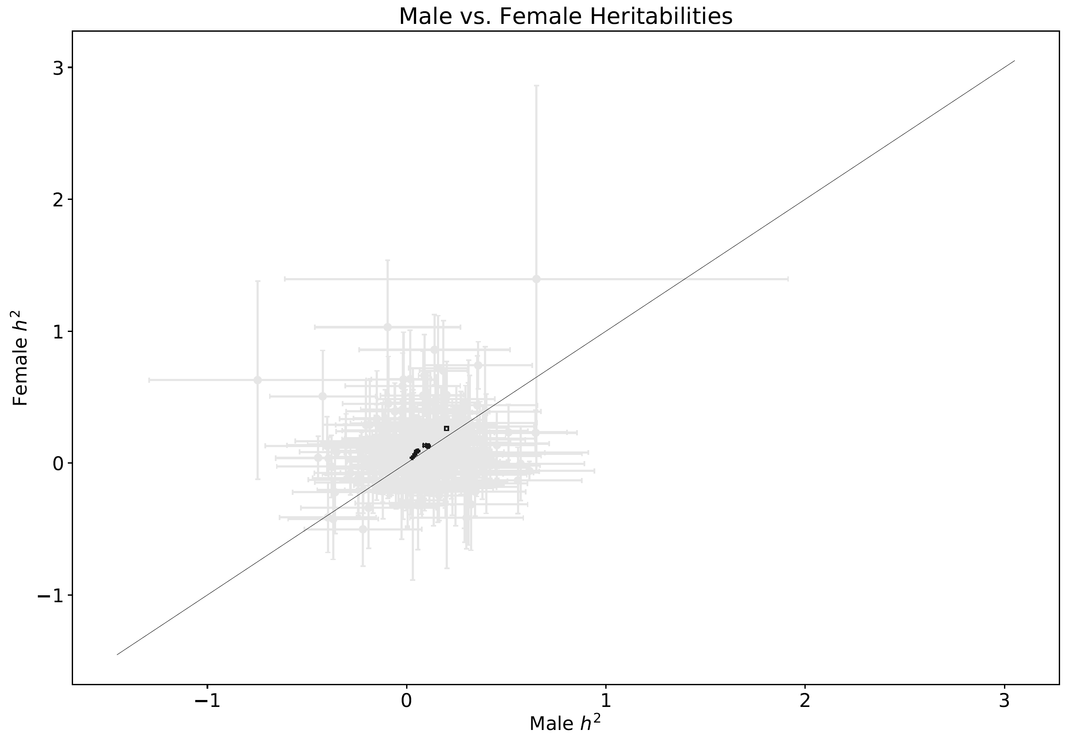
Figure 2. Double Manhattan Plots and Significant Loci for all Traits
P-values for the sex-stratified GWAS summary statistics were visualized using double Manhattan plots for all 5 trait groups, with FM traits shown in (a), BP traits shown in (b), creatinine levels shown in (c), snoring shown in (d), and birth weight shown in (e). Log-transformed female p-values were plotted on the positive y-axis and log-transformed male p-values were plotted on the negative y-axis. Nearby gene names for all identified SSE loci are annotated along with their peaks. A total of 47 loci with sex-specific effects were identified across the five trait groups, with 37 identified in FM traits and 10 identified in BP traits. No significant sex-specific loci were identified in creatinine levels, snoring, or birth weight after replication analysis.
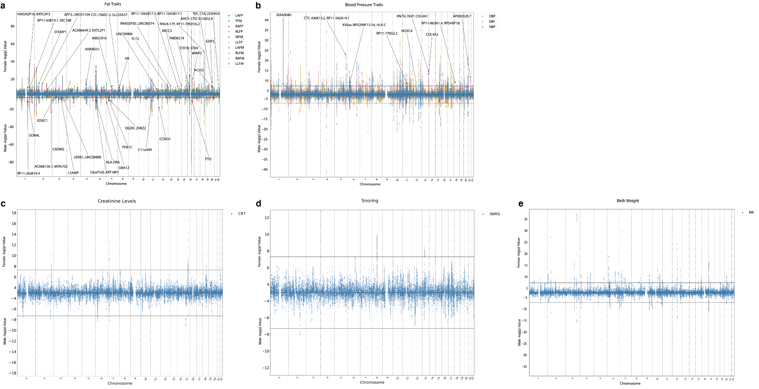
Figure 3. Replication Power Curves for Snoring, Creatinine, and BW
Power analyses for traits without replicated SSE loci were conducted, with the power curves for creatinine levels shown in (a), snoring shown in (b), and birth weight shown in (c). For each locus, the SNP with the highest effect size was selected in the analysis. β_{rep}, the effect size of the SNP in the replication study, was varied from 0.5β_{dis} to β_{dis}.
