β-actin
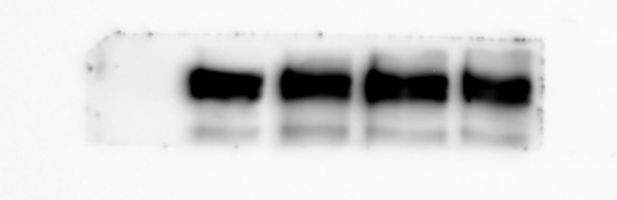
EZH2
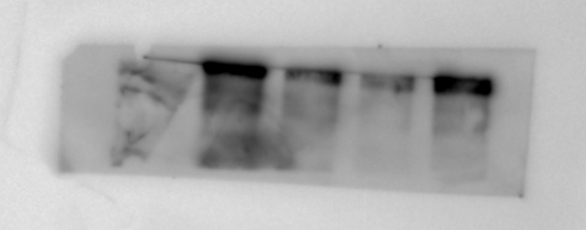
β-actin
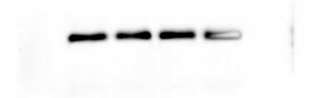
Nrf2
