Supplementary Information for

FeCu Dual-Single-Atom Catalyst Promotes Gradient H₂O₂ Activation for Enhanced Methane Oxidation to Methanol

Haonan Zhang ^{1†}, Shuai Wang ^{1†}, Yang Li ¹, Hongjie Qin ¹, Mingwang Wang ¹, Qinghai Chen ¹, Boshi Zheng ¹, Shuxu Zhu ¹, Pengye Zhang ¹, Chaoqun Gu ¹, Yunyun Li ¹, Qi Hua ¹, Mingbo Wu ¹ ²*, Wenting Wu¹*

¹ State Key Laboratory of Heavy Oil Processing, College of Chemistry and Chemical Engineering, Institute of New Energy, China University of Petroleum (East China), Qingdao 266580, P. R. China
² State Key Laboratory of Advanced Optical Polymer and Manufacturing Technology, College of Chemical Engineering, Qingdao University of Science & Technology, Qingdao 266061, P. R. China.
†Haonan Zhang and Shuai Wang contributed equally to this work.
Email: wuwt@upc.edu.cn, wumb@upc.edu.cn

Supplementary Information Text
The detection of HCHO. Formaldehyde (HCHO) concentrations were measured using a colorimetric method with a UV-Vis spectrophotometer (UV-2700, Shimadzu, Japan), as it could not be detected by ¹H NMR spectroscopy. The reagent solution was prepared by dissolving 15 g of ammonium acetate, 0.3 mL of acetic acid, and 0.2 mL of pentane-2,4-dione in 100 mL of water. For the analysis, 0.5 mL of the liquid sample was combined with 2.0 mL of water and 0.5 mL of the prepared reagent solution. The resulting mixture was incubated in a water bath at 35 °C and monitored by UV-Vis absorption spectroscopy until the absorbance at 413 nm reached a stable value.
•OH capture experiment. Coumarin was utilized as the probe for the detection of •OH via the production of 7-hydroxycoumarin (7-HC). Typically, 5 mg catalyst was dispersed in 20 mL coumarin solution (1 mM) and stirred for 1 min. The H₂O₂ (200 μL) was added, and stirred for 30 min at 80 ℃, PL spectra were then measured on the spectrofluorometer (RF-6000, Shimadzu, Japan) after filtering. The excitation wavelength was 330 nm, and the peak value at 454 nm was observed to semi-quantify the concentration of •OH.
•O₂⁻ capture experiment. •O₂⁻ was detected by degradation of Nitrotetrazolium Blue chloride (NBT) using NBT as a probe. Generally, 5 mg catalyst was dispersed in 20 mL NBT solution (0.02 mM), stirred for 1 min, and H₂O₂ (200 μL) was added. The total reaction time was 15 min at 80 ℃. After filtering a certain amount every 3 min, it was measured on the UV-vis spectrophotometer (RF-6000, Shimadzu, Japan). The excitation wavelength was 330 nm, the peak value was observed at 260 nm, and the •O₂⁻ concentration was semi-quantified.
Experimental details of quantification •OH and •O₂‒. Benzoic acid (BA) was used as a probe molecule to react with •OH in catalysts-H₂O₂ suspension under an anaerobic environment. Briefly, 10 mg catalyst was added into a round-bottomed flask with a rubber stopper and followed with Ar gas bubbling to remove oxygen. Subsequently, 20 mL of BA solution (10.4 mmol/L) was continuously bubbled with Ar gas for 30 min to ensure an oxygen-free environment and then pipetted into the round-bottomed flask with a rubber stopper by an injection syringe. Then the certain concentration of H₂O₂ was pipetted into pollutant suspension to trigger the reaction under shaking throughout the experiment. The reaction solution was collected at a predetermined time, and filtrated through 0.22 μm membranes. HPLC was used to determine the p-hydroxybenzoic acid (p-HBA) concentration. The mobile phase was acetonitrile: water (30 : 70, v₁ : v₂ ) and the detection wavelength was 270 nm. Injection volume, flow rate of mobile phase, and column temperature were fixed at 10 μL, 1.0 mL/min and 35 °C, respectively. Given that 5.87 ± 0.18 moles •OH reacting with BA produced one mole p-HBA. The cumulative •OH concentration is therefore approximately 5.87 times that of p-HBA concentration. Given the fact that 1 mol Nitroblue tetrazolium (NBT) can react with 4 mol •O₂–. We quantified the concentration of generated •O₂– in the Fenon suspension by recording the residual concentration of NBT on a UV-vis spectrophotometer (maximum absorbance at 260 nm). The experimental procedure was similar as •OH determination experiments except replacing BA with NBT.
The selectivity of oxidative activation H₂O₂ (to •O₂–) and reductive activation H₂O₂ (to •OH) within 90 minutes, were calculated by the following eq. S1 and eq. S2, respectively.
Selectivity (to •O₂⁻) (%) = 100 * [•O₂⁻] / ([•O₂⁻] + [•OH]) eq. S1
Selectivity (to •OH) (%) = 100 * [•OH] / ([•O₂⁻] + [•OH]) eq. S2
[•O₂–]t and [•OH]t referred to the concentrations of generated •O₂– and •OH in 90 minutes, respectively.
The detection of residual H₂O₂. After the reaction, the solution was diluted 10 times with water, then 0.1 mol/L H₂SO₄ and 0.05 mol/L potassium titanium oxalate were added, stirred for one minute, and the absorbance was measured by UV.
H₂O₂ utilization. The H₂O₂ utilization rate is calculated by the following formula:
H₂O₂ utilization =（1n_{CH3OH} + 2n_{HCHO} + 3n_{HCOOH} + 4n_{CO2}） / n_{consumed H2O2}
Temperature programmed desorption (TPD). Temperature programmed desorption (TPD) was measured on Micromeritics AutoChemHP-2950. The sample was pretreated in He flows under 500 ℃ for 40 min; and 10% CH₄/He (10% NH₃/He, 10% H₂/He) was used for absorption of the CH₄ (NH_{3,} H₂) on the sample with 10 mL/min for 1 h, followed by 1 h He flow with a flow rate of 50 mL/min at 80 ℃ for removing the physically adsorbed oxygen molecules. CH₄-TPD (NH₃-TPD, H₂-TPR) was measured in He flow at a rate of 50 mL/min. The initial temperature is 80 ℃, and the heating rate of 10 ℃/min increases to 300 ℃. Desorbed CH₄ (NH_{3,} H₂) was monitored by a thermal conductivity detector (TCD).
Density functional theory (DFT) calculations. All computations using spin polarised density functional theory (DFT) were carried out with the Vienna ab initio simulation package (VASP 5.4.4). The Perdew-Burke-Ernzerhof (PBE) functional based on generalized gradient approximation (GGA) was utilized to describe the exchange-correlation energy. The projector augmented wave (PAW) pseudopotential was implemented to account for the interaction between ions and electrons. The Grimme approach (DFT-D3) was employed to correct for weak van der Waals interactions. A Gamma k-point of 1 × 1 × 1 was used to sample the Brillouin zone. The kinetic energy cutoff was set to 400 eV, and atomic coordinates were relaxed until the maximum force was below 0.05 eV/Å. The electron self-consistent cycle convergence criterion was set to 1×10⁻⁴ eV. The VASPsol implicit solvation model was used to simulate the solution environment. The charge density difference was analyzed using VASPKIT and Multiwfn.
The adsorption free energy (ΔG) is calculated by ΔG = ΔE + ΔZPE − TΔS, where ΔE is the DFT based adsorption energy, ΔZPE and TΔS are the correction of zero point energy and entropy, respectively.
The MFI-type zeolite unit cell including 288 atoms was chosen as the computational model of ZSM-5 with a lattice constant of 20.09 Å × 19.74 Å × 13.14 Å from the Database of Zeolite Structures. Two Si atoms located at the T8 and T12 sites within two adjacent 5-membered rings of the straight channel were replaced by two Al atoms and the Brønsted acid sites of ZSM-5 were created by adding two H atoms bound to bridge O atoms of two -Si-O-Al- units to compensate the framework negative charge with Al substitution.

Supplementary Information Figures
Supplementary Fig. 1 | Standard curve. (A) Standard curve of CH₃OH in gas chromatography. (B) Standard curve of HCHO in UV-vis spectra. (C) Standard curve of CH₃OOH in ¹H-NMR. (D) Standard curve of formic acid in liquid chromatography.
Supplementary Fig. 2 | Standard curve and selective oxidation of CH₄ at low temperature under different reaction conditions. (A) Catalytic performance of different concentration of H₂O₂. Reaction conditions: 3.5 MPa CH₄, 20 mL H₂O, 10 mg catalyst, 3 h, 80 °C. (B) Catalytic performance of different mental loading amounts. Reaction conditions: 3.5 MPa CH₄, 20 mL 0.1 M H₂O₂, 10 mg catalyst, 3 h, 80 °C. (C) Catalytic performance of different temperatures. Reaction conditions: 3.5 MPa CH₄, 20 mL 0.1 M H₂O₂, 10 mg catalyst, 3 h. (D) Catalytic performance of different H₂O volume. Reaction conditions: 3.5 MPa CH₄, 10 - 80 mL 0.1 M H₂O₂, 10 mg catalyst, 3 h, 80 °C. (E) Catalytic performance of different reaction pressure. Reaction conditions: 0.1 - 4.0 MPa CH₄, 20 mL 0.1 M H₂O₂, 10 mg catalyst, 3 h, 80 °C. (F) Catalytic performance of different quality of catalysts. Reaction conditions: 3.5 MPa CH₄, 20 mL 0.1 M H₂O₂, 2-20 mg catalyst, 3 h, 80 °C.
Note: The results showed that the liquid products contained C₁ oxygen-containing compounds, such as CH₃OH, HCOOH, and HCHO. Without Cu metal, a large amount of HCOOH appeared in the reaction product. Increasing the Cu load to 0.2 wt%, the total liquid yield improved and it increased the selectivity of CH₃OH from 20% to 90%, suggesting that the introduction of Cu promote CH₃OH generation selectively. Further increases in Cu loading continued to improve both total yield and CH₃OH selectivity, but not significantly, indicating that Fe single atomic sites are crucial for methane activation while Cu single atomic sites play a key role in improving CH₃OH selectivity. However, excessive Cu loading may compete with Fe for methane adsorption and hinders its activation by Fe, leading to decreased yield. The amount of catalyst also affects the CH₃OH selectivity. The peak selectivity occurs at 10 mg of catalyst. However, using too much catalyst can lead to over-oxidation of CH₃OH due to the excessive decomposition of H₂O₂. Furthermore, the solvent amount used in the reaction influenced both the catalytic yield and selectivity of CH₃OH. As H₂O addition increased from 10 mL to 40 mL, there was a proportional increase in CH₃OH yield. At 80 mL conditions, CH₃OH selectivity approached 100%, albeit with a slight decrease in total yield. This is because the catalyst is more evenly dispersed in H₂O which can carry away the fresh product in time, and can better decompose and utilize H₂O₂, avoiding the peroxide process.
Supplementary Fig. 3 | Catalytic performance of different time. Reaction conditions: 3.5 MPa CH₄, 20 mL H₂O, 10 mg catalyst, 80 °C, 0.1 M H₂O₂.
Supplementary Fig. 4 |Comparison of CH₃OH selectivity of as-prepared samples under equivalent activity.Reaction conditions: 10 mg of Cat., 20 mL of H₂O as solvent, 0.1 M of H₂O₂ as oxidant, 3 MPa CH₄, 80 ºC, 1 h for FeCu/ZSM-CI, 2.2 h for FeCu/ZSM-CC, 2.4 h for FeCu/ZSM-II, 2.9 h for FeCu/ZSM-IC.
Supplementary Fig. 5 | Time-dependent conversion and hot filtration test of the reaction.
Supplementary Fig. 6 | XRD patterns of different fresh prepared metal loadings of FeCu/ZSM-CI.

Supplementary Fig. 7 | HRTEM and HRTEM-EDS-mapping images of Fe/ZSM-C. Where green, blue, purple and yellow represent Fe, Al, Si and O, respectively.
Supplementary Fig. 8 | HRTEM and HRTEM-EDS-mapping images of Fe/ZSM-C. Where orange, blue, purple and yellow represent Cu, Al, Si and O, respectively.
Supplementary Fig. 9 | HRTEM and HRTEM-EDS-mapping images of Fe/ZSM-C. Where green, orange, blue, purple and yellow represent Fe, Cu, Al, Si and O, respectively.

Supplementary Fig. 10 | SEM image and SEM-EDS-mapping images of FeCu/ZSM-CI catalyst. Where purple, red, orange, dark green and green represent Fe, Cu, Si, Al and O, respectively.

Supplementary Fig. 11 | Fe 2p XPS spectra of FeCu/ZSM-CI.
Supplementary Fig. 12 | Cu 2p XPS spectra of FeCu/ZSM-CI.

Supplementary Fig. 13 | (A) XANES spectra at Fe K-edge of FeCu/ZSM-CI in comparison with Fe foil, FeO and Fe₂O₃. (B) Fourier transform (FT) k³-weighted EXAFS spectra of FeCu/ZSM-CI in comparison with Fe foil, FeO and Fe₂O₃. (C) XANES spectra at Cu K-edge of FeCu/ZSM-CI in comparison with Cu foil, Cu₂O and CuO. (D) Fourier transform (FT) k³-weighted EXAFS spectra of FeCu/ZSM-CI in comparison with Cu foil, Cu₂O and CuO.
Supplementary Fig. 14 | EXAFS fitting analysis of FeCu/ZSM-CI. (a-b) Fe/Cu K-edge EXAFS; (c-d) Fe/Cu K-edge EXAFS (points) and curvefit (line) for FeCu/ZSM-CI, shown in k³ R- space (FT magnitude and imaginary component). The dates are k³-weighted and not phase-corrected. (e-f) Fe/Cu K-edge EXAFS (points) and the curvefit (line) for FeCu/ZSM-CI, shown in k³-weighted k-space.

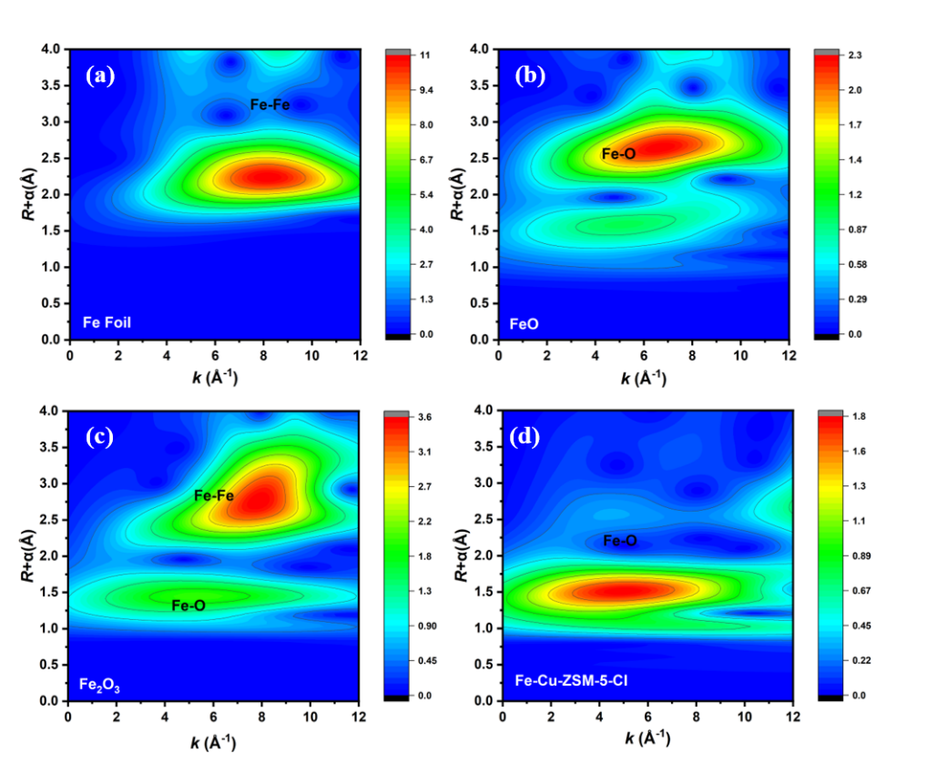
Supplementary Fig. 15 | Wavelet transform (WT) analysis of the Fe K-edge EXAFS oscillations of FeCu/ZSM-CI. (a) Fe foil, (b) FeO, (c) Fe₂O₃, (d) FeCu/ZSM-CI.
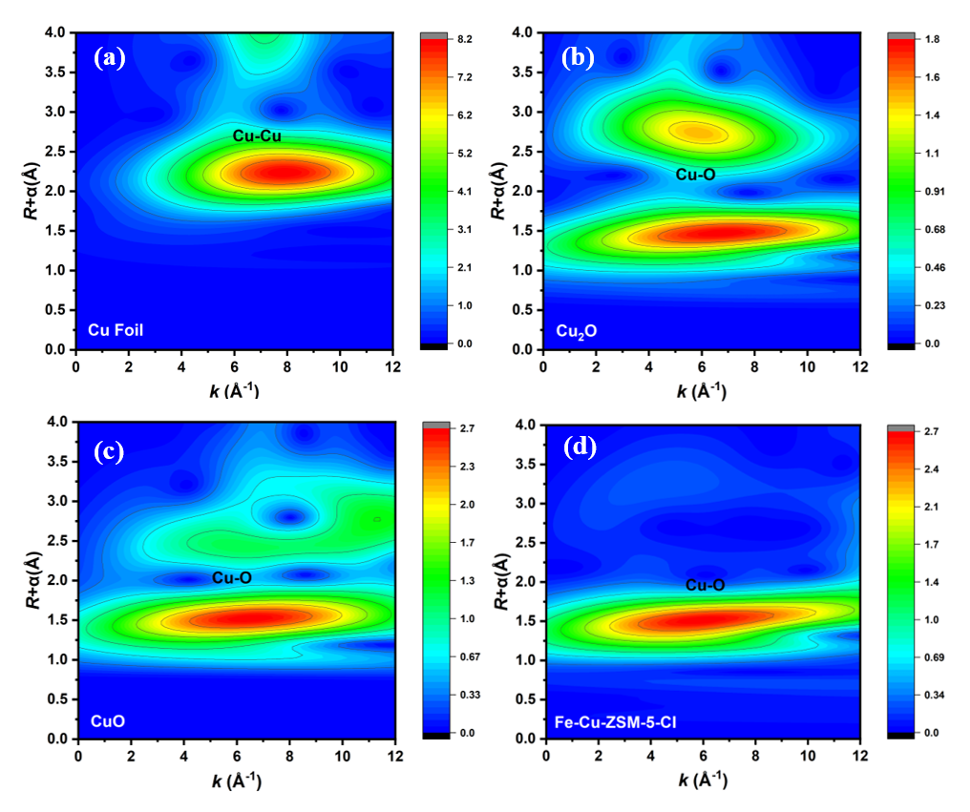
Supplementary Fig. 16 | Wavelet transform (WT) analysis of the Cu K-edge EXAFS oscillations of FeCu/ZSM-CI. (a) Cu foil, (b) Cu₂O, (c) CuO, (d) FeCu/ZSM-CI.
Supplementary Fig. 17 | XRD patterns of the fresh catalyst and catalyst after reaction of FeCu/ZSM-CI.
Supplementary Fig. 18 | DR UV-vis spectra of the fresh catalyst and catalyst after reaction of FeCu/ZSM-CI.
Supplementary Fig. 19 | IR spectra of the fresh catalyst and catalyst after reaction of FeCu/ZSM-CI.
Supplementary Fig. 20 | R-space of Fe K-edge EXAFS for the fresh catalyst and catalyst after reaction of FeCu/ZSM-CI.
Supplementary Fig. 21 | R-space of Cu K-edge EXAFS for the fresh catalyst and catalyst after reaction of FeCu/ZSM-CI.

Supplementary Fig. 22 | EPR spectra of FeCu/ZSM-CI under different reaction conditions.

Supplementary Fig. 23 | Determination of Fe^{IV}=O by DMSO.
Supplementary Fig. 24 | In-situ CV tests of catalysts for H₂O₂ activation.
Supplementary Fig. 25 | EPR spectra of •CH₃ unde Fe/ZSM-C and Cu/ZSM-I.
Supplementary Fig. 26 | Experiment on H₂O₂ decomposition. (a) •O₂⁻ under catalysts of different metal contents with time. (b) •OH capture under different catalysts of metal contents with time. (c) PL spectra of 7-hydroxycoumarin by •OH under different catalysts of metal contents. (d) The ratio of H₂O₂ to free radicals.
Note: •OH were initially detected at a faster rate and generated more rapidly than •OOH. This phenomenon can be attributed to the fact that •OH is predominantly produced through the decomposition of H₂O₂ at the external large pores’ copper sites, whereas •OOH primarily arises from H₂O₂ decomposition at the inner small pores’ iron sites. The diffusion characteristics of H₂O₂ vary between small and large pore sizes, leading to differential reaction rates across various active sites; consequently, •OH is preferentially formed and diffuses into the solution without being consumed, while •OOH formation occurs relatively slowly. After a reaction duration of 15 min, it became evident that the generation rate of •OOH surpassed that of •OH, primarily due to enhanced H₂O₂ decomposition at the iron site. By strategically adjusting the positions of different metal sites on ZSM-5 zeolite, one can effectively control both the generation pathways and quantities of free radicals.
Supplementary Fig. 27 | Utilization efficiency of H₂O₂.
Supplementary Fig. 28 | ¹H NMR of oxidation products under Standard reaction condition. (a) ¹H NMR spectra after reaction. (b) ¹H NMR spectrum of the solution after reaction, with the removal of methane gas and subsequent reaction. Reaction conditions: In a 50 mL high-pressure reactor, 20 mL H₂O₂ solution (concentration is 0.1 mol/L), reaction temperature is 80 ℃, catalyst dosage is 10 mg, CH₄ is 3.5 MPa, reaction time is 3 h.

Supplementary Fig. 29 | GC-MS results of the isotope labeling experiments.

Supplementary Fig. 30 | Kinetic isotope effect experiment of HCOOH over Fe/ZSM-C (A) and FeCu/ZSM-CI (B).
Supplementary Fig. 31 | Kinetic isotope effect experiment of HCOOH production over Fe/ZSM-C and FeCu/ZSM-CI.
Supplementary Fig. 32 | DFT-optimized structural model of mononuclear Fe bound in the H-ZSM-5 framework.
Supplementary Fig. 33 | DFT-optimized structural model of mononuclear Cu bound in the H-ZSM-5 framework.
Supplementary Information Tables
Supplementary Table S1 | Comparative experiment results obtained by replacing reactants.
Reaction condition | Productivity (mmol g_{cat}⁻¹ h⁻¹) |  |  |  | Selectivity of CH₃OH (%) | Gross productivity /mmol g_{cat}⁻¹ h⁻¹
Reaction condition | CH₃OH | HCHO | HCOOH | CO₂ | Selectivity of CH₃OH (%) | Gross productivity /mmol g_{cat}⁻¹ h⁻¹
Without H₂O₂ | No product |  |  |  | -- | --
Without CH₄ | No product |  |  |  | -- | --
Without catalyst | No product |  |  |  | -- | --
Without H₂O₂, 0.5 MPa O₂ | No product |  |  |  | -- | --
Additional 0.5 MPa O₂ | 21.45 | 0.11 | 2.04 | 0.15 | 90.3 | 23.76
Note: Reaction conditions: 3.5 MPa CH₄, 20 mL 0.1 M H₂O₂, 10 mg catalyst, 3 h, 80 °C.

Supplementary Table S2 | Comparisons with the representative catalytic performances on the yield and selectivity of CH₃OH.
Entry | Catalyst | Reaction temperature (℃) | Concentration of H₂O₂ (mol/L) | Reaction condition | CH₃OH selectivity in all oxygenates (%) | CH₃OH space-time yield (mmol g_{cat}⁻¹ h⁻¹) | H₂O₂ utilization (%) | Reference
1 | FeCu/ZSM-CI | 80 | 0.1 | 10mg catalyst, 3.5 MPa CH₄, 20 mL H₂O, 3 h | 90.1 | 20.2 | 74.6 | This work
2 | Ag₁-Cu₁/ZSM-5 hetero-SAC | 70 | 0.489 | 22 mg catalyst, 3 MPa CH₄, 21.05 mL H₂O, 0.5 h | 81 | 40.2 | 7.32 | (1)
3 | Cu-Fe (2/0.1)/ZSM-5 | 50 | 0.5 | 10 mg catalyst, 3 MPa CH₄, 20 mL H₂O, 1 h | 80 | 3.9 | 0.68 | (2)
4 | Cu₁/ZSM-5 | 50 | 0.5 | 28 mg catalyst, 3 MPa CH₄, 10 mL H₂O, 0.5 h | 74 | 8.2 | 4.72 | (3)
5 | CuFe/ZSM-5 | 50 | 0.5 | 27 mg catalyst, 3.05 MPa CH₄, 10 mL H₂O, 0.5 h | 85 | 8.2 | 3.39 | (4)
6 | Fe/ZSM-5 | 50 | 0.5 | 27 mg catalyst, 3.05 MPa CH₄, 10 mL H₂O, 0.5 h | 12 | 1.2 | 7.45 | (4)
7 | Au-Pd/TiO₂ | 50 | 0.5 | 10 mg catalyst, 3 MPa CH₄, 10 mL H₂O, 0.5 h | 12 | 0.14 | 0.32 | (5)
8 | Pd₁/ZSM-5 | 50 | 0.5 | 28 mg catalyst, 3 MPa CH₄, 20 mL H₂O, 0.5 h | 86.4 | 0.55 | 0.11 | (6)
9 | Rh₁/ZSM-5 | 70 | 0.5 | 30 mg catalyst, 3 MPa CH₄, 10 mL H₂O, 0.5 h | 64 | 0.62 | 0.50 | (7)
10 | Au-Pd colloid | 50 | 0.5 | 30 mg catalyst, 3 MPa CH₄, 10 mL H₂O, 0.5 h | 14 | 6 | 34.97 | (8)
11 | FeN₄/GN | 25 | 0.5 | 30 mg catalyst, 2 MPa CH₄, 10 mL H₂O, 10 h | 5 | 0.01 | 3.48 | (9)
12 | Fe/ZSM-5 (66) | 80 | 5 | 30 mg catalyst, 3 MPa CH₄, 10 mL H₂O, 0.5 h | 1.2 | 0.65 | 4.84 | (10)
13 | Cr₁/TiO₂ | 50 | 0.5 | 10 mg catalyst, 3 MPa CH₄, 9.5 mL H₂O, 1 h | 8 | 0.38 | 2.84 | (11)
14 | Rh₁/CeO₂ NWs | 50 | 1 | 10 mg catalyst, 0.5 MPa CH₄, 20 mL H₂O, 1 h | 75 | 2.9 | 0.29 | (12)
15 | Fe-HZ5-TF | 75 | 0.5 | 27 mg catalyst, 3 MPa CH₄, 10 mL H₂O, 0.42 h | 5 | 3 | 39.46 | (13)
16 | Fe-HZ5-C | 75 | 0.5 | 27 mg catalyst, 3 MPa CH₄, 10 mL H₂O, 0.42 h | 8 | 1.53 | 12.32 | (13)
17 | UiO-66-H | 50 | 0.25 | 10 mg catalyst, 3 MPa CH₄, 20 mL H₂O, 0.5 h | 5.4 | 0.04 | 0.21 | (14)

Supplementary Table S3 | Comparative experiment.
Catalyst | Productivity (mmol g_{cat}⁻¹ h⁻¹) |  |  |  | Selectivity of CH₃OH (%) | Gross productivity /mmol g_{cat}⁻¹ h⁻¹
Catalyst | CH₃OH | HCHO | HCOOH | CO₂ | Selectivity of CH₃OH (%) | Gross productivity /mmol g_{cat}⁻¹ h⁻¹
Iron acetylacetonate | No product |  |  |  | -- | --
FeCl₂ | No product |  |  |  | -- | --
Cu(NO₃)₂ | No product |  |  |  | -- | --
Iron acetylacetonate + CuCl₂ + FeCl₂ | No product |  |  |  | -- | --
Note: Reaction conditions: 3.5 MPa CH₄, 20 mL 0.1 M H₂O₂, 10 mg catalyst, 3 h, 80 °C.
Supplementary Table S4 | Element distribution and ICP-AES results of the catalysts synthesized from different iron sources.
Catalyst | Fe Content (wt%) | Cu Content (wt%)
FeCu/ZSM-CI (Iron acetylacetonate) | 0.67 | 0.50
FeCu/ZSM-CI (Ferric chloride) | 0.22 | 0.42
Fe/ZSM-C | 0.66 | 0
Cu/ZSM-I | 0 | 0.51
FeCu/ZSM-CI  (After the reaction) | 0.66 | 0.49
FeCu/ZSM-CI (Iron acetylacetonate) | 0.08 (SEM-EDS-mapping) | 0.49 (SEM-EDS-mapping)
Note: The metal loading was confirmed by inductively coupled plasma optical emission spectrometry (ICP-AES). The reaction solution was measured by ICP. According to the data in the fifth row of the figure, ICP results show that the values of Fe and Cu after conversion are less than 0.01 mg/kg, indicating that little iron or copper cation is leaching from the catalyst.

Supplementary Table S5 | Curve-fitting parameters for Fe K-edge and Cu K-edge EXAFS in FeCu/ZSM-CI.
Sample | Shell | S₀² | σ²/Å² | d^{b}/Å | R/Å | ΔE | CN
Fe K-edge | Fe-O₁ | 1.00 | 0.012±0.002 | 2.03 | 2.02±0.009 | 4.3±0.75 | 3.1±0.39
Fe K-edge | Fe-O₂ | 1.00 | 0.030±0.005 | 3.03 | 3.10±0.005 | 4.3±0.75 | 2.8±0.22
Cu K-edge | Cu-O | 1.00 | 0.004±0.001 | 2.12 | 1.95±0.006 | 0.45±0.61 | 3.3±0.18
S₀²: amplitude reduction factor;
σ²: Debye-Waller factor;
d: set distance;
R: fitted distance;
CN: coordination number.
ª Date ranges: 2.5 ≤ k ≤ 12.3 ,1.0 ≤ R ≤ 3.3 Å. The number of variable parameters is 6，4, out of a total of 11.04，24.3 independent data points. R factor for these fits are 1.8%，1.9%.
^{b} The distances for Fe-O are from the crystal structure of Fe₂O₃ and Fe₄O₅; The distance of Cu-O is from the crystal structure of CuO.
It was assumed that the Debye-Waller factor is the same for all the first-shell metal pairs (Fe-O and Cu-O) to minimize the number of fitting parameters.

REFERENCES
1. Yu B, et al. Silver and copper dual single atoms boosting direct oxidation of methane to methanol via synergistic catalysis. Adv. Sci. 10, 2302143, (2023).
2. Yu T, et al. Highly selective oxidation of methane into methanol over Cu-promoted monomeric Fe/ZSM-5. ACS Catal. 11, 6684-6691, (2021).
3. Tang X, et al. Direct oxidation of methane to oxygenates on supported single Cu atom catalyst. Appl. Catal. B Environ. 285, 119827, (2021).
4. Hammond C, et al. Direct catalytic conversion of methane to methanol in an aqueous medium by using copper-promoted Fe-ZSM-5. Angew. Chem. Int. Ed. 51, 5129-5133, (2012).
5. AbRahim MH, et al. Oxidation of methane to methanol with hydrogen peroxide using supported gold–palladium alloy nanoparticles. Angew. Chem. Int. Ed. 52, 1280-1284, (2012).
6. Huang W, et al. Low-temperature transformation of methane to methanol on Pd₁O₄ single sites anchored on the internal surface of microporous silicate. Angew. Chem. Int. Ed. 55, 13441-13445, (2016).
7. Kwon Y, Kim TY, Kwon G, Yi J, & Lee H. Selective activation of methane on single-atom catalyst of rhodium dispersed on zirconia for direct conversion. J. Am. Chem. Soc. 139, 17694-17699, (2017).
8. Jin Z, et al. Hydrophobic zeolite modification for in situ peroxide formation in methane oxidation to methanol. Science 367, 193-197, (2020).
9. Cui X, et al. Room-temperature methane conversion by graphene-confined single iron atoms. Chem 4, 1902-1910, (2018).
10. Zhu K, et al. Highly efficient conversion of methane to formic acid under mild conditions at ZSM-5-confined Fe-sites. Nano Energy 82, (2021).
11. Shen Q, et al. Single chromium atoms supported on titanium dioxide nanoparticles for synergic catalytic methane conversion under mild conditions. Angew. Chem. Int. Ed. 59, 1216-1219, (2019).
12. Bai S, et al. High-efficiency direct methane conversion to oxygenates on a cerium dioxide nanowires supported rhodium single-atom catalyst. Nat. Commun. 11, 954, (2020).
13. Cheng Q, et al. Maximizing active Fe species in ZSM-5 zeolite using organic-template-free synthesis for efficient selective methane oxidation. J. Am. Chem. Soc. 145, 5888-5898, (2023).
14. Fang G, et al. Zirconium-oxo nodes of MOFs with tunable electronic properties provide effective •OH species for enhanced methane hydroxylation. Angew. Chem. Int. Ed. 61, (2022).

