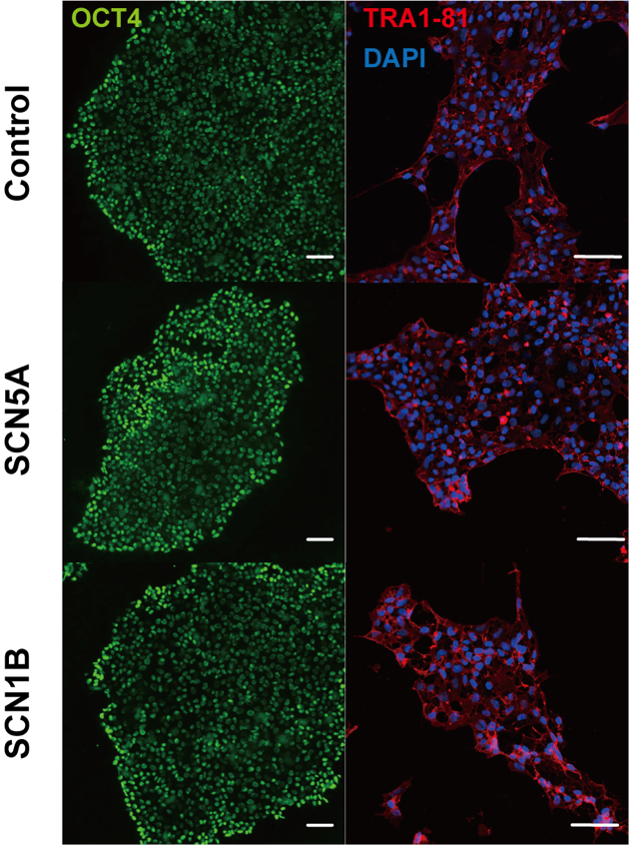
Figure S1 representative images of iPS cells showing pluripotency markers OCT4 (green), TRA1-81 (red) for control, hiPSC-SCN5A and hiPSC-SCN1B lines. Nuclei were stained with DAPI(blue). Scale bars represent 100 μm.

