Genome-wide screen uncovers novel host factors for L-A virus maintenance and a mutualistic-symbiosis relationship in yeast

Hsiao et al.

Supplementary Material

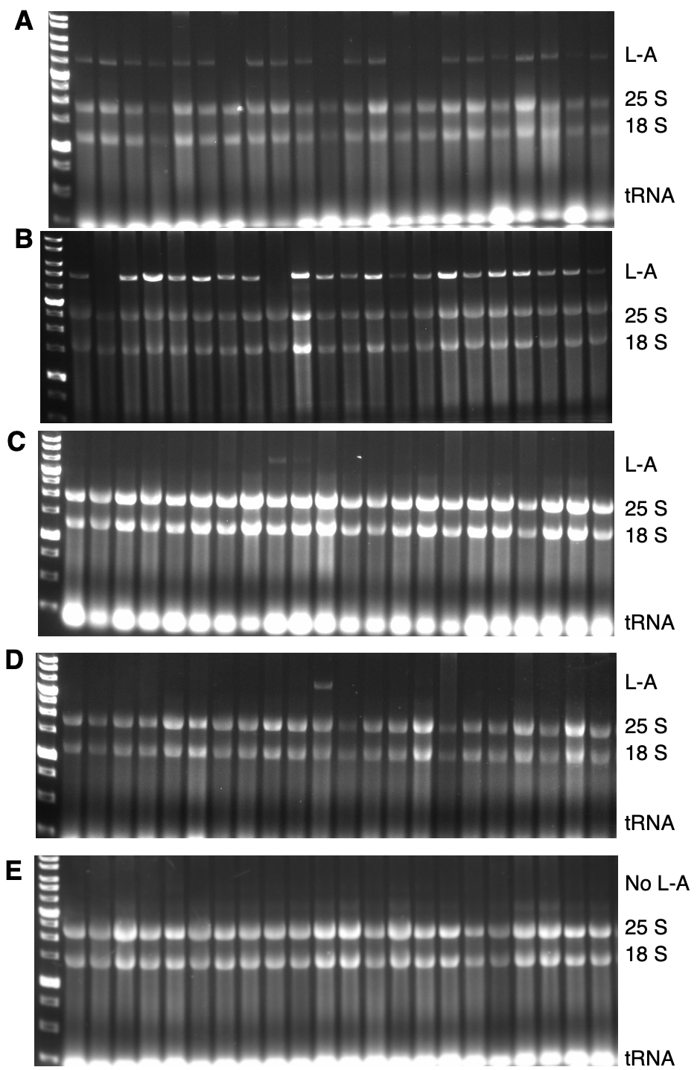

Supplementary Figure 1. Genome-wide screen for L-A-maintaining gene products using a collection of the yeast-gene-knockout strains. Panels A–E represent five successive rounds of visual elimination. For example, in panel A, most of the knockout strains still contain L-A dsRNA. Only those strains with significantly reduced L-A levels were selected for the second round of elimination (see Materials and methods).

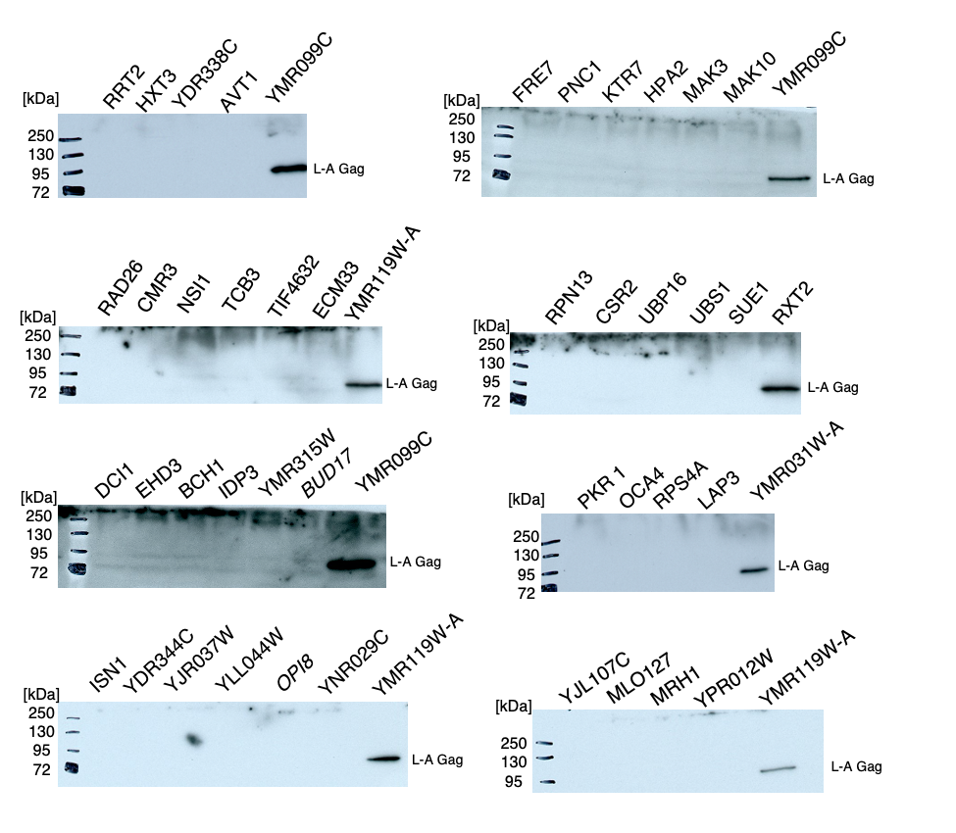
Supplementary Figure 2. Western blotting validation for the L-A virus loss. Shown are sample images from the Western blotting analysis. Three L-A⁺⁺ strains ymr031W-A∆, ymr119W-A∆ and ymr099c∆ (identified in this screen) were used as controls to contrast the loss of the L-A virus in many other knockout strains.

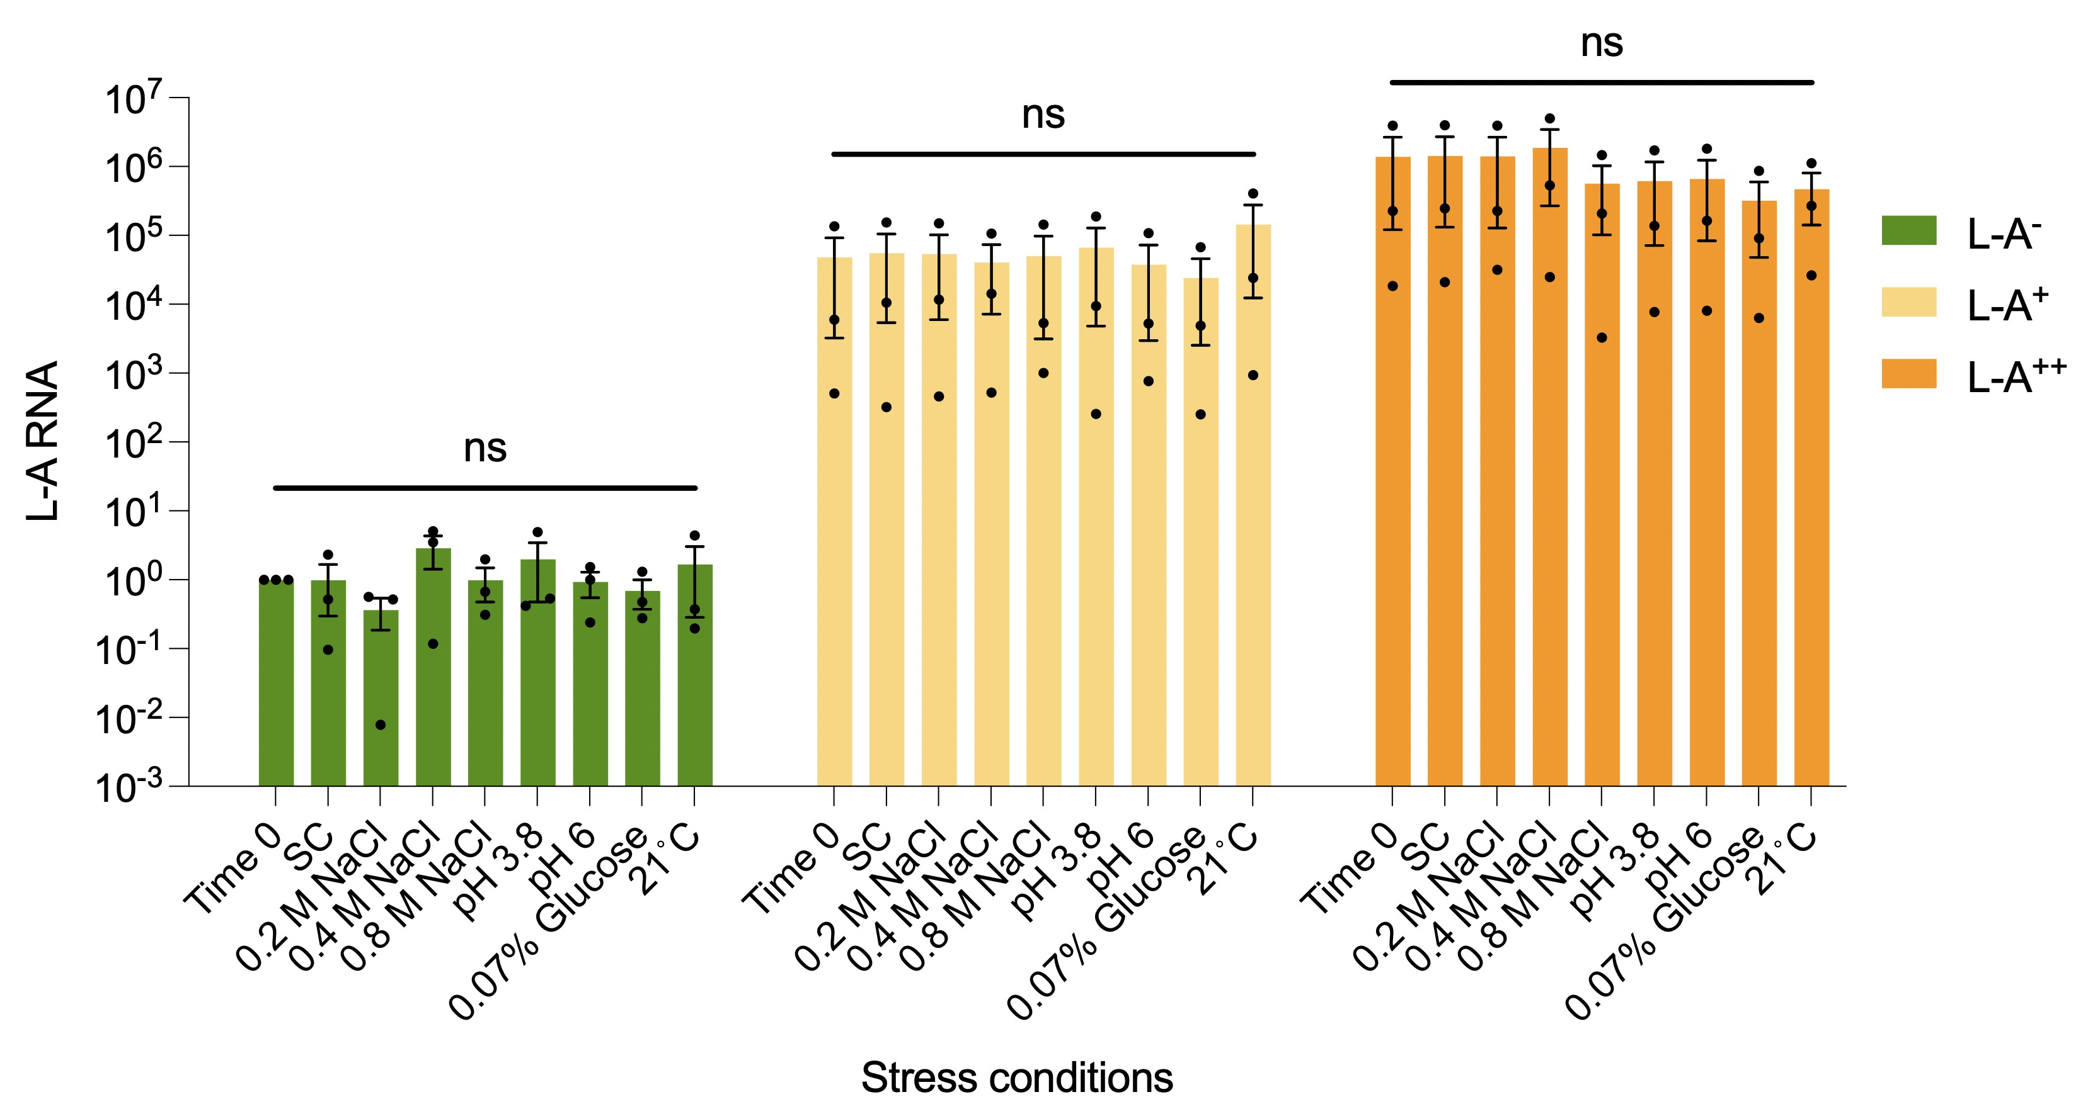

Supplementary Figure 3. The L-A dsRNA abundance remains constant over the course of the stress processes. The bar of “Time 0” represents RT-qPCR analysis of the cells withdrawn from the start of the stress process, whereas other bars represent cells analyzed at the end point of the stress process. L-A⁻, green; L-A⁺, yellow; L-A⁺⁺, orange. N = 3 biological repeats coupled with 3 technical repeats; error bars are ±SEM; ns, no statistical significance.

Supplementary Table S1. Host genes involved in maintaining L-A
Standard name | Systematic name | Function | Reference
RRT2 | YBR246W | Endosomal transport
HXT3 | YDR345C | Membrane, transmembrane transport
 | YDR338C | Transmembrane transport
AVT1 | YJR001W | Vacuolar amino acid transporter
PKR 1 | YMR123W | Vacuolar proton-transporting
OCA4 | YCR095C | RNA virus replication | BMV[1]
RPS4A | YJR145C | RNA binding | HIV, HCV [2, 3]
LAP3 | YNL239W | RNA binding
RAD26 | YJR035W | DNA repair | HCV [4]
CMR3 | YPR013C | DNA binding
NSI1 | YDR026C | DNA binding
TCB3 | YML072C | Lipid binding
TIF4632 | YGL049C | Translation initiation factor
ECM33 | YBR078W | Paralog: PST1, cell wall organization
RPN13 | YLR421C | Ubiquitin binding
CSR2 | YPR030W | Ubiquitin binding
UBP16 | YPL072W | Protein deubiquitination
UBS1 | YBR165W | Ubiquitination and nuclear export
SUE1 | YPR151C | Protein catabolic process
THI12 | YNL332W | Thiamine biosynthetic process
RIM15 | YFL033C | Protein serine/threonine kinase activity
SNO4 | YMR322C | Cysteine peptidase activity
DCI1 | YOR180C | Peroxisomal protein | TBSV [5]
EHD3 | YDR036C | 3-hydroxyisobutyryl-coa hydrolase
BCH1 | YMR237W | Small gtpase binding
IDP3 | YNL009W | NADP+ dehydrogenase
 | YMR315W | Oxidoreductase activity
BUD17 | YNR027W | Pyridoxal kinase activity
FRE7 | YOL152W | Ferric-chelate reductase activity
PNC1 | YGL037C | Nicotinamidase activity
KTR7 | YIL085C | Mannosyltransferase activity
HPA2 | YPR193C | N-acetyltransferase activity
MAK3 | YPR051W | N-acetyltransferase activity | L-A, TBSV [6, 7]
MAK10 | YEL035C | N-acetyltransferase activity | L-A [8]
ISN1 | YOR155C | IMP 5'-nucleotidase activity
 | YDR344C | Unknow function
 | YJR037W | Unknow function
 | YLL044W | Unknow function
OPI8 | YKR035C | Unknow function
 | YNR029C | Unknow function
 | YJL107C | Unknow function
 | YPR012W | Unknow function
MLO127 | YJR039W | Unknow function
MRH1 | YDR033W | Unknow function
 | YPR039W | Unknow function

Supplementary Table 2. Host genes involved in repressing L-A

Standard name | Systematic name | Function | Reference
 | YMR099C | Carbohydrate metabolism
SKI3 | YPR189W | 3'-5' RNA exonuclease | L-A, BMV [7, 9]
MET22 | YOL064C | Bisphosphate-3'-nucleotidase; human homolog BPNT1 | BMV [1]
PEX6 | YNL329C | AAA-peroxins, peroxisome biogenesis
 | YMR031W-A | Unknown
VPS9 | YML097C | Guanine nucleotide exchange factor (GEF) and ubiquitin receptor
 | YMR119W-A | Unknown

Supplementary Table 3. Host genes identified from the ts-library involved in maintaining L-A

Standard name | Systematic name | Function | Reference
WT | BY4741
TLG2 | YOL018C | T-snare affecting a late Golgi
POL1 | YNL102W | Subunit of the DNA polymerase I | TBSV [10]
MRC1 | YCL061C | Mediator of the replication checkpoint
LDB19 | YOR322C | Mating and zygote formation, Ub-ligase
LAT1 | YNL071W | Dihydrolipoyllysine acetyltransferase
MOB2 | YFL034C-B | Protein kinase activator involved in cell polarity | TBSV [11]
YIP1 | YGR172C | Vesicle-mediated transport from EM to the Golgi
HDA3 | YPR179C | Subunit of HDA1 histone deacetylase complex
TPM1 | YNL079C | Major isoform of tropomyosin (polarized cell growth)
SAP30 | YMR263W | Component of Rpd3L histone deacetylase complex | RVFV [12]
SSD1 | YDR293C | Translational repressor; involved in polar growth
SUR1 | YPL057C | Subunit of mannosylinositol phosphorylceramide (MIPC) synthase
NTF2 | YER009W | Ran GTPase binding protein involved in protein import into nucleus
 | YGR125W | Vacuolar Storage of arginine
BEM2 | YER155C | GTPase activator involved in actin cytoskeleton organization
URA6 | YKL024C | Bifunctional adenylate and uridylate kinase
SLX9 | YGR081C | G-Quadruplex binding protein, pre-rRNA processing
IES1 | YFL013C | Subunit of the INO80 chromatin remodeling complex
HDA1 | YNL021W | Subunit of the HDA1 histone deacetylase complex
ATP10 | YLR393W | ATP synthase
ARC19 | YKL013C | Actin cortical patch organization
MOB2 | YFL034C-B | Protein kinase activator involved in cell polarity
RCO1 | YMR075W | Component of the Rpd3S histone deacetylase complex
UBA4 | YHR111W | Sulfurtransferase and adenylyltransferase | BMV [1]
SNF4 | YGL115W | Sporulation, and peroxisome biogenesis | TBSV [7]

Supplementary Table 4. Host genes identified from the ts-library involved in suppressing L-A

Standard name | Systematic name | Function | Reference
CDC28 | YBR160W | Cyclin-dependent kinase (CDK), regulator of mitotic and meiotic cell cycles
RPT4 | YOR259C | Proteasome regulatory particle assembly | TBSV [10]
PRP4 | YPR178W | Splicing factor | HIV [13]
TAF4 | YMR005W | TFIID subunit, RNA polymerase II transcription initiation | Epstein-Barr virus [14]
SNM1 | YDR478W | Rnase MRP complex subunit, regulated degradation of daughter cell-specific mRNA | TBSV [11, 15]
DBP6 | YNR038W | DEAD-box protein involved in ribosome biogenesis | SARS-CoV-2 [16]
RAP1 | YNL216W | DNA-binding transcription regulator | Polyoma virus [17]
RPC40 | YPR110C | RNA polymerase subunit AC40
ABF1 | YKL112W | DNA binding protein with possible chromatin-reorganizing activity
PWP1 | YLR196W | rRNA processing
STU1 | YBL034C | Mitotic spindle assemble
DBF4 | YDR052C | Regulatory subunit of Cdc7p-Dbf4p kinase complex
NSL1 | YPL233W | Chromosome segregation
GPI2 | YPL076W | N-acetylglucosaminyltransferase
ARF1 | YDL192W | ADP-ribosylation factor | HCV [18]
CDC37 | YDR168W | Regulation of the cell cycle and MAPK signaling
ALT1 | YLR089C | Alanine transaminase, alanine biosynthesis and catabolism
VPS51 | YKR020W | Vacuolar protein sorting
MCD1 | YDL003W | Mitotic chromosome determinant
POL5 | YEL055C | Nucleolar rDNA-binding protein involved in rRNA transcription

References
1. Kushner DB, Lindenbach BD, Grdzelishvili VZ, Noueiry AO, Paul SM, Ahlquist P. Systematic, genome-wide identification of host genes affecting replication of a positive-strand RNA virus. Proc Natl Acad Sci. 2003;100:15764–9.
2. Naji S, Johnson JR, Krogan NJ, Iii JRY. Host cell interactome of HIV-1 rev includes RNA helicases involved in multiple facets of virus production. Mol Cell Proteomics. 2012;4:M111.015313.
3. Yuhashi K, Ohnishi S, Kodama T, Koike K, Kanamori H. In vitro selection of the 3′-untranslated regions of the human liver mRNA that bind to the HCV nonstructural protein 5B. Virology. 2014;450–451:13–23.
4. Wang S-C, Lai K-R, Li C-Y, Chiang C-S, Yu G-Y, Sakamoto N, et al. The paradoxical effects of different hepatitis C viral loads on host DNA damage and repair abilities. PLOS ONE. 2017;12:e0164281.
5. Serviene E, Shapka N, Cheng C-P, Panavas T, Phuangrat B, Baker J, et al. Genome-wide screen identifies host genes affecting viral RNA recombination. Proc Natl Acad Sci. 2005;102:10545–50.
6. Tercero JC, Wickner RB. MAK3 encodes an N-acetyltransferase whose modification of the L-A gag NH2 terminus is necessary for virus particle assembly. J Biol Chem. 1992;267:20277–81.
7. Panavas T, Serviene E, Brasher J, Nagy PD. Yeast genome-wide screen reveals dissimilar sets of host genes affecting replication of RNA viruses. Proc Natl Acad Sci. 2005;102:7326–31.
8. Lee YJ, Wickner RB. MAK10, a glucose-repressible gene necessary for replication of a dsRNA virus of Saccharomyces cerevisiae, has T cell receptor alpha-subunit motifs. Genetics. 1992;132:87–96.
9. Brown JT, Bai X, Johnson AW. The yeast antiviral proteins ski2p, ski3p, and ski8p exist as a complex in vivo. RNA. 2000;6:449–57.
10. Serviene E, Jiang Y, Cheng C-P, Baker J, Nagy PD. Screening of the yeast yTHC collection identifies essential host factors affecting tombusvirus RNA recombination. J Virol. 2006;80:1231–41.
11. Nawaz-ul-Rehman MS, Reddisiva Prasanth K, Baker J, Nagy PD. Yeast screens for host factors in positive-strand RNA virus replication based on a library of temperature-sensitive mutants. Methods. 2013;59:207–16.
12. Mansuroglu Z, Josse T, Gilleron J, Billecocq A, Leger P, Bouloy M, et al. Nonstructural NSs protein of rift valley fever virus interacts with pericentromeric DNA sequences of the host cell, inducing chromosome cohesion and segregation defects. J Virol. 2010;84:928–39.
13. Bennett EM, Lever AML, Allen JF. Human immunodeficiency virus type 2 gag interacts specifically with PRP4, a serine-threonine kinase, and inhibits phosphorylation of splicing factor SF2. J Virol. 2004;78:11303–12.
14. Yang Y-C, Chang L-K. Role of TAF4 in transcriptional activation by Rta of Epstein-Barr virus. PLoS ONE. 2013;8:e54075.
15. Jaag HM, Lu Q, Schmitt ME, Nagy PD. Role of RNase MRP in viral RNA degradation and RNA recombination. J Virol. 2011;85:243–53.
16. Singh A, Pandey KK, Agrawal SK, Srivastava RK, Bhattacharyya S, Verma B. The SARS-CoV-2 UTR’s intrudes host RBP’s and modulates cellular splicing. Adv Virol. 2023;2023:1–11.
17. Pollice A, Ciaramella M, Pulitzer JF. Saccharomyces cerevisiae multifunctional protein RAP1 binds to a conserved sequence in the polyoma virus enhancer and is responsible for its transcriptional activity in yeast cells. FEBS Lett. 1993;323:77–82.
18. Zhang L, Hong Z, Lin W, Shao R-X, Goto K, Hsu VW, et al. ARF1 and GBF1 generate a PI4P-enriched environment supportive of hepatitis C virus replication. PLoS ONE. 2012;7:e32135.

Supplementary Table 5. Host genes up-regulated by the L-A virus
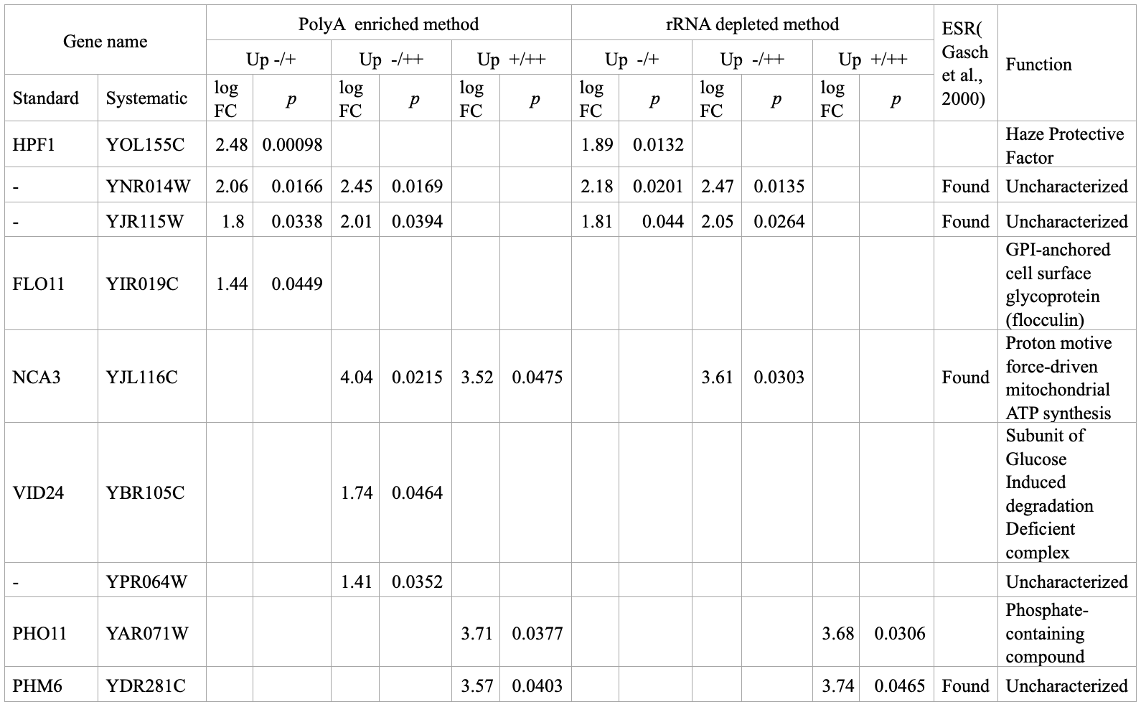
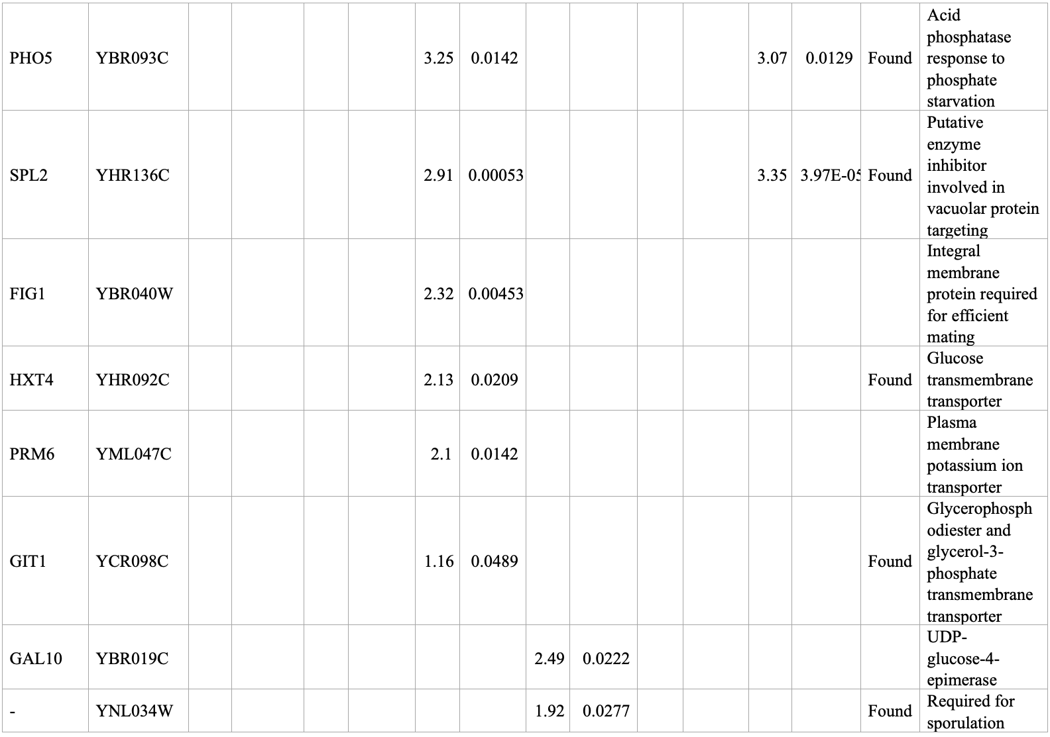
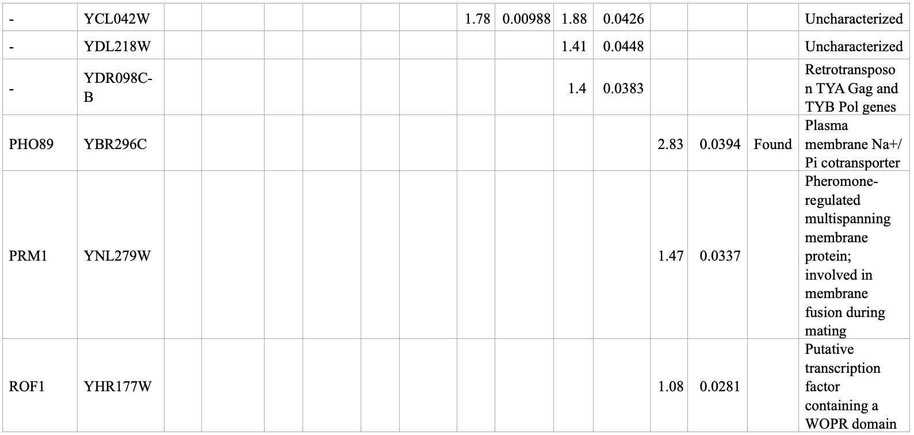

Supplementary Table 6. Host genes down-regulated by the L-A virus
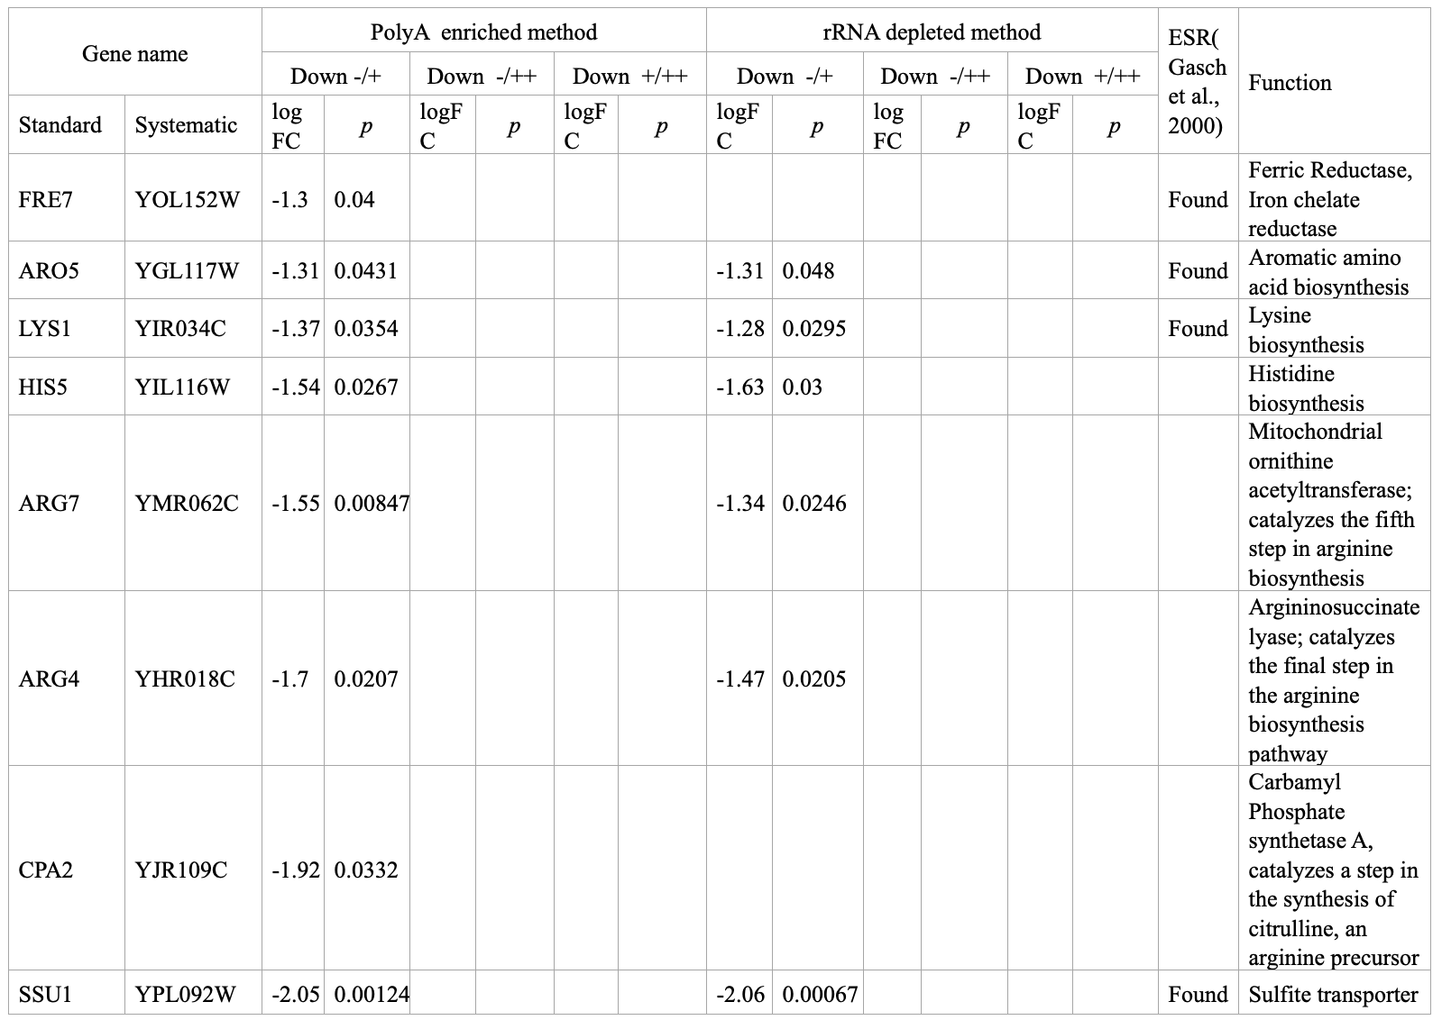
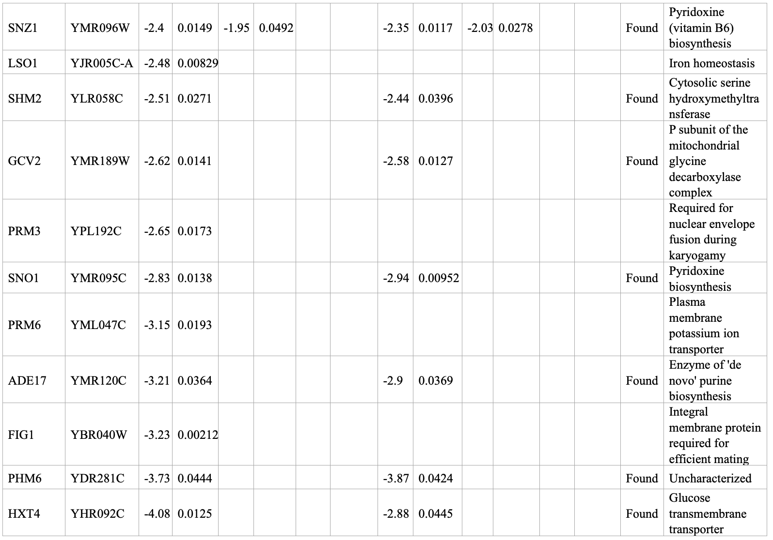
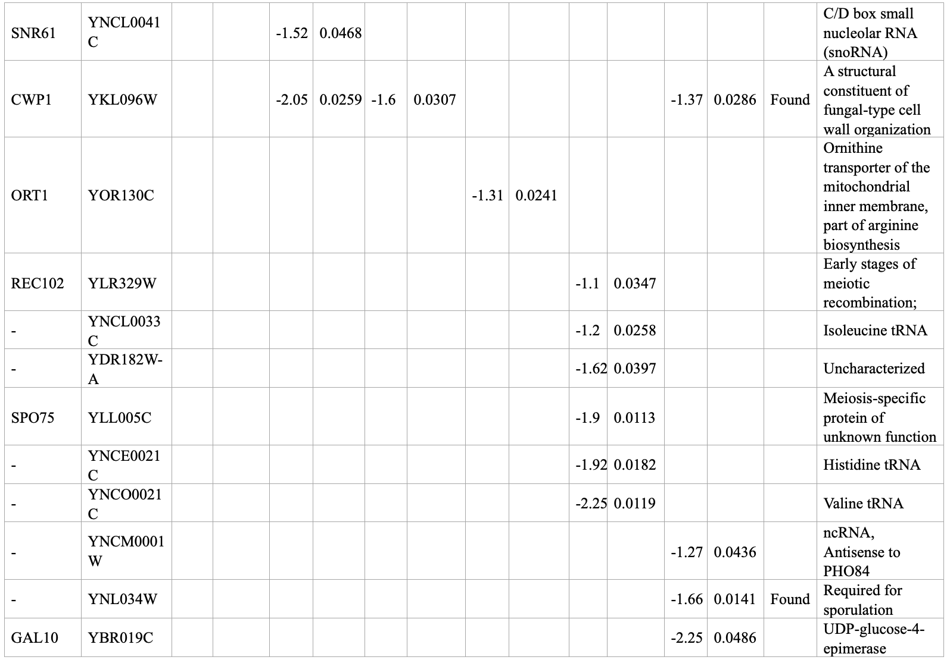

Supplementary Table 7. Single nucleotide polymorphism (SNP) uncovered by transcriptomic analysis
 | L-A⁻ strain (3 isolates) |  |  | L-A⁺ strain (3 isolates) |  |  | L-A⁺⁺ strain (3 isolates)
 | No. 1 | No. 2 | No. 3 | No. 1 | No. 2 | No. 3 | No. 1 | No. 2 | No. 3
Number of SNP | 574 | 492 | 530 | 546 | 535 | 530 | 564 | 526 | 579
Unique deletion | 0 | 2 | 0 | 1 | 0 | 1 | 2 | 1 | 2

 | Systematic Name | Standard Name | Nucleotide ID | Position | Change | Function
L-A⁻ strain  No. 2 | YNL325C | FIG4 | BK006947.3 | 28780 | C > T | Required for efficient mating and response to osmotic shock
L-A⁻ strain  No. 2 |  |  | BK006947.3 | 28797 | T > C
L-A⁻ strain  No. 2 |  |  | BK006947.3 | 28948 | C > T
L-A⁻ strain  No. 2 |  |  | BK006947.3 | 28951 | C > T
L-A⁻ strain  No. 2 |  |  | BK006947.3 | 28953 | CCAT > C
L-A⁻ strain  No. 2 |  |  | BK006947.3 | 34243 | T> A
L-A⁻ strain  No. 2 |  |  | BK006947.3 | 34244 | T> A
L-A⁻ strain  No. 2 |  |  | BK006947.3 | 34253 | T> A
L-A⁻ strain  No. 2 |  |  | BK006947.3 | 34262 | T> A
L-A⁻ strain  No. 2 |  |  | BK006947.3 | 34263 | G> A
L-A⁻ strain  No. 2 | YPR042C | PUF2 | BK006949.2 | 650502 | CTAT> C | PUF family mRNA-binding protein
L-A⁻ strain  No. 2 |  |  | BK006949.2 | 655061 | T> G
L-A⁻ strain  No. 2 |  |  | BK006949.2 | 655079 | GA> G
L-A⁻ strain  No. 2 |  |  | BK006949.2 | 655107 | T> C
L-A⁺ strain  No. 1 | YER177W | BMH1 | BK006939.2 | 546296 | A> G | Post-transcriptional control of the proteome
L-A⁺ strain  No. 1 |  |  | BK006939.2 | 546345 | CCAA> C
L-A⁺ strain  No. 3 | YMR273C | ZDS1 | BK006946.2 | 811237 | GGTT> G | Regulating Swe1p-dependent polarized growth
L-A⁺ strain  No. 3 |  |  | BK006946.2 | 811824 | C> T
L-A⁺⁺ strain  No. 1 | YBR150C | TBS1 | BK006936.2 | 541608 | TTTA> T | Unknown function
L-A⁺⁺ strain  No. 1 |  |  | BK006936.2 | 544637 | A> G
L-A⁺⁺ strain  No. 1 | YFL067W | _ | BK006940.2 | 550 | T> G | Unknown function
L-A⁺⁺ strain  No. 1 |  |  | BK006940.2 | 551 | C> T
L-A⁺⁺ strain  No. 1 |  |  | BK006940.2 | 874 | C> T
L-A⁺⁺ strain  No. 1 |  |  | BK006940.2 | 918 | TTAGTCCTGACGTTGATGCTGGCAGTGGTAGTCGCAC> T
L-A⁺⁺ strain  No. 2 | YLR309C | IMH1 | BK006945.2 | 751291 | ATTT> A | Vesicular transport
L-A⁺⁺ strain  No. 3 | YBR072W | HSP26 | BK006936.2 | 382160 | C> A | Chaperone involved in protein folding and the cellular response to heat
L-A⁺⁺ strain  No. 3 |  |  | BK006936.2 | 382466 | ACAAGGT> A
L-A⁺⁺ strain  No. 3 |  |  | BK006936.2 | 382488 | C> A
L-A⁺⁺ strain  No. 3 |  |  | BK006936.2 | 382665 | G> A
L-A⁺⁺ strain  No. 3 |  |  | BK006936.2 | 382666 | G> A
L-A⁺⁺ strain  No. 3 |  |  | BK006936.2 | 382667 | G> A
L-A⁺⁺ strain  No. 3 | YPR120C | CLB5 | BK006949.2 | 774827 | CCTTCTT> C | B-type cyclin involved in DNA replication during S phase

