Supplementary Information for
Highly-Efficient Thermoelectric-Pumped Light-Emitting-Diodes Based-on
Colloidal Quantum Dots
Xing Lin †, Xingliang Dai†, Zikang Ye†, Yufei Shu, and Xiaogang Peng*
† These authors contributed equally to this work.
* Corresponding to: xpeng@zju.edu.cn

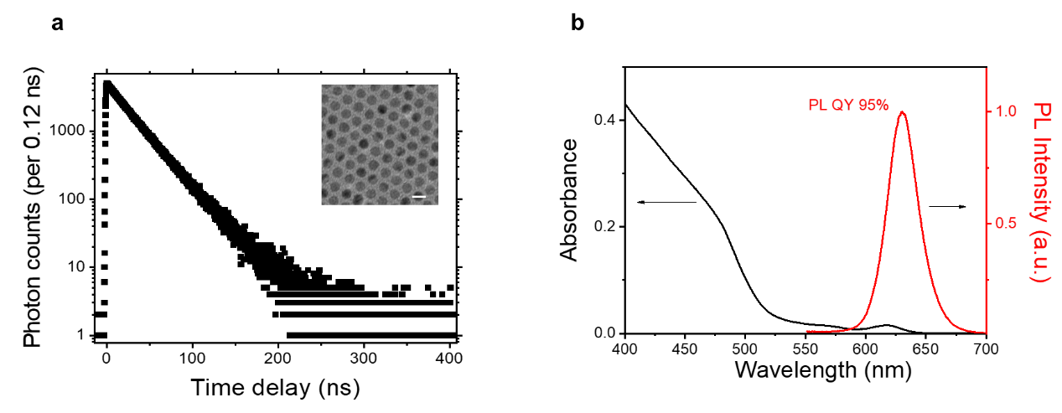
Supplementary Figure 1 | The CdSe/CdS core/shell QDs. a, PL decay dynamics of the ensemble QDs excited at 405 nm. Inset: a typical TEM image (scale bar: 10 nm). b, Ultraviolet-visible absorption and PL spectrum of the QD solution (in octane). The absolute PLQY excited at 450 nm is 95% measured with an optical integral-sphere system.

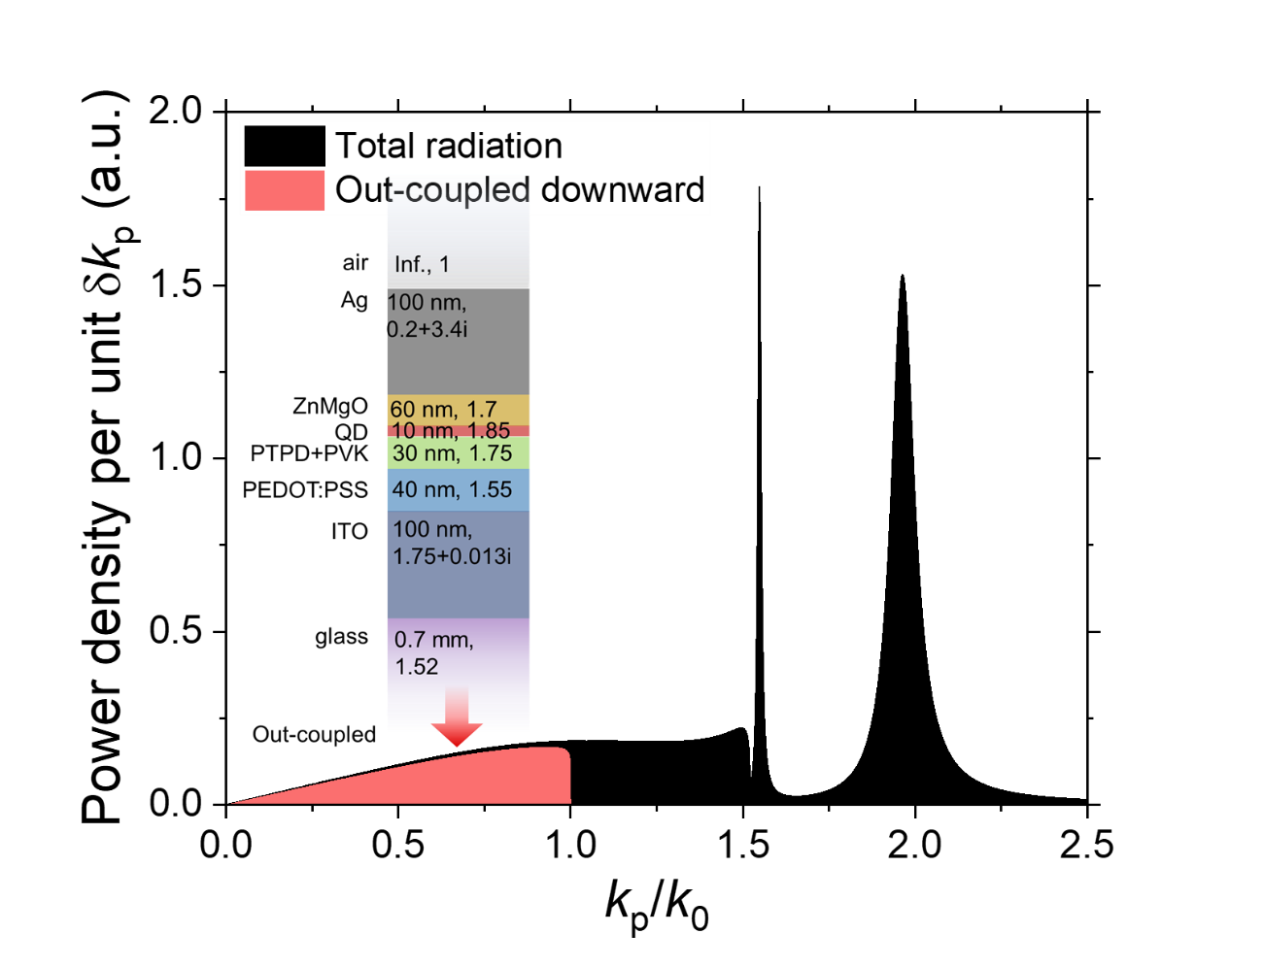
Supplementary Figure 2 | Calculated power density distribution along in-plane wave-vector k_{p}. The light extraction efficiency (LEE) is calculated as the ratio of area under red and black curve. Inset: the geometrical structure and optical refractive index used in calculation. k₀ is the magnitude of wave-vector in vacuum. The LEE is calculated as 23%.

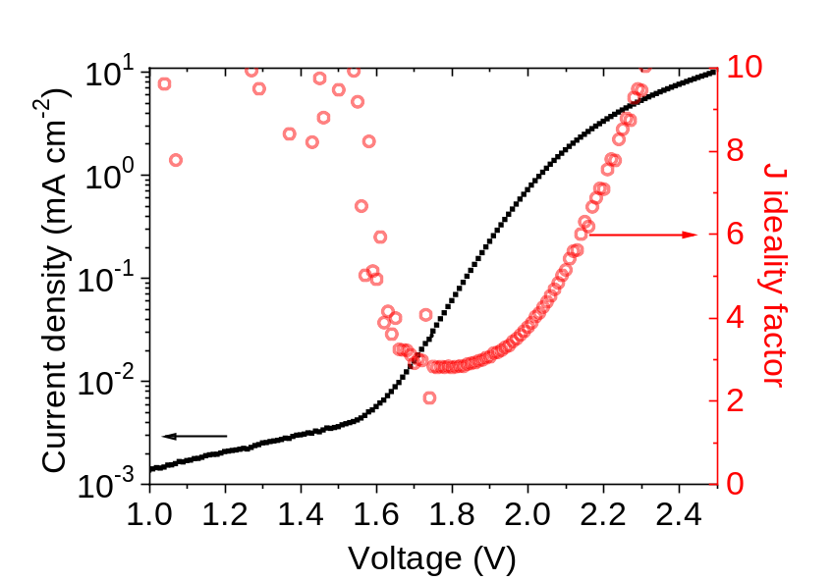
Supplementary Figure 3 | Electrical characterization of device in main text Figure 3a. Current ideality factor is calculated by $n_{j}={\left(\frac{k_{B}T}{q}\frac{dlnJ}{d V}\right)}^{-1}$, where J is the current density. n_{j} does not converge to unity at 1.2-1.4 V, which we attribute to shunt leaky current, consistent with fast EQE droop below 1.7 V (main text Figure 1c).

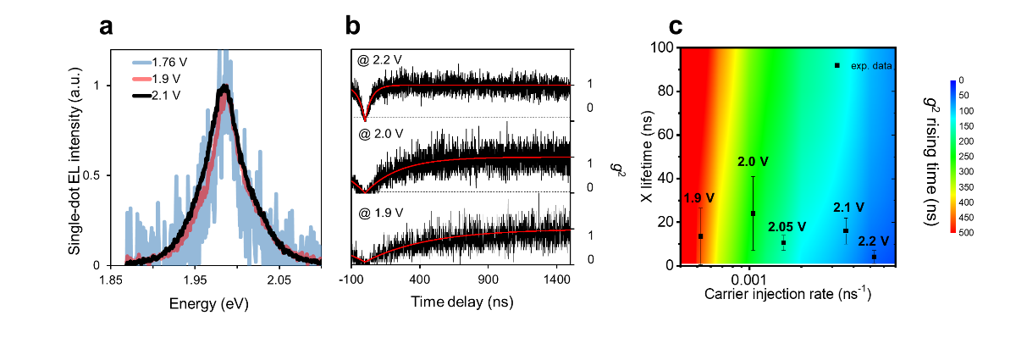
Supplementary Figure 4 | Sub-bandgap electroluminescence at single-dot level. a, Spectra acquired from sub- and above- photon voltage electroluminescence of single QD excitation exhibit similar peak position and contour. b, Second-order correlation (g²) measurement of single-dot electroluminescence with single-exponential curve come from an analytical model¹. c, Calculated 2D mapping of g² rising time versus exciton lifetime and charge carrier injection rate. Experimental data are positioned based on injection condition and g² rising time. Error bars come from rising time fitting uncertainty.

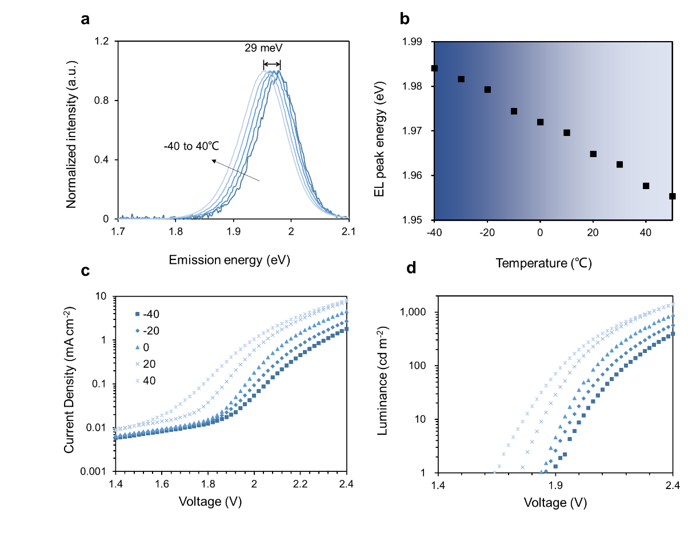
Supplementary Figure 5 | Temperature-dependence characterization of TEP-QLED. a, Normalized spectra acquired at 1.95 V show a red shift of 29-meV when operating temperature increases from -40 to 40℃. b, EL peak position from gaussian fitting versus temperature. c, Current density and d, Luminance versus bias voltage under varied temperatures based on which Figures 3c-e in main text are acquired.

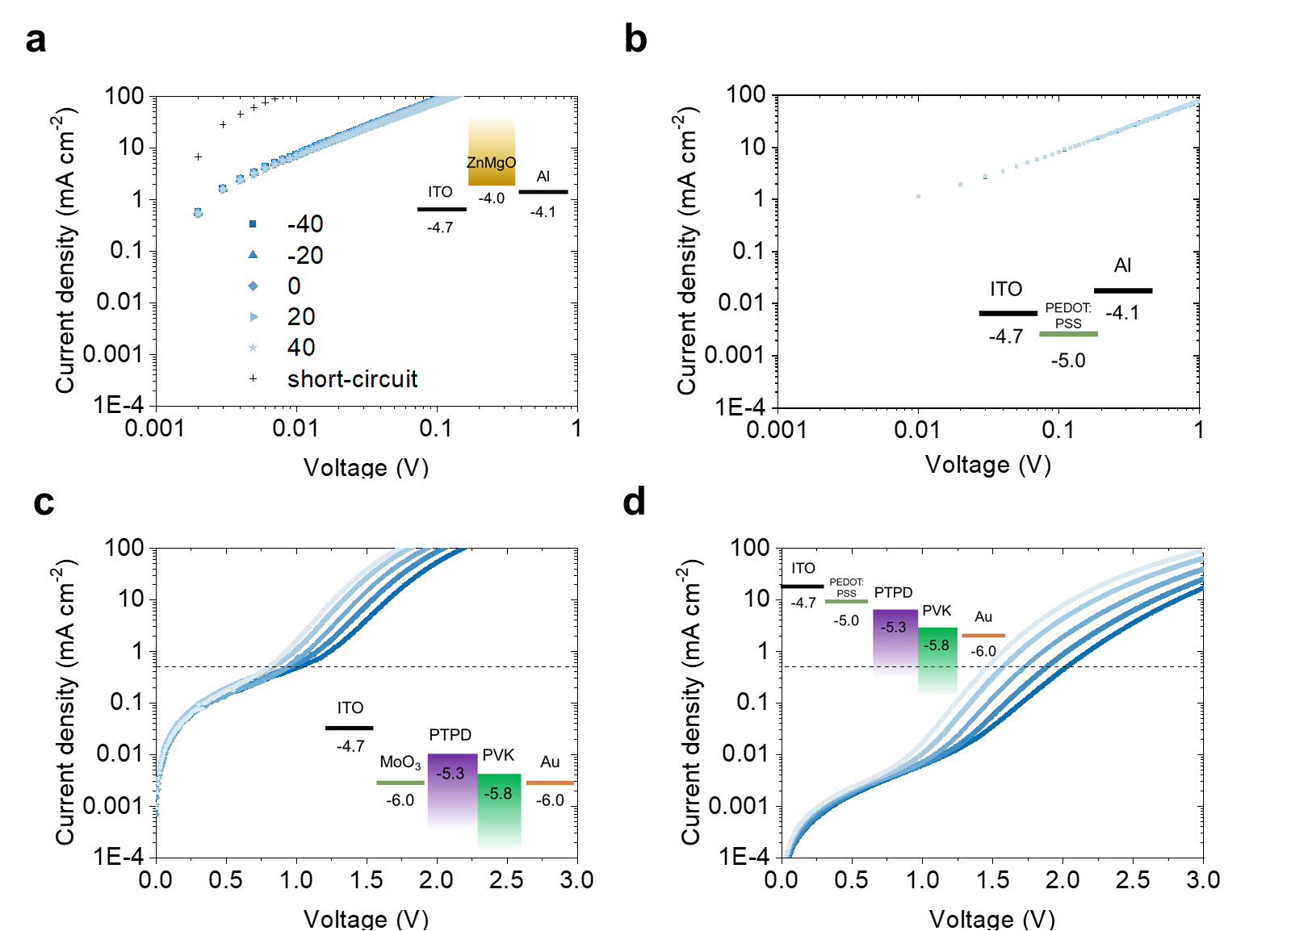
Supplementary Figure 6 | Temperature-dependent current density versus bias voltage. a, Electron-only device (ITO/Zn_{0.9}Mg_{0.1}O) shows a temperature insensitive characteristic when operating temperature increases from -40 to 40℃. The short-circuit current is marked as black cross. b, Hole-only device (ITO/PEDOT:PSS/Al) shows a temperature insensitive characteristic. c, Hole-only device (ITO/MoO₃/poly-TPD/PVK/Au) shows a medium temperature dependence. Horizontal dashed line indicates the current density level of 0.5 mA cm⁻². d, Hole-only device (ITO/PEDOT:PSS/poly-TPD/PVK/Au) shows a strong temperature dependence.

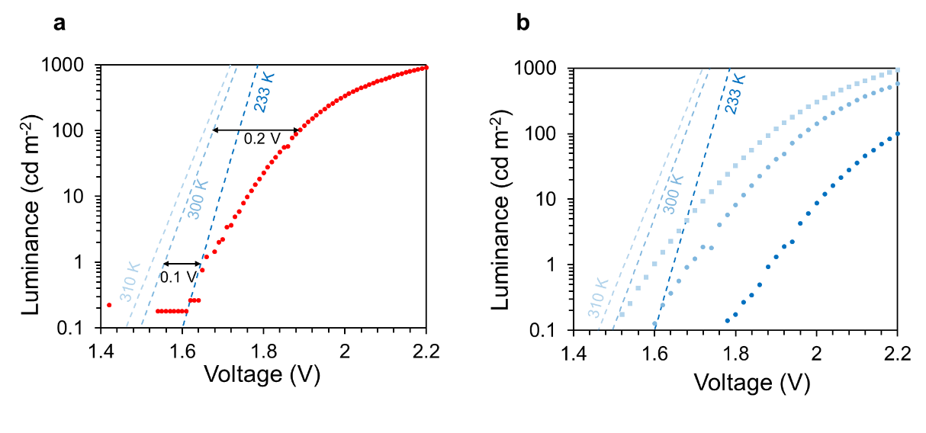
Supplementary Figure 7 | Comparison our TEP-QLED with thermodynamic limitation at varied temperatures. a, Semiconductor under non-equilibrium state (described by Quasi-Fermi level spread) radiate photons governed by generalized black-body radiation law². It sets a thermodynamic limitation on QLED brightness, shown by blue dashed lines with assumed 23%-LEE. Comparing our results (red dot) to the thermodynamic limit, we estimate a 0.1-0.2 V resistive potential drop on charge transport layers in luminance range of 1-100 cd m⁻². b, Luminance versus driving voltage under varied temperatures (blue dots), with thermodynamic limitation shown as blue dashed lines. At lower luminance and higher temperature, the performance of QLED is closer to its thermodynamic limit. There exists a cross point between theoretical predication and experimental data, indicating that the enhancement of luminance at elevated temperatures originates from both thermal-activation of charge transport and thermal-assisted charge injection. Extra room to further improve the performance of QLED to its theoretical limit lies in increasing the mobility of charge transport layers, just as the case in high-performance OLED
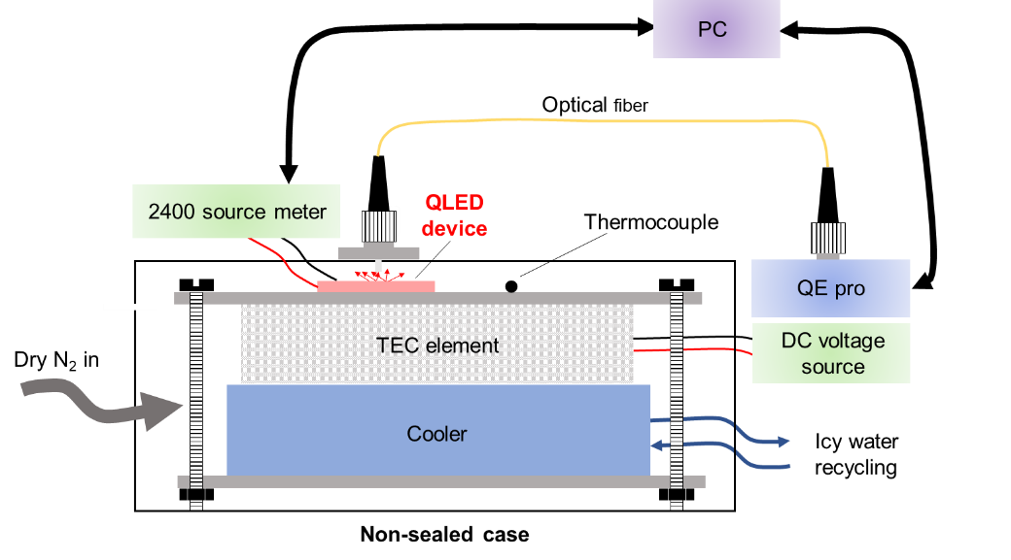
Supplementary Figure 8 | Schematic diagrams of the setup for temperature-dependent device characterization. The temperature control of device is realized by putting the device on the front-side of a thermo-electric cooler whose back-side temperature is kept at 0 ℃ by an icy-water recycling system. The temperature of device is acquired by a thermocouple placed next to the device under test. For each measurement, temperature is stabilized for >5 min before J-I-L data is recorded.

Supplementary Note 1: Auger-assisted carrier injection
In the proposed Auger process, one pair (or even multiple pairs) of electron and hole recombines at the interface between the quantum-dot layer and the electron/hole injection layer to promote the third free carrier into the emissive layer followed by electron-hole radiative recombination, emitting a photon of bandgap energy. Thus, the upper limit of IQE of an Auger-mediated processes is 50%.

Supplementary Note 2: Single-dot EL g⁽²⁾ analysis
Second-order temporal correlation function (g⁽²⁾) of electrically driven single-quantum-dot is measured by the Hanbury Brwon and Twiss method. The time delay in g⁽²⁾ measurement standards for the time intervals between two consecutive photon detection events. In an ideal two-level system emission cycle, after emitting a single-photon, the system has to be re-pumped to excited states before emitting the next photon. The pronounced dip around zero-delay reveal the single-photon emission nature from single-quantum-dot. The g⁽²⁾ ‘rising time’—the time when g² reaches 1-e⁻¹—reveal the excited-state recovery time, which is determined by both state generation rate (carrier injection rate) and state annihilation rate (recombination rate). To demonstrate the role of these two factors, we calculate ‘rising time’ by solving the rate equations and correlating states population to photon detection events under varied exciton lifetime and carrier injection rate¹. The calculated result is plotted in a color encoded 2D mapping as shown in Supplementary Figure 4. Shorter excited state lifetime and higher carrier injection rate fasten the recovery process, resulting in a shorter ‘rising time’.
Experimentally, g⁽²⁾ is measured at 1.9-, 2.0-, 2.1- and 2.2-volts DC bias. As shown in Supplementary Figure 3b, when the applied voltage increases, the rising time of g⁽²⁾ decreases (from 469 ns at 1.9 V to 46 ns at 2.2 V). Generally, carrier injection rate does not follow a linear dependence on applied voltage. Here, we use the average EL photon counting rates to indicate the electrical excitation level. With the estimated overall optical detection efficiency (~4%), EL photon counting rates is translated into charge carrier injection rate by assuming a constant EL quantum yield in 1.9-2.2 V range. With the corrected carrier injection rate, g⁽²⁾ measurement data are fitted leaving state recombination lifetime as the only free parameter. Fitting results and corresponding lifetime parameter are shown in Supplementary Figure 3b (red curves) and Fig. Supplementary Figure 3c (black squares). The recombination lifetime of emissive states varies in the range of 5-30 ns which is consistent with PL lifetime measurement (Supplementary Figure 1a) indicating that EL up-conversion and down-conversion share the same emissive state.
Supplementary Note 3: About thermodynamic limit of QLED
As discussed by Meerheim², semiconductor under non-equilibrium state (described by Quasi-Fermi level spread) radiates photons governed by generalized black-body radiation law³:
$j=a(hν)\frac{Ω}{4π^{3}ℏ^{3}c^{2}}\frac{{\left(hν\right)}^{2}}{e^{\frac{hν-{(EF}_{e}-EF_{h})}{k_{B}T}}-1}dhν$ (1)
, where ${EF}_{e}-EF_{h}$ is the difference of quasi-Fermi-level of electron and hole which is smaller than the voltage applied to the contacts of the device. In the calculation of Supplementary Figure 5, we use the same parameter as reference² except that we set the emission wavelength as 630 nm, set temperature to 297 K and multiply the LEE (23%) to get corrected result.
References
1 Lin, X. et al. Electrically-driven single-photon sources based on colloidal quantum dots with near-optimal antibunching at room temperature. Nat. Commun. 8, 1132 (2017).
2 Meerheim, R., Walzer, K., He, G., Pfeiffer, M. & Leo, K. Highly efficient organic light emitting diodes (OLED) for diplays and lighting. Vol. 6192 EPE (SPIE, 2006).
3 Würfel, P. & Würfel, U. Physics of solar cells: from basic principles to advanced concepts. (John Wiley & Sons, 2016).

