Electronic supplementary material

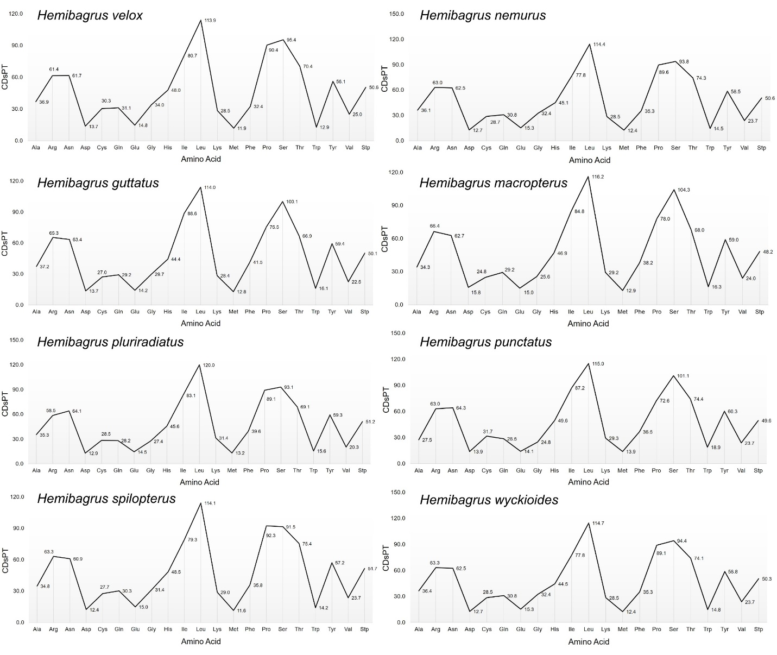

Supplementary Fig. 1 Codon distribution per thousand codons for all amino acids in the mitogenomes of H. velox and seven other Hemibagrus congeners.

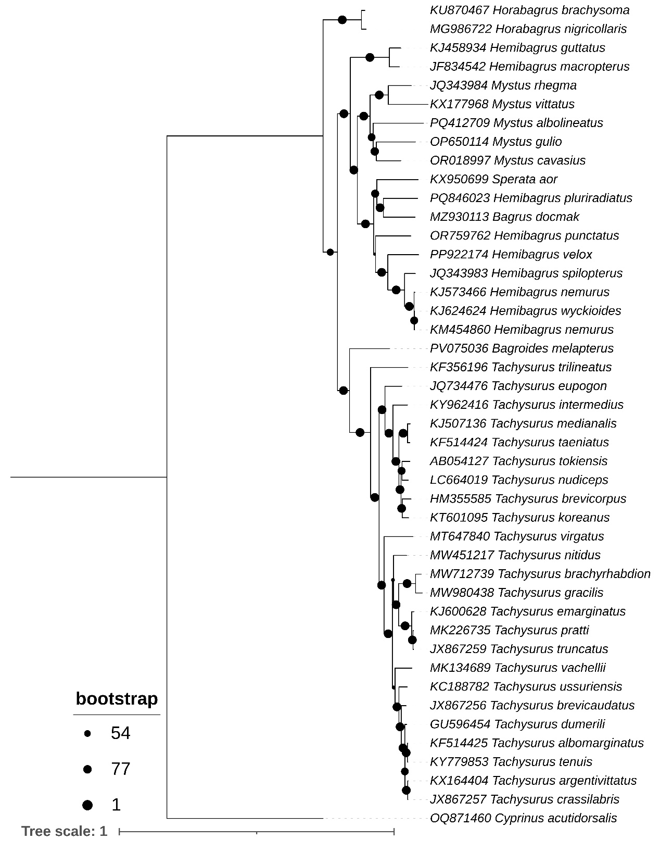

Supplementary Fig. 2 The Maximum Likelihood (ML) phylogenetic tree, constructed using concatenated sequences of 13 PCGs, clearly resolves the newly sequenced H. velox as distinct from other species within the family Bagridae. The bootstrap values derived from ML analysis, indicated in dark blue at each node, represent the statistical support for the inferred phylogenetic relationships.
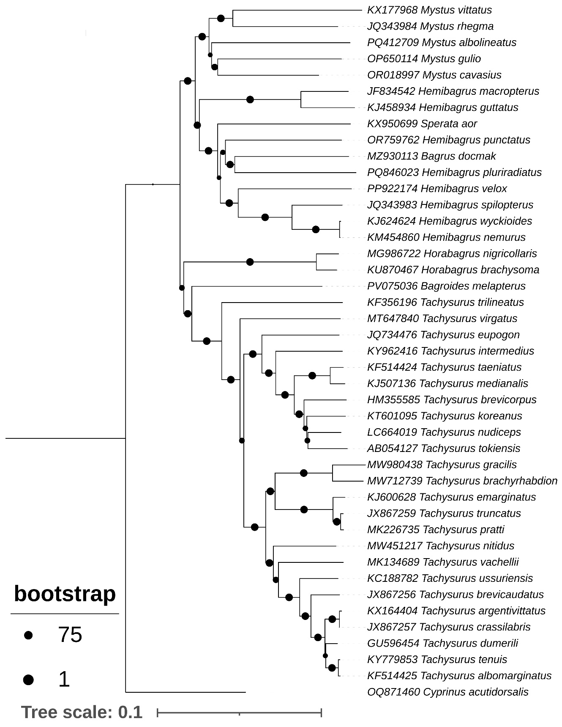
Supplementary Fig. 3 The Neighbor-Joining (NJ) phylogenetic tree based on 13 PCGs clearly distinguishes the newly sequenced H. velox as a distinct lineage within the Bagridae family.
Supplementary Table 1. Comparative data of the mitogenome of H. velox generated in this study and those of other Bagridae congeners retrieved from GenBank.
No. | Species name | Valid name | Length (bp) | Accession no. | Locality | References
1 | Hemibagrus  velox | Hemibagrus  velox | 16,541 | PP922174 | Lake Singkarak,  Indonesia | This study
2 | Hemibagrus  nemurus | Hemibagrus  nemurus | 16,526 | KM454860 | Kunming,  China | [41]
3 | Hemibagrus  guttatus | Hemibagrus  guttatus | 16,528 | KJ458934 | Guangxi,  China | [44]
4 | Hemibagrus  macropterus | Hemibagrus  macropterus | 16,530 | JF834542 | Chongqing,  China | [45]
5 | Hemibagrus  pluriradiatus | Hemibagrus  pluriradiatus | 16,519 | PQ846023 | China | Unpublished
6 | Hemibagrus  punctatus | Hemibagrus  punctatus | 16,527 | OR759762 | Hemmige  Karnataka, India | [46]
7 | Hemibagrus  spilopterus | Hemibagrus  spilopterus | 16,521 | JQ343983 | Siem Reap,  Cambodia | [47]
8 | Hemibagrus  wyckioides | Hemibagrus  wyckioides | 16,525 | KJ624624 | Guangzhou,  China | [48]
9 | Bagroides  melapterus | Bagroides  melapterus | 16,542 | PV075036 | Barito River,  Borneo, Indonesia | Unpublished
10 | Bagrus  docmak | Bagrus  docmak | 12,946 | MZ930113 | Nile River,  Sudan | Schedel et al. 2022
11 | Horabagrus  brachysoma | Horabagrus  brachysoma | 16,567 | KU870467 | India | Unpublished
12 | Horabagrus  nigricollaris | Horabagrus  nigricollaris | 16,561 | MG986722 | Chalakudy River,  Kerala, India | Kumar et al. 2025
13 | Leiocassis  crassilabris | Tachysurus  crassilabris | 16,534 | JX867257 | Yangtze River,  China | Liang et al. 2013a
14 | Leiocassis  longirostris | Tachysurus  dumerili | 16,534 | GU596454 | Yangtze River,  China | Wang et al. 2011
15 | Mystus  albolineatus | Mystus  albolineatus | 16,574 | PQ412709 | Can Tho,  Vietnam | Huynh et al. 2025
16 | Mystus  cavasius | Mystus  cavasius | 16,554 | OR018997 | Ganga River,  India | Roy et al. 2024
17 | Mystus  gulio | Mystus  gulio | 16,518 | OP650114 | Mekong Delta,  Can Tho, Vietnam | Nguyen et al. 2023
18 | Mystus  rhegma | Mystus  rhegma | 16,525 | JQ343984 | Siem Reap,  Cambodia | Duan et al. 2019
19 | Mystus  vittatus | Mystus  vittatus | 16,244 | KX177968 | India | Unpublished
20 | Pelteobagrus  eupogon | Tachysurus  eupogon | 16,562 | JQ734476 | Yangtze River,  China | Wang et al. 2012
21 | Pelteobagrus  intermedius | Tachysurus  intermedius | 16,532 | KY962416 | Guangxi,  China | Fan et al. 2018
22 | Pelteobagrus  vachelli | Tachysurus  vachellii | 16,532 | MK134689 | Huai River,  China | Pan et al. 2019
23 | Pseudobagrus  albomarginatus | Tachysurus  albomarginatus | 16,533 | KF514425 | Zhejiang,  China | Wei et al. 2013
24 | Pseudobagrus  brachyrhabdion | Tachysurus  brachyrhabdion | 16,532 | MW712739 | Guizhou,  China | [12]
25 | Pseudobagrus  brevicaudatus | Tachysurus  brevicaudatus | 16,533 | JX867256 | Yangtze River,  China | Liang et al. 2013b
26 | Pseudobagrus  brevicorpus | Tachysurus  brevicorpus | 16,526 | HM355585 | Kumho River,  South Korea | Kim et al. 2011
27 | Pseudobagrus  emarginatus | Tachysurus  emarginatus | 16,534 | KJ600628 | Yangtze River,  China | Shao et al. 2014
28 | Pseudobagrus  gracilis | Tachysurus  gracilis | 16,527 | MW980438 | Guangxi,  China | Zhu and Li 2021
29 | Pseudobagrus  koreanus | Tachysurus  koreanus | 16,532 | KT601095 | South Korea | Unpublished
30 | Pseudobagrus  medianalis | Tachysurus  medianalis | 16,647 | KJ507136 | Yangtze River,  China | Liang et al. 2014
31 | Pseudobagrus  ondon | Tachysurus  taeniatus | 16,534 | KF514424 | China | Wang et al. 2013
32 | Pseudobagrus  pratti | Tachysurus  pratti | 16,533 | MK226735 | Sichuan,  China | Zou et al. 2019
33 | Pseudobagrus  tenuis | Tachysurus  tenuis | 16,535 | KY779853 | Jiangxi,  China | Unpublished
34 | Pseudobagrus  tokiensis | Tachysurus  tokiensis | 16,529 | AB054127 | Japan | Saitoh et al. 2003
35 | Pseudobagrus  trilineatus | Tachysurus  trilineatus | 16,535 | KF356196 | China | Pan et al. 2014
36 | Pseudobagrus  truncatus | Tachysurus  truncatus | 16,533 | JX867259 | Yangtze River,  China | Liang et al. 2013c
37 | Pseudobagrus  ussuriensis | Tachysurus  ussuriensis | 16,536 | KC188782 | China | Wan et al. 2013
38 | Sperata  aor | Sperata  aor | 16,555 | KX950699 | India | Unpublished
39 | Tachysurus  argentivittatus | Tachysurus  argentivittatus | 16,534 | KX164404 | Heilongjiang,  China | Huang et al. 2016
40 | Tachysurus  nitidus | Tachysurus  nitidus | 16,537 | MW451217 | Geum River,  Korea | Kwak et al. 2021
41 | Tachysurus  nudiceps | Tachysurus  nudiceps | 16,529 | LC664019 | Kamo River,  Kyoto, Japan | Hashimoto et al. 2022
42 | Tachysurus  virgatus | Tachysurus  virgatus | 16,524 | MT647840 | Guangdong,  China | He and Li 2020
43 | Cyprinus  acutidorsalis | Cyprinus  acutidorsalis | 16,581 | OQ871460 | Hainan Wanquan  River, China | [58]
Relevant References
Duan S, Pan H, Peng Z. The complete mitochondrial genome of Mystus rhegma (Teleostei: Siluriformes) and its phylogenetic position. Mitochondrial DNA B Resour. 2019;4:1788–9. https://doi.org/10.1080/23802359.2019.1612291.
Fan JJ, Bai JJ, Ma DM. Characterization of the complete mitochondrial genome of Pelteobagrus intermedius (Nichols et Pope). Mitochondrial DNA B Resour. 2018;3:267–9. https://doi.org/10.1080/23802359.2018.1443031.
Hashimoto S, Kakehashi R, Mori T, Kambayashi C, Kanao S, Kurabayashi A. The complete mitochondrial genome of a bagrid catfish, Tachysurus nudiceps, and its phylogenetic implications for the classification of the bagrid genera. Mitochondrial DNA B Resour. 2022;7:606–8. https://doi.org/10.1080/23802359.2022.2057253.
He Y, Li J. The complete mitochondrial genome of Tachysurus virgatus (Oshima 1926) (Siluriformes: Bagridae) and its phylogenetic status. Mitochondrial DNA B Resour. 2020;5:3019–20. https://doi.org/10.1080/23802359.2020.1797555.
Huang T, Sun H, Han Y. The complete mitochondrial genome of Leiocassis argentivittatus (Siluriformes: Bagridae). Mitochondrial DNA B Resour. 2016;1:495–6. https://doi.org/10.1080/23802359.2016.1192503.
Huynh TT, Pham TP, Quang MT. Complete mitochondrial genome of the endemic catfish Mystus albolineatus Roberts, 1994 (Bagridae) and its phylogenetic relationship. Biomed Biotechnol Res J. 2025;9:48–53. https://doi.org/10.4103/bbrj.bbrj_36_25.
Kim SK, Choi EH, Hong KB, Jang KH, Ryu SH, Hwang UW. Complete mitochondrial genome of the Korean stumpy bullhead Pseudobagrus brevicorpus (Siluriformes, Bagridae). Mitochondrial DNA A DNA Mapp Seq Anal. 2011;22:44–6. https://doi.org/10.3109/19401736.2011.597388.
Kumar VJ, Chandhini S, Arjunan VM, Anvar Ali PH. Whole mitogenome analysis of endangered freshwater catfish Horabagrus nigricollaris. Ecol Genet Genomics. 2025;34:100335. https://doi.org/10.1016/j.egg.2025.100335.
Kwak YH, Kim KY, Song HY, Song MY. The complete mitochondrial genome of Tachysurus nitidus (Siluriformes: Bagridae) from the Geum river in Korea. Mitochondrial DNA B Resour. 2021;6:1330–1. https://doi.org/10.1080/23802359.2021.1906181.
Liang HW, Li Z, Zou GW, Shi MY. Complete mitochondrial DNA genome of Pseudobagrus medianalis (Siluriformes: Bagridae). Mitochondrial DNA A DNA Mapp Seq Anal. 2014;27:587–8. https://doi.org/10.3109/19401736.2014.908357.
Liang HW, Li Z, Zou GW. Complete mitochondrial DNA genome of Leiocassis crassilabris (Siluriformes: Bagridae). Mitochondrial DNA A DNA Mapp Seq Anal. 2013a;24:222–4. https://doi.org/10.3109/19401736.2012.752471.
Liang HW, Meng Y, Li Z, Zhang Y, Zou GW. Complete mitochondrial DNA genome of Pseudobagrus brevicaudatus (Siluriformes: Bagridae). Mitochondrial DNA A DNA Mapp Seq Anal. 2013b;25:169–70. https://doi.org/10.3109/19401736.2013.792060.
Liang HW, Meng Y, Li Z, Zhang Y, Zou GW. Complete mitochondrial DNA genome of Pseudobagrus truncatus (Siluriformes: Bagridae). Mitochondrial DNA A DNA Mapp Seq Anal. 2013c;25:179–80. https://doi.org/10.3109/19401736.2013.792065.
Nguyen HD, Vu MT, Do HDK. The complete mitochondrial genome of Mystus gulio Hamilton (Siluriformes: Bagridae) and its phylogenetic implication. Mitochondrial DNA B Resour. 2023;8:439–42. https://doi.org/10.1080/23802359.2023.2192311.
Pan D, Wei M, Wan Q, Tao G, Ma Z, Wang H. The complete mitochondrial genome of Pseudobagrus trilineatus (Siluriformes: Bagridae). Mitochondrial DNA A DNA Mapp Seq Anal. 2014;26:893–4. https://doi.org/10.3109/19401736.2013.861447.
Pan T, Ling J, Jiang H, Duan G, Hu Y, Zhou H, Cui K. The complete mitochondrial genome of Pelteobagrus vachelli. Mitochondrial DNA B Resour. 2019;4:828–9. https://doi.org/10.1080/23802359.2019.1567285.
Roy S, Parida PK, Ramya VL, Kumar V, Bhakta D, Behera BK, Das BK. Whole mitochondrial genome sequencing and phylogenetic analysis of Gangetic mystus (Mystus cavasius). Mitochondrial DNA B Resour. 2024;9:1539–43. https://doi.org/10.1080/23802359.2024.2427106.
Saitoh K, Miya M, Inoue JG, Ishiguro NB, Nishida M. Mitochondrial genomics of ostariophysan fishes: Perspectives on phylogeny and biogeography. J Mol Evol. 2003;56:464–72. https://doi.org/10.1007/s00239-002-2417-y.
Schedel FDB, Chakona A, Sidlauskas BL, Popoola MO, Usimesa Wingi N, Neumann D, Vreven EJWMN, Schliewen UK. New phylogenetic insights into the African catfish families Mochokidae and Austroglanididae. J Fish Biol. 2022; 100:1171–86. https://doi.org/10.1111/jfb.15014.
Shao K, Yan SX, Zhu B, Xiong MH, Tian H, Liao XL. The complete mitochondrial genome of Pseudobagrus emarginatus (Siluriformes: Bagridae). Mitochondrial DNA A DNA Mapp Seq Anal. 2014;27:639–40. https://doi.org/10.3109/19401736.2014.908468.
Wan Q, Tao G, Cheng Q, Chen Y, Qiao H. The complete mitochondrial genome sequence of Pseudobagrus ussuriensis (Siluriformes: Bagridae). Mitochondrial DNA A DNA Mapp Seq Anal. 2013;24:333–5. https://doi.org/10.3109/19401736.2012.760079.
Wang H, Li C, Yang X, Yang S, Han J, He L, Wei M, Chen C, Cai L. The complete mitochondrial genome of Pseudobagrus ondon Shaw. Mitochondrial DNA A DNA Mapp Seq Anal. 2013;26:631–2. https://doi.org/10.3109/19401736.2013.834437.
Wang J, Shen T, Ju J, Yang G. The complete mitochondrial genome of the Chinese longsnout catfish Leiocassis longirostris (Siluriformes: Bagridae) and a time-calibrated phylogeny of ostariophysan fishes. Mol Biol Rep. 2011;38:2507–16. https://doi.org/10.1007/s11033-010-0388-4.
Wang XY, Cao L, Liang HW, Li Z, Zou GW. Mitochondrial genome of the Shorthead catfish (Pelteobagrus eupogon). Mitochondrial DNA A DNA Mapp Seq Anal. 2012;24:1–2. https://doi.org/10.3109/19401736.2012.710222.
Wei M, He L, Yang X, Yang S, Wang H, Li C, Chen P. The complete mitochondrial genome of Pseudobagrus albomarginatus Rendhal: Sequencing and analysis. Mitochondrial DNA A DNA Mapp Seq Anal. 2013;26:633–5. https://doi.org/10.3109/19401736.2013.836511.
Zhu S, Li J. Determination of the complete mitochondrial genome of Pseudobagrus gracilis (Siluriformes: Bagridae) and its phylogeny. Mitochondrial DNA B Resour. 2021;6:2371–2. https://doi.org/10.1080/23802359.2021.1951626.
Zou Y, Xie M, Tang C, Li X, Fu P, Zhang J, Duan X. The complete mitochondrial genome of Pseudobagrus pratti and its phylogeny. Mitochondrial DNA B Resour. 2019;4:1611–2. https://doi.org/10.1080/23802359.2019.1604185.

Supplementary Table 2. Comparative analysis of intergenic spacer and overlapping regions among the mitogenomes of eight distinct Hemibagrus species.
Genes | H. velox  (PP922174) | H. nemurus  (KM454860) | H. guttatus  (KJ458934) | H. macropterus  (JF834542)
tRNA-Phe (F) | 0 | 0 | 0 | 0
12S rRNA | 0 | 0 | 0 | 0
tRNA-Val (V) | 0 | 0 | 0 | 0
16S rRNA | 0 | 0 | 0 | 0
tRNA-Leu (L2) | 0 | 0 | 0 | 0
ND1 | 1 | 1 | 5 | 2
tRNA-Ile (I) | -1 | -1 | -1 | -1
tRNA-Gln (Q) | -1 | -1 | -1 | -1
tRNA-Met (M) | 0 | 0 | 0 | 0
ND2 | 0 | 0 | 0 | 0
tRNA-Trp (W) | 3 | 3 | 2 | 2
tRNA-Ala (A) | 1 | 1 | 1 | 1
tRNA-Asn (N) | 31 | 30 | 30 | 32
tRNA-Cys (C) | 2 | 2 | 0 | 0
tRNA-Tyr (Y) | 1 | 1 | 1 | 1
COI | 0 | 0 | 0 | 0
tRNA-Ser (S2) | 4 | 4 | 4 | 4
tRNA-Asp (D) | 14 | 14 | 14 | 14
COII | 0 | 0 | 0 | 0
tRNA-Lys (K) | 1 | 1 | 1 | 1
ATP8 | -10 | -10 | -10 | -10
ATP6 | 0 | -1 | -1 | -1
COIII | 0 | 0 | 0 | 0
tRNA-Gly (G) | 0 | 0 | 0 | 0
ND3 | 0 | 0 | 0 | 0
tRNA-Arg (R) | 0 | 0 | 0 | 0
ND4L | -7 | -7 | -7 | 0
ND4 | 0 | 0 | 0 | 0
tRNA-His (H) | 0 | 0 | 0 | 0
tRNA-Ser (S1) | 5 | 6 | 4 | 3
tRNA-Leu (L1) | 0 | 0 | 0 | 0
ND5 | -4 | -4 | -4 | -4
ND6 | 0 | 0 | 0 | 0
tRNA-Glu (E) | 2 | 2 | 3 | 2
Cytb | 0 | 0 | 0 | 0
tRNA-Thr (T) | -2 | -2 | -2 | -2
tRNA-Pro (P) | 0 | -34 | 0 | 0
Control region | - | - | - | -

Supplementary Table 2. Continued
Genes | H. pluriradiatus  (PQ846023) | H. punctatus  (OR759762) | H. spilopterus  (JQ343983) | H. wyckioides  (KJ624624)
tRNA-Phe (F) | 0 | 0 | 0 | 0
12S rRNA | 0 | 0 | 0 | -1
tRNA-Val (V) | 0 | 0 | 0 | 0
16S rRNA | 0 | 0 | 0 | 0
tRNA-Leu (L2) | 0 | 0 | 0 | 0
ND1 | 0 | 0 | 0 | 1
tRNA-Ile (I) | -1 | -1 | -1 | -1
tRNA-Gln (Q) | -1 | -1 | -1 | -1
tRNA-Met (M) | 1 | 0 | 0 | 0
ND2 | 0 | 0 | 0 | 0
tRNA-Trp (W) | 2 | 2 | 3 | 3
tRNA-Ala (A) | 1 | 1 | 1 | 1
tRNA-Asn (N) | 30 | 30 | 30 | 30
tRNA-Cys (C) | 2 | 2 | 2 | 2
tRNA-Tyr (Y) | 1 | 1 | 1 | 1
COI | 0 | 0 | 0 | 0
tRNA-Ser (S2) | 4 | 4 | 4 | 4
tRNA-Asp (D) | 14 | 14 | 14 | 14
COII | 0 | 0 | 0 | 0
tRNA-Lys (K) | 1 | 1 | 1 | 1
ATP8 | -10 | -10 | -10 | -10
ATP6 | -1 | 0 | -1 | -1
COIII | 0 | 0 | 0 | 0
tRNA-Gly (G) | 0 | 0 | 0 | 0
ND3 | 0 | 0 | 0 | 0
tRNA-Arg (R) | 0 | 0 | 0 | 0
ND4L | -7 | -7 | 0 | 0
ND4 | 0 | 0 | 0 | 0
tRNA-His (H) | 0 | 0 | 0 | 0
tRNA-Ser (S1) | 4 | 4 | 6 | 6
tRNA-Leu (L1) | 0 | 0 | 0 | 0
ND5 | -4 | -4 | -4 | -4
ND6 | 0 | 0 | 0 | 0
tRNA-Glu (E) | 2 | 2 | 2 | 2
Cytb | 0 | 0 | 0 | 0
tRNA-Thr (T) | -2 | -2 | -1 | 0
tRNA-Pro (P) | -1 | 0 | 0 | 0
Control region | - | - | - | -

Supplementary Table 3. Comprehensive comparison of start and stop codons in the eight PCGs of Hemibagrus mitogenomes.
Genes | H. velox  (PP922174) |  | H. nemurus  (KM454860) |  | H. guttatus  (KJ458934) |  | H. macropterus  (JF834542)
Genes | Start | Stop | Start | Stop | Start | Stop | Start | Stop
ND1 | ATG | TAA | ATG | TAA | ATG | TAA | ATG | TAA
ND2 | ATG | TA- | ATG | T-- | ATG | T-- | ATG | T--
COI | GTG | TAA | GTG | TAA | GTG | TAA | GTG | TAA
COII | ATG | T-- | ATG | T-- | ATG | T-- | ATG | T--
ATP8 | ATG | TAA | ATG | TAA | ATG | TAA | ATG | TAA
ATP6 | ATG | TA- | ATG | TAA | ATA | TAA | ATG | TAA
COIII | ATG | T-- | ATG | T-- | ATG | T-- | ATG | T--
ND3 | ATG | T-- | ATG | T-- | ATG | T-- | ATG | T--
ND4L | ATG | TAA | ATG | TAA | ATG | TAA | ATG | TAA
ND4 | ATG | T-- | ATG | T-- | ATG | T-- | ATG | T--
ND5 | ATG | TAA | ATG | TAA | ATG | TAA | ATG | TAG
ND6 | ATG | TAA | ATG | TAG | ATG | TAG | ATG | TAG
Cytb | ATG | T-- | ATG | T-- | ATG | T-- | ATG | T--
Genes | H. pluriradiatus  (PQ846023) |  | H. punctatus  (OR759762) |  | H. spilopterus  (JQ343983) |  | H. wyckioides  (KJ624624)
Genes | Start | Stop | Start | Stop | Start | Stop | Start | Stop
ND1 | ATG | TA- | ATG | TA- | ATG | TAA | ATG | TAA
ND2 | ATG | T-- | ATG | T-- | ATG | T-- | ATG | T--
COI | GTG | TAA | GTG | TAA | GTG | TAA | GTG | TAA
COII | ATG | T-- | ATG | T-- | ATG | T-- | ATG | T--
ATP8 | ATG | TAA | ATG | TAA | ATG | TAA | ATG | TAA
ATP6 | ATG | TA- | ATG | TAA | ATG | TAA | ATG | TAA
COIII | ATG | T-- | ATG | T-- | ATG | T-- | ATG | T--
ND3 | ATG | T-- | ATG | T-- | ATG | T-- | ATG | T--
ND4L | ATG | TAA | ATG | TAA | ATG | TAA | ATG | TAA
ND4 | ATG | T-- | ATG | T-- | ATG | T-- | ATG | T--
ND5 | ATG | TAA | ATG | TAA | ATG | TAA | ATG | TAA
ND6 | ATG | TAG | ATG | TAG | ATG | TAG | ATG | TAG
Cytb | ATG | T-- | ATG | T-- | ATG | T-- | ATG | T--

Supplementary Table 4. Pairwise Ka/Ks ratios of the 13 PCGs among Hemibagrus species mitogenomes.

Genes | ND1 | ND2 | COI | COII | ATP8 | ATP6 | COIII
1 | 0.046425826 | 0.068467098 | 0.002614178 | 0.02919708 | 0.233357718 | 0.00878875 | 0.028215223
2 | 0.047274652 | 0.096951974 | 0.007439199 | 0.023774146 | 0.180689655 | 0.013339762 | 0.03724121
3 | 0.046386846 | 0.118267473 | 0.006725146 | 0.018431141 | 0.287467134 | 0.025200588 | 0.02937564
4 | 0.062659847 | 0.095305082 | 0.001986213 | 0.023138106 | 0.159340659 | 0.018954851 | 0.037861525
5 | 0.057618607 | 0.098567236 | 0.007270084 | 0.033109717 | 0.220440337 | 0.039392555 | 0.053393214
6 | 0.048578199 | 0.067863894 | 0.00423867 | 0.018603133 | 0.233357718 | 0.008856683 | 0.03147301
7 | 0.045771446 | 0.068467098 | 0.005374693 | 0.02919708 | 0.233357718 | 0.00878875 | 0.028215223
Average | 0.050673632 | 0.087698551 | 0.005092598 | 0.025064343 | 0.22114442 | 0.01761742 | 0.035110721
STDEV | 0.006687024 | 0.019702723 | 0.002217888 | 0.005627443 | 0.041438679 | 0.01143379 | 0.009014575
Genes | ND3 | ND4L | ND4 | ND5 | ND6 | Cytb
1 | 0.06124031 | 0.025252525 | 0.033438833 | 0.026553594 | 0.027804258 | 0.282644628
2 | 0.043526942 | 0.044122716 | 0.058639562 | 0.036881297 | 0.06234414 | 0.240378922
3 | 0.033655476 | 0.0409257 | 0.048237664 | 0.043170163 | 0.063147845 | 0.249313912
4 | 0.045547148 | 0.022814601 | 0.027295285 | 0.039227376 | 0.038946791 | 0.225922023
5 | 0.06647266 | 0.037276786 | 0.032740132 | 0.04911192 | 0.051017563 | 0.333038087
6 | 0.055364941 | 0.019329632 | 0.036779174 | 0.037187194 | 0.027260413 | 0.258370183
7 | 0.06124031 | 0.025252525 | 0.033438833 | 0.027492363 | 0.027804258 | 0.282644628
Average | 0.052435398 | 0.030710641 | 0.038652783 | 0.037089129 | 0.042617895 | 0.267473198
STDEV | 0.011833385 | 0.009821764 | 0.010902404 | 0.008054469 | 0.016172894 | 0.035665865

Supplementary Table 5. The RSCU abundance and CDsPT of the eight PCGs in the mitogenomes of Hemibagrus species.
Amino acids | H. velox (PP922174) |  | H. nemurus (KM454860) |  | H. guttatus (KJ458934)
Amino acids | Abundance | CDsPT | Abundance | CDsPT | Abundance | CDsPT
Ala | 140 | 36.900369 | 137 | 36.10964681 | 139 | 37.20556745
Arg | 233 | 61.41275698 | 239 | 62.99420137 | 244 | 65.31049251
Asn | 234 | 61.67633105 | 237 | 62.46705324 | 237 | 63.43683084
Asp | 52 | 13.70585134 | 48 | 12.65155509 | 51 | 13.6509636
Cys | 115 | 30.3110174 | 109 | 28.72957301 | 101 | 27.03426124
Gln | 118 | 31.10173959 | 117 | 30.83816552 | 109 | 29.17558887
Glu | 56 | 14.7601476 | 58 | 15.28729573 | 53 | 14.1862955
Gly | 129 | 34.0010543 | 123 | 32.41960991 | 111 | 29.71092077
His | 182 | 47.9704797 | 171 | 45.071165 | 166 | 44.43254818
Ile | 306 | 80.65366368 | 295 | 77.75434897 | 331 | 88.59743041
Leu | 432 | 113.8639958 | 434 | 114.3911439 | 426 | 114.0256959
Lys | 108 | 28.46599895 | 108 | 28.46599895 | 106 | 28.37259101
Met | 45 | 11.86083289 | 47 | 12.38798102 | 48 | 12.84796574
Phe | 123 | 32.41960991 | 134 | 35.31892462 | 155 | 41.4882227
Pro | 343 | 90.40590406 | 340 | 89.61518187 | 282 | 75.48179872
Ser | 362 | 95.41381128 | 356 | 93.8323669 | 374 | 100.1070664
Thr | 267 | 70.37427517 | 282 | 74.32788614 | 250 | 66.91648822
Trp | 49 | 12.91512915 | 55 | 14.49657354 | 60 | 16.05995717
Tyr | 213 | 56.1412757 | 222 | 58.51344228 | 222 | 59.42184154
Val | 95 | 25.03953611 | 90 | 23.72166579 | 84 | 22.48394004
Stp | 192 | 50.60622035 | 192 | 50.60622035 | 187 | 50.05353319
Amino acids | H. macropterus (JF834542) |  | H. pluriradiatus (PQ846023) |  | H. punctatus (OR759762)
Amino acids | Abundance | CDsPT | Abundance | CDsPT | Abundance | CDsPT
Ala | 130 | 34.25559947 | 134 | 35.33755274 | 103 | 27.47399306
Arg | 252 | 66.40316206 | 222 | 58.5443038 | 236 | 62.95012003
Asn | 238 | 62.7140975 | 243 | 64.08227848 | 241 | 64.28380902
Asp | 60 | 15.81027668 | 49 | 12.92194093 | 52 | 13.87036543
Cys | 94 | 24.76943347 | 108 | 28.48101266 | 119 | 31.74179781
Gln | 111 | 29.24901186 | 107 | 28.21729958 | 107 | 28.54094425
Glu | 57 | 15.01976285 | 55 | 14.50421941 | 53 | 14.13710323
Gly | 97 | 25.5599473 | 104 | 27.42616034 | 93 | 24.8066151
His | 178 | 46.90382082 | 173 | 45.62236287 | 186 | 49.61323019
Ile | 322 | 84.84848485 | 315 | 83.06962025 | 327 | 87.22325954
Leu | 441 | 116.2055336 | 455 | 119.9894515 | 431 | 114.9639904
Lys | 111 | 29.24901186 | 119 | 31.38185654 | 110 | 29.34115764
Met | 49 | 12.91172596 | 50 | 13.18565401 | 52 | 13.87036543
Phe | 145 | 38.20816864 | 150 | 39.55696203 | 137 | 36.54307815
Pro | 296 | 77.99736495 | 338 | 89.1350211 | 272 | 72.55268071
Ser | 396 | 104.3478261 | 353 | 93.0907173 | 379 | 101.093625
Thr | 258 | 67.98418972 | 262 | 69.092827 | 279 | 74.41984529
Trp | 62 | 16.3372859 | 59 | 15.55907173 | 71 | 18.93838357
Tyr | 224 | 59.02503294 | 225 | 59.33544304 | 226 | 60.28274206
Val | 91 | 23.97891963 | 77 | 20.30590717 | 89 | 23.73966391
Stp | 183 | 48.22134387 | 194 | 51.16033755 | 186 | 49.61323019
Amino acids | H. spilopterus (JQ343983) |  | H. wyckioides (KJ624624)
Amino acids | Abundance | CDsPT | Abundance | CDsPT
Ala | 132 | 34.79177649 | 138 | 36.37322088
Arg | 240 | 63.25777543 | 240 | 63.25777543
Asn | 231 | 60.88560886 | 237 | 62.46705324
Asp | 47 | 12.38798102 | 48 | 12.65155509
Cys | 105 | 27.67527675 | 108 | 28.46599895
Gln | 115 | 30.3110174 | 117 | 30.83816552
Glu | 57 | 15.02372167 | 58 | 15.28729573
Gly | 119 | 31.36531365 | 123 | 32.41960991
His | 184 | 48.49762783 | 169 | 44.54401687
Ile | 301 | 79.33579336 | 295 | 77.75434897
Leu | 433 | 114.1275698 | 435 | 114.654718
Lys | 110 | 28.99314707 | 108 | 28.46599895
Met | 44 | 11.59725883 | 47 | 12.38798102
Phe | 136 | 35.84607275 | 134 | 35.31892462
Pro | 350 | 92.25092251 | 338 | 89.08803374
Ser | 347 | 91.46020032 | 358 | 94.35951502
Thr | 286 | 75.38218239 | 281 | 74.06431207
Trp | 54 | 14.23299947 | 56 | 14.7601476
Tyr | 217 | 57.19557196 | 223 | 58.77701634
Val | 90 | 23.72166579 | 90 | 23.72166579
Stp | 196 | 51.66051661 | 191 | 50.34264628

Supplementary Table 6. The RSCU values of the eight PCGs in the mitogenomes of Hemibagrus species.
Hemibagrus velox (PP922174)
Codon | Count | RSCU | Codon | Count | RSCU | Codon | Count | RSCU | Codon | Count | RSCU
UUU(F) | 73 | 1.19 | UCU(S) | 64 | 1.06 | UAU(Y) | 118 | 1.11 | UGU(C) | 57 | 0.99
UUC(F) | 50 | 0.81 | UCC(S) | 58 | 0.96 | UAC(Y) | 95 | 0.89 | UGC(C) | 58 | 1.01
UUA(L) | 69 | 0.96 | UCA(S) | 70 | 1.16 | UAA(*) | 89 | 1.39 | UGA(*) | 52 | 0.81
UUG(L) | 32 | 0.44 | UCG(S) | 21 | 0.35 | UAG(*) | 51 | 0.80 | UGG(W) | 49 | 1.00
CUU(L) | 113 | 1.57 | CCU(P) | 114 | 1.33 | CAU(H) | 87 | 0.96 | CGU(R) | 26 | 0.67
CUC(L) | 64 | 0.89 | CCC(P) | 91 | 1.06 | CAC(H) | 95 | 1.04 | CGC(R) | 34 | 0.88
CUA(L) | 110 | 1.53 | CCA(P) | 104 | 1.21 | CAA(Q) | 91 | 1.54 | CGA(R) | 34 | 0.88
CUG(L) | 44 | 0.61 | CCG(P) | 34 | 0.40 | CAG(Q) | 27 | 0.46 | CGG(R) | 32 | 0.82
AUU(I) | 156 | 1.53 | ACU(T) | 103 | 1.54 | AAU(N) | 141 | 1.21 | AGU(S) | 59 | 0.98
AUC(I) | 65 | 0.64 | ACC(T) | 73 | 1.09 | AAC(N) | 93 | 0.79 | AGC(S) | 90 | 1.49
AUA(I) | 85 | 0.83 | ACA(T) | 77 | 1.15 | AAA(K) | 91 | 1.69 | AGA(R) | 45 | 1.16
AUG(M) | 45 | 1.00 | ACG(T) | 14 | 0.21 | AAG(K) | 17 | 0.31 | AGG(R) | 62 | 1.60
GUU(V) | 33 | 1.39 | GCU(A) | 31 | 0.89 | GAU(D) | 21 | 0.81 | GGU(G) | 28 | 0.87
GUC(V) | 19 | 0.80 | GCC(A) | 63 | 1.80 | GAC(D) | 31 | 1.19 | GGC(G) | 43 | 1.33
GUA(V) | 26 | 1.09 | GCA(A) | 37 | 1.06 | GAA(E) | 42 | 1.50 | GGA(G) | 29 | 0.90
GUG(V) | 17 | 0.72 | GCG(A) | 9 | 0.26 | GAG(E) | 14 | 0.50 | GGG(G) | 29 | 0.90
Hemibagrus nemurus (KM454860)
Codon | Count | RSCU | Codon | Count | RSCU | Codon | Count | RSCU | Codon | Count | RSCU
UUU(F) | 94 | 1.40 | UCU(S) | 57 | 0.96 | UAU(Y) | 125 | 1.13 | UGU(C) | 55 | 1.01
UUC(F) | 40 | 0.60 | UCC(S) | 60 | 1.01 | UAC(Y) | 97 | 0.87 | UGC(C) | 54 | 0.99
UUA(L) | 79 | 1.09 | UCA(S) | 69 | 1.16 | UAA(*) | 82 | 1.28 | UGA(*) | 61 | 0.95
UUG(L) | 32 | 0.44 | UCG(S) | 20 | 0.34 | UAG(*) | 49 | 0.77 | UGG(W) | 55 | 1.00
CUU(L) | 99 | 1.37 | CCU(P) | 111 | 1.31 | CAU(H) | 73 | 0.85 | CGU(R) | 31 | 0.78
CUC(L) | 77 | 1.06 | CCC(P) | 89 | 1.05 | CAC(H) | 98 | 1.15 | CGC(R) | 41 | 1.03
CUA(L) | 103 | 1.42 | CCA(P) | 108 | 1.27 | CAA(Q) | 90 | 1.54 | CGA(R) | 38 | 0.95
CUG(L) | 44 | 0.61 | CCG(P) | 32 | 0.38 | CAG(Q) | 27 | 0.46 | CGG(R) | 28 | 0.70
AUU(I) | 152 | 1.55 | ACU(T) | 105 | 1.49 | AAU(N) | 142 | 1.20 | AGU(S) | 59 | 0.99
AUC(I) | 63 | 0.64 | ACC(T) | 77 | 1.09 | AAC(N) | 95 | 0.80 | AGC(S) | 91 | 1.53
AUA(I) | 80 | 0.81 | ACA(T) | 78 | 1.11 | AAA(K) | 89 | 1.65 | AGA(R) | 43 | 1.08
AUG(M) | 47 | 1.00 | ACG(T) | 22 | 0.31 | AAG(K) | 19 | 0.35 | AGG(R) | 58 | 1.46
GUU(V) | 29 | 1.29 | GCU(A) | 35 | 1.02 | GAU(D) | 16 | 0.67 | GGU(G) | 27 | 0.88
GUC(V) | 21 | 0.93 | GCC(A) | 56 | 1.64 | GAC(D) | 32 | 1.33 | GGC(G) | 40 | 1.30
GUA(V) | 27 | 1.20 | GCA(A) | 36 | 1.05 | GAA(E) | 45 | 1.55 | GGA(G) | 35 | 1.14
GUG(V) | 13 | 0.58 | GCG(A) | 10 | 0.29 | GAG(E) | 13 | 0.45 | GGG(G) | 21 | 0.68
Hemibagrus guttatus (KJ458934)
Codon | Count | RSCU | Codon | Count | RSCU | Codon | Count | RSCU | Codon | Count | RSCU
UUU(F) | 98 | 1.26 | UCU(S) | 70 | 1.12 | UAU(Y) | 131 | 1.18 | UGU(C) | 51 | 1.01
UUC(F) | 57 | 0.74 | UCC(S) | 64 | 1.03 | UAC(Y) | 91 | 0.82 | UGC(C) | 50 | 0.99
UUA(L) | 105 | 1.48 | UCA(S) | 72 | 1.16 | UAA(*) | 79 | 1.27 | UGA(*) | 58 | 0.93
UUG(L) | 36 | 0.51 | UCG(S) | 21 | 0.34 | UAG(*) | 50 | 0.80 | UGG(W) | 60 | 1.00
CUU(L) | 86 | 1.21 | CCU(P) | 107 | 1.52 | CAU(H) | 90 | 1.08 | CGU(R) | 31 | 0.76
CUC(L) | 64 | 0.90 | CCC(P) | 77 | 1.09 | CAC(H) | 76 | 0.92 | CGC(R) | 51 | 1.25
CUA(L) | 95 | 1.34 | CCA(P) | 75 | 1.06 | CAA(Q) | 80 | 1.47 | CGA(R) | 30 | 0.74
CUG(L) | 40 | 0.56 | CCG(P) | 23 | 0.33 | CAG(Q) | 29 | 0.53 | CGG(R) | 21 | 0.52
AUU(I) | 168 | 1.52 | ACU(T) | 90 | 1.44 | AAU(N) | 152 | 1.28 | AGU(S) | 57 | 0.91
AUC(I) | 67 | 0.61 | ACC(T) | 70 | 1.12 | AAC(N) | 85 | 0.72 | AGC(S) | 90 | 1.44
AUA(I) | 96 | 0.87 | ACA(T) | 75 | 1.20 | AAA(K) | 86 | 1.62 | AGA(R) | 48 | 1.18
AUG(M) | 48 | 1.00 | ACG(T) | 15 | 0.24 | AAG(K) | 20 | 0.38 | AGG(R) | 63 | 1.55
GUU(V) | 29 | 1.38 | GCU(A) | 28 | 0.81 | GAU(D) | 27 | 1.06 | GGU(G) | 33 | 1.19
GUC(V) | 11 | 0.52 | GCC(A) | 62 | 1.78 | GAC(D) | 24 | 0.94 | GGC(G) | 22 | 0.79
GUA(V) | 35 | 1.67 | GCA(A) | 40 | 1.15 | GAA(E) | 39 | 1.47 | GGA(G) | 34 | 1.23
GUG(V) | 9 | 0.43 | GCG(A) | 9 | 0.26 | GAG(E) | 14 | 0.53 | GGG(G) | 22 | 0.79
Hemibagrus macropterus (JF834542)
Codon | Count | RSCU | Codon | Count | RSCU | Codon | Count | RSCU | Codon | Count | RSCU
UUU(F) | 97 | 1.34 | UCU(S) | 68 | 1.03 | UAU(Y) | 128 | 1.14 | UGU(C) | 46 | 0.98
UUC(F) | 48 | 0.66 | UCC(S) | 75 | 1.14 | UAC(Y) | 96 | 0.86 | UGC(C) | 48 | 1.02
UUA(L) | 95 | 1.29 | UCA(S) | 79 | 1.20 | UAA(*) | 77 | 1.26 | UGA(*) | 55 | 0.90
UUG(L) | 41 | 0.56 | UCG(S) | 20 | 0.30 | UAG(*) | 51 | 0.84 | UGG(W) | 62 | 1.00
CUU(L) | 105 | 1.43 | CCU(P) | 120 | 1.62 | CAU(H) | 97 | 1.09 | CGU(R) | 35 | 0.83
CUC(L) | 66 | 0.90 | CCC(P) | 73 | 0.99 | CAC(H) | 81 | 0.91 | CGC(R) | 49 | 1.17
CUA(L) | 97 | 1.32 | CCA(P) | 80 | 1.08 | CAA(Q) | 86 | 1.55 | CGA(R) | 31 | 0.74
CUG(L) | 37 | 0.50 | CCG(P) | 23 | 0.31 | CAG(Q) | 25 | 0.45 | CGG(R) | 23 | 0.55
AUU(I) | 162 | 1.51 | ACU(T) | 96 | 1.49 | AAU(N) | 147 | 1.24 | AGU(S) | 62 | 0.94
AUC(I) | 69 | 0.64 | ACC(T) | 70 | 1.09 | AAC(N) | 91 | 0.76 | AGC(S) | 92 | 1.39
AUA(I) | 91 | 0.85 | ACA(T) | 78 | 1.21 | AAA(K) | 87 | 1.57 | AGA(R) | 49 | 1.17
AUG(M) | 49 | 1.00 | ACG(T) | 14 | 0.22 | AAG(K) | 24 | 0.43 | AGG(R) | 65 | 1.55
GUU(V) | 26 | 1.14 | GCU(A) | 22 | 0.68 | GAU(D) | 31 | 1.03 | GGU(G) | 29 | 1.20
GUC(V) | 16 | 0.70 | GCC(A) | 60 | 1.85 | GAC(D) | 29 | 0.97 | GGC(G) | 19 | 0.78
GUA(V) | 36 | 1.58 | GCA(A) | 40 | 1.23 | GAA(E) | 38 | 1.33 | GGA(G) | 33 | 1.36
GUG(V) | 13 | 0.57 | GCG(A) | 8 | 0.25 | GAG(E) | 19 | 0.67 | GGG(G) | 16 | 0.66
Hemibagrus pluriradiatus (PQ846023)
Codon | Count | RSCU | Codon | Count | RSCU | Codon | Count | RSCU | Codon | Count | RSCU
UUU(F) | 95 | 1.27 | UCU(S) | 59 | 1.00 | UAU(Y) | 137 | 1.22 | UGU(C) | 43 | 0.80
UUC(F) | 55 | 0.73 | UCC(S) | 53 | 0.90 | UAC(Y) | 88 | 0.78 | UGC(C) | 65 | 1.20
UUA(L) | 92 | 1.21 | UCA(S) | 69 | 1.17 | UAA(*) | 87 | 1.35 | UGA(*) | 58 | 0.90
UUG(L) | 29 | 0.38 | UCG(S) | 21 | 0.36 | UAG(*) | 49 | 0.76 | UGG(W) | 59 | 1.00
CUU(L) | 120 | 1.58 | CCU(P) | 117 | 1.38 | CAU(H) | 92 | 1.06 | CGU(R) | 35 | 0.95
CUC(L) | 62 | 0.82 | CCC(P) | 94 | 1.11 | CAC(H) | 81 | 0.94 | CGC(R) | 29 | 0.78
CUA(L) | 112 | 1.48 | CCA(P) | 101 | 1.20 | CAA(Q) | 80 | 1.50 | CGA(R) | 34 | 0.92
CUG(L) | 40 | 0.53 | CCG(P) | 26 | 0.31 | CAG(Q) | 27 | 0.50 | CGG(R) | 21 | 0.57
AUU(I) | 174 | 1.66 | ACU(T) | 98 | 1.50 | AAU(N) | 145 | 1.19 | AGU(S) | 58 | 0.99
AUC(I) | 56 | 0.53 | ACC(T) | 72 | 1.10 | AAC(N) | 98 | 0.81 | AGC(S) | 93 | 1.58
AUA(I) | 85 | 0.81 | ACA(T) | 76 | 1.16 | AAA(K) | 94 | 1.58 | AGA(R) | 47 | 1.27
AUG(M) | 50 | 1.00 | ACG(T) | 16 | 0.24 | AAG(K) | 25 | 0.42 | AGG(R) | 56 | 1.51
GUU(V) | 24 | 1.25 | GCU(A) | 29 | 0.87 | GAU(D) | 21 | 0.86 | GGU(G) | 21 | 0.81
GUC(V) | 14 | 0.73 | GCC(A) | 60 | 1.79 | GAC(D) | 28 | 1.14 | GGC(G) | 31 | 1.19
GUA(V) | 25 | 1.30 | GCA(A) | 39 | 1.16 | GAA(E) | 43 | 1.56 | GGA(G) | 30 | 1.15
GUG(V) | 14 | 0.73 | GCG(A) | 6 | 0.18 | GAG(E) | 12 | 0.44 | GGG(G) | 22 | 0.85
Hemibagrus punctatus (OR759762)
Codon | Count | RSCU | Codon | Count | RSCU | Codon | Count | RSCU | Codon | Count | RSCU
UUU(F) | 80 | 1.17 | UCU(S) | 63 | 1.00 | UAU(Y) | 130 | 1.15 | UGU(C) | 52 | 0.87
UUC(F) | 57 | 0.83 | UCC(S) | 61 | 0.97 | UAC(Y) | 96 | 0.85 | UGC(C) | 67 | 1.13
UUA(L) | 96 | 1.34 | UCA(S) | 80 | 1.27 | UAA(*) | 86 | 1.39 | UGA(*) | 52 | 0.84
UUG(L) | 30 | 0.42 | UCG(S) | 21 | 0.33 | UAG(*) | 48 | 0.77 | UGG(W) | 71 | 1.00
CUU(L) | 119 | 1.66 | CCU(P) | 101 | 1.49 | CAU(H) | 97 | 1.04 | CGU(R) | 30 | 0.76
CUC(L) | 61 | 0.85 | CCC(P) | 62 | 0.91 | CAC(H) | 89 | 0.96 | CGC(R) | 28 | 0.71
CUA(L) | 90 | 1.25 | CCA(P) | 86 | 1.26 | CAA(Q) | 82 | 1.53 | CGA(R) | 34 | 0.86
CUG(L) | 35 | 0.49 | CCG(P) | 23 | 0.34 | CAG(Q) | 25 | 0.47 | CGG(R) | 18 | 0.46
AUU(I) | 167 | 1.53 | ACU(T) | 108 | 1.55 | AAU(N) | 154 | 1.28 | AGU(S) | 62 | 0.98
AUC(I) | 64 | 0.59 | ACC(T) | 77 | 1.10 | AAC(N) | 87 | 0.72 | AGC(S) | 92 | 1.46
AUA(I) | 96 | 0.88 | ACA(T) | 81 | 1.16 | AAA(K) | 90 | 1.64 | AGA(R) | 53 | 1.35
AUG(M) | 52 | 1.00 | ACG(T) | 13 | 0.19 | AAG(K) | 20 | 0.36 | AGG(R) | 73 | 1.86
GUU(V) | 32 | 1.44 | GCU(A) | 21 | 0.82 | GAU(D) | 25 | 0.96 | GGU(G) | 23 | 0.99
GUC(V) | 14 | 0.63 | GCC(A) | 42 | 1.63 | GAC(D) | 27 | 1.04 | GGC(G) | 25 | 1.08
GUA(V) | 29 | 1.30 | GCA(A) | 35 | 1.36 | GAA(E) | 42 | 1.58 | GGA(G) | 24 | 1.03
GUG(V) | 14 | 0.63 | GCG(A) | 5 | 0.19 | GAG(E) | 11 | 0.42 | GGG(G) | 21 | 0.90
Hemibagrus spilopterus (JQ343983)
Codon | Count | RSCU | Codon | Count | RSCU | Codon | Count | RSCU | Codon | Count | RSCU
UUU(F) | 97 | 1.43 | UCU(S) | 53 | 0.92 | UAU(Y) | 122 | 1.12 | UGU(C) | 55 | 1.05
UUC(F) | 39 | 0.57 | UCC(S) | 57 | 0.99 | UAC(Y) | 95 | 0.88 | UGC(C) | 50 | 0.95
UUA(L) | 90 | 1.25 | UCA(S) | 61 | 1.05 | UAA(*) | 80 | 1.22 | UGA(*) | 64 | 0.98
UUG(L) | 27 | 0.37 | UCG(S) | 25 | 0.43 | UAG(*) | 52 | 0.80 | UGG(W) | 54 | 1.00
CUU(L) | 98 | 1.36 | CCU(P) | 119 | 1.36 | CAU(H) | 90 | 0.98 | CGU(R) | 28 | 0.70
CUC(L) | 77 | 1.07 | CCC(P) | 89 | 1.02 | CAC(H) | 94 | 1.02 | CGC(R) | 42 | 1.05
CUA(L) | 98 | 1.36 | CCA(P) | 114 | 1.30 | CAA(Q) | 89 | 1.55 | CGA(R) | 34 | 0.85
CUG(L) | 43 | 0.60 | CCG(P) | 28 | 0.32 | CAG(Q) | 26 | 0.45 | CGG(R) | 31 | 0.78
AUU(I) | 150 | 1.50 | ACU(T) | 108 | 1.51 | AAU(N) | 136 | 1.18 | AGU(S) | 57 | 0.99
AUC(I) | 65 | 0.65 | ACC(T) | 78 | 1.09 | AAC(N) | 95 | 0.82 | AGC(S) | 94 | 1.63
AUA(I) | 86 | 0.86 | ACA(T) | 80 | 1.12 | AAA(K) | 91 | 1.65 | AGA(R) | 46 | 1.15
AUG(M) | 44 | 1.00 | ACG(T) | 20 | 0.28 | AAG(K) | 19 | 0.35 | AGG(R) | 59 | 1.48
GUU(V) | 29 | 1.29 | GCU(A) | 30 | 0.91 | GAU(D) | 19 | 0.81 | GGU(G) | 26 | 0.87
GUC(V) | 22 | 0.98 | GCC(A) | 57 | 1.73 | GAC(D) | 28 | 1.19 | GGC(G) | 43 | 1.45
GUA(V) | 26 | 1.16 | GCA(A) | 34 | 1.03 | GAA(E) | 45 | 1.58 | GGA(G) | 29 | 0.97
GUG(V) | 13 | 0.58 | GCG(A) | 11 | 0.33 | GAG(E) | 12 | 0.42 | GGG(G) | 21 | 0.71
Hemibagrus wyckioides (KJ624624)
Codon | Count | RSCU | Codon | Count | RSCU | Codon | Count | RSCU | Codon | Count | RSCU
UUU(F) | 94 | 1.40 | UCU(S) | 57 | 0.96 | UAU(Y) | 125 | 1.12 | UGU(C) | 55 | 1.02
UUC(F) | 40 | 0.60 | UCC(S) | 60 | 1.01 | UAC(Y) | 98 | 0.88 | UGC(C) | 53 | 0.98
UUA(L) | 79 | 1.09 | UCA(S) | 70 | 1.17 | UAA(*) | 82 | 1.29 | UGA(*) | 60 | 0.94
UUG(L) | 32 | 0.44 | UCG(S) | 20 | 0.34 | UAG(*) | 49 | 0.77 | UGG(W) | 56 | 1.00
CUU(L) | 100 | 1.38 | CCU(P) | 110 | 1.30 | CAU(H) | 72 | 0.85 | CGU(R) | 31 | 0.78
CUC(L) | 77 | 1.06 | CCC(P) | 89 | 1.05 | CAC(H) | 97 | 1.15 | CGC(R) | 42 | 1.05
CUA(L) | 103 | 1.42 | CCA(P) | 107 | 1.27 | CAA(Q) | 90 | 1.54 | CGA(R) | 38 | 0.95
CUG(L) | 44 | 0.61 | CCG(P) | 32 | 0.38 | CAG(Q) | 27 | 0.46 | CGG(R) | 28 | 0.70
AUU(I) | 153 | 1.56 | ACU(T) | 105 | 1.49 | AAU(N) | 142 | 1.20 | AGU(S) | 59 | 0.99
AUC(I) | 63 | 0.64 | ACC(T) | 76 | 1.08 | AAC(N) | 95 | 0.80 | AGC(S) | 92 | 1.54
AUA(I) | 79 | 0.80 | ACA(T) | 80 | 1.14 | AAA(K) | 89 | 1.65 | AGA(R) | 43 | 1.07
AUG(M) | 47 | 1.00 | ACG(T) | 20 | 0.28 | AAG(K) | 19 | 0.35 | AGG(R) | 58 | 1.45
GUU(V) | 29 | 1.29 | GCU(A) | 34 | 0.99 | GAU(D) | 16 | 0.67 | GGU(G) | 27 | 0.88
GUC(V) | 21 | 0.93 | GCC(A) | 58 | 1.68 | GAC(D) | 32 | 1.33 | GGC(G) | 40 | 1.30
GUA(V) | 27 | 1.20 | GCA(A) | 36 | 1.04 | GAA(E) | 45 | 1.55 | GGA(G) | 34 | 1.11
GUG(V) | 13 | 0.58 | GCG(A) | 10 | 0.29 | GAG(E) | 13 | 0.45 | GGG(G) | 22 | 0.72

Supplementary Table 7. Comparative overview of anticodons identified in the tRNA genes across the mitogenomes of Hemibagrus species.
Genes | H. velox  (PP922174) | H. nemurus  (KM454860) | H. guttatus  (KJ458934) | H. macropterus  (JF834542)
tRNA-Phe (F) | GAA | GAA | GAA | GAA
tRNA-Val (V) | TAC | TAC | TAC | TAC
tRNA-Leu (L2) | TAA | TAA | TAA | TAA
tRNA-Ile (I) | GAT | GAT | GAT | GAT
tRNA-Gln (Q) | TTG | TTG | TTG | TTG
tRNA-Met (M) | CAT | CAT | CAT | CAT
tRNA-Trp (W) | TCA | TCA | TCA | TCA
tRNA-Ala (A) | TGC | TGC | TGC | TGC
tRNA-Asn (N) | GTT | GTT | GTT | GTT
tRNA-Cys (C) | GCA | GCA | GCA | GCA
tRNA-Tyr (Y) | GTA | GTA | GTA | GTA
tRNA-Ser (S2) | TGA | TGA | TGA | TGA
tRNA-Asp (D) | GTC | GTC | GTC | GTC
tRNA-Lys (K) | TTT | TTT | TTT | TTT
tRNA-Gly (G) | TCC | TCC | TCC | TCC
tRNA-Arg (R) | TCG | TCG | TCG | TCG
tRNA-His (H) | GTG | GTG | GTG | GTG
tRNA-Ser (S1) | GCT | GCT | GCT | GCT
tRNA-Leu (L1) | TAG | TAG | TAG | TAG
tRNA-Glu (E) | TTC | TTC | TTC | TTC
tRNA-Thr (T) | TGT | TGT | TGT | TGT
tRNA-Pro (P) | TGG | TGG | TGG | TGG
Genes | H. pluriradiatus  (PQ846023) | H. punctatus  (OR759762) | H. spilopterus  (JQ343983) | H. wyckioides  (KJ624624)
tRNA-Phe (F) | GAA | GAA | GAA | GAA
tRNA-Val (V) | TAC | TAC | TAC | TAC
tRNA-Leu (L2) | TAA | TAA | TAA | TAA
tRNA-Ile (I) | GAT | GAT | GAT | GAT
tRNA-Gln (Q) | TTG | TTG | TTG | TTG
tRNA-Met (M) | CAT | CAT | CAT | CAT
tRNA-Trp (W) | TCA | TCA | TCA | TCA
tRNA-Ala (A) | TGC | TGC | TGC | TGC
tRNA-Asn (N) | GTT | GTT | GTT | GTT
tRNA-Cys (C) | GCA | GCA | GCA | GCA
tRNA-Tyr (Y) | GTA | GTA | GTA | GTA
tRNA-Ser (S2) | TGA | TGA | TGA | TGC
tRNA-Asp (D) | GTC | GTC | GTC | GTC
tRNA-Lys (K) | TTT | TTT | TTT | TTT
tRNA-Gly (G) | TCC | TCC | TCC | TCC
tRNA-Arg (R) | TCG | TCG | TCG | TCG
tRNA-His (H) | GTG | GTG | GTG | GTG
tRNA-Ser (S1) | GCT | GCT | GCT | GCT
tRNA-Leu (L1) | TAG | TAG | TAG | TAG
tRNA-Glu (E) | TTC | TTC | TTC | TTC
tRNA-Thr (T) | TGT | TGT | TGT | TGT
tRNA-Pro (P) | TGG | TGG | TGG | TGG

