SUPPLEMENTARY INFORMATION
In Vitro and In Silico Characterization of Crocatin A from Red Betel Leaves: Targeting DNA Gyrase B and DNA Ligase of Enterococcus faecalis with ADMET-Based Druglikeness Analysis
Devi Meliani,¹ Trisna Yuliana², Dikdik Kurnia^{1*}
¹Chemistry Department, Faculty of Mathematics and Natural Sciences, Universitas Padjadjaran, West Java, Indonesia; ²Chemistry Department, Faculty of Science, Jendral Achmad Yani University, West Java, Indonesia
Corresponding author: Dikdik Kurnia; dikdik.kurnia@unpad.ac.id
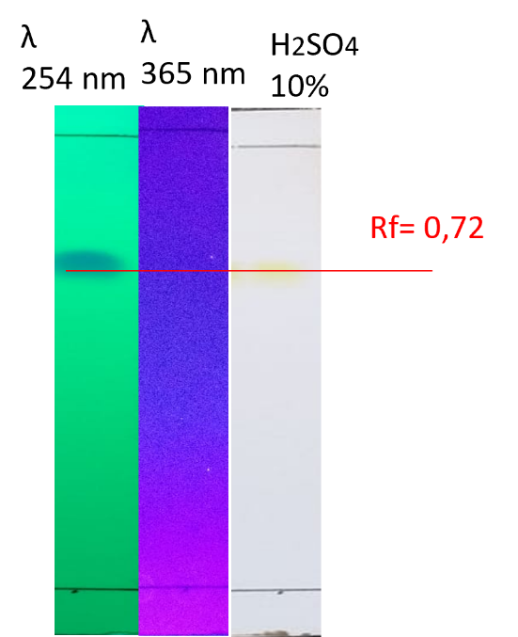
Figure S1. Thin layer chromatographic analysis of Crocatin A
Stationary phase: Silica G 60 F₂₅₄
Mobile phase: n-hexane – ethyl acetate (3:7)

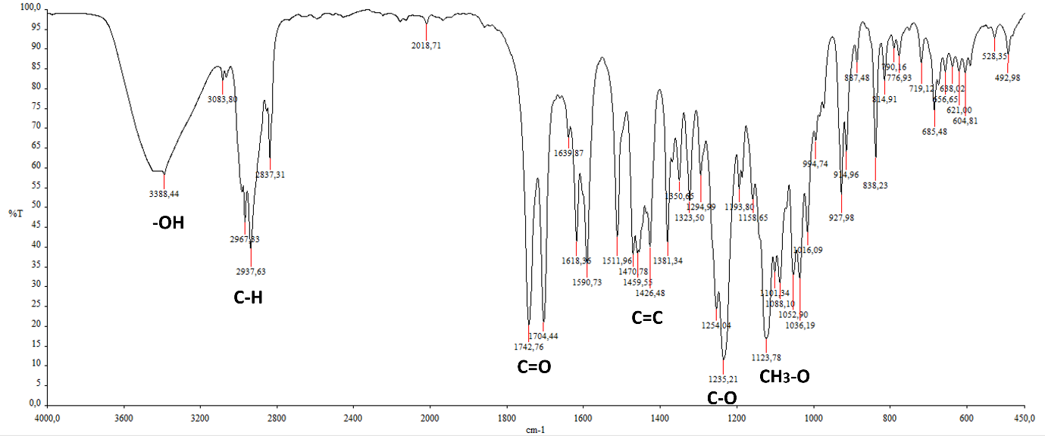
Figure S2. IR spectrum from Compound 1 (in KBr)

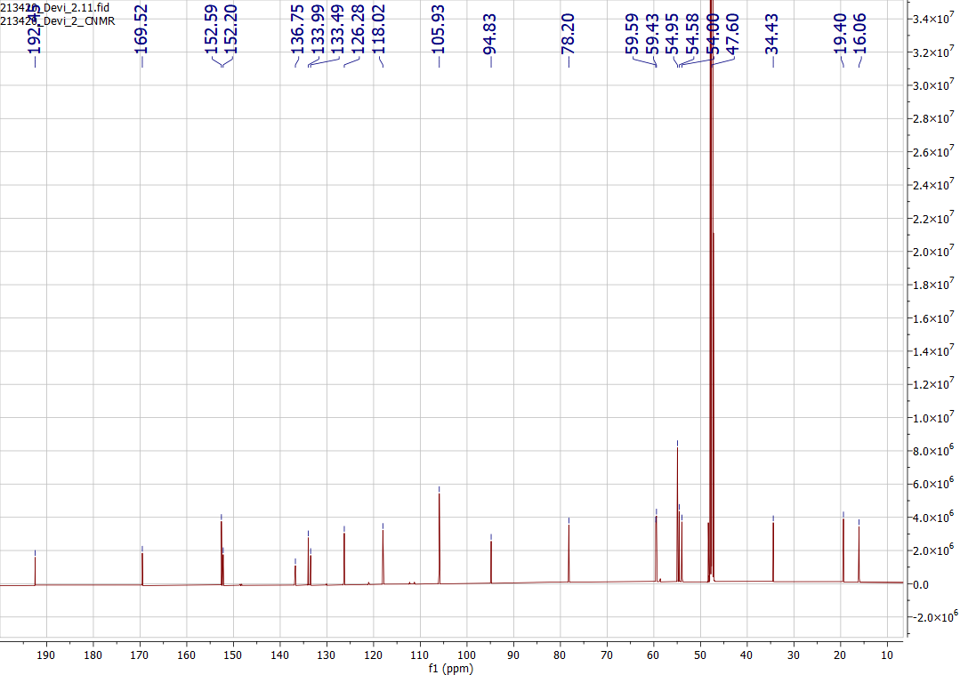
Figure S3. ¹³C-NMR spectrum from Compound 1
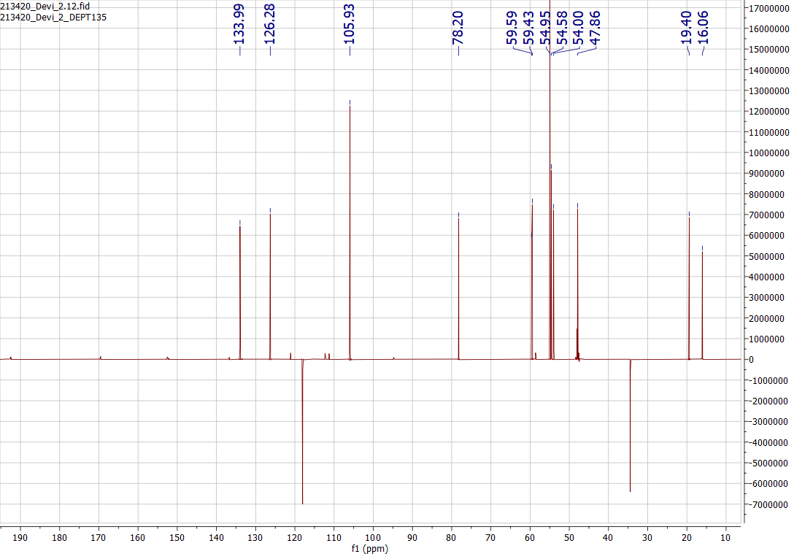
Figure S4. DEPT spectrum from Compound 1

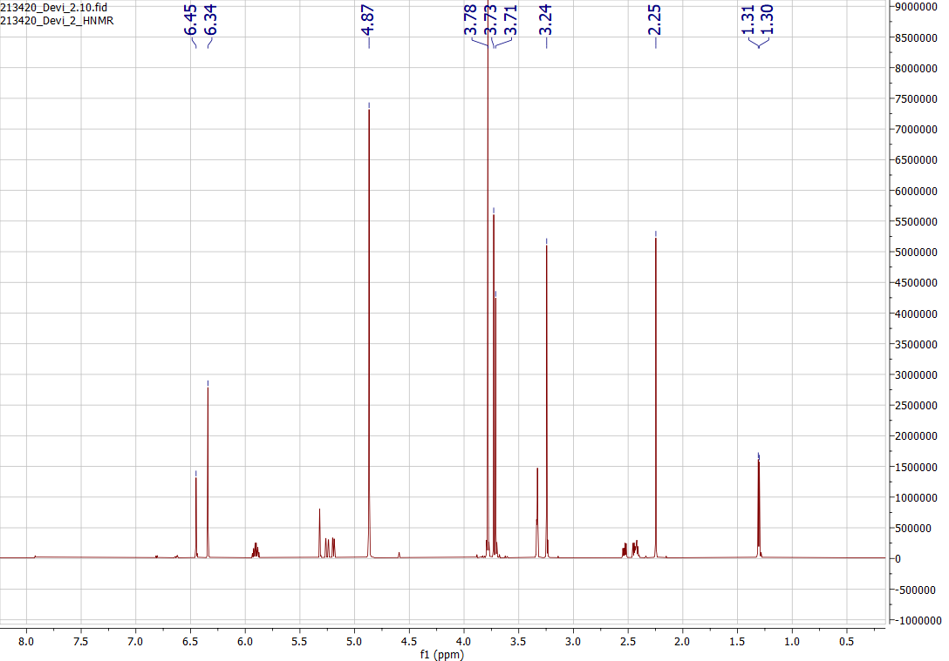
Figure S5. ¹H-NMR spectrum from Compound 1

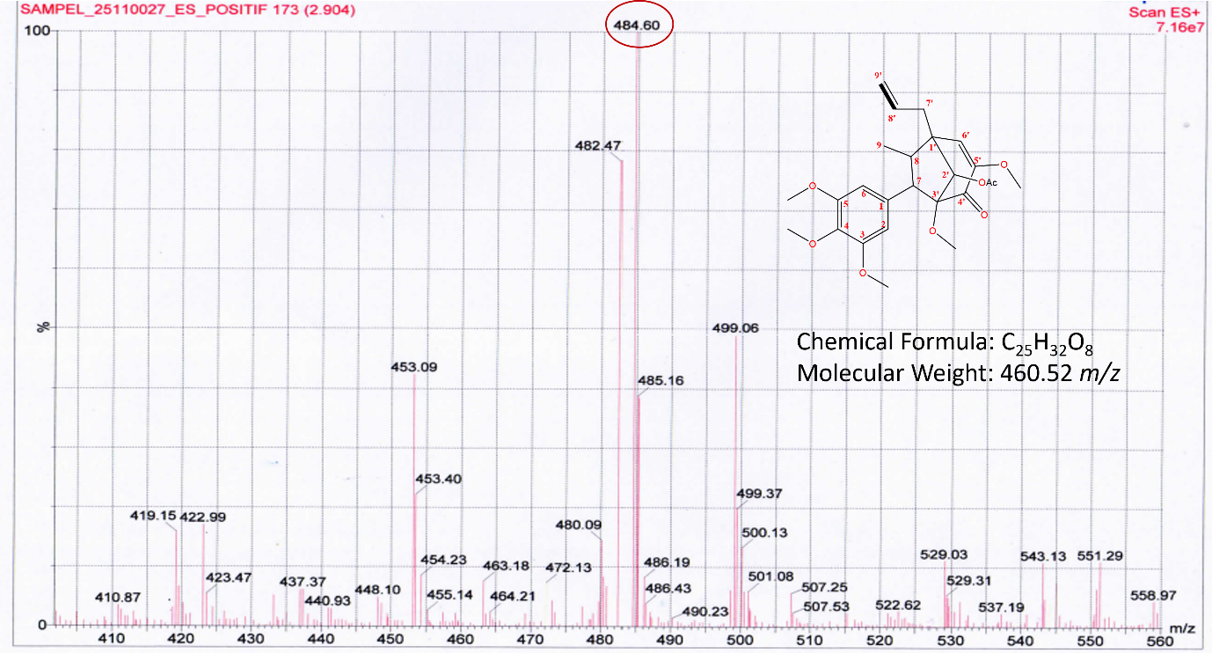
Figure S6. MS spectrum from Compound 1

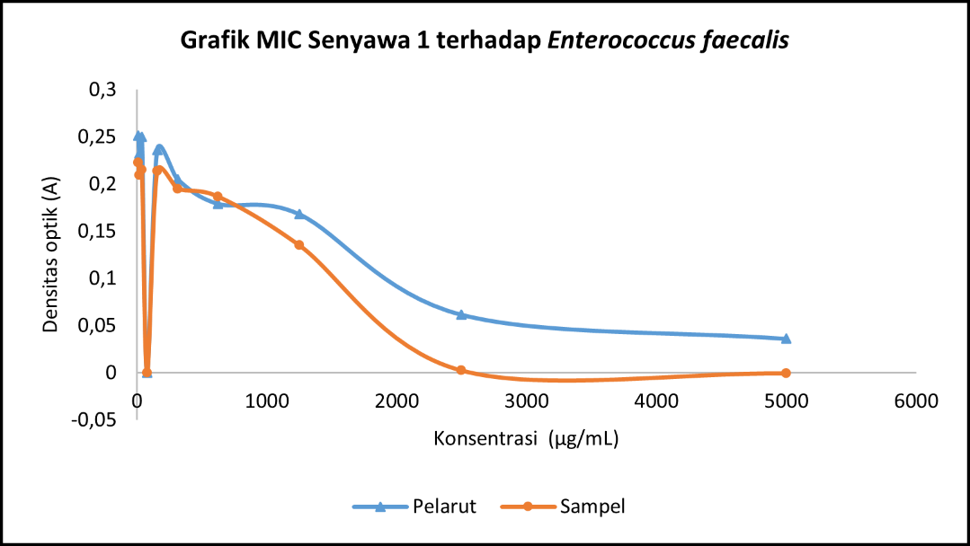
Figure S7. MIC curve of compound 1 against E. faecalis. The MIC is the lowest concentration that results in reduction of the viability of an inoculum of a microorganism.

References
[1] M.O. Aliba, I.G. Ndukwe, H. Ibrahim, Isolation and characterization of Β-sitosterol from methanol extracts of the stem bark of large- leaved rock fig (Ficus abutilifolia Miq.), Journal of Applied Sciences and Environmental Management 22 (2018) 1639. https://doi.org/10.4314/jasem.v22i10.19.
[2] Erwin, W.R. Pusparohmana, R.D. Safitry, E. Marliana, Usman, I.W. Kusuma, Isolation and characterization of stigmasterol and beta-sitosterol from wood bark extract of Baccaurea macrocarpa Miq. Mull. Arg, Rasayan Journal of Chemistry 13 (2020) 2552–2558. https://doi.org/10.31788/RJC.2020.1345652.

