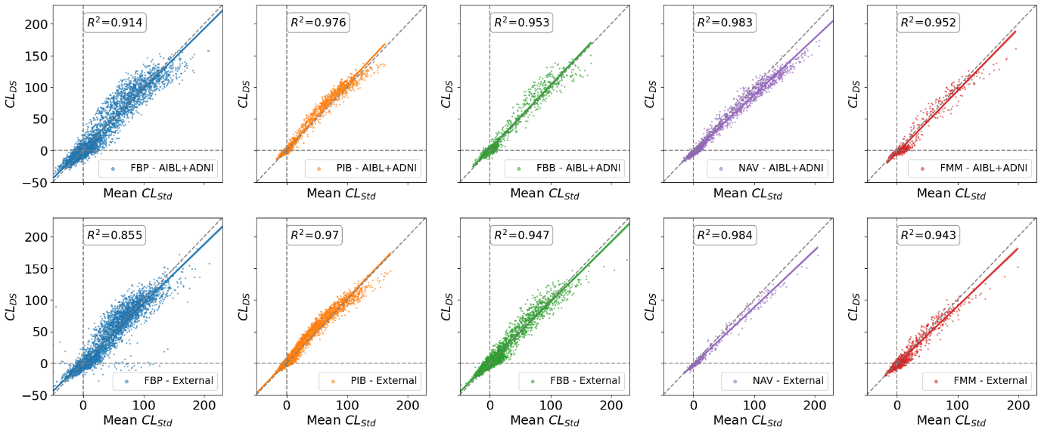
Sup Figure 1. Scatterplot of the correlation between the DeepSUVR Centiloids and the Standard Centiloids. The correlation between the tracers is assessed using the coefficient of determination R². The first row presented the correlation in each tracer in the AIBL+ADNI dataset, which was used to train the model. The bottom row presented the correlation in each tracer in the 10 external datasets (PISA, ADNeT, ADNI DOD, MCSA, OASIS, DLBS, AMYPAD, A4-Learn, HABS-HD, WRAP)

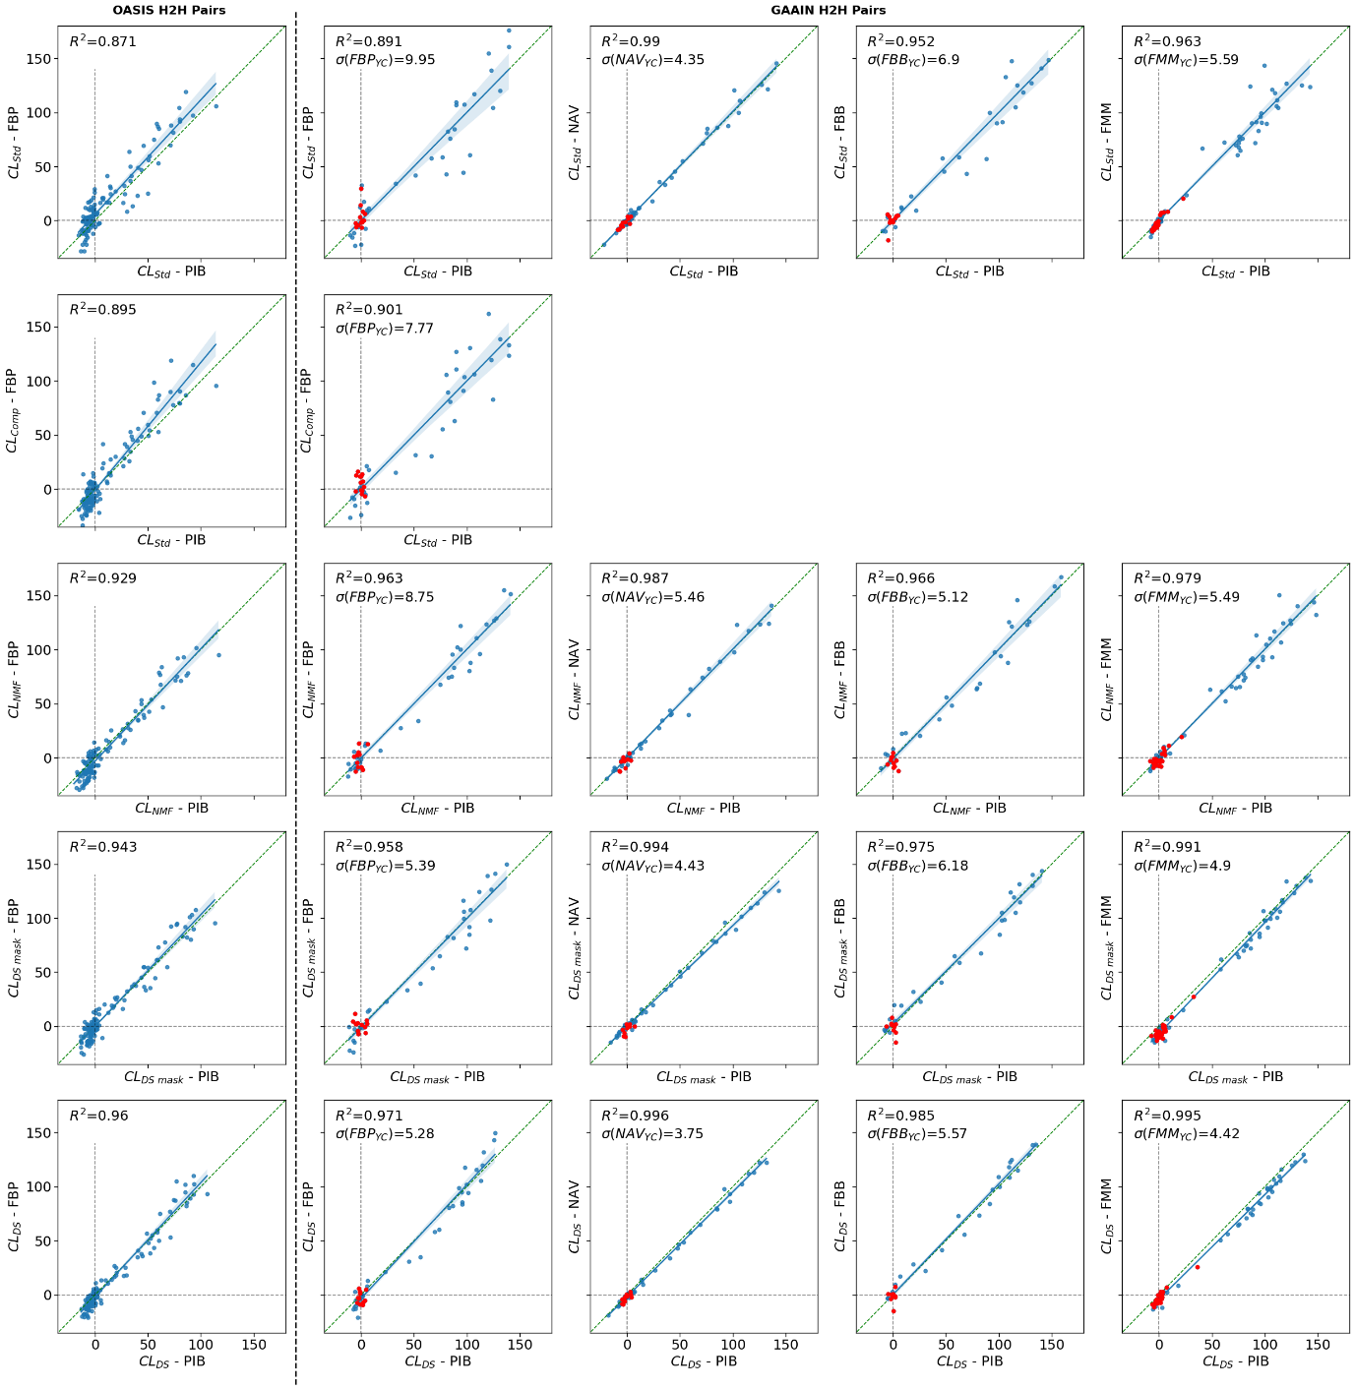
Sup Figure 2. Scatterplot of the PiB vs FBP in the OASIS Head-to-Head dataset (left) and between each 18F-Tracer compared to PIB in the GAAIN Head-to-Head Calibration dataset (Right). The correlation between each pair of tracers is assessed using the coefficient of determination R². Each row shows the results using a different quantification method, with the Standard masks, Composite reference region for FBP, NMF, DeepSUVR-derived masks and DeepSUVR. The standard deviation in the Young Controls is denoted using σ(Tracer_{YC}). Note that for FMM, one YC with a CL>20 on both PIB and FMM across all methods was determined to be an outlier and excluded from the standard deviation.

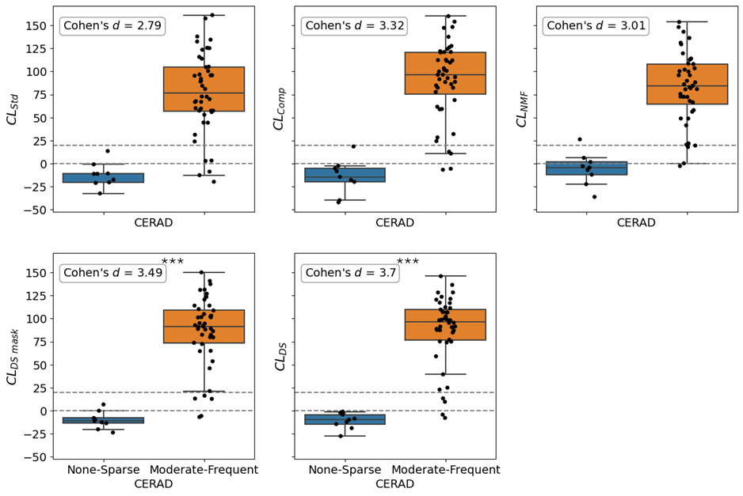
Sup Figure 3. Comparison of FBP CLs in the ADNI Neuropathology datasets between CERAD score for diffuse plaques grouped as none/sparse and moderate/frequent. Effect size (Cohen’s d) and boxplot between none/sparse and moderate/frequent are presented for each quantification method. Horizontal dashed lines indicate the CL=0 and CL=20 thresholds and are presented just for reference. The statistical significance over CL_{Std} based on bootstrapping is indicated using: * p<0.05, **p<0.01, *** p<0.001.

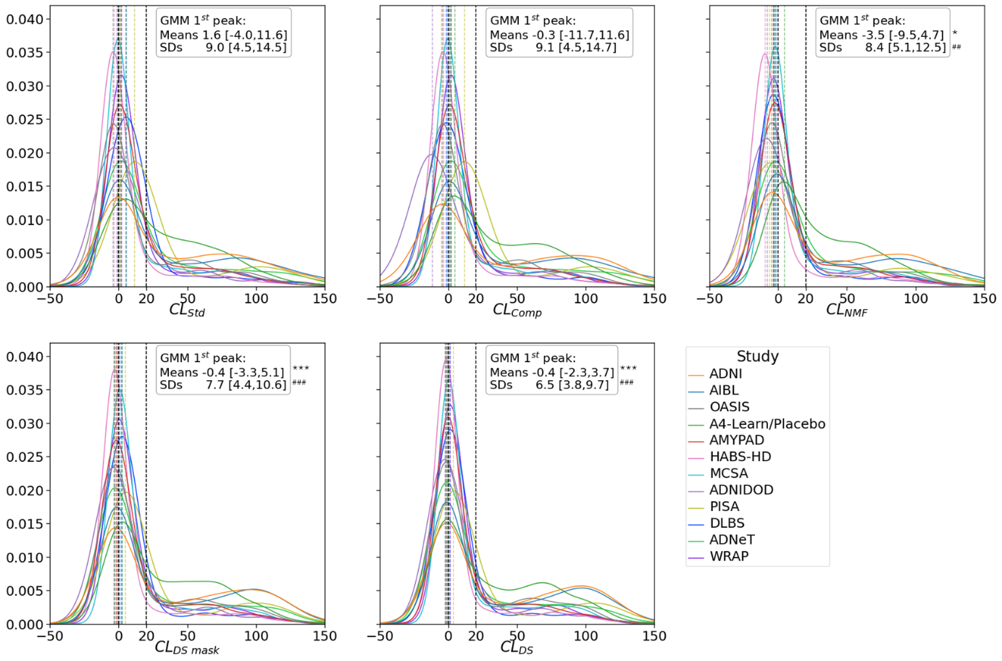
Sup Figure 4. Histogram distribution across the 12 cohorts using the Standard, Composite, NMF, DeepSUVR-derived masks and DeepSUVR CL methods. For each approach, a Gaussian mixture is fitted to the distribution of Cl values of each study, and the mean [min,max] and standard deviation [min,max] of the first peak across all studies is reported. The dashed lines mark the 0CL and 20CL. The methods showing significantly lower variability in the means and standard deviations compared to CL_{Std} across studies based on bootstrapping are indicated using: * p<0.05, ** p<0.01, *** p<0.001 for lower variabilities in the means and # p<0.05, ## p<0.01, ### p<0.001 for lower variabilities in the standard deviations.

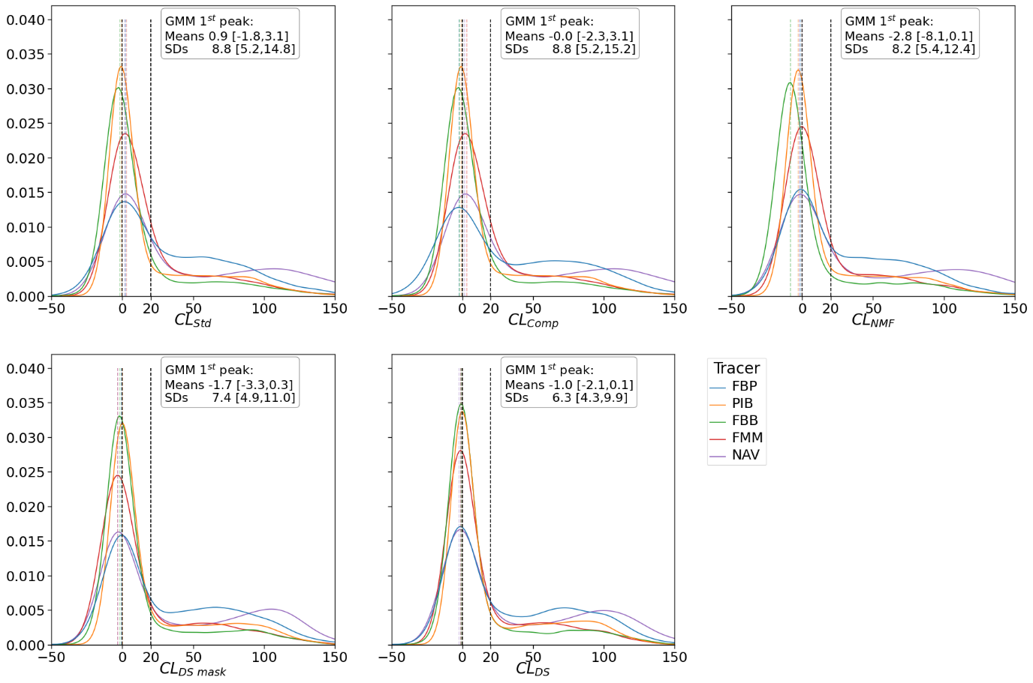
Sup Figure 5. Histogram distribution across the 12 cohorts using the Standard, Composite, NMF, DeepSUVR-derived masks and DeepSUVR CL methods. For each approach, a Gaussian mixture is fitted to the distribution of Cl values of each tracer, and the mean [min,max] and standard deviation [min,max] of the first peak across all tracers is reported. The dashed lines mark the 0CL and 20CL. The methods showing significantly lower variability in the means and standard deviations compared to CL_{Std} across tracers based on bootstrapping are indicated using: * p<0.05, ** p<0.01, *** p<0.001 for lower variabilities in the means and # p<0.05, ## p<0.01, ### p<0.001 for lower variabilities in the standard deviations.

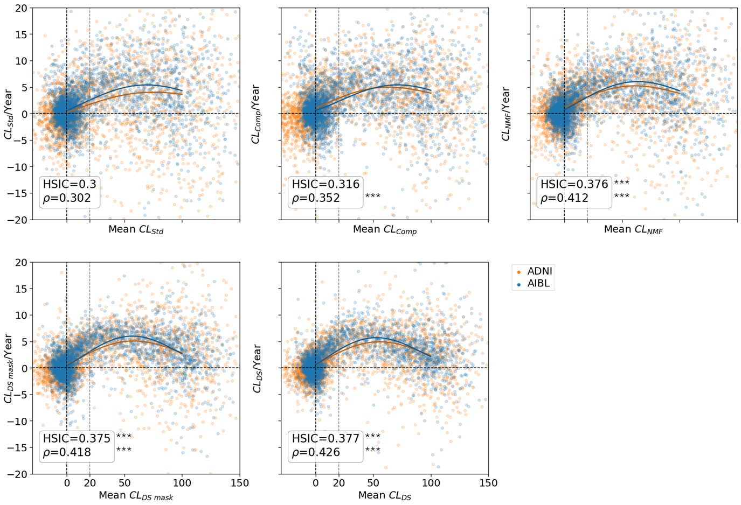
Sup Figure 6. Rate of CL change per year compared to mean CL computed from the 2 training cohorts (AIBL/ADNI) using the Standard, Composite WM, NMF, DeepSUVR-derived mask and DeepSUVR CL methods. Each point represents the mean and rate of change between a pair of consecutive visits from the same participant. Each curve shows a 5th order polynomial fitted to each study. The Spearman rank correlation between Mean CL and CL/Year is denoted using ρ. The vertical dashed lines mark the 0CL and 20CL, while the horizontal dashed line mark the 0CL/Year. The methods showing significantly higher HSIC or Spearman ρ compared to CL_{Std} based on bootstrapping are indicated using: * p<0.05, ** p<0.01, *** p<0.001.

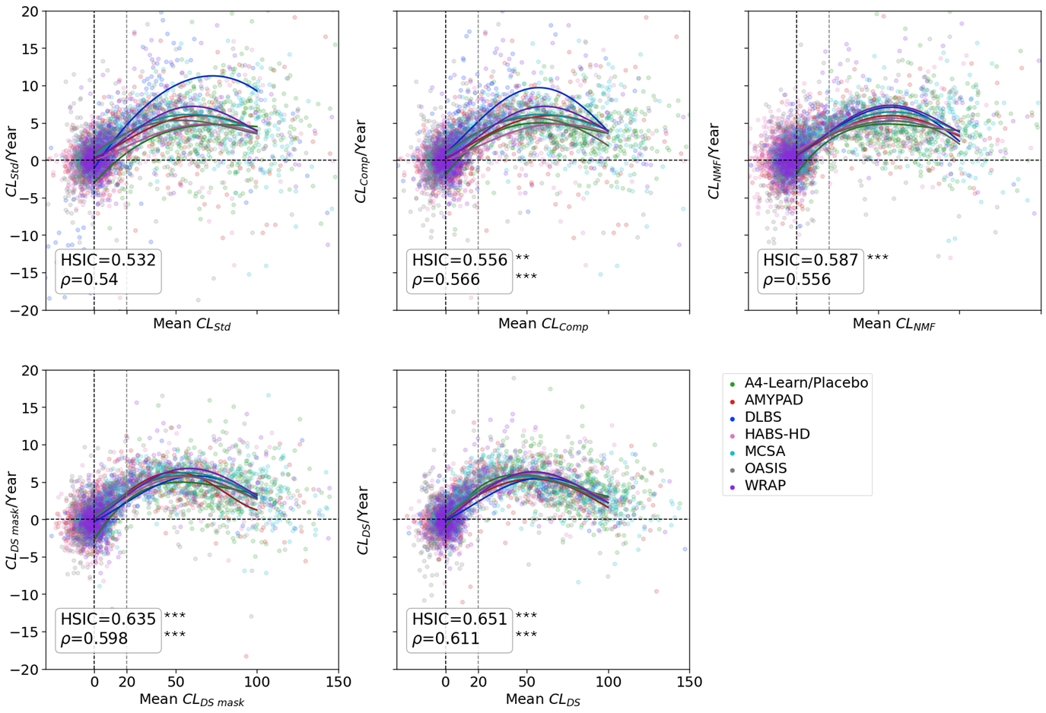
Sup Figure 7. Rate of CL change per year compared to mean CL computed from the 7 testing cohorts with longitudinal data (A4-Placebo, AMYPAD, HABS-HD, OASIS, DLBS, WRAP, MCSA) using the Standard, Composite WM, NMF, DeepSUVR-derived mask and DeepSUVR CL methods. Each point represents the mean and rate of change between a pair of consecutive visits from the same participant. Each curve shows a 5th order polynomial fitted to each study. The Spearman rank correlation between Mean CL and CL/Year is denoted using ρ. The vertical dashed lines mark the 0CL and 20CL, while the horizontal dashed line mark the 0CL/Year. The methods showing significantly higher HSIC or Spearman ρ compared to CL_{Std} based on bootstrapping are indicated using: * p<0.05, ** p<0.01, *** p<0.001.

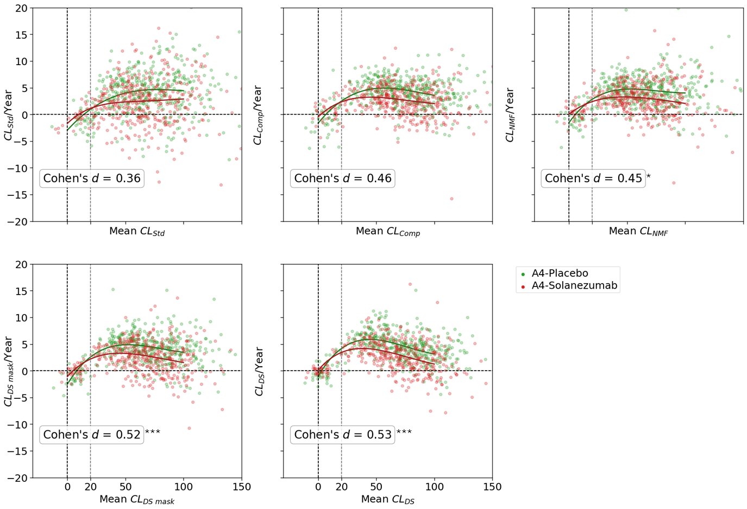
Sup Figure 8. Rate of CL change per year compared to mean CL computed from the placebo and treatment arms of the A4 Study Standard, Composite WM, NMF, DeepSUVR-derived mask and DeepSUVR CL methods. Each point represents the mean and rate of change between the 2 and 56 months visits from the same participant. Each curve shows a 5th order polynomial fitted to each study. The effect size of the CL accumulation per year between the 2 arms of the A4 study is denoted using Cohen’s d. The vertical dashed lines mark the 0CL and 20CL, while the horizontal dashed line mark the 0CL/Year. The methods showing significantly higher Cohen’s d compared to CL_{Std} based on bootstrapping are indicated using: * p<0.05, ** p<0.01, *** p<0.001.
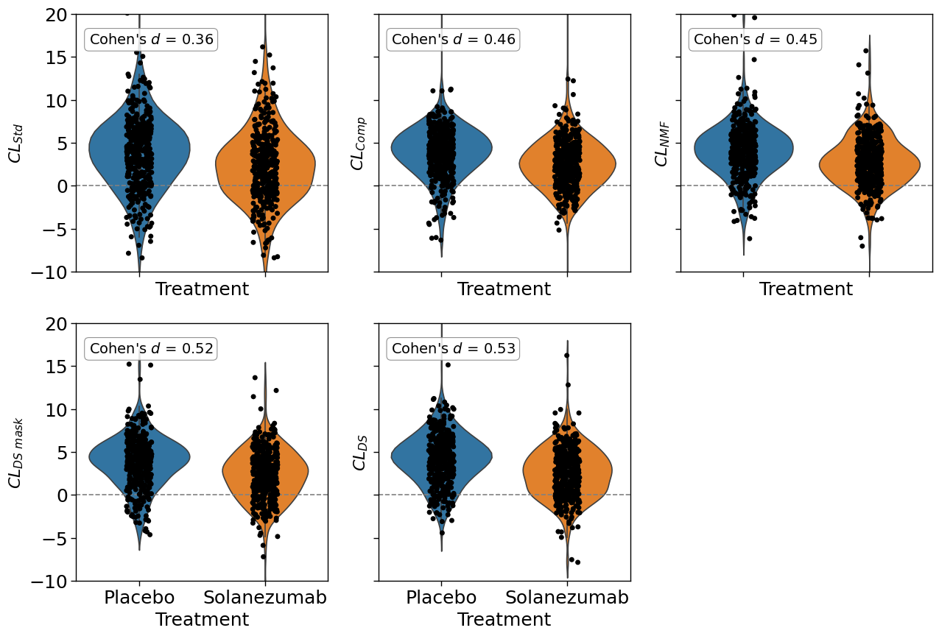
Sup Figure 9. Violin plot of the rate of CL change per year in the placebo and treatment arms of the A4 Study Standard, Composite WM, NMF, DeepSUVR-derived mask and DeepSUVR CL methods. The effect size of the CL accumulation per year between the 2 arms of the A4 study is denoted using Cohen’s d. The horizontal dashed lines marks 0CL/Y and 20CL, while the horizontal dashed line mark the 0CL/Year. The methods showing significantly higher Cohen’s d compared to CL_{Std} based on bootstrapping are indicated using: * p<0.05, ** p<0.01, *** p<0.001.

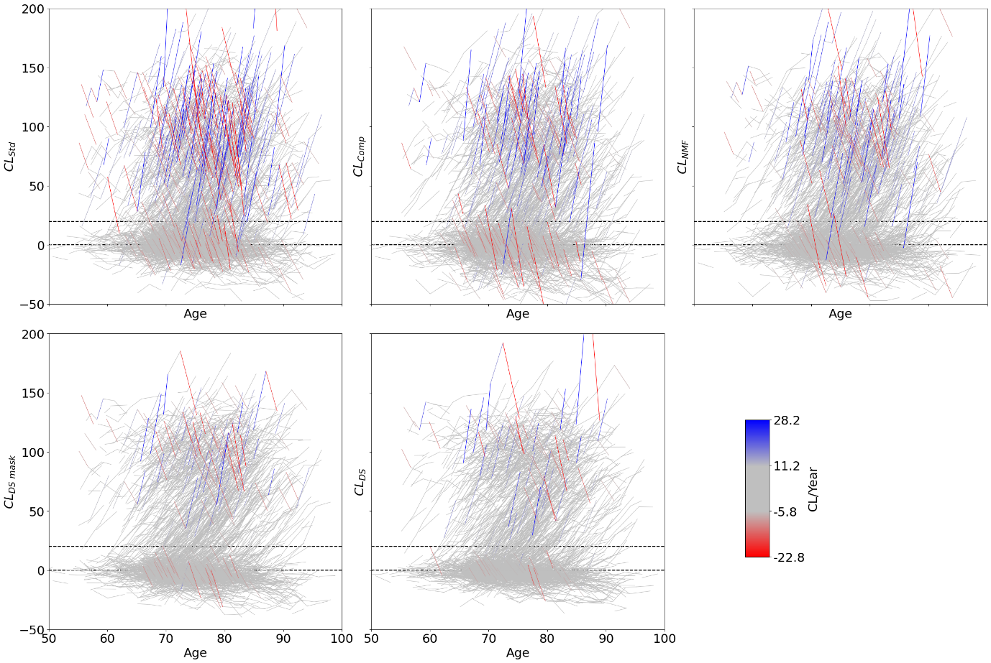
Sup Figure 10. Spaghetti plot of Centiloid value changes over time of all subjects with longitudinal scans in the training set. Each line connects CL values from unique subjects. Trajectories in red indicate negative changes that are greater than -5.8CL/Y and trajectories in blue indicate positive changes that are greater than 11.2CL/Y. The horizontal dashed lines mark 0CL and 20CL.

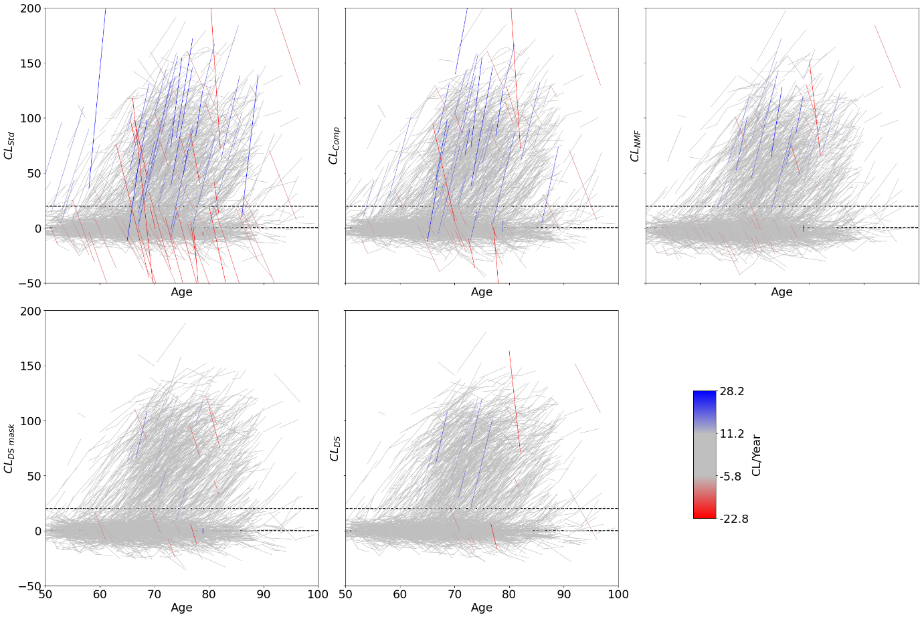
Sup Figure 11. Spaghetti plot of Centiloid value changes over time of all subjects with longitudinal scans in the testing set. Each line connects CL values from unique subjects. Trajectories in red indicate negative changes that are greater than -5.8CL/Y and trajectories in blue indicate positive changes that are greater than 11.2CL/Y. The horizontal dashed lines mark 0CL and 20CL.

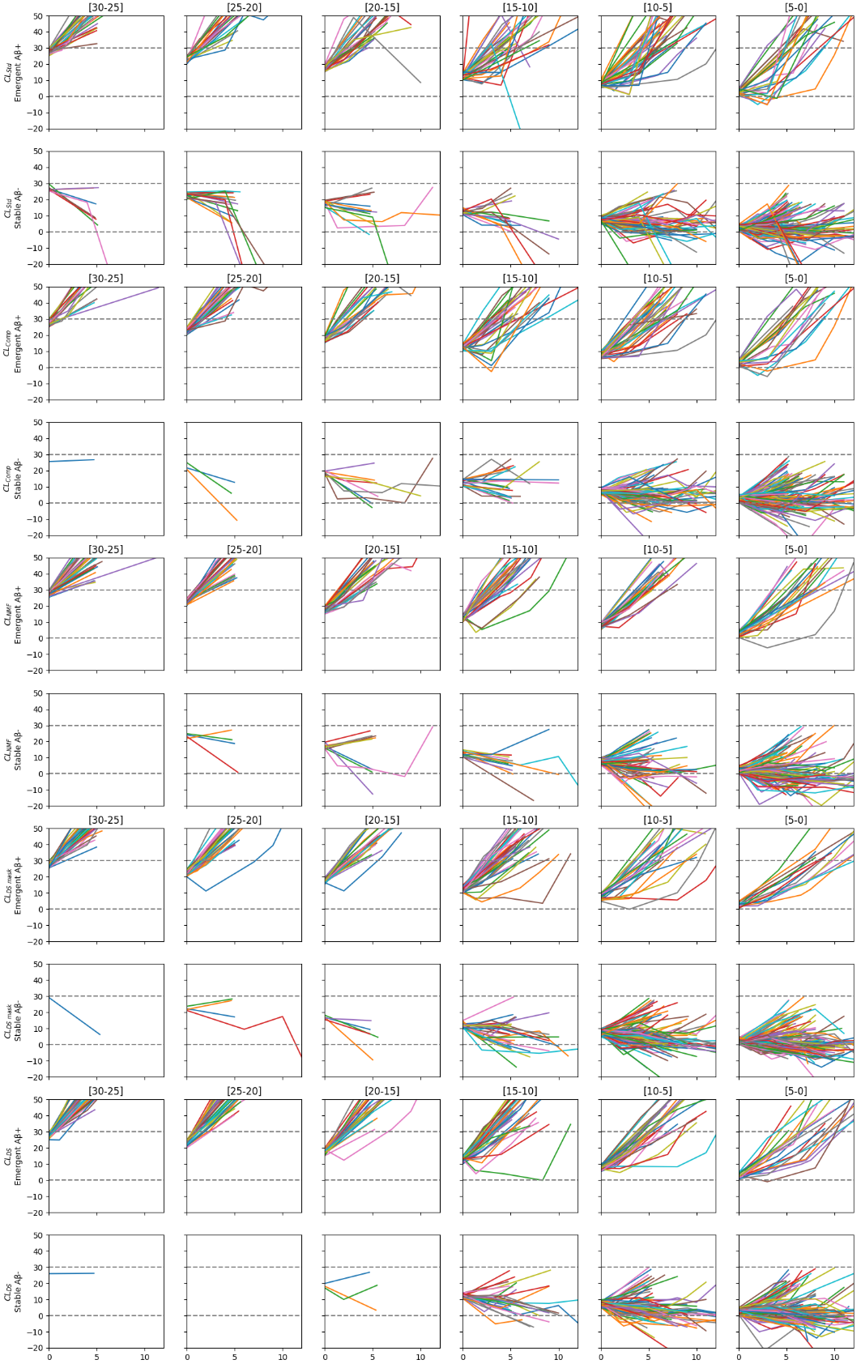
Sup Figure 12. Spaghetti plot of Centiloid changes against the number of years since baseline in the testing set with each column representing a baseline CL bracket. For each quantification method, the top row only shows the emergent Aβ+, defined as participants with a negative baseline CL (<30CL) and with at least one follow-up above 30CL. The second row only shows participants which remain stable Aβ-. The horizontal dashed lines mark 0CL and 30CL.
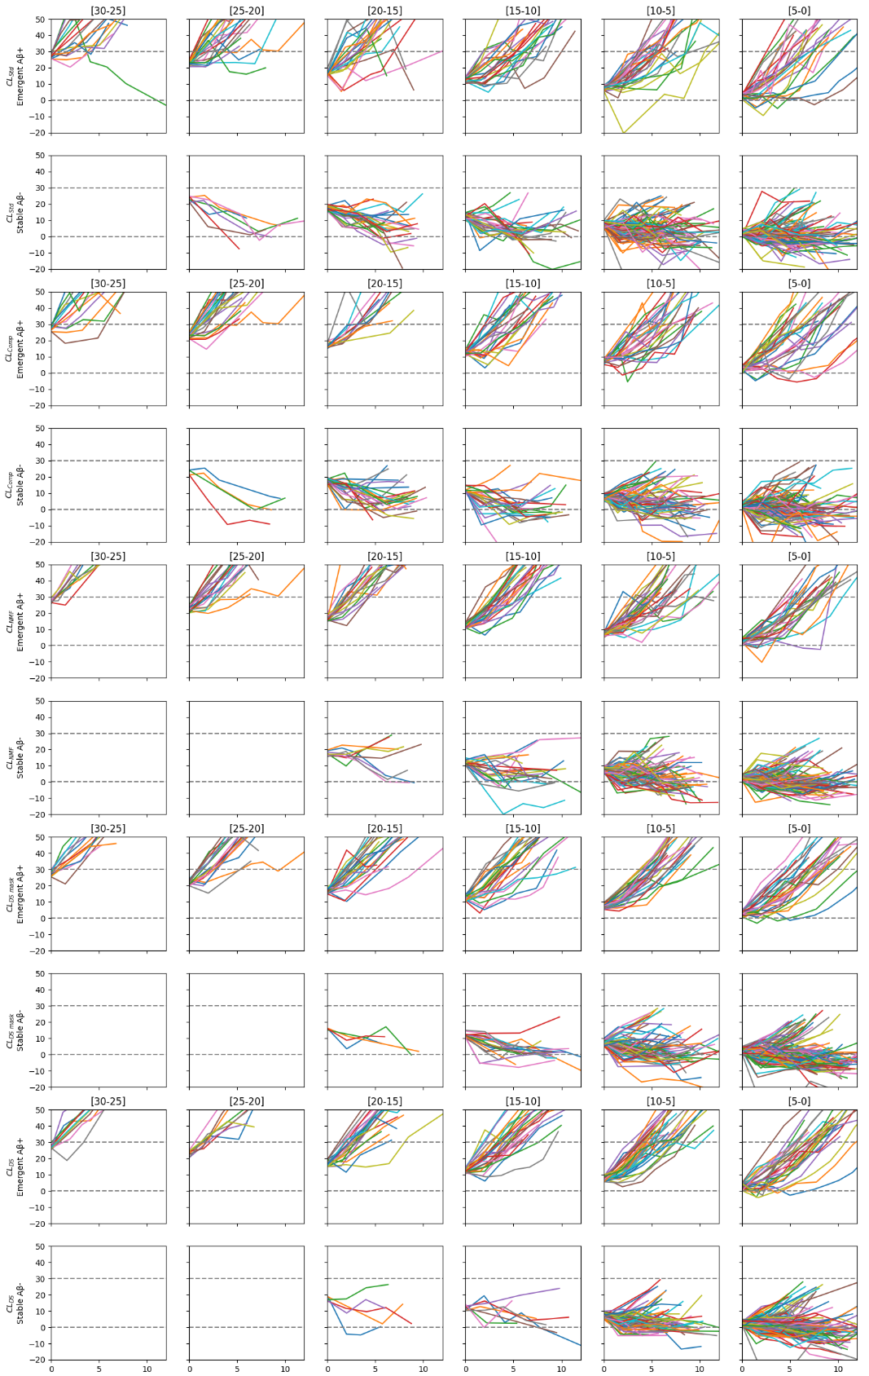
Sup Figure 13. Spaghetti plot of Centiloid changes against the number of years since baseline in the training set with each column representing a baseline CL bracket. For each quantification method, the top row only shows the emergent Aβ+, defined as participants with a negative baseline CL (<30CL) and with at least one follow-up above 30CL. The second row only shows participants which remain stable Aβ-. The horizontal dashed lines mark 0CL and 30CL.
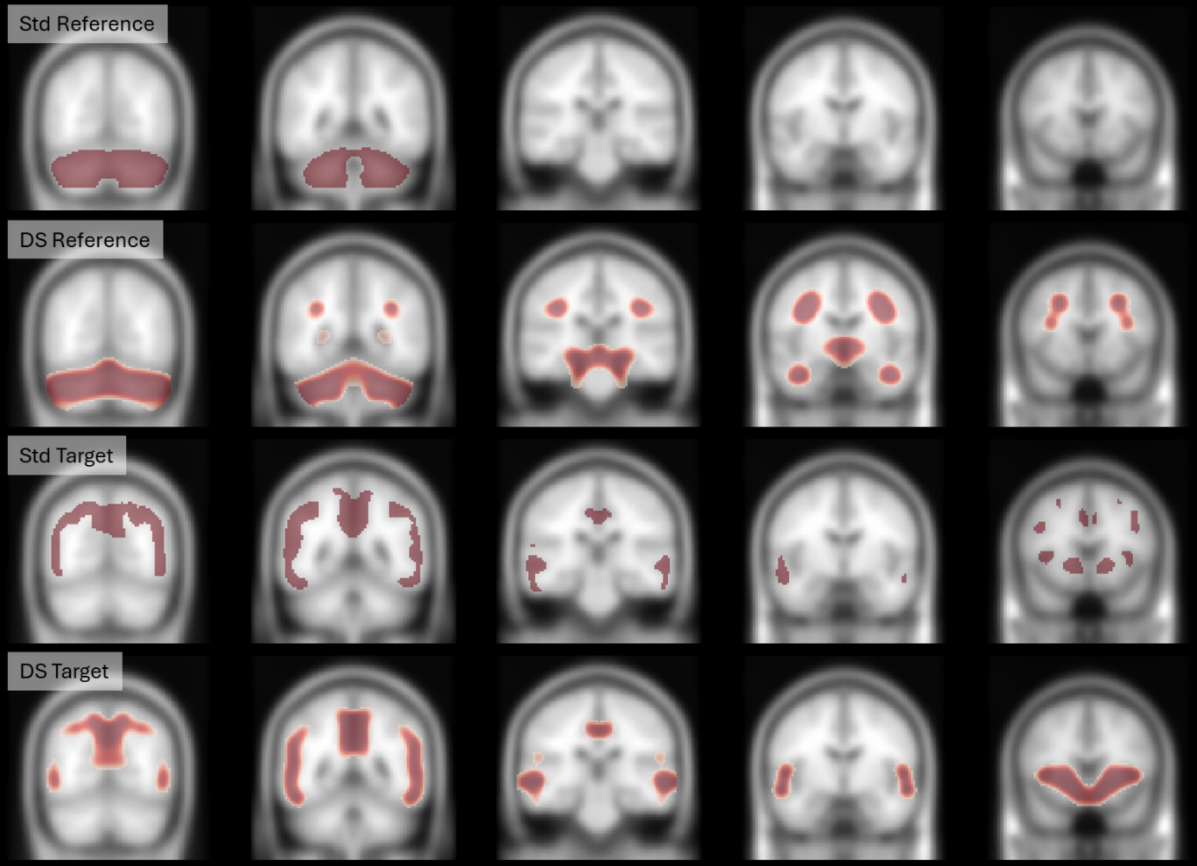
Suppl. Figure 14. Coronal views of the Standard CL reference mask (row1) and the new reference mask derived from DeepSUVR (row2), the Standard CL target mask (row3) and the new target mask derived from DeepSUVR (row4)
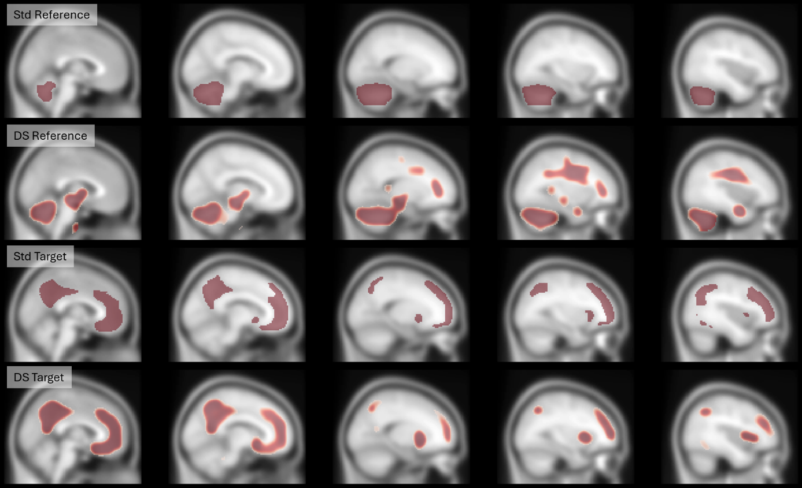
Suppl. Figure 15. Sagittal views of the Standard CL reference mask (row1) and the new reference mask derived from DeepSUVR (row2), the Standard CL target mask (row3) and the new target mask derived from DeepSUVR (row4)

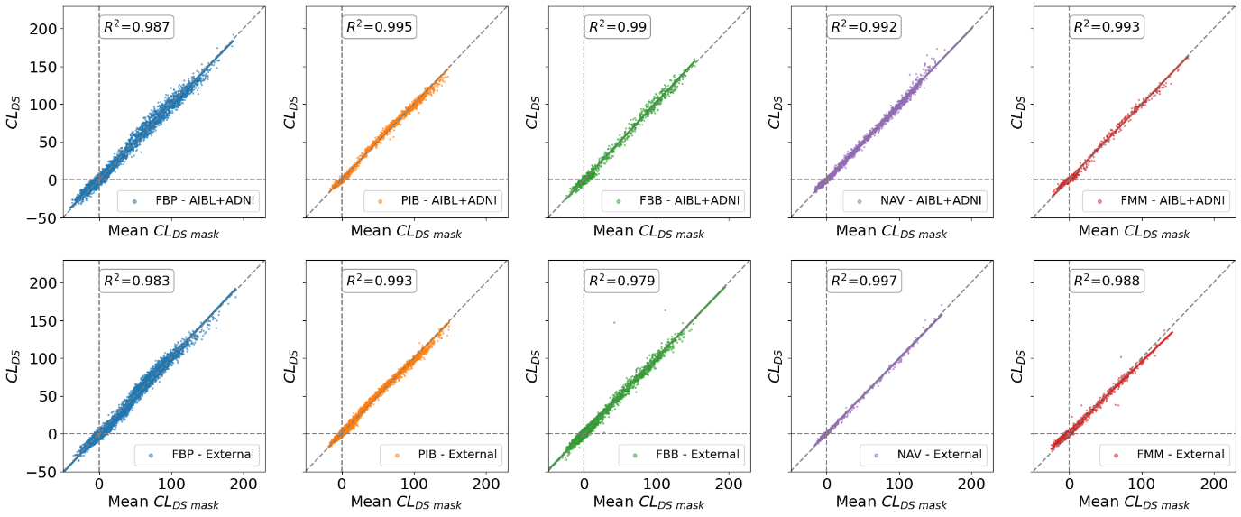
Sup Figure 16. Scatterplot of the correlation between the DeepSUVR Centiloids and the Centiloids obtained using the DeepSUVR-derived masks. The correlation between the tracers is assessed using the coefficient of determination R². The first row presented the correlation in each tracer in the AIBL+ADNI dataset, which was used to construct the new masks. The bottom row presented the correlation in each tracer in the 10 external datasets (PISA, ADNeT, ADNI DOD, MCSA, OASIS, DLBS, AMYPAD, A4-Learn, HABS-HD, WRAP)

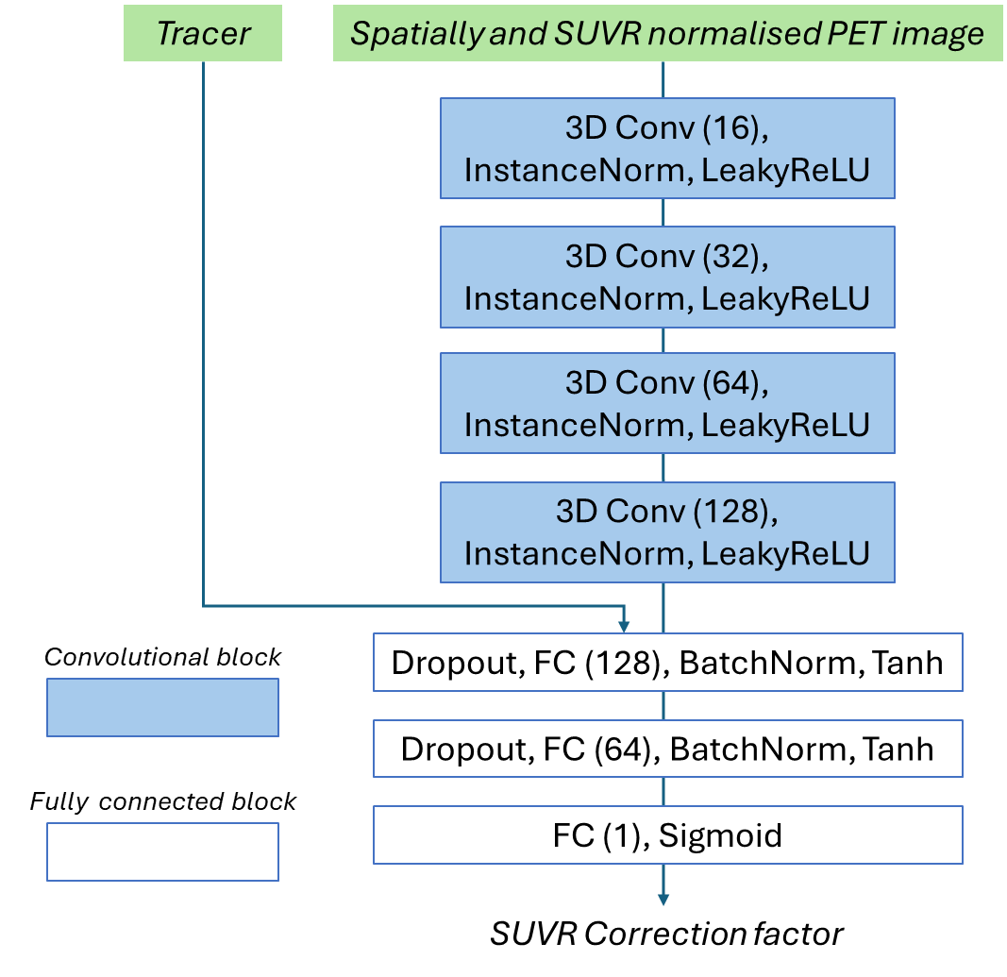
Suppl. Figure 17. Architecture of the DeepSUVR model with 4 convolutional blocks, followed by 3 fully connected layers. The tracer information feeds into the fully connected layer as a one-hot vector

 | AIBL | ADNI | A4-Learn | ADNI-DOD | AMYPAD | DLBS | HABS-HD
Baseline Age | 72.18 (7.98) | 73.02 (7.63) | 71.66 (4.76) | 69.91 (4.72) | 68.23 (9.08) | 64.89 (13.44) | 65.47 (8.68)
Baseline CDR | 0.23 (0.35) | 0.35 (0.35) | 0.0 (0.02) | 0.1 (0.32) | NA | NA | 0.18 (0.38)
Baseline MMSE | 27.18 (3.08) | 27.57 (2.82) | 28.81 (1.23) | 28.3 (1.61) | NA | 28.33 (1.23) | 22.46 (224.95)
Length of follow-up | 5.3 (3.43) | 4.63 (2.91) | 4.68 (0.92) | 1.09 (0.22) | 3.31 (1.25) | 5.81 (2.66) | 2.16 (0.28)
Number of longitudinal studies | 1202 | 1132 | 925 | 9 | 784 | 176 | 608
Number of scans per tracer (FBP/PIB/FBB/FMM/NAV) | 652/1545/243/539/2169 | 3257/202/659/-/- | 2706/-/-/-/- | 243/-/-/-/- | -/-/999/1265/- | 542/-/-/-/- | -/-/3685/-/-
Number of scanner models | 5 | 27 | NA | 15 | 21 | 3 | 2
Number of visits | 3.44 (1.64) | 3.07 (1.31) | 2.0 (0.0) | 2.0 (0.0) | 2.15 (0.36) | 2.4 (0.49) | 2.0 (0.0)
 | MCSA | OASIS | WRAP | ADNeT | PISA | All
Baseline Age | 70.84 (9.95) | 69.4 (9.51) | 64.81 (7.74) | 67.13 (7.19) | 61.8 (6.97) | 69.62 (8.79)
Baseline CDR | 0.07 (0.18) | 0.12 (0.27) | NA | 0.1 (0.22) | NA | 0.16 (0.31)
Baseline MMSE | 28.12 (1.73) | 28.49 (2.19) | NA | 27.81 (2.63) | NA | 26.96 (97.97)
Length of follow-up | 3.38 (1.72) | 5.51 (3.28) | 6.45 (4.18) | NA | NA | 4.37 (2.73)
Number of longitudinal studies | 829 | 400 | 317 | 0 | 0 | 6382
Number of scans per tracer (FBP/PIB/FBB/FMM/NAV) | -/2989/-/-/- | 466/1098/-/-/- | -/1114/-/-/19 | -/-/-/-/429 | -/-/251/-/- | 7866/6948/5828/1814/2617
Number of scanner models | 2 | 4 | 3 | 3 | 1 | -
Number of visits | 2.44 (0.7) | 2.94 (1.14) | 2.91 (1.09) | NA | NA | 2.65 (1.16)

Sup Table 1. Basic demographics, with mean (standard deviation) and distribution of the number of scans per tracers used in each cohort.

 | MMSE vs CL (ρ) | CDR 0 vs CDR 0.5 (Cohen's d) | CDR 0.5 vs CDR 1 (Cohen's d) | CDR 0 vs CDR 1 (Cohen's d)
CL_{Std} | -0.077 | 0.272 | 0.644 | 0.960
CL_{Comp} | -0.077 | 0.244 | 0.691*** | 0.983
CL_{NMF} | -0.073 | 0.256 | 0.706** | 1.017**
CL_{DS mask} | -0.093*** | 0.285 | 0.727*** | 1.055***
CL_{DS} | -0.111*** | 0.303*** | 0.718*** | 1.061***
Sup Table 2. Correlation (Spearman rank) between the baseline CL and MMSE, and effect size when comparing CDR 0 to CDR 0.5, CDR 0.5 to CDR 1 and CDR 0 to CDR 1 in the external testing cohorts: OASIS3, A4-Learn, ADNI-DOD, DLBS, HABS-HD, MCSA, WRAP, ADNeT. The strongest correlation and largest effect sizes are highlighted with bold font. For each method where the correlations and effect size are significantly improved compared to using CL_{Std}, the significance is denoted using: * p<0.05, **p<0.01, *** p<0.001

 | MMSE vs CL (ρ) | CDR 0 vs CDR 0.5 (Cohen's d) | CDR 0.5 vs CDR 1 (Cohen's d) | CDR 0 vs CDR 1 (Cohen's d)
CL_{Std} | -0.360 | 0.762 | 0.582 | 1.478
CL_{Comp} | -0.373 | 0.799** | 0.686*** | 1.647***
CL_{NMF} | -0.380** | 0.796** | 0.686*** | 1.649***
CL_{DS mask} | -0.378*** | 0.804*** | 0.710*** | 1.706***
CL_{DS} | -0.383*** | 0.803*** | 0.710*** | 1.708***
Sup Table 3. Correlation (Spearman rank) between the baseline CL and MMSE, and effect size when comparing CDR 0 to CDR 0.5, CDR 0.5 to CDR 1 and CDR 0 to CDR 1 in training cohorts: AIBL, ADNI. The strongest correlation and largest effect sizes are highlighted with bold font. For each method where the correlations and effect size are significantly improved compared to using CL_{Std}, the significance is denoted using: * p<0.05, **p<0.01, *** p<0.001

 | Emerging Aβ+ (N/Total) (%)
Baseline CL | CL_{Std} | CL_{Comp} | CL_{NMF} | CL_{DS-Mask} | CL_{DS}
[25-30] | 29/36 (81%) | 19/20 (95%) | 38/38 (100%) | 31/32 (97%) | 31/32 (97%)
[20-25] | 23/39 (59%) | 27/30 (90%) | 27/31 (87%) | 32/36 (89%) | 31/31 (100%)
[15-20] | 29/42 (69%) | 23/32 (72%) | 28/37 (76%) | 21/26 (81%) | 30/33 (91%)
[10-15] | 34/50 (68%) | 32/53 (60%) | 29/41 (71%) | 38/69 (55%) | 34/62 (55%)
[5-10] | 44/108 (41%) | 39/100 (39%) | 27/82 (33%) | 23/127 (18%) | 29/114 (25%)

Sup Table 4. Number of participants in the testing cohorts with emerging Aβ+ for each baseline CL bracket, and their proportion compared to the total number of participants within those brackets. For each bracket, the quantification methods with the highest proportion emerging Aβ+ are highlighted with bold font.

 | Emerging Aβ+ (N/Total) (%)
Baseline CL | CL_{Std} | CL_{Comp} | CL_{NMF} | CL_{DS-Mask} | CL_{DS}
[25-30] | 16/16 (100%) | 13/13 (100%) | 9/9 (100%) | 12/12 (100%) | 10/10 (100%)
[20-25] | 23/30 (77%) | 23/27 (85%) | 18/18 (100%) | 18/18 (100%) | 9/9 (100%)
[15-20] | 22/46 (48%) | 12/37 (32%) | 19/28 (68%) | 21/25 (84%) | 21/26 (81%)
[10-15] | 24/54 (44%) | 25/50 (50%) | 26/47 (55%) | 23/41 (56%) | 25/33 (76%)
[5-10] | 30/119 (25%) | 27/89 (30%) | 29/98 (30%) | 28/88 (31%) | 33/95 (35%)

Sup Table 5. Number of participants in the training cohorts with emerging Aβ+ for each baseline CL bracket, and their proportion compared to the total number of participants within those brackets. For each bracket, the quantification methods with the highest proportion emerging Aβ+ are highlighted with bold font.

 | Slope | Intercept
PIB | 0.633 | 0.886
FBP | 0.336 | 0.878
FMM | 0.470 | 0.860
NAV | 0.685 | 0.878
FBB | 0.409 | 0.852

Sup Table 6. Centiloid transforms for the DeepSUVR-derived masks. These are defined for each tracer in the same format as the standard Centiloid transform, so that CL_{DS mask} =100*(SUVR_{DS mask}-Intercept)/Slope

 | A4-Learn | ADNI | ADNIDOD | HABS-HD | AMYPAD | AMYPAD
CL_{Std} | 0.919 | 0.973 | 0.915 | 0.989 | 0.975 | 0.961
CL_{Comp} | 0.951*** | 0.965 | 0.927 | 0.989 | 0.975 | 0.961
CL_{NMF} | 0.948*** | 0.972 | 0.928 | 0.993** | 0.975 | 0.973***
CL_{DS mask} | 0.951*** | 0.976 | 0.953* | 0.994*** | 0.979 | 0.980***
CL_{DS} | 0.954*** | 0.978 | 0.942* | 0.994*** | 0.980 | 0.981***
Tracers | FBP | FBP/FBB | FBP | FBB | FBB | FMM
N | 1772 | 138 | 230 | 1094 | 985 | 1275
Visual Positivity (%) | 35.0 | 48.6 | 30.9 | 7.8 | 19.1 | 23.8

Sup Table 7. AUC between visual reads in ADNI, ADNI-DOD, A4 and HABS-HD and the CL obtained using each quantification method. The quantification with the highest AUC for each cohort is presented using bold font. The quantifications highest AUC for each cohort is presented using bold font. The number of scans with visual reads, the tracer used, as well as the proportion of scan visually read as positive is presented under the Visual reads sub-heading. For each method where the AUC is significantly increased compared to using CL_{Std}, the significance is denoted using: * p<0.05, **p<0.01, *** p<0.001

 | AIBL/ADNI |  | External
 | Neg outliers (%) | Pos outliers (%) | Neg outliers (%) | Pos outliers (%)
CL_{Std} | 6.45 | 6.74 | 2.48 | 1.76
CL_{Comp} | 5.84 | 4.95 | 1.80 | 1.26
CL_{NMF} | 4.70 | 3.69 | 1.17 | 1.22
CL_{DS mask} | 2.11 | 2.86 | 0.52 | 0.56
CL_{DS} | 1.58 | 1.92 | 0.48 | 0.50

Sup Table 8. Percentage of outliers based on the 95% confidence interval of yearly change in CL_{Std} measured in PiB in AIBL, when no change of tracer or scanner occurred. The smallest percentage of outliers are presented using a bold font.

Simulation Study:
To evaluate the ability of DeepSUVR to preserve potential variability between participants, the training dataset was randomly split in 2 subsets (20/80), with 20% of participants assigned a simulated slower or faster rate of change by a factor of 0.9, 1.1, 1.2, 1.5 and 2 by artificially scaling the number of days between each scans (subset 2), while the remaining participant kept their original rate of change (subset 1). New models were trained using each of the simulated dataset and evaluated on the out-of-fold simulated data as well as the real data (Sup Figure 18). A 5th order polynomial was fitted to each subset of participants to evaluate their trajectories and the peak of each polynomial used as a surrogate marker of the peak rate of accumulation. When the models were evaluated on the out-of-folds simulated data, the simulated rate of change was mostly preserved with a measured difference in peak accumulation of 0.85, 1.09, 1.20, 1.47, 1.81 (compared to the introduced rate of 0.9, 1.1, 1.2, 1.5 and 2). When those models were evaluated on the real data, the derived trajectories had peaks within 10% of each other’s.
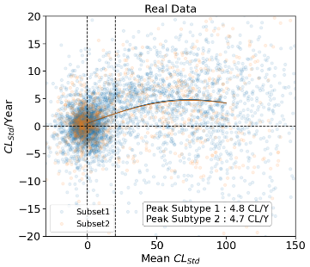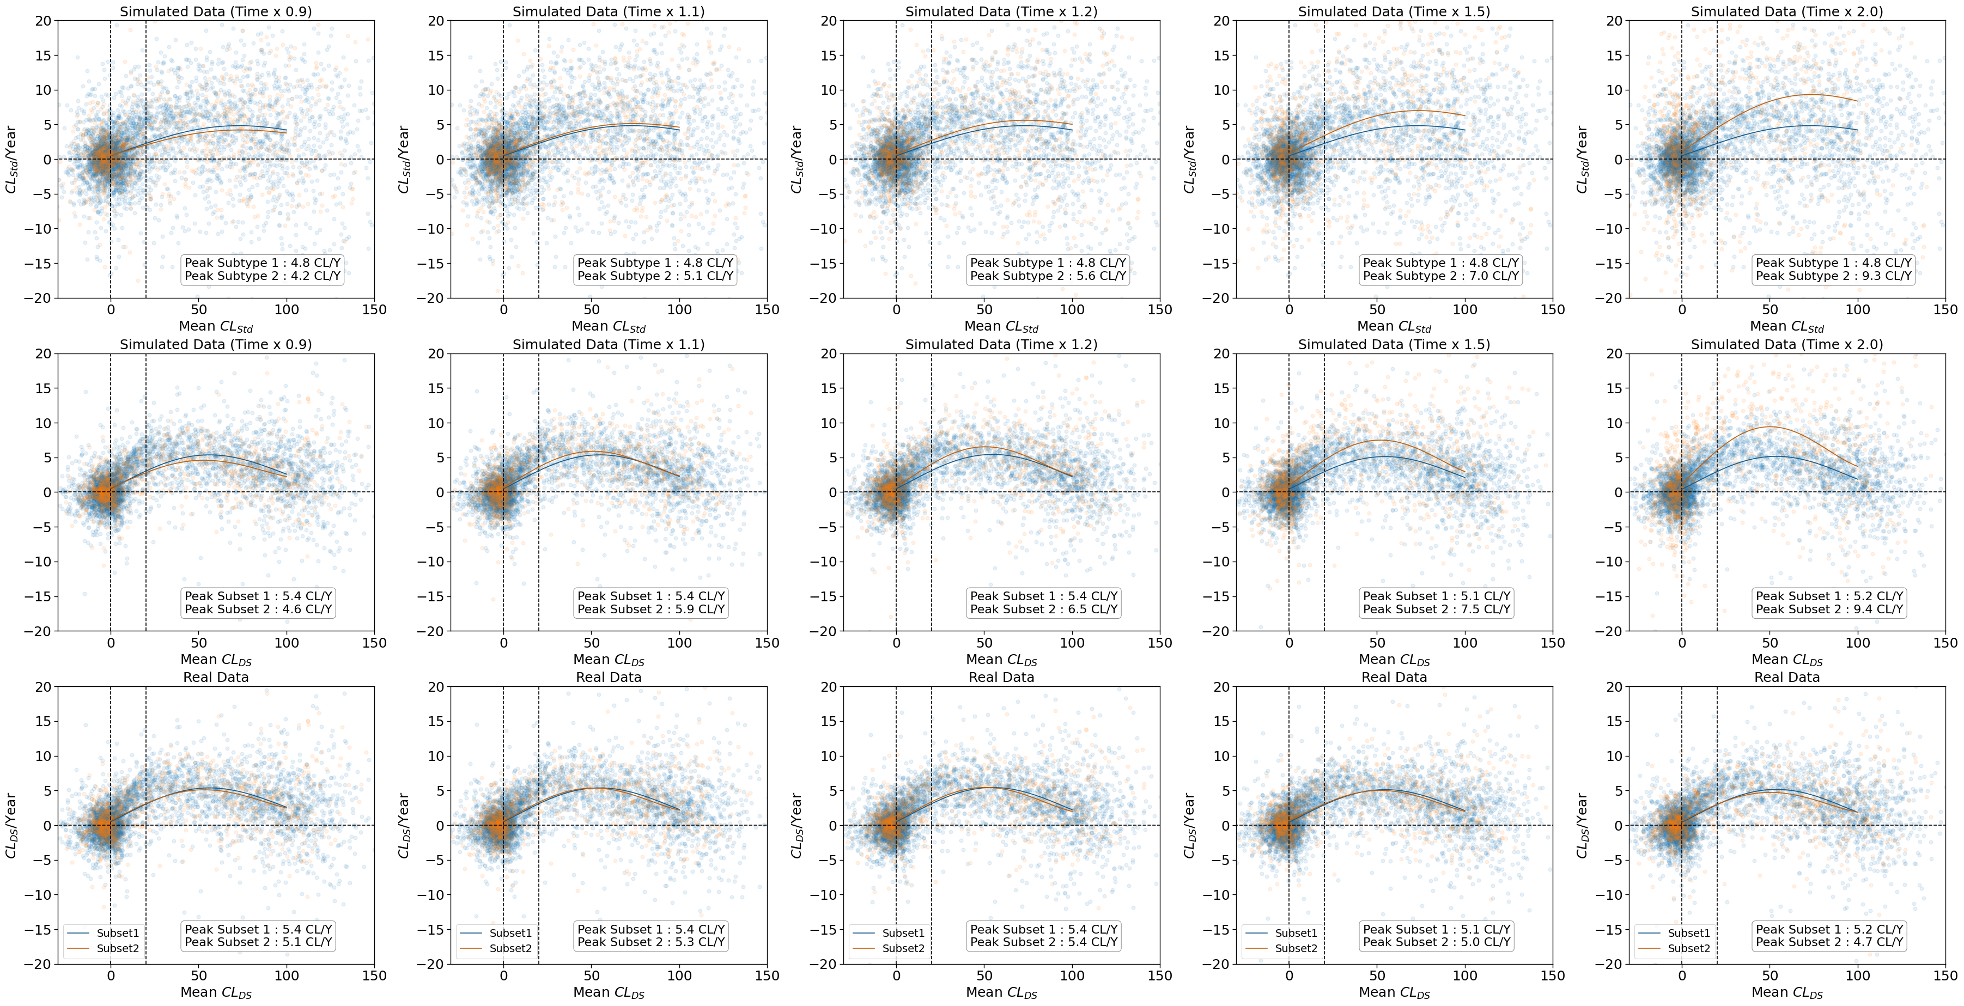
Sup Figure 19. Simulated slowed/accelerated rate of CL increase, where 20% of participants (Subset 2) in the training set are assigned a 0.9x, 1.1x, 1.2x, 1.5x and 2x increase rate of CL change before training DeepSUVR (top row). Evaluation of DeepSUVR on the out-of-fold simulated data (middle row) and on the real data (bottom row). Each curve shows a 5th order polynomial fitted to each subset, with the peak of the fitted polynomial used as an estimate of the peak rate of accumulation.

