Body mass index and healthcare costs: using genetic variants from the HUNT study as instrumental variables

Additional information

Overview of tables included in the additional information file
Table S1: Results from the one-sample 2SLS regressions for each type of healthcare cost and using three different instruments. As a sensitivity analysis, the estimates were adjusted for study period, years of data for which participants were alive and living in Norway, birth year, sex, educational level, marital status, smoking status, and urbanity. 11
Table S2: Beta coefficients and standard errors (SE) for the first- and second-stage results of the one-sample 2SLS regressions† for each type of healthcare cost, using three different instruments. The estimates were adjusted for study period (HUNT 2 or HUNT 3), years of data participants were alive and living in the country during the cost estimation period (2009-2016), sex, birth year, and the first 10 genetic principal components. 12
Table S3: Sex-specific, first- and second-stage results of the one-sample 2SLS regressions for each type of healthcare cost, using three different instruments. The estimates were adjusted for study period (HUNT 2 or HUNT 3), years of data participants were alive and living in the country during the cost estimation period (2009-2016), and birth year. 13
Table S4: Sex-specific, first- and second-stage results of the one-sample 2SLS regressions for specialist costs by type of healthcare provider, using three different instruments. The estimates were adjusted for study period (HUNT 2 or HUNT 3), years of data participants were alive and living in the country during the cost estimation period (2009-2016), and birth year. 14
Table S5: First- and second-stage results of the one-sample 2SLS regressions for GP costs with outliers excluded, using three different instruments. The estimates were adjusted for study period (HUNT 2 or HUNT 3), years of data participants were alive and living in the country during the cost estimation period (2009-2016), sex, and birth year. 15
Table S6: First- and second-stage results of the one-sample 2SLS regressions for specialist costs with the outlier excluded, using three different instruments. The estimates were adjusted for study period (HUNT 2 or HUNT 3), years of data participants were alive and living in the country during the cost estimation period (2009-2016), sex, and birth year. 15
Table S7: First- and second-stage results of the one-sample 2SLS regressions for GP- and specialist costs within families (N=29 199), using three different instruments. The estimates were adjusted for study period (HUNT 2 or HUNT 3), years of data participants were alive and living in the country during the cost estimation period (2009-2016), sex, and birth year. 16

Procedure for costing contacts without an available DRG-weight
For psychiatric and substance-abuse related contacts that did not have a registered DRG weight we used the average cost per policlinic consultation and one over-night inpatient stay for psychiatric and Interdisciplinary specialized drug treatment related contacts (Norwegian Directorate of Health, 2018). The cost of an inpatient stay was estimated by multiplying the average cost of one over-night inpatient stay with the number of days of inpatient care, and day-treatments were assumed to cost half of one over-night inpatient stay. For the years where the average costs were unavailable, we estimated the average cost for that year by KPI-adjusting the cost registered for the nearest available year. For contacts that did not have a registered DRG-weight, and that were not psychiatric or substance-abuse related contacts, we estimated the cost of this contact for a particular year based on the average cost registered for patients admitted with the same main diagnosis, or that underwent the same procedure during the same year.

Power calculations
We used the mRnd power calculator (Brion et al., 2013) to gauge the power of our effect estimates. We assumed an α=0.05, and an R² = 0.027 based on the proportion of variation in BMI explained by the GVs reported by Locke et al. (2015). We used the non-stratified OLS estimates adjusted for study period, years of data available, birth year, and sex (β_{GP} = 5.8, β_{specialist} = 44.6) (Table 3), and variances (σ² (BMI) = 19.47, σ² (GP cost) = 32 836.6, and σ² (specialist costs) =3.82*10⁷) calculated from our study sample. According to our calculations, we should be able to detect effect estimates of € 2.8 and above for GP costs, and € 97 and above for specialist costs (Supplementary information, Figure S1) given our sample of 60 786 individuals.
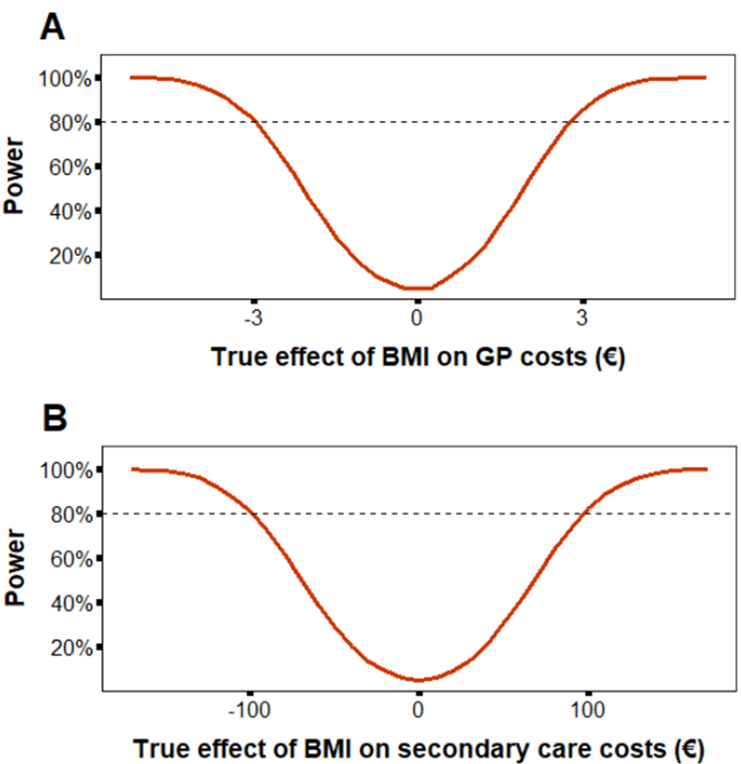
Figure S1: Plot showing the amount of power to detect the true effect of BMI on A) GP costs, and B) specialist costs. The stippled line represents the 80% power threshold.

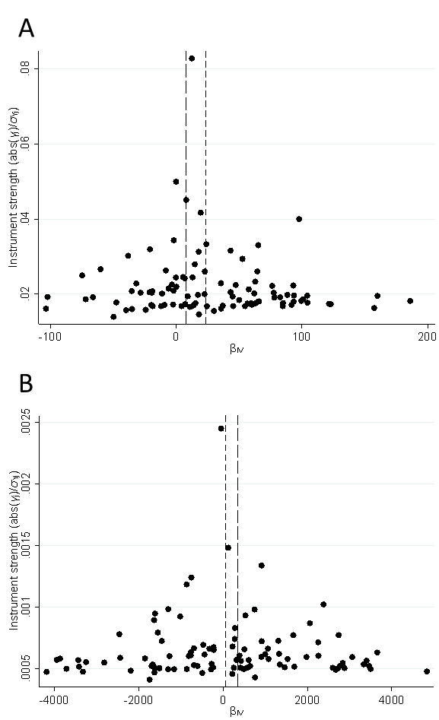
Figure S2: Funnel plots for A) GP-costs and B) specialist costs: showing the estimated Wald ratios for each individual genetic variant plotted against the strength of the association between the genetic variant and BMI.

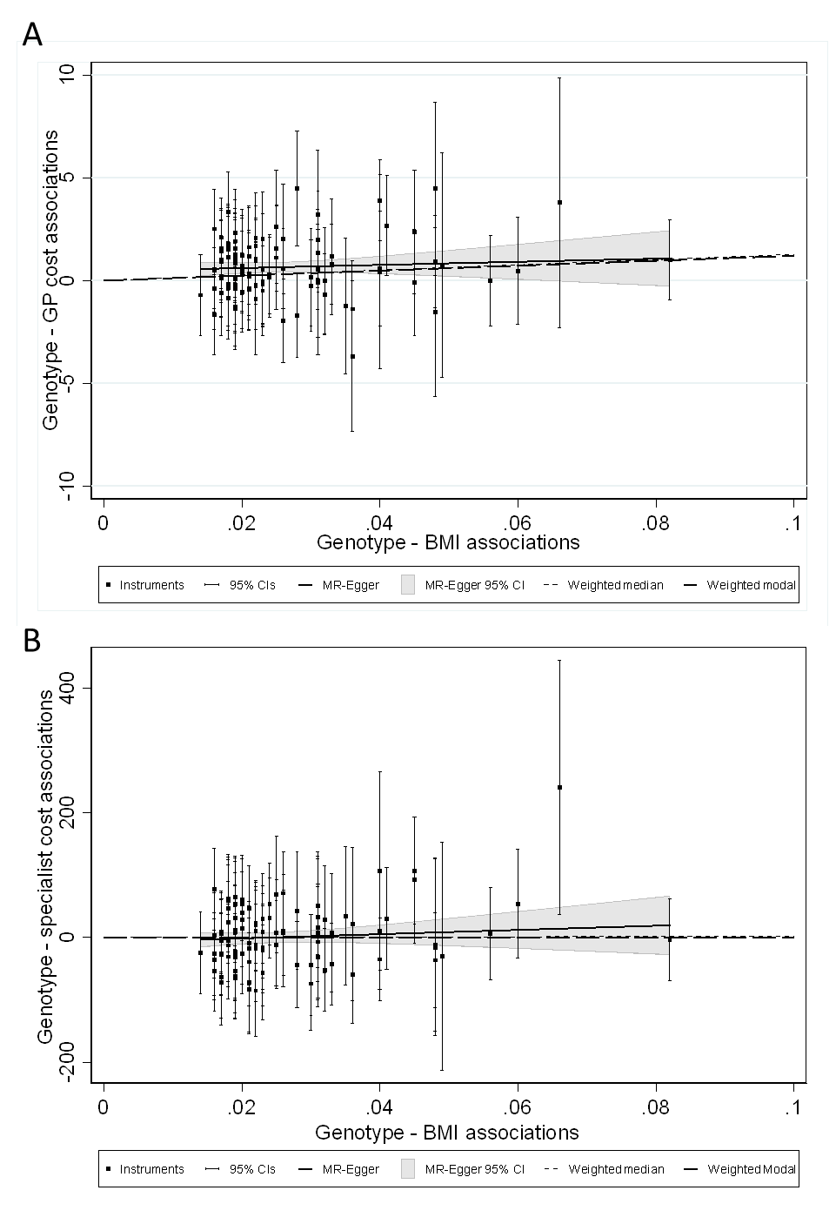
Figure S3: Association between the BMI-related genetic variants and A) GP costs, and B) specialist costs, when using the IVW, MR-Egger, weighted-median, and weighted-modal estimators.
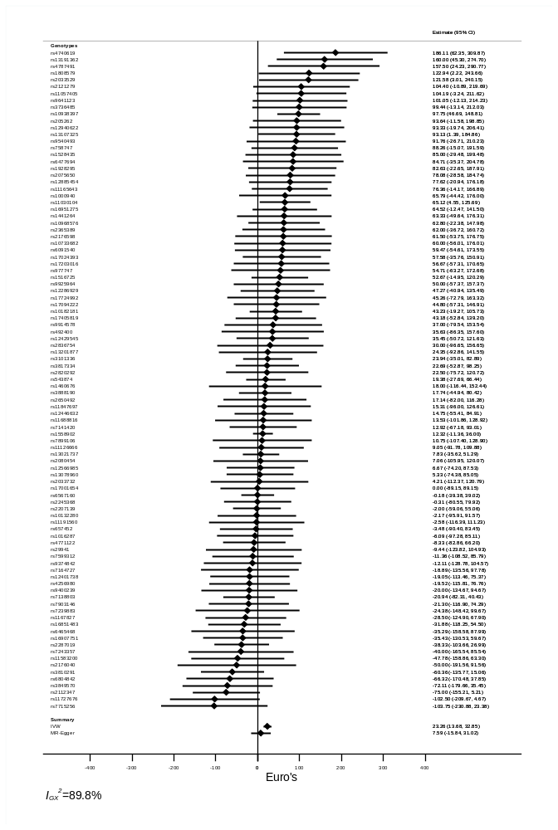
Figure S4: Forest plot showing the effect of each of the genetic variants on GP costs. The summary measures from the IVW and MR-Egger analyses are displayed at the bottom of the plot, and these are similar suggesting that bias from pleiotropy is likely to be small.
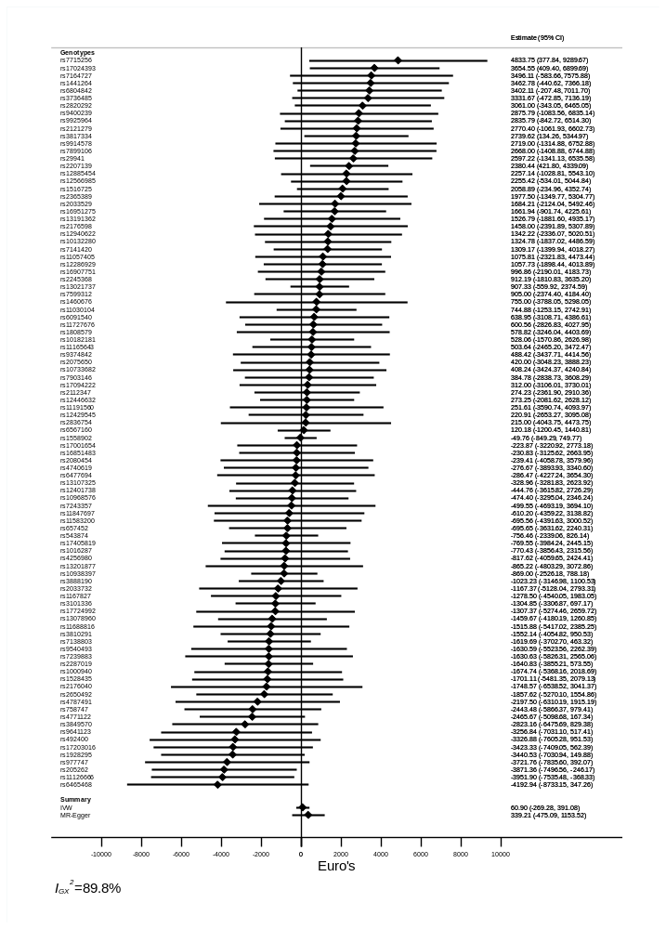
Figure S5: Forest plot showing the effect of each of the genetic variants on specialist costs. The summary measures from the IVW and MR-Egger analyses are displayed at the bottom of the plot, and these are similar suggesting that bias from pleiotropy is likely to be small.
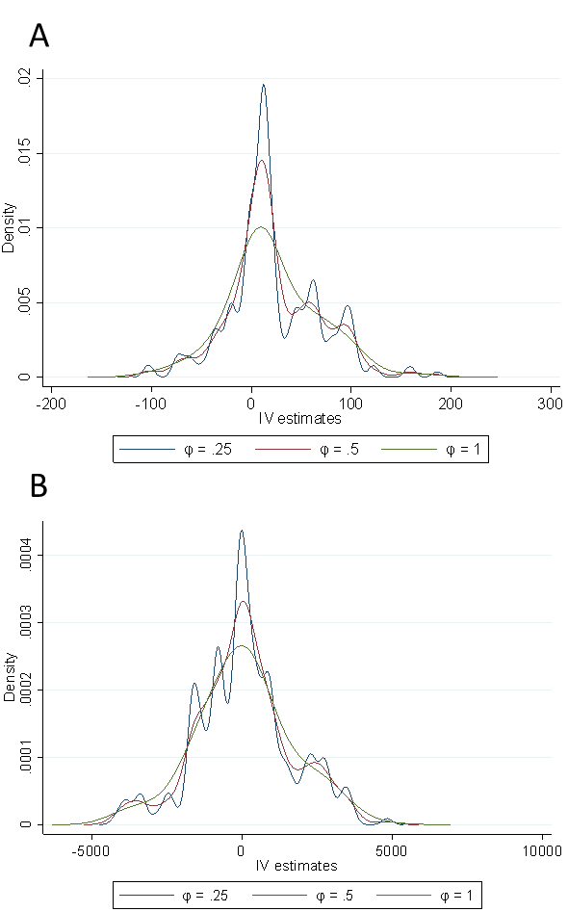
Figure S6: Density plots for A) GP-costs and B) specialist costs with different bandwidth (smoothing parameter) values ($φ$).

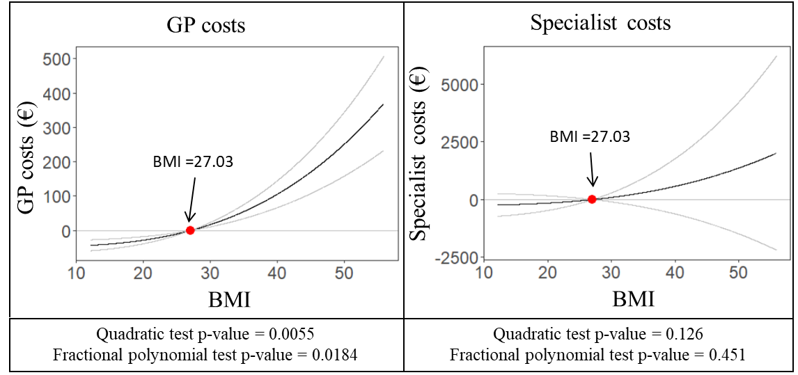
Figure S7: Non-linear IV-models estimating GP costs (left) and specialist costs (right). The gradient at each point on the curve is the localised average causal effect. The red point indicates mean BMI, and the grey lines represent 95% confidence intervals.

Table S1: Results from the one-sample 2SLS regressions for each type of healthcare cost and using three different instruments. As a sensitivity analysis, the estimates were adjusted for study period, years of data for which participants were alive and living in Norway, birth year, sex, educational level, marital status, smoking status, and urbanity.
Type of healthcare cost | Instrument | 2SLS First-stage Beta (SE) | 2SLS Second-stage  Beta € (SE) | F-stat.
GP costs | Unweighted GRS | 0.1 (0.003)*** | 6.1 (1.181)*** | 1128.6
 | Weighted GRS | 4.0 (0.104)*** | 5.2 (1.031)*** | 1491.6
 | FTO & MC4R | 0.4 (0.025)*** &  0.3 (0.028)*** | 1.2 (2.163) | 168.3
Specialist costs | Unweighted GRS | 0.1 (0.003)*** | -1.8 (40.467) | 1128.6
Specialist costs | Weighted GRS | 4.0 (0.104)*** | 15.4 (35.288) | 1491.6
 | FTO & MC4R | 0.4 (0.025)*** &  0.3 (0.028)*** | 9.7 (73.589) | 168.3
Total (GP + secondary care) costs | Unweighted GRS | 0.1 (0.003)*** | 4.3 (40.792) | 1128.6
Total (GP + secondary care) costs | Weighted GRS | 4.0 (0.104)*** | 20.6 (35.572) | 1491.6
Total (GP + secondary care) costs | FTO & MC4R | 0.4 (0.025)*** &  0.3 (0.028)*** | 10.8 (74.189) | 168.3
*** (p-value <0.001), ** (p-value <0.01), * (p-value<0.05), and · (p-value <0.1)

Table S2: Beta coefficients and standard errors (SE) for the first- and second-stage results of the one-sample 2SLS regressions† for each type of healthcare cost, using three different instruments. The estimates were adjusted for study period (HUNT 2 or HUNT 3), years of data participants were alive and living in the country during the cost estimation period (2009-2016), sex, birth year, and the first 10 genetic principal components.
Type of healthcare cost | Instrument | 2SLS First-stage Beta instrument (SE) | 2SLS Second-stage Beta BMI (SE) €
 |  |  |  | F-stat.
General practitioner costs | Unweighted GRS | 0.1 (0.003)*** | 6.8 (1.186)*** | 1117.3
General practitioner costs | Weighted GRS | 4.1 (0.105)*** | 5.7 (1.034)*** | 1478.2
General practitioner costs | FTO &  MC4R | 0.4 (0.025)*** &  0.3 (0.028)*** | 1.8 (2.133) | 172.0
Specialist costs | Unweighted GRS | 0.1 (0.003)*** | 1.1 (40.082) | 1117.3
Specialist costs | Weighted GRS | 4.0 (0.105)*** | 13.9 (34.940) | 1478.2
Specialist costs | FTO &  MC4R | 0.4 (0.025)*** &  0.3 (0.028)*** | -2.4 (71.793) | 172.0
Total costs | Unweighted GRS | 0.1 (0.003)*** | 7.9 (40.411) | 1117.3
Total costs | Weighted GRS | 4.0 (0.105)*** | 19.5 (35.228) | 1478.2
Total costs | FTO &  MC4R | 0.4 (0.025)*** &  0.3 (0.028)*** | -0.5 (72.392) | 172.0
*** (p-value <0.001), ** (p-value <0.01), * (p-value<0.05), and · (p-value <0.1)

Table S3: Sex-specific, first- and second-stage results of the one-sample 2SLS regressions for each type of healthcare cost, using three different instruments. The estimates were adjusted for study period (HUNT 2 or HUNT 3), years of data participants were alive and living in the country during the cost estimation period (2009-2016), and birth year.
Type of healthcare cost |  | Instrument | 2SLS First-stage  Beta (SE) | 2SLS Second-stage  Beta (SE) | F-stat.
Type of healthcare cost | Sex
GP | Male | Unweighted GRS | 0.1 (0.003)*** | 7.6 (1.790)*** | 591.3
GP | Male | Weighted GRS | 3.6 (0.133)*** | 6.4 (1.589)*** | 754.3
GP | Male | FTO &  MC4R | 0.4 (0.032)*** &  0.2 (0.036)*** | -3.1 (3.528)· | 79.0
 | Female | Unweighted GRS | 0.1 (0.004)*** | 6.1 (2.717)*** | 567.5
 |  | Weighted GRS | 4.3 (0.154)*** | 5.4 (1.328)*** | 777.1
 |  | FTO &  MC4R | 0.4 (0.038)***&  0.4 (0.043)*** | 4.7 (2.629) | 97.5
Specialist | Male | Unweighted GRS | 0.1 (0.003)*** | 54.2 (68.859) | 591.3
Specialist | Male | Weighted GRS | 3.6 (0.133)*** | 92.9 (61.159) | 754.3
Specialist | Male | FTO &  MC4R | 0.4 (0.032)*** &  0.2 (0.036)*** | 136.0 (132.365) | 79.0
 | Female | Unweighted GRS | 0.1 (0.004)*** | -32.6 (47.733) | 567.5
 |  | Weighted GRS | 4.3 (0.154)*** | -39.5 (40.938) | 777.1
 |  | FTO &  MC4R | 0.4 (0.038)***&  0.4 (0.043)*** | -80.9 (81.286) | 97.5
Total | Male | Unweighted GRS | 0.1 (0.003)*** | 61.8 (69.320) | 591.3
Total | Male | Weighted GRS | 3.6 (0.133)*** | 99.3 (61.567) | 175.3
Total | Male | FTO &  MC4R | 0.4 (0.032)*** &  0.2 (0.036)*** | 132.9 (133.209) | 79.0
 | Female | Unweighted GRS | 0.1 (0.004)*** | -26.4 (48.195) | 567.5
 |  | Weighted GRS | 4.3 (0.154)*** | -34.1 (41.335) | 777.1
 |  | FTO &  MC4R | 0.4 (0.038)***&  0.4 (0.043)*** | -76.2 (82.077) | 97.5
*** (p-value <0.001), ** (p-value <0.01), * (p-value<0.05), and · (p-value <0.1)

Table S4: Sex-specific, first- and second-stage results of the one-sample 2SLS regressions for specialist costs by type of healthcare provider, using three different instruments. The estimates were adjusted for study period (HUNT 2 or HUNT 3), years of data participants were alive and living in the country during the cost estimation period (2009-2016), and birth year.
Specialist healthcare provider | Sex | Instrument | 2SLS First-stage Beta (SE) |  | 2SLS Second-stage  Beta (SE) |  | F-stat
Somatic hospital | Both | Unweighted GRS | 0.1 (0.003)*** |  | 21.2 (33.086) |  | 1119.4
Somatic hospital |  | Weighted GRS | 4.0 (0.105)*** |  | 19.5 (25.863) |  | 1481.4
Somatic hospital |  | FTO &  MC4R | 0.4 (0.025)*** &  0.3 (0.028)*** |  | 4.7 (59.220) |  | 172.6
Somatic hospital | Male | Unweighted GRS | 0.1 (0.003)*** |  | 92.1 (61.369) |  | 591.3
Somatic hospital |  | Weighted GRS | 3.7 (0.133)*** |  | 96.8 (54.495)· |  | 754.3
Somatic hospital |  | FTO &  MC4R | 0.4 (0.032)*** &  0.2 (0.036)*** |  | 127.4 (117.931) |  | 79.0
Somatic hospital | Female | Unweighted GRS | 0.1 (0.004)*** |  | -29.2 (35.708) |  | 567.5
Somatic hospital |  | Weighted GRS | 4.3 (0.154)*** |  | -41.0 (30.647) |  | 777.1
Somatic hospital |  | FTO &  MC4R | 0.4 (0.038)*** &  0.4 (0.043)*** |  | -64.8 (60.823) |  | 97.5
Contracted provider of somatic and psychological healthcare | Both | Unweighted GRS | 0.1 (0.003)*** |  | -3.9 (4.350) |  | 1119.4
Contracted provider of somatic and psychological healthcare |  | Weighted GRS | 4.0 (0.105)*** |  | -1.2 (3.8794) |  | 1481.4
Contracted provider of somatic and psychological healthcare |  | FTO &  MC4R | 0.4 (0.025)*** &  0.3 (0.028)*** |  | 3.0 (7.782) |  | 172.6
Contracted provider of somatic and psychological healthcare | Male | Unweighted GRS | 0.1 (0.003)*** |  | 2.3 (5.593) |  | 591.3
Contracted provider of somatic and psychological healthcare |  | Weighted GRS | 3.7 (0.133)*** |  | 3.7 (4.966) |  | 754.3
Contracted provider of somatic and psychological healthcare |  | FTO &  MC4R | 0.4 (0.032)*** &  0.2 (0.036)*** |  | 9.7 (10.749) |  | 79.0
Contracted provider of somatic and psychological healthcare | Female | Unweighted GRS | 0.1 (0.004)*** |  | -8.4 (6.342) |  | 567.5
Contracted provider of somatic and psychological healthcare |  | Weighted GRS | 4.3 (0.154)*** |  | -4.4 (5.431) |  | 777.1
Contracted provider of somatic and psychological healthcare |  | FTO &  MC4R | 0.4 (0.038)*** &  0.4 (0.043)*** |  | -0.2 (10.745) |  | 97.5
Psychiatric care | Both | Unweighted GRS | 0.1 (0.003)*** |  | 1.4 (16.370) |  | 1119.4
Psychiatric care |  | Weighted GRS | 4.0 (0.105)*** |  | 4.1 (14.280) |  | 1481.4
Psychiatric care |  | FTO &  MC4R | 0.4 (0.025)*** &  0.3 (0.028)*** |  | 15.6 (29.298) |  | 172.6
Psychiatric care | Male | Unweighted GRS | 0.1 (0.003)*** |  | -11.8 (20.350) |  | 591.3
Psychiatric care |  | Weighted GRS | 3.7 (0.133)*** |  | 3.9 (18.061) |  | 754.3
Psychiatric care |  | FTO &  MC4R | 0.4 (0.032)*** &  0.2 (0.036)*** |  | 28.7 (39.102) |  | 79.0
Psychiatric care | Female | Unweighted GRS | 0.1 (0.004)*** |  | 11.4 (24.186) |  | 567.5
Psychiatric care |  | Weighted GRS | 4.3 (0.154)*** |  | 9.3 (20.732) |  | 777.1
Psychiatric care |  | FTO &  MC4R | 0.4 (0.038)*** &  0.4 (0.043)*** |  | 4.8 (41.025) |  | 97.5
Interdisciplinary Specialized Drug Treatment | Both | Unweighted GRS | 0.1 (0.003)*** | -5.1 (7.304) |  | 1119.4
Interdisciplinary Specialized Drug Treatment |  | Weighted GRS | 4.0 (0.105)*** |  | -2.1 (6.370) |  | 1481.4
Interdisciplinary Specialized Drug Treatment |  | FTO &  MC4R | 0.4 (0.025)*** &  0.3 (0.028)*** |  | -20.6 (13.114) |  | 172.6
 | Male | Unweighted GRS | 0.1 (0.003)*** |  | -11.8 (13.625) |  | 591.3
 |  | Weighted GRS | 3.7 (0.133)*** |  | -4.4 (12.093) |  | 754.3
 |  | FTO &  MC4R | 0.4 (0.032)*** &  0.2 (0.036)*** |  | -21.3 (26.188) |  | 79.0
 | Female | Unweighted GRS | 0.1 (0.004)*** |  | 0.5 (7.821) |  | 567.5
 |  | Weighted GRS | 4.3 (0.154)*** |  | -0.6 (6.705) |  | 777.1
 |  | FTO &  MC4R | 0.4 (0.038)*** &  0.4 (0.043)*** |  | -20.5 (13.362) |  | 97.5
*** (p-value <0.001), ** (p-value <0.01), * (p-value<0.05), and · (p-value <0.1)

Table S5: First- and second-stage results of the one-sample 2SLS regressions for GP costs with outliers excluded, using three different instruments. The estimates were adjusted for study period (HUNT 2 or HUNT 3), years of data participants were alive and living in the country during the cost estimation period (2009-2016), sex, and birth year.
 | Instrument | 2SLS First Stage  Beta (SE) | 2SLS Second-stage  Beta (SE)
Outliers excluded | Instrument | 2SLS First Stage  Beta (SE) | 2SLS Second-stage  Beta (SE) | F-stat.
rs4740619 | Unweighted GRS | 0.1 (0.003)*** | 6.2 (1.181)*** | 1113.2
 | Weighted GRS | 4.1 (0.105)*** | 5.4 (1.029)*** | 1476.1
rs13191362 | Unweighted GRS | 0.1 (0.003)*** | 6.4 (1.182)*** | 1112.5
 | Weighted GRS | 4.0 (0.105)*** | 5.4 (1.030)*** | 1472.1
rs4787491 | Unweighted GRS | 0.1 (0.003)*** | 6.3 (1.182)*** | 1111.7
 | Weighted GRS | 4.0 (0.105)*** | 5.5 (1.030)*** | 1473.6
rs4740619, rs13191362, & rs4787491 | Unweighted GRS | 0.1 (0.003)*** | 5.7 (1.193)*** | 1091.8
rs4740619, rs13191362, & rs4787491 | Weighted GRS | 4.0 (0.106)*** | 5.0 (1.037)*** | 1453.0
*** (p-value <0.001), ** (p-value <0.01), * (p-value<0.05), and · (p-value <0.1)

Table S6: First- and second-stage results of the one-sample 2SLS regressions for specialist costs with the outlier excluded, using three different instruments. The estimates were adjusted for study period (HUNT 2 or HUNT 3), years of data participants were alive and living in the country during the cost estimation period (2009-2016), sex, and birth year.
Outliers excluded | Instrument | 2SLS First Stage  Beta (SE) | 2SLS Second-stage  Beta (SE) | F-stat.
rs7715256 | Unweighted GRS | 0.1 (<0.003)*** | -8.3 (40.195) | 1114.6
 | Weighted GRS | 4.0 (0.105)*** | 9.4 (35.033) | 1474.5

Table S7: First- and second-stage results of the one-sample 2SLS regressions for GP- and specialist costs within families (N=29 199), using three different instruments. The estimates were adjusted for study period (HUNT 2 or HUNT 3), years of data participants were alive and living in the country during the cost estimation period (2009-2016), sex, and birth year.
Type of healthcare cost | Instrument | 2SLS First-stage | 2SLS Second-stage
Type of healthcare cost | Instrument | Beta (SE) | Beta (SE) €
GP | Unweighted GRS | 0.1 (0.006)*** | 2.7 (2.458)
GP | Weighted GRS | 4.3 (0.235)*** | 1.7 (2.185)
GP | FTO &  MC4R | 0.4 (0.056)*** &  0.4 (0.064)*** | 0.8 (3.970)
Specialist | Unweighted GRS | 0.1 (0.006)*** | -65.6 (91.458)
Specialist | Weighted GRS | 4.3 (0.235)*** | -83.7 (81.239)
Specialist | FTO &  MC4R | 0.4 (0.056)*** &  0.4 (0.064)*** | -155.9 (147.701)
*** (p-value <0.001), ** (p-value <0.01), * (p-value<0.05), and · (p-value <0.1)

Figure S8: Simple overview of the number of contacts made by males and females to GPs (left) and somatic hospital care (right) for different diagnoses, during 2012 in Norway, based on aggregated data from Statistics Norway (Statistics Norway; Statistics Norway). Females generally had higher number of contacts, but males had more GP consultations due to heart disease, diabetes, cancer, administrative contacts, and accidents and injuries, and had more somatic hospital visits due to injuries and poisonings, infectious and parasitic diseases, diseases of the respiratory system, diseases of the ear, and diseases of the circulatory system.

References
Brion, M.-J.A., Shakhbazov, K., & Visscher, P.M. (2013). Calculating statistical power in Mendelian randomization studies. International Journal of Epidemiology, 42, 1497-1501.DOI: 10.1093/ije/dyt179
Locke, A.E., Kahali, B., Berndt, S.I., Justice, A.E., Pers, T.H., Day, F.R., et al. (2015). Genetic studies of body mass index yield new insights for obesity biology. Nature, 518, 197-206.DOI: 10.1038/nature14177
Norwegian Directorate of Health. (2018). Hovedresultater Samdata Spesialisthelsetjenesten 2013-2017.
Statistics Norway. Tabell 10141: Konsultasjoner hos fastlegen, etter alder, kjønn og diagnose 2012 - 2018.
Statistics Norway. Tabell 10261: Pasienter, behandlinger og liggedager ved somatiske sykehus, etter kjønn, alder og diagnose (F) 2012 - 2018.

