Supplementary Information

Uphill energy transfer mechanism for photosynthesis in the Antarctic alga

Makiko Kosugi^{1,2,3}*, Masato Kawasaki^{4,5}*, Yutaka Shibata⁶*, Kojiro Hara⁷, Shinichi Takaichi⁸, Toshio Moriya⁴, Naruhiko Adachi⁴, Yasuhiro Kamei^{9,10}, Yasuhiro Kashino¹¹, Sakae Kudoh^{12,13}, Hiroyuki Koike³, Toshiya Senda^{4,5,14*}

¹Astrobiology Center, National Institutes of Natural Science, 2-21-1 Osawa, Mitaka, Tokyo 181-8588, Japan.
²National Astronomical Observatory of Japan, 2-21-1 Osawa, Mitaka, Tokyo 181-8588, Japan
³Department of Biological Sciences, Faculty of Science and Engineering, Chuo University, 1-13-27 Kasuga, Bunkyo-ku, Tokyo 112-8551, Japan.
⁴Structural Biology Research Center, Photon Factory, Institute of Materials Structure Science, High Energy Accelerator Research Organization (KEK), 1-1 Oho, Tsukuba, Ibaraki 305-0801, Japan.
⁵Department of Materials Structure Science, School of High Energy Accelerator Science, The Graduate University of Advanced Studies (Soken-dai), 1-1 Oho, Tsukuba, Ibaraki 305-0801, Japan.
⁶Department of Chemistry, Graduate School of Science, Tohoku University, 6-3 Aza Aoba Aramaki, Aoba-ku, Sendai 980-8578, Japan.
⁷Department of Biological Production, Akita Prefectural University, 241-438 Kaidobata-nishi, Shimoshinjo-nakano, Akita, 010-0195, Japan.
⁸Department of Molecular Microbiology, Tokyo University of Agriculture, 1-1 Sakuragaoka, Setagaya-ku, Tokyo 156-8502, Japan.
⁹National Institute for Basic Biology, National Institutes of Natural Sciences, 38 Nishigonaka, Myodaiji, Okazaki, Aichi 444-8585, Japan.
¹⁰Department of Basic Biology, School of Life Sciences, SOKENDAI (The Graduate University for Advanced Studies), 38 Nishigonaka, Myodaiji, Okazaki, Aichi 444-8585, Japan.
¹¹Graduate School of Science, University of Hyogo, 3-2-1 Kohto, Kamigohri, Ako-gun, Hyogo 678-1297, Japan.
¹²National Institute of Polar Research, Research Organization of Information and Systems, 10-3 Midori-cho, Tachikawa, Tokyo 190-8518, Japan.
¹³Department of Polar Science, School of Multidisciplinary Science, SOKENDAI (The Graduate University for Advanced Studies), 10-3 Midori-cho, Tachikawa, Tokyo 190-8518, Japan.
¹⁴Faculty of Pure and Applied Sciences, University of Tsukuba, 1-1-1 Tennodai, Tsukuba, Ibaraki 305-8572, Japan

*These authors contributed equally to this work.

Supplementary Tables

Supplementary Table 1. Statics of single-particle cryo-EM data and atomic model refinement
 | P. crispa fr-LHC
Data collection
Microscope | FEI Talos Arctica
Voltage [kV] | 200
Detector | Falcon 3EC
Magnification | 92 k
Pixel size [Å/pixel] | 1.13
Automation software | EPU
Total exposure [e-/Å2] | 50
Exposure rate [e-/Å2 frame] | 1.00
Number of frames | 50
Defocus range [µm] | 1.0 to 3.0
Micrographs | 1,555
Number of particles for Class2D | 696,095
Number of particles for Class3D | 654,477
Number of particles for Refine3D | 99,510
Symmetry imposed | C11
Map resolution [Å]  FSC threshold | 3.13  0.143
Map resolution range [Å] | 2.93 – 12.06
Model refinement
Program | phenix.real_space_refine
Resolution limit | 3.13
Number of chains | 11
Number of residues | 2,651
Number of the non-hydrogen atoms | 29,271
RMS bond length | 0.014
RMS bond angle | 1.598
Ramachandran plot
Preferred [%] | 88.70
Allowed [%] | 11.30
Outliers [%] | 0.00
MolProbity score
Clash score | 14.73
Rotamer outliers [%] | 6.74
Overall score | 2.89
EMDB/PDB codes | EMD-31486/7F78

Supplementary Table 2. The transition dipole moment (in debye) of the lower mixed excited states of the strongly interacting Chl pairs in Extended data Table 2.

 | μ_{x} | μ_{y} | μ_{z} |  | μ_{x} | μ_{y} | μ_{z} | |μ₋|
Chl601 | 2.72 | −1.32 | −3.47 | Chl602 | −3.78 | −2.01 | −1.67 | 4.8
Chl603 | 4.35 | 0.40 | −1.45 | Chl609 | −4.19 | −1.90 | 0.02 | 6.3
Chl603 | 4.35 | 0.40 | −1.45 | Chl708 | 0.85 | −0.37 | 4.51 | 4.3
Chl609 | −4.19 | −1.90 | 0.02 | Chl708 | 0.85 | −0.37 | 4.51 | 4.9
Chl610 | 3.53 | 2.57 | −1.45 | Chl612 | 4.28 | −1.26 | −1.13 | 5.9
Chl611 | 4.43 | 0.83 | 0.93 | Chl612 | 4.28 | −1.26 | −1.13 | 6.2
Chl613 | −0.85 | 3.16 | 3.24 | Chl614 | −3.60 | 2.86 | −0.11 | 3.1
Chl609 | -4.19 | −1.90 | 0.02 | Chl611’ | 3.28 | 3.09 | 0.93 | 6.4
Chl708 | 0.85 | −0.37 | 4.51 | Chl611’ | 3.28 | 3.09 | 0.93 | 3.9
Chl708 | 0.85 | -0.37 | 4.51 | Chl614’ | −4.58 | 0.47 | −0.11 | 4.1

Supplementary Note

Probability of EET from Pc-frLHC to bound acceptor complexes
The exit probability of EET $P_{exit}$ to neighboring complexes can be estimated according to the formula
$$P_{exit}=\frac{k_{exit}}{k_{exit}+k_{deexcitation}}.$$

$k_{exit}$ and $k_{deexcitation}$ are the rate constants of the exit of the exciton to acceptor complexes and the de-excitation, respectively. $k_{deexcitation}$ is expressed by the inverse of the fluorescence lifetime of approximately 2 ns. If we assume the equilibrium of EET in Pc-frLHC, $k_{exit}$ can be written as
$$k_{exit}=P_{exit Chl}×k_{ES exit}×\left(N_{exit}/11\right)$$
Here, $P_{exit Chl}$ is the probability of excitation energy residing at the exit-site Chl of each subunit, and $k_{ES exit}$ is the rate constant of the elementary step of the exciton exit corresponding to the EET step from the exit-site Chl to the pigments in the neighboring acceptor complex. $N_{exit}$ is the number of acceptor complexes bound to Pc-frLHC. $P_{exit Chl}$ is estimated with the Boltzmann factor,
$$P_{exit Chl}=\frac{\exp\left(\frac{-⊿E}{k_{B}T}\right)}{N_{bulk}\exp\left(\frac{-⊿E}{k_{B}T}\right)+N_{LWC}},$$

where $N_{bulk}$ and $N_{LWC}$ are the numbers of bulk Chls and LWC within a subunit, respectively. The energy gap $⊿E$ between LWC at 708 nm and the bulk Chls is expressed as

$$⊿E=hc×\left(\frac{1}{680 nm}-\frac{1}{708 nm}\right)=1.16×{10}^{-20} J \left(=6.96 kJ {mol}^{-1}\right).$$

The ratio $N_{bulk}:N_{LWC}$ can be estimated to be 4:1 based on the area ratio of their absorption bands (Fig. 1d). It should be noted that the probability of uphill EET is fourfold enhanced by the entropic effect.

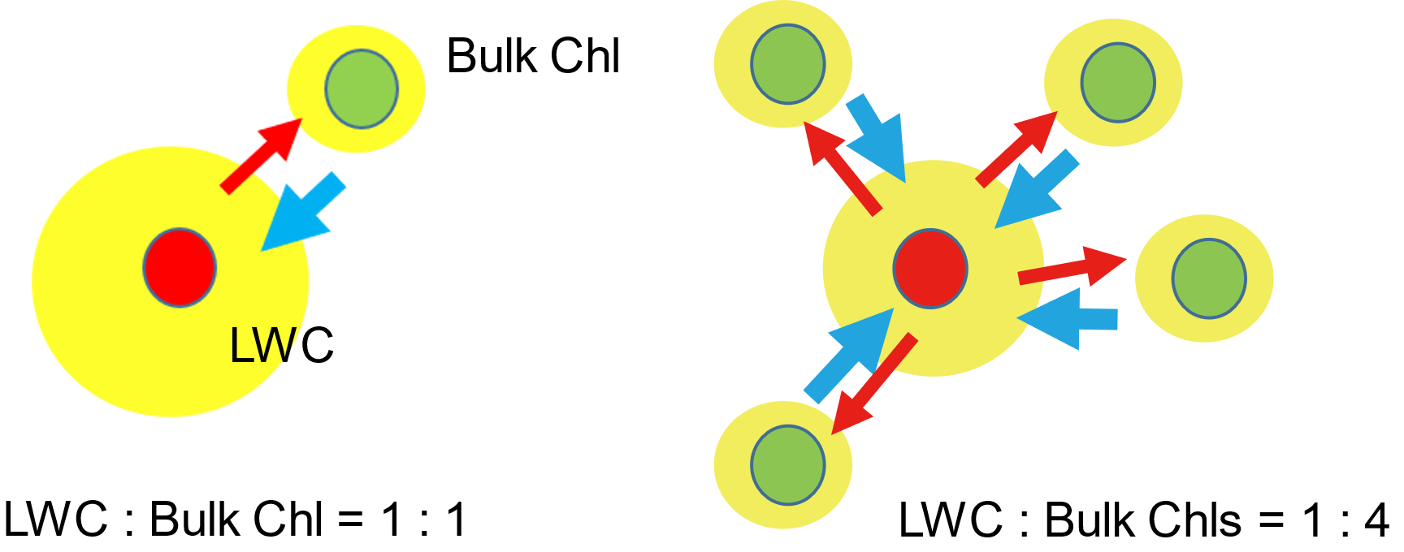

Since each subunit binds 10 Chl a, we can estimate $N_{bulk}=8$ and $N_{LWC}=2$. At 5°C, the value of $P_{exit Chl}$ is estimated to be ca. 0.02. Finally, we obtain an expression for $P_{exit}$,

$$P_{exit}≈\frac{0.02×k_{ES exit} [{ns}^{-1}]×\left(N_{exit}/11\right)}{0.02×k_{ES exit} [{ns}^{-1}]×\left(N_{exit}/11\right)+0.5 [{ns}^{-1}]}.$$

If we assume a likely time constant of 1 ps for the EET from the exit Chl to the bound acceptor ($k_{ES exit}=$1000 [ns⁻¹]), the exit probability of EET $P_{exit}$ reaches almost 80% even if only one acceptor complex is bound. When five acceptor complexes are bound, $P_{exit}$ reaches 95%.

