Table S1. Association of excess adiposity (measured by high BMI and high WC) at baseline with systolic hypertension incidence and resolution by age group.
Status at baseline | Incidence,  OR (95% CI) | Resolution,  OR (95% CI)
High BMI Versus Normal BMI
3-17 years | 13.98 (5.54, 34.70) | -
18-40 years | 4.19 (3.59, 4.87) | 0.45 (0.31, 0.64)
41-60 years | 1.99 (1.89, 2.10) | 0.79 (0.71, 0.87)
61-80 years | 1.55 (1.45, 1.66) | 0.72 (0.67, 0.79)
1-SD increase in BMI
3-17 years | 7.85 (5.33, 11.56) | -
18-40 years | 2.39 (2.25, 2.53) | 0.81 (0.71, 0.93)
41-60 years | 1.75 (1.71, 1.79) | 0.68 (0.65, 0.72)
61-80 years | 1.55 (1.51, 1.60) | 0.67 (0.64, 0.69)
High WC Versus Normal WC
3-17 years | 3.14 (1.75, 5.20) | -
18-40 years | 2.15 (1.72, 2.67) | 0.71 (0.47, 1.05)
41-60 years | 1.79 (1.69, 1.90) | 0.84 (0.75, 0.93)
61-80 years | 1.39 (1.30, 1.49) | 0.67 (0.62, 0.73)
1-SD increase in WC
3-17 years | 24.5 (13.2, 51.6) | -
18-40 years | 2.67 (2.52, 2.83) | 0.99 (0.87, 1.12)
41-60 years | 1.77 (1.73, 1.81) | 0.72 (0.68, 0.75)
61-80 years | 1.47 (1.43, 1.51) | 0.71 (0.68, 0.73)
Note: Model adjusted for baseline SBP, baseline DBP, sex, survey year, nationality, education, region, smoking, drinking, physical activity and follow-up years.
Abbreviations: OR, odd ratio; CI, confidence incidence; SD, standard deviation; BMI, body mass index; WC, waist circumference.

Table S2. Association of excess adiposity (measured by high BMI and high WC) at baseline with diastolic hypertension incidence and resolution by age group.
Status at baseline | Incidence,  OR (95% CI) | Resolution,  OR (95% CI)
High BMI Versus Normal BMI
3-17 years | 1.12 (0.68, 1.74) | 0.97 (0.29, 3.07)
18-40 years | 2.33 (2.16, 2.51) | 0.84 (0.71, 1.01)
41-60 years | 2.00 (1.93, 2.08) | 0.63 (0.59, 0.67)
61-80 years | 1.87 (1.74, 2.02) | 0.61 (0.56, 0.67)
1-SD increase in BMI
3-17 years | 1.37 (1.21, 1.56) | 0.76 (0.63, 0.92)
18-40 years | 1.83 (1.78, 1.88) | 0.86 (0.81, 0.91)
41-60 years | 1.77 (1.74, 1.80) | 0.74 (0.72, 0.76)
61-80 years | 1.60 (1.55, 1.65) | 0.65 (0.62, 0.68)
High WC Versus Normal WC
3-17 years | 1.34 (0.47, 2.96) | -
18-40 years | 2.18 (1.98, 2.39) | 0.63 (0.50, 0.79)
41-60 years | 1.48 (1.42, 1.55) | 0.73 (0.68, 0.78)
61-80 years | 1.66 (1.54, 1.79) | 0.53 (0.48, 0.58)
1-SD increase in WC
3-17 years | 1.39 (1.21, 1.59) | -
18-40 years | 2.02 (1.96, 2.07) | 0.95 (0.90, 1.01)
41-60 years | 1.80 (1.77, 1.83) | 0.80 (0.78, 0.82)
61-80 years | 1.50 (1.46, 1.55) | 0.72 (0.69, 0.75)
Note: Model adjusted for baseline SBP, baseline DBP, sex, survey year, nationality, education, region, smoking, drinking, physical activity and follow-up years.
Abbreviations: OR, odd ratio; CI, confidence incidence; SD, standard deviation; BMI, body mass index; WC, waist circumference.

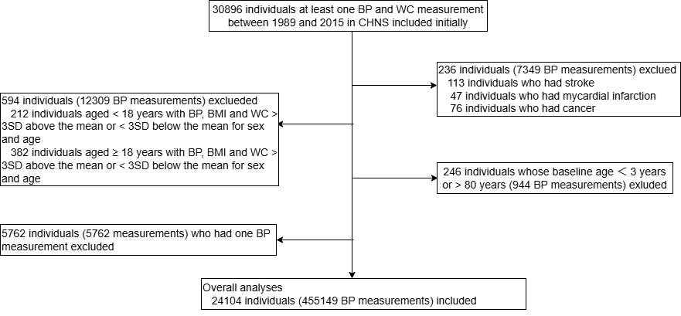
Figure S1. Flowchart of participant selection.

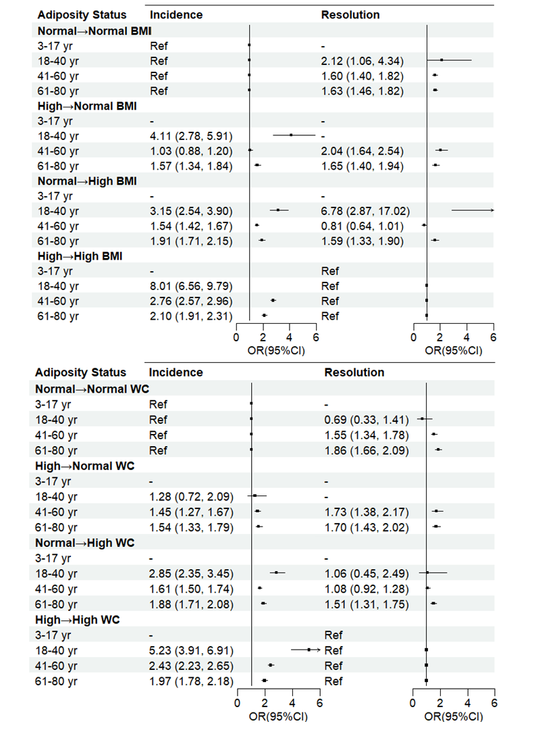
Figure S2. Association of adiposity status transition with systolic hypertension incidence and resolution by age group.
Abbreviations: BMI, body mass index; WC, waist circumference. Model adjusted for baseline SBP, baseline DBP, sex, survey year, nationality, education, region, smoking, drinking, physical activity and follow-up years.

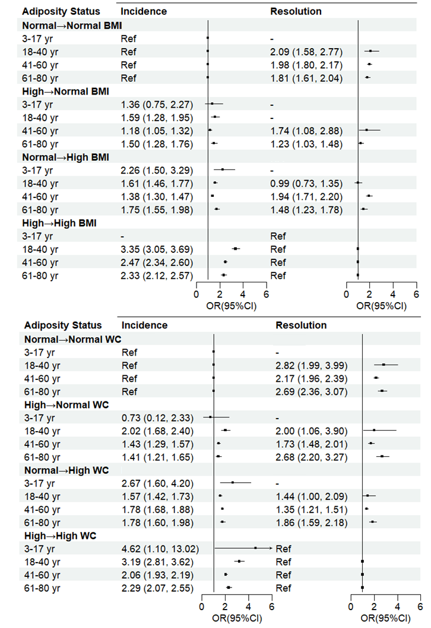
Figure S3. Association of adiposity status transition with diastolic hypertension incidence and resolution by age group.
Abbreviations: BMI, body mass index; WC, waist circumference. Model adjusted for baseline SBP, baseline DBP, sex, survey year, nationality, education, region, smoking, drinking, physical activity and follow-up years.

