Supplementary Information

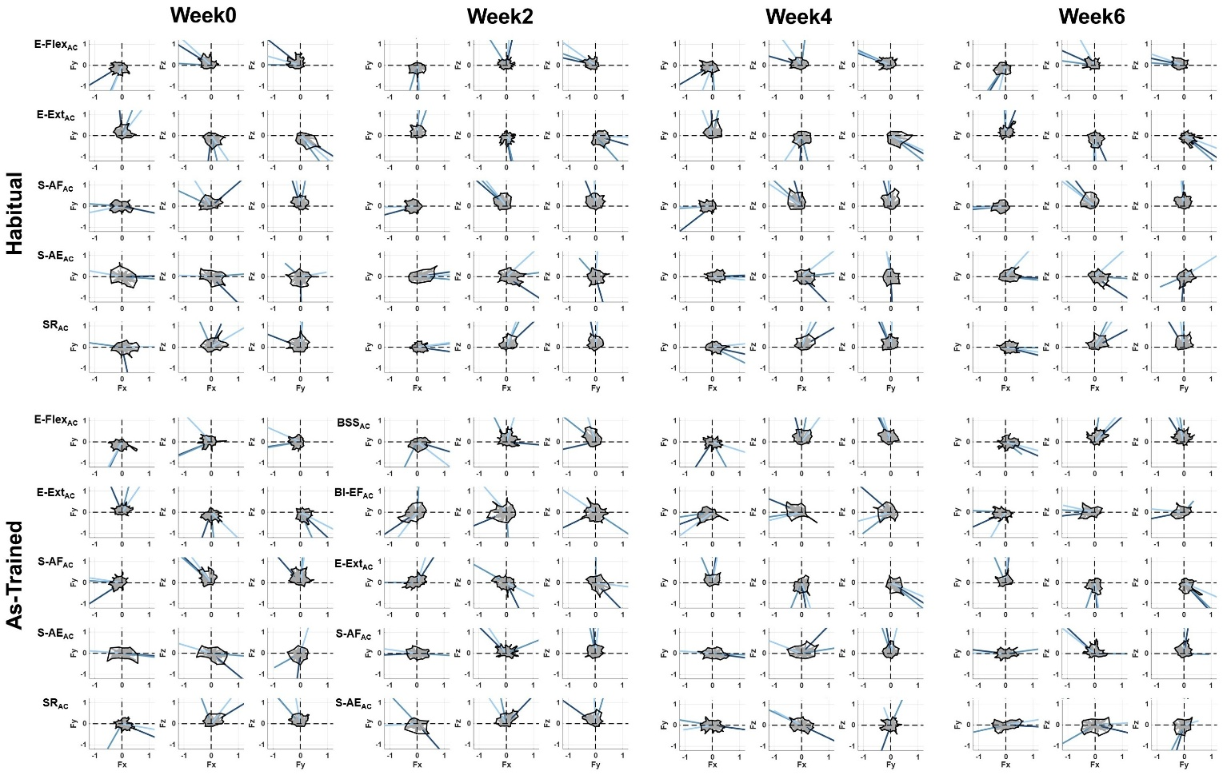
Supplementary Figure 1. The age-matched control group’s tuning curves of the synergy activation profiles as a function of end-point forces. The tuning curves are projected on the horizontal (lateral(+Fx)/medial(-Fx) & forward(+Fy)/backward(-Fy)), frontal (±Fx & upward(+Fz)/downward(-Fz)), and sagittal plane (±Fy & ±Fz). Each color-coded line indicates the tuning direction of each participant’s synergy activation.
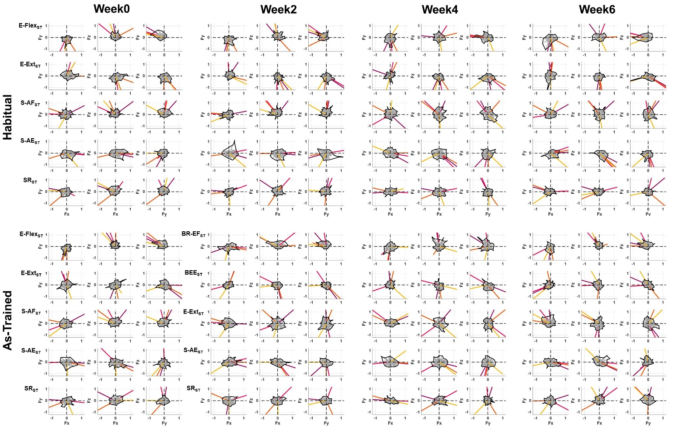
Supplementary Figure 2. The stroke group’s tuning curves of the synergy activation profiles as a function of end-point forces. The tuning curves are projected on the horizontal (lateral(+Fx)/medial(-Fx) & forward(+Fy)/backward(-Fy)), frontal (±Fx & upward(+Fz)/downward(-Fz)), and sagittal plane (±Fy & ±Fz). Each color-coded line indicates the tuning direction of each participant’s synergy activation.
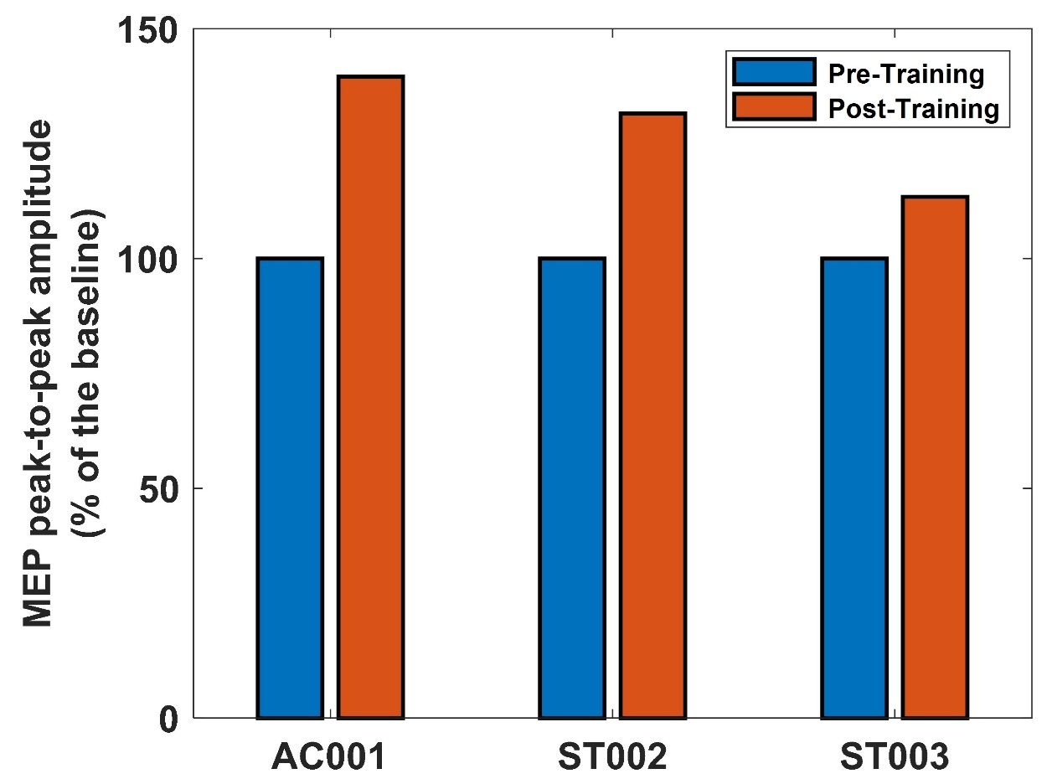
Supplementary Figure 3. Effect of training on MEP amplitude in stroke and age-matched control participants. The percentage of motor-evoked-potential (MEP) peak-to-peak amplitude elicited at 120% of resting motor threshold (rMT) recorded from the brachioradialis (BRD) muscle increased after six weeks of training in one age-matched healthy volunteer and two stroke participants. (blue: pre-training (Week0), red: post-training (Week6)). The healthy participant (AC001) exhibited a 39.55% increase, while the two stroke survivors (ST002 and ST003) showed increases of 31.55% and 13.43%, respectively. The rMT was estimated using a single TMS pulse delivered by a Magstim stimulator (model 200; Whitland, UK). By applying suprathreshold TMS pulses with a figure-of-eight coil, the primary motor cortex (M1) region (i.e. hotspot) that represents BRD was found. The rMT was defined as the TMS output that elicited at least 50µV MEP amplitude (peak-to-peak) in 5 out of 10 consecutive trials over the BRD hotspot [1]. The rMT per participant was estimated in the first session, and the same rMT was used across sessions. The consistency in the positioning of the TMS coil intra- and inter-session was ensured by using the Brainsight neuronavigation system (Rogue Research, Montreal, Canada). To investigate potential changes in the MEP amplitude due to the training, 20 MEPs were obtained in each assessment session using single-pulse TMS at 120% rMT of the BRD muscle. Four sessions were collected in total, two before training and two after training. The TMS Adult Safety Screen [2] was used to screen the participants for potential risk of adverse reactions to TMS following the guidelines provided by Rossi [3]).
References
- Rossini, P. M., Barker, A. T., Berardelli, A., Caramia, M. D., Caruso, G., Cracco, R. Q., ... & Tomberg, C. (1994). Non-invasive electrical and magnetic stimulation of the brain, spinal cord and roots: basic principles and procedures for routine clinical application. Report of an IFCN committee. Electroencephalography and clinical neurophysiology, 91(2), 79-92.
- Keel, J. C., Smith, M. J., & Wassermann, E. M. (2001). A safety screening questionnaire for transcranial magnetic stimulation. Clinical neurophysiology: official journal of the International Federation of Clinical Neurophysiology, 112(4), 720.
- Rossi, S., Hallett, M., Rossini, P. M., Pascual-Leone, A., & Safety of TMS Consensus Group. (2009). Safety, ethical considerations, and application guidelines for the use of transcranial magnetic stimulation in clinical practice and research. Clinical neurophysiology, 120(12), 2008-2039.

