Supplementary Figure 1 Venn diagram of DEGs at 6 timepoints profiling GSE37635.

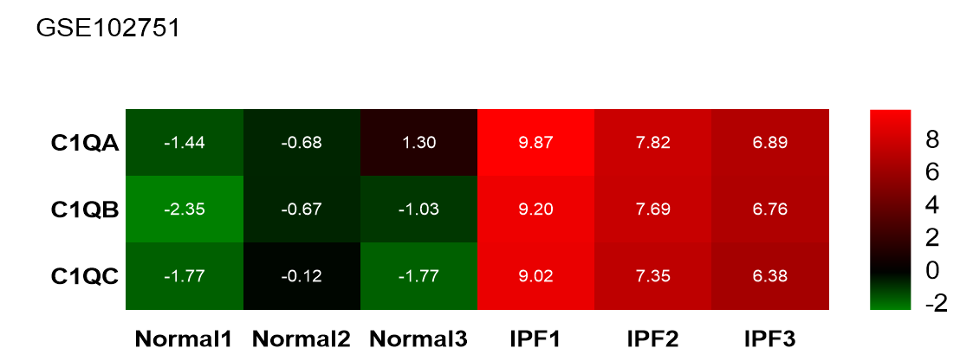
Supplementary Figure 2 The heatmap of GSE102751. It indicates the significant differences between the blood of control and IPF patients. The high expression and low expression are represented in red and green, respectively.
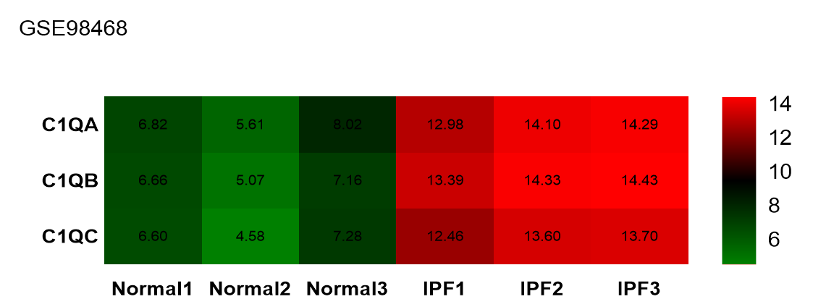
Supplementary Figure 3 The heatmap of GSE98468. It indicates the significant differences between the balf of control and IPF mice. The high expression and low expression are represented in red and green, respectively.

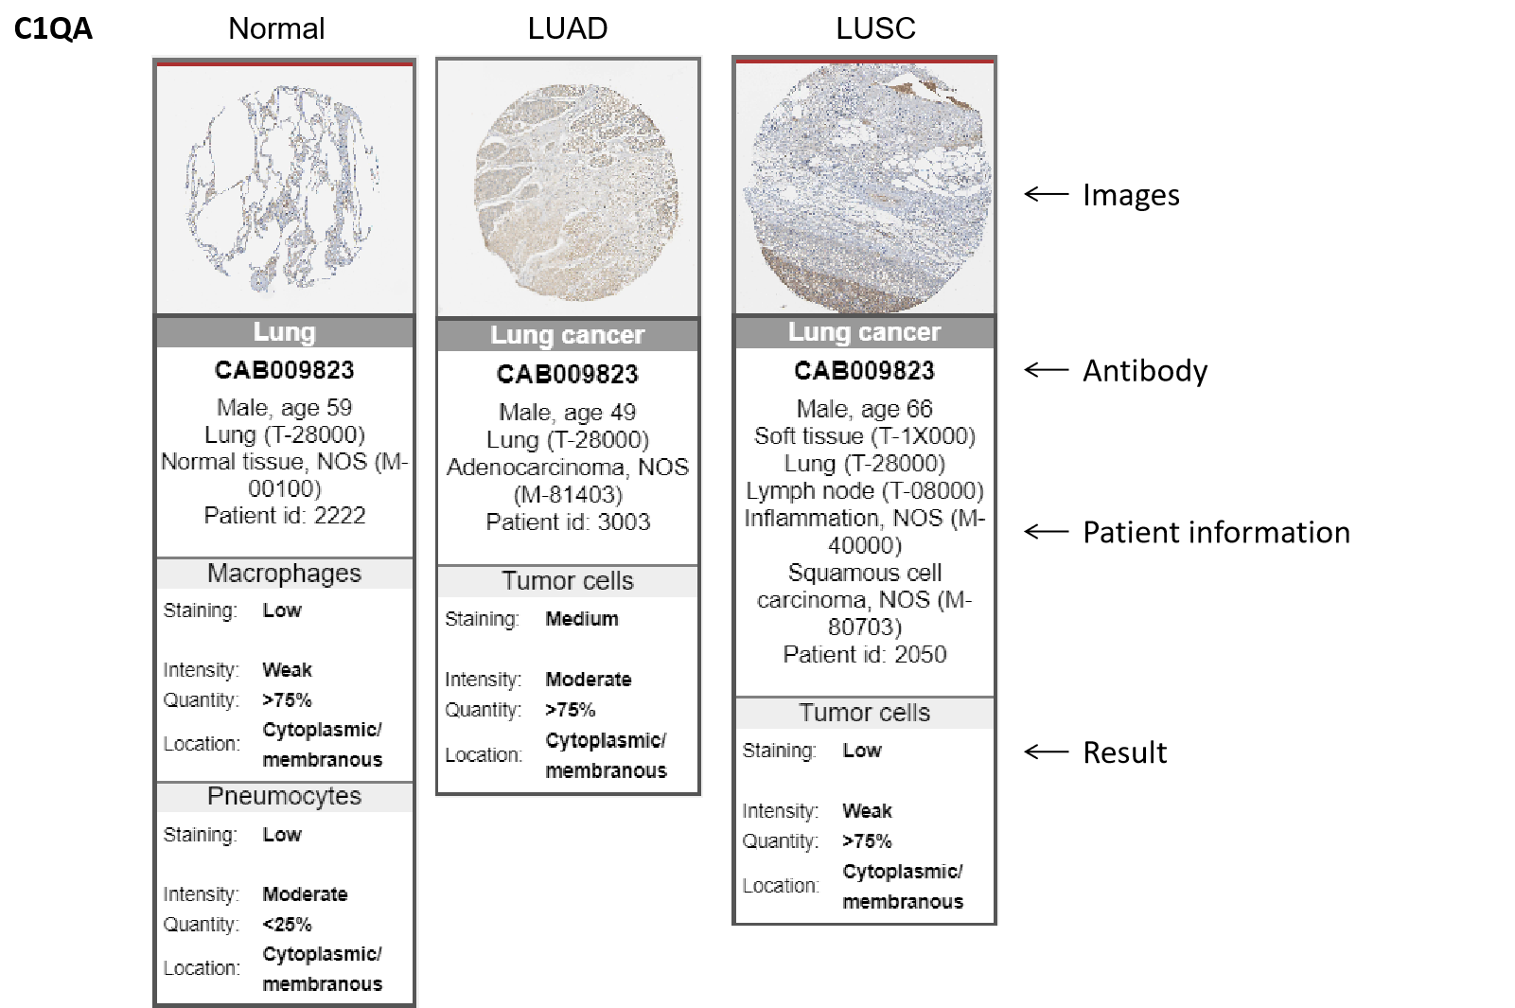
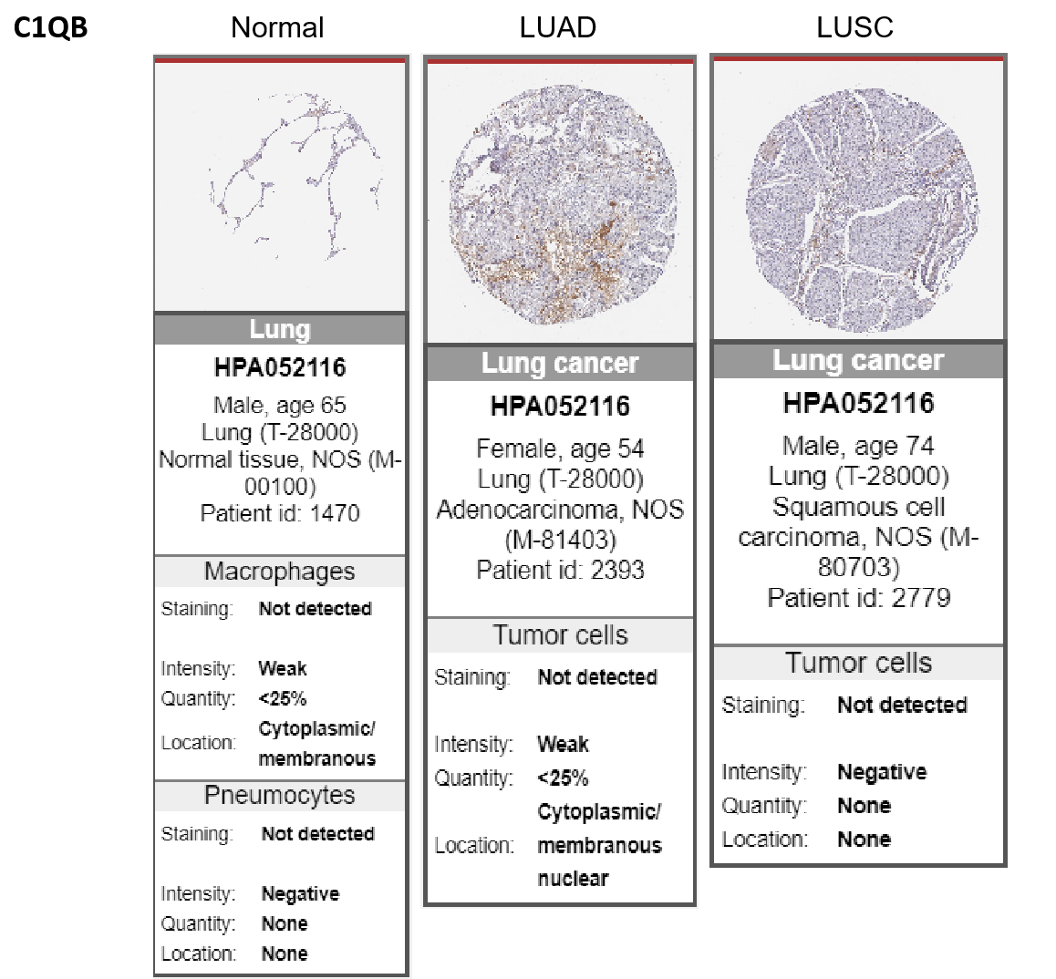
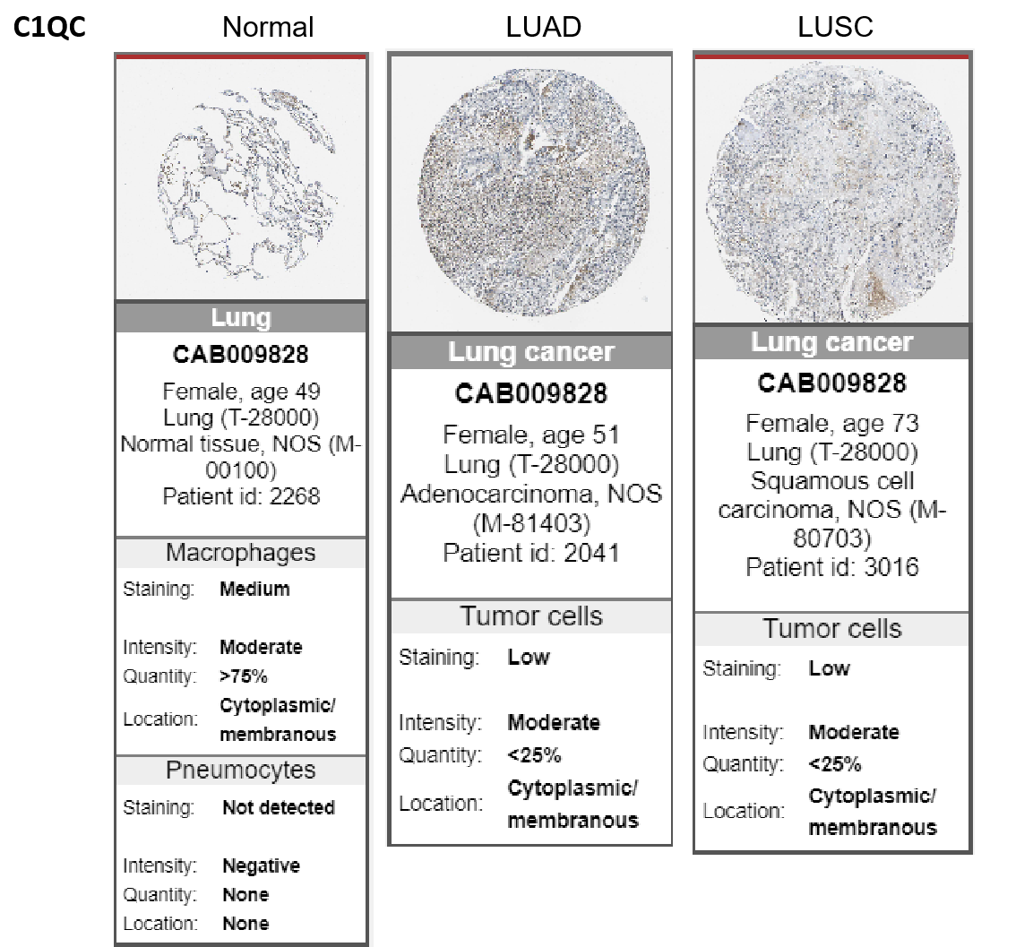
Supplementary Figure 4 Immunohistochemistry data of C1q (C1qa, C1qb and C1qc) in normal lung, LUAD and LUSC from The Human Protein Atlas.

Supplementary Figure 5 DNA methylation levels of probes of hub genes in LUAD. (A) 5 methylation probes of C1qa showed significant difference in normal group and LUAD group; (B) 10 methylation probes of C1qb showed significant difference in normal group and LUAD group; (C) 9 methylation probes of C1qc showed significant difference in normal group and LUAD group;(D) 5 methylation probes of Ccr5 showed significant difference in normal group and LUAD group.

Supplementary Figure 6 Methylation levels of hub genes in LUSC. (A) 6 methylation probes of C1qa showed significant difference in normal group and LUSC group; (B) 10 methylation probes of C1qb showed significant difference in normal group and LUAD group; (C) 10 methylation probes of C1qc showed significant difference in normal group and LUSC group;(D) 4 methylation probes of Ccr5 showed significant difference in normal group and LUSC group.

Supplementary Figure 7 Methylation levels of hub genes in IPF. (A) 9 methylation probes of C1qa showed significant difference in normal group and IPF group; (B) 10 methylation probes of C1qb showed significant difference in normal group and IPF group; (C) 9 methylation probes of C1qc showed significant difference in normal group and IPF group;(D) 4 methylation probes of Ccr5 showed significant difference in normal group and IPF group.

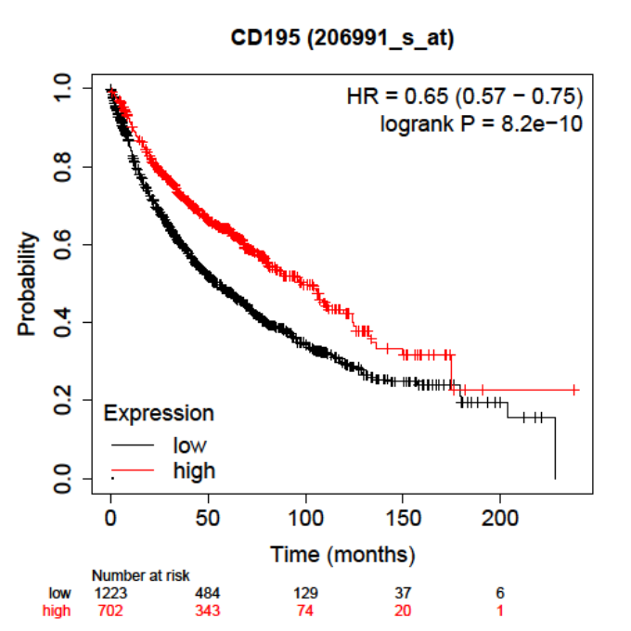
Supplementary Figure 8 Overall survival analysis of Ccr5 in NSCLC patients.

Supplemental Table 1 Characteristics of the genes included in datasets
Gene Name | Primer | Sequence
C1QA -MS | Formate 5’-3’ | GGACTGGTATCCGAGGTTTTAA
 | Reverse 5’-3’ | GATATTGCCTGGATTGCCTTTC
C1QB -MS | Formate 5’-3’ | CTACACAGAAAGTCGCCTTCTC
 | Reverse 5’-3’ | CTGGCATGATAGGTGAAGTAGT
C1QC -MS | Formate 5’-3’ | TACTTCGTCTACTACACATCGC
 | Reverse 5’-3’ | GGAAACAGTAGGAAACCAGAGA
ACTA2 -MS | Formate 5’-3’ | GTCCCAGACATCAGGGAGTAA
 | Reverse 5’-3’ | TCGGATACTTCAGCGTCAGGA
COL1A1 -MS | Formate 5’-3’ | TAAGGGTCCCCAATGGTGAGA
 | Reverse 5’-3’ | GGGTCCCTCGACTCCTACAT
FN1 -MS | Formate 5’-3’ | ATGTGGACCCCTCCTGATAGT
 | Reverse 5’-3’ | GCCCAGTGATTTCAGCAAAGG
GAPDH -MS | Formate 5’-3’ | AGGTCGGTGTGAACGGATTTG
 | Reverse 5’-3’ | TGTAGACCATGTAGTTGAGGTCA

Supplemental Table 2 The logFC of DEGs. Up-regulated genes were labeled in red, down-regulated genes were labeled in black.
Genes | 1W | 2W | 3W | 4W | 5W | GSE485 | GSE97546 | GSE31013
Pon1 | -0.71 | -1.07 | -0.90 | -0.72 | -0.38 | -2.16 | -2.53 | -4.91
Asgr1 | -2.79 | -2.53 | -2.30 | -1.61 | -1.23 | -2.56 | -3.58 | -4.75
Atp1a2 | -1.19 | -0.90 | -0.78 | -0.56 | -0.45 | -1.61 | -2.02 | -3.38
Snhg11 | -1.59 | -1.42 | -1.04 | -0.80 | -0.32 | -1.47 | -1.87 | -1.79
Pld3 | 1.25 | 1.27 | 1.19 | 0.75 | 0.68 | 1.01 | 2.32 | 1.10
C1qc | 2.19 | 1.77 | 1.78 | 1.28 | 0.95 | 2.28 | 3.25 | 1.11
Ptgs1 | 1.27 | 0.94 | 0.71 | 0.81 | 0.62 | 0.77 | 1.91 | 1.14
Ccr5 | 3.86 | 3.23 | 2.50 | 2.57 | 1.81 | 2.78 | 3.51 | 1.17
Camk2d | 1.08 | 1.12 | 1.13 | 1.07 | 1.15 | 1.00 | 3.03 | 1.29
Hif1a | 1.38 | 2.15 | 1.65 | 1.09 | 1.15 | 0.72 | 3.25 | 1.35
C1qa | 1.98 | 1.36 | 1.30 | 0.88 | 0.45 | 2.00 | 2.64 | 1.38
Lgals3 | 1.13 | 0.72 | 0.52 | 0.51 | 0.49 | 1.11 | 2.27 | 1.39
Capg | 1.09 | 0.68 | 0.76 | 0.54 | 0.48 | 3.13 | 1.74 | 1.40
Ccl9 | 2.64 | 1.98 | 1.84 | 1.27 | 0.82 | 2.44 | 3.14 | 1.61
C1qb | 2.73 | 2.24 | 2.14 | 1.69 | 1.22 | 3.07 | 2.88 | 2.04
Mmp13 | 2.24 | 2.12 | 1.64 | 1.43 | 0.95 | 2.05 | 4.45 | 2.76
Gsta3 | -0.89 | -0.88 | -0.70 | -0.51 | -0.81 | -0.91 | -1.59
Adgre1 | 1.82 | 1.18 | 1.29 | 1.14 | 0.62 | 1.49 | 2.83
Eif5a | 0.60 | 0.80 | 0.66 | 0.58 | 0.44 | 1.94 | 1.74
Fcgr1 | 2.41 | 1.07 | 1.17 | 0.93 | 1.27 | 1.13 | 3.59
Mtdh | 0.54 | 0.60 | 0.33 | 0.36 | 0.32 | 1.22 | 1.91
Zmat3 | 0.82 | 0.84 | 0.96 | 0.81 | 0.77 | 0.77 | 1.88
Spp1 | 3.04 | 2.46 | 2.26 | 1.82 | 1.48 | 1.97 | 4.95
Glipr2 | 0.90 | 1.02 | 0.89 | 0.89 | 0.50 | 0.73 | 3.57
Evi2a | 1.32 | 1.53 | 1.30 | 1.11 | 0.53 | 0.81 | 1.71
Clec4d | 2.15 | 2.25 | 1.98 | 1.43 | 1.14 | 2.52 | 4.10
Cxcl10 | 3.77 | 2.36 | 1.83 | 1.39 | 0.94 | 2.30 | 3.06
Cyba | 0.97 | 0.68 | 0.78 | 0.47 | 0.41 | 1.34 | 1.56
Lrg1 | 1.46 | 1.17 | 0.98 | 0.86 | 0.82 | 1.13 | 2.08
Tnc | 2.59 | 2.10 | 1.73 | 1.12 | 0.79 | 2.83 | 6.52
Lmna | 0.86 | 0.62 | 1.09 | 0.46 | 0.64 | 1.13 | 2.40
Lgmn | 1.42 | 1.21 | 1.09 | 0.97 | 0.70 | 1.71 | 3.22
Slc11a1 | 1.20 | 1.97 | 1.97 | 1.29 | 1.18 | 1.92 | 3.79
Tgfbi | 1.74 | 1.02 | 0.64 | 0.39 | 0.36 | 1.42 | 1.90
Ccl8 | 2.65 | 1.44 | 1.83 | 1.08 | 1.44 | 4.47 | 4.20
Rab11fip5 | 0.53 | 0.52 | 0.40 | 0.40 | 0.29 | 1.07 | 1.62
Capzb | 0.82 | 0.89 | 0.75 | 0.75 | 0.90 | -2.31 | 2.52
Cd22 | 1.11 | 1.11 | 0.86 | 0.84 | 0.97 | -0.78 | -0.90
Srprb | -0.96 | -0.75 | 0.87 | 0.72 | -0.64 | -1.11 | 1.69
Tbc1d22a | 0.44 | 0.46 | 0.45 | 0.30 | 0.31 | -1.50 | 0.75
Kif1b | -0.39 | -0.43 | -0.45 | -0.41 | -0.58 | -0.93 | 2.05
Traf6 | 1.05 | 0.71 | 1.02 | 0.62 | -0.44 | 1.45 | 2.57
Zfp60 | -0.57 | -0.67 | -0.61 | -0.53 | -0.52 | -0.76 | 1.39
Ankrd40 | 0.43 | 0.81 | 0.95 | 0.87 | 0.78 | -1.05 | 1.02
Slc9a3r2 | 1.16 | 1.81 | 1.57 | 2.12 | 1.40 | -1.04 | 1.94
Pou2af1 | 0.74 | 1.21 | 1.34 | 1.32 | 1.08 | -1.87 | -1.46
Cd3d | 0.84 | 0.54 | 0.94 | 0.67 | 0.68 | -2.09 | -1.49
Aif1 | 1.36 | 0.59 | 0.73 | 0.67 | 0.58 | 2.45 | 1.50
Cd79b | 1.08 | 1.51 | 1.28 | 1.07 | 1.28 | -1.40 | -2.04
Irf9 | 0.67 | 0.46 | 0.79 | 0.91 | 0.74 | -0.96 | 1.22
Gpcpd1 | 0.43 | 1.06 | 1.06 | 1.14 | 0.83 | -0.74 | 2.43
Mat2a | -0.62 | -0.38 | -0.88 | -0.33 | -0.59 | -0.91 | 1.17
Gfpt2 | -0.49 | -0.39 | -0.61 | -0.47 | -0.58 | 1.42 | 2.73
Rasgrp1 | 1.21 | 0.88 | 0.64 | 0.67 | 0.47 | -0.91 | -1.15
Tpm3 | 1.03 | 0.90 | 0.72 | 0.64 | 0.49 | -1.70 | 2.48
Cd8b1 | 0.93 | 0.71 | 0.78 | 0.73 | 0.72 | -1.93 | -1.95
Atp2a2 | -1.16 | -1.13 | -1.02 | -0.63 | -0.65 | -1.30 | 2.32
Acta2 | -0.76 | -0.82 | -0.79 | -0.73 | -0.50 | 0.69 | 2.49
Elp5 | 0.48 | 0.40 | 0.47 | 0.41 | 0.49 | -1.73 | 2.64
Slc35e1 | 0.79 | 0.90 | 0.81 | 0.92 | 0.47 | -0.72 | 2.15

Supplemental Table 3 Characteristics of the genes included in datasets
Dataset ID | Group of samples | Number of detected genes | Number of differentially expressed genes (up/down) | Ranking of C1q (among the differentially regulated genes%)
GSE37635 | 1w vs 0w | 9781 | 3492 (1742/1750) | C1QA 48 (1.37%)  C1QB 2 (0.05%)  C1QC 19 (0.54%)
GSE37635 | 2w vs 0w | 9781 | 3290 (1691/1599) | C1QA 493 (14.98%)  C1QB 15 (0.46%)  C1QC 127 (3.86%)
GSE37635 | 3w vs 0w | 9781 | 2917 (1541/1376) | C1QA 218 (7.47%)  C1QB 19 (0.65%)  C1QC 32 (1.10%)
GSE37635 | 4w vs 0w | 9781 | 2443 (1368/1075) | C1QA 387 (15.84%)  C1QB 8 (0.33%)  C1QC 55 (2.25%)
GSE37635 | 5w vs 0w | 9781 | 1617 (877/740) | C1QA 1617 (100%)  C1QB 67 (4.14%)  C1QC 145 (8.96%)
GSE97546 | IPF vs CTRL | 20141 | 10295 (9444/851) | C1QA 858 (8.33%)  C1QB 1543 (14.99%)  C1QC 242 (2.35%)
GSE485 | IPF vs CTRL | 9176 | 941 (415/526) | C1QA 130 (13.81%)  C1QB 107 (11.37%)  C1QC 220 (25.71%)
GSE31013 | NSCLC vs CTRL | 22073 | 4856 (1580/3276) | C1QA 1929 (39.72%)  C1QB 1410 (29.03%)  C1QC 2655 (54.67%)

Supplemental Table 4 Characteristics of human subjects
 | Control | IPF
Number | 6 | 10
Sex | Male | Male
Age (year) | 57.8 ± 10.7 | 57.0 ± 5.1
Weight (kg) | 83.2 ± 13.6 | 72.9 ± 10.3
Height (cm) | 175.8 ± 5.9 | 172.6 ± 6.7
BMI | 26.8 ± 3.5 | 24.4 ± 2.2
Smoking History
non smoker (ns) | 4 | 0
former smoker (fs) | 1 | 10
current smoker (cs) | 1 | 0
Pack year | Fs=24 cs=39 | 22.8 ± 11.8
FEV₁ (L) | - | 1.99 ± 0.51
FVC (L) | - | 2.40 ± 0.77
FEV₁/FVC | - | 0.85 ± 0.08
TLC (L) | - | 3.6 ± 1.2
FEV₁pp (%) | - | 60.7 ± 15.5
FVCpp (%) | - | 58.7 ± 19.7
TLCpp (%) | - | 54.9 ± 16.9
DLCDpp (%) | - | 27.6 ± 7.8

