Supplementary Material for:

Carboxymethyl kappa-carrageenan polyelectrolyte multilayers: a cytocompatible, anticoagulant, and antibacterial coating, as a sustainable alternative to heparin for blood-contacting surfaces
Liszt Y. C. Madruga, ^{†, a,e} Somayeh Baghersad, ^{†, b} Paulo C.F. da Câmara, ^{c} Roberta M. Sabino, ^{d}, Matt J. Kipper ^{a, b} and Ketul C. Popat, ^{b, e,*}
- Department of Chemical and Biological Engineering, Colorado State University, Fort Collins, CO 80526, USA.
- School of Biomedical Engineering, Colorado State University, Fort Collins, CO 80526, USA.
- Laboratory of Petroleum Research, LAPET, Institute of Chemistry, Federal University of Rio Grande do Norte, UFRN, 59078-970 Natal, RN, Brazil.
- Department of Chemical and Biomedical Engineering, University of Wyoming, Laramie, WY, 82071, USA.
- Department of Bioengineering, George Mason University, Fairfax, VA 22030, USA.
† These authors contributed equally.
* Corresponding author. Ketul Popat, kpopat@gmu.edu

Methodologies

Carboxymethylation of kappa-carrageenan
Carboxymethyl-kappa-carrageenan was synthesized using Williamson’s ether synthesis technique. Initially, 10 g of kappa-carrageenan was dissolved in a solution of 80% w/v 2-propanol (200 mL). After that, sodium hydroxide solution (20% w/v, 20 mL) was added gradually over a period of 15 minutes. The mixture was vigorously stirred at 40 °C for one hour. Following this, monochloroacetic acid (8.75 g dissolved in NaOH solution) was added slowly while the temperature was increased to and held at 55 °C for four hours. This is an MCA:KC monomer ratio of 3:5. In previous work, we showed that this procedure results in CMKC with a degree of substitution of 1.1 [1]. After the reaction, the substance underwent vacuum filtration and washing with both an 80% ethanol/water solution followed by pure ethanol. The filtered solid was then dissolved in deionized water overnight before undergoing dialysis against water until its conductivity fell below 20 mS·cm⁻¹ for purification purposes. Finally, the material was freeze-dried to produce CMKC with a substitution degree of 1.1.

Polyelectrolyte Multilayer Preparation
Polymer solutions were prepared at a 1.0 mg/mL concentration in 0.2 M sodium acetate buffer (pH 5.0) and stirred overnight. An acidic rinse solution was prepared using aqueous acetic acid (pH 4.0). These solutions were filtered using 0.22 μm PVDF syringe filters from Fisher Scientific (Waltham, MA, USA). The LbL deposition process was conducted on oxygen plasma-oxidized glass surfaces (diameter of 8 mm and a thickness of 0.15 mm) placed in the wells of 48-well plates. The rinse and deposition steps were performed on an orbital shaker at 150 rpm. Initially, oxidized surfaces were rinsed, followed by polycation solution application, subsequent rinsing, and then polyanion solution deposition. This process was repeated to construct PEMs with either 10 or 16 layers terminated with a polyanion, or 11 or 17 layers terminated with a polycation. The PEMs were identified based on the polyanion-polycation pairing and the number of layers, such as, “CMKC-CHI 16.”

Characterization
The deposition process of PEMs using FT-SPR, inspired by earlier studies [2], involved gold-coated glass chips (47 nm thickness) pre-treated with a 1 mM MUA monolayer in ethanol for 24 hours. The LbL assembly was executed in a flow cell of the SPR-100 module, integrated with a Nicolet 8700 FT-IR spectrometer. FT-SPR was conducted using a white light/near-infrared source, CaF₂ beam splitter, and InGaS detector. Data was captured between 6000 and 12000 cm⁻¹ at 8 cm⁻¹ resolution with Omnic 7.3 software. The intensity as a function of wavenumber for p-polarized light reflected from the back side of the gold film was measured to monitor the LbL assembly of the PEM in real-time. The flow of polycation, polyanion, and rinse solutions through the cell was controlled at a rate of 1 mL/min by a peristaltic pump. The surfaces were exposed to an alternating sequence of solutions (polycation, rinse, polyanion, rinse) for five minutes per step, to achieve the specific number of layers.
The composition of the PEMs was examined using XPS (5800 spectrometer, Physical Electronics, Chanhassen, MN, USA). This involved a survey scan spanning an energy range of 10 to 1100 eV, at a pass energy setting of 187 eV. Additionally, high-resolution spectra targeting the carbon (C1s) envelopes were acquired with a pass energy of 23 eV. These spectra were then subjected to spectral analysis using MultiPak software (Physical Electronics, Chanhassen, MN, USA) for peak fitting and composition characterization.
The wettability of the surfaces was assessed by measuring the static contact angle using a Ramé-Hart 260F4 goniometer. A droplet of DI water, measuring 10 μL, was deposited on the surface. After three seconds, the contact angle was precisely measured using DROPimage software.
The evaluation of the surface morphology and roughness of PEMs was carried out in PBS using a Bruker BioScope Resolve BIOAFM, controlled by a Nanoscope V, in ScanAsyst-fluid mode. This mode utilized a V-shaped silicon nitride lever on a PFQNM-LC probe, featuring a spring constant of about 0.089 N/m. For the imaging process, the chosen peak force was 1 nN, fine-tuned through Bruker NanoScope software. Imaging took place at ambient temperature, capturing distinct images from at least two separate regions. These images were then processed with Bruker NanoScope Analysis software (version 2.0) to assess surface details. The measurement area was fixed at 2 × 2 μm² with a resolution of 512 pixels × 512 pixels. The calculation of the root-mean-square roughness (R_{q}) was based on Equation (1).
$$R_{q}=\sqrt{\frac{\sum_{i}{{(z_{i}-\overline{z})}^{2}}}{N}}$$
where 𝑧_{𝑖} is the distance of the i-th pixel from the mean height, $\overline{z}$, and N is the number of pixels.

Cytocompatibility Studies

Cell Culture
Human ADSCs (bellow passage 5) were cultured at 37 °C in a 5% CO₂ atmosphere in 175 cm² surface area tissue-culture polystyrene flasks using growth media (MEM Alpha Modification, HyCloneTM) with 10% fetal bovine serum and 1% penicillin/streptomycin added. Before cell seeding, PEM-coated surfaces were sterilized with 70% ethanol for 30 min. The cells were seeded onto samples at a concentration of 10⁴ cells per well in 48-well plates, and they were cultured at 37 °C in a 5% CO₂. All experimental conditions were measured at least in triplicate or quadruplicate (n= 3 or n= 4).

Cell Viability and Cytotoxicity
Cell viability was assessed using the CellTiter-Blue cell viability assay (Promega G808A) after 4 days of cell growth on the surfaces. Following the manufacturer’s guidelines, 50 µL of CellTiter-Blue reagent was added to each sample, which contained 500 µL of culture media. The samples were then incubated for 8 hours at 37 °C in a 5% CO₂ environment. Post-incubation, a microplate reader (FLUOstar Omega, BMG LABTECH, Cary, NC, USA) was used to measure the absorbances at 570 and 600 nm to evaluate cell viability. For comparative purposes, tissue-culture polystyrene surfaces were utilized as the positive control for cell viability.
For the cytotoxicity assay, cells on polystyrene (PS) served as the negative control for cytotoxicity (C−), and cells on polystyrene treated with Triton X in the media (1.0 vol%) served as the positive control (C+) for cytotoxicity. After a 24-hour incubation period with cells, 50 µL of the medium from each sample was combined with an equal amount of LDH reagent Quantichrom Bioassay Systems, Hayward, CA, USA) in a 96-well plate. This mixture was then incubated for 30 minutes. The cytotoxicity was quantified by measuring the absorbance of the solution at 490 nm and 680 nm using a plate reader (FLUOstar Omega, BMG LABTECH, Cary, NC, USA).

Adhesion and Proliferation
ADSCs were seeded onto PEM-coated surfaces in 48-well plates, using 400 µL of culture medium per well, maintaining a density of 10⁴ cells/mL. The control group used tissue-culture polystyrene surfaces. Media was changed on days two and five. After 4 and 7 days, cell adhesion and proliferation were examined using fluorescence microscopy (Zeiss Axioskop 2 epifluorescence microscope). The cells were fixed with 3.7% formaldehyde for 15 minutes at room temperature, followed by three PBS washes. Subsequently, cells were exposed to 1% Triton X-100 in PBS for 3 minutes, then rinsed thrice with PBS. For cellular staining, cytoskeletal structures were labeled using rhodamine phalloidin at a concentration of 70 nM in PBS for a duration of 25 minutes. For nuclear staining, 4′,6-diamidino-2-phenylindole (DAPI, Invitrogen) was used at a concentration of 300 nM, with an incubation period of 5 minutes. Then cells were rinsed twice with PBS and imaged via fluorescence microscopy using a Zeiss Axiovision fluorescence microscope. The quantity of adhered ADSCs was assessed by counting the stained nuclei in DAPI images at 10× magnification. Fluorescence images were further analyzed and processed using ImageJ software.

Antibacterial Activity Studies
The antibacterial activity assay was adopted from previous studies [3,4]. Two bacterial strains were used: S. aureus (ATCC 6538), a Gram-positive bacterium, and P. aeruginosa (ATCC 15692), a Gram-negative bacterium. These bacteria were cultivated in a nutrient broth media solution (NBM, tryptic soy broth, Sigma). The cultivation process started with an incubation period of 12 hours at 37 °C, resulting in a bacterial solution with an optical density of 0.52 at a wavelength of 562 nm, indicative of a concentration of about 10⁹ CFU/mL. This solution was subsequently diluted to a concentration of 10⁶ CFU/mL, which is an appropriate concentration for assessing bacterial adhesion and growth on the surfaces [5,6]. The prepared and sterilized surfaces were placed into a 24-well plate, each well receiving 500 μL of the diluted bacterial solution and were then incubated at 37 °C for periods of 6 and 24 hours to facilitate bacterial interaction with the surfaces. Under identical conditions, control samples of glass were also included.
Fluorescence microscopy (Zeiss Axiovision, Jena, Germany) was employed to assess bacterial adhesion on experimental and control surfaces. After the incubation periods, the surfaces were rinsed three times with PBS to remove any non-adherent bacteria. The surfaces were then immersed in a staining solution composed of propidium iodide and SYTO 9 in a 1:1 ratio with PBS, at a concentration of 3 μL/mL, and incubated for 15 minutes in a dark environment. Following this, the surfaces were rinsed with PBS three times. The bacteria were then fixed using a 3.7% formaldehyde solution for 15 minutes, followed by three rinses with PBS. The samples were immediately visualized using a fluorescence microscope (n = 3). The percentages of the surface area covered by live and dead bacteria were measured using ImageJ software (version 1.54 g, NIH, Bethesda, MD, USA).
In addition to fluorescence microscopy, SEM imaging was used to examine the morphology of the bacteria and biofilm formation on the surfaces. After the incubation period (6 h and 24 h), the surfaces were rinsed with PBS and the cells were fixed using a solution containing 25% glutaraldehyde, 0.1 M sucrose, and 0.1 M sodium cacodylate for 45 minutes. Following this, the samples were incubated in a buffer solution of 0.1 M sodium cacodylate and 0.1 M sucrose for 10 minutes. A graded ethanol series (35%, 50%, 70%, 100%) was then used for sequential and dehydration, 10 minutes for each concentration. The samples were coated with a 10-nm layer of palladium–gold alloy and imaged using a scanning electron microscope (JEOL JSM-6500F) at an accelerating voltage of 15 kV, a working distance of 10 mm, and a vacuum pressure below 3 × 10⁻⁴ Pa. SEM images were captured at magnifications of 2000×

Results

X-ray Photoelectron Spectroscopy
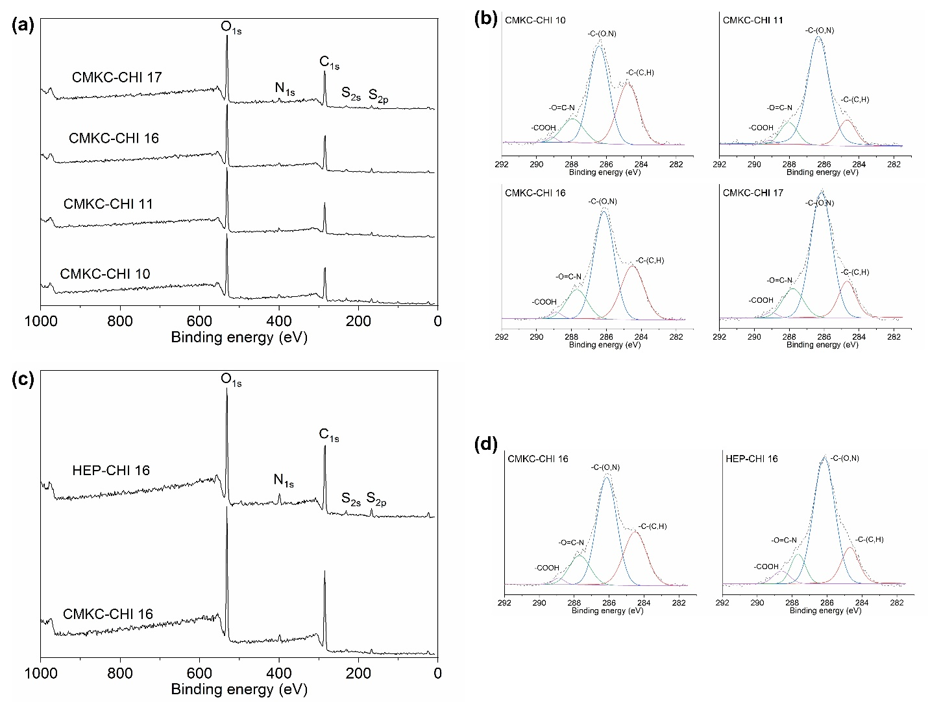

Figure S1. Survey (a) and high-resolution X-ray photoelectron spectra of the C1s region (b) of CMKC-CHI PEM surfaces with different layers. Survey (c) and high-resolution X-ray photoelectron spectra of the C1s region (d) of CMKC-CHI 16 and HEP-CHI 16 PEM surfaces. Black lines represent data; colored lines represent individual peak fits.

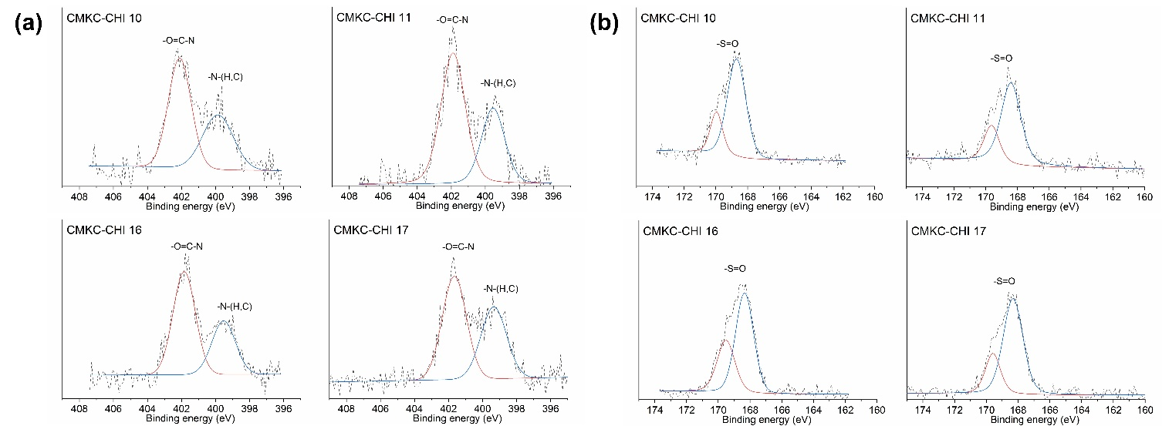
Figure S2. High-resolution X-ray photoelectron spectra of the N1s region (a) and S2p region (b) of CMKC-CHI PEM surfaces with different layers. Black lines represent data; colored lines represent individual peak fits.

Cell Viability and Toxicity Assays
Figure S3. Cell viability represented as percentage of cytotoxicity of the PEMs (analyzed by measuring the absorbance of LDH after 24 h of cell culture on the PEMs) (a) and percentage reduction of alamarBlue after 4 days of cell culture (b). Values represent mean ± standard deviation (n = 4). “ns” p ≥ 0.05.

Antibacterial Activity
  - Figure S4. Fluorescence microscopy and SEM images of S. aureus (a) and P. aeruginosa (b) on the glass controls and PEMs after 6 hours. Live bacteria are represented in green (SYTO 9 stain) and dead bacteria in red (propidium iodide stain). Original magnification of SEM images is 2000×. Scale bars on fluorescence microscopy and SEM images represent 50 and 10 µm, respectively.

Protein Adsorption
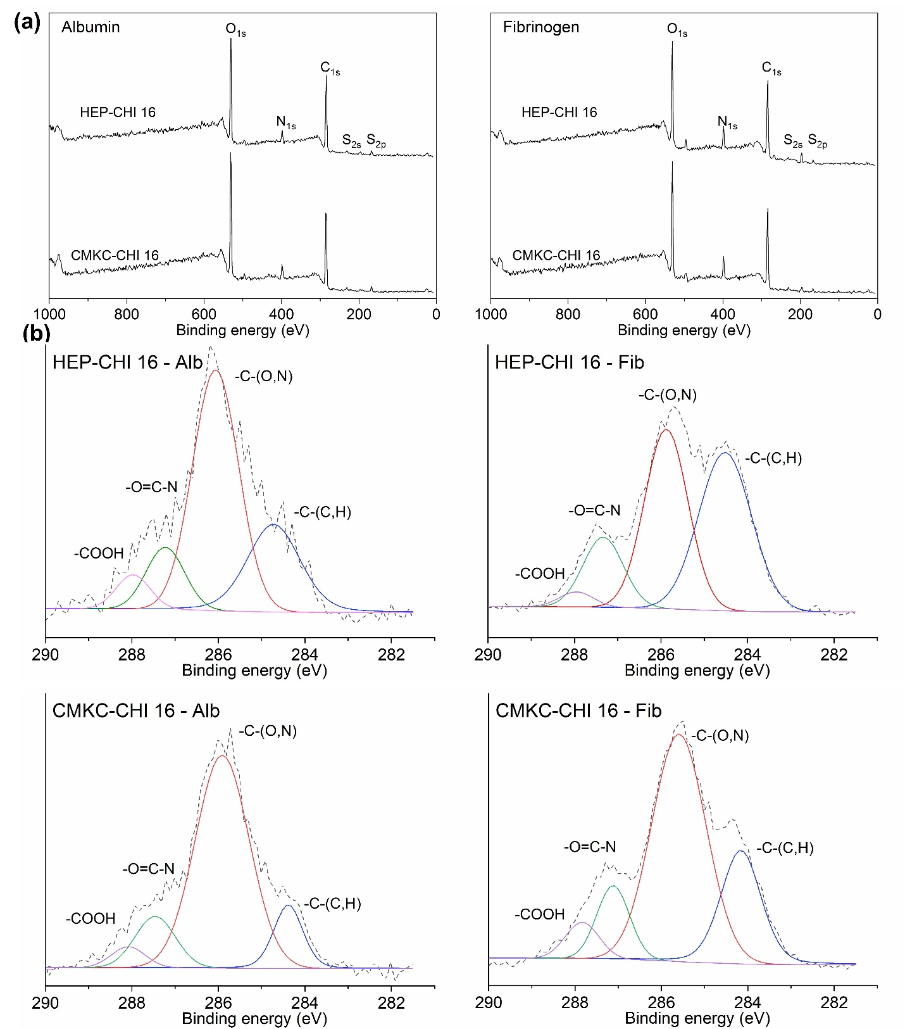Figure S5. Survey spectra (a) and high resolution C1s scans for Fib and Alb adsorbed on PEM surfaces showing C-C, C-N, N–C=O, and COOH envelopes (b).

Platelet Adhesion
  - Figure S6. Representative fluorescence microscopy images depicting adhered platelets and leukocytes, with platelets stained red using rhodamine phalloidin and leukocytes highlighted in blue with DAPI staining. Scale bars on fluorescence microscopy images represent 50 µm.

References
[1] L.Y.C. Madruga, R.M. Sabino, E.C.G. Santos, K.C. Popat, R. de C. Balaban, M.J. Kipper, Carboxymethyl-kappa-carrageenan: A study of biocompatibility, antioxidant and antibacterial activities, Int J Biol Macromol 152 (2020) 483–491. https://doi.org/10.1016/j.ijbiomac.2020.02.274.
[2] S. Baghersad, L.Y.C. Madruga, A.F. Martins, K.C. Popat, M.J. Kipper, Expanding the Scope of an Amphoteric Condensed Tannin, Tanfloc, for Antibacterial Coatings, J Funct Biomater 14 (2023) 554. https://doi.org/10.3390/jfb14110554.
[3] D.P. Facchi, A.C. Lima, J.H. de Oliveira, D. Lazarin-Bidóia, C. V. Nakamura, E.A. Canesin, E.G. Bonafé, J.P. Monteiro, J. V. Visentainer, E.C. Muniz, A.F. Martins, Polyelectrolyte complexes based on alginate/tanfloc: Optimization, characterization and medical application, Int J Biol Macromol 103 (2017) 129–138. https://doi.org/10.1016/j.ijbiomac.2017.05.033.
[4] A.V. Savargaonkar, A.H. Munshi, P. Soares, K.C. Popat, Antifouling Behavior of Copper-Modified Titania Nanotube Surfaces, J Funct Biomater 14 (2023). https://doi.org/10.3390/jfb14080413.
[5] S. Li, P. She, L. Zhou, X. Zeng, L. Xu, Y. Liu, L. Chen, Y. Wu, High-Throughput Identification of Antibacterials Against Pseudomonas aeruginosa, Front Microbiol 11 (2020). https://doi.org/10.3389/fmicb.2020.591426.
[6] S. Kreve, A.C.D. Reis, Bacterial adhesion to biomaterials: What regulates this attachment? A review, Japanese Dental Science Review 57 (2021) 85–96. https://doi.org/10.1016/j.jdsr.2021.05.003.

