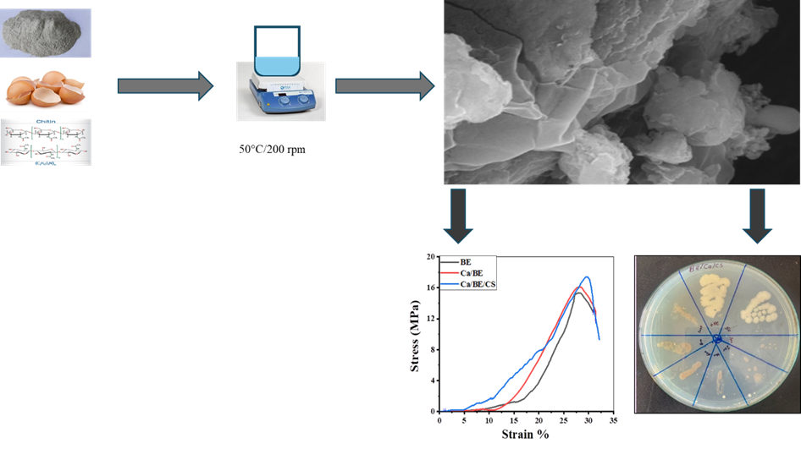
Schematic flow chart for the simple Calcium/ Bentonite/ Chitosan preparation and Anti-microbial and mechanical properties.

