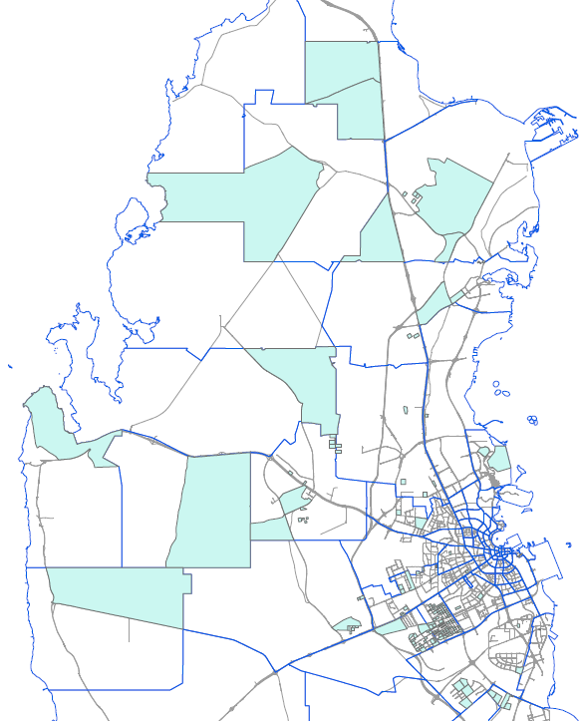

Annex 1: Sampled area map No.1

