Supplementary Figure 1

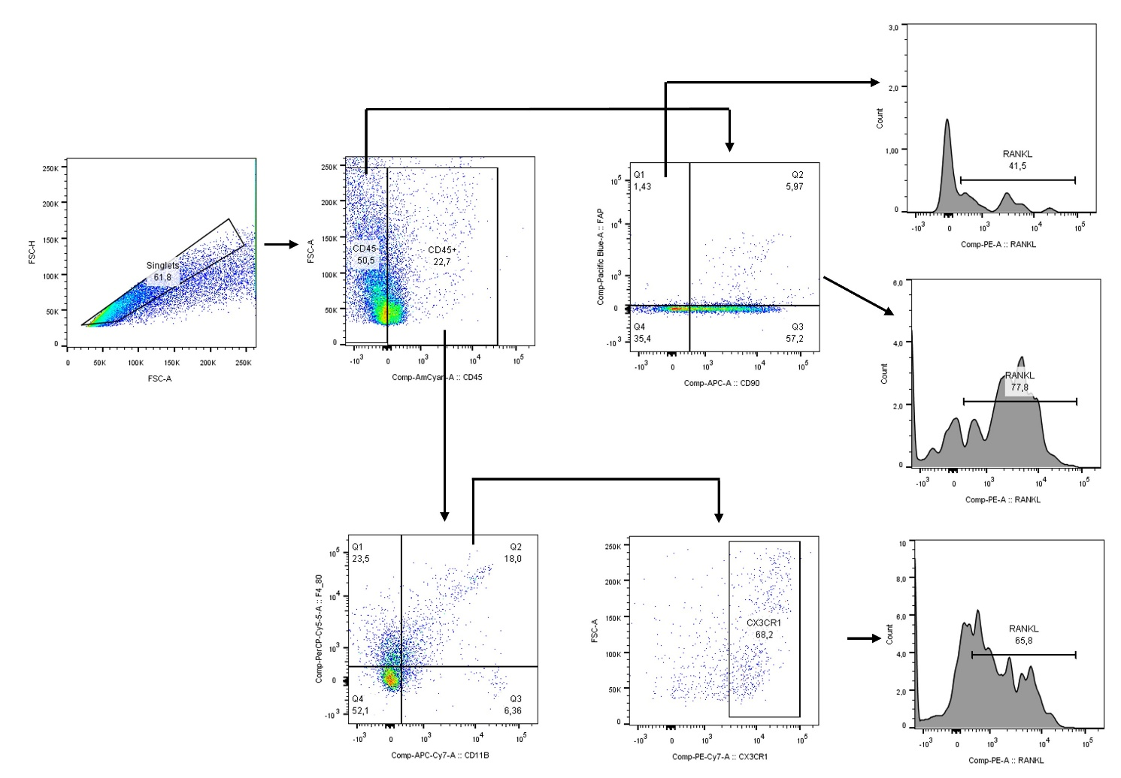
Gatting strategy related to Figure 6

