Figure S1. Relationship between Pb concentrations in 17 paired whole blood and RBC samples used to adjust our larger sample of RBC-derived American Robin blood Pb data. The darker band and line show the 95% confidence interval and fitted values for our GLM, whereas the lighter band and line show predictions from this model extended to the full range of our RBC-derived blood Pb data. The dashed line shows the 1:1 relationship between blood Pb concentrations.

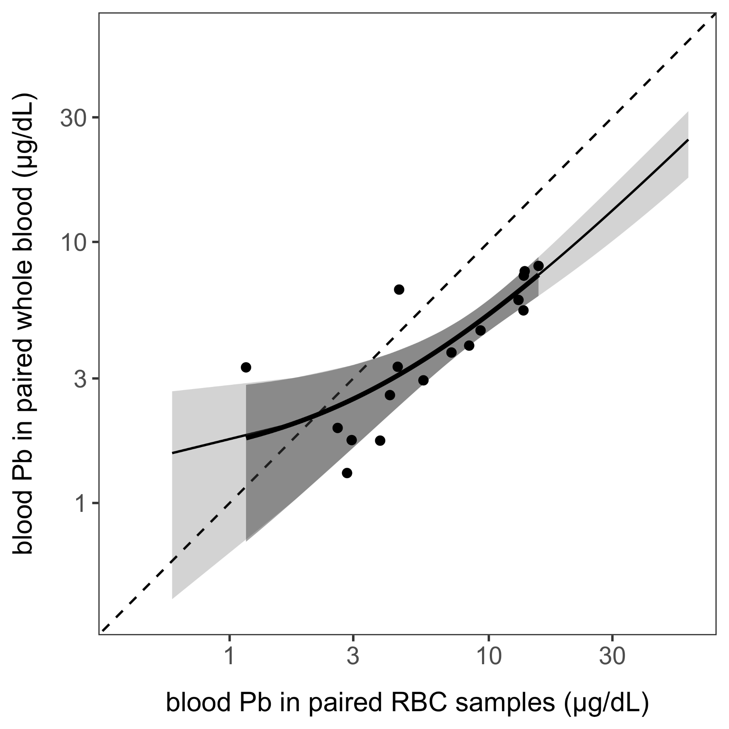

Table S1. GLM results from the analysis of demographic factors predicting log₁₀-transformed American Robin blood Pb concentration in our whole dataset (n = 245).

Coefficient | β | SE | t | p
Intercept | 0.77 | 0.08 | 9.61 | < 0.001
Male | -0.11 | 0.06 | -1.75 | 0.08
Unknown sex | -0.11 | 0.06 | -1.85 | 0.06
AHY | -0.15 | 0.06 | -2.61 | < 0.01
Unknown age | -0.09 | 0.13 | -0.75 | 0.45

Table S2. GLM results from the analysis of geographic factors predicting log₁₀-transformed American Robin blood Pb concentration in our spring data subset (n = 162).

Coefficient | β | SE | t | p
Intercept | 0.54 | 0.05 | 10.21 | < 0.001
Indiana | 0.13 | 0.04 | 3.42 | < 0.001
Male | -0.10 | 0.05 | -1.95 | 0.05
Unknown sex | -0.15 | 0.06 | -2.74 | < 0.01

Table S3. GAM results from the season-focused analysis of log₁₀-transformed American Robin blood Pb concentration within our Indiana subset of the data (n = 194). The table reports the parametric results.

Coefficient | β | SE | t | p
Intercept | 0.72 | 0.10 | 7.08 | < 0.001
2022 | 0.03 | 0.06 | 0.45 | 0.66
2023 | 0.01 | 0.07 | 0.19 | 0.85
Male | -0.07 | 0.08 | -0.83 | 0.41
Unknown sex | -0.08 | 0.09 | -0.98 | 0.33
AHY | -0.12 | 0.06 | -1.87 | 0.06
Unknown age | -0.03 | 0.13 | -0.20 | 0.84

Table S4. GLM results from American Robin blood Pb concentration predicting body condition (n = 216).

Coefficient | β | SE | t | p
Intercept | -0.10 | 1.85 | -0.05 | 0.96
log₁₀ Pb | -0.91 | 1.17 | -0.78 | 0.44
Male | -0.08 | 1.37 | -0.06 | 0.95
Unknown sex | -0.04 | 1.35 | -0.03 | 0.98
AHY | 0.64 | 1.04 | 0.61 | 0.54
Unknown age | 3.55 | 2.39 | 1.49 | 0.14

