Electronic Supplementary Information
Tailoring Band Gap and Light Absorption in M-TiNT (M= Cu²⁺, Ni²⁺, Co²⁺ and Fe³⁺) for Water Remediation
Melissa Méndez-Galván*, César L. Ordoñez-Romero, Hugo A. Lara-García* and Gabriela Díaz*
ª Instituto de Física, Depto. Física Química, Universidad Nacional Autónoma de México, Cd. Universitaria, A.P. 20-364, 01000 CDMX, México. Email: hugo.lara@fisica.unam.mx
Corresponding Author: Hugo A. Lara-García

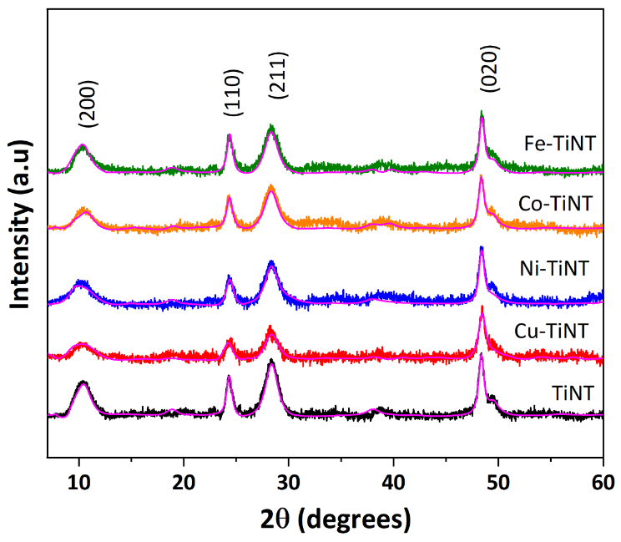
Figure S1. Experimental XRD patterns and smoothed-free background XRD patterns by Rietveld refinement of as-prepared TiNT.
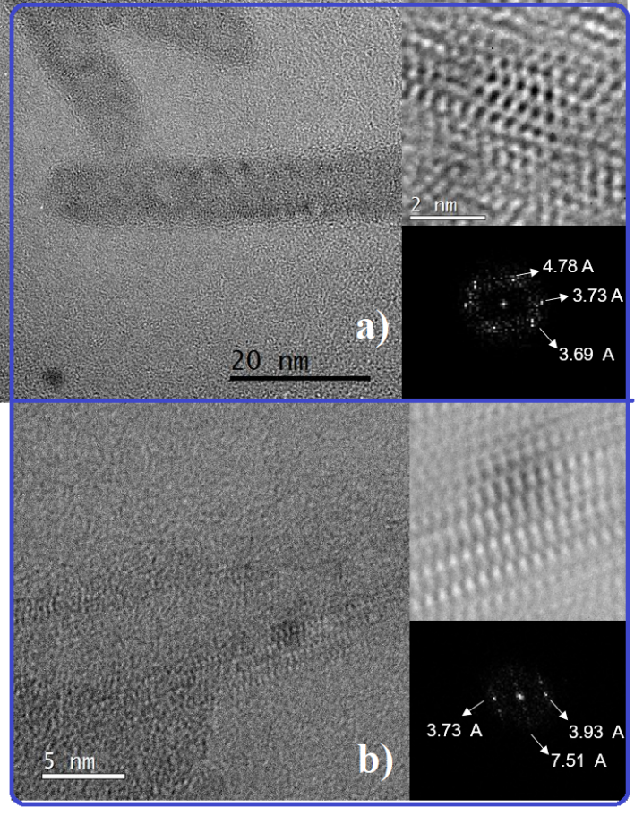
Figure S2. Representative HRTEM image of: (a) Ni-TiNT, showing nucleated nanoparticles on the walls of the TiNT, and (b) Co-TiNT presenting a moiré pattern.

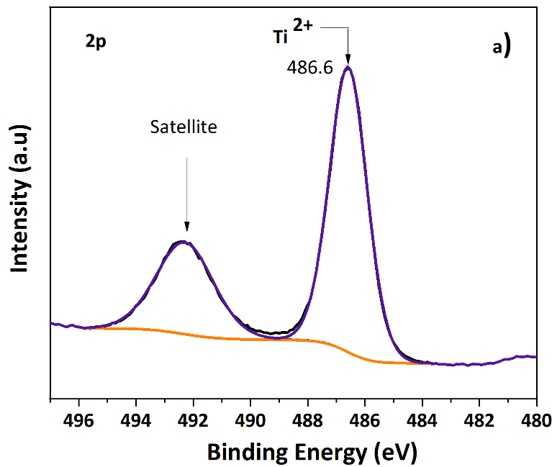
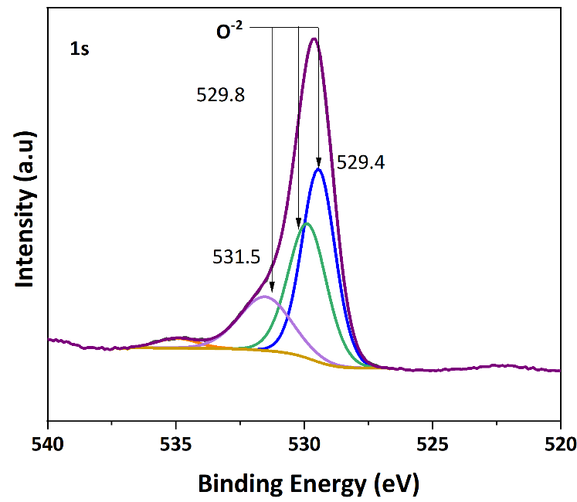
Figure S3. a) XPS spectra and fitting curves of 2p Ti, and b) 1s O regions of the TiNT.

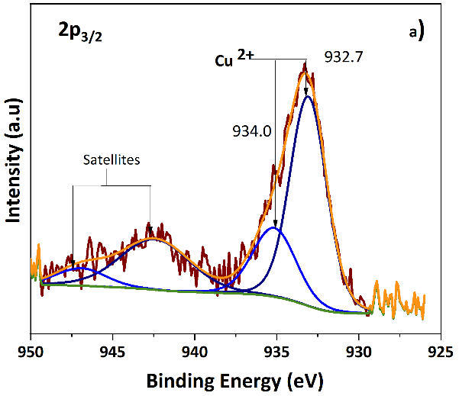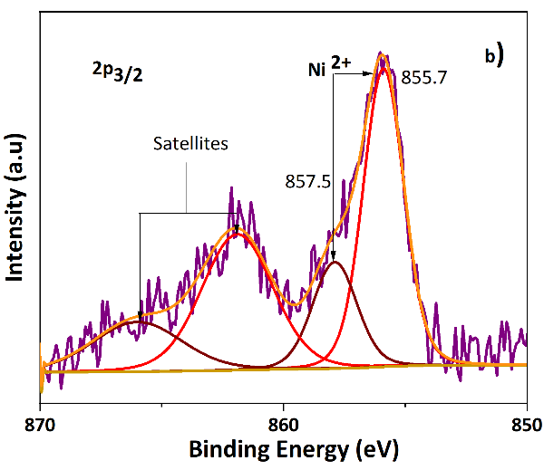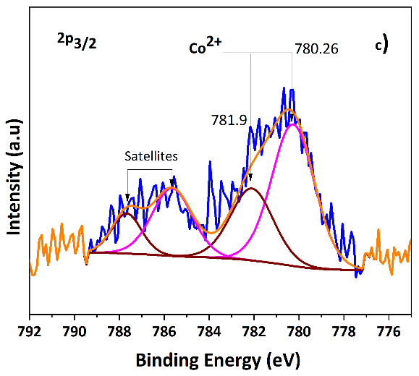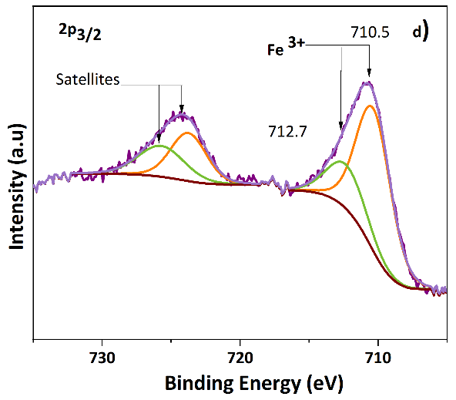
Figure S4. XPS spectra and fitting curves of Cu, Ni, Co and Fe 2p_{3/2} region (a) Cu-TiNT, (b) Ni-TiNT, (c) Co-TiNT and (d) Fe-TiNT.

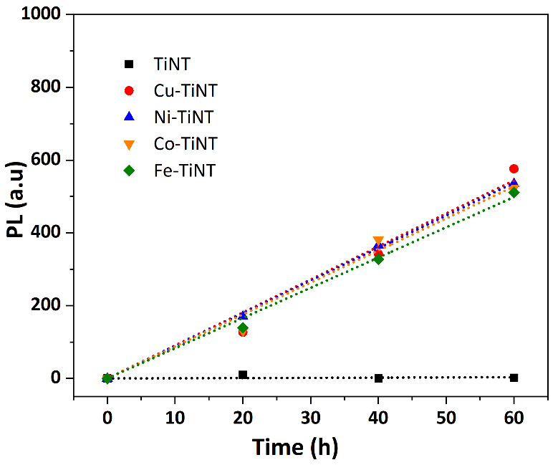
Figure S5. PL intensity as a function of the •OH radical concentration, under visible light.

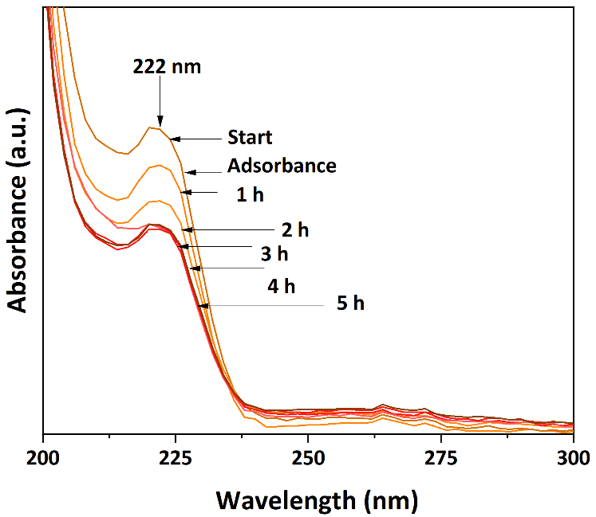
Figure S6 Representative spectrum of the ibuprofen degradation using Co-TiNT under visible light.

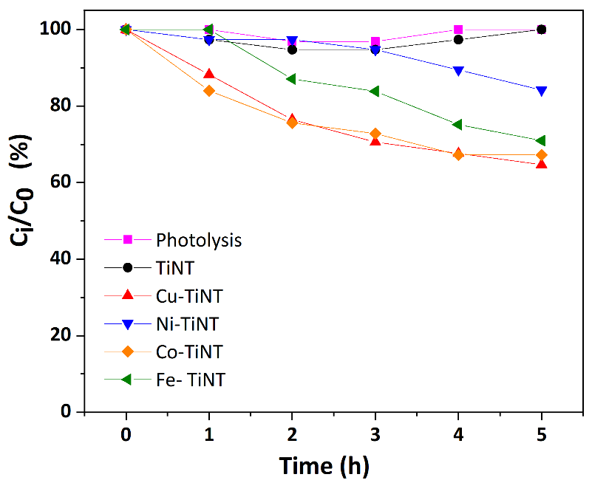
Figure S7. Ibuprofen degradation vs. time under visible light.

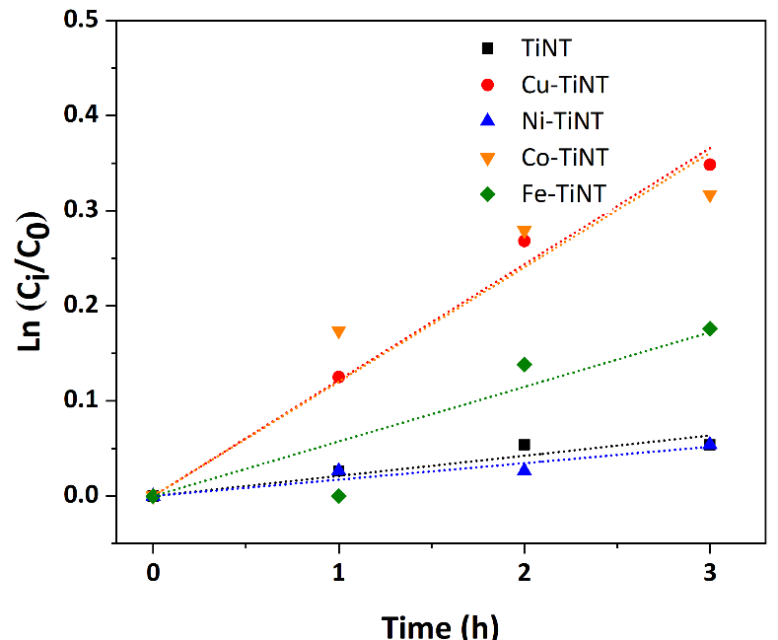
Figure S8 Pseudo first-order kinetic model for the IB decomposition under visible light.

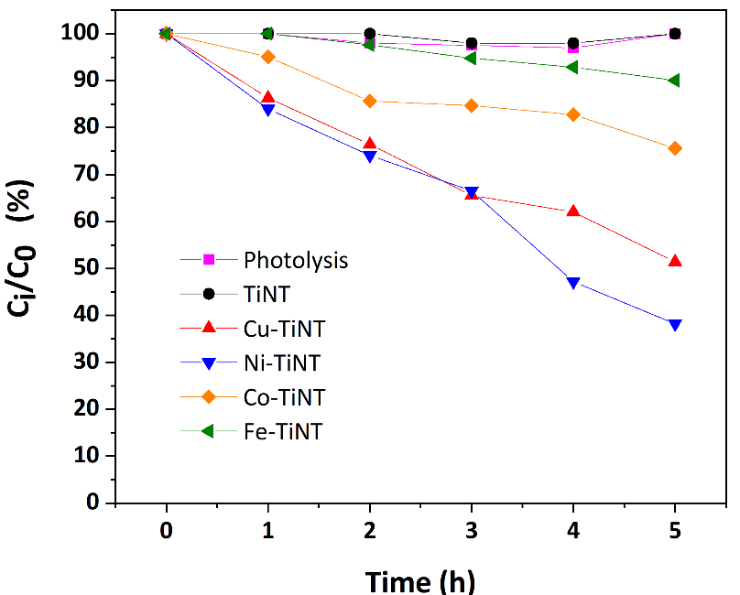
Figure S9. Indigo carmine degradation vs. time under visible light.

