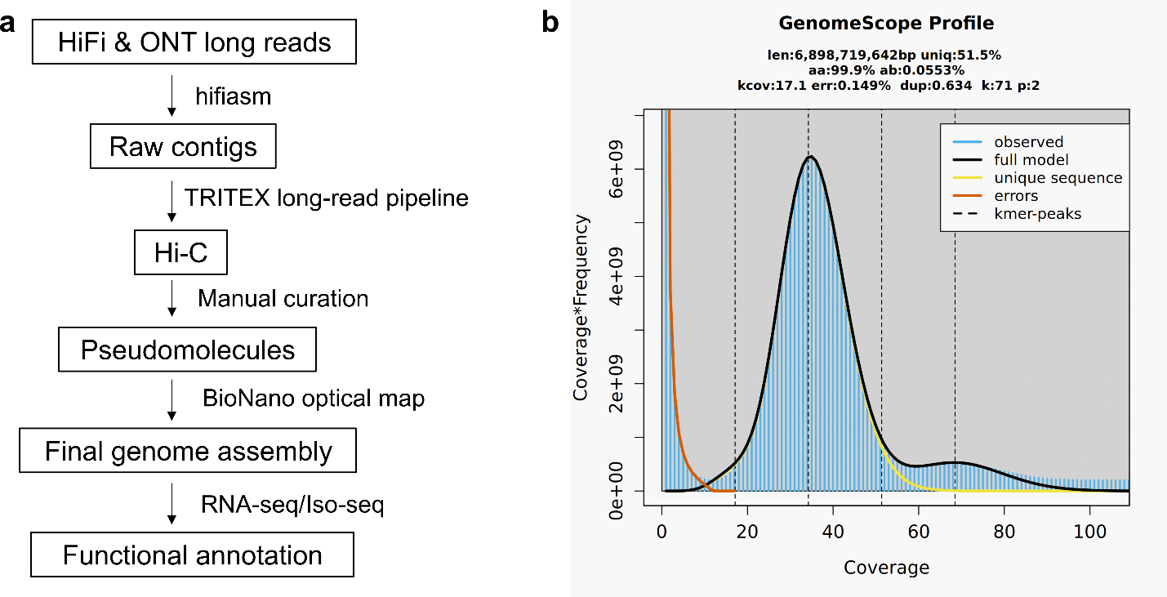

Supplementary Figure 1. Genome assembly pipeline and heterozygosity estimation of Lo7. a Genome assembly and functional annotation pipeline of Lo7_V3. b Heterozygosity estimation of Lo7. Heterozygosity was determined by GenomeScope 2.0¹, based on k-mer (71) analysis of HiFi reads.

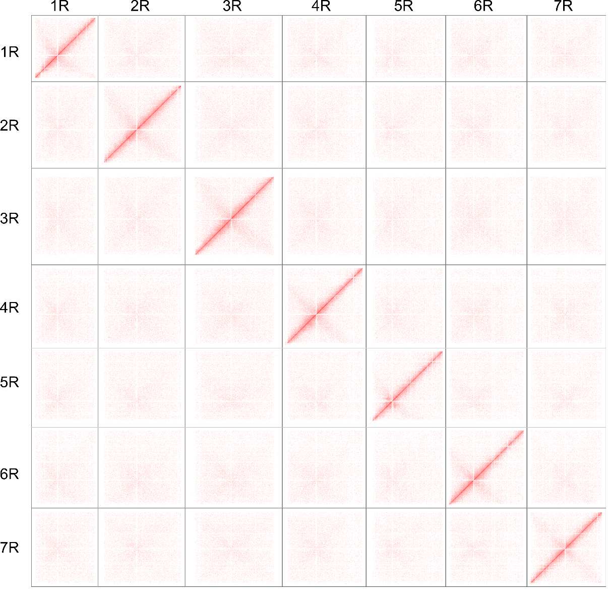

Supplementary Figure 2. Hi-C contact map of Lo7_V3. Hi-C contact matrix visualized at 200 kb resolution shows chromatin interaction frequency across the assembled rye chromosomes. The intensity of each pixel reflects the contact frequency between two genomic regions. Centromeric and pericentromeric regions exhibit reduced contact frequencies.

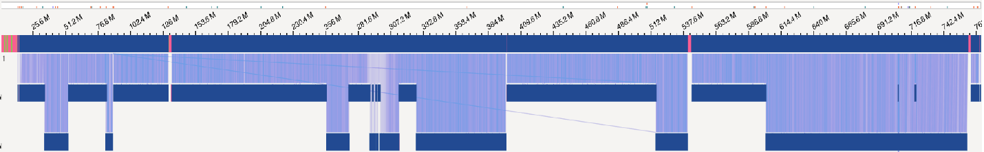

Supplementary Figure 3. Validation of pseudomolecule assembly using optical genome map. Optical genome map (OGM) contigs were aligned to chromosome 1R pseudomolecule.

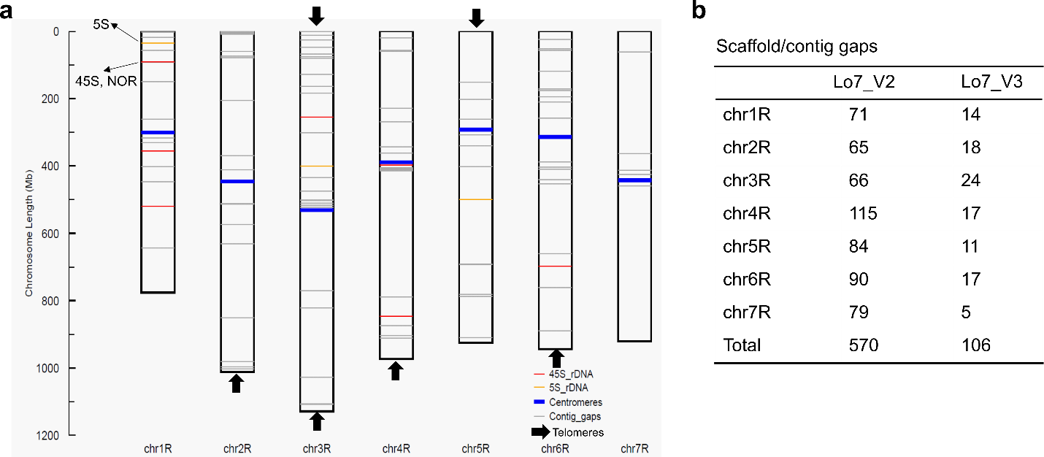

Supplementary Figure 4. Assessment of genome assembly completeness. a Visualization of 5S and 45S rDNA, centromeres, telomeres, and contig gaps across the seven chromosomes of Lo7_V3. b Comparison of gap counts between Lo7_V2 (scaffold-based) and Lo7_V3 (contig-based) assemblies.
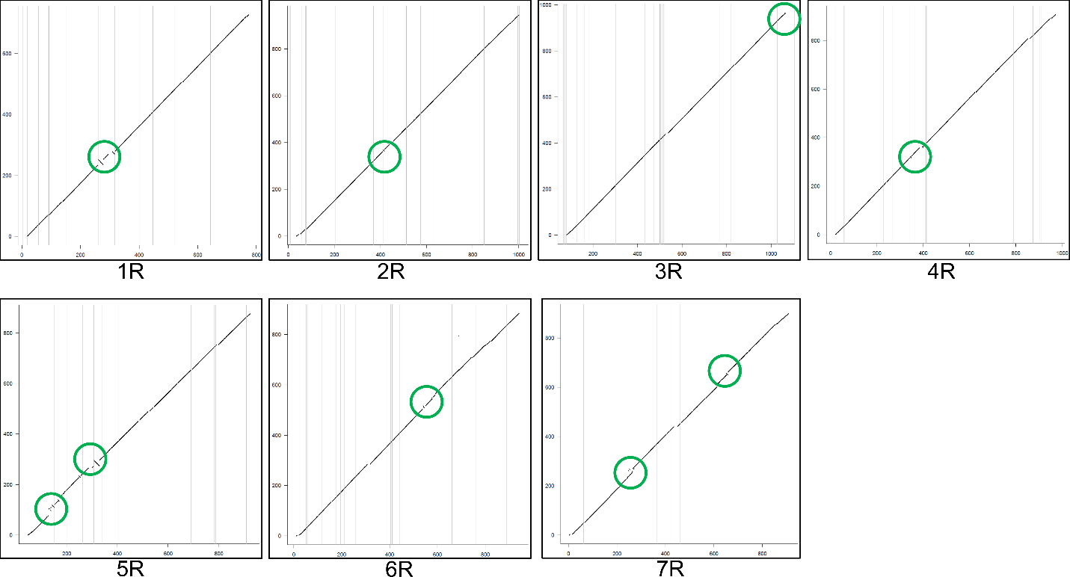

Supplementary Figure 5. Collinearity plot between Lo7_V2 and Lo7_V3. Each green circle indicates a region of orientation error identified in Lo7_V2. x-axis, Lo7_V3; y-axis, Lo7_V2.

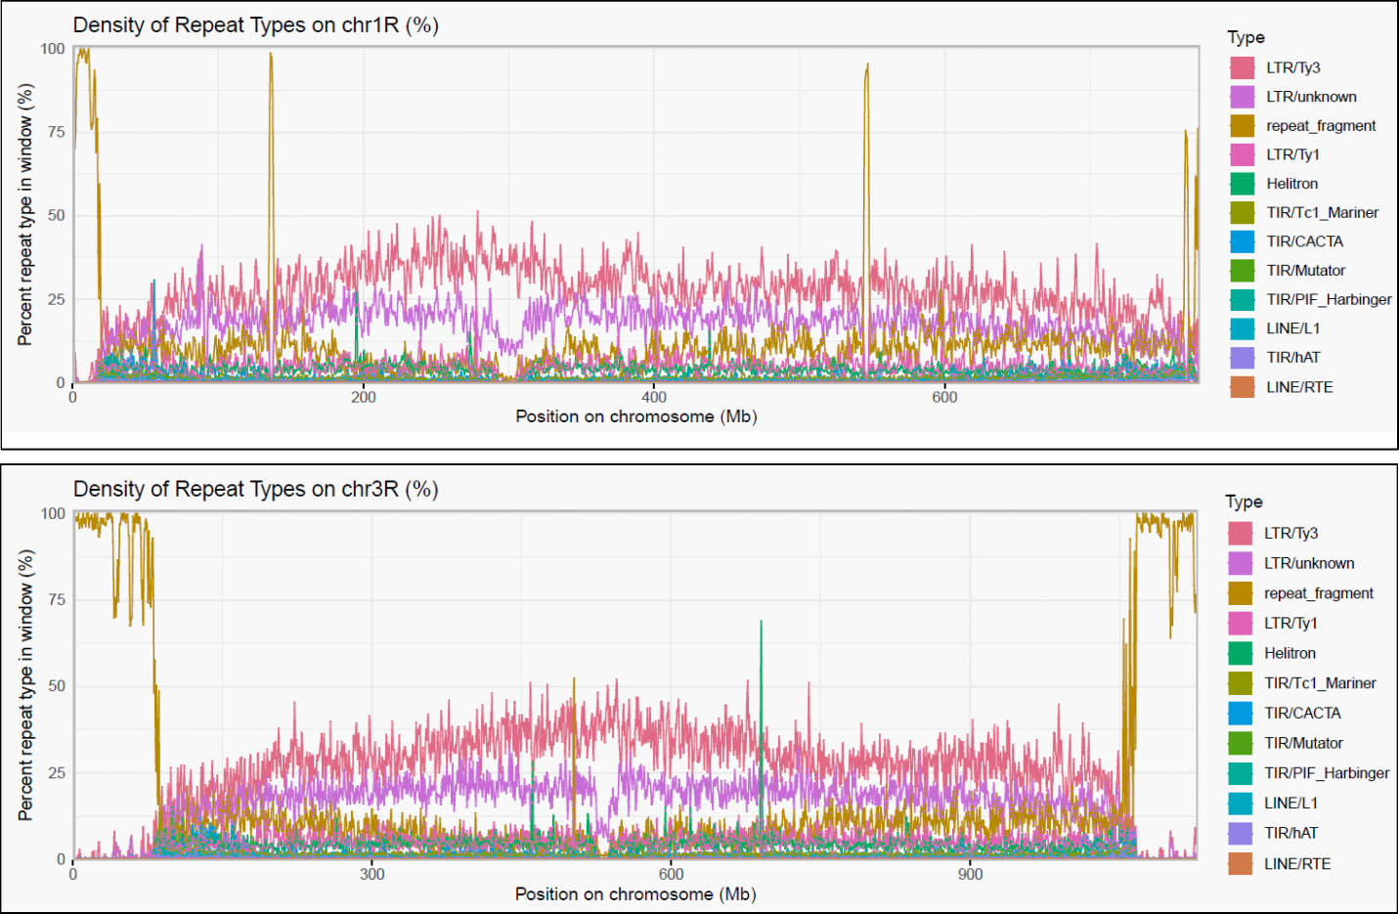

Supplementary Figure 6. Repeat content across the genome was identified and classified using EDTA. The density of major repeat types, including LTR retrotransposons (Gypsy and Copia), DNA transposons, and unclassified elements, was calculated in fixed genomic windows to visualize their distribution patterns along chromosomes 1R and 3R. DNA transposons were further classified into terminal inverted repeat (TIR) elements, Helitron (rolling-circle transposons), and non-LTR retrotransposons such as LINEs (long interspersed nuclear elements).

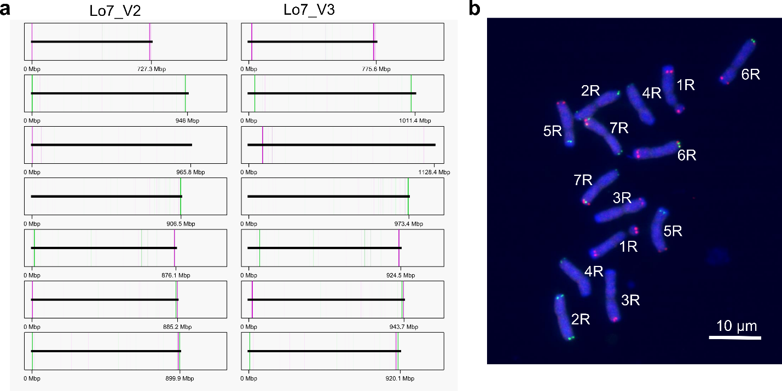

Supplementary Figure 7. Painting probes were designed from Lo7_V2 and Lo7_V3 assemblies. a Probes were developed and visualized based on the two Lo7 genome assemblies. b Fluorescence in situ hybridization (FISH) experiments were performed using the painting probes derived from in silico computation. Scale bar: 10 µm.

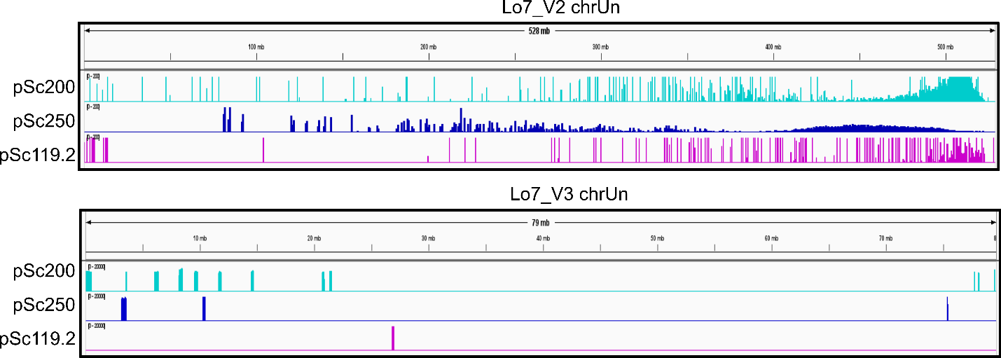

Supplementary Figure 8. Visualization of pSc200, pSc250 and pSc119.2 distribution in unanchored parts of two Lo7 assemblies. chrUn, unanchored regions.

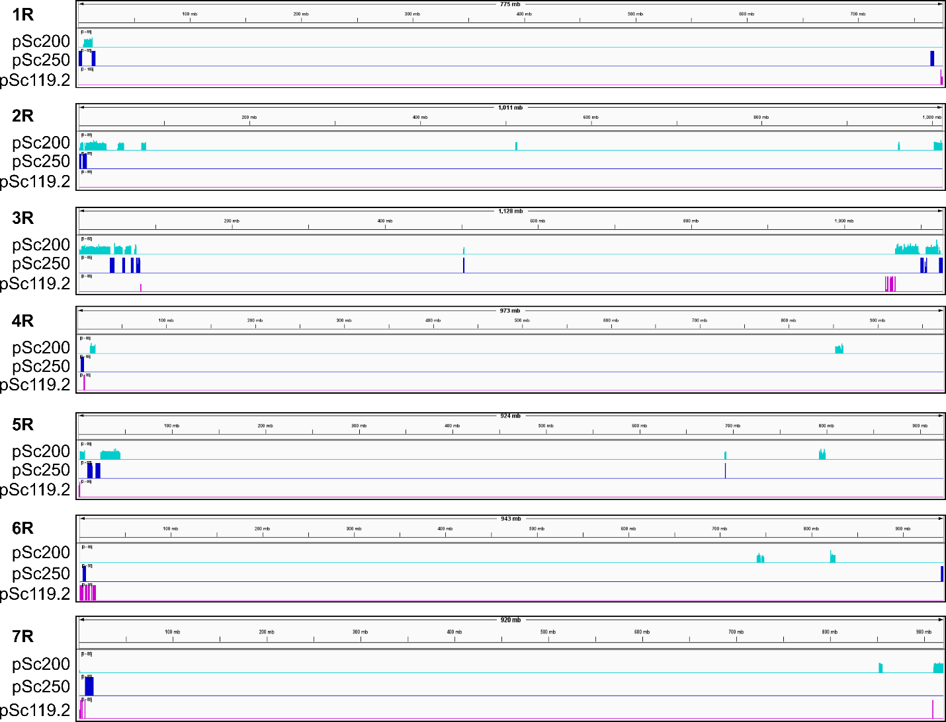

Supplementary Figure 9. Visualization of pSc200, pSc250 and pSc119.2 distribution from Lo7 1R-7R.

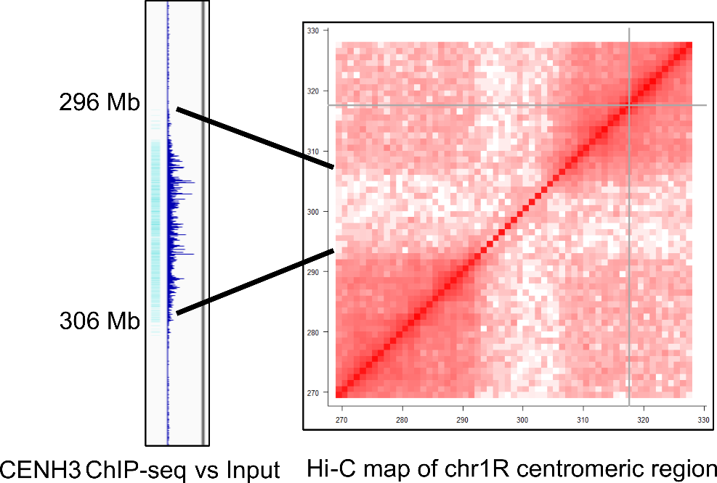

Supplementary Figure 10. Centromere size predictions of Lo7_V3. (a) Seven complete rye centromeres were identified and their sizes were determined. (b) Identification of the centromeric region on chromosome 1R using CENH3 ChIP-seq data combined with Hi-C interaction analysis. Gray lines in Hi-C maps denote contig gap within chromosome 1R.
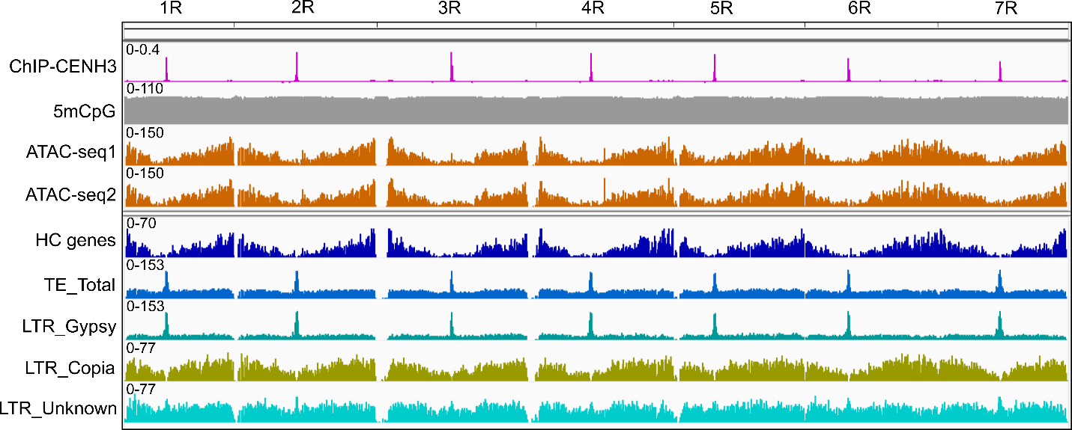

Supplementary Figure 11. Structural analysis of seven rye complete centromeres. To investigate the structural organization of genes within centromeric regions, we integrated multiple genomic and epigenomic datasets, including CENH3 ChIP-seq, ATAC-seq, 5mCpG methylation, high-confidence gene annotations, and TE annotations.
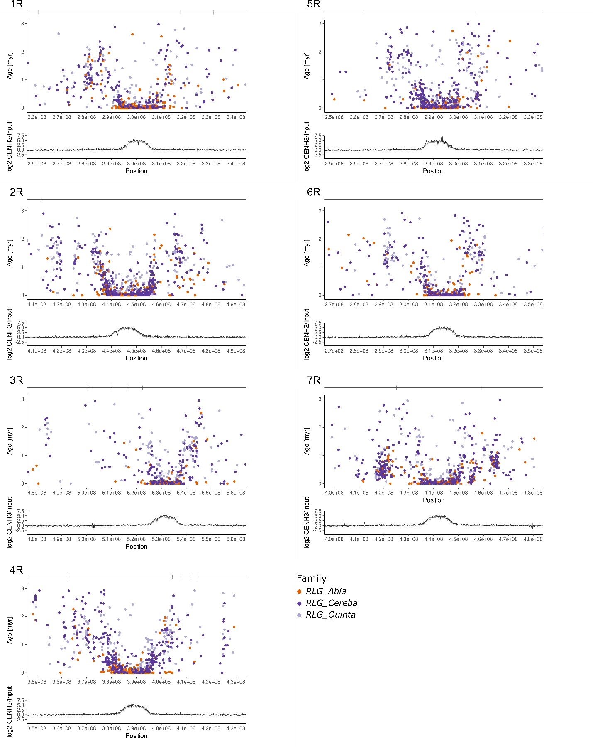

Supplementary Figure 12. Distribution of the estimated insertion ages of copies from the retrotransposon families RLG_Avia (orange), RLG_Cereba (dark purple) and RLG_Quinta (light purple) across the pericentromeric regions of rye Lo7. Copies with an estimated insertion age of 3 million years or younger are shown. The marks on the gray track at the top display the assembly gaps found in the respective region per chromosome. The bottom track shows the corresponding CENH3 ChIP-seq data.

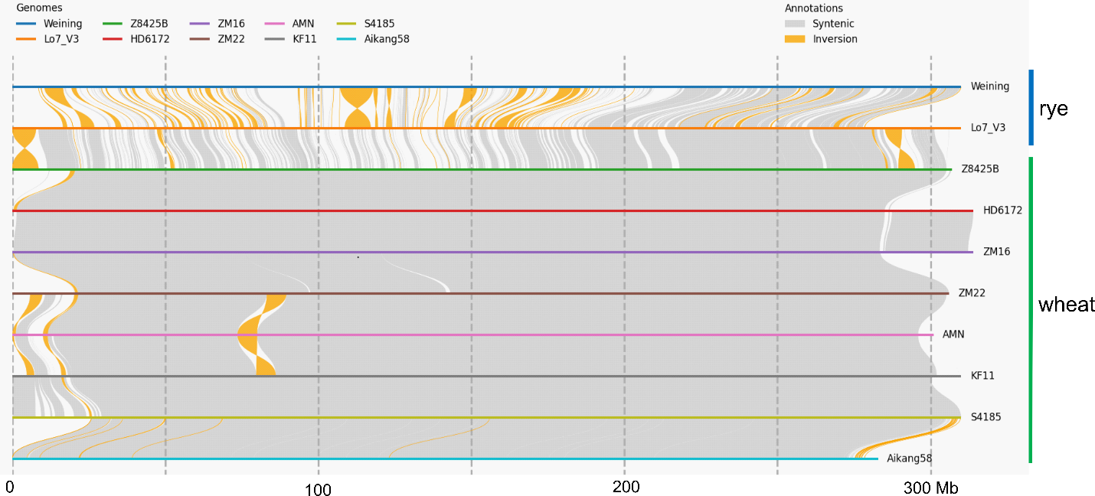

Supplementary Figure 13. Comparative analysis of 1RS between wheat and rye accessions. Comparative analysis of the 1RS chromosome arm was conducted between two rye accessions and the 1RS arm of eight diverse wheat accessions. The analysis reveals conserved synteny as well as structural variations, highlighting the divergence and potential introgression events between species.

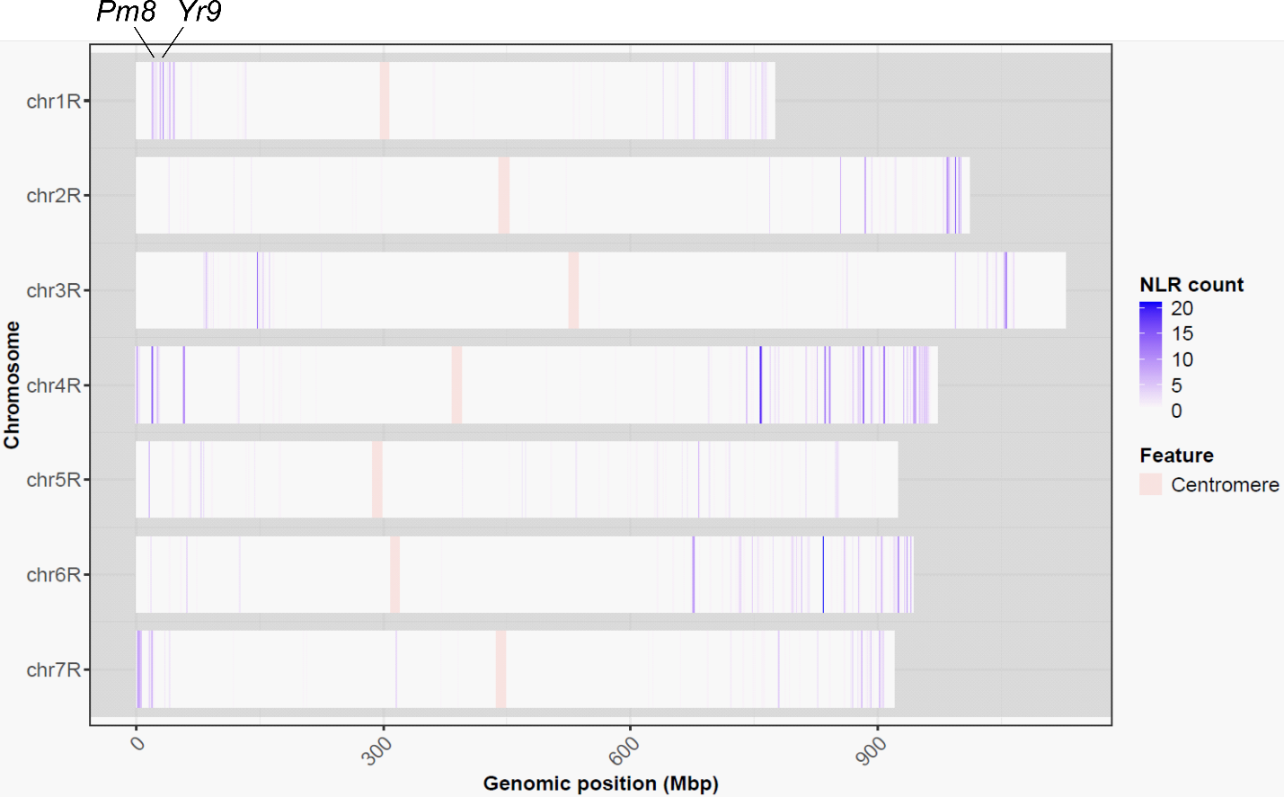

Supplementary Figure 14. Distribution of R genes across the seven chromosomes. The number of R genes (e.g., NLRs) was calculated in non-overlapping 1 Mb genomic bins along each chromosome, using NLR-Annotator². Color intensity represents the gene count per bin, ranging from low (white) to high (blue). Centromeric regions are highlighted in mistyrose. Blast resistance-associated genes, including Pm8/S.CEREALE.LO7.r2.1RG00003910³ and Yr9/S.CEREALE.LO7.r2.1RG00006720 ^{4,5}, are located on chromosome 1R.

References
1 Ranallo-Benavidez, T. R., Jaron, K. S. & Schatz, M. C. GenomeScope 2.0 and Smudgeplot for reference-free profiling of polyploid genomes. Nat Commun 11, 1432, doi:10.1038/s41467-020-14998-3 (2020).
2 Steuernagel, B. et al. The NLR-Annotator Tool Enables Annotation of the Intracellular Immune Receptor Repertoire. Plant Physiol 183, 468-482, doi:10.1104/pp.19.01273 (2020).
3 Hurni, S. et al. Rye Pm8 and wheat Pm3 are orthologous genes and show evolutionary conservation of resistance function against powdery mildew. Plant J 76, 957-969, doi:10.1111/tpj.12345 (2013).
4 Yu, Y. et al. Wheat stripe rust resistance gene Yr9, derived from rye, is a CC-NBS-LRR gene in a highly conserved NLR cluster. Sci China Life Sci, doi:10.1007/s11427-024-2932-5 (2025).
5 Wang, C. et al. The Yr9 gene encoding a CC-NBS-LRR protein in the 1RS-1BL translocation confers wheat stripe rust resistance. Sci China Life Sci, doi:10.1007/s11427-025-2929-6 (2025).

