Appendix A.
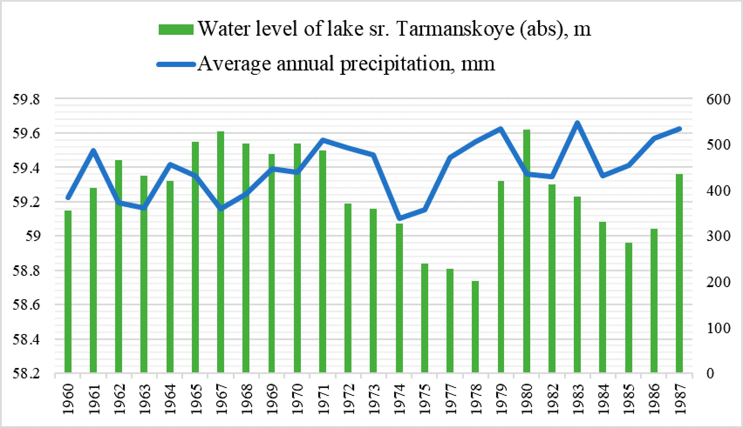
Figure 11. Water level of lake Sr. Tarmanskoe
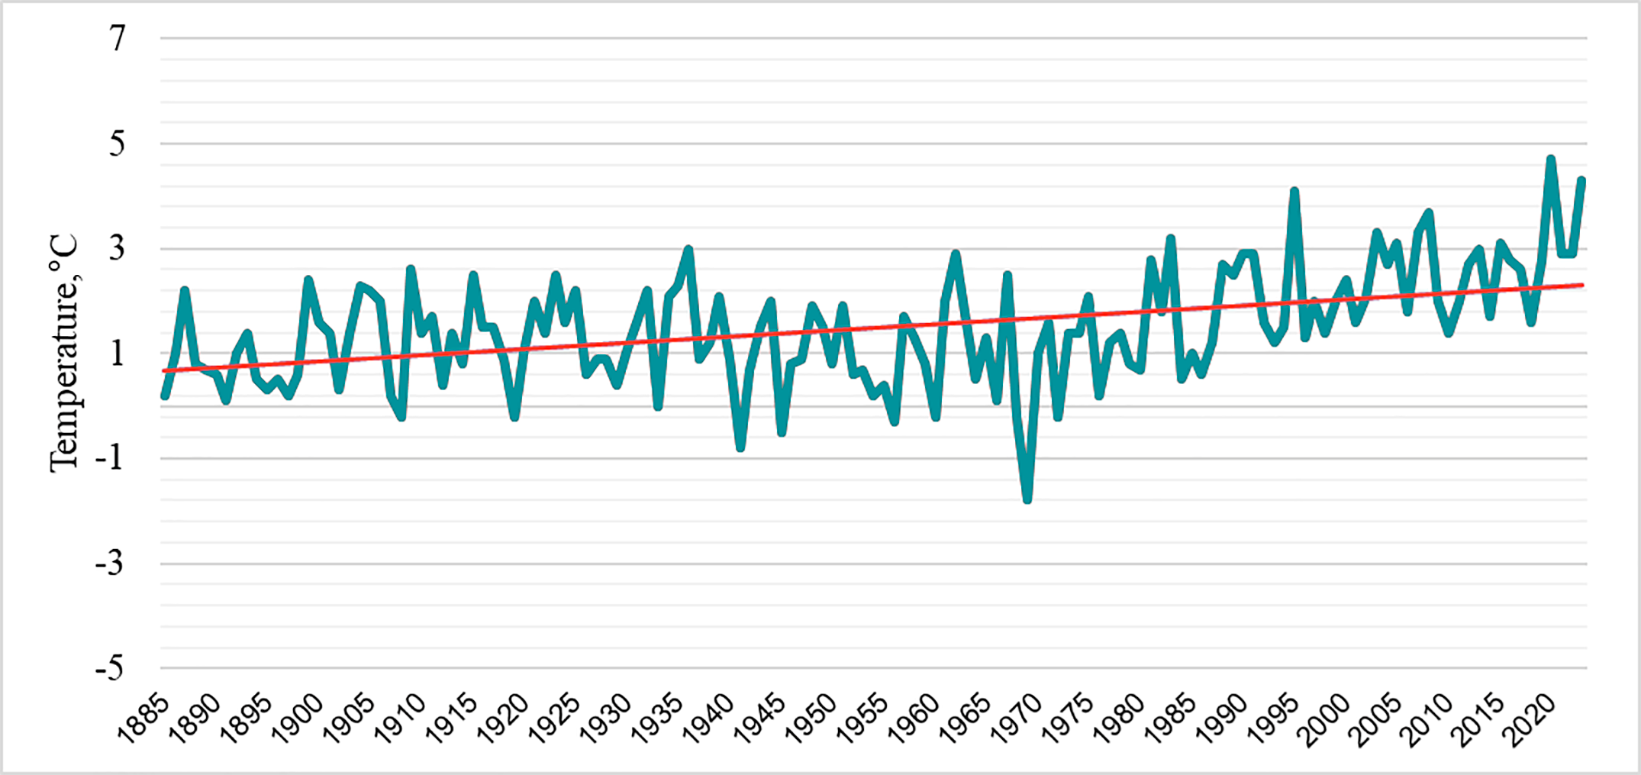
Figure 12. Average annual temperature dynamics from 1885 to 2023
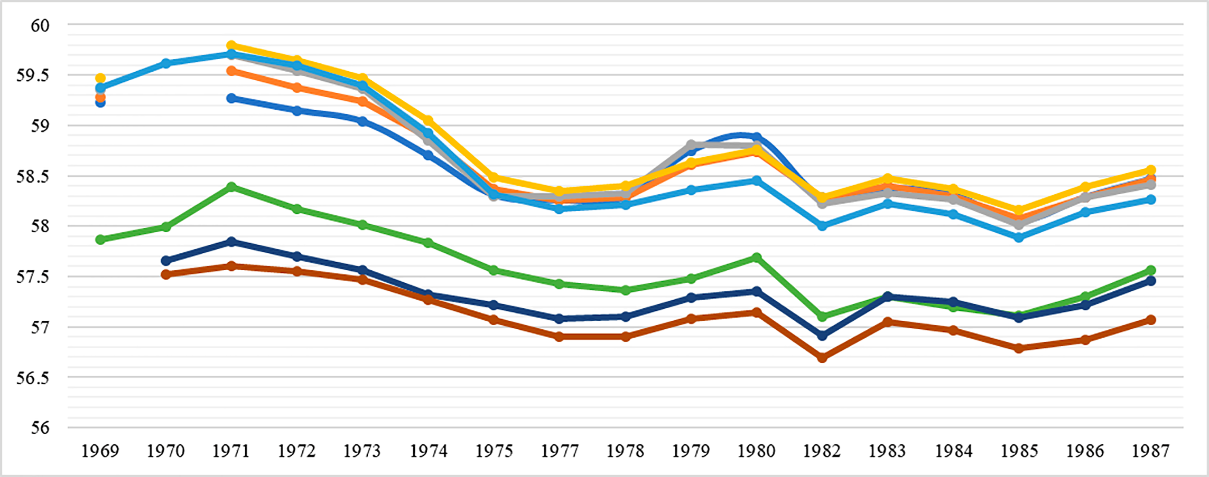
Figure 13. Level of shallow groundwater in hydrological wells
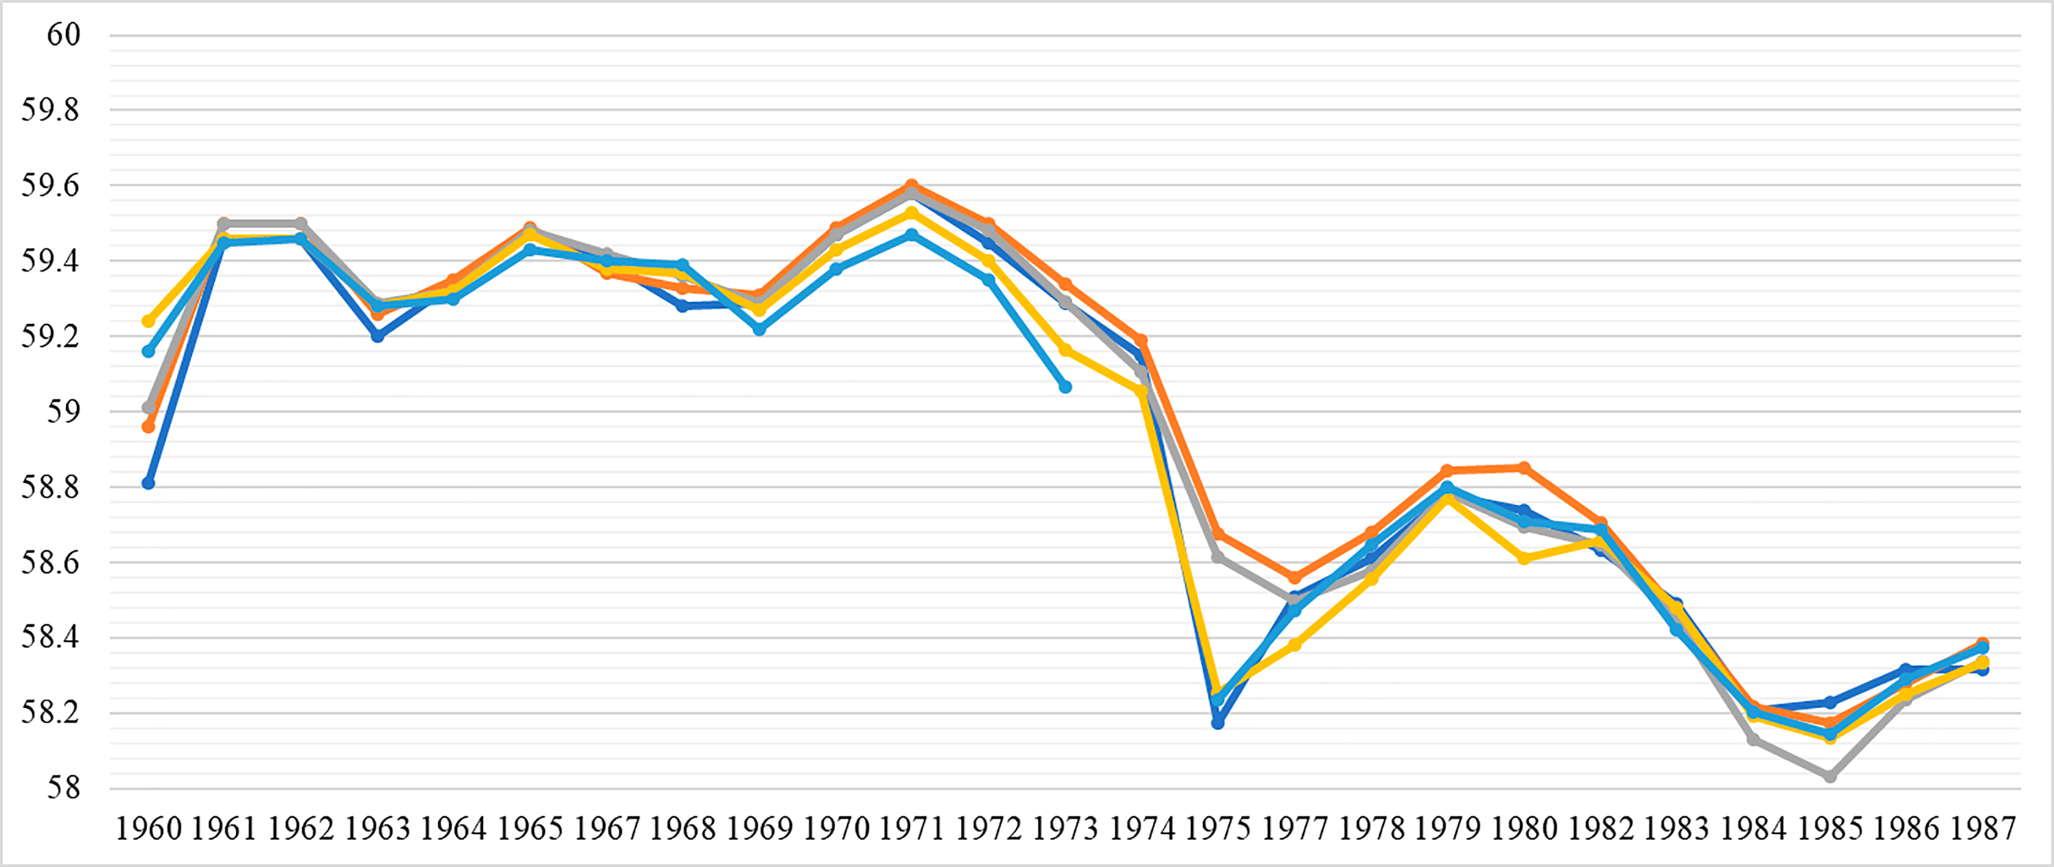
Figure 14. Level of fen water

