Supplemental materials

The dual role of the C4 proteins and consequences in first-episode psychosis

Authors: Shokouh Arjmand^{1,2*}, Samudyata¹, Fredrik Piehl³, Aurimantas Pelanis⁴, Göran Engberg^{1,5}, Simon Cervenka^{6,7}, Mikael Landén ^{8,9}, Sophie Erhardt¹, Carl M. Sellgren^{1,6*}

¹ Department of Physiology and Pharmacology, Karolinska Institutet, Stockholm, Sweden
² Department of Clinical Medicine, Translational Neuropsychiatry Unit, Aarhus University, Aarhus, Denmark
³ Neuroimmunology Unit, Department of Clinical Neuroscience, Karolinska Institutet, and Neuro Division, Karolinska University Hospital, Stockholm, Sweden
⁴ Department of Anesthesiology, Sahlgrenska University Hospital, Gothenburg, Sweden
⁵ Institute of Sport Science and Innovations, Lithuanian Sports University, Kaunas, Lithuania
⁶ Centre for Psychiatry Research, Department of Clinical Neuroscience, Karolinska Institutet & Stockholm Health Care Services, Region Stockholm, Sweden
⁷ Department of Medical Sciences, Psychosis Research and Preventive Psychiatry, Uppsala University, Uppsala, Sweden
⁸ Institute of Neuroscience and Physiology, University of Gothenburg, Gothenburg, Sweden
⁹ Department of Medical Epidemiology and Biostatistics, Karolinska Institutet, Stockholm, Sweden

*Correspondence to: Shokouh Arjmand (shokouh.arjmand@ki.se) & Carl M. Sellgren (carl.sellgren@ki.se)
C3 Fysiologi och farmakologi, C3 FyFa Cellulär modellering av psykiatriska sjukdomar, 171 77 Stockholm
Table S1: Demographic and clinical characteristics of the participants
 |  |  |  |  |  |  |  |  |  |  |  |  |  |  |  |  | 95% Confidence Interval Std. Dev.
 |  |  |  |  | Valid |  |  | p values |  |  | Mean |  |  | Std. Deviation |  |  | Lower |  |  | Upper
Sex (F/M) |  |  | HCs |  |  | 90 (42/48) |  |  | 0.136 |  |  | - |  |  | - |  |  | - |  |  | -
 |  |  | FEPs |  |  | 113 (41/72) |  |  |  |  |  | - |  |  | - |  |  | - |  |  | -
Age |  |  | HCs |  |  | 90 |  |  | 0.006 |  |  | 37.66 |  |  | 14.22 |  |  | 12.40 |  |  | 16.67
 |  |  | FEPs |  |  | 113 |  |  |  |  |  | 31.94 |  |  | 10.03 |  |  | 8.87 |  |  | 11.54
BMI (kg/m²) |  |  | HCs |  |  | 88 |  |  | 0.920 |  |  | 24.68 |  |  | 3.58 |  |  | 3.11 |  |  | 4.20
 |  |  | FEPs |  |  | 111 |  |  |  |  |  | 24.69 |  |  | 4.25 |  |  | 3.76 |  |  | 4.90
Nicotine use |  |  | HCs |  |  | 88 (15/88) |  |  | 0.020 |  |  | - |  |  | - |  |  | - |  |  | -
 |  |  | FEPs |  |  | 87 (29/87) |  |  |  |  |  | - |  |  | - |  |  | - |  |  | -
PANSS Positive |  |  | HCs |  |  | NA
 |  |  | FEPs |  |  | 90 |  |  |  |  |  | 17.61 |  |  | 6.12 |  |  | 5.34 |  |  | 7.180
PANSS Negative |  |  | HCs |  |  | NA
 |  |  | FEPs |  |  | 90 |  |  |  |  |  | 16.50 |  |  | 6.59 |  |  | 5.75 |  |  | 7.73
PANSS General |  |  | HCs |  |  | NA
 |  |  | FEPs |  |  | 90 |  |  |  |  |  | 35.99 |  |  | 10.48 |  |  | 9.15 |  |  | 12.29
PANSS Total |  |  | HCs |  |  | NA
 |  |  | FEPs |  |  | 90 |  |  |  |  |  | 70.10 |  |  | 18.99 |  |  | 16.56 |  |  | 22.26
GAF-S |  |  | HCs |  |  | 52 |  |  |  |  |  | 84.58 |  |  | 7.71 |  |  | 6.46 |  |  | 9.56
 |  |  | FEPs |  |  | 67 |  |  |  |  |  | 33.63 |  |  | 10.34 |  |  | 8.84 |  |  | 12.47
GAF-F |  |  | HCs |  |  | 52 |  |  |  |  |  | 85.11 |  |  | 7.17 |  |  | 6.01 |  |  | 8.89
 |  |  | FEPs |  |  | 67 |  |  |  |  |  | 41.82 |  |  | 13.07 |  |  | 11.17 |  |  | 15.75
CGI |  |  | HCs |  |  | NA
 |  |  | FEPs |  |  | 72 |  |  |  |  |  | 4.53 |  |  | 1.20 |  |  | 1.03 |  |  | 1.43
DUP (Months) |  |  | HCs |  |  | NA
 |  |  | FEPs |  |  | 58 |  |  |  |  |  | 11.26 |  |  | 17.85 |  |  | 15.09 |  |  | 21.86
PANSS: Positive and Negative Syndrome Scale; GAF: Global Assessment of Functioning (Symptoms and Function); CGI: Clinical Global Impression; DUP: Duration of Psychosis; NA: Not Applicable

Figure S1

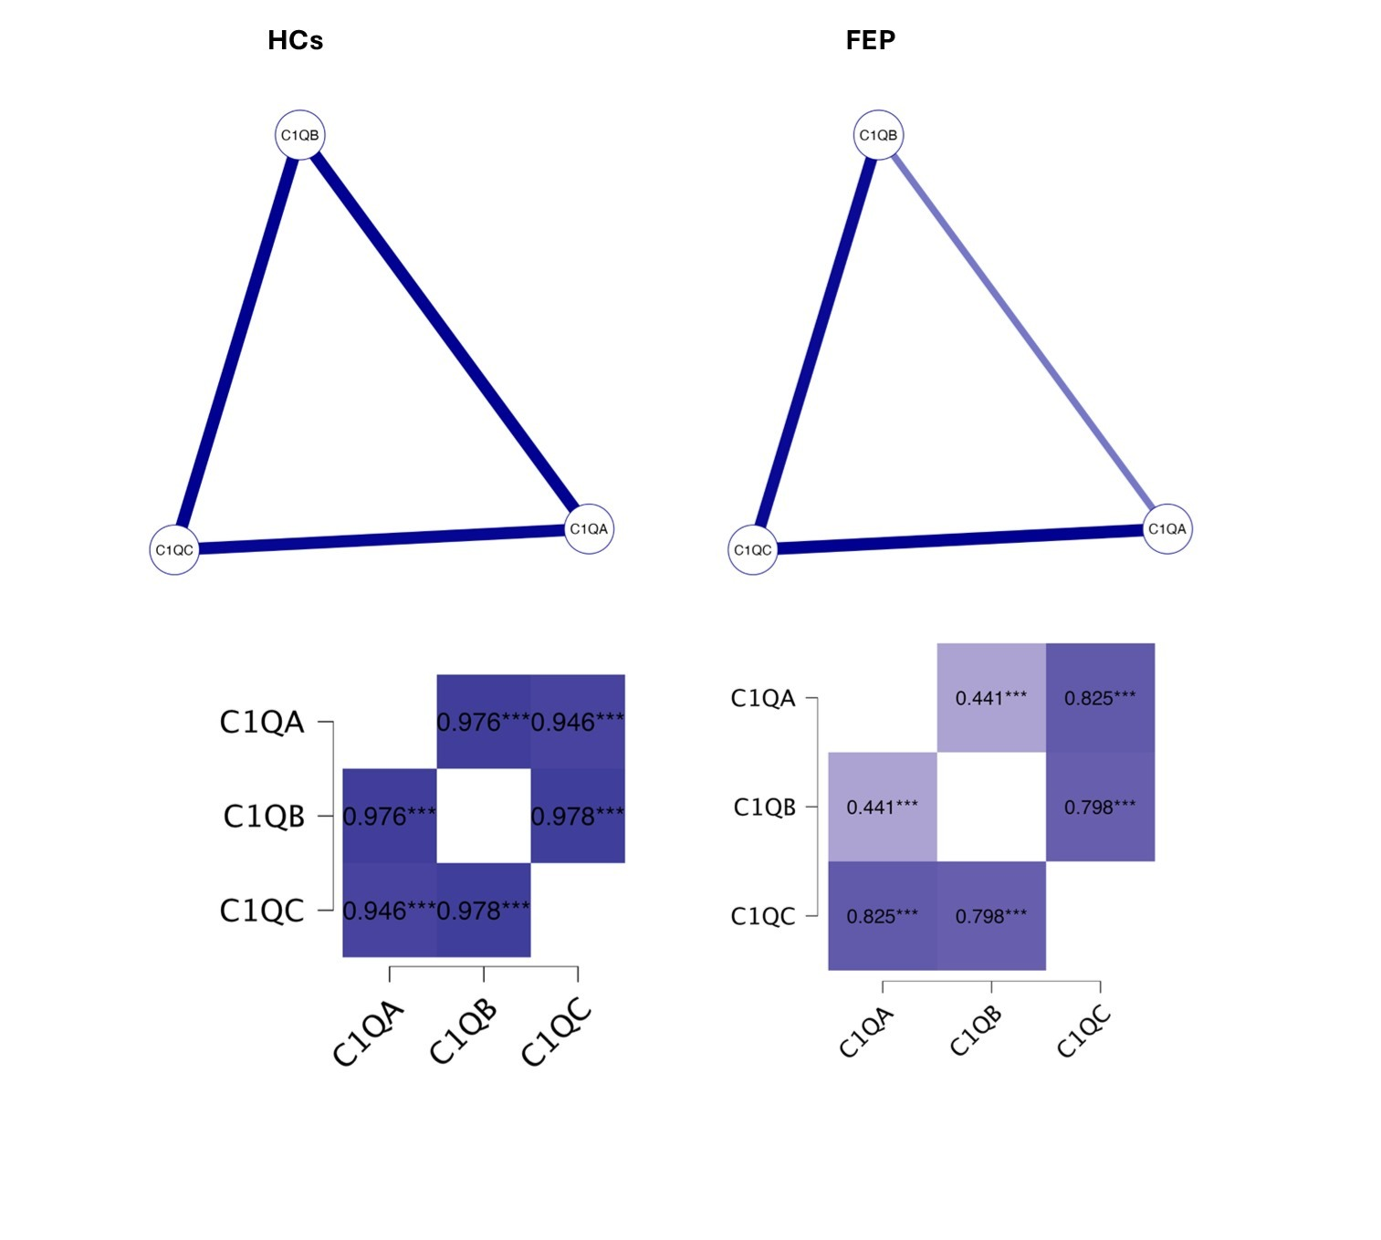

Fig. S1 | Network analyses and correlation matrices of the associations between CSF protein levels of C1QA, C1QB, and C1QC in healthy controls (HCs) and first-episode psychosis (FEP) patients adjusted for sex, age, and BMI.
In HCs, C1Q subtypes exhibit strong inter-correlations. Although the correlations remain statistically significant in FEP patients, their strength is comparatively reduced (strong for C1QA-C1QC as well as C1QB-C1QC, and moderate for C1QA-C1QB).

Figure S2

Fig. S2 | Correlation matrices of the associations between CSF protein levels of complement factors with sex, age, and BMI.

