Climate change triggers supply-chain losses that substantially exceed direct damages

Supplementary Information

Mengyu Li*, Manfred Lenzen*
ISA, School of Physics A28, The University of Sydney, NSW 2006, Australia
* Co-Corresponding author

Keywords: climate change impacts; production disruption; supply chains.

Table of Contents

SI 1: Detailed methods 2
SI 1.1 Input-output analysis 2
SI 1.2 Multi-region input-output disaster methods 2
SI 1.3 Minimum-disruption disaster method 4
SI 1.4 Constrained optimisation formalism 5
SI 1.5 Parameter and assumptions space sweeped 7
SI 1.6 Future crop yield assessments 8
SI 1.7 Assessing production recipe flexibility 11
SI 1.8 Producers’ and consumers’ losses – the total differential 14
SI 1.9 Production layers 14
SI 1.10 Structural paths 15
SI 2: Mixed- (1st- and 2nd-) order polynomial disruption function 16
SI 3: Literature comparison 17
SI 4: Supplementary results 18
References 19

SI 1: Detailed methods

SI 1.1 Input-output analysis

Let an economy be described by an $N×N$ intermediate transactions matrix T, an $N×N$ input coefficients matrix $A=T{\hat{x}}^{-1}$, $N×M$ final demand Y, $L×N$ value added V, and $N×1$ total output $x=Ti^{T}+Yi^{Y}={(I-A)}^{-1} Yi^{Y}=:{(I-A)}^{-1} Yi^{Y}$, where $L={(I-A)}^{-1}$ is the so-called Leontief inverse, and I is a suitable identity matrix, $i^{T}$ and $i^{Y}$ are suitable column summation operators of the form {1,1,…,1}$'$, the prime ‘$'$’ denotes vector and matrix transposition, $i^{V'}$ is a suitable row summation operator of the form {1,1,…,1}, and the hat ‘^’ symbol denotes vector diagonalization. This economy is in equilibrium, when $Ax+Y=x$. Let $S=\left[\begin{matrix}T & Y \\ V & 0\end{matrix}\right]$ be a $\left(L+N\right)×\left(N+M\right)$ compound input-output transactions matrix incorporating intermediate demand, final demand and value added. Let $B=S{\hat{\left(Si^{T}\right)}}^{-1}$be a compound input coefficients matrix, the equivalent of A for T (see ¹). Define an $N×N$ diagonal matrix $Γ$ of sectoral production losses, where the $Γ_{ii}∈[0,1]$ describe the fractional loss of production of sector $i$. Define {$\tilde{x},\tilde{Y},…$} as the post-disaster quantities of {$x,Y,…$}.

SI 1.2 Multi-region input-output disaster methods

A prominent method for investigating cascading spill-over effects of disasters is (multi-region) input-output (MRIO) analysis.² This research stream has a long-standing tradition³⁻⁵. As an example for climate-change-related impacts, a number of researchers⁶⁻¹¹ have investigated the economic impacts of floods.

Natural disasters and other large-scale shocks often impose severe constraints on the availability of essential inputs for economic production. When production technologies are characterized by fixed input coefficients (A in SI 1.1), the consequences of such shocks can be especially acute. In a Leontief framework (L in SI 1.1), inputs are required in strict proportions, and the absence or reduction of any one input leads to a directly proportional reduction in output, as substitution between inputs is not possible¹². This rigidity implies that the economy cannot reallocate resources flexibly to buffer the impact of the shock, leading to what can be described as a proportionally shrunken economy^{13,14}.

Under disaster conditions, supply chain disruptions, labour force displacement, and infrastructure damage may render key inputs partially or wholly unavailable.¹⁵ For example, if electricity supply is curtailed or transportation infrastructure is damaged, industries that depend on these services are unable to operate at full capacity, regardless of the availability of other inputs such as labour or raw materials. In such scenarios, the fixed production structure ensures that even minor disruptions in critical inputs can cascade through the production network, causing systemic reductions in economic output.^{3,16} The concept of a proportionally shrunken economy is thus a direct result of both the physical constraints imposed by disasters and the structural characteristics of input-output relationships. Input-output models, which are well-suited to capturing these interdependencies, consistently show that in the presence of non-substitutability, losses in input supply translate into proportionate losses in sectoral and aggregate output.¹⁷

In input-output (IO) disaster modelling, a persistent issue is the risk of excessive cascading effects due to the fixed production recipe assumption. Early approaches¹⁴ attempted to address disaster shocks by allocating all production losses to final demand. This removed disrupted outputs without triggering inter-industry feedbacks but often produced negative final demand values – interpreted as calls for external aid rather than internal economic responses. Later models^{16,18} introduced constraints to prevent such negative final demand. Instead of forcing unrealistic consumption reductions, they redirected the burden of losses into intermediate demand. This better captured supply-chain disruptions, but with fixed technical coefficients, it often led to amplified ripple effects and proportional shrinkage across sectors. To mitigate this, Schulte in den Bäumen¹⁶ introduced a methodological refinement: the elimination of marginal input coefficients (those contributing minimally to output). By excluding weak interdependencies, this reduced excessive knock-on effects and helped contain the size of the disrupted economic network, limiting cascading impacts. In these frameworks, final demand was stressed to the greatest extent possible, under the rationale that losses to intermediate demand could propagate through production chains and induce cascading effects that – because of the fixed production recipe – amplify economic damage and lead to a proportionally shrunken economy.

Oosterhaven and Bouwmeester^{19,20} emphasized that future disaster IO analyses should allow for flexibility and substitution in production. They critiqued the rigidity of standard IO assumptions and called for more behaviourally realistic models. Similarly, the European Central Bank²¹ acknowledged that global IO linkages amplify climate-related physical risks but also advocated for incorporating substitution to reflect real-world adaptive capacities.

Li et al.¹³ (used in this work) take a concrete step in this direction by introducing production recipe flexibility into the IO framework. Their model allows sectors to partially substitute inputs in response to shocks, thereby softening the impact of upstream disruptions and avoiding the unrealistic, proportionally shrunken economy typical of fixed-coefficient models. This methodological evolution marks an advance toward better reflecting economic resilience and adaptive behaviour in disaster contexts. The model has been validated in a case study of Venezuela.¹³

SI 1.3 Minimum-disruption disaster method

In this work we use an advanced, flexible disaster-analysis approach¹³ that allows incorporating human decisions, such as prioritising parts of the economy that need to be shielded from the disaster, and accounting for input substitutability (see the research gap identified by the European Central Bank²¹). This approach assumes a tendency of the economy to strive for minimum-disruption^{22,23}, by establishing post-disaster transactions $S$ that are as close as possible to pre-disaster equivalents $S_{0}$, subject to penalty weights. Proops and co-workers²⁴ define a symmetrical quadratic disruption function $D\left(S,S_{0},w\right)=\sum_{i}{{∆S}_{i}^{2}}=\sum_{i}{{\left(S_{i}-S_{0,i}\right)}^{2}}$, penalising losses and gains equally. This does however not conform with the well-known loss aversion principle: Losses should receive a higher penalty that gains²⁵. We therefore define a mixed- (1st- and 2nd-) order polynomial disruption function

$P_{αβ}\left(S,S_{0},w\right)=\sum_{ij}{w_{ij}\left[{∆S}_{ij}^{2}-α{∆S}_{ij}^{}\right]}$ with ${∆S}_{ij}^{}={({\tilde{S}}_{ij}-S_{0,ij})}^{β}{\left(\frac{{\tilde{S}}_{ij}-S_{0,ij}}{S_{0,ij}}\right)}^{1-β}=\frac{{\tilde{S}}_{ij}-S_{0,ij}}{{S_{0,ij}}^{1-β}}$, with
$0≤β≤1$ and $α={0.25 a×10}^{-1.386β}$with $0.2≤a≤1.8$ (1)

that consists of a quadratic pure-disruption term, and a negative-linear loss-aversion term (SI 2). The $w_{ij}$ are decision-maker’s priority weights¹³: large $w_{ij}$ characterise inflexible transactions $S_{ij}$ that, when affected, would cause significant social disruption, and that therefore a decision-maker does not wish to be altered when moving to the post-disaster equilibrium. Examples for such inflexible transactions are domestic food, water and energy supply, or health services. Small $w_{ij}$ characterise non-essential and therefore adjustable transactions $S_{ij}$ such as gambling or entertainment services. Food exports may also attract a small weight, because in case of a disaster affecting food production (for example a cyclone), a government may decide to curtail food exports for the sake of safeguarding the local population. Through these weights, disaster-borne changes ${∆S}_{ij}^{}$ attract a more or less high penalty in the disruption function $P_{αβ}$.

The priority horizon $β$ is another subjective decision variable that controls the nature of the penalty function, in that penalty is exerted on relative changes for $β=0$, on absolute changes for $β=1$, and on intermediate variants for $0<β<1$. When $β=0$, every region, even small ones, look after not disrupting their own economy with priority; when $β=1$, all regions prefer not disrupting large and important transactions, irrespective of the region in which they are completed. The practical consequences of setting $β$ are that for $β=0$, large changes for small countries would be avoided, but not for $β=1$. The loss aversion $α$ is a subjective decision variable that controls the asymmetry shape of the penalty, asymptotically ranging from $α=0$ for symmetrical disruption²⁴ to $α→∞$ for negative-linear loss aversion. For non-zero $α$, $P_{αβ}$ is negative for small gains as required, and asymmetrical, where the asymmetry is more pronounced for important transactions (those attracting a large priority weight w; Fig. SI 2.1). For non-zero $α$, losses always receive a higher penalty that gains, thus reflecting the pertinent literature.²⁵

SI 1.4 Constrained optimisation formalism

The post-disaster economy $S$ is then determined by minimising disruption as

$\min_{S_{ij}}{\sum_{ij}{w_{ij}\left[{∆S}_{ij}^{2}-α{∆S}_{ij}^{}\right]}}=\min_{S_{ij}}{\sum_{ij}{w_{ij}\left[\frac{{\left({\tilde{S}}_{ij}-S_{0,ij}\right)}^{2}}{{S_{0,ij}}^{2-2β}}-α\frac{{\tilde{S}}_{ij}-S_{0,ij}}{{S_{0,ij}}^{1-β}}\right]}}$. (2)

subject to the following five conditions (compare with Refs ²⁰,):

- Loss of production output: For every sector $i$ we ask that post-disaster production possibilities $\tilde{x}$ are bound by $\tilde{x_{i}}≤\left({1-Γ}_{ii}\right)x_{i}$, where $Γ_{ii}$ is the relative production loss of sector $i$²⁶, and ${1-Γ}_{ii}$ is the relative remaining productive capacity of sector $i$. Negative values of $Γ_{ii}$can be used to simulate slack capacity that can be mobilised to compensate losses elsewhere (see Fig. SI 1.5.1).
- Equilibrium: The post-disaster economy {$\tilde{x},\tilde{Y}$} is in a new equilibrium, leading to the sectoral input-output balance $\tilde{T}i^{T}+\tilde{Y}1^{Y}=[i^{V}'\tilde{V}+i^{T}'\tilde{T}]'$ .¹⁴
- Country-wise trade balance: As an optional constraint, we allow imposing a trade balance condition, to reflect cases where a country may not be able to increase its trade deficit in the short term. The trade balance constraint then becomes $m_{k}=e_{k}∀k$, where m and e are imports and exports vectors, respectively, and the index k runs over countries or regions.
- Non-negative transactions: Except for items such as net taxes, subsidies, and changes in inventories, all input-output transactions shall be non-negative: $T_{ij}≥0 ∀i,j$; $Y_{ij}≥0 ∀i,j$, $V_{ij}≥0 ∀i,j$.
- Aggregate production recipe constancy: A major innovation in our approach responds to the European Central Bank’s²¹ future research agenda in representing post-disaster input substitutability. Let $C$ be a rectangular $K×\left(L+N\right)$ concordance matrix connecting substitutes, that is $C_{ji}=1$ for all products $i$ that are alternative choices of inputs for an aggregate product $j$, and $C_{ji}=0$ otherwise²⁷. In a multi-regional context, products $i$ can be sectors producing the same product in different countries. $CB$ is then a compressed input coefficients matrix, distinguishing K un-substitutable aggregate inputs into $N$ sectors. Whilst imposing constancy of B would fix every individual input coefficient, requiring $CB$ to be constant ($CB=CB_{0}$) allows for input substitution during the adjustment to post-disaster conditions. Asking that $\left|CB-CB_{0}\right|≤ε$ provides further flexibility in that not only input coefficients can be altered within the limits of the $ε_{ij}$, but marginal inputs smaller than $ε_{ij}$ can be omitted from the production recipe altogether. Note that $B$ and $CB$ include value added and final demand, and thus the condition $\left|CB-CB_{0}\right|≤ε$ encompasses substitution of labour for intermediate inputs, and final demand structure.

Our minimum-disruption approach (Eq. 1) follows – at least in principle, and despite not being purely quadratic – Oosterhaven’s approach²⁰, in that “economic actors try to maintain their pre-disaster pattern of economic transactions”. However, we do not use their Kullback-Theil information measure because, as a common error function (for example used in estimating large input-output frameworks²⁸⁻³⁰, a quadratic or polynomial form is free of singularities and differentiable over its entire definition space³¹. This choice becomes important practically when configuring a large-scale solver for Eq. 2 and its constraints, because these solvers perform at much improved runtimes when informed with the gradients and Hessians of the objective function and nonlinear constraints. For this reason, we have also specified the aggregate production recipe constancy as ${\left(CB-CB_{0}\right)}^{2}≤ε^{2}$.

SI 1.5 Parameter and assumptions space sweeped

In our modelling exercise, we sweep a 7-dimensional variable space, as follows:
- direct hits $Γ_{ii}$ as in Ref. {Li, 2025 #7467} and concurrency of losses, ie the standard deviations $σ(Γ_{ii})$.
- decision priority weights $w∈\{competitive, national,equal,collaborative,solidary\}$ (see Eq. 1 above); setting priority weights allows shielding specific transactions from changing during the minimum-disruption optimisation.
- slack capacity $-2\%≤Γ_{jj}≤0$ (Fig. SI 1.5); non-zero slack capacity assumes that stockpiles can be accessed in case of a disaster.
- production recipe flexibility $ε_{ij}≥0$ (see constraint v. above and data in Fig. SI 1.7); a non-zero production recipe flexibility allows producers to alter their intermediate and primary input structures, including the proportions of labour and capital in total inputs.
- substitution possibilities $C∈\{none, all imports,only geopolitical blocs,perfect\}$ (see constraint v. above); substitution allows for switching between different commodities (eg replacing meat with fish) or input origins (eg replacing domestically produced with imported inputs.
- decision-makers’ priority horizon $0≤β≤1$; allows continuous switching between globally- ($β=1$, absolute disruptions) and nationally-focused ($β=0$, relative disruptions) priorities. Penalising absolute disruptions implies that small economies could undergo large changes at the cost of preserving large countries’ structures, whilst penalising relative disruptions focuses on all countries equally, irrespective of size. The former option would reflect absolute geopolitical power of large economies over small ones, whilst the latter emphasises the sovereignty of each country in safeguarding their economy.
- decision-makers’ loss aversion $α={0.25a×e}^{-1.386β}$ with $0.2≤a≤1.8$ (see SI 2 for asymmetric penalty curve shapes); loss aversion facilitates that gains attract less penalty than losses²⁵, and that small gains are rewarded.

For the above parameter space, we minimise the penalties $P_{αβ}\left(S,S_{0},w\right)$ as a function of ${∆S}_{ij}^{}={({\tilde{S}}_{ij}-S_{0,ij})}^{β}{\left(\frac{{\tilde{S}}_{ij}-S_{0,ij}}{S_{0,ij}}\right)}^{1-β}$.

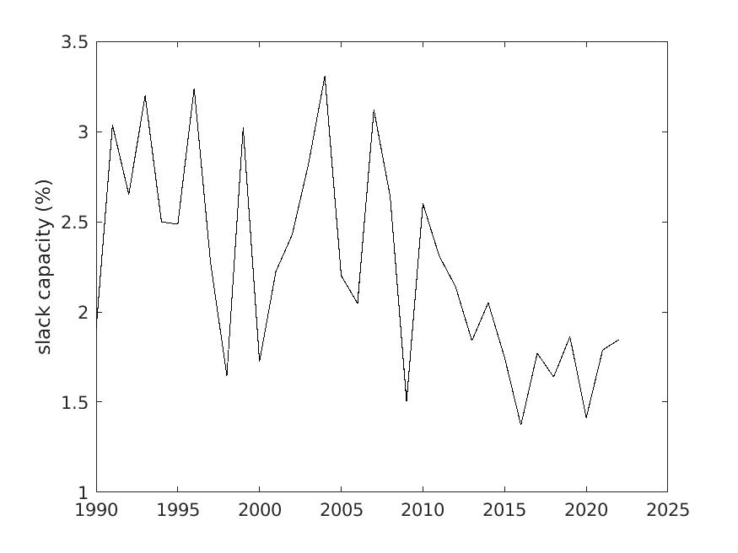
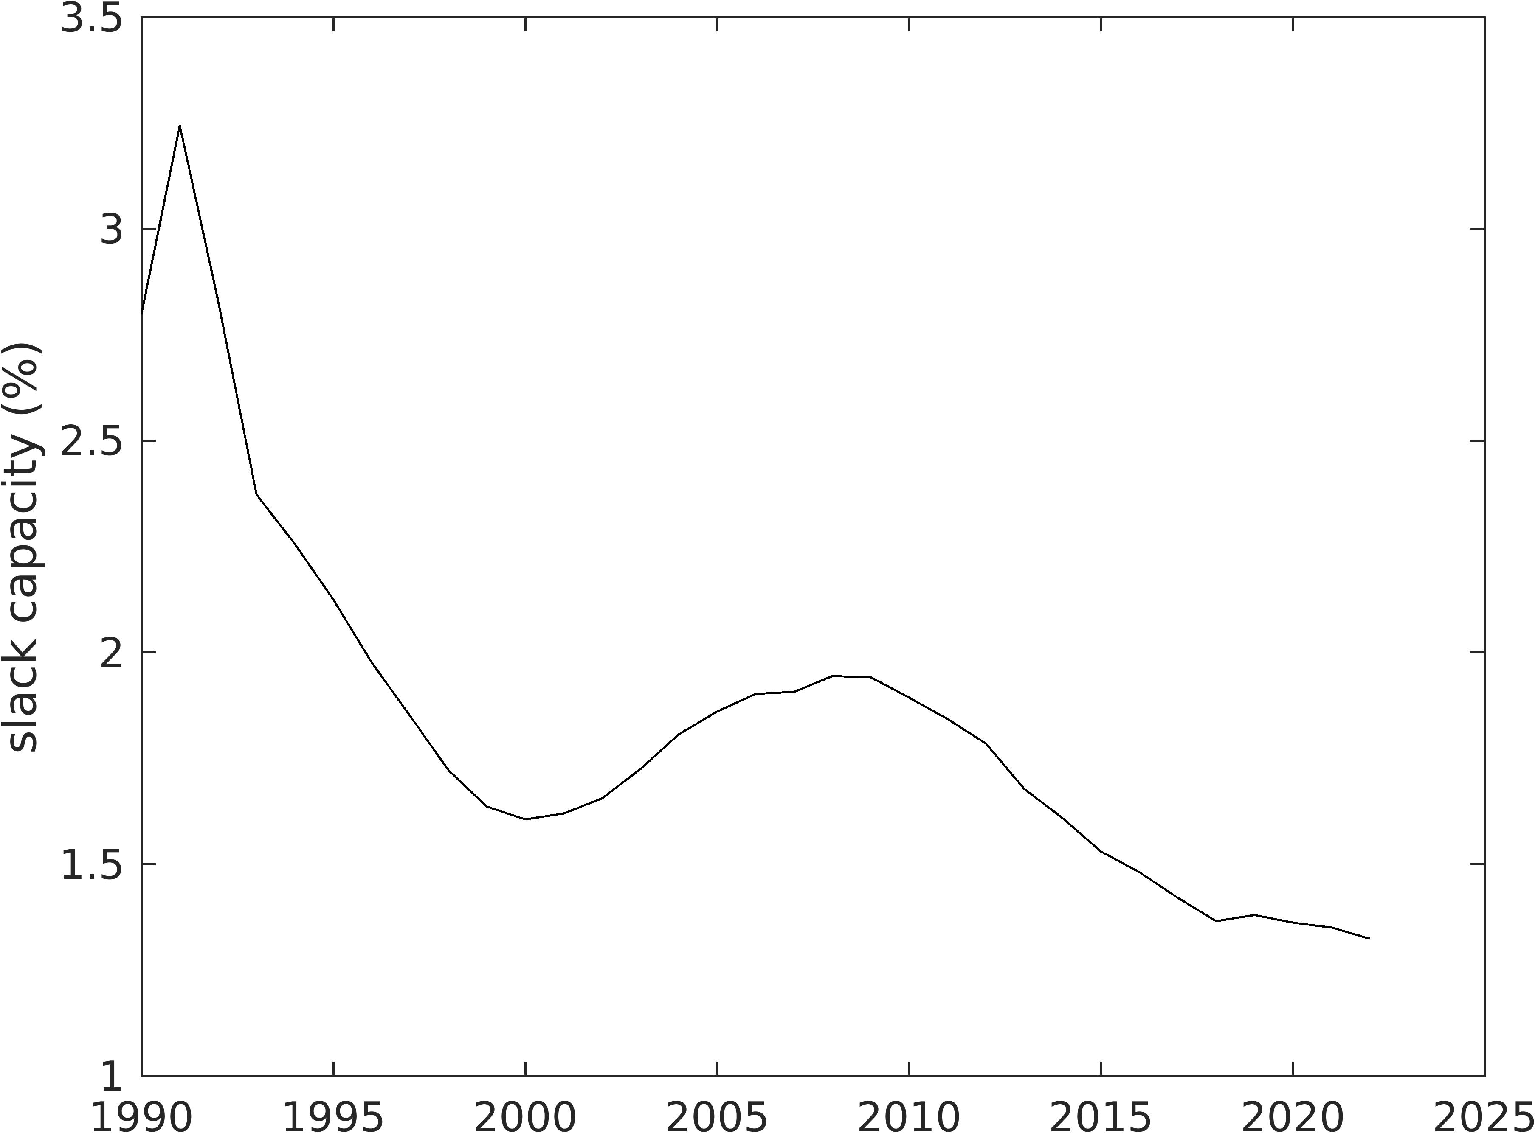

Fig. SI 1.5: Slack capacity (in units of %) over time.
Notes: Derived as the quotient of changes in inventories and total output, from the GLORIA MRIO database³². Main figure smoothed version; insert unsmoothed version.

SI 1.6 Future crop yield assessments

There are a number of assessments of global crop yields under future climate change. Here we describe two more recent examples of those assessments.

Li et al. combine a crop yield response database (CGIAR) with climate model data from the 6th Coupled Model Intercomparison Project (CMIP6) and Global Circulation Models (GCMs) to estimate yield responses to climatic factors.{Li, 2025 #7467} CGIAR comprises more than 8,800 point observations as a function of temperature, rainfall, CO₂ concentration, amongst others. Li et al. apply statistical models to arrive at fitted temperature-anomaly-yield response functions, for the four staple crops wheat, maize, rice, and soybeans. The authors distinguish mean yield changes, as well as low and high values separated from the means by one standard deviation.

Hasegawa et al. publish a global dataset comprising 8,703 crop-yield simulations derived from 202 studies published between 1984 and 2020.²² The dataset includes yield projections for wheat, maize, rice, and soybeans across 91 countries under major climate emission scenarios, providing a solid basis for a quantitative assessment of the impacts of climate change on crop production. It also contains geographical coordinates along with current and projected temperature and precipitation data, considering both scenarios with and without adaptation measures. The authors distinguish projections with and without adaptation, with the latter representing an upper-bound estimate of potential climate impacts on crop yields.

Hultgren et al.{Hultgren, 2025 #7501} estimate global crop yield impacts due to climate change, taking into account both adaptation benefits and costs. Using current global cropland distributions, the authors finds that all major crops except rice are likely to experience yield declines by 2050 under a high-emissions scenario. By the end of the century, projected yield losses under the high-emissions scenario (RCP 8.5) and the moderate-emissions scenario (RCP 4.5) are substantial for most crops: maize yields are expected to decline by 27.8% (RCP 8.5) and 12.0% (RCP 4.5), soybean by 35.6% and 22.4%, cassava by 29.8% and 12.8%, sorghum by 21.7% and 5.9% (RCP 4.5), and wheat by 28.2% and 13.5%. Rice is the only exception, with smaller estimated losses of 6.0% and 1.1%.

In this work we use Li et al.‘s high yield change values, because i) they largely agree with Hasegawa et al.’s data without adaptation (Figs. 1.6.1 and 1.6.2), and ii) they are more recent estimates. Taking estimates without adaptation also reduces reliance on uncertain assumptions about future adaptation strategies, allowing our assessment to clearly identify areas of greatest vulnerability.

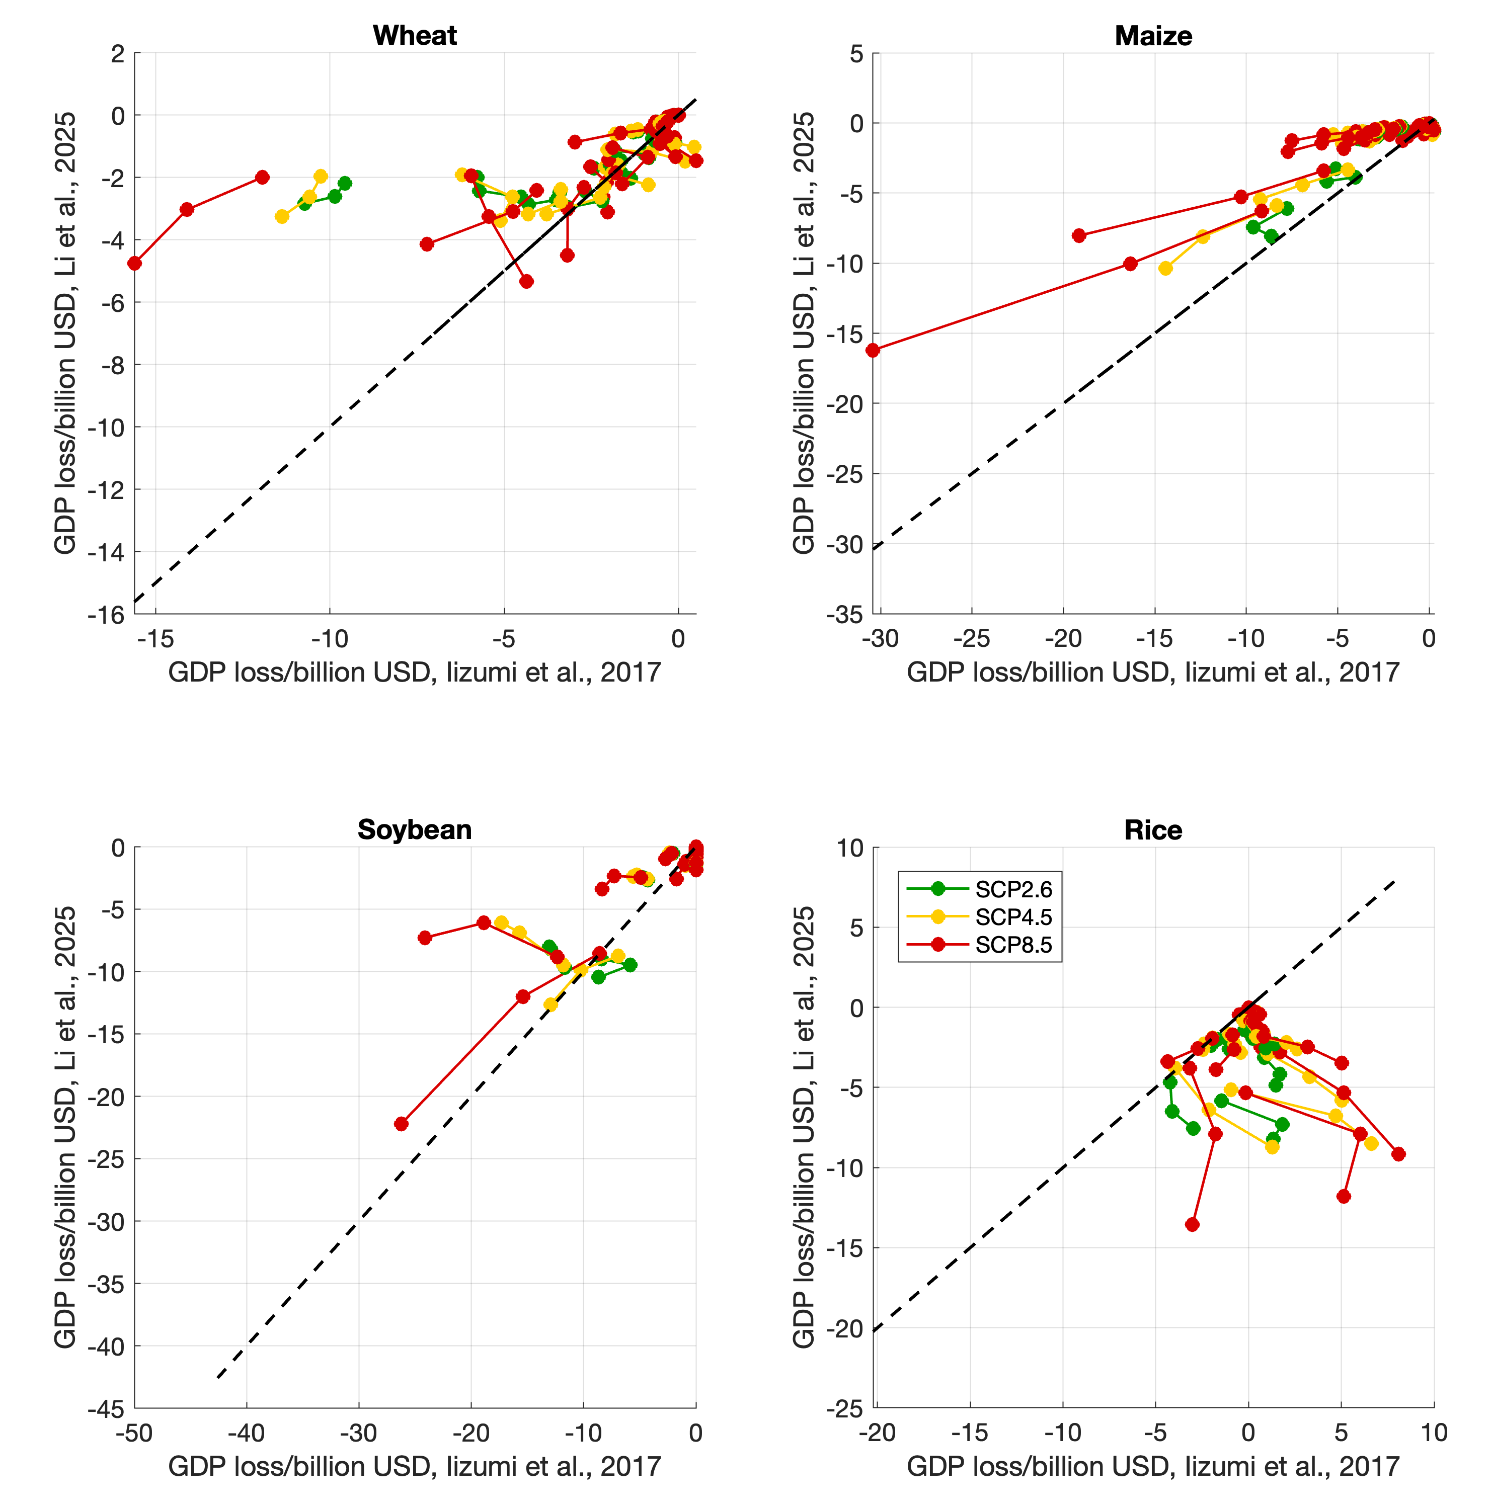
Fig. SI 1.6.1: Comparison of two future yield change studies.²²{Li, 2025 #7467}
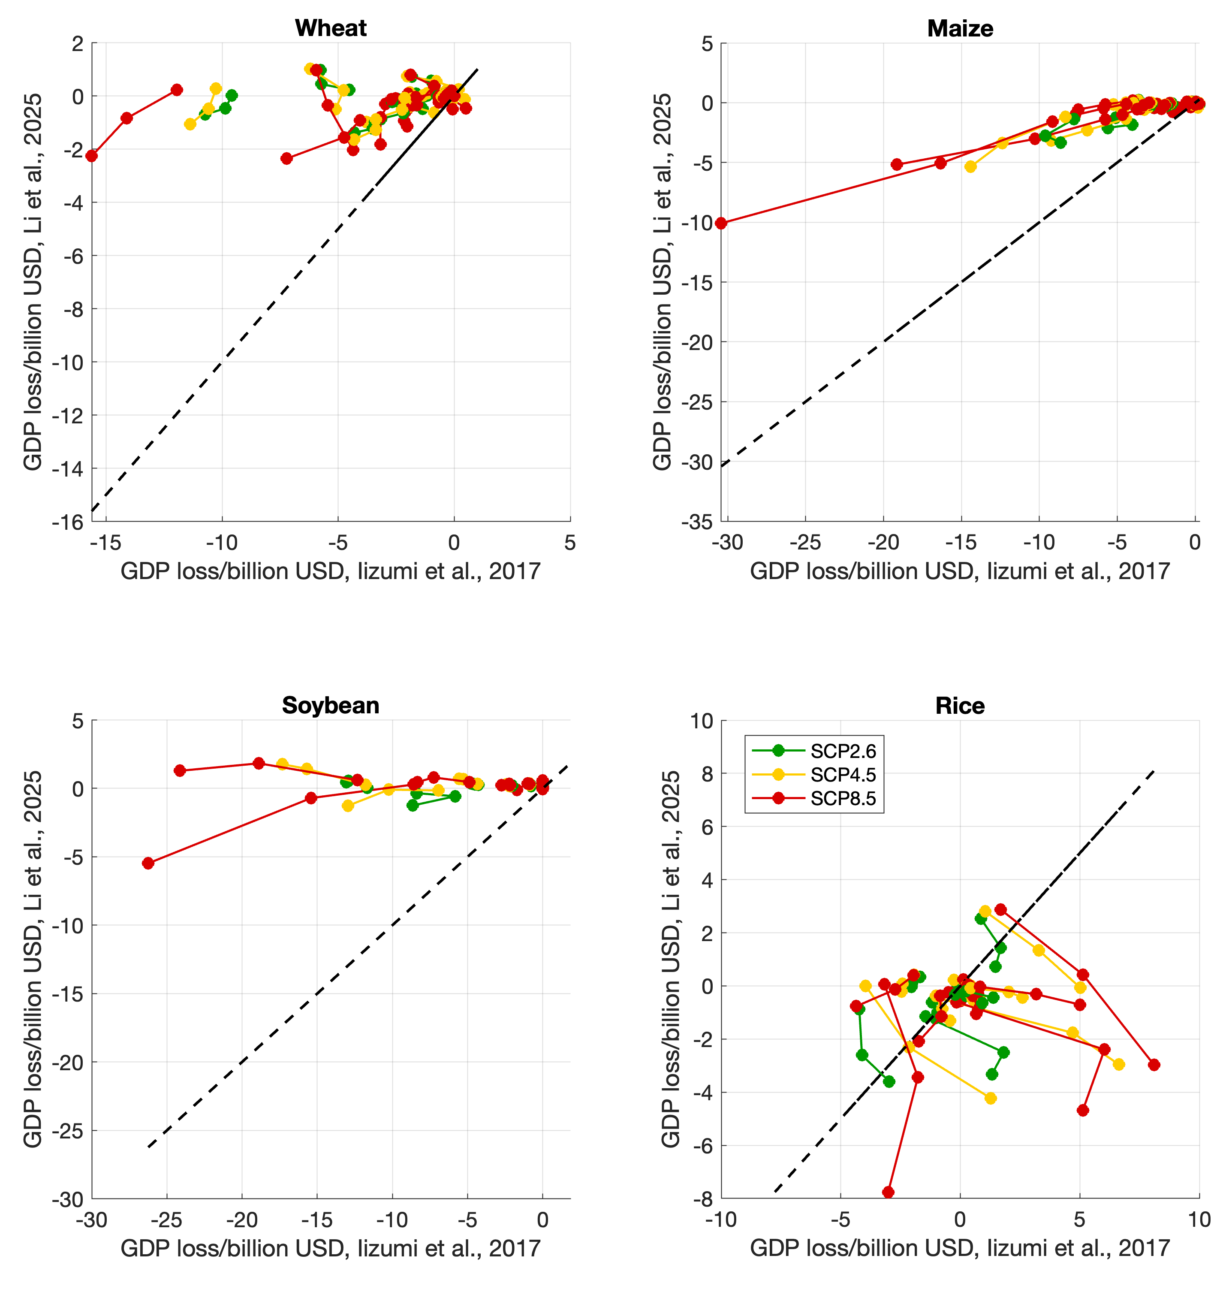
Fig. SI 1.6.2: Comparison of two future yield change studies.²²{Li, 2025 #7467} Li’s mean values.

SI 1.7 Assessing production recipe flexibility

We estimate production recipe flexibility $ε_{ij}$ (see constraint v.) by analysing historical changes in input-output coefficients $B_{ij}$, which represent the share of each input used per unit output in industry sectors. Specifically, we calculate $\frac{B_{ij}^{t+1}-B_{ij}^{t}}{\overline{B_{ij}}}$​ over different time windows (e.g. $w=$ 2, 5, 10, 20, 25, or 33 years) using the GLORIA, OECD and FIGARO MRIO databases. These empirical changes provide a proxy for how much production structures have adapted in the past. The resulting standard deviations $σ_{t}\left(\frac{B_{ij}^{t+w}-B_{ij}^{t}}{\overline{B_{ij}}}\right)$​ serve as candidate values for the $ε_{ij}$ in our disruption model. Standard deviations for the ${\left(CB\right)}_{ij}$ can then be derived via error propagation.

However, when applying empirically observed long-term high flexibility values (e.g. 20–50% over 30 years; Fig. 1.7), an input-output-based disruption model tends to project very limited economic damage from even substantial shocks.^{33,34} This raises the question: Are these empirically derived past flexibility estimates too optimistic for a future world disrupted by climate change? How much can input-output coefficients $B_{ij}$ realistically change over multi-decadal horizons under climate-induced stress?

Although the measured changes in input-output coefficients over past decades are empirically grounded, they reflect an idealised adaptation context. We use the term idealised not because the data are inaccurate, but because the conditions under which these structural shifts occurred were favourable compared to what is expected under severe climate stress.

First, past changes were not forced by crisis. Most shifts in input-output structure over the past 25–30 years were driven by benign forces: technological upgrading, globalization, outsourcing, capital investment, and policy liberalisation. These transitions unfolded in macroeconomic environments marked by relative political stability, global trade integration, and consistent economic growth. They occurred with time, capital, and policy support, not under pressure to substitute scarce or collapsing inputs in short timeframes.

Second, future adaptation will be constrained by physical, institutional, and systemic stress. Under scenarios such as RCP4.5 or RCP8.5, declining agricultural yields, water scarcity, heat stress, and extreme weather will coincide with global supply chain frictions, social unrest, and governance challenges. Adaptive changes that were once smooth may now be costly, contested, or infeasible. Key infrastructure may degrade, labour productivity may fall, and coordination failures may delay necessary transitions. These constraints significantly reduce the feasible rate of structural change in production recipes.

Third, technological substitutability has limits. While digitalisation and innovation can support production recipe reconfiguration, sectors dependent on biophysical constraints, such as food, energy, and water, will face hard boundaries.

Fig. SI 1.7: Production recipe flexibility (in units of %) as a function of input coefficient magnitude.
Notes: Derived as the standard deviations of A matrix coefficients (SI 1.1) between 1990 and 2022, with time windows varying between 2 and 33 years, from the GLORIA MRIO database³². Linear fits in red (OLS) and green (WLS), logarithmic fits in purple (OLS) and blue (WLS).
For these reasons, historical $\frac{B_{ij}^{t+1}-B_{ij}^{t}}{\overline{B_{ij}}}$​ reflect what is possible in theory, not necessarily feasible under duress.

A growing body of literature highlights the importance of reduced substitution and adaptive flexibility under stress conditions such as climate change or systemic disruptions. Adaptive mechanisms such as substitution, input reallocation, and temporary policy interventions can significantly mitigate economic losses; without such resilience mechanisms, losses from trade and labour disruptions would be far more severe.³⁴ As substitution elasticities decrease, abatement costs tend to rise non-linearly, suggesting that economies with less flexible production structures face steeper costs in transitioning to low-carbon pathways. ³³

Given these considerations, historical input-output coefficient changes should be treated as upper bounds. For modelling under climate duress, it is prudent to scale down these empirical values to reflect structural frictions, physical limits, and socio-political constraints. While the literature confirms reduced flexibility under stress, it offers no consensus on numerical values. Conservative scenario design and sensitivity testing remain the best available tools for approximating future economic adaptability.

SI 1.8 Producers’ and consumers’ losses – the total differential

Producers’ and consumers’ losses are calculated from total losses $dx= x-x_{0}=Ly-L_{0}y_{0}$, where $L$ is the Leontief inverse and $y$ is final demand (SI 1.1). Taking the Marshall-Edgeworth decomposition form³⁵ of the total differential yields $dx=dL \overline{y}+\overline{L} dy$, with $\overline{y}=\frac{y_{0}+y}{2}$, $dy=y_{0}-y$, $\overline{L}=\frac{L_{0}+L}{2}$, and $dL={L-L}_{0}$. $dL \overline{y}$ enumerates changes in intermediate demand and reflects producers’ losses, whilst $\overline{L} dy$ enumerates changes in final demand and reflects consumers’ losses.

SI 1.9 Production layers

Unravelling the total differential $dx= x-x_{0}=Ly-L_{0}y_{0}$ using the series expansion³⁶ of the Leontief inverse yields

$dx= x-x_{0}=Ly-L_{0}y_{0}$
$= \left(I+A+A^{2}+A^{3}+…\right)y-\left(I+A_{0}+{A_{0}}^{2}+{A_{0}}^{3}+…\right)y_{0}$ .

Decomposing this series expansion via the Marshall-Edgeworth scheme yields

$dx= dy+\overline{A}dy+{\overline{A}}^{2}dy+{\overline{A}}^{3}dy$ (final demand changes)
$+ 0+dA\overline{y}+dA^{2}\overline{y}+dA^{3}\overline{y}$ , (intermediate demand changes)

with $\overline{y}=\frac{y_{0}+y}{2}$ and $\overline{A}=\frac{A_{0}+A}{2}$.

The term $dy$ captures the immediate (1st-order) effects of the direct hit on final demand, that is mainly consumers in households. $\overline{A}dy$ represents the consequences of these immediate effects on those producers that directly supply consumers (so-called 2nd-order consumer effects). ${\overline{A}}^{2}dy$ describes the consumer effects on suppliers of suppliers, and so on.
Similarly, the terms $dA\overline{y}$, $dA^{2}\overline{y}$, and so on capture the 1st-, 2nd- and higher-order producer effects of the direct hit. The various order of the series expansion are interpreted as production layers of the supply-chain network.

SI 1.10 Structural paths

We apply Structural Path Analysis (SPA)³⁷⁻³⁹ to the production layer expansion in Section SI 1.8. Because here, SPA acts on a differential form, it is termed Structural Path Decomposition (SPD) in the literature.⁴⁰

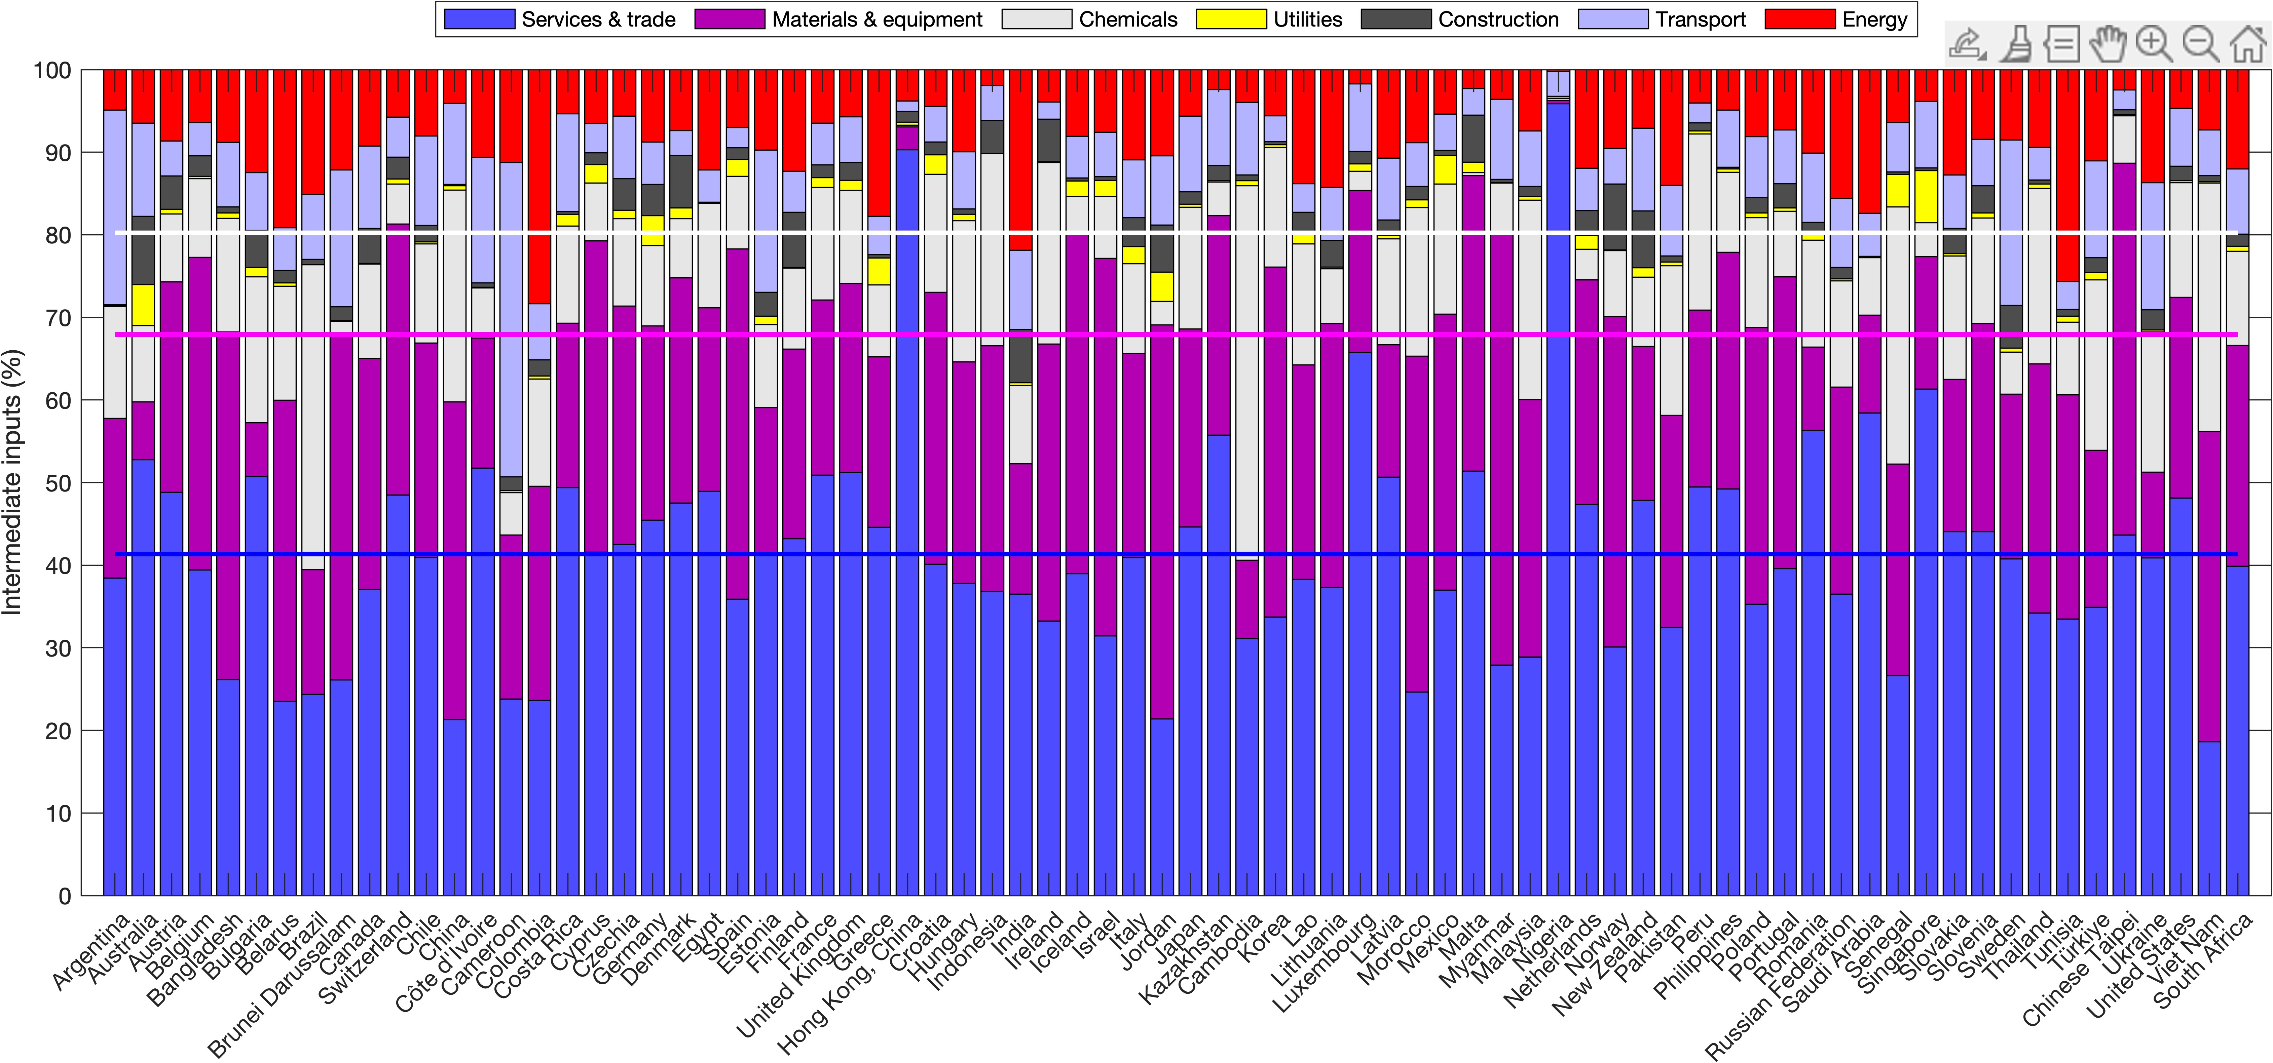

Fig. SI 1.10: Production recipe for agriculture in 76 countries.
Notes: Taken for the year 2020 from the OECD Inter-Country Input-Output tables.⁴¹ On average, services represent about 40% of intermediate inputs (blue solid line), materials and equipment another 30% (purple line), and chemicals another 10% (white line).

SI 2: Mixed- (1st- and 2nd-) order polynomial disruption function

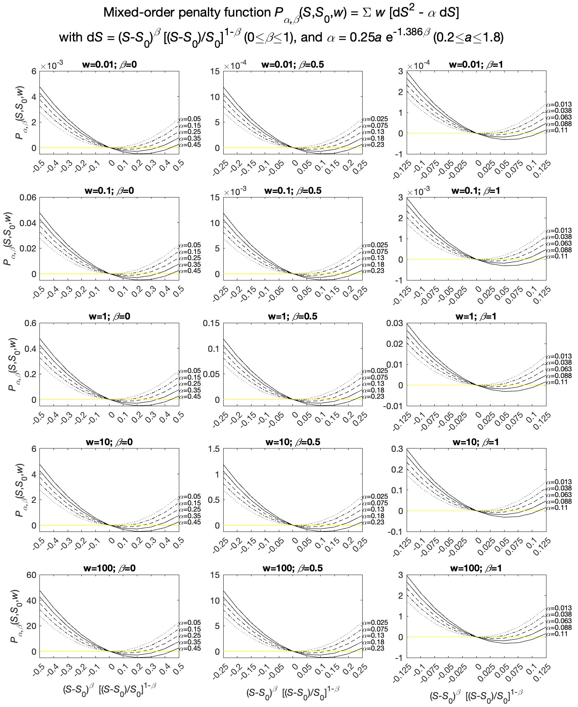

Fig. SI 2.1: $P_{αβ}\left(S,S_{0},w\right)$ as a function of ${∆S}_{ij}^{}={({\tilde{S}}_{ij}-S_{0,ij})}^{β}{\left(\frac{{\tilde{S}}_{ij}-S_{0,ij}}{S_{0,ij}}\right)}^{1-β}$, and parametrised by the priority weights w, the loss-aversion shape factor α, and the penalty control

SI 3: Literature comparison
Ref |  | Title | Event | Sectors / variable | Time | Main result | Method | Indirect eff.
⁴² | Influence of extreme weather disasters on global crop production |  | Droughts and extreme heat | Cereals, harvest area | 1964–2007 | ~10% total loss during past 50 years; | Statistical method | no
⁴³ | Future warming increases probability of globally synchronized maize production shocks |  | Global warming | Maize vs global warming | 21st century | 7% under 2°C warming and 86% under 4°C warming, per year | Regression model | no
⁴⁴ | Risks of synchronized low yields are underestimated in climate and crop model projections |  | Heatwaves | Maize and wheat | 1960–2014 | >one wave event lead to 7% in EAS, −6% to in NA and −3% in EEU. | Statistical method | no
⁴⁵ | Amplified Rossby waves enhance risk of concurrent heatwaves in major breadbasket regions |  | Heatwaves | Maize, wheat, soybean and rice | n/a | 4% reductions in production, regional decreases of up to 11% | Statistical method | no
⁴⁶ | Global impacts of heat and water stress on food production and severe food insecurity |  | Heat and water stress | Cereal crops (rice, soybean, maize, and wheat) | n/a | 6%, 10%, and 14% to 2050 for RCP4.5-SSP2, RCP8.5-SPP2, and RCP8.5-SSP3 | CGE | no
⁴⁷ | Global supply chains amplify economic costs of future extreme heat risk |  | Heat stress | Economic losses caused by heat stress on human activities | to 2060 | By 2060, economic losses 0.6–4.6%; attributed to health (37–45%), labour (18–37%) and indirect (12–43%) | Hybrid input–output and CGE | based on VA losses
⁴⁸ | The economic commitment of climate change |  | Global warming | Labour and agricultural productivity, temperature variability effect on agricultural productivity and health, precipitation effect on agricultural productivity, labour outcomes and flood damages | next 26 years to 2050 | 19% in 26 years | Statistical method | no
⁴⁹ | A meta-analysis of the total economic impact of climate change |  | Global warming | n/a | n/a | 1% GDP losses for each °C of additional warming | Meta analysis | no
⁵⁰ | Reconciling widely varying estimates of the global economic impacts from climate change |  | Global warming | Refs 1,5,6,12,13,14,15 | n/a | Up to 68% GDP loss | Statistical modelling | no
⁵¹ | Dependence of economic impacts of climate change on anthropogenically directed pathways |  | Global warming | Impact of changes in (1) agricultural productivity, (2) undernourishment, (3) heat-related excess mortality, (4) cooling/heating demand, (5) occupational-health cost, (6) hydroelectric power generation capacity, (7) thermal power generation, (8) fluvial flooding and (9) coastal inundation | 2100 | 6.6% GDP loss in 2100 | Bottom up | no
⁵² | Climate damage projections beyond annual temperature |  | Temperature means and variability, rainfall patterns and extreme precipitation |  | n/a | 10% loss for 3°C warming | Statistical modelling | no
⁵³ | The Macroeconomic Impact of Climate Change: Global vs. Local Temperature |  | Global warming | Damage functions | n/a | 12% GDP loss for 1°C warming | Statistical modelling | no
⁵⁴ | Temperature increase reduces global yields of major crops in four independent estimates |  | Global warming | Wheat, rice, maize, and soybeans | n/a | 1°C warming = wheat by 6.0%, rice by 3.2%, maize by 7.4%, and soybean by 3.1% | statistical modelling + bottom up | no
⁵⁵ | The impact of 1.5 °C and 2.0 °C global warming on global maize production and trade |  | Global warming | Maize | n/a | 10.8% yield changes = 2°C | crop model + price model | no
²⁶ | A global dataset for the projected impacts of climate change on four major crops. |  |  | Maize, rice, soybean, and wheat | 1984 and 2020 | Dataset | Meta-analyses | no
⁵⁶ | Global economic impact of weather variability on the rich and the poor |  | Temperature and rainfall | Agriculture, manufacturing and services / consumption risk | 2010-2040 | Up to 1% consumption risk (90th %ile of consumption losses) by 2040 | Agent-based global supply-chain model | total & direct loss

SI 4: Supplementary results

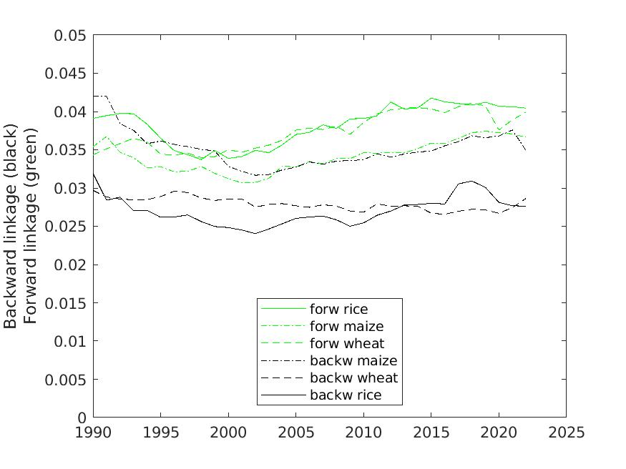
Fig. SI 4.1: Backward (black) and forward (green) linkages of the wheat (dashed), maize (dot-dashed) and rice (solid) sectors in the global economy between 1990 and 2022.
Notes: Forward linkages refer to the connections an industry has with downstream sectors that use its products as inputs, fostering industrial expansion and value chain development. Backward linkages, on the other hand, involve a sector's reliance on upstream suppliers, stimulating demand for raw materials, intermediate goods, and services, which supports local economic growth and industrialization.⁵⁷⁻⁶³ Rice and wheat are mainly destined for the final consumption of households, hence their forward linkages are stronger than those of maize, which is used in animal feed, biofuels, industrial products, pharmaceuticals, and beverage production, making it a highly versatile crop. Maize has stronger backward linkages than rice and wheat because it relies more on commercial inputs like hybrid seeds, fertilizers, pesticides, and mechanized equipment. Additionally, its integration with agribusiness, use in livestock feed and biofuels, and adaptability to diverse climates drive higher demand for upstream industries, reinforcing its backward linkages. Data derived⁶⁴ from the Leontief inverse $L$ (SI 1.1) as $λ_{∙j}=\frac{L_{∙j}}{\overline{L}}=\frac{\sum_{i}{L_{ij}}/N}{\sum_{ij}{L_{ij}}/N^{2}}$ (backward) and $λ_{i∙}=\frac{L_{i∙}}{\overline{L}}=\frac{\sum_{j}{L_{ij}}/N}{\sum_{ij}{L_{ij}}/N^{2}}$ (forward) using data from the GLORIA MRIO database³².

References

1 Lenzen, M. & Rueda-Cantuche, J. M. A note on the use of supply-use tables in impact analyses. Statistics and Operations Research Transactions 36, 139-152 (2012).
2 Koks, E. E. & Thissen, M. A Multiregional Impact Assessment Model for disaster analysis. Economic Systems Research 28, 429-449, doi:10.1080/09535314.2016.1232701 (2016).
3 Okuyama, Y. Economic Modeling for Disaster Impact Analysis: Past, Present, and Future. Economic Systems Research 19, 115-124, doi:10.1080/09535310701328435 (2007).
4 Okuyama, Y. & Santos, J. R. Disaster impact and input-output analysis. Economic Systems Research 26, 1-12, doi:10.1080/09535314.2013.871505 (2014).
5 Galbusera, L. & Giannopoulos, G. On input-output economic models in disaster impact assessment. International Journal of Disaster Risk Reduction 30, 186-198, doi:https://doi.org/10.1016/j.ijdrr.2018.04.030 (2018).
6 Schulte in den Bäumen, H., Többen, J. & Lenzen, M. Labour forced impacts and production losses due to the 2013 flood in Germany. Journal of Hydrology 527, 142-150, doi:http://dx.doi.org/10.1016/j.jhydrol.2015.04.030 (2015).
7 Oosterhaven, J. & Többen, J. Wider economic impacts of heavy flooding in Germany: a non-linear programming approach. Spatial Economic Analysis 12, 404-428, doi:10.1080/17421772.2017.1300680 (2017).
8 Xia, Y. et al. Assessing the economic impacts of IT service shutdown during the York flood of 2015 in the UK. Proceedings of the Royal Society A: Mathematical, Physical and Engineering Sciences 475, 20180871, doi:doi:10.1098/rspa.2018.0871 (2019).
9 Zeng, Z., Guan, D., Steenge, A. E., Xia, Y. & Mendoza-Tinoco, D. Flood footprint assessment: a new approach for flood-induced indirect economic impact measurement and post-flood recovery. Journal of Hydrology 579, 124204, doi:https://doi.org/10.1016/j.jhydrol.2019.124204 (2019).
10 Mendoza-Tinoco, D. et al. Flood Footprint Assessment: A Multiregional Case of 2009 Central European Floods. Risk Analysis 40, 1612-1631, doi:https://doi.org/10.1111/risa.13497 (2020).
11 Lyu, Y., Xiang, Y. & Wang, D. Evaluating Indirect Economic Losses from Flooding Using Input-Output Analysis: An Application to China's Jiangxi Province. Int J Environ Res Public Health 20, doi:10.3390/ijerph20054509 (2023).
12 Miller, R. E. & Blair, P. D. Input-Output Analysis: Foundations and Extensions. (Prentice-Hall, 2010).
13 Li, M., Lenzen, M., Pedauga, L. E. & Malik, A. A minimum-disruption approach to input–output disaster analysis. Spatial Economic Analysis, 1-25, doi:10.1080/17421772.2022.2056231 (2022).
14 Steenge, A. E. & Bočkarjova, M. Thinking about imbalances in post-catastrophe economies: An input–output based proposition. Economic Systems Research 19, 205-223, doi:10.1080/09535310701330308 (2007).
15 Hallegatte, S. An adaptive regional input-output model and its application to the assessment of the economic cost of Katrina. Risk Analysis 28, 779–799 (2008).
16 Schulte in den Bäumen, H., Moran, D., Lenzen, M., Cairns, I. & Steenge, A. How severe space weather can disrupt global supply chains. Natural Hazards and Earth System Science 14, 2749-2759, doi:10.5194/nhess-14-2749-2014 (2014).
17 Rose, A. & Liao, S.-Y. Modeling Regional Economic Resilience to Disasters: A Computable General Equilibrium Analysis of Water Service Disruptions. Journal of Regional Science 45, 75-112, doi:https://doi.org/10.1111/j.0022-4146.2005.00365.x (2005).
18 Faturay, F. et al. Using Virtual Laboratories for disaster analysis – A case study of Taiwan. Economic Systems Research 32, 58-83 (2020).
19 Oosterhaven, J. On the limited usability of the inoperability IO model. Economic Systems Research 29, 452-461, doi:10.1080/09535314.2017.1301395 (2017).
20 Oosterhaven, J. & Bouwmeester, M. C. A new approach to modeling the impacts of disruptive events. Journal of Regional Science 56, 583-595, doi:10.1111/jors.12262 (2016).
21 Fahr, S., Senner, R. & Vismara, A. The globalization of climate change: amplification of climate-related physical risks through input-output linkages. Report No. No 2942, (European Central Bank, 2024).
22 Creedy, J. & Sleeman, C. Carbon dioxide emissions reduction in New Zealand: A minimum disruption approach. Australian Economic Papers 44, 199-220, doi:10.1111/j.1467-8454.2005.00260.x (2005).
23 Cornwell, A. Reducing carbon dioxide emissions in Australia: a minimum disruption approach. Australian Economic Review, 65-81 (1996).
24 Proops, J. L. R., Faber, M. & Wagenhals, G. in Reducing CO2 Emissions 227-246 (Springer-Verlag, 1993).
25 Kahneman, D., Knetsch, J. L. & Thaler, R. D. The endowment effect, loss aversion, and status quo bias. Journal of Economic Perspectives 5, 193-206 (1991).
26 Hasegawa, T. et al. A global dataset for the projected impacts of climate change on four major crops. Scientific Data 9, 58, doi:10.1038/s41597-022-01150-7 (2022).
27 Duchin, F. & Levine, S. H. Sectors may use multiple technologies simultaneously: the rectangular choice-of-technology model with binding factor constraints. Economic Systems Research 23, 281-302, doi:10.1080/09535314.2011.571238 (2011).
28 Nagurney, A. & Chen, H. K. An algorithm for the solution of a quadratic programming problem, with application to constrained matrix and price equilibrium problems. Environment and Planning A 21, 99-114 (1989).
29 Nagurney, A. & Robinson, A. G. Algorithms for quadratic constrained matrix problems. Mathematical and Computer Modelling 16, 53-65 (1992).
30 Harrigan, F. & Buchanan, I. A quadratic programming approach to input-output estimation and simulation. Journal of Regional Science 24, 339-358 (1984).
31 Bernas, T., Asem, E. K., Robinson, J. P. & Rajwa, B. Quadratic form: A robust metric for quantitative comparison of flow cytometric histograms. Cytometry Part A 73A, 715-726, doi:https://doi.org/10.1002/cyto.a.20586 (2008).
32 Lenzen, M. & Li, M. The GLORIA Multi-Region Input-Output database. Report No. https://ielab.info/resources/gloria, (The University of Sydney, Sydney, Australia, 2025).
33 Lu, Y. & Stern, D. I. Substitutability and the Cost of Climate Mitigation Policy. Environmental and Resource Economics 64, 81-107, doi:10.1007/s10640-015-9936-7 (2016).
34 Rose, A., Asay, G., Wei, D. & Leung, B. (2009).
35 Lenzen, M. Structural Decomposition Analysis and the Mean-Rate-of-Change Index. Applied Energy 83, 185–198 (2006).
36 Waugh, F. V. Inversion of the Leontief matrix by power series. Econometrica 18, 142-154 (1950).
37 Defourny, J. & Thorbecke, E. Structural path analysis and multiplier decomposition within a social accounting matrix framework. Economic Journal 94, 111-136 (1984).
38 Khan, H. A. & Thorbecke, E. Macroeconomic effects of technology choice: multiplier and structural path analysis within a SAM framework. Journal of Policy Modeling 11, 131-156 (1989).
39 Treloar, G. Extracting embodied energy paths from input-output tables: towards an input-output-based hybrid energy analysis method. Economic Systems Research 9, 375-391 (1997).
40 Wood, R. & Lenzen, M. Structural path decomposition Energy Economics 31, 335-341 (2009).
41 OECD. OECD Inter-Country Input-Output (ICIO) Tables. Report No. https://www.oecd.org/sti/ind/inter-country-input-output-tables.htm, (Organisation for Economic Co-operation and Development, Paris, France, 2022).
42 Lesk, C., Rowhani, P. & Ramankutty, N. Influence of extreme weather disasters on global crop production. Nature 529, 84-87, doi:10.1038/nature16467 (2016).
43 Tigchelaar, M., Battisti, D., Naylor, R. & Ray, D. Future warming increases probability of globally synchronized maize production shocks. Proceedings of the National Academy of Sciences 115, 201718031, doi:10.1073/pnas.1718031115 (2018).
44 Kornhuber, K. et al. Risks of synchronized low yields are underestimated in climate and crop model projections. Nature Communications 14, 3528, doi:10.1038/s41467-023-38906-7 (2023).
45 Kornhuber, K. et al. Amplified Rossby waves enhance risk of concurrent heatwaves in major breadbasket regions. Nature Climate Change 10, 48-53, doi:10.1038/s41558-019-0637-z (2020).
46 Kompas, T., Che, T. N. & Grafton, R. Q. Global impacts of heat and water stress on food production and severe food insecurity. Scientific Reports 14, 14398, doi:10.1038/s41598-024-65274-z (2024).
47 Sun, Y. et al. Global supply chains amplify economic costs of future extreme heat risk. Nature 627, 797-804, doi:10.1038/s41586-024-07147-z (2024).
48 Kotz, M., Levermann, A. & Wenz, L. The economic commitment of climate change. Nature 628, 551-557, doi:10.1038/s41586-024-07219-0 (2024).
49 Tol, R. S. J. A meta-analysis of the total economic impact of climate change. Energy Policy 185, 113922, doi:https://doi.org/10.1016/j.enpol.2023.113922 (2024).
50 Morris, J. et al. Reconciling widely varying estimates of the global economic impacts from climate change. Nature Climate Change 15, 124-127, doi:10.1038/s41558-024-02232-7 (2025).
51 Takakura, J. y. et al. Dependence of economic impacts of climate changeon anthropogenically directed pathways. Nature Climate Change 9, 737-741, doi:10.1038/s41558-019-0578-6 (2019).
52 Waidelich, P., Batibeniz, F., Rising, J., Kikstra, J. S. & Seneviratne, S. I. Climate damage projections beyond annual temperature. Nature Climate Change 14, 592-599, doi:10.1038/s41558-024-01990-8 (2024).
53 Bilal, A. & Känzig, D. The Macroeconomic Impact of Climate Change: Global vs. Local Temperature. SSRN Electronic Journal, doi:10.2139/ssrn.4826056 (2024).
54 Zhao, C. et al. Temperature increase reduces global yields of major crops in four independent estimates. Proceedings of the National Academy of Sciences 114, 201701762, doi:10.1073/pnas.1701762114 (2017).
55 Li, K., Pan, J., Xiong, W., Xie, W. & Ali, T. The impact of 1.5 °C and 2.0 °C global warming on global maize production and trade. Sci Rep 12, 17268, doi:10.1038/s41598-022-22228-7 (2022).
56 Quante, L., Willner, S. N., Otto, C. & Levermann, A. Global economic impact of weather variability on the rich and the poor. Nature Sustainability 7, 1419-1428, doi:10.1038/s41893-024-01430-7 (2024).
57 McGilvray, J. in Structure, System and Economic Policy (ed W. Leontief) 49-56 (Cambridge University Press, 1977).
58 Cella, G. The input-output measurement of interindustry linkages. Oxford Bulletin of Economics and Statistics 46, 73-84 (1984).
59 Harrigan, F. J. & McGilvray, J. The measurement of interindustry linkages. Ricerche Economiche XLII, 325-343 (1988).
60 Dietzenbacher, E. The measurement of interindustry linkages: key sectors in the Netherlands. Economic Modelling 9, 419-437 (1992).
61 Guilhoto, J. & Hewings, G. J. D. (unpublished manuscript, 1995).
62 Sonis, M., Guilhoto, J. J. M., Hewings, G. J. D. & Martins, E. B. Linkages, key sectors, and structural change: some new perspectives. Developing Economies 33, 233-270 (1995).
63 Dietzenbacher, E. & van der Linden, J. A. Sectoral and spatial linkages in the EC production structure. Journal of Regional Science 37, 629-651 (1997).
64 Lenzen, M. Environmentally important linkages and key sectors in the Australian economy. Structural Change and Economic Dynamics 14, 1-34 (2003).

Condition ii. is O&B’s Eq. 2. Condition iv. is on O&B’s p. 587, but no distinction is made for subsidies and decreases in inventories. Instead of our condition i., O&B model specific scenarios in Eqs. 7 and 8. Conditions iii. and v. do not appear in O&B.

