Supplementary:

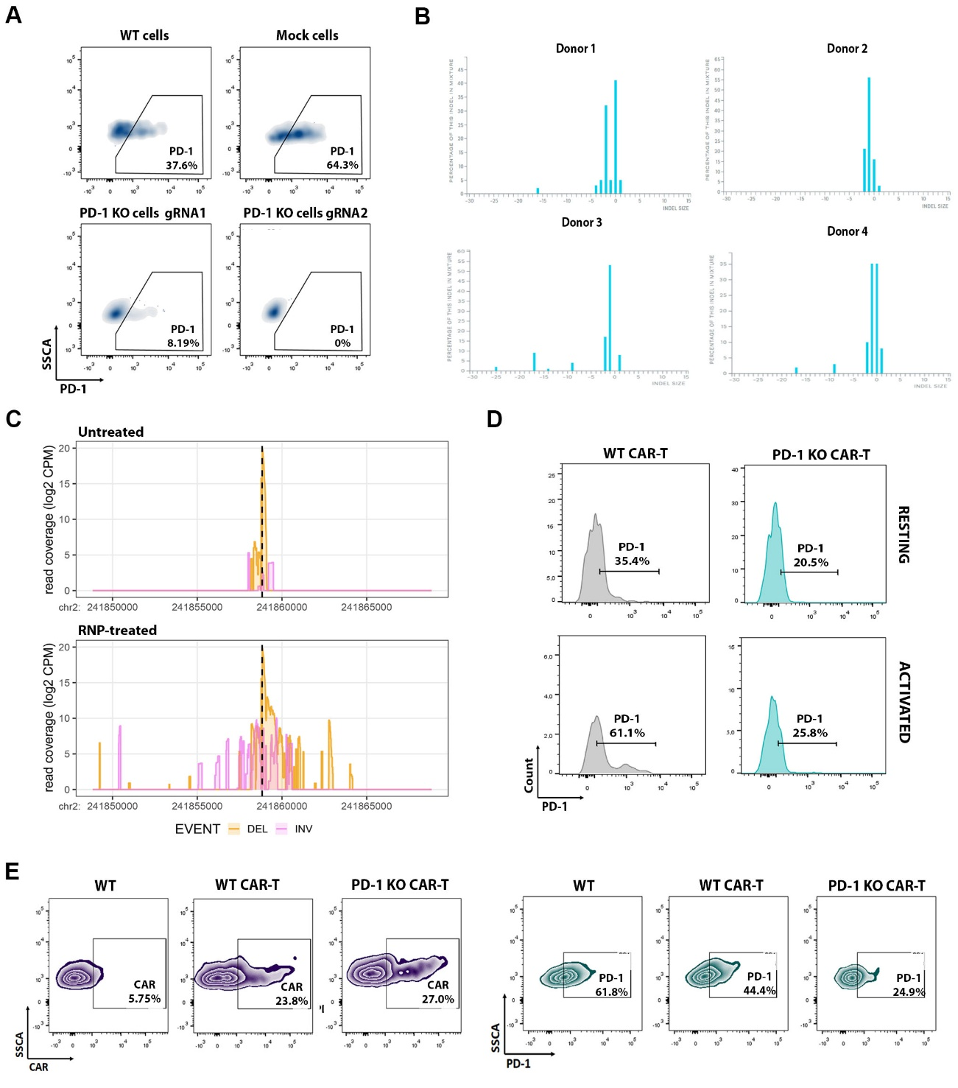
Supplementary Figure 1. Validation of PD-1 knock-out efficiency and specificity in primary T and CAR-T cells
A) Flow cytometry plots showing extracellular PD-1 expression on T cells three days after stimulation with αCD3/αCD28 nanomatrix. B) INDEL frequency distribution generated by gRNA2 across four healthy donors, analysed by Sanger sequencing. C) Genomic coverage plots aligned to a ±10 kb region surrounding the PDCD1 locus. Chromosomal rearrangements at the on-target site are shown, with deletions (DEL) highlighted in orange (positive strand) and inversions (INV) in purple (negative strand). The dotted vertical line indicates the Cas9 cleavage site.
D) Flow cytometry analysis of PD-1 expression in CAR-T WT and PD-1 KO cells, both in resting and αCD3/αCD28-activated conditions. E) CAR expression (left) and PD-1 expression (right) in WT, WT CAR-T, and PD-1 KO CAR-T cells after activation.

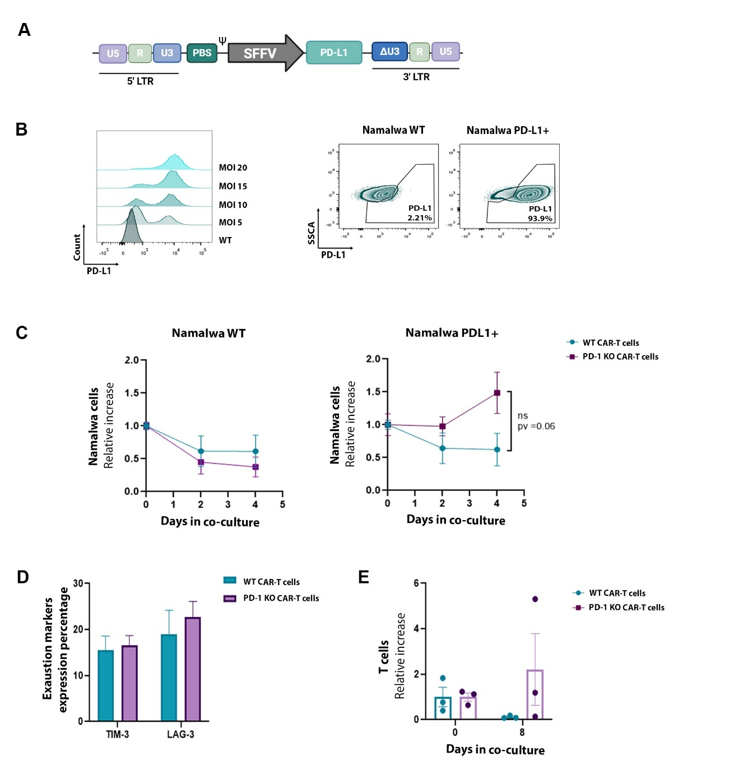
Supplementary Figure 2. Generation and Validation of PD-L1+ Namalwa Target Cells and Functional Co-culture Assays with PD-1 KO CAR-T Cells
A) Schematic representation of the lentiviral vector used to express PD-L1 in Namalwa CD19⁺ cells.
B) Left: Histogram showing PD-L1 expression in Namalwa cells transduced with lentiviral vectors at increasing multiplicities of infection (MOIs). Right: Flow cytometry plots comparing PD-L1 expression between WT and PD-L1⁺ Namalwa cells. C) Relative expansion normalized to day 0. Optimization of co-culture conditions using WT and PD-1 KO CAR-T cells against Namalwa WT (left) and Namalwa PD-L1⁺ (right) cells during lysis experiment at standard conditions at lab. D) Expression levels of the exhaustion markers TIM-3 and LAG-3 at the endpoint of the co-culture experiment (n = 4). E) T cell persistence measured as fold change in CAR-T cell frequency from day 0 to day 8 of the cytotoxicity assay. Graphs show mean ± SEM. Statistical analysis is based on a paired one-tailed T-test. * = p value ≤ 0.05; ** = p value ≤ 0.005; *** = p value ≤ 0.0005; **** = p value ≤0.0001

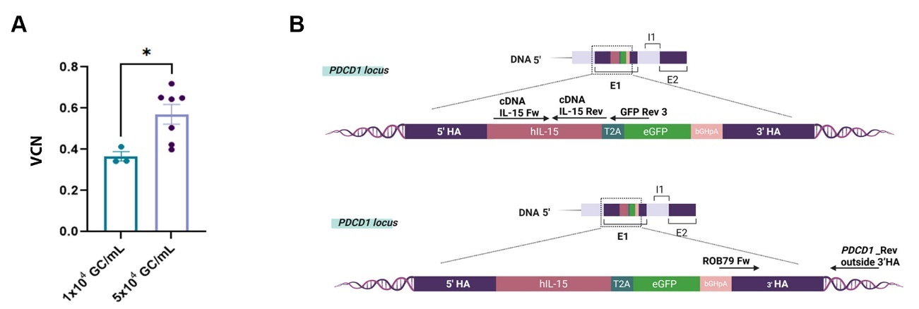
Supplementary Figure 3. Quantification of site-specific Knock-In efficiency at the PDCD1 locus by ddPCR
A) Quantification of vector copy number (VCN) per cell using droplet digital PCR (ddPCR) in T cells transduced at two different MOIs (1×10⁴ and 5×10⁴ GC/mL) to optimize knock-in efficiency. A significant increase in integration events was observed at higher viral concentration. B) Schematic representation of the PDCD1 locus and the primer/probe design used for ddPCR to detect precise integration. Top: wild-type (WT) configuration. Bottom: modified locus with IL-15-eGFP inserted downstream of exon 1. Primer binding sites flanking the knock-in region are indicated.
Graphs show mean ± SEM. Statistical analysis is based on a paired one-tailed T-test.
* = p value ≤ 0.05; ** = p value ≤ 0.005; *** = p value ≤ 0.0005; **** = p value ≤0.0001
Supplementary Table 1. gRNA and primer sequences used for PDCD1 editing and off-target evaluation
PRIME NAME | 5’ – 3’ SEQUENCE | OFFTARGET DETECTION | ICE Sensitivity
PD-1 OFF_Guide2 1 Fw | GTTGCCGTTACAGTCTGCTCCG | NO | 5%
PD-1 OFF_Guide2 1 Rev | AAGCGGTGTTGGCCTCCTCTGG | NO | 5%
PD-1 OFF_Guide2 2 Fw | ATTTATTTTGGACAATCACCAGGGG | NO | 5%
PD-1 OFF_Guide2 2 Rev | ATACATAACGTCTCTGCAAAGGGA | NO | 5%
PD-1 OFF_Guide2 3 Fw | ATAAATTCCAGTGCACTCATCCCT | NO | 5%
PD-1 OFF_Guide2 3 Rev | TACAAAAAATAAGCCAGGCACGGT | NO | 5%
PD-1 OFF_Guide2 4 Fw | GCTTAACTGAGGTGATTTAAAGACC | NO | 5%
PD-1 OFF_Guide2 4 Rev | TCGTTAGAATTCAAAGCAGGAC | NO | 5%
PD-1 OFF_Guide2 5 Fw | AGGAATGCAACCACAACAAACT | NO | 5%
PD-1 OFF_Guide2 5 Rev | ATTCTTCCTCCCTGTGTGTTTT | NO | 5%
This table lists the guide RNA (gRNA) sequences and PCR primers used for the genomic editing and analysis of the PDCD1 locus. For each gRNA, potential off-target sites were assessed (Yes/No), and editing efficiency was estimated by ICE (Inference of CRISPR Edits) analysis, expressed as the percentage of ICE sensitivity.
Supplementary Table 2. Summary of CAST-Seq-detected genomic breakpoints near the PDCD1 locus
Category* | ON
Chromosome | chr2
Start | 241853087
End | 241864253
Reads rep1 | 57231
Reads rep2 | 57794
Reads rep3 | 553032
CAST-Seq hits | 2179
Overlap | 3
NB. SIGNIF** | 3
Genomic location | 5' UTR
Closest element | PDCD1
Genes within 100 kb | NEU4 (241808825:241817413); RTP5 (241869600:241873823); PDCD1 (241849884:241858894); GAL3ST2 (241776825:241804208); D2HGDH (241734602:241768816)
Score gRNA | 20,5
Putative target sequence gRNA*** | tccaggcatgcagatcccacAGg
Only genomic sites identified as significant in at least two out of three replicates were considered putative editing-associated events. *ON=On-target; OMT= Off-target mediated translocation; HMT= Homology-mediated translocation; NBS= Non-classified Break Site; LD=Large deletion (within 100 kb of ON). **Number of samples in which the site was significantly detected (out of 3). ***Best alignment for sgRNA TCCAGGCATGCAGATCCCAC AGG. Capital letters indicate mismatches, "+" insertions, "-" deletions.

