Supplementary information

Mitochondria-targeted, Single-atom Nanozymes Accelerate Bone Regeneration by Augmenting Stem Cell Energy Metabolism​

Yuwen Wang ^{1,#}, Xinzhi Liang ^{3,#}, Tiandi Xiong ^{1,4,#}, Zheng Zhong ^{1,3}, Ning Zhang ^{1,3}, Boguang Yang ^{1,4}, Dong Li ^{1,4},Qiongjiao Zeng ^{1,2}, Xian Chen ^{1,2}, Yiting Lei ^{1,5}, Shangsi Chen ^{1,4}, Chao Zheng ⁶, Liu Yang ⁶, Wei Huang ⁵, Rocky S. Tuan ^{1,4,7,*}, Denghui Xie ^{3,*}, Zhong Alan Li ^{1,2,4,7,*}

- Department of Biomedical Engineering, Faculty of Engineering, The Chinese University of Hong Kong, Shatin, Hong Kong SAR, China
- Shun Hing Institute of Advanced Engineering, The Chinese University of Hong Kong, NT, Hong Kong SAR, China
- Department of Orthopedic Surgery, Center for Orthopedic Surgery, and Guangdong Provincial Key Laboratory of Bone and Joint Degeneration Diseases, The Third Affiliated Hospital of Southern Medical University, Guangzhou, 510630, PR China
- Center for Neuromusculoskeletal Restorative Medicine, Hong Kong Science Park, NT, Hong Kong SAR, P.R. China
- Department of Orthopaedic Surgery, The First Affiliated Hospital of Chongqing Medical University, Chongqing, 400016, China.
- Orthopaedics, Xijing Hospital, The Fourth Military Medical University, No. 127, Changle West Road, Xi'an, Shaanxi Province, China.
- Institute for Tissue Engineering and Regenerative Medicine, School of Biomedical Sciences, The Chinese University of Hong Kong, Shatin, Hong Kong SAR, China

# These authors contributed equally to this work.
* Corresponding authors: tuanr@cuhk.edu.hk (RST); xiedenghui221122@smu.edu.cn (DHX) alanli@cuhk.edu.hk (ZAL).

Materials and methods
Characterization of nanoparticles
The Ultraviolet–visible (UV–vis) transmittance spectra were obtained by SpectraMax iD3 plate reader (Molecular Devices, USA). The structural features of nanoparticles were analyzed by transmission electron microscopy (TEM; Hitachi H7700) and elemental analyses were performed by scanning transmission electron microscope (STEM; Talos F200X). Zetasizer (Malvern) was used to test the zeta potential of prepared nanoparticles. FT-IR data was tested by Cary 630 FTIR Spectrometer.

Cell viability
Cell Counting Kit-8 (CCK-8; APExBIO, USA) was used to determine the viability and proliferation of stem cells. Cell viability using cell densities of 1 × 10⁴ cells/well seeded at the bottom of 96-well plates. After the cells reached 80% - 90% fusion, nanoparticles were added. 10% of the total volume of CCK-8 reagent was added to each well. After 120 min of incubation, the optical density of each well was measured at 450 nm using a SpectraMax iD3 microplate spectrophotometer (Molecular Devices, USA).

Alkaline phosphatase (ALP) activity and staining
The stem cells were seeded into 6-well plates and when the cells reached 70% confluence, the growth medium was changed to bone differentiation medium. At the same time, nanoparticles were added. On day 7, the ALP activity of the cells was detected using the ALP Assay Kit (Shanghai Beyotime Biotechnology Institute). Western and IP cell lysates were added at 100 ul per well, and after dilution, 50 μL of supernatant and 50 μL of color development substrate were mixed in a 96-well plate. The plate is then incubated at 37 °C for 10 minutes in the dark before adding 100 μL of termination solution and measuring absorbance at 405 nm. For staining, the stem cells were seeded into 24-well plates at a density of 5×10⁴ cells/well. On day 7, cells were washed by PBS 3 times and fixed by 10% formalin. Subsequently, the BCIP/NBT ALP Staining Kit was used according to the manufacturer's instructions. The ALP staining results were observed using an inverted light microscope (Nikon, ECLIPSE Ts2) and photographed using a digital camera.

Alizarin red staining and quantification
The cells were cultured and treated in the same way as ALP staining. On day 14, the cells were washed, fixed and stained with 2% ARS staining solution (Sigma Aldrich). The results of ARS staining were observed and photographed according to the ALP staining procedure. After desorption of the mineral deposits stained with 10% (w/v) cetylpyridinium chloride (Aladdin), the absorbance was measured at a wavelength of 562 nm

RNA sequencing
Total RNA was isolated from stem cells using TRIzol reagent, followed by quantification (Nanodrop ND-1000) and integrity assessment (Agilent Bioanalyzer 2100). Polyadenylated mRNA was enriched via oligo(dT) magnetic bead selection (Thermo Fisher) and fragmented at 94°C for 5 min using a magnesium-based RNA fragmentation kit (New England BioLabs). First-strand cDNA synthesis was performed with reverse transcriptase (Thermo Fisher), and second-strand synthesis was achieved using RNase H and DNA polymerase I (New England BioLabs). Double-stranded DNA libraries were prepared by end-repair with dUTP (Thermo Fisher), adapter ligation, and UDG-mediated excision of the second strand (New England BioLabs). Libraries were amplified via PCR (8 cycles: 98°C denaturation, 60°C annealing, 72°C extension) and size-selected (300 ± 50 bp) using magnetic beads. Sequencing was performed on an Illumina Novaseq 6000 platform by LC-Bio Technologies (Hangzhou, China).

H₂O₂ Catalytic Elimination Assay
A mixture of 10 mM H₂O₂ and 100 μg/mL nanoparticles in PBS was prepared (2 mL total volume). At hourly intervals over 6 hours, 100 μL of the reaction solution was combined with 100 μL titanium sulphate (Ti (SO₄)₂) solution (32 mg Ti (SO₄)₂ and 0.83 mL H₂SO₄ in 5.33 mL ultrapure water). Residual H₂O₂ concentrations were quantified by measuring the absorbance at 405 nm.

DPPH Scavenging Assay
0.1 mM DPPH radical solution (1 mL) was mixed with 1 mL nanoparticles solution (100 μg/mL) and incubated in the dark at 25°C for 60 minutes. Absorbance was measured at 517 nm using a UV-Vis spectrophotometer.

•OH Scavenging Assay
•OH were generated via a Fenton-like reaction by combining 800 μL deionized water, 20 μL H₂O₂ (3%), 100 μL 3,3′,5,5′-Tetramethylbenzidine (TMB, 2 mg/mL), and 20 μL CuCl₂ (1 mg/mL) with 20 μL nanoparticles solution (100 μg/mL). Absorbance of the oxidized TMB product was measured at 652 nm.

Cytochrome c Oxidase (CcO) Mimetic Activity
CcO (1 mg/mL in PBS, 100 μL) was mixed with 100 μL nanoparticle suspension (1 mg/mL) in 1 mL PBS (pH 7.4). After 60 minutes, nanoparticles were removed by centrifugation, and residual CcO was assessed via UV-vis spectroscopy.

NAD⁺ contents detection
stem cells were treated with or without nanozymes for 48 hours. Cells were lysed in cold buffer (1:4 dilution), and NAD⁺ levels were measured using a commercial NAD⁺/NADH assay kit (Beyotime) via the WST-8 method. For NADH quantification, lysates were heat-treated at 60°C for 30 minutes to degrade NAD⁺ prior to analysis. Samples (20 μL) were mixed with alcohol dehydrogenase, incubated at 37°C for 10 minutes, and reacted with chromogenic solution for 1 hour. Total NAD⁺/NADH content was determined by omitting the heat-treatment step. Absorbance at 450 nm was measured against a standard curve to calculate concentrations.

Intracellular ROS Scavenging
Stem cells seeded in 24-well plates were treated with nanoparticles for 24 hours, followed by exposure to 400 μM H₂O₂ for 2 hours. Cells were stained with 10 μM 2',7'-Dichlorodihydrofluorescein diacetate (DCFH-DA) for 60 minutes, washed with PBS and imaged by fluorescence microscopy. ROS levels were quantified by fluorescence intensity analysis (ImageJ 1.44 software).

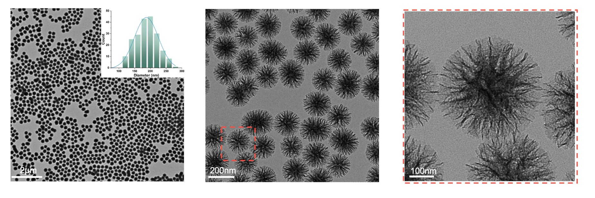
Supplementary Figure 1. TEM images of uniform spherical DMSNs.

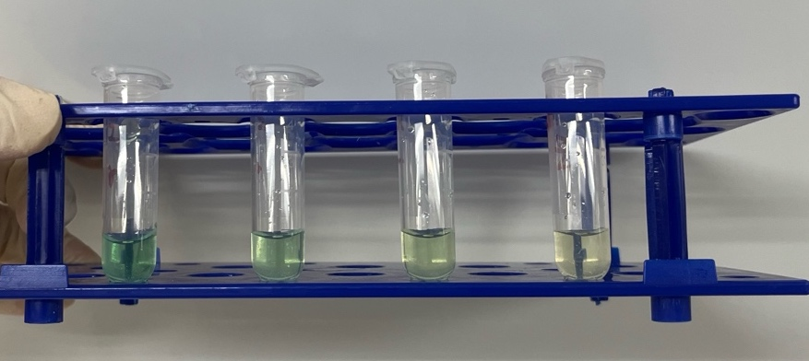

Supplementary Figure 2. Scavenging capacity of NPs for •OH.

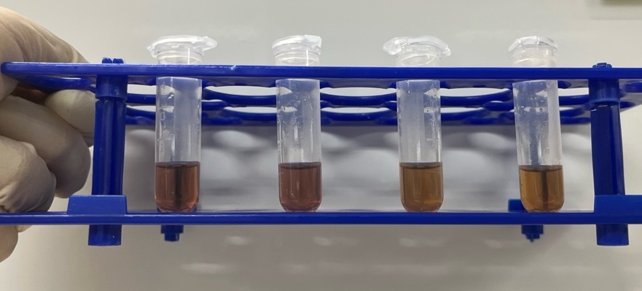

Supplementary Figure 3. Scavenging capacity of NPs for DPPH.
Supplementary Figure 4. CCK8 results of stem cells after coincubation with different concentrations of a. DMSN, b. DMSN-Fe/Cu, and c. TPP- DMSN-Fe/Cu for 24 hours.

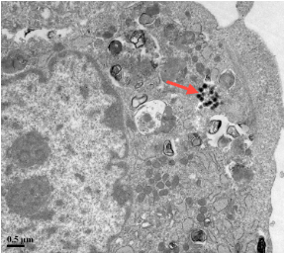

Supplementary Figure 5. TEM images after 4 hours of treatment with DMSN-Fe/Cu nanozymes (red arrows indicate nanozymes).

Supplementary Figure 6. Real-time OCRs of stem cells in the cell mitochondrial stress test and semiquantitative analysis of non-mitochondrial oxygen consumption and spare respiratory capacity.

Supplementary Figure 7. GO term multidimensional enrichment string diagram.

Supplementary Figure 8. GSEA plot showing enrichment of the “Positive regulation of autophagy” and “Mitochondrial proton transporting atp synthase complex” gene set in control and TPP- DMSN-Fe/Cu groups.

Supplementary Figure 9. Gene expression of the osteogenic markers Col1a1 in the stem cells. qPCR data are presented as the means ± SDs (n = 4).

Supplementary Figure 10. Western blot quantitative analysis of osteogenic markers: COL1A1, RUNX2, ALP, OCN, using Image J 1.44 software. Data are presented as the means ± SDs (n = 3).

Supplementary Figure 11. Immunofluorescence staining images of COL1A1 at 7 days. The error bars indicate the mean ± standard deviation (n = 4). Scale bar = 100 μm.
Supplementary Figure 12. Immunofluorescence staining images of RUNX2 at 7 days. The error bars indicate the mean ± standard deviation (n = 4). Scale bar = 100 μm.

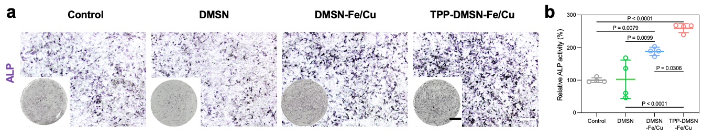

Supplementary Figure 13. ALP activity of stem cells treated by different nanoparticles for 7 days (n = 4). Scale bar = 2 mm and 100 µm.

Supplementary Figure 14. Gene expression of the mitochondrial function markers Rpl13a, Opa1, Pfkm, and Sdha in the stem cells. qPCR data are presented as the means ± SDs (n = 4).

Supplementary Figure 15. Western blot quantitative analysis of AMPK, p-AMPK, and PGC-1α, using Image J 1.44 software. Data are presented as the means ± SDs (n = 3).

Supplementary Figure 16. The number of OCN-positive cells in different groups. The error bars indicate mean ± standard deviation (n = 3).
Supplementary Figure 17. Immunofluorescence staining images intensity of COL1A1. The error bars indicate mean ± standard deviation (n = 3).

Supplementary Figure 18. Immunofluorescence staining images intensity of PGC-1α. The error bars indicate mean ± standard deviation (n = 3).

Supplementary Figure 19. Immunofluorescence staining images intensity of ATP5A. The error bars indicate mean ± standard deviation (n = 3).

Supplementary Figure 20. Biocompatibility evaluation in vivo. The photographs of the heart, liver, spleen, lung, and kidney.
Supplementary Figure 21. The tissue sections H&E staining of the heart, liver, spleen, lung, and kidney. Scale bar = 200 μm.

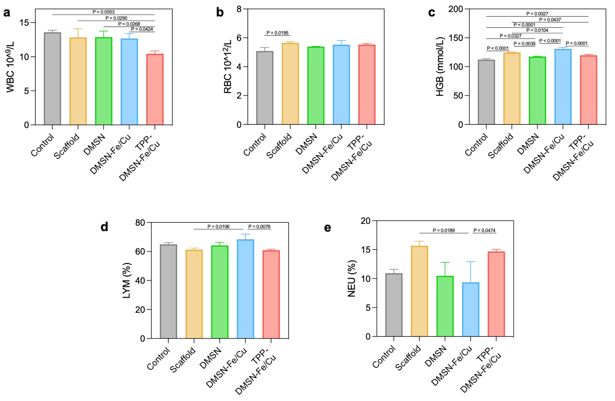
Supplementary Figure 22. Blood indices of rat femoral defect model after different treatments, including a white blood cell count (WBC), b red blood cell count (RBC), c hemoglobin (HGB), d lymphocyte percentage (Lymph %), and e Neutrophils percentage (NEU %). The error bars indicate mean ± standard deviation (n = 3).

Supplementary Table 1. All gene primer sequences used in the RT-qPCR experiments.
 | Gene Name | Forward Sequences | Reverse Sequences
Osteogenic | Runx2 | GGTGAAACTCTTGCCTCGTC | AGTCCCAACTTCCTGTGCT
Osteogenic | Col1a1 | GCTCCTCTTAGGGGCCACT | ATTGGGGACCCTTAGGCCAT
Osteogenic | Ocn | TCTGACAAAGCCTTCATGTCC | AAATAGTGATACCGTAGATGCG
Osteogenic | Opn | ACACTTTCACTCCAATCGTCC | TGCCCTTTCCGTTGTTGTCC
Osteogenic | Alp | GGCTGGAGATGGACAAATTCC | CCGAGTGGTAGTCACAATGCC
Metabolism | Rpl13a | CTGTGAAGGCATCAACATTTCTG | GACCACCATCCGCTTTTTCTT
Metabolism | Opa1 | CTGCAGGTCCCAAATTGGTT | TCTTTGTCTGACACCTTCCTGT
Metabolism | Cpt1a | TCGGTGAGCCTGGCCT | TTGAGTGGTGACCGAGTCTG
Metabolism | Dnm1l | CCAGAGGAACTGGTGTGGTC | CCATTCTTCTGCTTCAACTCCATT
Metabolism | Fam36a | GAAAAAGCCCTTCAAGCTCCT | GAAATGTCCAAGTCCAGTCACA
Metabolism | Atp5a | TCTCCATGCCTCTAACACTCG | CCAGGTCAACAGACGTGTCAG
Metabolism | Pfkm | CATCGCCGTGTTGACCTCT | CCCGTGAAGATACCAACTCGG
Metabolism | Sdha | GGAACACTCCAAAAACAGACCT | CCACCACTGGGTATTGAGTAGAA
Metabolism | Cat | ATGGTCACCGGCACATGAAT | GCCCTGGTCGGTCTTGTAAT
Metabolism | Pgc-1a | TATGGAGTGACATAGAGTGTGCT | GTCGCTACACCACTTCAATCC
 | GAPDH | AGGTCGGTGTGAACGGATTTG | GGGGTCGTTGATGGCAACA

Supplementary Table 2. Information of antibodies used in this western blot experiment.
Antibody  Reference | Company, Catalog | Dilution
GAPDH | Abcam, ab8245 | 1:2000
Osteogenic marker
Anti-Collagen I | Abcam, ab270993 | 1:1000
Anti-RUNX2 | Abcam, ab236639 | 1:1000
Anti-ALP | Abcam, ab229126 | 1:1000
Anti-Osteocalcin | Abcam, ab309521 | 1:1000
Signal pathway marker
Anti-Beclin1 | Abcam, ab207612 | 1:2000
Anti-LC3B | Abcam, ab192890 | 1:2000

Supplementary Table 3. Information of antibodies used in immunocytochemistry (ICC), immunohistochemistry (IHC), & tissue immunofluorescence staining experiment.
Antibody | Company, Catalog | Dilution
For ICC
Anti-Collagen I | Abcam, ab270993 | 1:200
Anti-RUNX2 | Abcam, ab236639 | 1:200
Anti-Osteocalcin | Abcam, ab309521 | 1:200
For IHC
Anti-Osteocalcin  For Immunofluorescence | Abcam, ab309521 | 1:500
PGC-1α | Proteintech, 66369-1-ig | 1: 500
ATP-5A | Proteintech, 14676-1-AP | 1: 500
COL1A1 | Affinity, AF7001 | 1: 500

