Statistical Test Results Data

Figures and tables of statistical test calculation results using SmartPLS version 3.0 in the Effectiveness of Below-the-Line (BTL) Health Campaigns in Reducing Non-Communicable Diseases (NCDs) Among Industrial Workers: A Quasi-Experimental Study.

The first step in data testing is to conduct an outer loading test to obtain the loading factor (LF) value of each indicator against its variable. The result is as shown in the following image:

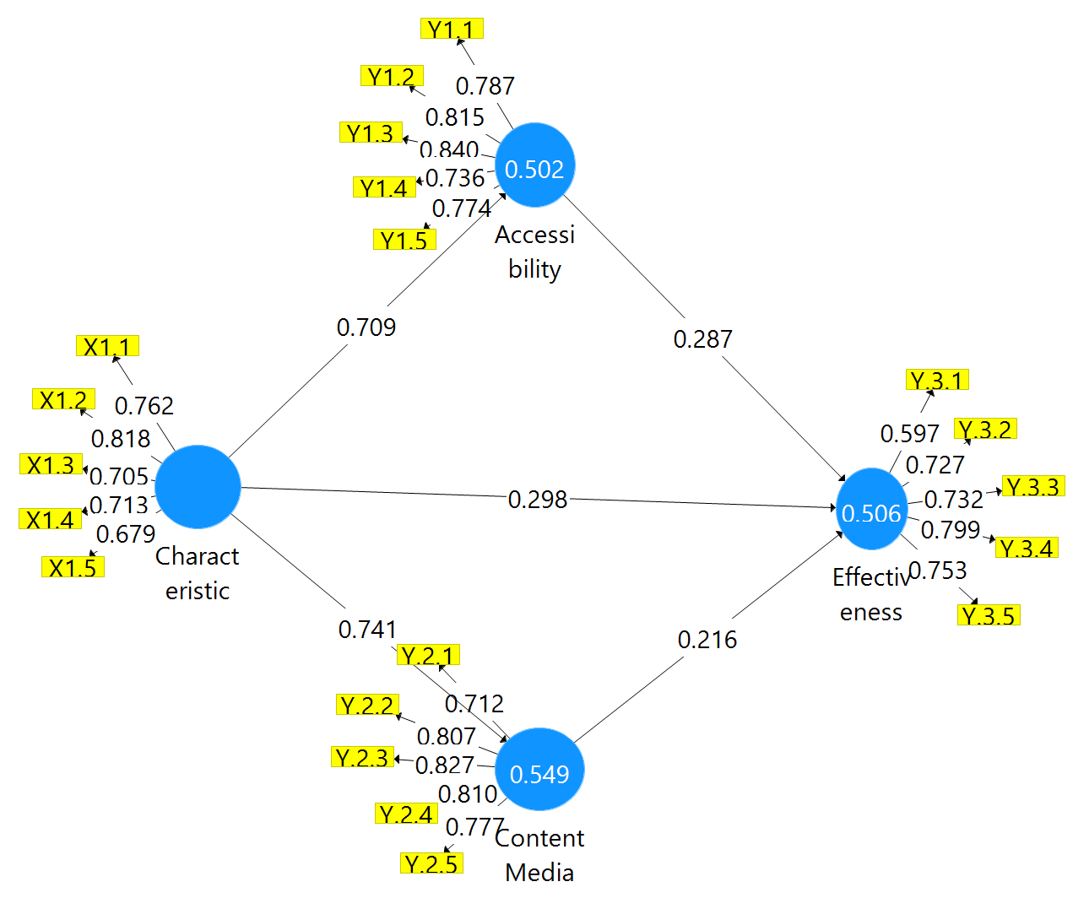

Figure 1. Preliminary Test Results of Outer Model for LF Used Indicators

The image explains that two indicators must be set aside from the next model test, namely X1.5 and Y3.1, because the loading factor value is <0.7, while the other indicator can explain that the existing indicators can reflect their respective variables.

After the two indicators were removed, the model was recalculated to get the reliability and validity values of the model, namely Cronbach’s alpha (ca), composite reliability (cr) and average variance extracted (ave) value, where if the values of ca and cr >0.7 mean good and consistent reliability, while if ave>0.5 means valid. The results are presented in Table 1 below.

Table 1: Construct Reliability and Validity Results

 | Cronbach’s Alpha | rho_A | Composite Reliability | Average Variance Extracted (AVE)
Accessibility | 0,850 | 0,853 | 0,893 | 0,626
Characteristic | 0,789 | 0,797 | 0,855 | 0,543
Content Media | 0,846 | 0,850 | 0,891 | 0,620
Effectiveness | 0,773 | 0,790 | 0,846 | 0,525

Table 1 above illustrates that the constructs in the model exhibit good reliability and relatively high convergent validity. In other words, the instruments used in the study are reliable and effectively measure the constructs.

Table 2 R-Square Values
 | R Square | R Square Adjusted
Accessibility | 0,502 | 0,499
Content Media | 0,549 | 0,547
Effectiveness | 0,506 | 0,499

Table 2 above presents the higher R² and Adjusted R² values, indicating that the model explains the variation in the dependent variables quite well. In this case, Media Content exhibits a higher explanatory ability than Accessibility and Effectiveness, as indicated by its greater R² and R² Adjusted values.

F-Square (f²) is a measure of the effect or strength of influence of an independent variable on a dependent variable in a structural model. This f-Square value is used to assess the magnitude of the influence or contribution of changes in independent variables to changes in dependent variables, as described in the table below.

Table 3 Value of F-squares
 | Accessibility | Characteristic | Content Media | Effectiveness
Accessibility |  |  |  | 0,082
Characteristic | 1,008 |  | 1,217 | 0,060
Content Media |  |  |  | 0,042
Effectiveness

Table 3 above explains that Objective Characteristics have a significant influence on Accessibility and Media Content, with f-squared values of 0.924 and 1.235, indicating a strong influence. The effect of Accessibility on Effectiveness is relatively small, with a value of f-squares of 0.066. The Objective Characteristic has little influence on effectiveness, with an F-squared value of 0.051. There was no measurable relationship between accessibility, media content, and other variables in this model.

Table 4 Path Coefficients in the inner model
 | Original Sample (O) | Sample Mean (M) | Standard Deviation (STDEV) | T Statistics (|O/STDEV|) | P Values
Accessibility -> Effectiveness | 0,287 | 0,288 | 0,096 | 2,994 | 0,003
Characteristic -> Accessibility | 0,709 | 0,712 | 0,048 | 14,742 | 0,000
Characteristic -> Content Media | 0,741 | 0,744 | 0,036 | 20,737 | 0,000
Characteristic -> Effectiveness | 0,298 | 0,305 | 0,105 | 2,845 | 0,005
Content Media -> Effectiveness | 0,216 | 0,215 | 0,083 | 2,616 | 0,009

From Table 4, it can be concluded that all the relationships between the variables tested showed a significant influence. First, the relationship between Accessibility and Effectiveness showed a positive influence of 0.287, with a t-statistical value of 2.994 and a p-value of 0.003. This result indicates that accessibility has a significant positive influence on effectiveness, meaning that improved accessibility leads to higher effectiveness.
Furthermore, the relationship between Characteristics and Accessibility has a powerful influence with an original sample value of 0.709, a very high t-statistic of 14.742, and a very small p-value (0.000). This result shows that Characteristics have a very significant influence on accessibility, so better goal characteristics can improve accessibility.
In addition, the relationship between Characteristics and Media Content showed a powerful influence, with an original sample value of 0.741, a t-statistic of 20.737, and a p-value of 0.000. This result indicates that Characteristics play a very significant role in improving Media Content, so the better the target characteristics, the better the media content produced.
The relationship between Characteristics and Effectiveness also showed a significant positive influence, with an original sample value of 0.298, a t-statistic of 2.845, and a p-value of 0.005. This result suggests that good characteristics can also significantly increase effectiveness.
Finally, the relationship between Media Content and Effectiveness had a positive influence of 0.216, with a t-statistical value of 2.616 and a p-value of 0.009, which shows that Media Content also has a significant influence on effectiveness. Overall, all of the relationships tested in this model showed a strong and significant influence between the variables involved, indicating that the constructed model can describe relevant and significant relationships in the context of this study. The last step is to examine the results of the model fit test, as shown in Table 5.

Table 5. Fitness Test Results of the model
 | Saturated model | Estimated model
SRMR | 0,077 | 0,077

The table provides an identical SRMR value (0.077), indicating that the difference between the Saturated Model and the Estimated Model in terms of model fit to the data is minimal. This result shows that the estimated model has an excellent fit, and the data presented can be relied upon for use in further analysis.

