Supporting Information for
Room-Temperature Fabrication of Dual-Functional SiO₂/TiO₂ Coating for Photovoltaic Efficiency Enhancement: from Laboratory Development to Field Validation
Pengge Wang^{1,2,3}, Xinwei Li⁴, Ning Zhang^{1,2,3}, Yue Zhai⁵, Zhenyu Wang^{1,2,3}, Suixin Liu^{1,2,3}, Wingkei Ho⁶, Yu Huang^{1,2,3*}, and Shun-cheng Lee⁷

¹ State Key Laboratory of Loess Science, Institute of Earth Environment, Chinese Academy of Sciences, Xi'an 710061, China

² National Observation and Research Station of Regional Ecological Environment Change and Comprehensive Management in the Guanzhong Plain, Xi'an 710061, China

³ Shaanxi Key Laboratory of Atmospheric and Haze-fog Pollution Prevention, Xi'an 710061, China

⁴ Department of Civil and Environmental Engineering, The Hong Kong Polytechnic University, Hong Kong, China

⁵ Xi’an Institute for Innovative Earth Environment Research, Xi’an 710061, China

^{6.} Department of Science and Environmental Studies, The Education University of Hong Kong, Hong Kong, China

⁷ Earth, Ocean and Atmospheric Sciences Thrust, Function Hub, The Hong Kong University of Science and Technology (Guangzhou), Guangzhou 511442, China

Corresponding author: Yu Huang (huangyu@ieecas.cn)
Table S1 The specifications for the 550 Wp monocrystalline PV module.
Power (Pmax / Wp) | 550
Open-Circuit Voltage (Voc / V) | 49.80
Short-Circuit Current (Isc /A) | 13.98
Voltage at Pmax (Vmp / V) | 41.95
Current at Pmax (Imp / A) | 13.12
Efficiency (%) | 21.7
Size (mm) | 2256 × 1133 × 35
Weight (kg) | 27.2

Table S2 The specifications for the 110 kW string inverter.
Model Number (kW) | 110
Maximum Input Voltage (V) | 1100
Rated Input Voltage (V) | 600
Rated Output Power (kW) | 110
Maximum Output Power (kW) | 121
Maximum Efficiency (%) | 99

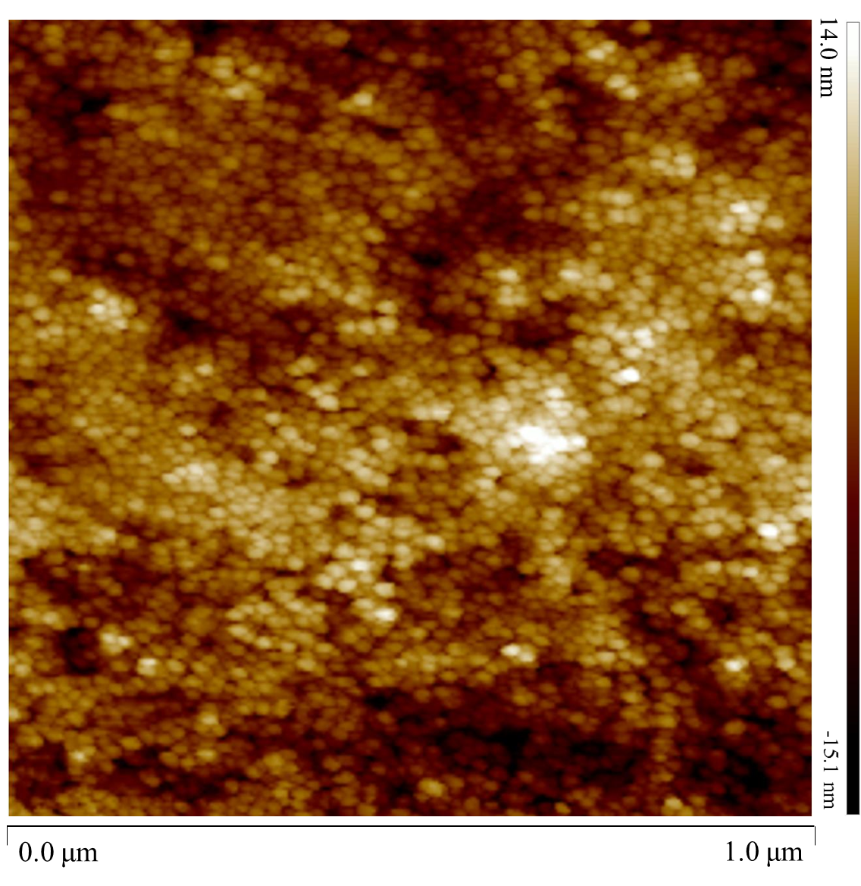
Fig. S1 2D AFM images of the ST-coated glass.

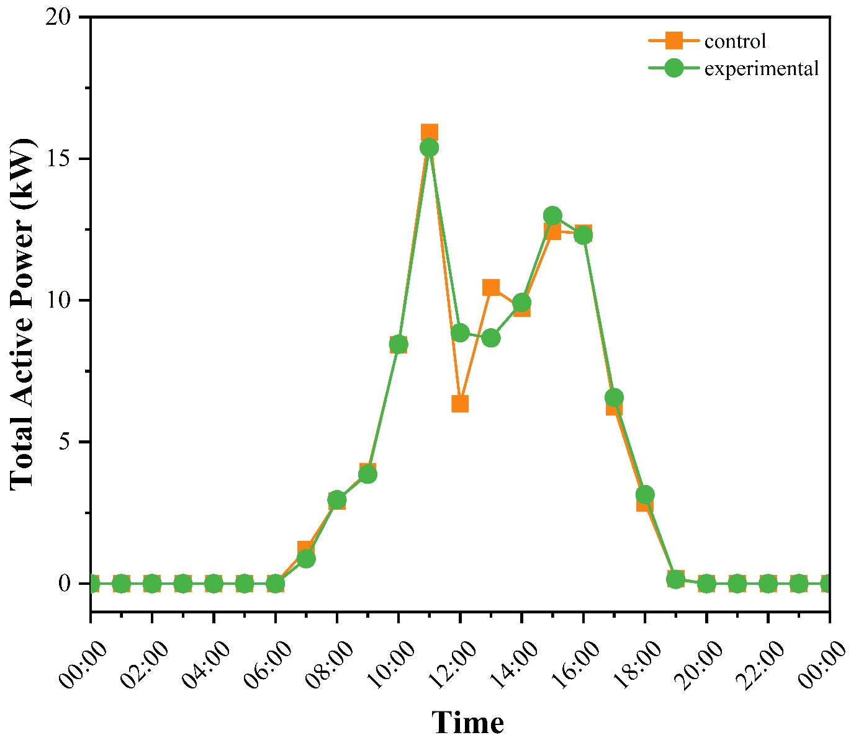
Fig. S2 Variation of total active power for experimental and control PV modules on a rainy day (April 22, 2023).

