Machine learning-based identification of associations between phthalate exposure and glaucoma: Analysis of data from the US NHANES (2005–2008)

Table of Contents
Supplemental Figure 1. Receiver Operating Characteristic (ROC) Curves for the 11 Machine Learning Models in the Training Cohort.

Supplemental Figure 2.Classification Performance Assessment Using Confusion Matrices for the Predictive Models.

Supplemental Figure 3. Ranking of Feature Importance within the Predictive Model.

Supplemental Figure 4. Individualized Glaucoma Risk Probability Estimation.

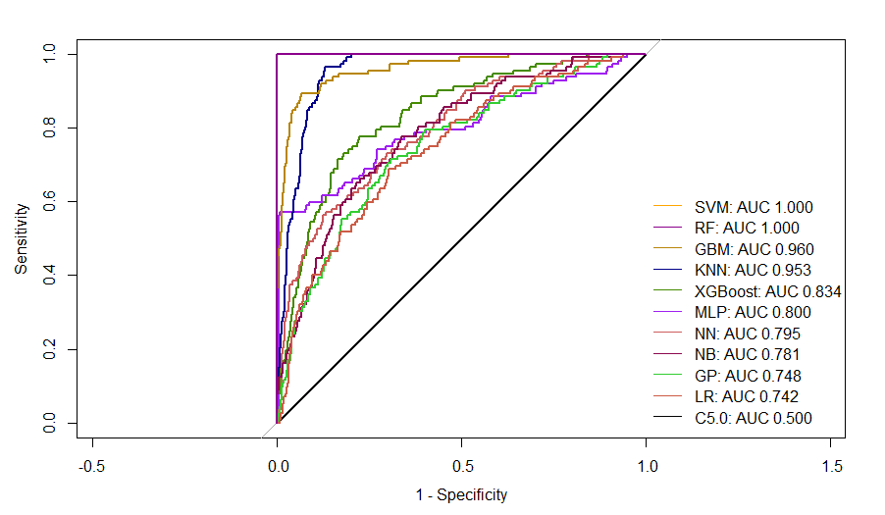
Supplemental Figure 1. Receiver Operating Characteristic (ROC) Curves for the 11 Machine Learning Models in the Training Cohort.

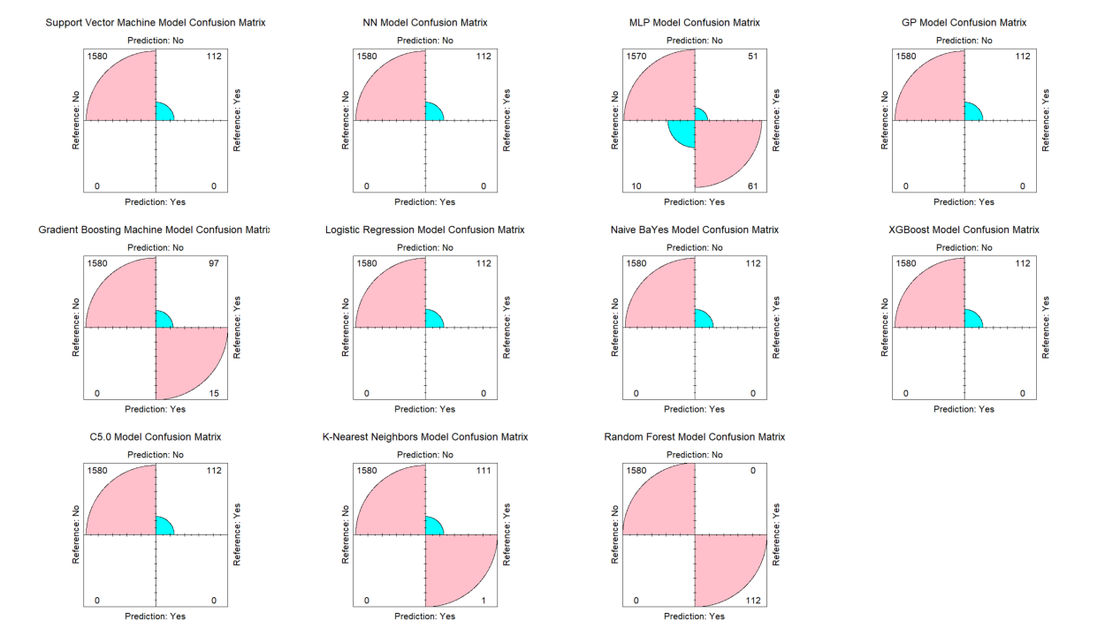
Supplemental Figure 2. Classification Performance Assessment Using Confusion Matrices for the Predictive Models.

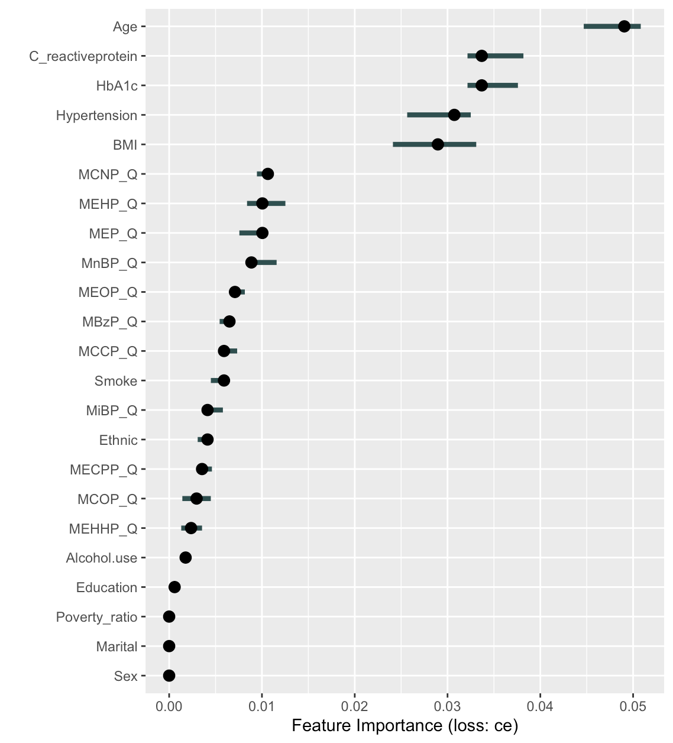
Supplemental Figure 3. Ranking of Feature Importance within the Predictive Model.

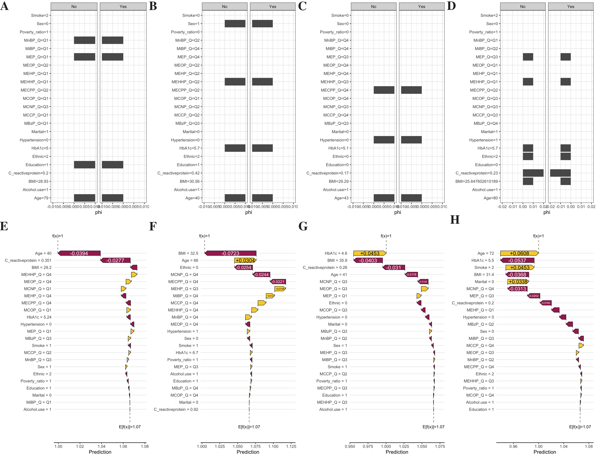
Supplemental Figure 4. Individualized Glaucoma Risk Probability Estimation.
SHAP was utilized in individualized decision-making analysis to visualize patient-specific profiles for outcome prediction. In panels E–H, yellow bars represent variables that promote glaucoma progression, while purple bars denote factors associated with a protective effect.

