Figure S1: Spatial distribution of the mean monthly ratio between total fish weight and number per set (kg), averaged per fishing patch (a), along with its seasonal predictions (b) across the entire study area.

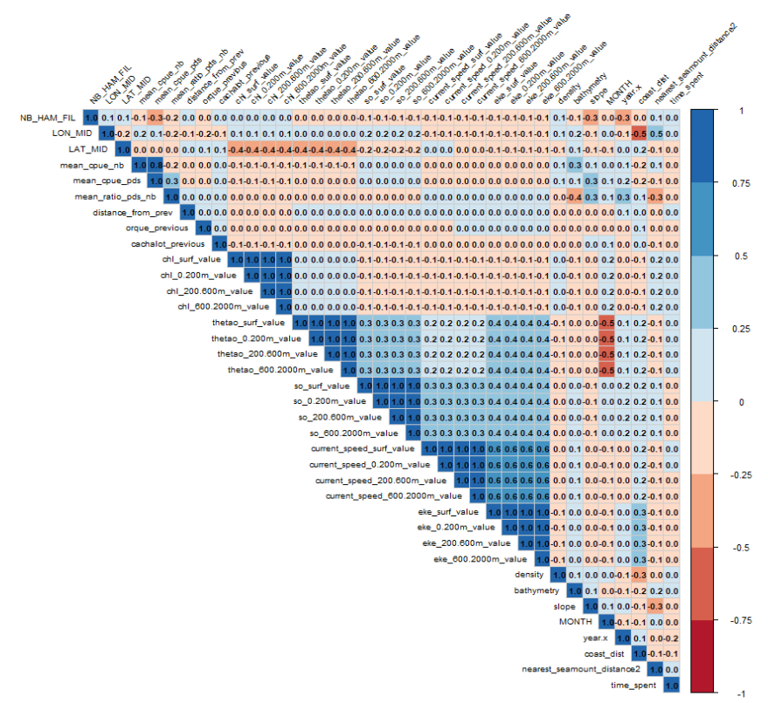
Figure S2: Correlation plot between all covariates included in the analysis.

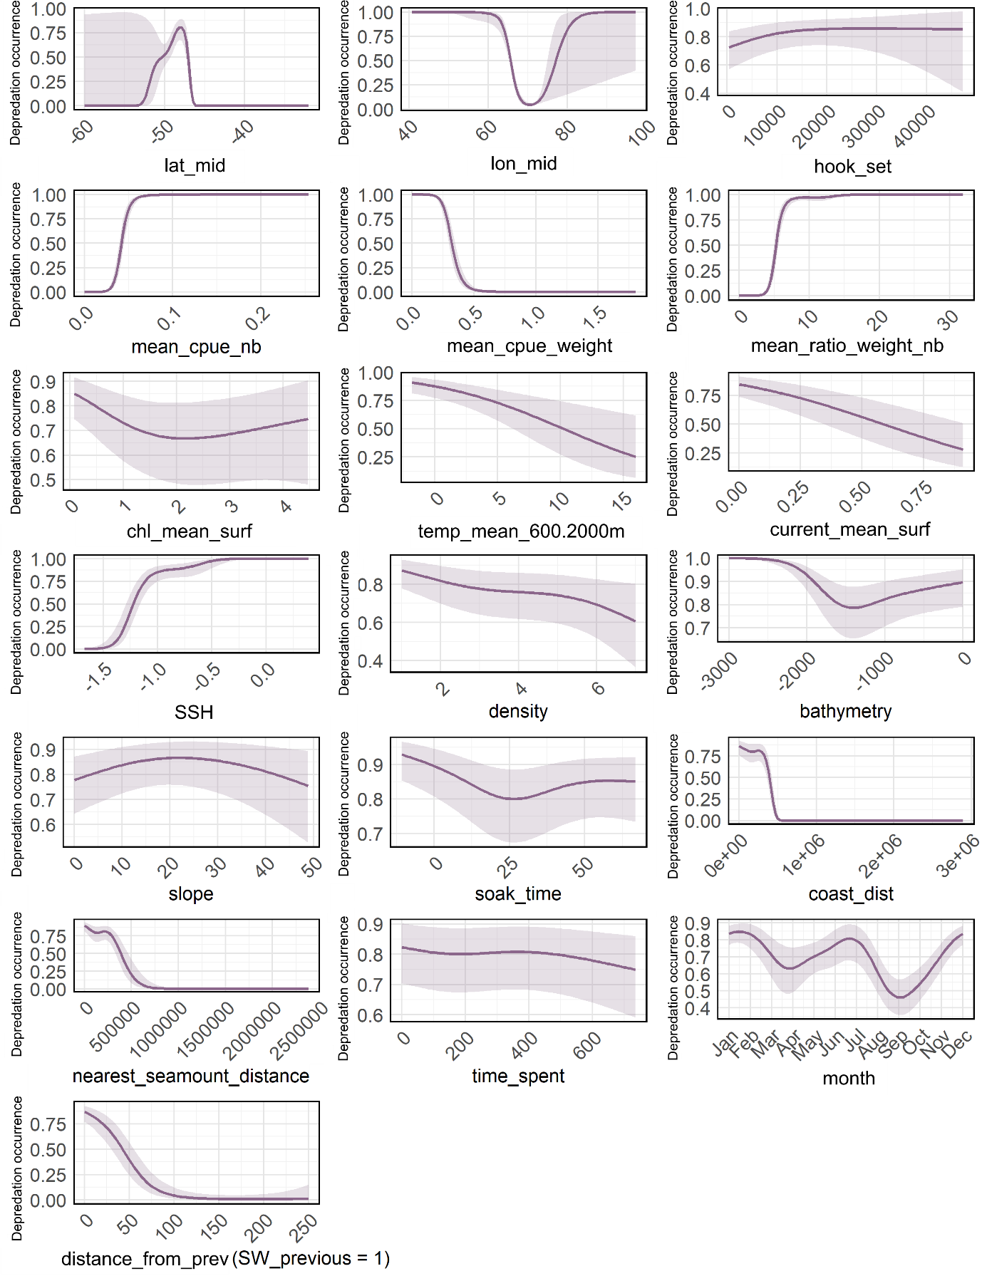

Figure S3: Relationships between the probability of sperm whale depredation occurrence and the variables selected in the final GAMs. Solid lines represent the estimated smooth functions and shaded regions show the approximate 95% confidence intervals, both averaged over the 10-folds cross-validation.

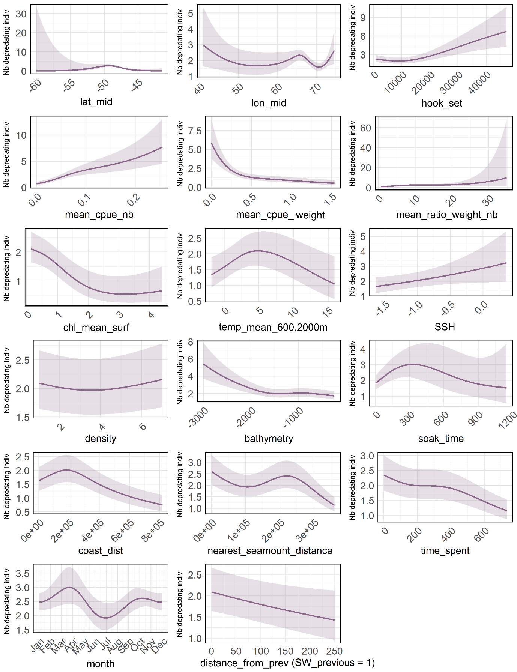
Figure S4: Relationships between the predicted number of depredating sperm whales and the variables selected in the final GAMs. Solid lines represent the estimated smooth functions and shaded regions show the approximate 95% confidence intervals, both averaged over the 10-folds cross-validation.

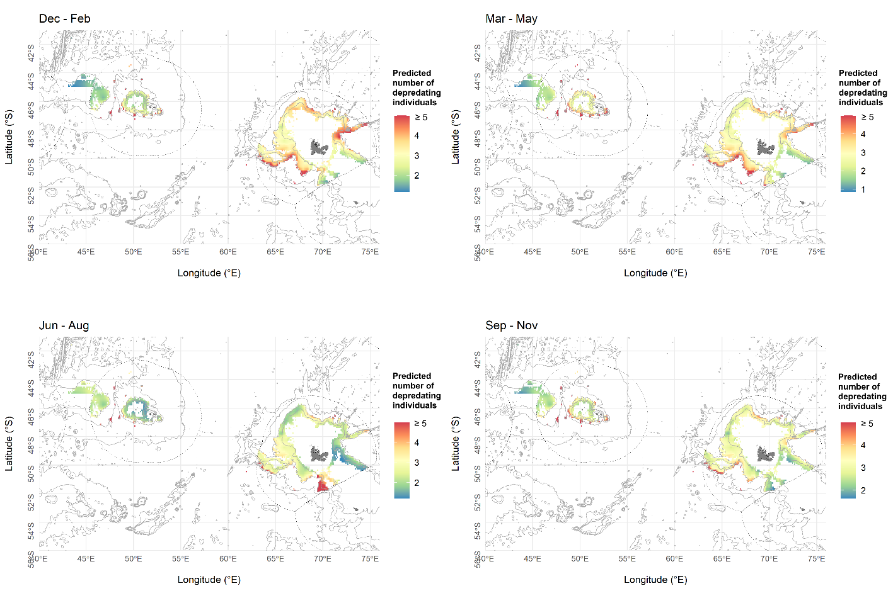
Figure S5: Mean predicted number of depredating sperm whales over the 2010-2020 period across the Crozet and Kerguelen EEZs averaged over seasons: summer (December-February), autumn (March-May), winter (June-August) and spring (September-November).

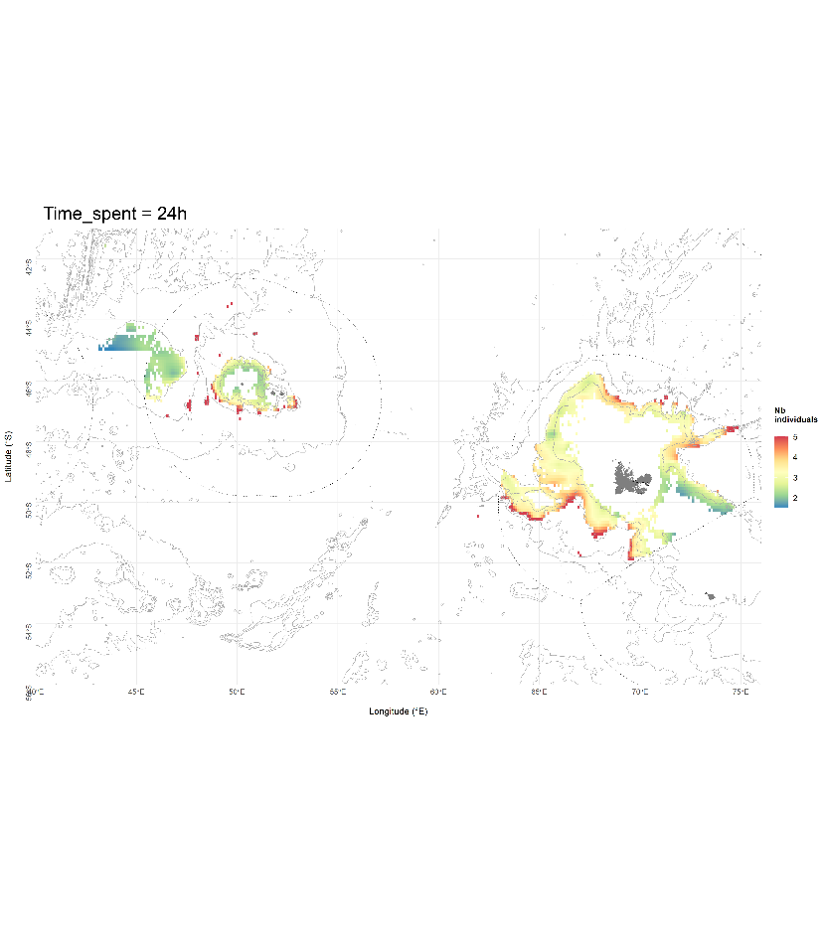
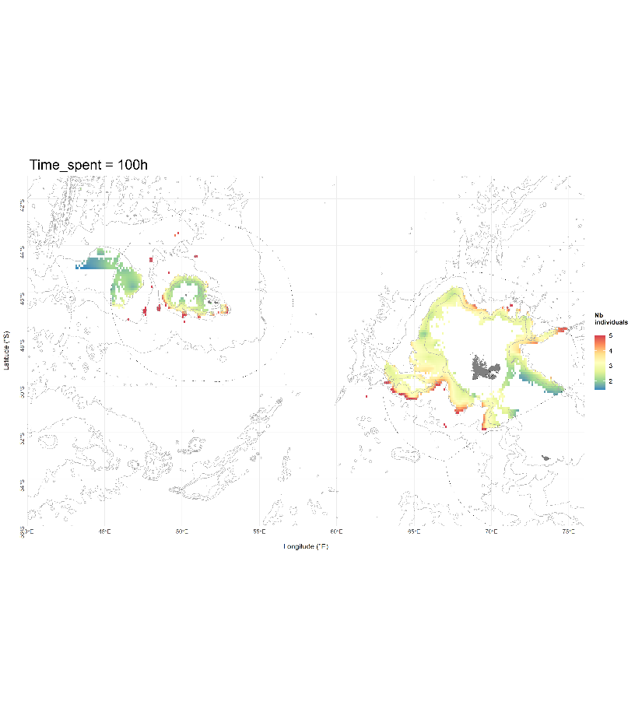
Figure S6: Mean predicted number of depredating sperm whales over the 2010-2020 period across the Crozet and Kerguelen EEZs for 24 hours and 100 hours spent in a same fishing patch.

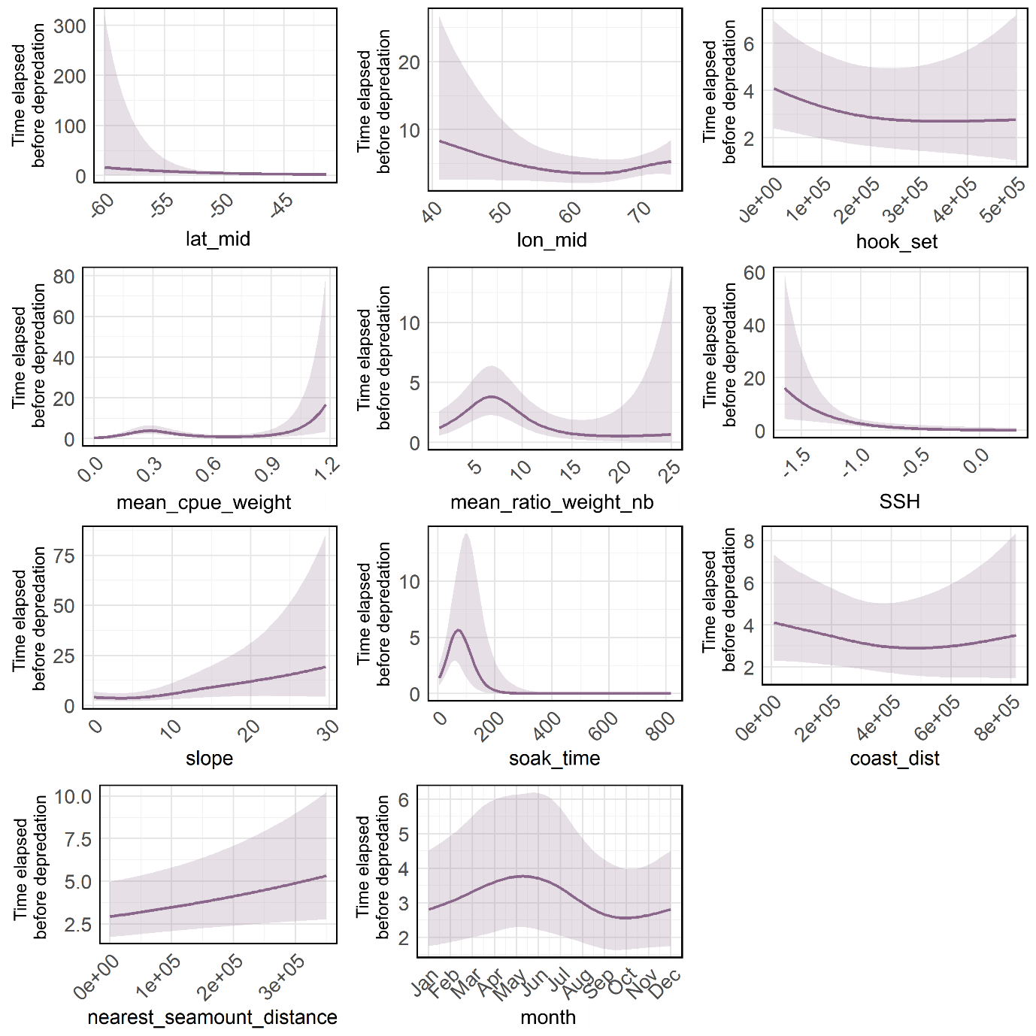
Figure S7: Relationships between the predicted time elapsed before sperm whale depredation occurred in a given patch (days) and the variables selected in the final GAMs. Solid lines represent the estimated smooth functions and shaded regions show the approximate 95% confidence intervals, both averaged over the 10-folds cross-validation.

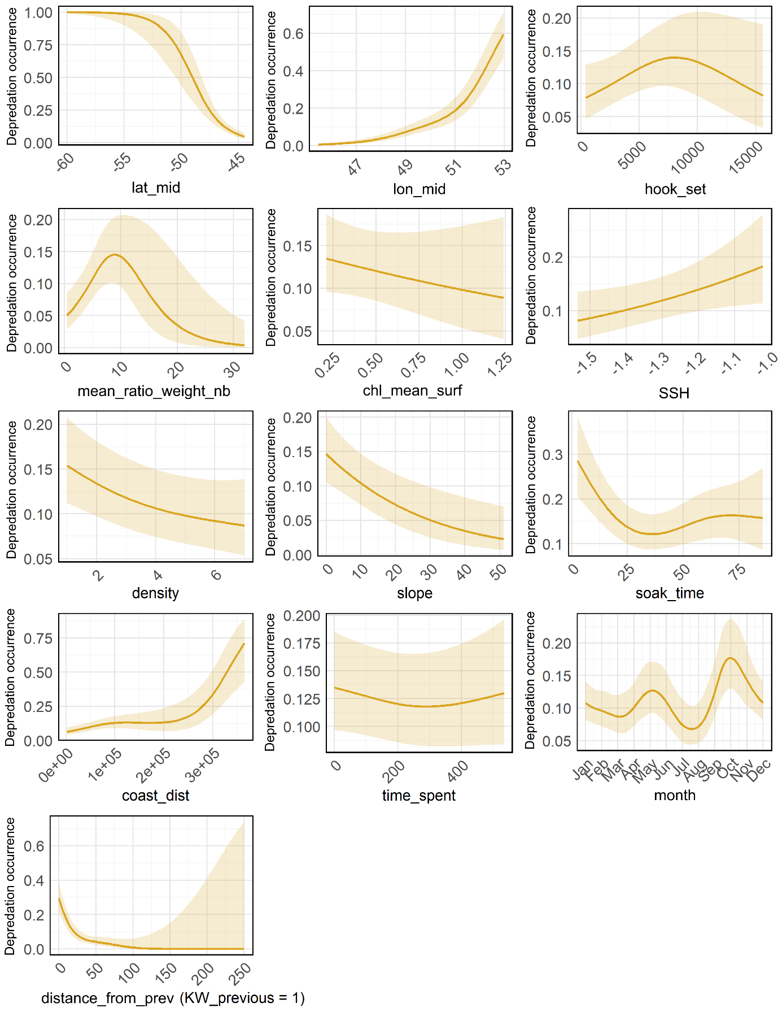
Figure S8: Relationships between the probability of Crozet type killer whale depredation occurrence and the variables selected in the final GAMs. Solid lines represent the estimated smooth functions and shaded regions show the approximate 95% confidence intervals, both averaged over the 10-folds cross-validation.

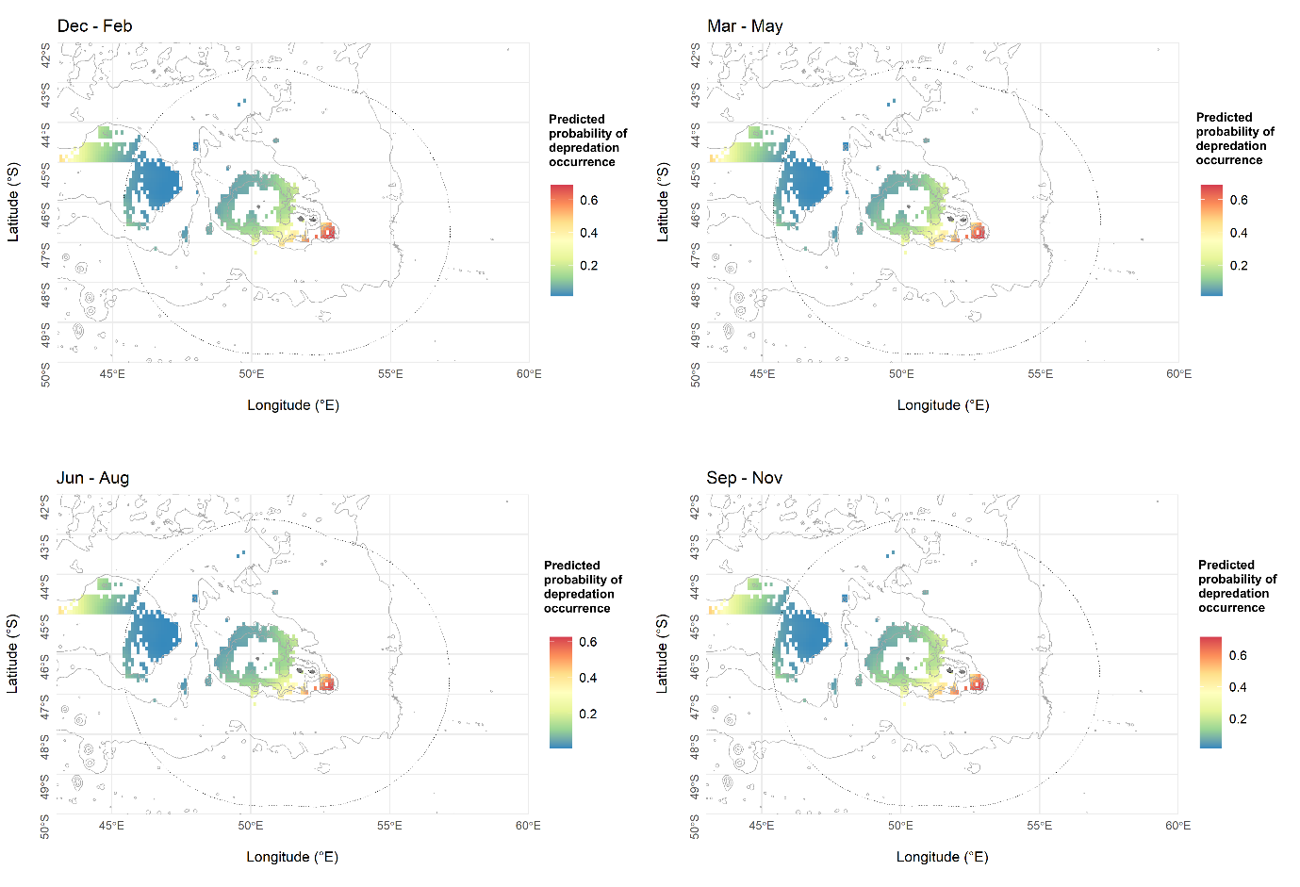

Figure S9: Mean predicted probabilities of Crozet type killer whale depredation occurrence over the 2010-2020 period across the Crozet area, averaged over seasons: summer (December-February), autumn (March-May), winter (June-August) and spring (September-November).

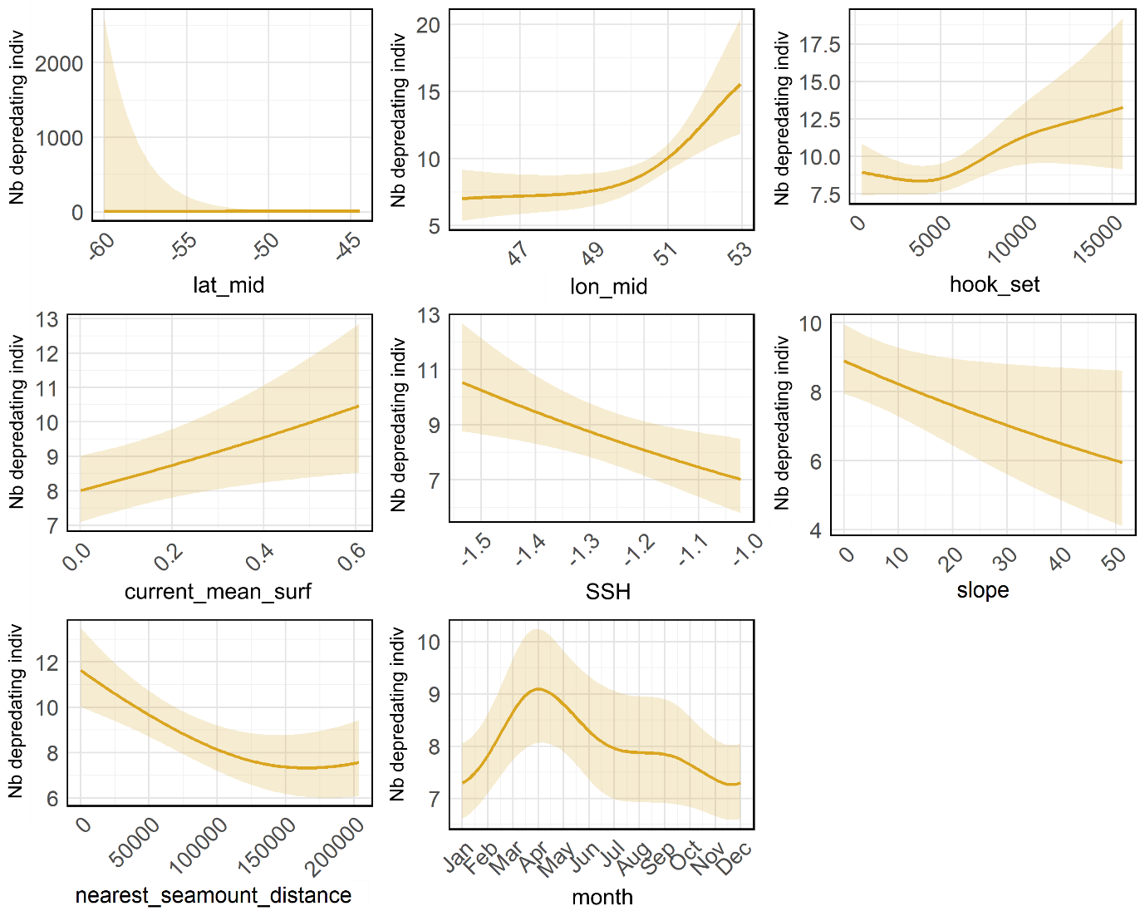
Figure S10: Relationships between the predicted number of depredating Crozet type killer whales and the variables selected in the final GAMs. Solid lines represent the estimated smooth functions and shaded regions show the approximate 95% confidence intervals, both averaged over the 10-folds cross-validation.

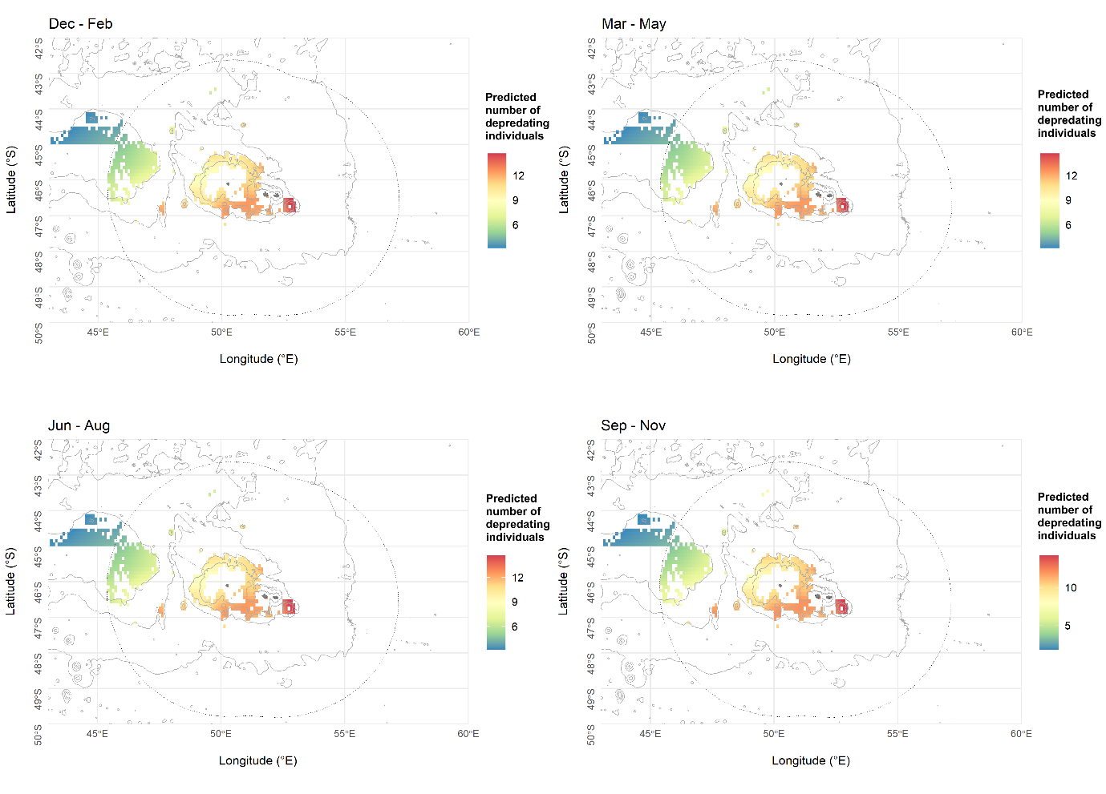

Figure S11: Mean predicted number of depredating Crozet type killer whales over the 2010-2020 period across the Crozet area, averaged over seasons: summer (December-February), autumn (March-May), winter (June-August) and spring (September-November).

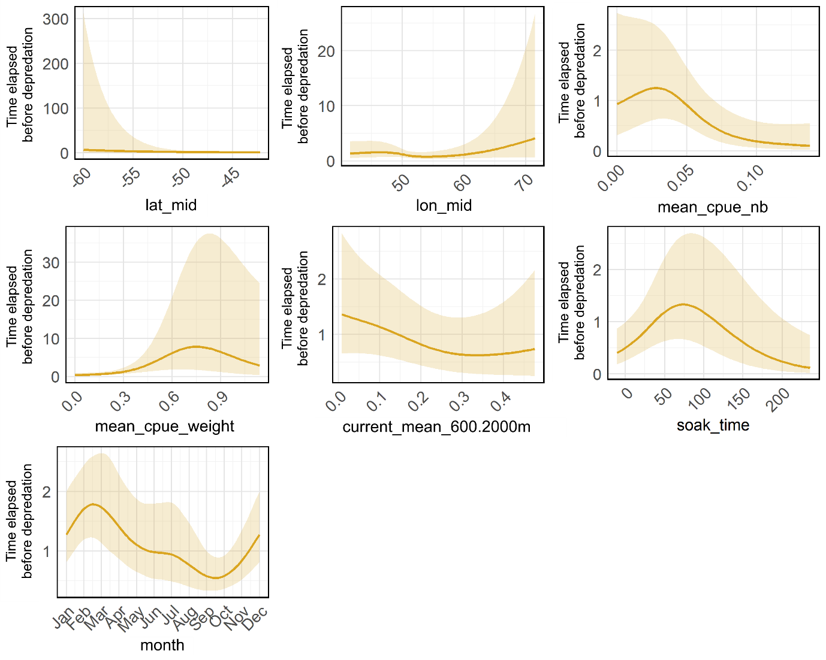
Figure S12: Relationships between the predicted time elapsed before Crozet type killer whale depredation occurred in a given patch (days) and the variables selected in the final GAMs. Solid lines represent the estimated smooth functions and shaded regions show the approximate 95% confidence intervals, both averaged over the 10-folds cross-validation.

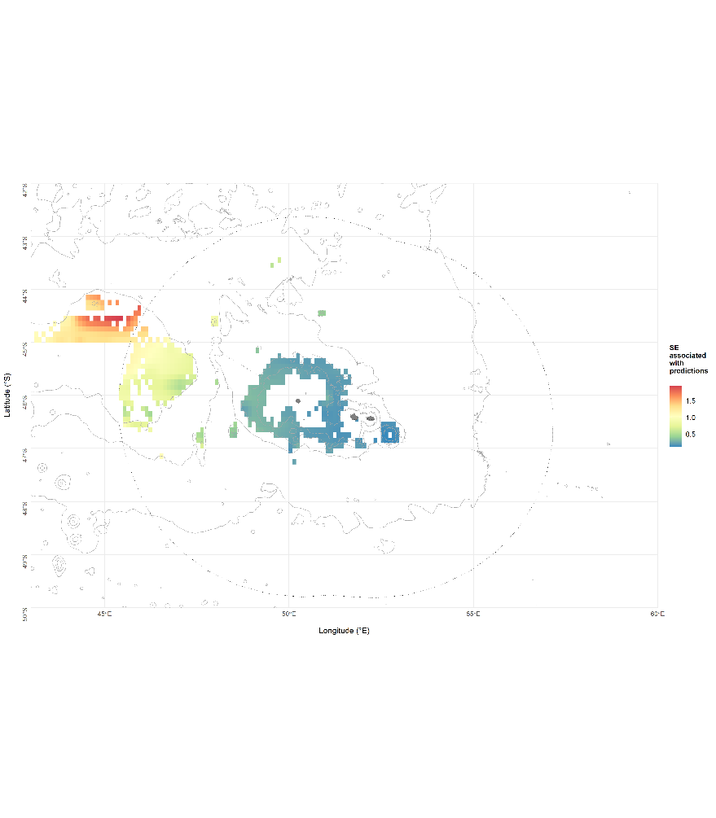
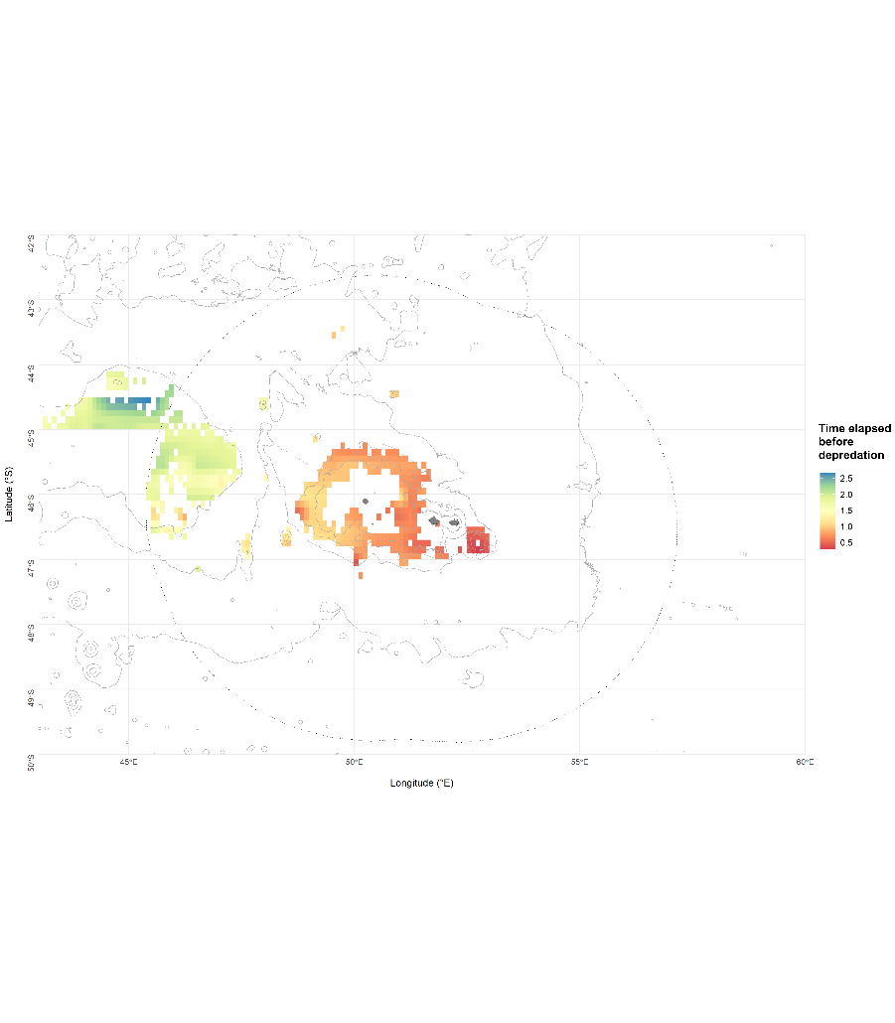

Figure S13: Mean predicted time elapsed before Crozet type killer whale depredation occurred in a given patch (days), in the Patagonian toothfish fishery over the 2010-2020 period across the Crozet area where fishing data were available. Map of standard errors associated with predictions is presented on the right side.

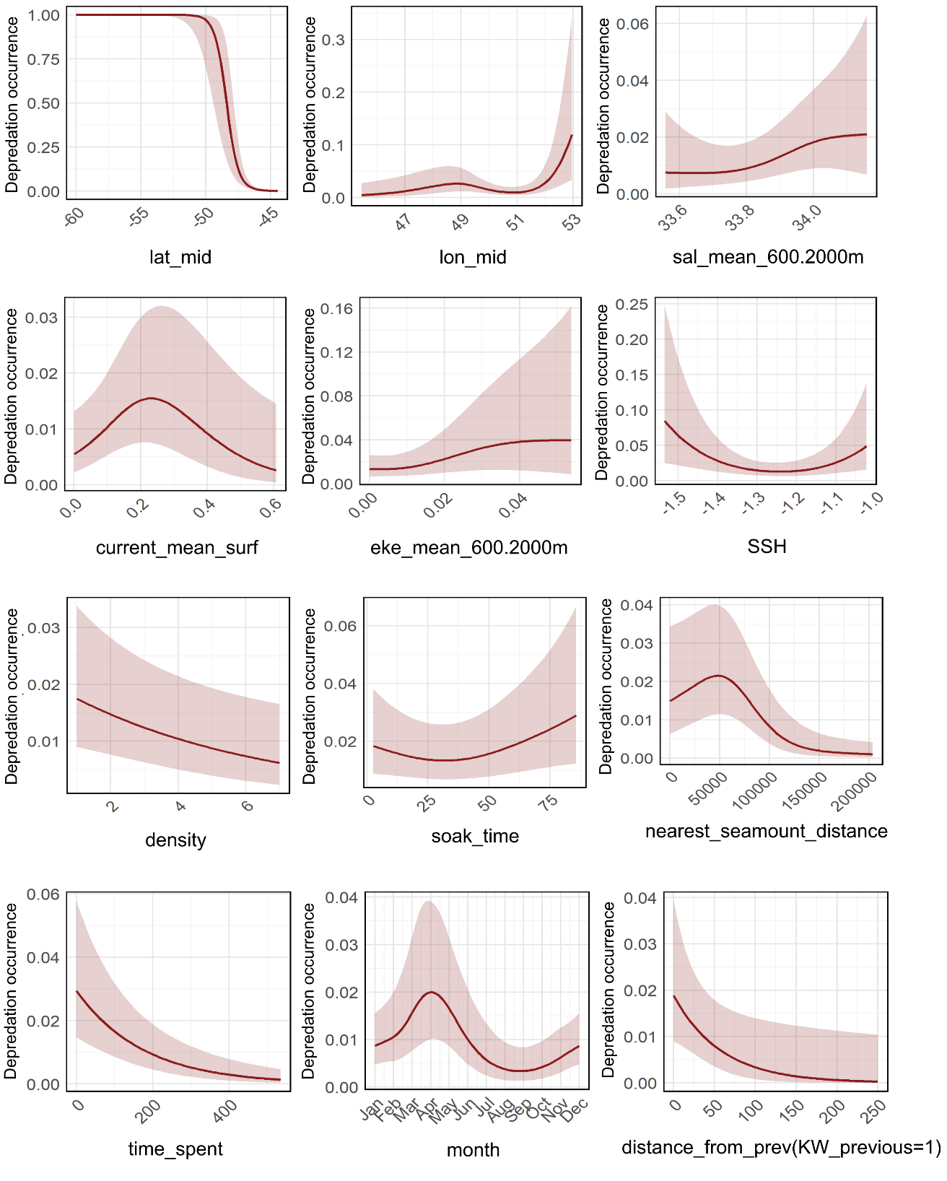
Figure S14: Relationships between the predicted probability of type D killer whale depredation occurrence and the variables selected in the final GAMs. Solid lines represent the estimated smooth functions and shaded regions show the approximate 95% confidence intervals, both averaged over the 10-folds cross-validation.

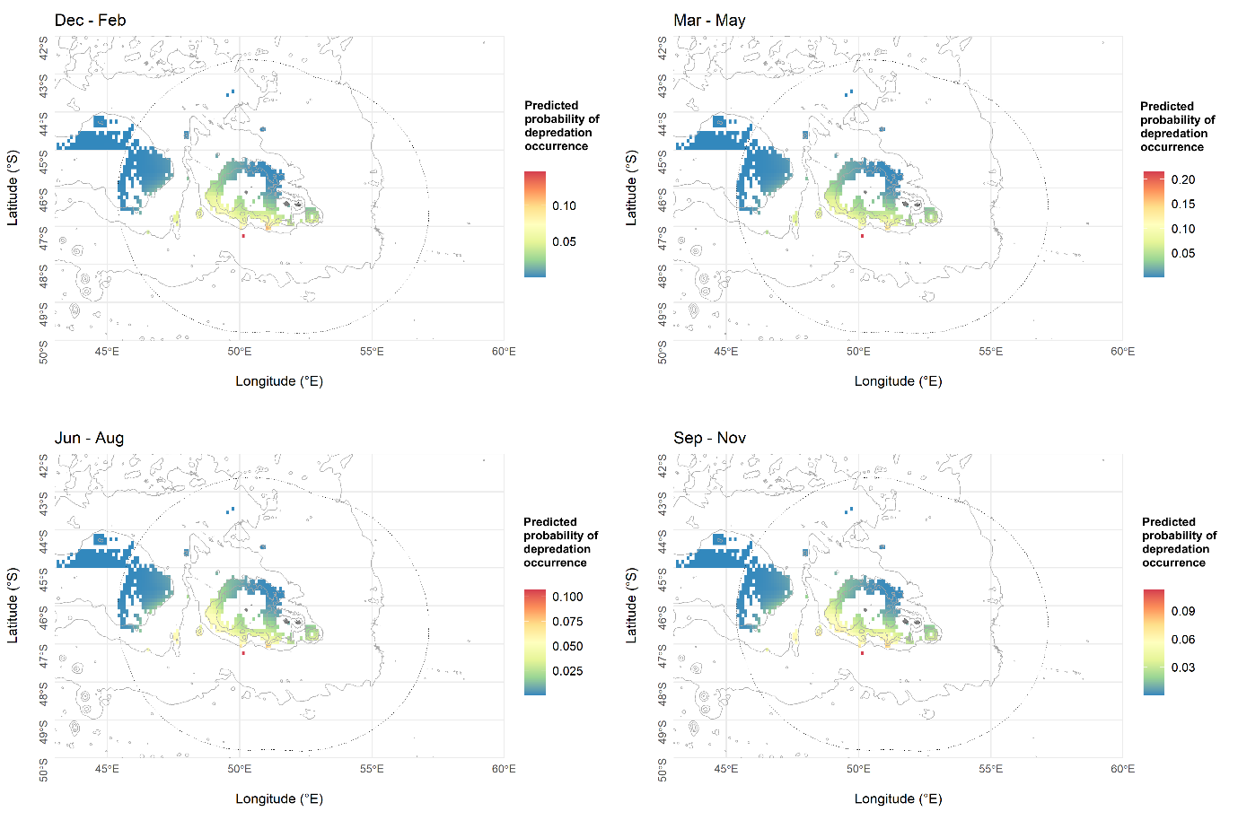

Figure S15: Mean predicted probabilities of Type D killer whale depredation occurrence over the 2010-2020 period across the Crozet area, averaged over seasons: summer (December-February), autumn (March-May), winter (June-August) and spring (September-November).

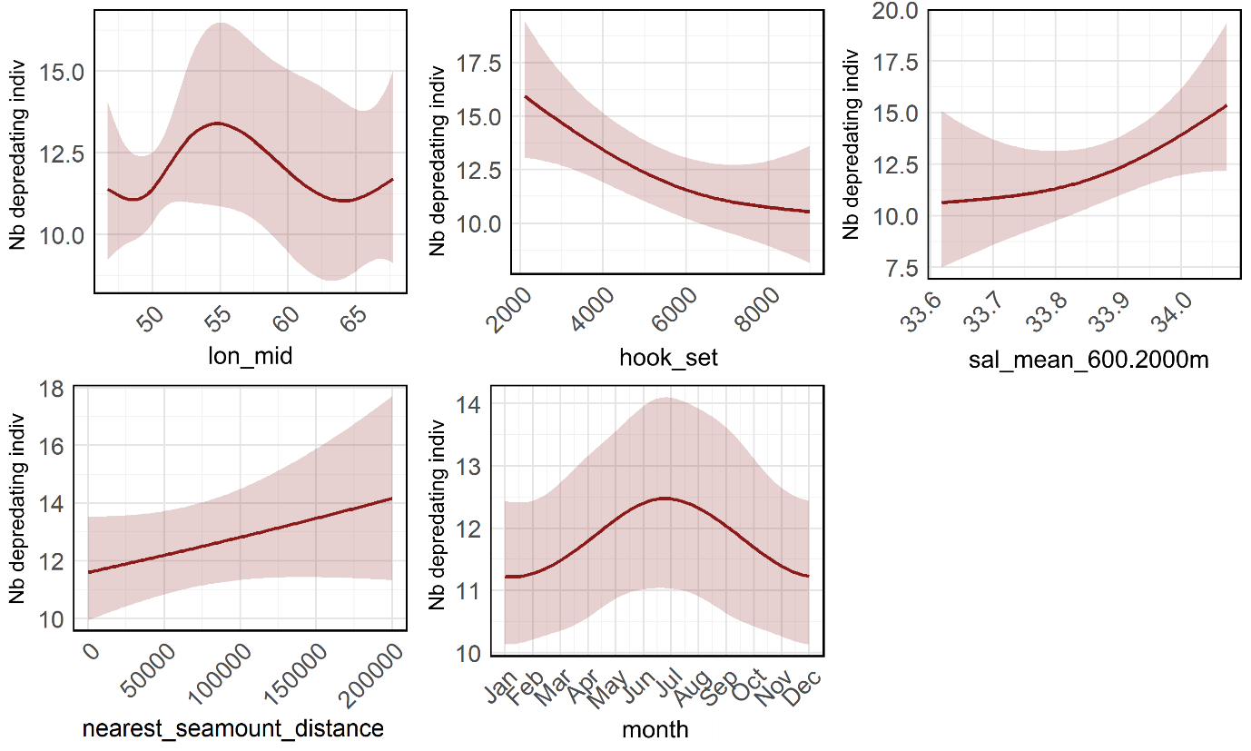
Figure S16: Relationships between the predicted number of depredating type D killer whales and the variables selected in the final GAMs. Solid lines represent the estimated smooth functions and shaded regions show the approximate 95% confidence intervals, both averaged over the 10-folds cross-validation.

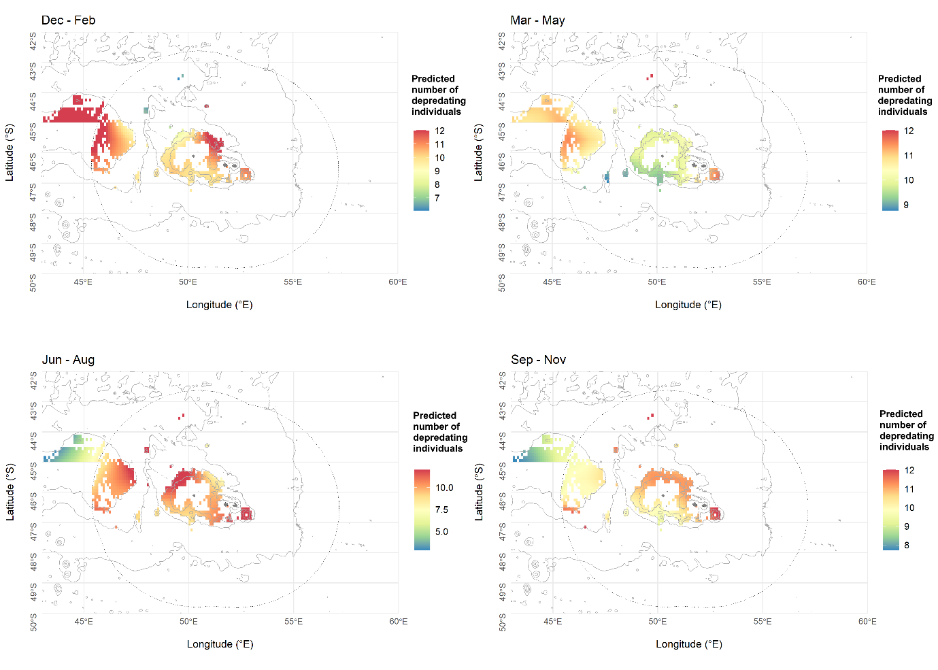

Figure S17: Mean predicted number of depredating Type D killer whales over the 2010-2020 period across the Crozet area, averaged over seasons: summer (December-February), autumn (March-May), winter (June-August) and spring (September-November).
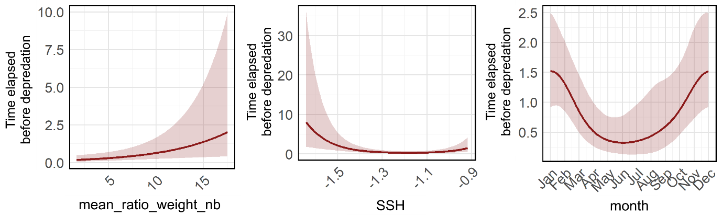

Figure S18: Relationships between the predicted time elapsed before Type D killer whale depredation occurred in a given patch (days) and the variables selected in the final GAMs. Solid lines represent the estimated smooth functions and shaded regions show the approximate 95% confidence intervals, both averaged over the 10-folds cross-validation.

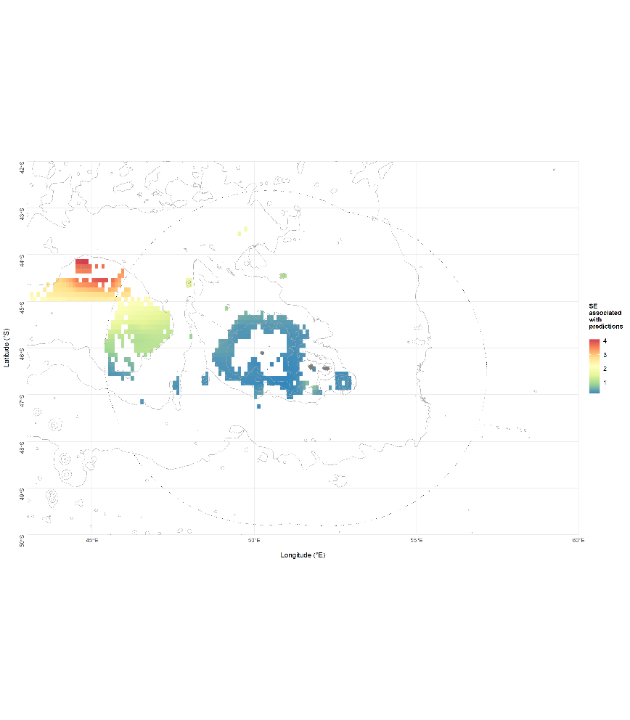
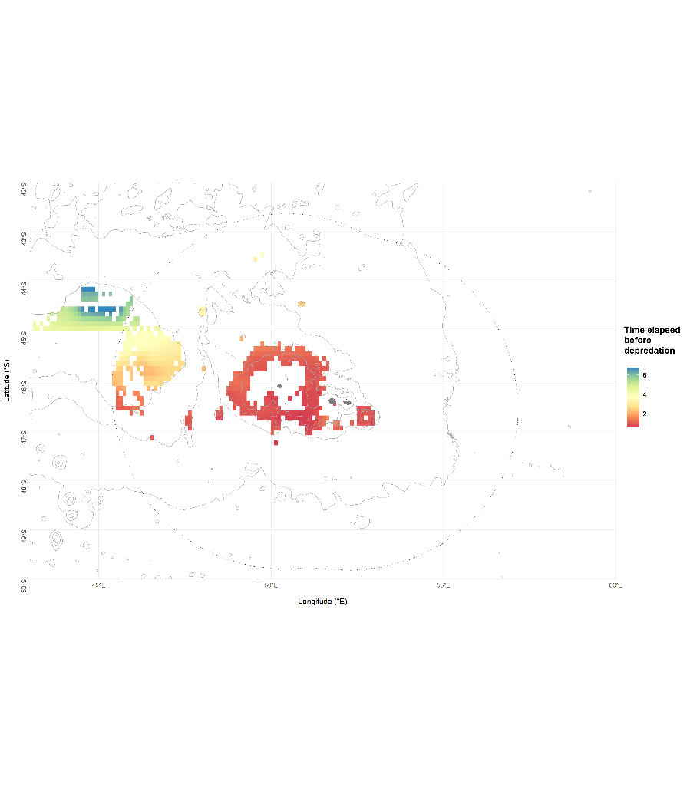

Figure S19: Mean predicted time elapsed before Type D killer whale depredation occurred in a given patch (days), in the Patagonian toothfish fishery over the 2010-2020 period across the Crozet area where fishing data were available. Map of standard errors associated with predictions is presented on the right side.

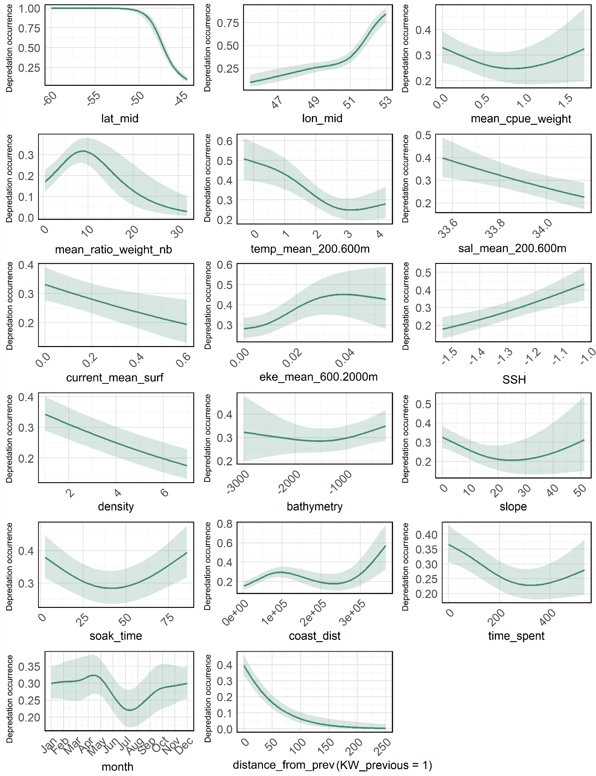
Figure S20: Relationships between the predicted probability of killer whale (both ecotypes) depredation occurrence and the variables selected in the final GAMs. Solid lines represent the estimated smooth functions and shaded regions show the approximate 95% confidence intervals, both averaged over the 10-folds cross-validation.
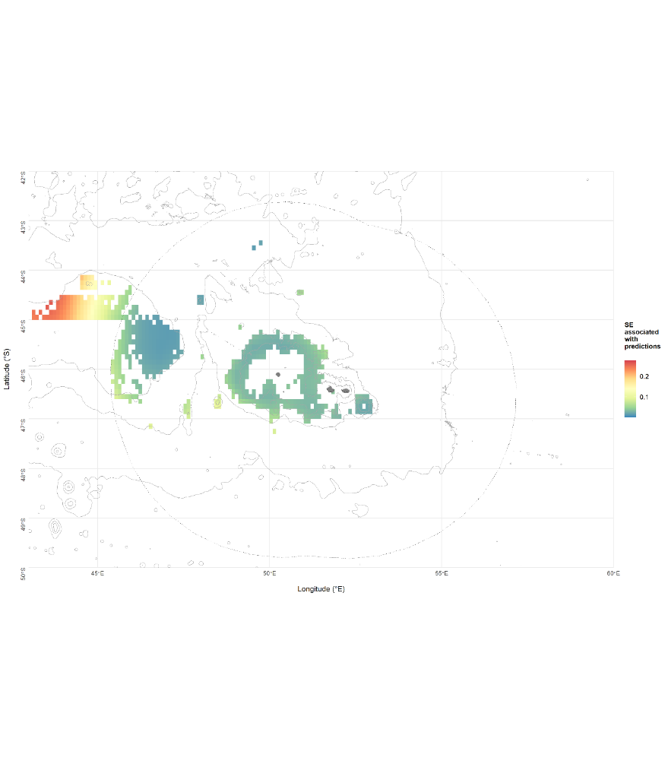
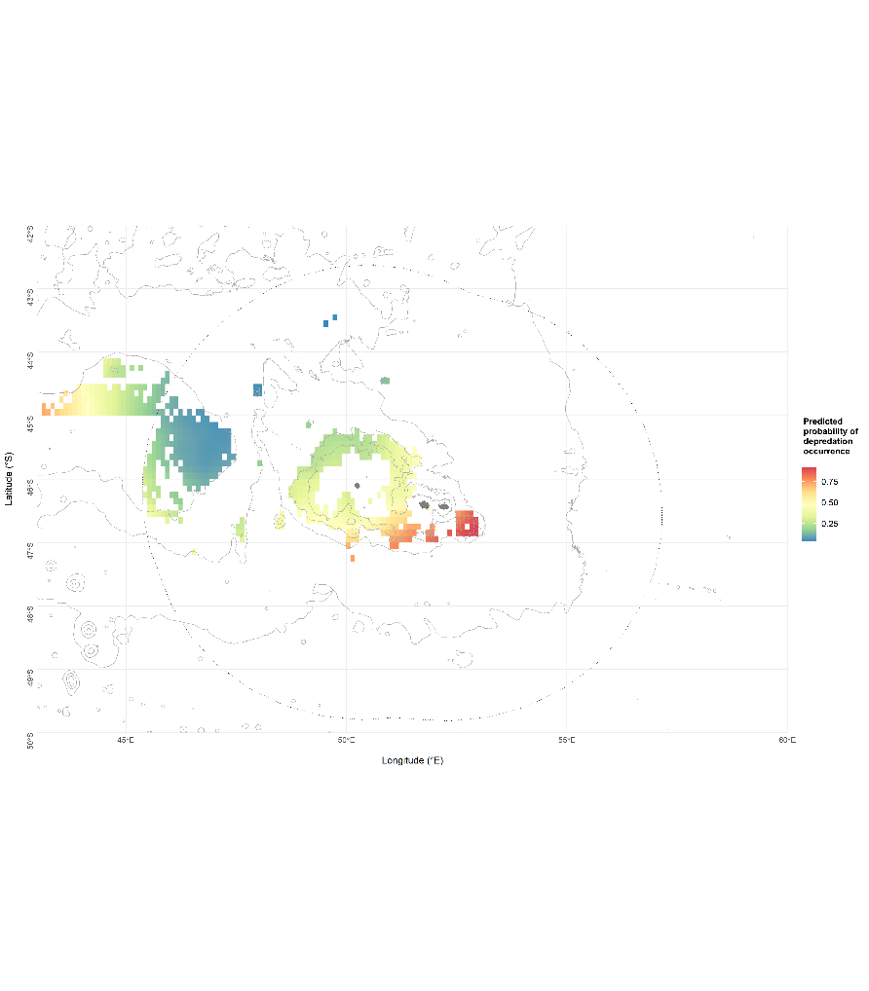

Figure S21: Mean predicted probabilities of killer whale (both ecotypes) depredation occurrence (a) and predicted number of depredating killer whales (b), in the Patagonian toothfish fishery over the 2010-2020 period across the Crozet area where fishing data were available. Maps of standard errors associated with predictions are presented on the right side.

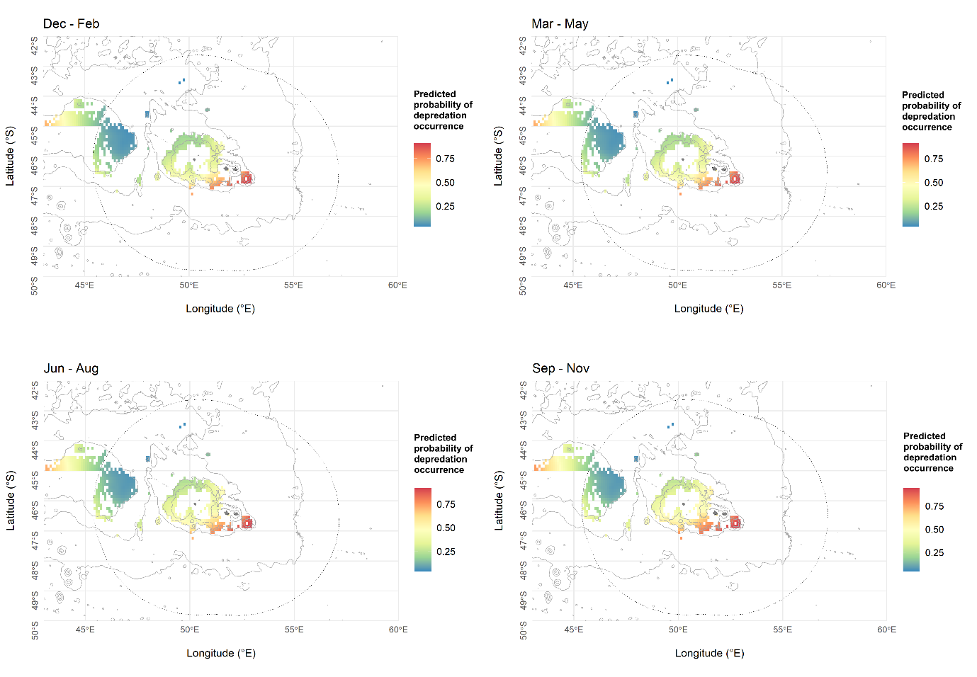Figure S22: Mean predicted probabilities of killer whale (both ecotypes) depredation occurrence over the 2010-2020 period across the Crozet area averaged over seasons: summer (December-February), autumn (March-May), winter (June-August) and spring (September-November).

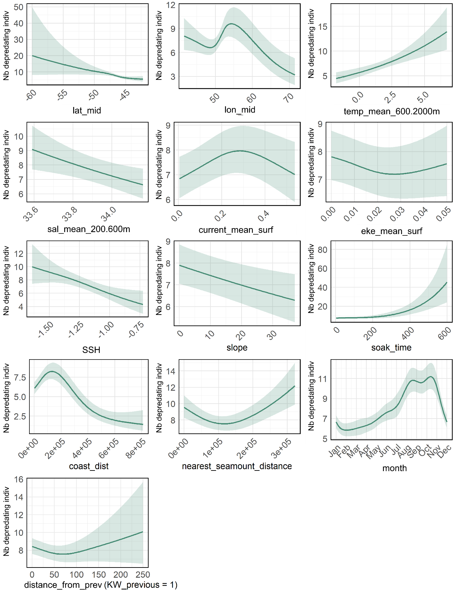
Figure S23: Relationships between the predicted number of depredating killer whales (both ecotypes) and the variables selected in the final GAMs. Solid lines represent the estimated smooth functions and shaded regions show the approximate 95% confidence intervals, both averaged over the 10-folds cross-validation.

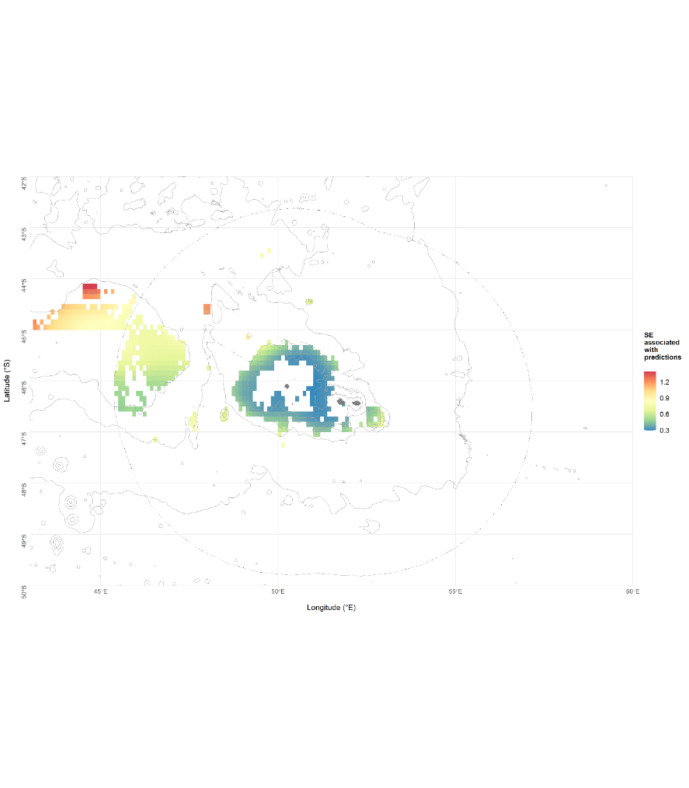
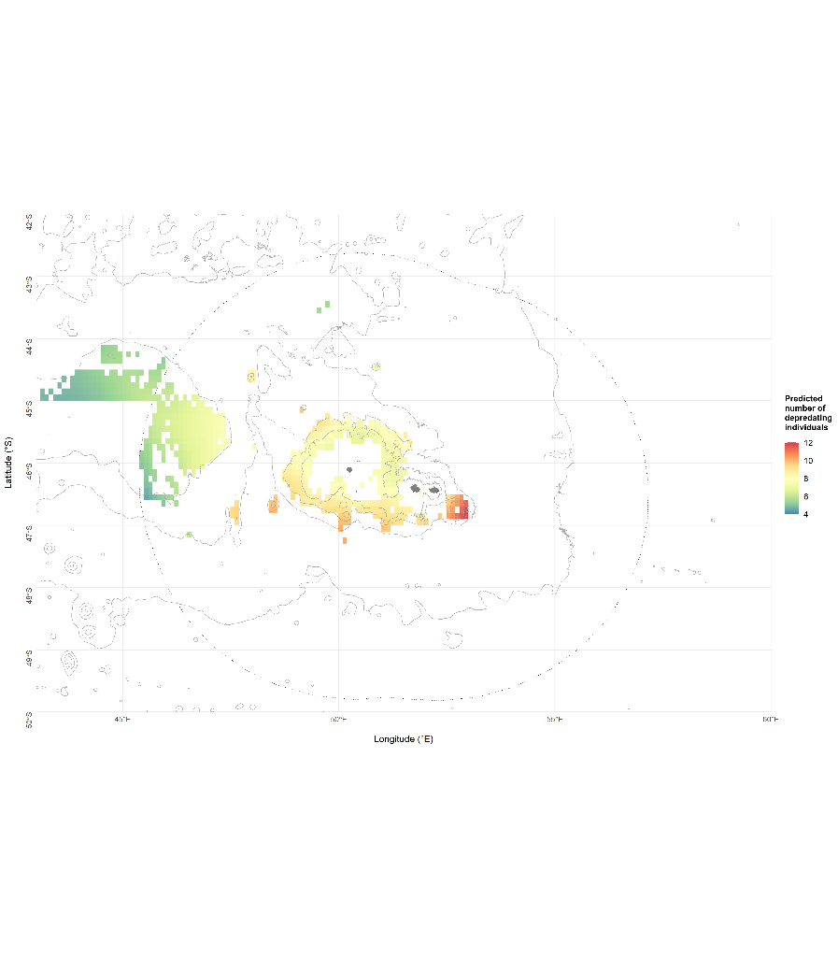

Figure S24: Mean predicted number of depredating killer whales (both ecotypes) over the 2010-2020 period across the Crozet area averaged over seasons: summer (December-February), autumn (March-May), winter (June-August) and spring (September-November).

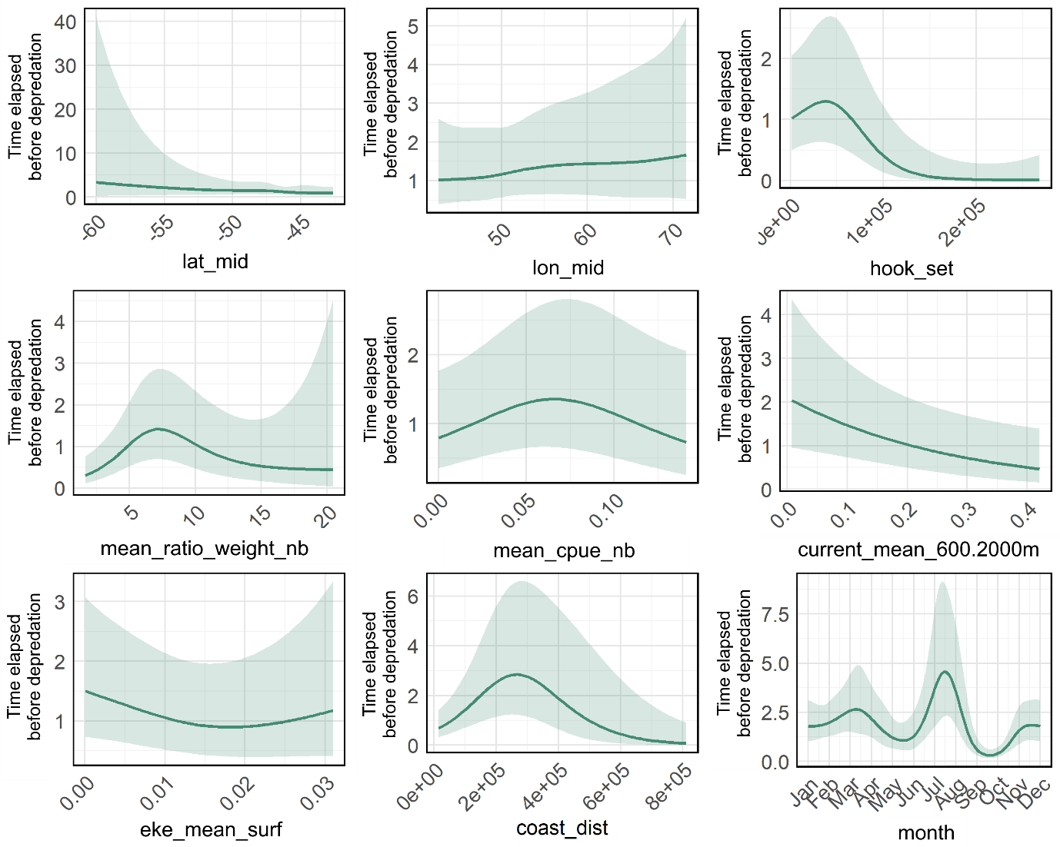
Figure S25: Relationships between the predicted time elapsed before killer whale (both ecotypes) depredation occurred in a given patch (days) and the variables selected in the final GAMs. Solid lines represent the estimated smooth functions and shaded regions show the approximate 95% confidence intervals, both averaged over the 10-folds cross-validation.

