Table S1 Detailed information for datasets used in this study
Data categories | Data | Datasets | Geo-spatial information | Data time | Ref
Activity data | Crop harvested areas and physical areas | · CROPGRID  · LUCAS (Land Use and Coverage Area frame Survey)  · CLMS (Copernicus Land Monitoring Service) | · CROPGRID: Global, 0.05°，crop specific  · LUCAS: EU27 + the UK, 100m, crop specific  · CLMS: Europe,100m, crop-grassland explicit | · CROPGRID: circa 2020  · LUCAS: 2018  · CLMS: 2018 | ^{1–3}
 | Livestock number | GLW v4 (Gridded Livestock of the World, version 4) | Global, 0.083°, livestock specific | 2015 | ⁴
 | Fertilizer use | · FUBC v9 (Fertilizer use by crop, version 9)  · EuropeAgriDB v1 (crop production and nitrogen flows in European cropland) | · FUBC v9: Global main fertilization countries, country-level, crop-specific  · EuropeAgriDB v1: 26 European countries, country-level, crop-grassland explicit | · FUBC v9: 2017-2018  · EuropeAgriDB v1: 1961-2019 | ^{5,6}
Intermediate parameters | Livestock systems and grazing ratios | · GLP v5 (Global Livestock Production System, version 5)  · NIR reports 2018 (National Inventory Reports) | · GLP: Global, 0.083°，explicit livestock systems for ruminants  · NIR: IPCC Annex I countries, country-level, livestock specific | · GLP: no specific year  · NIR: 2016 or 2017 | ^{7,8}
 | Manure systems | · NIR reports 2018 (National Inventory Reports)  · ClimLPS report (Climate and Livestock Production Systems) | · NIR: As stated above  · ClimLPS: EU28+EFTA excluding Iceland, NUT2-level, livestock specific | · NIR: 2016  · ClimLPS: 2008 | ^{8,9}
 | Manure excretion factors | · NIR (National Inventory reports)  · GAINS model (Greenhouse Gas and Air Pollution Interactions and Synergies) | · NIR: As stated above  · GAINS: 38 countries in Europe, country-level, livestock specific | · NIR: 2016  · GAINS: 2010 | ^{8,10,11}
 | Manure TAN proportions | EEA-2019 guideline | Europe, Europe-level, livestock specific | No specific year | ¹²
 | Manure application rates | · INTEGRATOR model (Integrated Nitrogen Tool acoss Europe for Greenhouse gases and Ammonia Targeted to Operational Responses) | 30 countries in Europe, country-level, livestock specific | 1996 | ^{13,14}
 | Manure allocating ratios | · MITERRA-EUROPE model | EU27, Allocate at the NUTS2 level, crop group explicit | No specific year | ¹⁵
Emission factors | Manure deposition emission factors | EEA-2019 guideline | As stated above | updated with data after 2008 | ¹²
 | Manure housing emission factors | EEA-2019 guideline | As stated above | updated with data after 2008 | ¹²
 | Manure storage emission factors | EEA-2019 guideline | As stated above | updated with data after 2008 | ¹²
 | Manure application emission factors | EEA-2019 guideline;  Sommer et al. | EEA-2019: as stated above;  Sommer et al. : Europe, European level, temperature explicit | updated with data after 2008 | ^{12,16}
 | Synthetic fertilizer emission factors | · High-resolution cropland emission factors model | Global, crop specific | updated with data in 2017 | ¹⁷

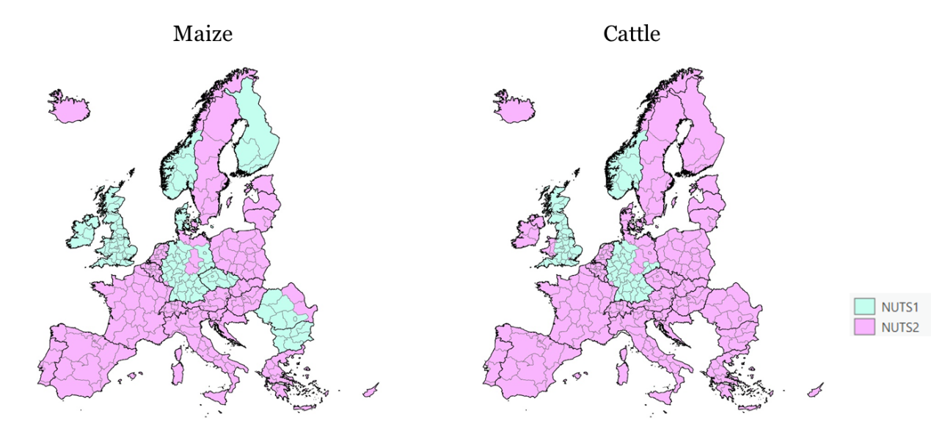
Fig S1 Disaggregation levels for cattle and maize

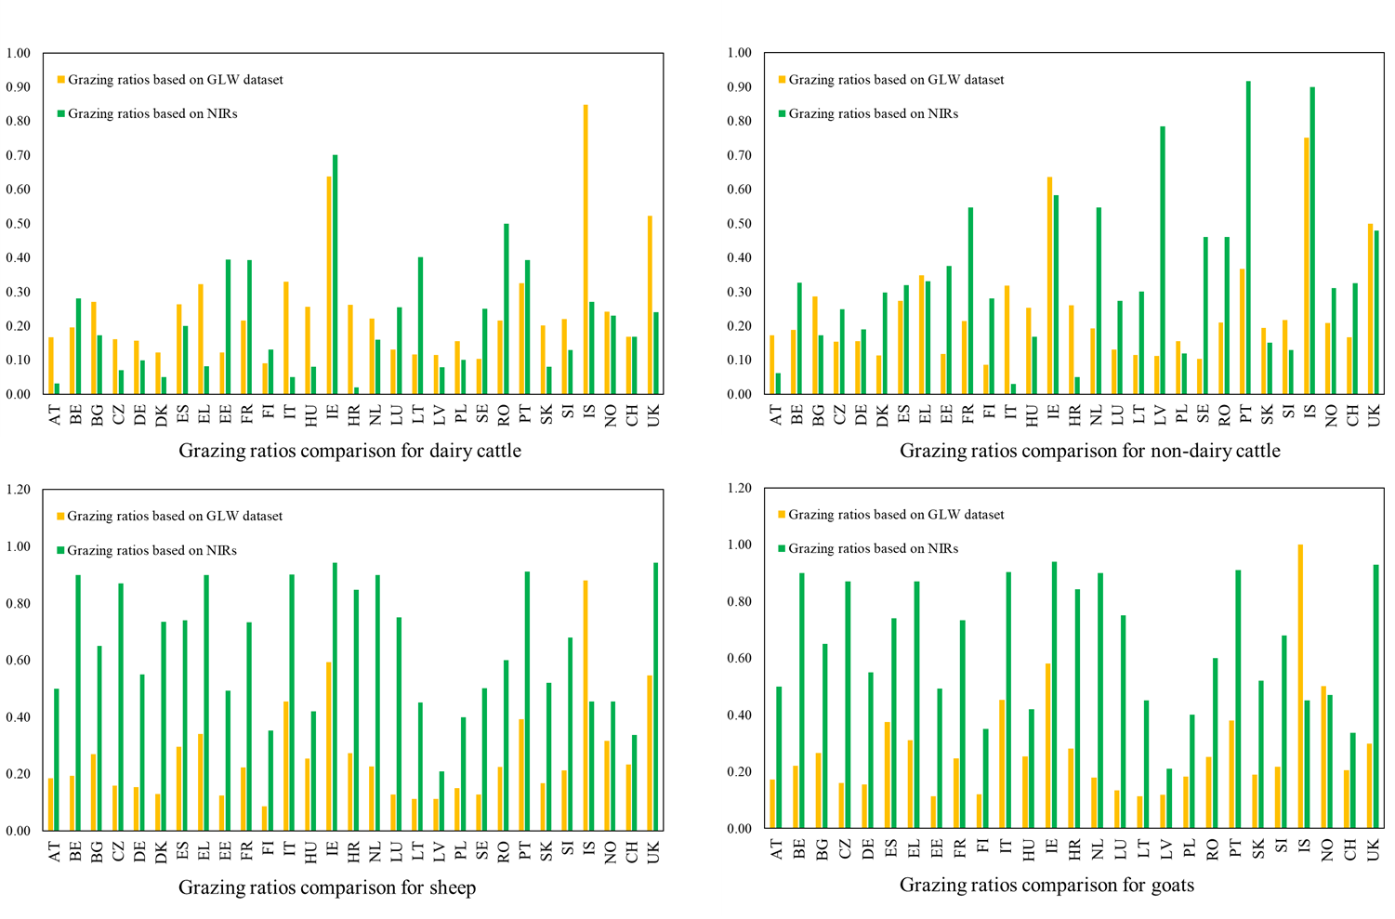
Fig. S2 Comparisons of grazing ratios between GLW/GLP^{4,7} and NIR⁸ datasets

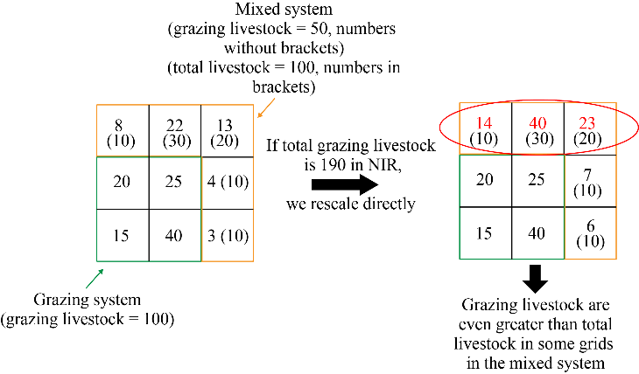
Fig. S3 An example of rescaling dilemmas when aligning gridded grazing animals to those in NIR datasets

Table S2 Livestock manure system categorization (adapted from Uwizeye et al.¹⁸)
Manure management systems of non-grazing animals in NIR reports | Manure system categories in our study
Aerobic Treatment | Liquid
Anaerobic digestion | Liquid
Anaerobic lagoon | Liquid
Composting | Solid
Deep litter | Solid
Digester | Liquid
Dry lot | Solid
Liquid with crust | Solid
Liquid/Slurry | Liquid
Manure with litter (poultry) | Solid
Manure without litter (poultry) | Solid
Solid | Solid
Solid storage | Solid
Confinement | Liquid for dairy and other cattle in feedlot systems; Solid for dairy and cattle excluding those in feedlot systems, sheep, goats, swine and poultry
Daily spread | Liquid for dairy cattle in mixed systems and swine; solid for dairy cattle excluding those in mixed systems, other cattle, sheep, goats and poultry
Pit | Liquid for dairy cattle, other cattle, sheep, goats, swine, poultry excluding those intensive systems; solid for poultry in intensive systems

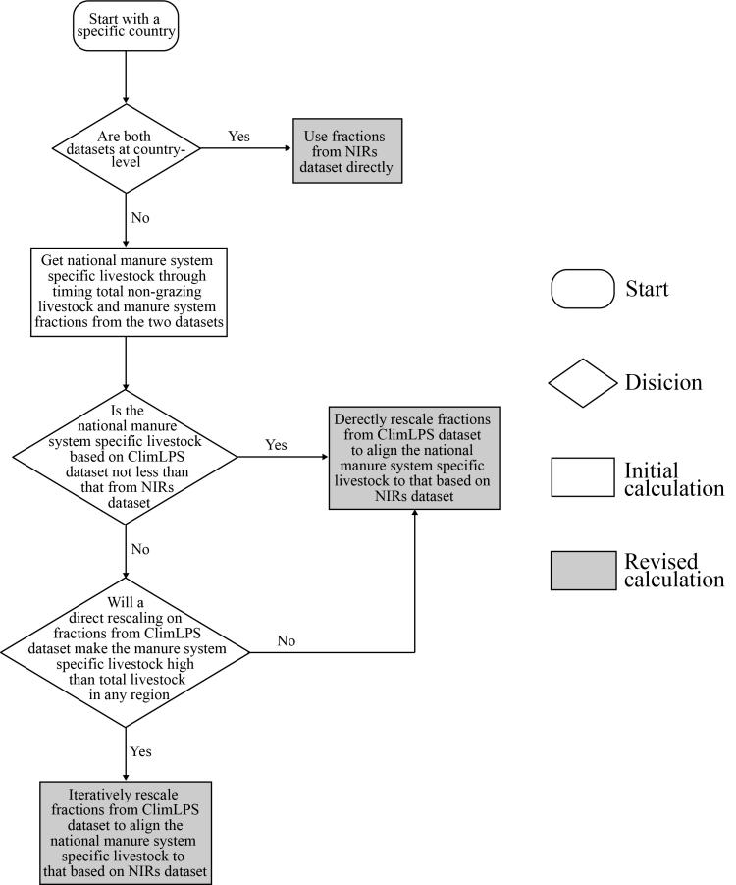
Fig. S4 Decision making tree determining solid manure system fractions at the grid level

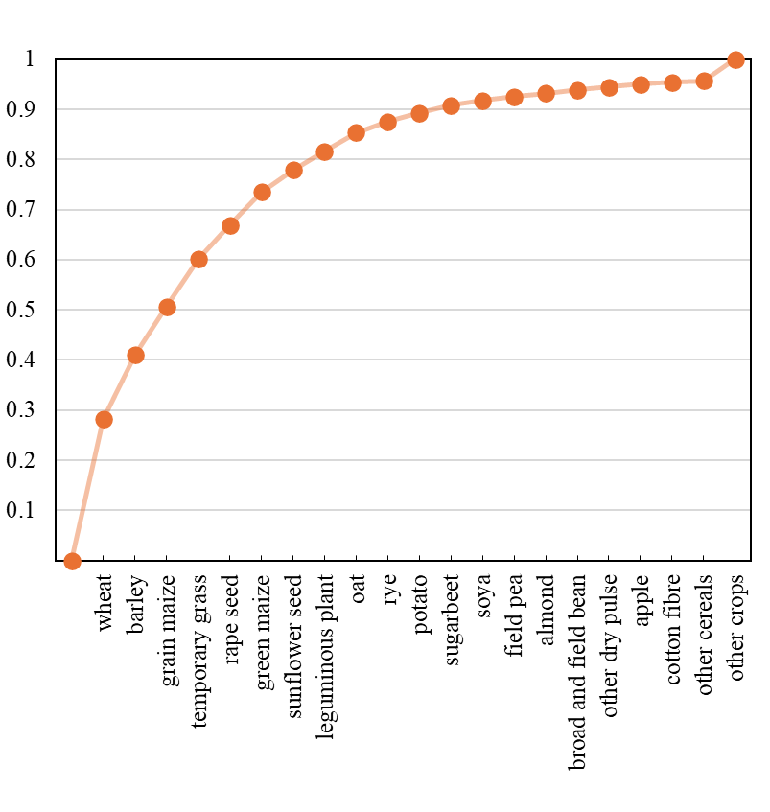
Fig. S5 Cumulative proportion of specific crop areas (data source: Eustat¹⁹)

Table S3. Feed types and mapping schemes among datasets
Feed types in our study | Feed type in Eurostat¹⁹ | Mapping scheme based on LUCAS² or CROPGRID¹ maps
Temporary grassland | Temporary grasses (G1000) | Grassland (500) * Share_{temporary}
Permanent grassland | Permanent grassland (J0000) | Grassland (500) * Share_{permanent}
Legume fodder | Alfalfa (G2100)  Other legume (G2900) | Other fodder (excl. temporary grass) (250) * Share _{legume}
Green maize | Green maize (G3000) | Maize * Share _{green maize}
Other fodder | Other plants harvested green from arable land (G9000)  Other root crops (R9000) | Other fodder (excl. temporary grass) (250) * (1-Share _{legume}) + other roots (223)
Note: numbers in brackets are codes of land use types in corresponding datasets

Table S4 Mapping table for crops in this study, fertilizer use by crops (FUBC)⁵ dataset and the MITTERA-EUROPE¹⁵ model
Commodity names in this study | FUBC names | Crop groups for the manure allocation | Coefficients for the manure allocation
Wheat | Wheat | Group1 (G1) | 1
Barley | Barley | Group1 (G1) | 1
Maize | Grain maize, including corn cob maize | Group2 (G2) | 0.5
Green maize | Silage maize | Group2 (G2) | 0.5
Temporary grassland | Grassland* | Grass (Grass G1) | 1
Legume fodder | Fodder (legumes) | Group4 (G4) | 0
Rapeseed | Oilseed rape | Group1 (G1) | 1
Sunflower | Sunflower, soya, linseed | Group2 (G2) | 0.5
Soybean | Sunflower, soya, linseed | Group4 (G4) | 0
Oats | Rye, triticale, oats, rice | Group2 (G2) | 0.5
Rice | Rye, triticale, oats, rice | Group4 (G4) | 0
Rye | Rye, triticale, oats, rice | Group2 (G2) | 0.5
Potato | Potato | Group2 (G2) | 0.5
Sugarbeet | Sugar beet | Group1 (G1) | 1
Peas and beans | Pulses | Group4 (G4) | 0
Nuts | Other crops | Group3 (G3) | 0.25
Fruit | Permanent fruit | Group3 (G3) | 0.25
Vegetable | Vegetables | Group2 (G2) | 0.5
Permanent grassland | Grassland* | Grass (Grass G2) | 0.5
Note: * means ratios of permanent grass fertilizer use to temporary grass fertilizer use were taken from Einarsson et al.⁶
G1, G2 ,G3, G4, Grass G1 and Grass G2 are abbreviations of crop and grass groups for manure allocations, which correspond to abbreviations used in equations in our main text.

Table S5 Country categories regarding grassland fertilization
Country groups | Characters of fertilization on grasses | Countries
Group 1 (GF1) | Only temporary grasses are fertilized | Bulgaria, Spain, Greece, Estonia, Finland, Hungary, Croatia, Netherlands, Lithuania, Latvia, Sweden, Romania, Portugal, the United Kingdom
Group 2 (GF2) | Ratios between temporary and permanent grasses could be obtained from Einarsson et al. directly | Belgium, Germany, Denmark, Ireland
Group 3 (GF3) | Ratios between temporary and permanent grasses could be calculated via information in Einarsson et al.⁶ and Ludemann et al.⁵ | Austria, Czech Republic, France, Italy, Poland, Slovakia, Slovenia, Norway, Switzerland
Group 4 (GF4) | No information, just refer to neighbouring countries | Cyprus,Malta,Luxembourg, Iceland, Liechtenstein
Note: GF1, GF2 and GF3 are abbreviations of grassland fertilization groups, which correspond to abbreviations used in equations in our main text.

Table S6 Regression functions estimating each items in ammonia models in Zhan et al.¹⁷
 | Rice | Upland crops
EF_SF0 | 0.132992 | 0.093408
f (pH) | $$\text{0.0224×}{\text{e}}^{\text{0.5555 ×pH}}$$ | $$\text{0.0429×}{\text{e}}^{\text{0.4955×pH}}$$
f (Temp) | $$\text{0.0033×}{\text{e}}^{\text{0.2233}}\text{×Temp}$$ | $$\text{0.179×}{\text{e}}^{\text{0.094}}\text{×Temp}$$
f (Windsd) | $$\text{0.2737×Ln Windsd+1.0605}$$ | $$\text{0.2737×Ln Windsd+0.9975}$$
f (Ftype) | $$\sum_{\text{j}}{{\text{Prop}}_{\text{j}}\text{×}{\text{y}}_{\text{j}}}$$  where $y_{j}=\left\{\begin{aligned}\text{1.4797, j=ABC} \\ \text{1, j=Urea, AP,other NP, NK,NPK} \\ \text{0.3345, j=AN,CAN,AS,AA,} \\ \text{ N solutions}\end{aligned}\right.$ | $$\sum_{\text{j}}{{\text{Prop}}_{\text{j}}\text{×}{\text{y}}_{\text{j}}}$$  Where${\text{ y}}_{\text{j}}\text{=}$  $$\left\{\begin{aligned}\text{2.2910, j=ABC} \\ \text{1, j=Urea, AP,other NP, NK,NPK} \\ \text{0.5779, j=AN,CAN,AS,AA,} \\ \text{ N solutions}\end{aligned}\right.$$
f (Methd) | $$\left\{\begin{aligned}\text{1,}\text{ j=ABC,Urea,AP,other NP,} \\ \text{ NK,AN,}\text{C}\text{AN,AS} \\ \text{0}\text{.7326, j=AA, N solutions}\end{aligned}\right.$$ | $$\left\{\begin{aligned}\text{1,}\text{ j=ABC, Urea,AP, other NP,} \\ \text{ NK, AN, }\text{C}\text{AN, AS} \\ \text{0}\text{.4966, j= N solutions} \\ \text{0}\text{.2477, j=AA}\end{aligned}\right.$$
Note: EF_SF0 is the emission factors of synthetic fertilizers under the reference condition (chamber-based using urea applied through broadcasting with soil pH of 7 and air temperature of 20℃ for upland crops or of 26℃for rice). f(pH), f(Temp), f(Windsd), f(FType), and f(Methd) are emission modifying functions for soil pH, air temperature and wind speed during crop growth seasons (vary with crop types), and fertilizer application types and methods. Subscript j represents the type of synthetic fertilizer, including ABC(ammonium bicarbonate), AP(Ammonium phosphate), other NP (NP compound except AP), NK (NK compound), NPK(NPK compound), AN(ammonium nitrate), CAN(calcium ammonium nitrate), AS(ammonium sulfate), and AA(anhydrous ammonia). Prop_{j} is the proportion of synthetic fertilizer j.

Table S7 Datasets used to update the ammonia models proposed by Zhan et al.¹⁷
Variables | Datasets | Time | Ref
Soil pH | Harmonized World Soil Database (HWSD) v1.2 | No specific year | ²⁰
Temperature | Climatic Research Unit gridded Time Series (CRU TS) v4.07 | 2017 | ²¹
Wind speed | TerraClimate | 2017 | ²²
Fertilizer type | IFASTAT | 2017 | ²³
Fertilization method | Eustat | 2010 | ²⁴
Crop growth period | USDA Foreign Agricultural Service;IFA Crop Calendars by Country | No specific year | ^{25,26}

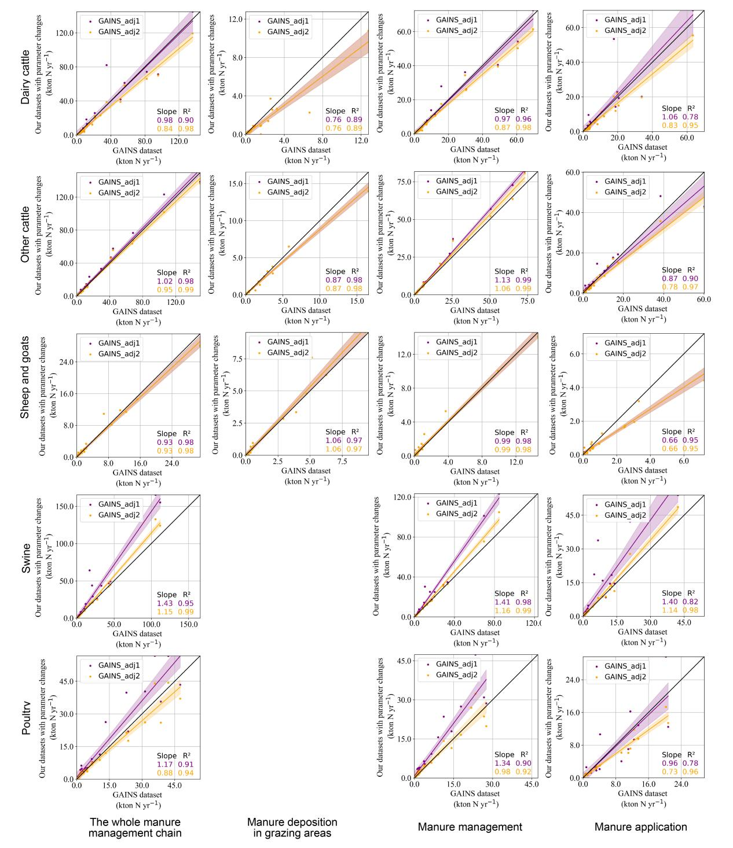
Fig. S6 Comparisons of NH₃ emissions by livestock product and stage between GAINS model and our model with GAINS’s excretion and emission factors (GAINS_adj1) and further with mitigation factors (GAINS_adj2)

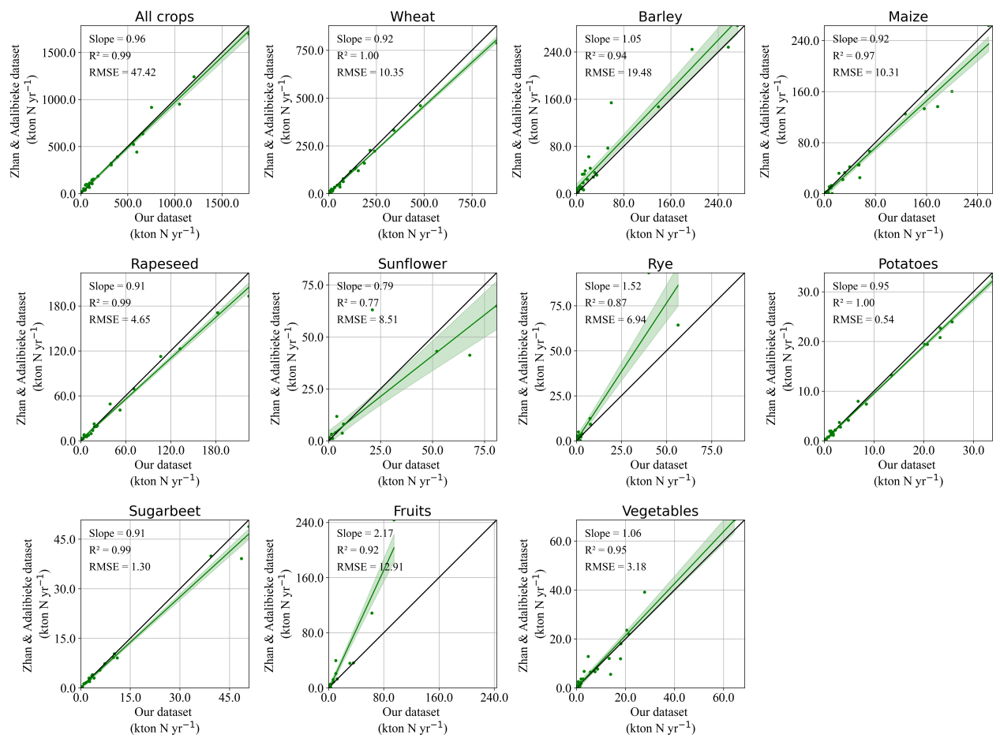
Fig. S7 Comparisons of synthetic fertilizer N by crop product

References
1. Tang, F. H. M. et al. CROPGRIDS: a global geo-referenced dataset of 173 crops. Sci Data 11, 413, https://doi.org/ 10.1038/s41597-024-03247-7 (2024).
2. d’Andrimont, R. et al. From parcel to continental scale – A first European crop type map based on Sentinel-1 and LUCAS Copernicus in-situ observations. Remote Sensing of Environment 266, 112708, https://doi.org/10.1016/j.rse.2021.112708 (2021).
3. Copernicus Land Monitoring (CLMS) Grassland 2015 (raster 100 m), Europe, 3-yearly. https://doi.org/10.2909/b77b7ce3-04f8-44ae-aaae-b5e5af0f9682 (2018).
4. Gilbert, M. et al. Global livestock distribution in 2015 (5 minutes of arc). Harvard Dataverse, https://dataverse.harvard.edu/citation?persistentid=doi:10.7910/dvn/sxhlf3 (2022).
5. Ludemann, C. I., Gruere, A., Heffer, P. & Dobermann, A. Global data on fertilizer use by crop and by country. Sci Data 9, 501, https://doi.org/10.1038/s41597-022-01592-z (2022).
6. Einarsson, R. et al. Crop production and nitrogen use in European cropland and grassland 1961–2019. Sci Data 8, 288, https://doi.org/10.1038/s41597-021-01061-z (2021).
7. Robinson, T. et al. Global Livestock Production Systems. (Food and Agriculture Organization of the United Nations, Rome, 2011).
8. UNFCCC. National Inventory Submissions 2018 of Annex I Parties, https://unfccc.int/process-and-meetings/transparency-and-reporting/reporting-and-review/reporting-and-review-under-the-convention/greenhouse-gas-inventories-annex-i-parties/submissions/national-inventory-submissions-2018 (2018).
9. Bioteau, T., Burton, C., Guiziou, F. & Martinez, J. Qualitative Assessment of Manure Management in Main Livestock Production Systems and a Review of Gaseous Emissions Factors of Manure throughout EU27.( European Commission, Joint Research Centre, 2007)
10. Klimont, Z. & Brink, C. Modelling of Emissions of Air Pollutants and Greenhouse Gases from Agricultural Sources in Europe. (International Institute for Applied Systems Analysis, 2004)
11. Velthof, G. L., Hou, Y. & Oenema, O. Nitrogen excretion factors of livestock in the European Union: a review. Journal of the Science of Food and Agriculture 95, 3004–3014, https://doi.org/10.1002/jsfa.7248 (2015).
12. European Environment Agency. EMEP/EEA Air Pollutant Emission Inventory Guidebook 2019: Technical Guidance to Prepare National Emission Inventories. (Publications Office of the European Union, 2019).
13. Menzi, H. Manure management in Europe: results of a recent survey. in Proceedings of the 10th International Conference of the RAMIRAN Network (University of Veterinary Medicine, Slovak Republic, Štrbské Pleso, High Tatras, Slovak Republic, 2002).
14. Schulte-Uebbing, L. & de Vries, W. Reconciling food production and environmental boundaries for nitrogen in the European Union. Science of The Total Environment 786, 147427, https://doi.org/10.1016/j.scitotenv.2021.147427 (2021).
15. Velthof, G. L. et al. Integrated assessment of nitrogen losses from agriculture in EU-27 using MITERRA-EUROPE. Journal of Environmental Quality 38, 16, https://doi.org/10.2134/jeq2008.0108 (2009).
16. Sommer, S. G., Webb, J. & Hutchings, N. D. New Emission Factors for Calculation of Ammonia Volatilization From European Livestock Manure Management Systems. Frontiers in Sustainable Food Systems 3, https://doi.org/10.3389/fsufs.2019.00101 (2019).
17. Zhan, X. et al. Improved Estimates of Ammonia Emissions from Global Croplands. Environ. Sci. Technol. 55, https://doi.org /10.1021/acs.est.0c05149, 1329–1338 (2021).
18. Uwizeye, A. et al. Nitrogen emissions along global livestock supply chains. Nat Food 1, 437–446, https://doi.org/10.1038/s43016-020-0113-y (2020).
19. European Union. Eurostat, https://ec.europa.eu/eurostat/data/database (2024).
20. FAO, International Institute for Applied Systems Analysis(IIASA), ISRIC-World Soil Information, Institute of Soil Science, Chinese Academy of Sciences (ISSCAS) & Joint Research Centre of the European Commission (JRC). Harmonized World Soil Database - Version 1.2, https://www.fao.org/soils-portal/data-hub/soil-maps-and-databases/harmonized-world-soil-database-v20/en/
21. Harris, I., Osborn, T. J., Jones, P. & Lister, D. Version 4 of the CRU TS monthly high-resolution gridded multivariate climate dataset. Scientific Data 7, 109, https://doi.org/10.1038/s41597-020-0453-3 (2020).
22. Abatzoglou, J. T., Dobrowski, S. Z., Parks, S. A. & Hegewisch, K. C. TerraClimate, a high-resolution global dataset of monthly climate and climatic water balance from 1958–2015. Sci Data 5, 170191, https://doi.org/10.1038/sdata.2017.191 (2018).
23. International Fertilizer Industry Association (IFA). IFASTAT database, https://www.ifastat.org/databases/supply-trade (2024).
24. Eustat. Tilled arable area by tillage practice, EU-27, IS, NO, CH, ME and HR, 2010. https://ec.europa.eu/eurostat/statistics-explained/index.php?title=File:Tilled_arable_area_by_tillage_practice,_EU-27,_IS,_NO,_CH,_ME_and_HR,_2010.png&oldid=137925#file (2013).
25. US Department of Agriculture (USDA). USDA Foreign Agricultural Service, Crop Calendars for Europe, https://ipad.fas.usda.gov/rssiws/al/crop_calendar/europe.aspx (2024).
26. International Fertilizer Industry Association (IFA). FUBC Crop Calendars by Country, https://www.ifastat.org/consumption/fertilizer-use-by-crop (2024).

