Supplementary information for
Label-free Tracking of Single Virus Entry
Yitao Cao^{1,3,8}, Qingwen Ding^{2,3,8}, Yingjie Dou^{1,3,8}, Fei Wang^{1,3}, Yang Zhao¹, Jiaqi Gu^{1,3}, Yifei Ye^{1,3}, Xiaofeng Luan^{1,3}, Jiahong Jiang¹, Sai Zhang^{2,3}, Xiaoxi Ding^{1,3}, Runze Fang^{1,3}, Yuan Zhang², Jianguang Li⁴, Lusheng Gu⁵, Jin Yang¹, Nan Li¹, Chengjun Huang^{1,3}, Yang Xia^{1,3,6,7,}*, Wei Ji^{5,}*, Zhenhua Zheng^{2,}*, Xinchao Lu^{1,}*
¹Institute of Microelectronics, Chinese Academy of Sciences, Beijing 100029, China
²State Key Laboratory of Virology and Biosafety, Wuhan Institute of Virology, Chinese Academy of Sciences, Wuhan 430071, China
³University of Chinese Academy of Sciences, Beijing 100049, China
⁴State Key Laboratory of Optoelectronic Materials and Devices, Institute of Semiconductors, Chinese Academy of Sciences, Beijing 100083, China
⁵National Laboratory of Biomacromolecules, Institute of Biophysics, Chinese Academy of Sciences, Beijing 100101, China
⁶University of Science and Technology of China, Hefei 230026, China
⁷Suzhou Institute for Advanced Research, University of Science and Technology of China, Suzhou 215123, China
⁸These authors contributed equally.
*Email: xiayang@ime.ac.cn, jiwei@ibp.ac.cn, zhengzh@wh.iov.cn, luxinchao@ime.ac.cn

Table of contents:
1. Supplementary Figures
Supplementary Figure 1: Label-free single virus tracking instrument and three viruses as well as living cell adhered to the Au film substrate.
Supplementary Figure 2: The comparison of standard deviation of lateral xy peak localization by using three localization methods.
Supplementary Figure 3: The verification of both ECTV and PRV infecting Vero cells and PRV not entry SF9 cells.
Supplementary Figure 4: The unknown particles in Vero cell environment as well as virus-host cell environment.
2. Supplementary Tables
Supplementary Table 1: Parameters retrieved from MSD fitting to label-free BV, ECTV and PRV.
3. Supplementary Notes
Supplementary Note 1: MATLAB code of 3D trajectory reconstruction, instant velocity and MSD fitting.
4. Description of Supplementary Movies
Supplementary Movie 1: Tracking single BV entry SF9 cell.
Supplementary Movie 2: Tracking single ECTV entry Vero cell.
Supplementary Movie 3: Tracking single PRV with directional movement of Step 3.
Supplementary Movie 3: Tracking single PRV entry Vero cell with confinement movement.

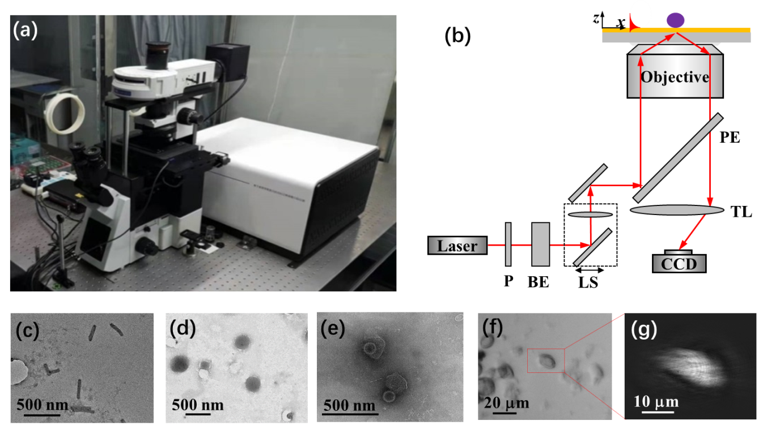

Supplementary Figure 1
Label-free single virus tracking instrument and three viruses as well as living cell adhered to the Au film substrate.
(a) Homebuilt label-free single virus tracking instrument SPVT-600. (b) The Optical path diagram of the SPVT-600, P: polarizer, BE: Beam expander, LS: linear stage, PE: Pellicle, TL: Tube lens. Electron microscopy imaging of (c) baculovirus (BV), (d) ectromelia virus (ECTV), and (e) pseudorabies virus (PRV). (f) Surface plasmon resonance microscopy (SPRM) and (f) epi-microscopy imaging of a single SF9 cell.

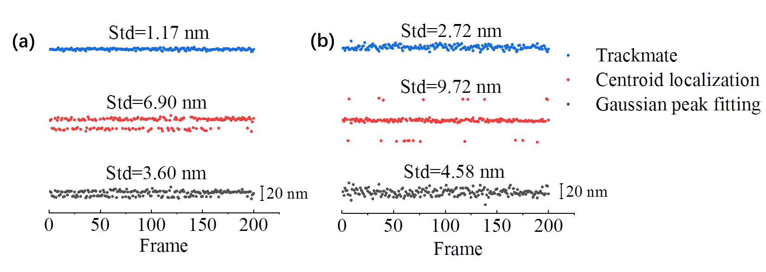
Supplementary Figure 2
The comparison of standard deviation of xy localization by using three peak localization methods.
The standard deviation of (a) x and (b) y peak localization by using three peak localization methods, including Trackmate, Centroid localization and Gaussian peak fitting. The standard deviation in the xy positions are 1.17 nm and 2.72 nm by using Trackmate, respectively. While, the Centroid localization and Gaussian peak fitting indicate worse standard deviations, which is 6.90 nm (x) and 9.72 nm (y), as well as 3.6 nm (x) and 4.58 nm (y), respectively.
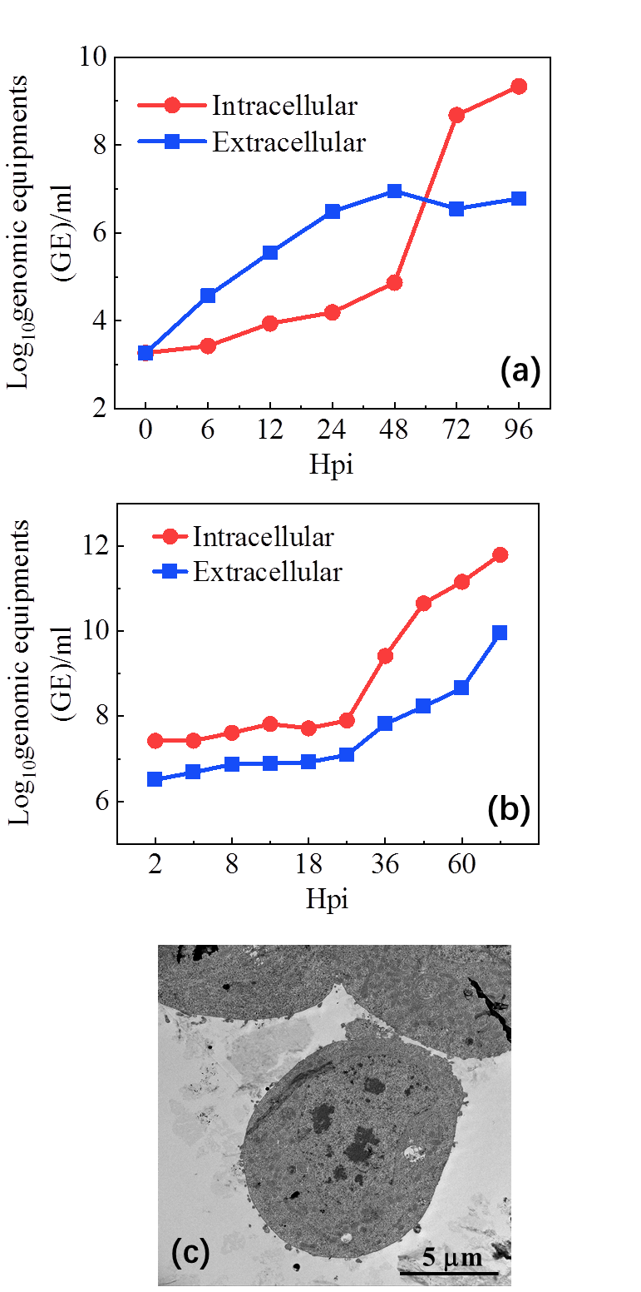

Supplementary Figure 3
The verification of both ECTV and PRV infecting Vero cells and PRV not entry SF9 cells.
The kinetic curves of viral RNA in (a) ECTV and (b) PRV-infected Vero cells, respectively. (c) The electron microscopy imaging of PRV without entry SF9 cells.

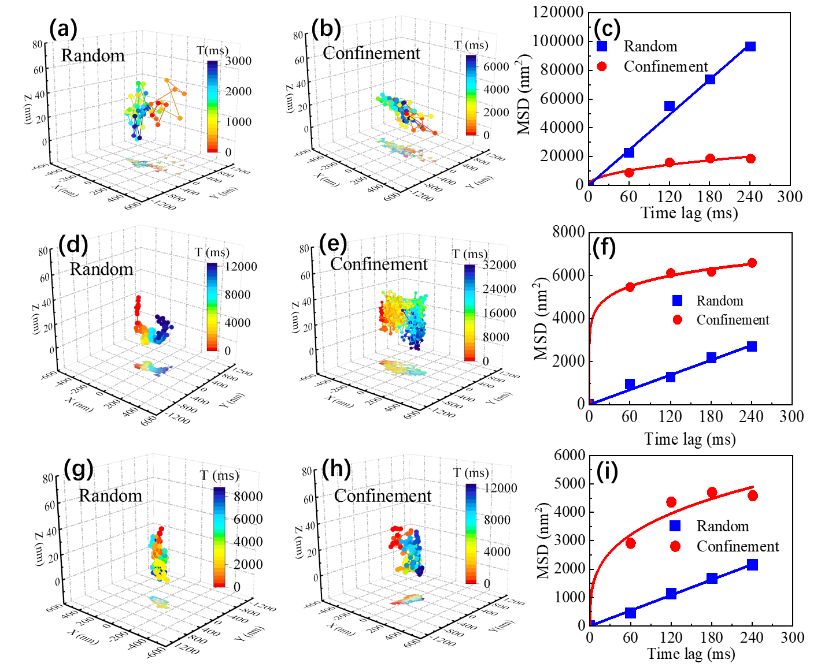
Supplementary Figure 4
The unknown particles in Vero cell environment as well as virus-host cell environment.
The unknown particles with (a) random and (b) confinement movement in Vero cell solution without viruses. (c) The MSD curves of (a) and (b). The unknown particles in ECTV-host cell with (d) random and (e) confinement movement. (f) The MSD curves of (d) and (e). The unknown particles in PRV-host cell with (g) random and (h) confinement movement. (i) The MSD curves of (g) and (h).

Supplementary Table 1
Parameters retrieved from MSD fitting to label-free BV, ECTV and PRV.
Virus | Motion type | Instantaneous velocity  (nm/ms) | Diffusion coefficient  (nm²/ms) | Fitted direct velocity  (nm/ms) |  | Abnormal diffusion coefficient  (nm/ms)
BV  (non-host cell) | Random | 0-6 | 25.75
Unentry  BV-SF9 | Random | 0-5 | 22.03
ECTV  (non-host cell) | Random | 0-6 | 100.37
BV-SF9 | Directional | 0-7 | 34.18 |  | 0.57
ECTV-Vero | Directional | 0-2 | 3.75 |  | 0.19
PRV-Vero | Directional | 0-8 | 20.9 |  | 0.19
PRV-Vero | Confinement | 0-7 | 83.04 |  |  |  | 0.90

Supplementary Note 1
MATLAB code of 3D trajectory reconstruction, instant velocity and MSD fitting.
clc
clear
DD='...\';
A = readmatrix(strcat(DD,'export.csv'));
P2L = 10000/248;
a1=2+0;
nn = 0;
x = A(a1:end-nn,5)*P2L;
y = A(a1:end-nn,6)*P2L;
z = A(a1:end-nn,17);
Im_f = A(a1:end-nn,9)+1;
N = length(x);
MSD = zeros(N,1);
r = [x,y];
for n =1:N
sumdr = 0;
for i =1:N-n
dr = norm(r(i+n,:)-r(i,:))^2;
sumdr = sumdr+dr;
end
MSD(n) = 1/(N-n)*sumdr;
end
figure(1)
nn=9;
plot(1:nn,MSD(1:nn)-MSD(1));
set(gcf,'color','white');
n1 = length(x);
t3 = (Im_f-1).*(1/16.6);
t1 = (( t3(1:n1-1)) * 1000);
Vt1 = zeros(n1-1,1);
for i = 1 : n1-1
t = 1/16.6 * 10^3;
a = [x(i) y(i)];
b = [x(i+1) y(i+1)];
Vt1(i) = norm(b - a) /(t*(Im_f(i+1)-Im_f(i)));
end
figure(2)
plot(t1,Vt1);
set(gcf,'color','white');
z1 = -100*log(z/z(1));
n1 = length(x);
yy = 1280;
y = yy - y;
xx1 = (x - x(1));
yy1 = (y - y(1));
figure(3)
plot3(xx1,yy1,z1);
colorMarker1 = linspace(0,n1,n1)*1/16.6*1000;
cla('reset')
patch([xx1;NaN],[yy1;NaN],[z1;NaN],[colorMarker1,NaN],'EdgeColor','in terp','Marker','o','MarkerFaceColor','flat','LineWidth',2)
xlabel('X (nm)')
ylabel('Y (nm)')
zlabel('Δz (nm)')
colormap(jet) ;
colorbar;
set(gca,'linewidth',1,'FontSize',18,'FontName','Times New Roman');
set(gca,'tickdir','in');
set(gcf,'color','white');
view(3)
box on

Supplementary Movie 1: Real-time movie of the 2D trajectory of single BV in SF9 cell context shown in Figure 3(c) of the main text. The white line indicates the outline of the cell adhesion to Au substrate. The single label-free BV moves directionally and eventually disappears in the cell. The frame rate of the movie is set as 16.6 fps.

Supplementary Movie 2: Real-time movie of the 2D trajectory of single ECTV in Vero cell context shown in Figure 4(g) of the main text. The white line indicates the outline of the cell adhesion to Au substrate. The single label-free ECTV moves directionally and eventually disappears in the cell. The frame rate of the movie is set as 16.6 fps.

Supplementary Movie 3: Real-time movie of the 2D trajectory of single ECTV in Vero cell context shown in Figure 4(j) of the main text. The white line indicates the outline of the cell adhesion to Au substrate. The single label-free ECTV moves directionally and eventually disappears in the cell. The frame rate of the movie is set as 16.6 fps.

Supplementary Movie 4: Real-time movie of the 2D trajectory of single PRV in Vero cell context shown in Figure 5(i) of the main text. The white line indicates the outline of the cell adhesion to Au substrate. The single label-free PRV moves directionally near the cell. The frame rate of the movie is set as 16.6 fps.

Supplementary Movie 5: Real-time movie of the 2D trajectory of single PRV in Vero cell context shown in Figure 5(k) of the main text. The white line indicates the outline of the cell adhesion to Au substrate. The single label-free PRV indicates confinement movement near the cell and eventually disappears in the cell. The frame rate of the movie is set as 16.6 fps.

