Table 1. Surface physical characteristics of MSA-SB@Ni

Properties | MSA-SB@Ni
BET surface area (m² g⁻¹) | 16.829
Micropore surface area (m² g⁻¹) | 12.150
External surface area (m² g⁻¹) | 21.12
Langmuir surface area (m² g⁻¹) | 42.012
Total pore volume (cm³ g⁻¹) | 0.0865
Average pore diameter (nm) | 4.61

Table 2. Optimization and evaluation of catalyst, reactant and reaction conditions.
Yield (%) | Temp (˚C) | Time (h) | cat (mg) [mol %] | Catalyst | Rª | Entry
92 | 100 | 4 | 15[1.50] | MSA-SB@Ni ^{b} | H- | 1
82 | 100 | 4 | 10[0.66] | MSA-SB@Ni | -H | 2
71 | 80 | 4 | " | MSA-SB@Ni | -H | 3
86 | 70 | 4 | 15[1.50] | MSA-SB@Ni | -H | 4
87 | 100 | 4 | " | MSA-SB@Ni | CH₃- | 5
81 | 100 | 4 | " | MSA-SB@Ni | CH₃ -di | 6
95 | 90 | 4 | " | MSA-SB@Ni | NO₂- | 7
93 | 90 | 4 | " | MSA-SB@Ni | Cl- | 8
88 | 100 | 4 | " | MSA-SB@Ni | OH- | 9
40 | 100 | 4 | " | MSA-SB@Cu^{c} | H- | 10
36 | 100 | 4 | " | MSA-SB@Mn^{d} | H- | 11
38 | 100 | 4 | " | MSA-SB@Zn^{e} | -H | 12
90 | 90 | 4 | " | MSA-SB@Ni | -H | 13
81 | 100 | 3 | " | MSA-SB@Ni | -H | 14
87 | 100 | 3 | " | MSA-SB@Ni | -NO₂ | 15
15 | 110 | 8 | 0 | - | H- | 16^{f}
Reaction condition: reaction between aldehyde, β-naphthol, and amide with MSA-SB@Ni as nanocatalyst for green synthesis of amido alkyl naphthol.
a) Benzaldehyde derivatives.
b) MSA-SB@Ni= Fe₃O₄@SiO₂/APTES-Schiff base of Ni as catalyst.
c) MSA-SB@Cu= Fe₃O₄ @SiO₂/APTES-Schiff base of Cu as catalyst.
e) MSA-SB@Zn= Fe₃O₄@SiO₂/APTES-Schiff base of Zn as catalyst.
f) In this step the reaction performed without a catalyst.

Table 3. Model reaction and synthesis of amidoalkyl naphthol derivatives via multi-component reaction in the presence of MSA-SB@Ni nano-catalyst in solvent free conditions.
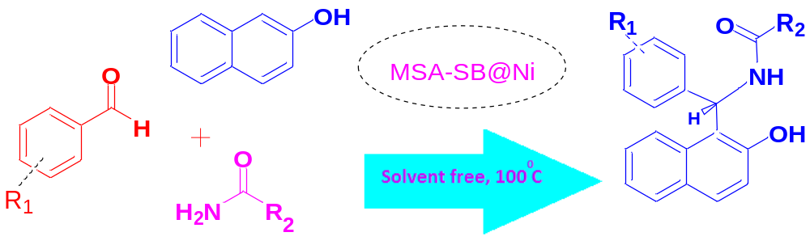

Yield (%)^{f} | Time  (h) | TON^{e} | TOF  (h⁻¹)^{d} | Product ^{c} | R₂ ^{b} | R₁ ª | Entry
92 | 4 | 61.3 | 15.32 | 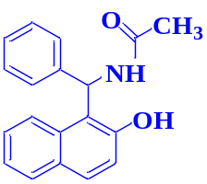 | 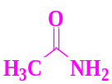 | 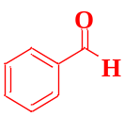 | 1
93 | 4 | 62 | 15.5 | 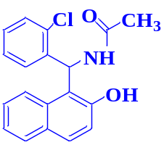 | 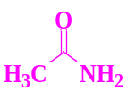 | 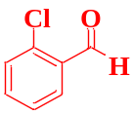 | 2
95 | 3.5 | 63.3 | 18.08 | 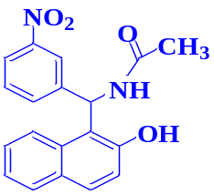 | 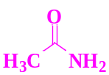 | 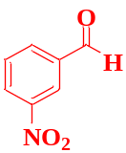 | 3
88 | 4 | 58.66 | 14.66 | 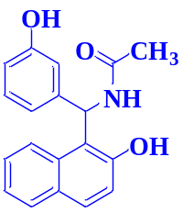 | 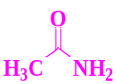 | 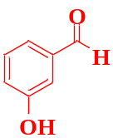 | 4
86 | 4 | 57.33 | 14.33 | 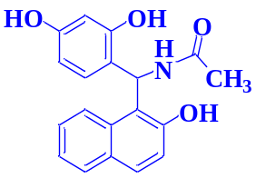 |  | 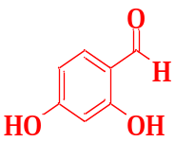 | 5
93 | 4 | 62 | 15.5 | 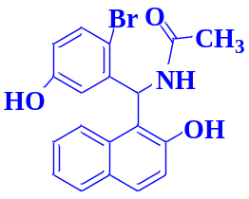 | 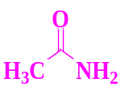 | 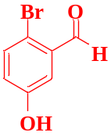 | 6
90 | 4 | 60 | 15 | 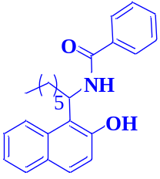 | 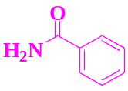 | 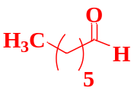 | 7
94 | 4 | 62.66 | 15.66 | 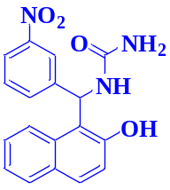 | 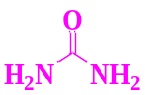 | 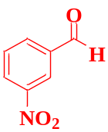 | 8
89 | 4 | 59.33 | 14.8 | 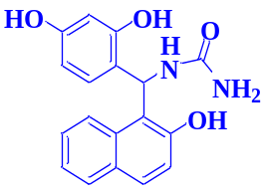 | 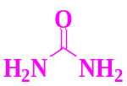 | 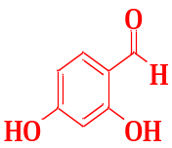 | 9
88 | 4 | 58.66 | 14.66 | 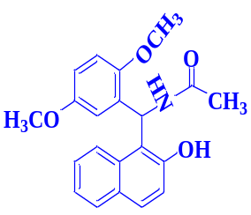 | 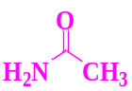 | 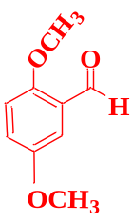 | 10
92 | 4 | 61.33 | 15.33 | 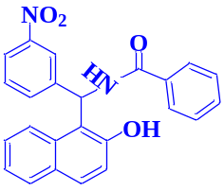 | 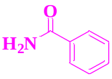 | 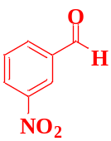 | 11

Reaction conditions: β naphthol (1 mmol as fix reactant), aldehyde (1 mmol) with and amide (1.5 mmol) in the presence of MSA-SB@Ni as nanocatalyst (0.015 g) at 80-100°C under solvent-free conditions. Isolated yield. Mmol of active site of catalyst =1.5×10⁻²
- Aldehyde derivatives as reactant 1
- Amide derivatives as reactant 2
- Amido-alkyl-2-naphthol as product
- TOF (h⁻¹) = Turn over frequency of catalyst: (TON / time of the reaction (h))
- TON = Turn over number of catalyst: (mmol of product / mmol of active site of catalyst).
- The efficiency of product in thermal method and free solvent.

Table 4. Comparison of the catalytic efficiency of MSA-SB@Ni nano catalyst with other reported catalysts that used for the synthesis of amidoalkyl naphthol.
Entry | Catalyst | Solvent | Temp. (˚C) | Time (h) | Yield (%) | Ref.
1 | K₅CoW₁₂O₄₀.3H₂O | (CH₂)₂Cl₂ | 25 | 10 | 92 | [43]
2 | HClO₄ | - | 90 | 3 | 80 | [44]
3 | I₂ | - | 125 | 5.5 | 85 | [44]
4 | Ce(SO₄)₂ | - | reflux | 36 | 72 | [44]
5 | Na₂SO₄ | - | 100 | 4 | 12 | [45]
6 | CuO | - | 100 | 4.3 | 69 | [45]
7 | Fe₂O₃ | - | 100 | 5 | 20 | [45]
8 | CaO | - | 100 | 4.1 | 71 | [45]
9ª | MSA-SB@Ni | - | 100 | 4 | 92 | This work
a) reaction between benzaldehyde, β-naphthol and acetamide with MSA-SB@Ni as catalyst for green synthesis of amidoalkyl naphthol ( Table 3.entry 1)

