Supplementary files

The association between neutrophil-to-lymphocyte ratio and all-cause and cardiovascular specific mortality in patients with diabetes and prediabetes complicated by cardiometabolic syndrome
Author Names: Xiangdong Meng PhD^{1†}, Mingming Fu PhD^{2†}, Chao Fu PhD³, Xiangdong Meng PhD^{1*}
Author Affiliations: 1. The Second Clinical Medical College of North Sichuan Medical College, Nanchong, 637000, Sichuan Province, China.
2. North Sichuan Medical College, Nanchong, 637000, Sichuan Province, China.
3. Department of Cardiology, The Second Affiliated Hospital of Harbin Medical University, The Key Laboratory of Myocardial Ischemia, Chinese Ministry of Education, Harbin, Heilongjiang Province, China.
†Xiangdong Meng and Mingming Fu contributed equally to this work.

Correspondence and Reprint Addressed to: * The Second Clinical Medical College of North Sichuan Medical College, Nanchong, 637000, Sichuan Province, China. E-mail: jxdx112@163.com.

Table S1 Subgroup analysis of the associations between NLR and all‑cause mortality
Variables | n (%) | HR (95%CI) | P | P for interaction
Gender |  |  |  | 0.071
Female | 2522 (52.18) | 1.16 (1.10 ~ 1.22) | <0.001
Male | 2311 (47.82) | 1.11 (1.07 ~ 1.15) | <0.001
Race |  |  |  | 0.038
Mexican | 876 (18.13) | 1.20 (1.11 ~ 1.28) | <0.001
Non-Hispanic Black | 1169 (24.19) | 1.15 (1.01 ~ 1.30) | 0.029
Non-Hispanic White | 1972 (40.80) | 1.10 (1.07 ~ 1.14) | <0.001
Other | 816 (16.88) | 1.31 (1.11 ~ 1.54) | 0.002
Education |  |  |  | 0.752
Below high school | 1548 (32.03) | 1.11 (1.03 ~ 1.20) | 0.005
High School or above | 3285 (67.97) | 1.12 (1.09 ~ 1.15) | <0.001
Marital |  |  |  | 0.159
No | 1904 (39.40) | 1.13 (1.09 ~ 1.17) | <0.001
Yes | 2929 (60.60) | 1.10 (1.05 ~ 1.15) | <0.001
Drinking |  |  |  | 0.156
No | 2170 (44.90) | 1.16 (1.11 ~ 1.22) | <0.001
Yes | 2663 (55.10) | 1.11 (1.07 ~ 1.14) | <0.001
Smoking Status |  |  |  | 0.187
Current Smoker | 853 (17.65) | 1.06 (0.99 ~ 1.14) | 0.074
Former Smoker | 1611 (33.33) | 1.11 (1.07 ~ 1.15) | <0.001
Never Smoker | 2369 (49.02) | 1.18 (1.10 ~ 1.26) | <0.001
Poverty |  |  |  | <0.001
No | 3286 (67.99) | 1.11 (1.07 ~ 1.15) | <0.001
Yes | 1547 (32.01) | 1.24 (1.15 ~ 1.33) | <0.001
BMI |  |  |  | 0.587
< 25 | 502 (10.39) | 1.12 (1.02 ~ 1.23) | 0.019
25–30 | 1499 (31.02) | 1.12 (1.09 ~ 1.16) | <0.001
≥ 30 | 2832 (58.60) | 1.15 (1.07 ~ 1.24) | <0.001
Abbreviation: BMI: Body Mass Index; NLR: Neutrophil-to-Lymphocyte Ratio; HR: Hazard ratios.

Table S2 Subgroup analysis of the associations between NLR and cardiovascular specific mortality
Variables | n (%) | HR (95%CI) | P | P for interaction
Gender |  |  |  | 0.137
Female | 2522 (52.18) | 1.19 (1.10 ~ 1.29) | <0.001
Male | 2311 (47.82) | 1.12 (1.06 ~ 1.18) | <0.001
Race |  |  |  | 0.167
Mexican | 876 (18.13) | 1.22 (1.06 ~ 1.41) | 0.005
Non-Hispanic Black | 1169 (24.19) | 1.12 (0.90 ~ 1.38) | 0.302
Non-Hispanic White | 1972 (40.80) | 1.13 (1.08 ~ 1.19) | <0.001
Other | 816 (16.88) | 1.42 (1.06 ~ 1.92) | 0.020
Education |  |  |  | 0.487
Below high school | 1548 (32.03) | 1.09 (0.95 ~ 1.26) | 0.238
High School or above | 3285 (67.97) | 1.14 (1.10 ~ 1.20) | <0.001
Marital |  |  |  | 0.158
No | 1904 (39.40) | 1.16 (1.10 ~ 1.22) | <0.001
Yes | 2929 (60.60) | 1.11 (1.03 ~ 1.20) | 0.007
Drinking |  |  |  | 0.896
No | 2170 (44.90) | 1.16 (1.05 ~ 1.27) | 0.003
Yes | 2663 (55.10) | 1.13 (1.08 ~ 1.19) | <0.001
Smoking Status |  |  |  | 0.195
Current Smoker | 853 (17.65) | 1.12 (1.02 ~ 1.23) | 0.017
Former Smoker | 1611 (33.33) | 1.12 (1.05 ~ 1.19) | <0.001
Never Smoker | 2369 (49.02) | 1.25 (1.14 ~ 1.37) | <0.001
Poverty |  |  |  | 0.001
No | 3286 (67.99) | 1.12 (1.06 ~ 1.18) | <0.001
Yes | 1547 (32.01) | 1.36 (1.22 ~ 1.51) | <0.001
BMI |  |  |  | 0.002
< 25 | 502 (10.39) | 1.35 (1.19 ~ 1.53) | <0.001
25–30 | 1499 (31.02) | 1.09 (1.01 ~ 1.18) | 0.022
≥ 30 | 2832 (58.60) | 1.29 (1.16 ~ 1.44) | <0.001
Abbreviation: BMI: Body Mass Index; NLR: Neutrophil-to-Lymphocyte Ratio; HR: Hazard ratios.

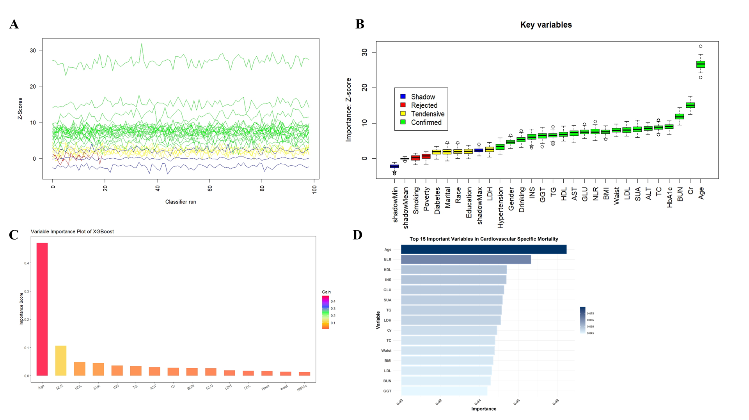
Fig. S1 The critical covariates associated with cardiovascular specific mortality identified by three distinct machine learning methods. The critical covariates associated with cardiovascular specific mortality identified by three distinct machine learning methods. A. Schematic of the Boruta algorithm iteration process. B. Key features selected after 500 iterations based on minimum cost function: x-axis represents input variables; y-axis shows feature importance (Z-scores). Shadow features are denoted by blue boxplots (minimum/mean/maximum Z-scores), while confirmed, tentative, and rejected features are indicated by green, yellow, and red boxplots, respectively. C-D. Top 15 important features ranked by XGBoost (C) and SVM-RFE (D) algorithms. BMI: Body Mass Index; TC: Total Cholesterol; FBG: Fasting Blood Glucose; HbA1c: Glycated Hemoglobin; FINS: Fasting Insulin; HDL: High-Density Lipoprotein; LDL: Low-Density Lipoprotein; TG: Triglycerides; ALT: Alanine Aminotransferase; AST: Aspartate Aminotransferase; Cr: Creatinine; SUA: Serum Uric Acid; GGT: Gamma-Glutamyl Transferase; LDH: Lactate Dehydrogenase; NLR: Neutrophil-to-Lymphocyte Ratio; XGBoost: eXtreme Gradient Boosting; SVM-RFE: Support Vector Machine - Recursive Feature Elimination.

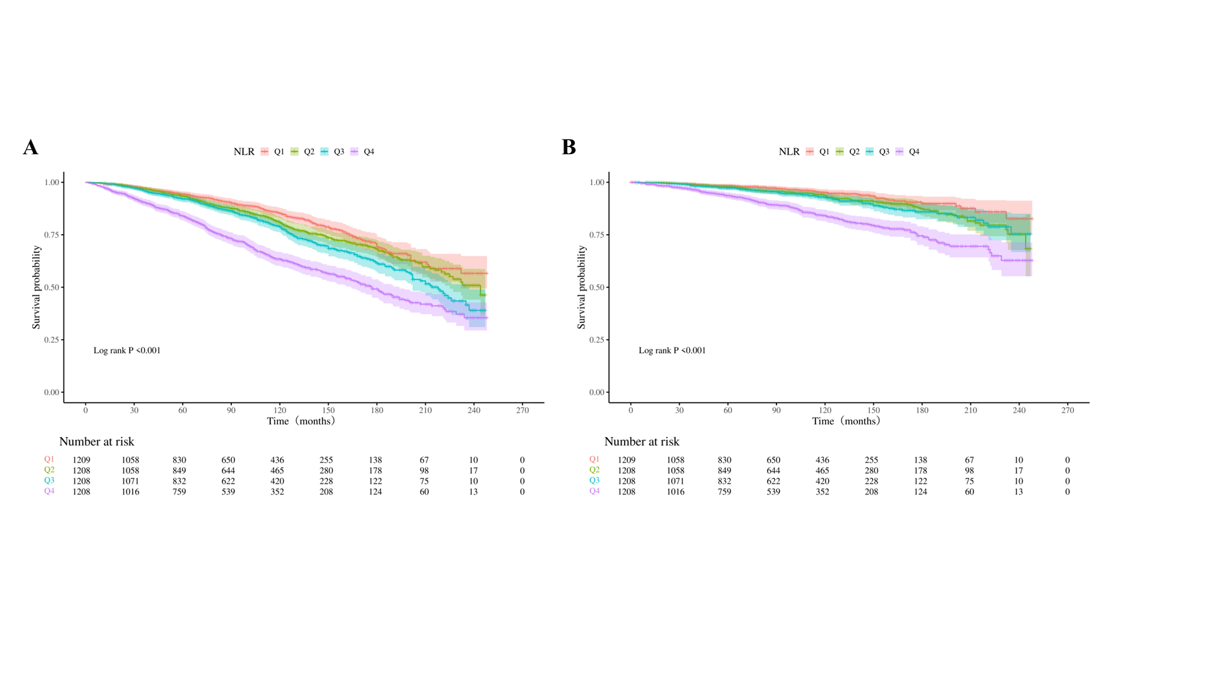
Fig. S2 Kaplan-Meier analysis shows all‑cause (A) and cardiovascular specific mortality (B) across NLR quartiles. Abbreviation: NLR: Neutrophil-to-Lymphocyte Ratio.

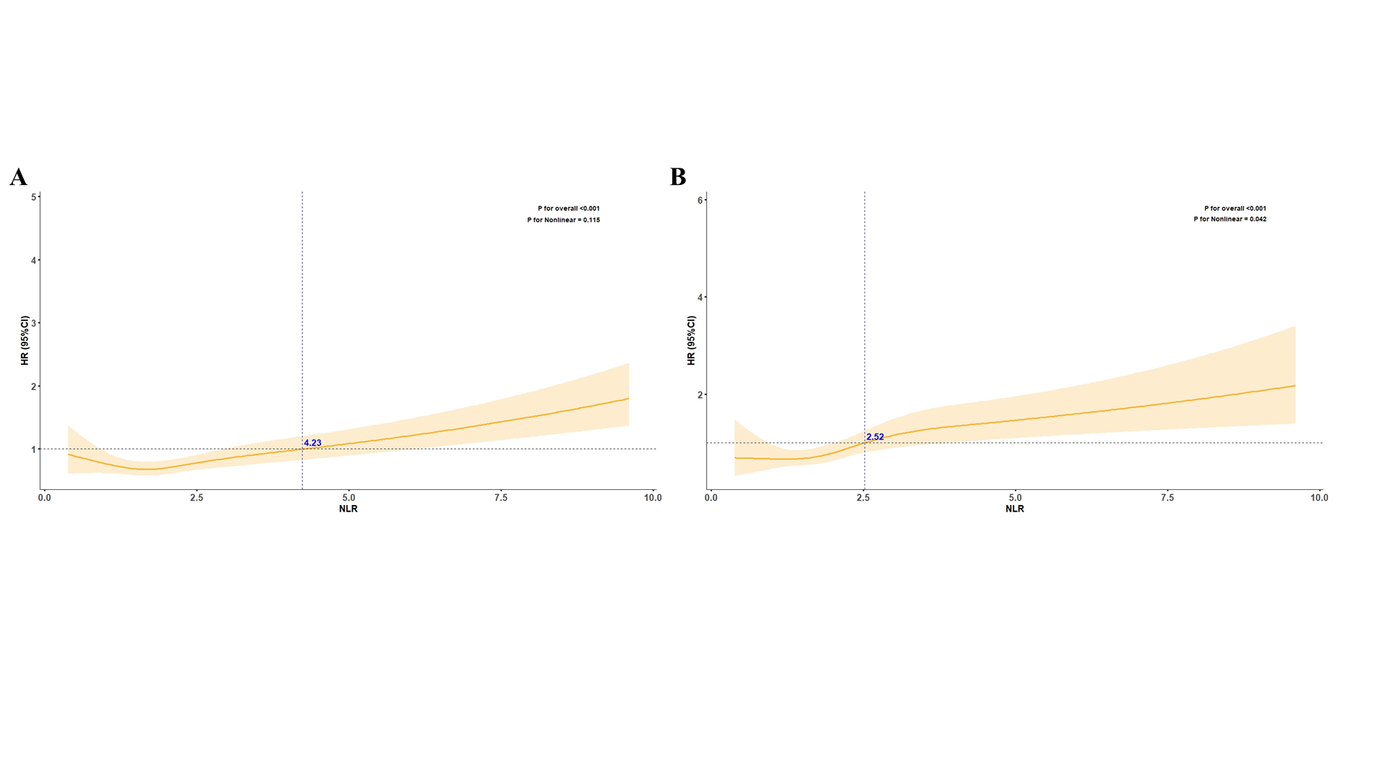
Fig. S3 RCS analysis of the association between NLR levels and risks of all-cause mortality (A) and cardiovascular-specific mortality (B). Abbreviation: NLR: Neutrophil-to-Lymphocyte Ratio; HR: Hazard ratios; CI: Confidence Interval.

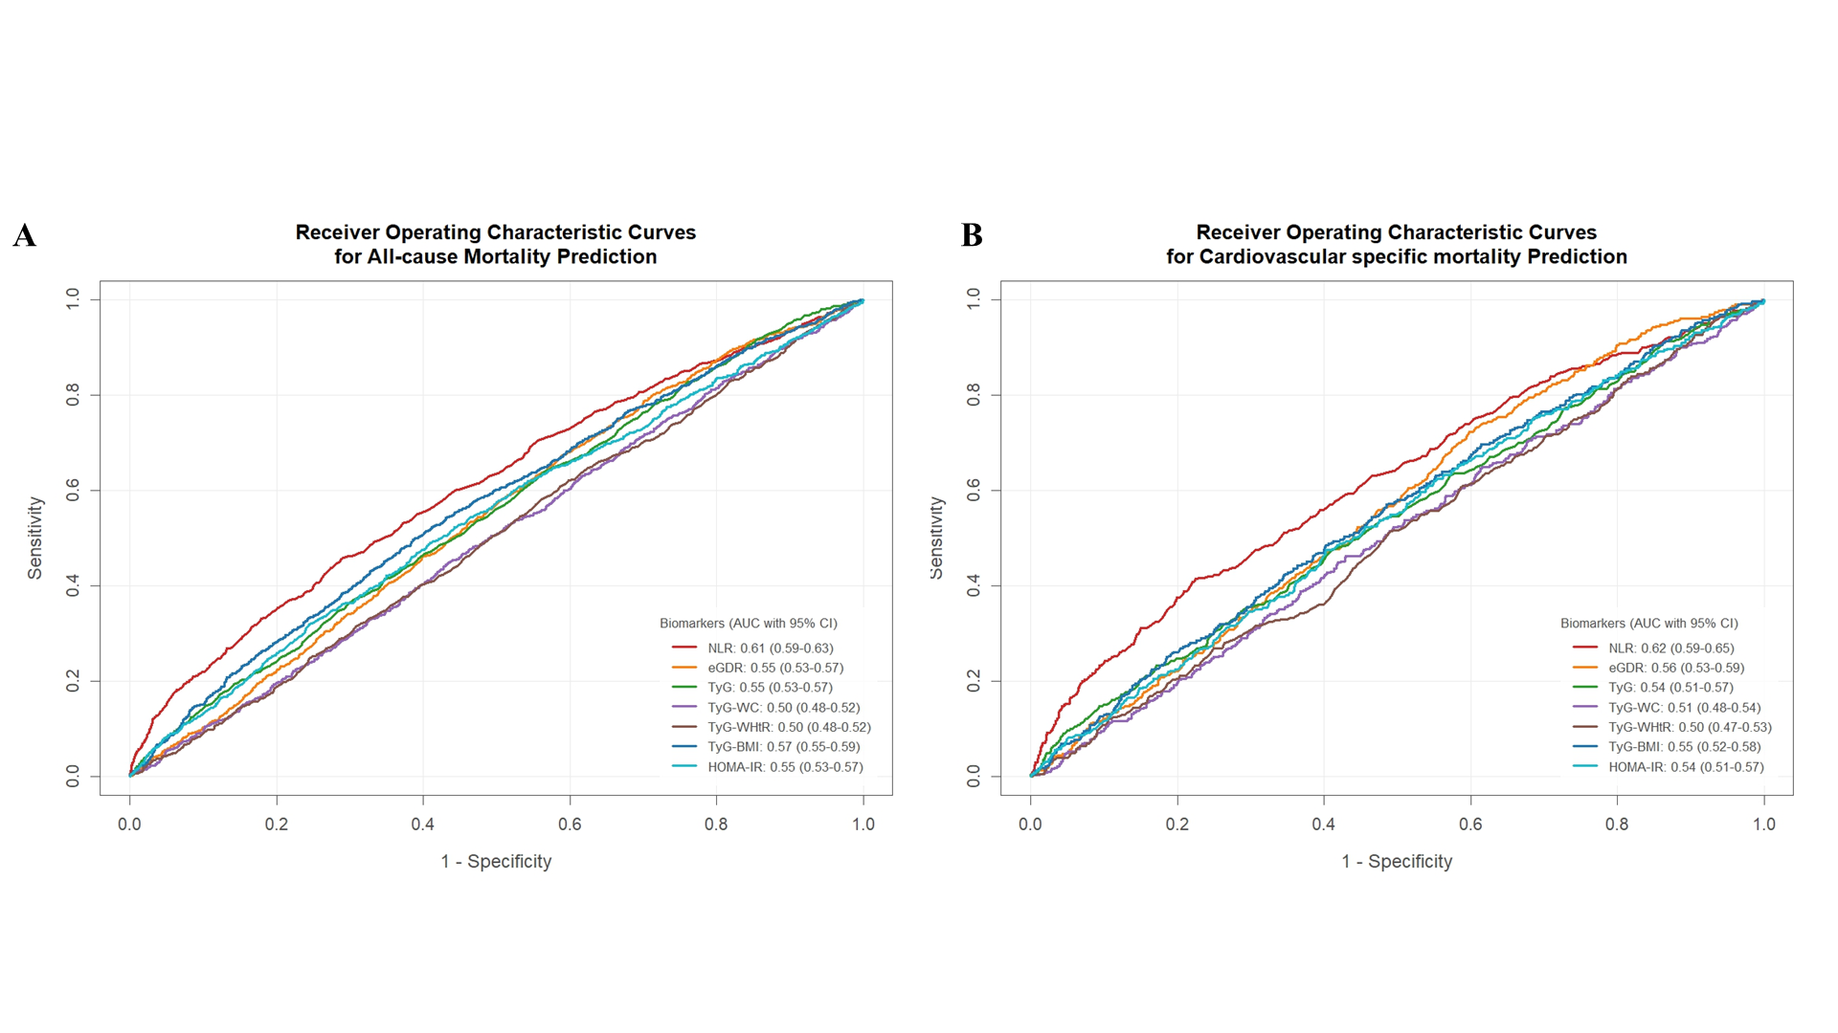
Fig. S4 ROC curves of the NLR and IR indices for predicting all-cause (A) and cardiovascular-specific mortality (B). Abbreviation: AUC: Area under the curve; CI: Confidence Interval; NLR: Neutrophil-to-Lymphocyte Ratio; eGDR: Estimated Glucose Disposal Rate; TyG: Triglyceride-Glucose Index; TyG-BMI: Triglyceride-Glucose-Body Mass Index; TyG-WC: Triglyceride-Glucose-Waist Circumference; TyG-WHtR: Triglyceride-Glucose-Waist-to-Height Ratio; HOMA-IR: Homeostatic Model Assessment of Insulin Resistance.

