Supplementary Information
Nematicidal Effects of Juniperus chinensis Leaf Extracts on the Pine Wood Nematode (Bursaphelenchus xylophilus)
Yandong Liu¹, Yujiang Sun², Fan Wang¹, Lijiao Wang¹, Xu Chen¹, Bing Zhang¹, Yiting Han¹, Guicai Du^{1*}, Qunqun Guo^{1*}
¹ College of Life Sciences, Qingdao University, Qingdao 266071, China
² Qingdao Landscape and Forestry Intergrated Service Center, Qingdao 266061, China
*Correspondence: duguicai@qdu.edu.cn; gqunqun@qdu.edu.cn

NMR spectra (Figure S1-S3) of the isolated nematicidal Compounds 1-3 in this research were listed as follows.

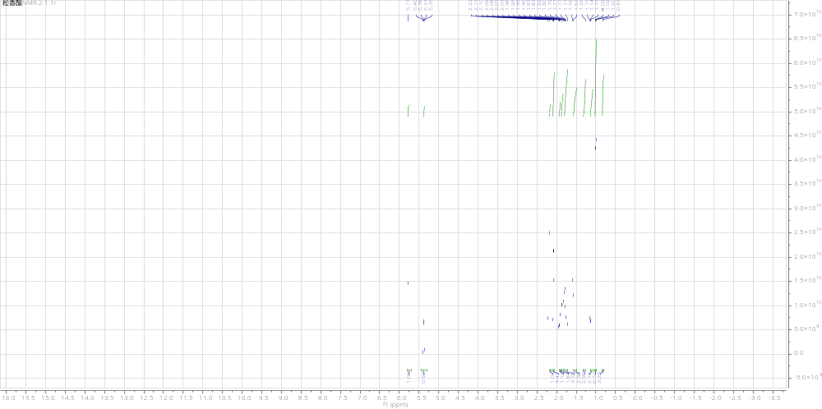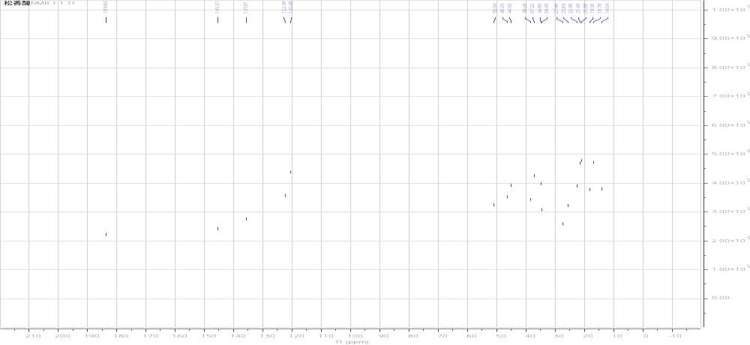
A
B
Fig. S1 ¹H NMR (A) and ¹³C NMR (B) spectrum of compound 1

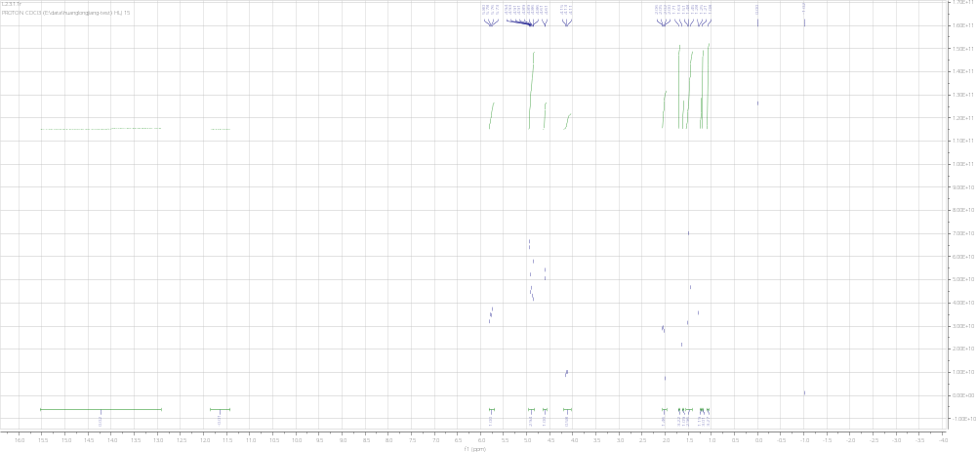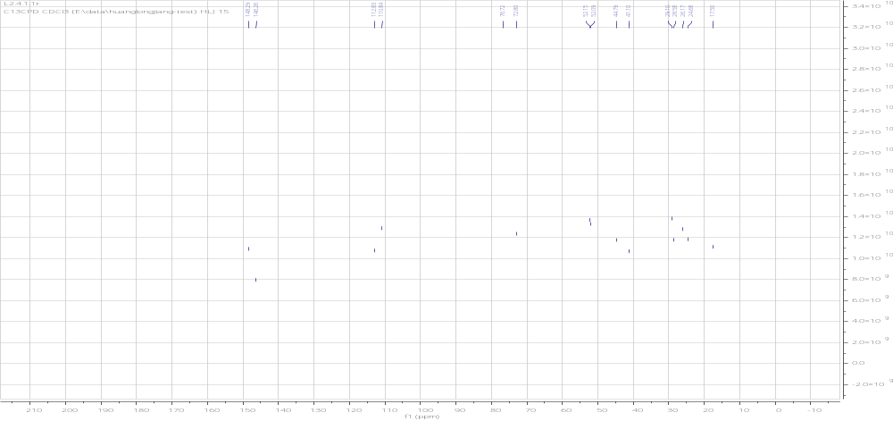
B
A
Fig. S2 ¹H NMR (A) and ¹³C NMR (B) spectrum of compound 2

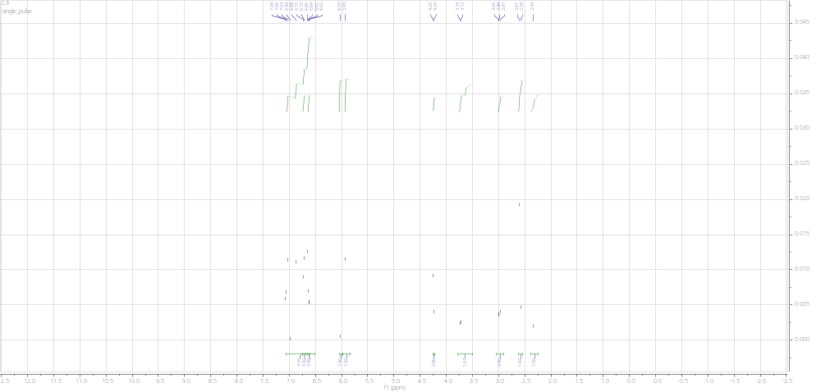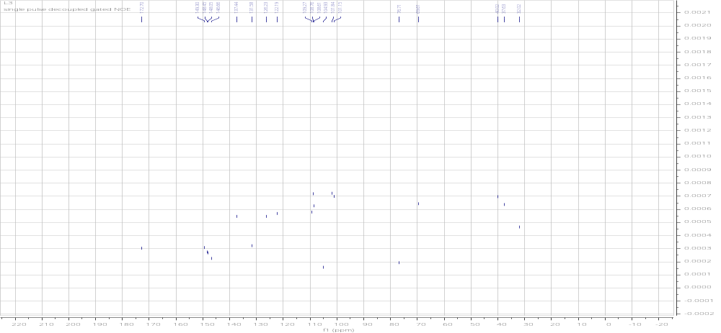
B
A
Fig. S3 ¹H NMR (A) and ¹³C NMR (B) spectrum of compound 3

