(Supplementary Appendix 1): Search Strategy

PubMed Search Strategy (2.5.2024)
("Diabetic Nephropathies"[MeSH Terms] OR ("diabetic nephropath*"[Title/Abstract] OR "diabetic kidney disease*"[Title/Abstract] OR "Diabetic Glomerulosclerosis"[Title/Abstract])) AND ("HAVCR1 protein, human" [Supplementary Concept] OR “kidney injury molecule 1 protein”[Title/Abstract] OR "KIM-1 protein"[Title/Abstract] OR "KIM1 protein"[Title/Abstract] OR "kidney injury molecule-1"[Title/Abstract] OR "KIM 1*"[Title/Abstract] OR "LCN2 protein, human" [Supplementary Concept] OR "Neutrophil gelatinase-associated lipocalin"[Title/Abstract] OR "Neutrophil gelatinase associated lipocalin "[Title/Abstract] OR "lipocalin 2 protein"[Title/Abstract] OR "NGAL protein"[Title/Abstract] OR "NGAL"[Title/Abstract] OR "Acetylglucosaminidase"[Mesh] OR "beta-D-Acetamido-2-Deoxyglucosidase"[Title/Abstract] OR "beta D Acetamido 2 Deoxyglucosidase"[Title/Abstract] OR "beta-D-N-acetylglucosaminidase"[Title/Abstract] OR "N-Acetyl-beta-D-glucosaminidase"[Title/Abstract] OR "Chitobiase"[Title/Abstract] OR "NAG*"[Title/Abstract] OR "Fatty Acid-Binding Proteins"[Mesh] OR "Fatty Acid-Binding Protein*"[Title/Abstract] OR "Liver Fatty Acid-Binding Protein"[Title/Abstract] OR "liver-type fatty acid-binding protein"[Title/Abstract] OR "*FABP*"[Title/Abstract] OR "L-FABP"[Title/Abstract] OR "Liver FABP"[Title/Abstract] OR "LFABP"[Title/Abstract] OR "FABP1"[Title/Abstract] OR "intestinal FABP"[Title/Abstract] OR "IFABP"[Title/Abstract] OR "FABP2"[Title/Abstract]) AND ("cohort studies"[MeSH Terms:noexp] OR "longitudinal studies"[MeSH Terms:noexp] OR "follow up studies"[MeSH Terms:noexp] OR "prospective studies"[MeSH Terms:noexp] OR "retrospective studies"[MeSH Terms:noexp] OR "cohort"[Title/Abstract] OR "longitudinal"[Title/Abstract] OR "prospective"[Title/Abstract] OR "retrospective"[Title/Abstract])

Scopus search strategy (2.5.2024)
( TITLE-ABS-KEY ( "diabetic nephropath*" OR "diabetic kidney disease*" OR "Diabetic Glomerulosclerosis" ) ) AND ( TITLE-ABS-KEY ("HAVCR1 protein" OR “kidney injury molecule 1 protein” OR "KIM-1 protein" OR "KIM1 protein" OR "kidney injury molecule-1" OR "KIM 1*" OR "LCN2 protein, human" OR "Neutrophil gelatinase-associated lipocalin" OR " Neutrophil gelatinase associated lipocalin " OR " lipocalin 2 protein" OR " NGAL protein" OR "NGAL" OR ("Acetylglucosaminidase" OR "beta-D-Acetamido-2-Deoxyglucosidase" OR "beta D Acetamido 2 Deoxyglucosidase" OR "beta-D-N-acetylglucosaminidase" OR "N-Acetyl-beta-D-glucosaminidase" OR "Chitobiase" OR "NAG*" OR "Fatty Acid-Binding Proteins" OR "Fatty Acid-Binding Protein*" OR "Liver Fatty Acid-Binding Protein" OR "liver-type fatty acid-binding protein" OR "*FABP*" OR "L-FABP" OR "Liver FABP" OR "LFABP" OR "FABP1" OR "intestinal FABP" OR "IFABP" OR "FABP2")) AND ( TITLE-ABS-KEY ("cohort" OR "longitudinal" OR "prospective" OR "retrospective"))

Web of science search strategy (2.5.2024)
TS=("diabetic nephropath*" OR "diabetic kidney disease*" OR "Diabetic Glomerulosclerosis") AND TS= ("HAVCR1 protein" OR “kidney injury molecule 1 protein” OR "KIM-1 protein" OR "KIM1 protein" OR "kidney injury molecule-1" OR "KIM 1*" OR “LCN2 protein, human" OR "Neutrophil gelatinase-associated lipocalin" OR "Neutrophil gelatinase associated lipocalin " OR " lipocalin 2 protein" OR " NGAL protein" OR "NGAL" OR “Acetylglucosaminidase" OR "beta-D-Acetamido-2-Deoxyglucosidase" OR "beta D Acetamido 2 Deoxyglucosidase" OR "beta-D-N-acetylglucosaminidase" OR "N-Acetyl-beta-D-glucosaminidase" OR "Chitobiase" OR "NAG*" OR "Fatty Acid-Binding Proteins" OR "Fatty Acid-Binding Protein*" OR "Liver Fatty Acid-Binding Protein" OR "liver-type fatty acid-binding protein" OR "*FABP*" OR "L-FABP" OR "Liver FABP" OR "LFABP" OR "FABP1" OR "intestinal FABP" OR "IFABP" OR "FABP2") AND TS= ("cohort" OR "longitudinal" OR "prospective" OR "retrospective")
Indexes=SCI-EXPANDED, SSCI, A&HCI, CPCI-S, CPCI-SSH, BKCI-S, BKCI-SSH, ESCI Timespan=All years

Supplementary Figures:

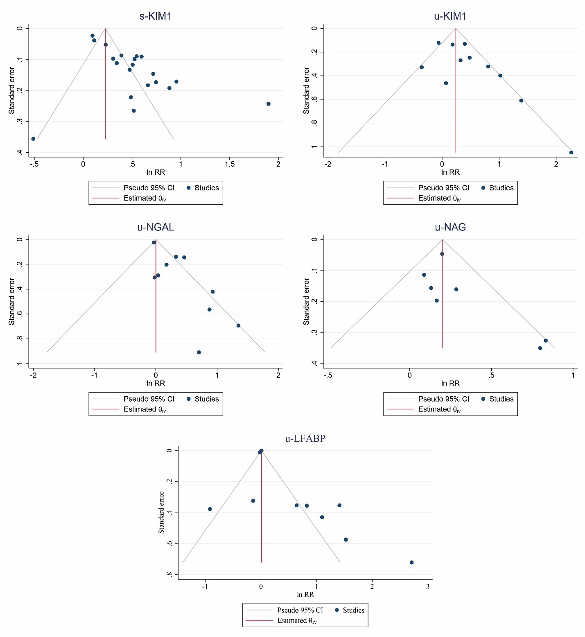

Supplementary figure 1: funnel plots
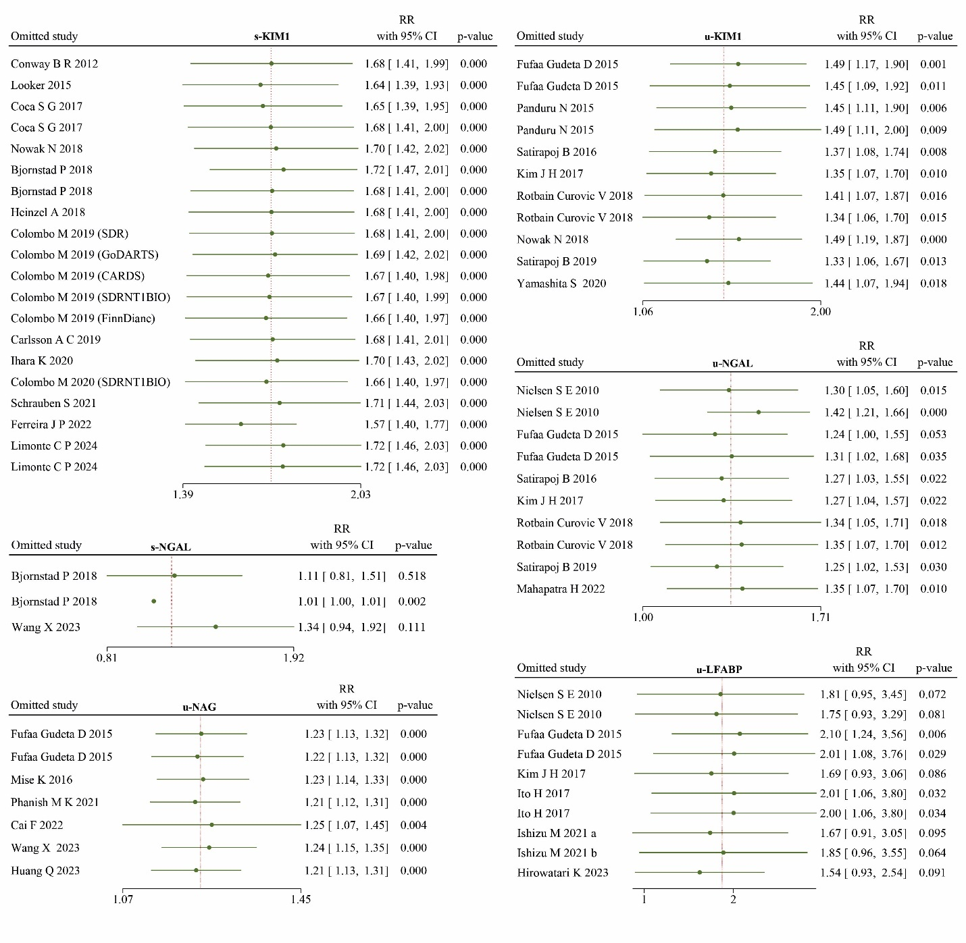
Supplementary figure 2: sensitivity analysis

Supplementary Table 1. s-KIM1
 | No. of studies | No. of patients | RR (95% CI) | p-value | P > Q | % I² | P meta-regression
Overall | 20 | 19663 | 1.68(1.42,1.97) | <.001 | <.001 | 94.65
Exposure to outcome
DM to DN | 10 | 14191 | 1.72(1.3,2.28) | <.001 | <.001 | 97.45 | 0.8
DN to DN progression | 7 | 2713 | 1.74(1.34,2.26) | <.001 | 0.001 | 78.81
DN to ESRD or death | 3 | 2759 | 1.49(1.17,1.9) | 0.001 | 0.007 | 76.66
Outcome
eGFR decline | 14 | 9805 | 1.68(1.48,1.90) | <.001 | <.001 | 78.23 | 0.73
Albuminuria | 2 | 1968 | 0.90(0.52,1.57) | 0.715 | 0.089 | 65.4
ESRD | 3 | 6925 | 2.38(0.89,6.36) | 0.082 | <.001 | 98.72
Mortality | 1 | 965 | 1.68(0.1,2.83) | 0.051 | . | .
Outcome stage
Early | 16 | 11773 | 1.59(1.39,1.82) | <.001 | <.001 | 89.63 | 0.23
Advanced | 4 | 7890 | 2.18(1.07,4.46) | 0.033 | <.001 | 97.5
Female%
Under 50% | 14 | 16786 | 1.72(1.39,2.12) | <.001 | <.001 | 96.26 | 0.72
Above 50% | 6 | 2877 | 1.63(1.25,2.11) | <.001 | 0.003 | 81.38
No. of patients
Under 500 | 7 | 2323 | 1.87(1.6,2.18) | <.001 | 0.034 | 57.9 | 0.22
Above 500 | 13 | 17340 | 1.56(1.22,2.00) | <.001 | <.001 | 97.23
Age
Under 50 years | 6 | 5880 | 1.37(0.99,1.88) | 0.055 | <.001 | 96.74 | 0.11
Above 50 years | 14 | 13783 | 1.81(1.51,2.18) | <.001 | <.001 | 89.79
Duration of follow-up
Under 8 years | 12 | 13466 | 1.97(1.61,2.40) | <.001 | <.001 | 86.41 | 0.006
Above 8 years | 8 | 6197 | 1.32(1.11,1.56) | 0.001 | <.001 | 92.01
Type of Diabetes
T1DM | 7 | 6739 | 1.43(1.09,1.88) | 0.009 | <.001 | 96.07 | 0.44
T2DM | 12 | 12386 | 1.89(1.53,2.33) | <.001 | <.001 | 88.26
TxDM | 1 | 538 | 1.26(1.14,1.40) | <.001 | . | .
Diabetes duration
Under 10 years | 7 | 9898 | 1.89(1.21,2.95) | 0.005 | <.001 | 98.68 | 0.47
Above 10 years | 9 | 6778 | 1.62(1.44,1.83) | <.001 | 0.013 | 47.65
HbA1c
Under 8 | 12 | 7435 | 1.57(1.4,1.77) | <.001 | <.001 | 65.83 | 0.27
Above 8 | 7 | 11196 | 2.00(1.30,3.07) | 0.009 | <.001 | 98.61
eGFR
<60 | 6 | 3073 | 1.69(1.4,2.06) | <.001 | <.001 | 83.19 | 0.82
>60 | 14 | 16590 | 1.66(1.31,2.11) | <.001 | <.001 | 96.28
Albuminuria
Normoalbuminuria | 11 | 9650 | 1.51(1.32,1.73) | <.001 | <.001 | 88.43 | 0.40
Microalbuminuria | 4 | 2393 | 1.45(0.85,2.48) | 0.172 | 0.001 | 87.79
Macroalbuminuria | 4 | 2489 | 1.76(1.32,2.34) | <.001 | <.001 | 86.2
Albuminuria %
<40% | 11 | 9007 | 1.50(1.31,1.72) | <.001 | <.001 | 90.27 | 0.36
>40% | 8 | 5525 | 1.68(1.33,2.12) | <.001 | <.001 | 80.45

Supplementary Table 2. u-KIM1
 | No. of studies | No. of patients | RR (95% CI) | p-value | P > Q | % I2 | P meta-regression
Overall | 11 | 3535 | 1.47(1.17,1.81) | 0.005 | 0.003 | 62.31
Exposure to outcome
DM to DN | 4 | 1839 | 1.25(0.92,1.69) | 0.152 | 0.04 | 61.95 | 0.287
DM to ESRD or death | 3 | 712 | 1.3(0.69,2.46) | 0.421 | 0.04 | 70.57
DN to DN progression | 2 | 376 | 4.99(1.78,14.03) | 0.002 | 0.47 | 0
DN to ESRD or death | 2 | 608 | 1.68(0.75,3.74) | 0.207 | 0.047 | 74.68
Outcome stage
Early | 6 | 2215 | 1.44(1.01,2.07) | 0.045 | 0.007 | 65.63 | 0.908
Advanced | 5 | 1320 | 1.42(0.94,2.15) | 0.094 | 0.034 | 66.82
Female%
Under 50% | 8 | 2942 | 1.45(1.11,1.89) | 0.006 | 0.007 | 64.06 | 0.649
Above 50% | 3 | 593 | 1.4(0.58,3.36) | 0.451 | 0.032 | 76.38
No. of patients
Under 500 | 10 | 2503 | 1.494(1.19,1.87) | <.001 | 0.035 | 39.89 | 0.083
Above 500 | 1 | 1032 | 0.94(0.741,1.192) | 0.61 | . | .
Age
Under 50 years | 4 | 1140 | 1.15(0.92,1.43) | 0.213 | 0.413 | 0 | 0.103
Above 50 years | 7 | 2395 | 1.79(1.21,2.64) | 0.004 | 0.001 | 75.22
Duration of follow-up
Under 8 years | 9 | 3015 | 1.54(1.16,2.05) | 0.003 | 0.003 | 67.41 | 0.217
Above 8 years | 2 | 520 | 1.01(0.52,1.96) | 0.98 | 0.11 | 60.84
Type of Diabetes
T1DM | 2 | 620 | 1.19(0.92,1.54) | 0.185 | 0.812 | 0 | 0.436
T2DM | 9 | 2915 | 1.54 (1.11,2.14) | 0.009 | 0.001 | 71.73
Diabetes duration
Under 10 years | 1 | 73 | 4(1.21,13.22) | 0.023 | . | .
Above 10 years | 10 | 3462 | 1.35(1.07,1.70) | 0.01 | 0.006 | 58.51 | 0.106
HbA1c
Under 8% | 5 | 1290 | 1.78(1.36,2.32) | 0 | 0.196 | 20.64 | 0.037
Above 8% | 5 | 1213 | 1.2(0.96,1.48) | 0.103 | 0.14 | 0
eGFR
<60 | 3 | 911 | 2.23(0.87,5.74) | 0.096 | 0.023 | 75.1 | 0.39
> 60 | 8 | 2624 | 1.34(1.02,1.76) | 0.038 | 0.009 | 60.63
Albuminuria
Normoalbuminuria | 5 | 1426 | 1.53(0.93,2.51) | 0.095 | 0.028 | 69.16 | 0.675
Microalbuminuria | 5 | 1758 | 1.51(0.96,2.35) | 0.072 | 0.01 | 66.44
Macroalbuminuria | 1 | 351 | 1.2(0.92,1.57) | 0.181 | . | .
Albuminuria %
<40% | 1 | 346 | 1.49(1.15,1.92) | 0.002 | . | . | 0.935
>40% | 10 | 3189 | 1.44(1.06,1.94) | 0.018 | 0.003 | 66.21

Supplementary Table 3. u-NGAL
 | No. of studies | No. of patients | RR (95% CI) | p-value | P > Q | % I2 | P meta-regression
Overall | 10 | 1813 | 1.30(1.06,1.60) | 0.013 | <.001 | 60.63
Exposure to outcome
DM to DN | 2 | 312 | 1.12(0.81,1.56) | 0.495 | 0.6 | 0 | 0.26
DM to ESRD or death | 3 | 712 | 1.43(1.19,1.72) | <.001 | 0.406 | 0
DN to DN progression | 3 | 454 | 1.69(0.71,4.02) | 0.231 | 0.039 | 66.85
DN to ESRD or death | 2 | 335 | 2.43(1.15,5.13) | 0.02 | 0.822 | 0
Outcome stage
Early | 5 | 766 | 1.09(0.87,1.36) | 0.456 | 0.112 | 29.5 | 0.006
Advanced | 5 | 1047 | 1.47(1.23,1.76) | <.001 | 0.449 | 0
Female%
Under 50% | 7 | 1220 | 1.15(0.91,1.45) | 0.253 | 0.096 | 36.44 | 0.04
Above 50% | 3 | 593 | 1.50(1.24,1.82) | <.001 | 0.559 | 0
Age
Under 50 years | 5 | 796 | 1.22(0.94,1.58) | 0.128 | 0.001 | 72.68 | 0.38
Above 50 years | 5 | 1017 | 1.58(1.02,2.45) | 0.041 | 0.151 | 44.1
Duration of follow-up
Under 8 years | 8 | 1293 | 1.23(0.94,1.60) | 0.128 | 0.065 | 45.89 | 0.19
Above 8 years | 2 | 520 | 1.48(1.22,1.80) | <.001 | 0.5 | 0
Type of Diabetes
T1DM | 2 | 156 | 0.97(0.93,1.02) | 0.208 | 0.42 | 0 | <.001
T2DM | 8 | 1657 | 1.41(1.21,1.65) | <.001 | 0.264 | 0
Diabetes duration
Under 10 years | 2 | 193 | 1.35(0.58,3.14) | 0.48 | 0.164 | 48.48 | 0.9
Above 10 years | 8 | 1620 | 1.32(1.05,1.65) | 0.018 | <.001 | 66.63
HbA1c
Under 8 | 4 | 944 | 1.5(0.93,2.39) | 0.094 | 0.126 | 48.41 | 0.61
Above 8 | 6 | 869 | 1.26(0.98,1.63) | 0.075 | 0.001 | 69.65
eGFR
<60 | 2 | 560 | 2.83(1.4,5.73) | 0.004 | 0.605 | 0 | 0.03
>60 | 8 | 1253 | 1.22(1,1.48) | 0.05 | 0.003 | 58.68
Albuminuria
Normoalbuminuria | 2 | 520 | 1.48(1.22,1.80) | <.001 | 0.5 | 0 | <.001
Microalbuminuria | 5 | 834 | 1.25(0.96,1.63) | 0.094 | 0.263 | 0
Macroalbuminuria | 3 | 459 | 1.57(0.63,3.93) | 0.336 | 0.101 | 55.96
Albuminuria %
<40% | 3 | 593 | 1.50(1.24,1.82) | <.001 | 0.559 | 0 | 0.04
>40% | 7 | 1220 | 1.15(0.91,1.45) | 0.253 | 0.096 | 36.44

Supplementary Table 4. u-LFABP
 | No. of studies | No. of patients | RR (95% CI) | p-value | P > Q | % I2 | P meta-regression
Overall | 10 | 2177 | 1.83(1.03,3.25) | 0.04 | <.001 | 99.93
Exposure
DM to DN | 3 | 858 | 2.82(0.64,12.44) | 0.17 | <.001 | 93.8 | 0.97
DM to ESRD or death | 3 | 685 | 0.997(0.32,3.07) | 0.99 | 0.002 | 85.81
DN to DN progression | 4 | 634 | 2.213(1.06,4.64) | 0.04 | <.001 | 85.07
Outcome
eGFR decline | 5 | 1005 | 3.02(1.27,7.17) | 0.01 | <.001 | 89.19 | 0.19
Albuminuria | 2 | 487 | 1.405(0.64,3.08) | 0.4 | 0.022 | 81.02
ESRD | 1 | 260 | 0.4(0.19,0.84) | 0.02 | . | .
Mortality | 2 | 425 | 1.56(0.47,5.25) | 0.47 | 0.021 | 81.16
Outcome stage
Early | 7 | 1492 | 2.34(1.24,4.42) | 0.009 | <.001 | 99.95 | 0.16
Advanced | 3 | 685 | 0.997(0.32,3.07) | 0.996 | 0.002 | 85.81
Female%
Under 50% | 6 | 1523 | 1.99(1.05,3.79) | 0.04 | <.001 | 99.95 | 0.62
Above 50% | 4 | 654 | 1.55(0.48,4.97) | 0.47 | <.001 | 89.24
Age
Under 50 years | 4 | 850 | 1.23(0.50,2.995) | 0.65 | 0.001 | 83.66 | 0.27
Above 50 years | 6 | 1327 | 2.43(1.12,5.24) | 0.02 | <.001 | 99.97
duration of follow-up
Under 8 years | 6 | 1327 | 2.43(1.12,5.24) | 0.02 | <.001 | 99.97 | 0.27
Above 8 years | 4 | 850 | 1.23(0.50,2.995) | 0.65 | 0.001 | 83.66
Type of Diabetes
T1DM | 3 | 391 | 3.05(1.995,4.65) | <.001 | 0.502 | 0 | 0.21
T2DM | 7 | 1786 | 1.52(0.7,3.28) | 0.29 | <.001 | 99.97
Diabetes duration
Under 10 years | 3 | 403 | 2.84( 1.75,4.61) | <.001 | 0.575 | 0 | 0.05
Above 10 years | 6 | 1547 | 1.17(0.66,2.07) | 0.6 | <.001 | 99.94
HbA1c
Under 8 | 5 | 1254 | 2.22(0.93,5.31) | 0.08 | <.001 | 99.98 | 0.36
Above 8 | 3 | 593 | 1.10(0.29,4.25) | 0.89 | 0.002 | 88.16
Albuminuria
Normoalbuminuria | 6 | 1543 | 1.63(0.67,4.00) | 0.29 | <.001 | 93.33 | 0.94
Microalbuminuria | 3 | 312 | 3.09(1.73,5.54) | <.001 | 0.221 | 36.72
Macroalbuminuria | 1 | 322 | 1.01(1.009,1.011) | <.001 | . | .
Albuminuria %
<40% | 3 | 796 | 1.71(0.84,3.5) | 0.14 | 0.002 | 80.64 | 0.96
>40% | 7 | 1381 | 1.92(0.83,4.44) | 0.13 | <.001 | 93.32

