Supplemental information

Results

Main task effects
Across drug sessions, participants were both more accurate and had faster response times (RTs) on trials following an unexpected outcome (reversal trials) than on regular trials (Figure S1; Table S1; expectancy effect on accuracy: B = 0.217, CI = [0.136, 0.301]; expectancy effect on RT: B = -0.052, CI = [-0.061, -0.043]). The increase in accuracy was larger after unexpected punishments compared with regular punishment trials than it was for rewards (Figure S1A; expectancy x valence effect on accuracy: B = -0.055, CI = [-0.105, -0.003]).
Analyses of the main effects of unexpected outcomes on BOLD signal, irrespective of drug session and individual differences, revealed strong task effects, particularly in fronto-striatal circuitry (Figure 1B in main text for main effect of outcome expectancy) comparable with those reported previously^{48,112,113}. In addition, we demonstrate that unexpected outcomes increase face/scene stimulus-specific BOLD signal in visual association cortex, consistent with the need for updating outcome predictions for faces/scenes following unexpected events (Figure 1C in main text).
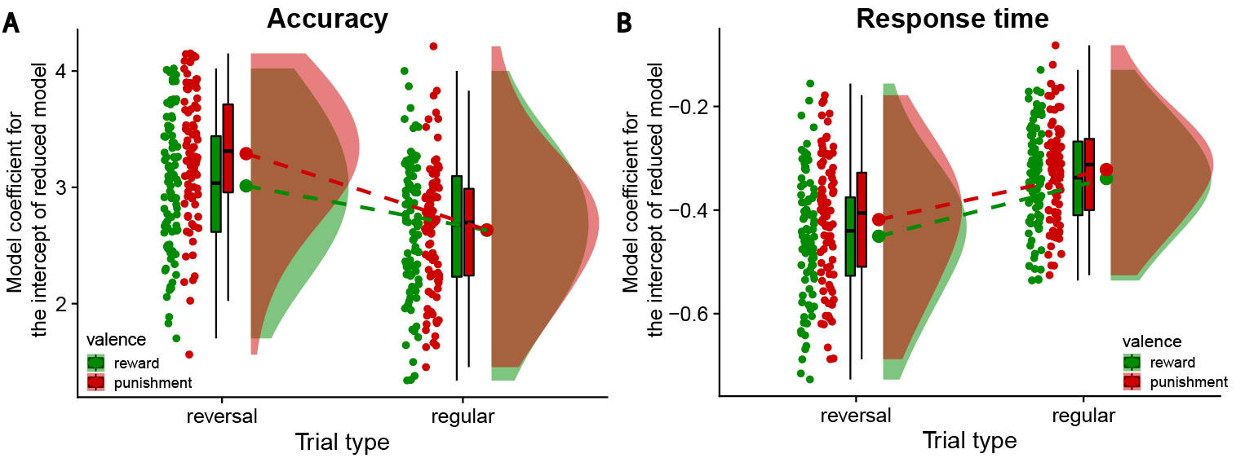
Figure S1. Across drug sessions, participants were both more accurate and responded faster on reversal trials (after unexpected outcomes) than on regular trials. The increase in accuracy was greater for punishment reversal trials than reward reversal trials. (A) Model coefficients of the intercepts of reduced models that only contained the trials of each specific condition (e.g. only reward reversal trials). The models contained one factor for drug (methylphenidate, sulpiride, placebo). (B) Same as in panel A, but the dependent variable was response time.

Table S1. Averaged raw accuracy scores for overall task performance and separated by trial type, for each of the three drug conditions (N = 88). Values represent mean proportion (standard error of mean) of correct responses. Trial types: expected reward (ER), update after unexpected reward (UR), expected punishment (EP), update after unexpected punishment (UP).
Drug | overall | ER | UR | EP | UP
Placebo | 0.90 (0.006) | 0.88 (0.007) | 0.92 (0.008) | 0.88 (0.007) | 0.94 (0.008)
Methylphenidate | 0.94 (0.005) | 0.93 (0.006) | 0.95 (0.006) | 0.93 (0.005) | 0.96 (0.007)
Sulpiride | 0.88 (0.007) | 0.86 (0.009) | 0.89 (0.010) | 0.87 (0.007) | 0.91 (0.010)

Dopamine synthesis capacity
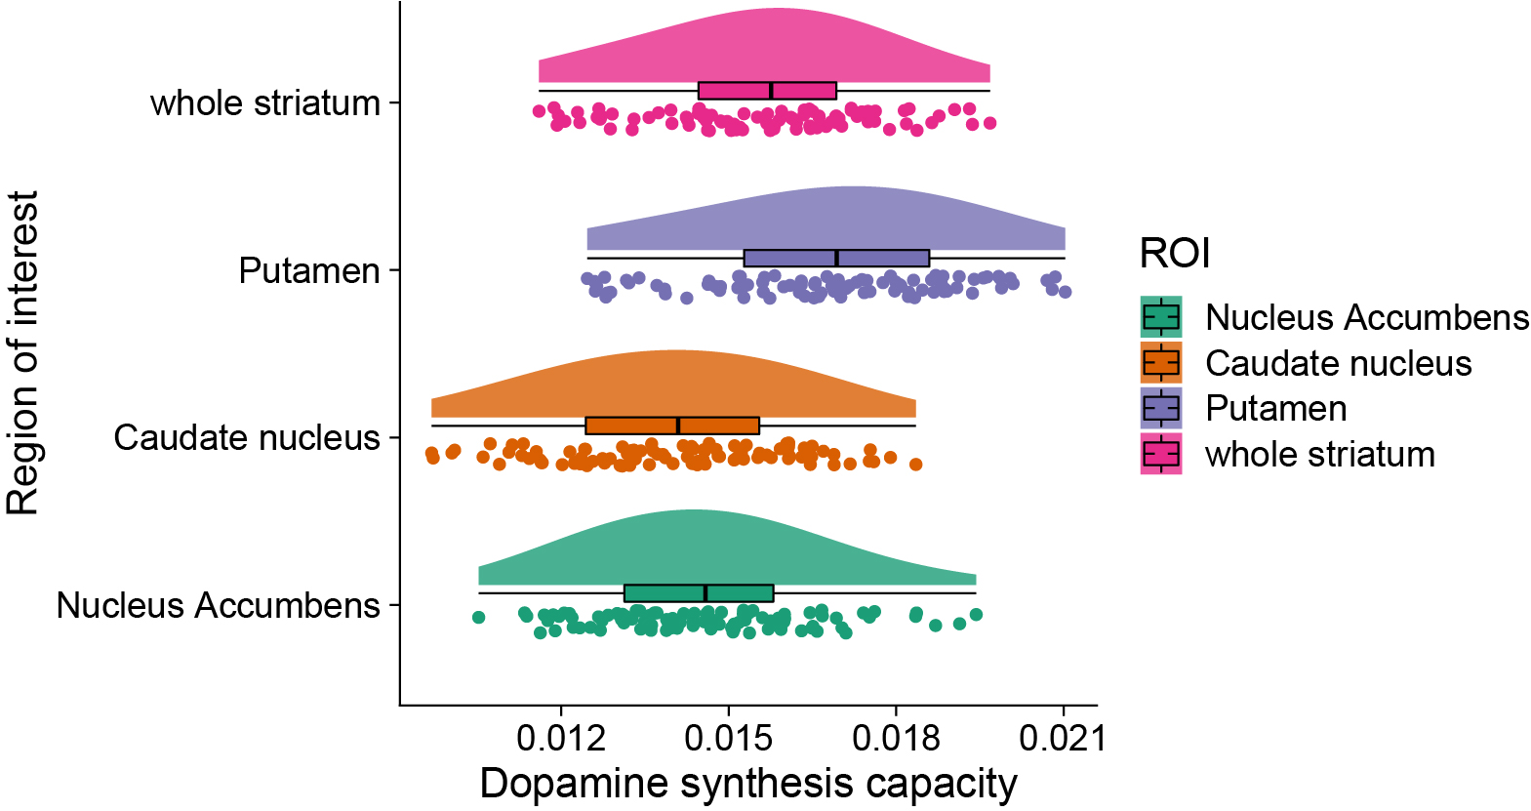
Figure S2. Distribution of dopamine synthesis capacity (k_{i}^{cer}) values in the striatal regions of interest (ROI): caudate nucleus, putamen and nucleus accumbens. The whole striatum ROI is the combination of all three subregions of interest.

Table S2. Pearson correlation coefficients for dopamine synthesis capacity in the three striatal regions of interest.
 | Caudate nucleus | Putamen | Nucleus Accumbens
Caudate nucleus | 1 | 0.751 | 0.649
Putamen | 0.751 | 1 | 0.787
Nucleus Accumbens | 0.649 | 0.787 | 1

Striatal dopamine-dependent effects on striatal BOLD signal
Methylphenidate and sulpiride increased surprise-related BOLD signal in the caudate nucleus to a greater degree in participants with lower dopamine synthesis capacity in the caudate nucleus (Figure 2 main text; Figure S3). There was no evidence for an effect of caudate nucleus dopamine synthesis capacity on caudate nucleus BOLD signals during unexpected outcomes under placebo (Figure S4; peak voxel: x,y,z = 10,13,7, Z = 3.50, p_{peak FWE SVC} = 0.142).
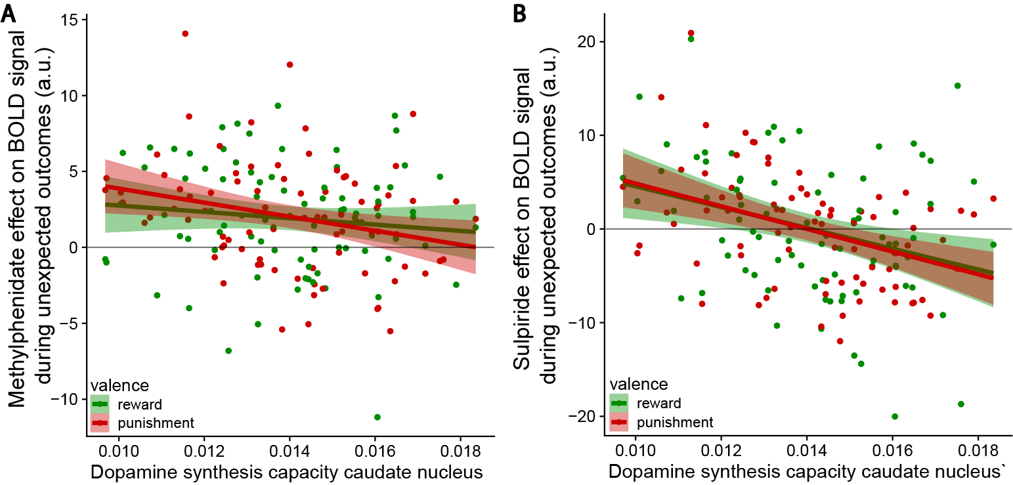
Figure S3. Drug effects on striatal BOLD signal during unexpected outcomes. Supplement to Figure 2 main text, without median split. (A) Effect of methylphenidate on reversal signal in the significant clusters with dopamine synthesis-independent methylphenidate effect (Figure 2A) as a function of caudate nucleus k_{i}^{cer}, displayed separately for unexpected reward and punishment outcomes. (B) Effect of sulpiride on reversal signal in the significant clusters in the right caudate nucleus (Figure 2C) as a function of caudate nucleus k_{i}^{cer}, displayed separately for unexpected reward and punishment outcomes.
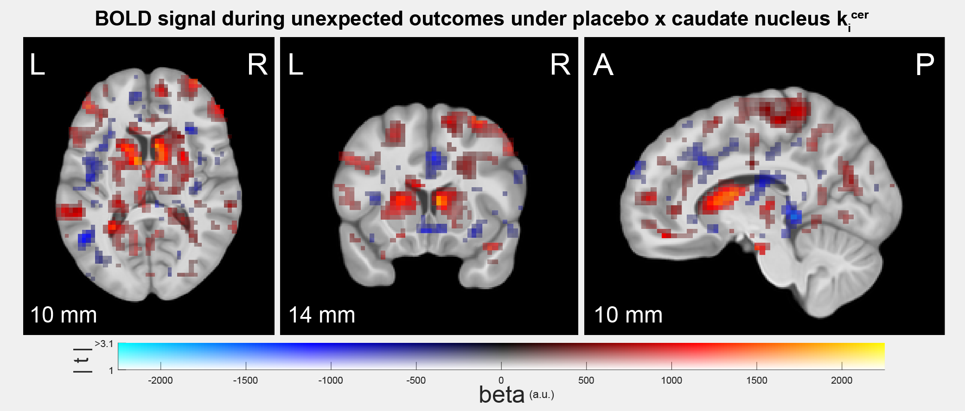
Figure S4. Data from placebo session. BOLD map showing (absence of) effect of dopamine synthesis capacity in the caudate nucleus on BOLD signal to unexpected outcomes. Figure conventions are as in Figure 1B.

Striatal dopamine-dependent effects on stimulus-specificity in visual cortex
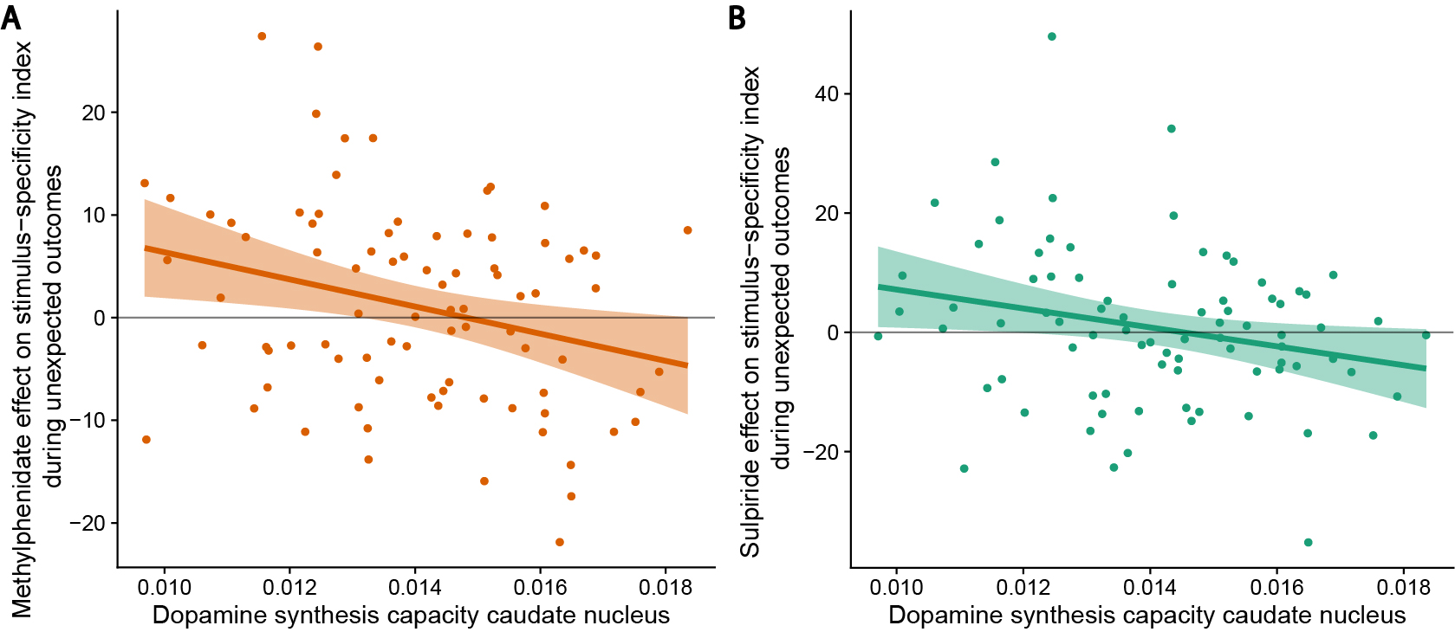
Figure S5. Drug effects on stimulus-specificity of BOLD signal in the fusiform face area (FFA) and parahippocampal place area (PPA) during unexpected outcomes. Supplement to Figure 3 main text, without median split. Effect of methylphenidate (A) and sulpiride (B) on stimulus-specific reversal-related signal in FFA/PPA as a function of caudate nucleus k_{i}^{cer}.

Striatal dopamine-dependent effect of methylphenidate on prefrontal BOLD signal
Methylphenidate increased prefrontal BOLD signal to unexpected rewards versus punishments as a function of dopamine synthesis capacity in the putamen (Figure 4 main text) and in the nucleus accumbens (peak voxel with nucleus accumbens k_{i}^{cer}: x,y,z = -43,39,16, Z = 3.99, p_{cluster FWE WB} = 0.016). Including three covariates for dopamine synthesis capacity in the analysis of methylphenidate's effect on BOLD signal, one for each striatum ROI, in a single voxel-wise regression model revealed that the bilateral prefrontal clusters were significantly associated with dopamine synthesis capacity in the putamen, over and above the other two regions (Figure S6B; peak voxel: x,y,z = 29,63,7, Z = 4.71, p_{cluster FWE WB} = 0.002).
The putamen dopamine-dependent effect of methylphenidate in the prefrontal cortex was driven by reward reversal signals and not present for punishment reversal signals (Figure S6C; peak voxel in methylphenidate x expectancy x putamen k_{i}^{cer} for reward only: x,y,z = -20,53,21, Z = 4.69, p_{cluster FWE WB} = 0.038). Under placebo, reward reversal signals in prefrontal cortex were stronger for 'lower-dopamine' participants, while under methylphenidate, reward reversal signals were stronger for 'higher-dopamine' participants. The negative association under placebo was significant in a voxel-wise regression analysis with dopamine synthesis capacity in the nucleus accumbens, but not putamen (Figure S7; prefrontal peak voxel for expectancy x valence x nucleus accumbens k_{i}^{cer} for placebo only: x,y,z = -47,39,19, Z = 3.74, p_{cluster FWE WB} = 0.024; prefrontal peak voxel with putamen k_{i}^{cer} values: x,y,z = 39,49,21, Z = 3.75, p_{cluster FWE WB} = 0.257).
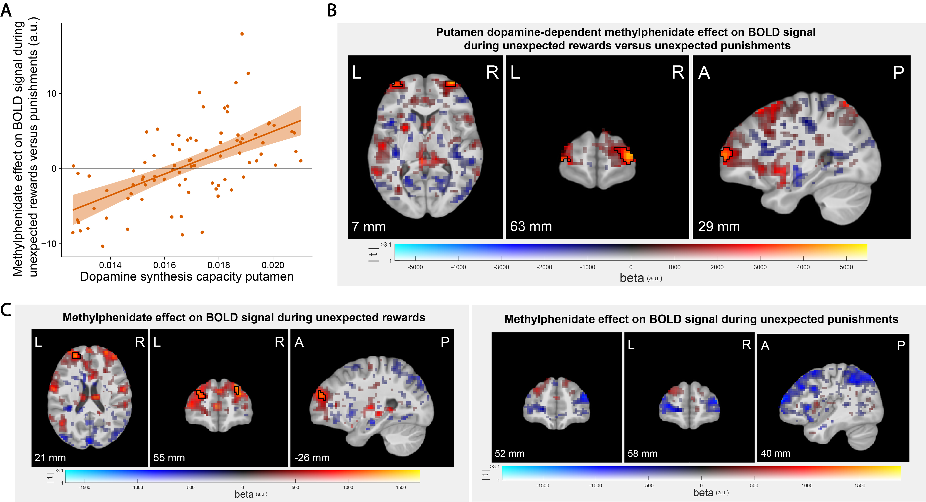
Figure S6. Methylphenidate effect on prefrontal BOLD signal. (A) Average contrast estimates extracted from the significant clusters where methylphenidate increased BOLD signal during unexpected reward versus punishment outcomes as a function of dopamine synthesis capacity in the putamen. Supplement to Figure 4 in main text. (B) Methylphenidate increased BOLD signal during unexpected reward versus punishment outcomes in bilateral prefrontal clusters as a function of dopamine synthesis capacity in the putamen, over and above the caudate nucleus and nucleus accumbens. Result for putamen from a general linear model in which k_{i}^{cer} values from all three ROIs were included as covariates. (C) The putamen dopamine-dependent effect of methylphenidate in prefrontal cortex was driven by reward reversal signals. There was a significant methylphenidate effect during unexpected rewards, but not during unexpected punishments. Figure conventions are as in Figure 1B.
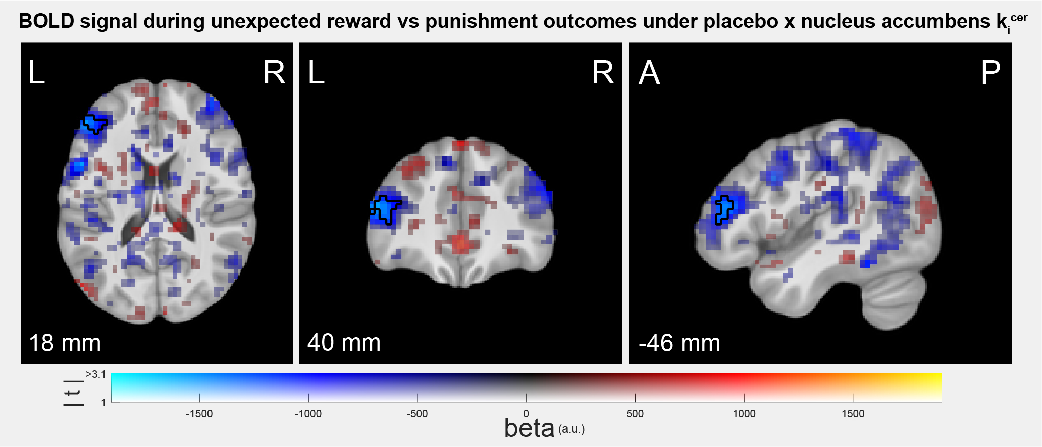
Figure S7. Data from placebo session. BOLD map showing the negative association between dopamine synthesis capacity in the nucleus accumbens and BOLD signal related to unexpected reward versus unexpected punishment outcomes under placebo. Figure conventions are as in Figure 1B.

Main drug effects on outcome-related fMRI BOLD signal
Across drug sessions and trial types there were large-scale BOLD signal increases in striatum, motor cortex and posterior parietal cortex, and large-scale BOLD signal decreases in insula, medial frontal cortex, and medial parietal cortex (Figure S8A).
Methylphenidate increased BOLD signal across outcome types in bilateral parietal cortex, and this effect was greater in participants with lower dopamine synthesis capacity in all three striatal ROIs (Figure S8B-C and Table S3). Sulpiride decreased outcome-related BOLD signal across trial types, independent of dopamine synthesis capacity, in the right posterior putamen, and increased BOLD signal in the right motor cortex (Figure S8D; peak voxel putamen: x,y,z = 29,-7,-8, Z = 4.72, p_{peak FWE SVC} = 0.001; Table S3).
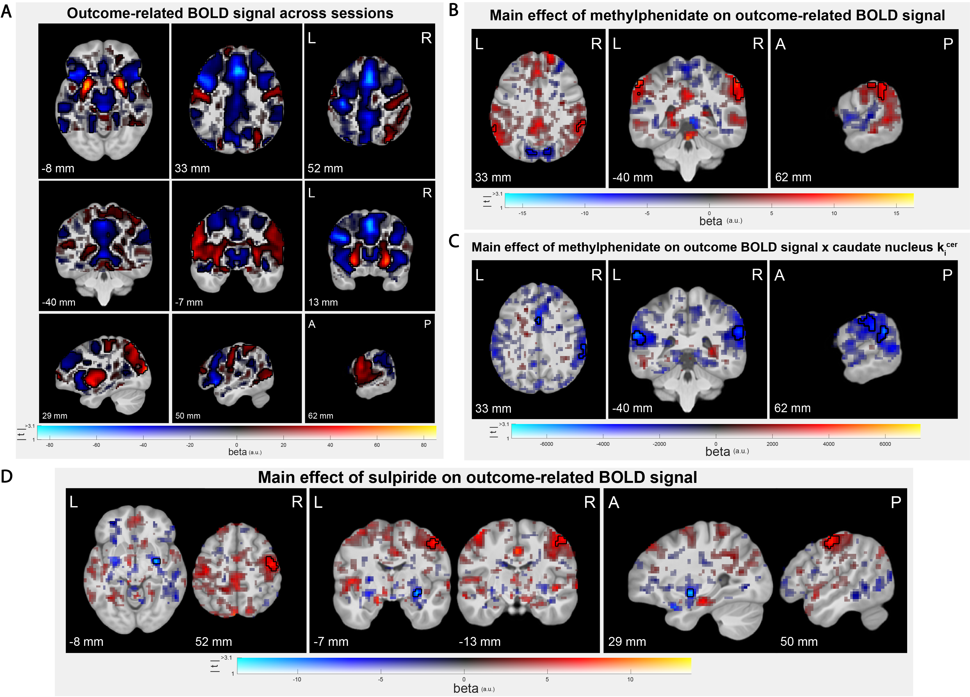
Figure S8. Main effects on fMRI BOLD signal across outcome types. (A) Outcome-related BOLD signal averaged across drug sessions and outcome types, independent of dopamine synthesis capacity. (B) Main effect of methylphenidate on outcome-related BOLD signal independent of dopamine synthesis capacity, and (C) as function of dopamine synthesis capacity in the caudate nucleus. (D) Main effect of sulpiride on outcome-related BOLD signal, independent of dopamine synthesis capacity. Figure conventions are as in Figure 1B.

Table S3. List of all clusters in the fMRI analyses that were significant at p < 0.001 uncorrected and/or p < 0.05 with cluster-level FWE correction at the whole-brain level. MPH: methylphenidate; SUL: sulpiride; PBO: placebo; BA: Brodmann Area; aPFC: anterior prefrontal cortex.
Contrast | Direction of effect | Region | hemisphere | x | y | z | voxel  Z-value | p(z)  uncorrected | cluster size (k) | p(k)  uncorrected | p(k)  FWE correction
MPH main effect | positive | supramarginal gyrus / BA 40 | L | -60 | -43 | 48 | 4 | 0 | 28 | 0.003 | 0.046
MPH main effect | positive | supramarginal gyrus / BA 40 | R | 62 | -40 | 33 | 3.88 | 0 | 54 | 0 | 0.002
MPH main effect | positive | supramarginal gyrus / BA 40 | L | -56 | -63 | 45 | 3.85 | 0 | 46 | 0 | 0.005
MPH main effect | negative | superior occipital lobe / BA 7 | L | -14 | -79 | 27 | 5.14 | 0 | 59 | 0 | 0.001
MPH main effect | negative | superior occipital lobe / BA 7 | R | 13 | -79 | 33 | 4.12 | 0 | 29 | 0.002 | 0.04
MPH main effect | negative | motor cortex M1 / BA 4 | R | 33 | -23 | 62 | 4.06 | 0 | 44 | 0 | 0.006
MPH main effect x putamen k_{i}^{cer} | negative | Insula / BA 13 | L | -43 | 0 | -11 | 4.51 | 0 | 28 | 0.003 | 0.046
MPH main effect x putamen k_{i}^{cer} | negative | dorsal posterior cingulate / BA 31 | L | 0 | -17 | 45 | 4.37 | 0 | 28 | 0.003 | 0.046
MPH main effect x putamen k_{i}^{cer} | negative | supramarginal gyrus / BA 40 | R | 69 | -36 | 30 | 4.05 | 0 | 52 | 0 | 0.002
MPH main effect x caudate k_{i}^{cer} | negative | supramarginal gyrus / BA 40 | L | -60 | -33 | 21 | 4.55 | 0 | 108 | 0 | 0
MPH main effect x caudate k_{i}^{cer} | negative | dorsal posterior cingulate / BA 31 | L | 0 | -17 | 45 | 4.37 | 0 | 34 | 0.001 | 0.02
MPH main effect x caudate k_{i}^{cer} | negative | supramarginal gyrus / BA 40 | R | 59 | -43 | 30 | 4.34 | 0 | 110 | 0 | 0
MPH main effect x caudate k_{i}^{cer} | negative | inferior frontal gyrus | R | 46 | 6 | 19 | 4.18 | 0 | 48 | 0 | 0.004
MPH main effect x accumbens k_{i}^{cer} | negative | somatosensory cortext / BA 1 | R | 66 | -20 | 30 | 3.72 | 0 | 33 | 0.001 | 0.023
MPH main effect x accumbens k_{i}^{cer} | negative | ventral anterior cingulate cortex (ACC) | L | -4 | 0 | 39 | 3.71 | 0 | 36 | 0.001 | 0.016
MPH x expectancy | positive | Putamen | L | -30 | 3 | -5 | 4.34 | 0 | 72 | 0 | 0
MPH x expectancy x valence x putamen k_{i}^{cer} | positive | aPFC / BA 10 | L | -20 | 59 | -2 | 5.25 | 0 | 42 | 0 | 0.006
MPH x expectancy x valence x putamen k_{i}^{cer} | positive | aPFC / BA 10 | R | 39 | 53 | 21 | 4.23 | 0 | 27 | 0 | 0.047
MPH x expectancy x valence x accumbens k_{i}^{cer} | positive | aPFC / BA 10 | L | -43 | 39 | 16 | 3.99 | 0 | 35 | 0.001 | 0.016
SUL main effect | positive | motor cortex M1 / BA 4 | R | 52 | -13 | 54 | 4.38 | 0 | 54 | 0 | 0.003
PBO: main effect of caudate k_{i}^{cer} | positive | supramarginal gyrus / BA 40 | L | -63 | -30 | 21 | 4.86 | 0 | 35 | 0.001 | 0.021
PBO: expectancy x caudate k_{i}^{cer} | positive | somatosensory cortex / BA 5 | L | 0 | -33 | 59 | 4.74 | 0 | 102 | 0 | 0
PBO: expectancy x valence x accumbens k_{i}^{cer} | negative | premotor cortex/BA 6 | L | -20 | -13 | 62 | 4.24 | 0 | 36 | 0.001 | 0.016
PBO: expectancy x valence x accumbens k_{i}^{cer} | negative | aPFC / BA 46 | L | -47 | 39 | 19 | 3.74 | 0 | 33 | 0.001 | 0.024

Striatal dopamine-dependent drug effects on reward versus punishment reversal learning
Breakdown of the significant dopamine-dependent effect of methylphenidate on reward versus punishment reversal accuracy into its constituent simple interaction effects revealed that the effect was primarily driven by baseline dopamine-dependent modulation of punishment learning: methylphenidate boosted punishment reversal accuracy to a greater degree in participants with lower striatal dopamine synthesis capacity (Figure 5B main text; Figure S9A; methylphenidate x expectancy x putamen k_{i}^{cer} for punishment: B = -0.131, CI = [-0.226, -0.037]; methylphenidate x putamen k_{i}^{cer} for punishment reversal trials: B = -0.222, CI = [-0.417, -0.026]; methylphenidate x putamen k_{i}^{cer} for punishment regular trials: B = 0.028, CI = [-0.042, 0.098]; methylphenidate x expectancy x putamen k_{i}^{cer} for reward: B = 0.007, CI = [-0.076, 0.088]). Further breakdown revealed a significant negative effect of putamen k_{i}^{cer} on punishment reversal accuracy under methylphenidate (B = -0.328, CI = [-0.686, -0.014]). There was no evidence for an effect of putamen k_{i}^{cer} on punishment reversal accuracy under placebo (B = 0.093, CI = [-0.187, 0.384]).
The significant dopamine-dependent effect of sulpiride was primarily driven by changes in reward rather than punishment learning (Figure 5D main text; Figure S9B; sulpiride x expectancy x caudate nucleus k_{i}^{cer} for reward: B = 0.086, CI = [0.017, 0.156]; sulpiride x caudate nucleus k_{i}^{cer} for reward reversal trials: B = 0.130, CI = [-0.005, 0.274]; sulpiride x caudate nucleus k_{i}^{cer} for reward regular trials: B = -0.058, CI = [-0.117, 0.000]; sulpiride x expectancy x caudate nucleus k_{i}^{cer} for punishment: B = -0.059, CI = [-0.140, 0.022]). There was no evidence for lower-order interaction effects (effect of caudate nucleus k_{i}^{cer} on reward reversal accuracy under placebo: B = -0.072, CI = [-0.344, 0.187]; and under sulpiride (B = 0.213, CI = [-0.021, 0.448]; effect of caudate nucleus k_{i}^{cer} on punishment reversal accuracy under placebo: B = 0.259, CI = [-0.025, 0.547] and sulpiride: B = -0.037, CI = [-0.296, 0.224]).
In contrast to prior PET work with this task⁴⁵, there was a negative effect of dopamine synthesis capacity under placebo. Reward versus punishment reversal accuracy was lower for participants with higher caudate nucleus dopamine synthesis capacity (Figure S10).
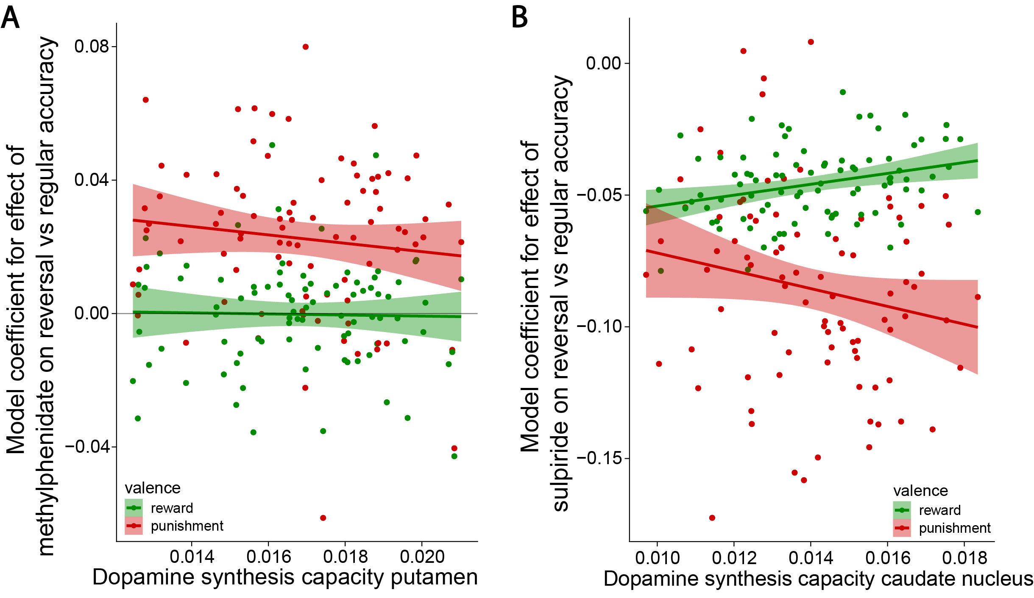
Figure S9. Relationship between dopamine synthesis capacity and drug effects on reward versus punishment reversal learning performance. Supplement to Figure 5 in main text. (A) Methylphenidate increased punishment versus reward reversal accuracy to a greater degree in participants with lower striatal dopamine synthesis capacity. Model coefficients for the effect of methylphenidate on reward and punishment reversal accuracy as function of putamen k_{i}^{cer}. (B) Sulpiride increased reward versus punishment reversal accuracy to a greater degree in participants with higher striatal dopamine synthesis capacity. Model coefficients for the effect of sulpiride on reward and punishment reversal accuracy as function of caudate nucleus k_{i}^{cer}.
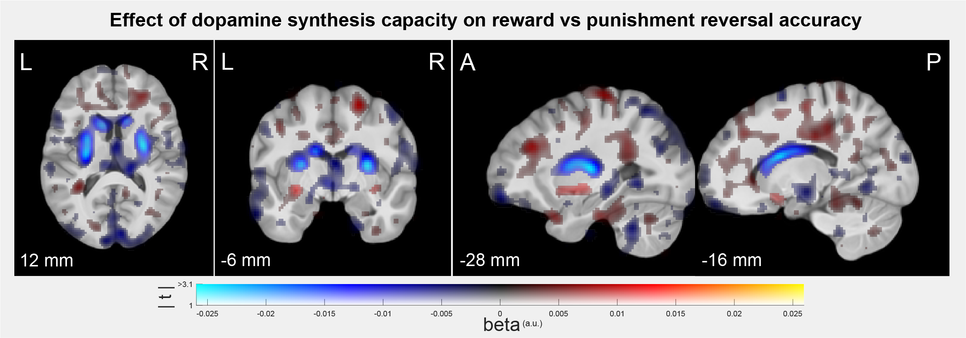
Figure S10. Relationship between striatal dopamine synthesis capacity and the effect of unexpected rewards versus unexpected punishments on accuracy under placebo. Voxel-wise covariation analysis of the PET k_{i}^{cer} data with individual participants' model coefficients for the expectancy x valence interaction effect on accuracy as covariate. Figure conventions are as in Figure 1B.

Striatal dopamine-dependent drug effects on reward versus punishment prediction response times
The pattern of dopamine effects on response times (RTs) generally paralleled those on accuracy. Both methylphenidate and sulpiride decreased RTs for reward versus punishment predictions to a greater degree in participants with higher dopamine synthesis capacity in the nucleus accumbens (Figure S11A-B; methylphenidate x valence x nucleus accumbens k_{i}^{cer} on RTs: B = -0.004, CI = [-0.008, -0.001]; Figure S11C-D; sulpiride x valence x putamen k_{i}^{cer} on RTs: B = -0.005, CI = [-0.009, -0.002]; sulpiride x valence x nucleus accumbens k_{i}^{cer} on RTs: B = -0.006, CI = [-0.010, -0.003]). Thus, the drugs decreased RTs for punishment predictions compared to reward predictions to a greater degree in 'lower-dopamine' participants, similar to the results for accuracy. The simple interaction effects for reward or punishment trials separately were not significant (methylphenidate x nucleus accumbens k_{i}^{cer} for reward trials: B = 0.002, CI = [-0.011, 0.015]; for punishment trials: B = 0.011, CI = [-0.001, 0.022]; sulpiride x putamen k_{i}^{cer} for reward trials: B = -0.003, CI = [-0.012, 0.008]; for punishment trials: B = 0.009, CI = [-0.001, 0.019]; sulpiride x nucleus accumbens k_{i}^{cer} for reward trials: B = -0.008, CI = [-0.017, 0.002]; for punishment trials: B = 0.005, CI = [-0.005, 0.015]).

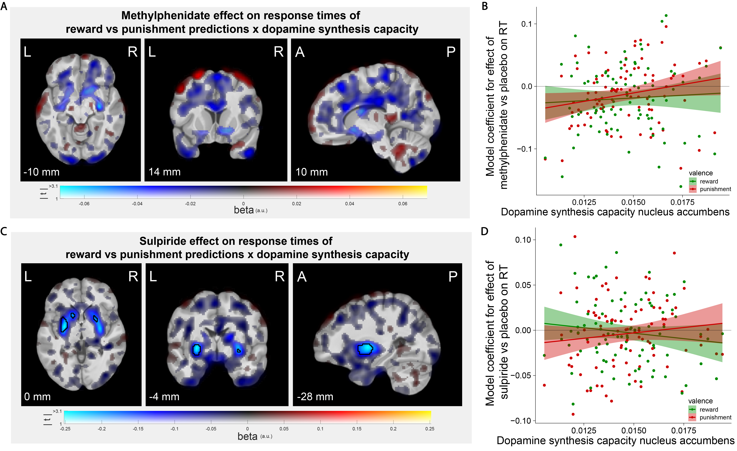
Figure S11. Relationship between striatal dopamine synthesis capacity and drug effects on reward versus punishment prediction response times (RTs; N = 88). (A) Voxel-wise covariation analysis of the PET k_{i}^{cer} data with individual participants' model coefficients for the methylphenidate x valence interaction effect on response times as covariates. (B) Model coefficients for the effect of methylphenidate versus placebo on response times for only reward and only punishment predictions as a function of dopamine synthesis capacity in the nucleus accumbens. (C-D) Same as A-B, but for the effect of sulpiride. Figure conventions of the voxel-wise images are as in Figure 1B.

Trial-level outcome-related BOLD signal does not interact with outcome expectancy or valence to predict performance
The associations between trial-level outcome-related BOLD signal and subsequent accuracy did not differ as a function of outcome expectancy or valence (striatal BOLD signal x expectancy: B = 0.030, CI = [-0.015, 0.077]; striatal BOLD x valence: B = 0.012, CI = [-0.035, 0.060]; striatal BOLD x expectancy x valence: B = 0.005, CI = [-0.044, 0.054]; OFC BOLD signal x expectancy: B = 0.044, CI = [-0.001, 0.089]; OFC BOLD x valence: B = 0.000, CI = [-0.046, 0.046]; OFC BOLD x expectancy x valence: B = -0.005, CI = [-0.050, 0.040]; stimulus-specificity FFA/PPA BOLD signal x expectancy: B = 0.031, CI = [-0.015, 0.076]; stimulus-specificity FFA/PPA x valence: B = -0.001, CI = [-0.053, 0.039]; stimulus-specificity FFA/PPA x expectancy x valence: B = -0.005, CI = [-0.050, 0.041]).
The associations with subsequent RT also did not differ as a function of outcome expectancy or valence (striatal BOLD signal x expectancy: B = -0.001, CI = [-0.004, 0.002]; striatal BOLD x valence: B = -0.001, CI = [-0.004, 0.001]; striatal BOLD x expectancy x valence: B = -0.002, CI = [-0.005, 0.000]; OFC BOLD signal x expectancy: B = -0.002, CI = [-0.005, 0.000]; OFC BOLD x valence: B = -0.001, CI = [-0.004, 0.001]; OFC BOLD x expectancy x valence: B = -0.001, CI = [-0.004, 0.001]; stimulus-specificity FFA/PPA BOLD signal x expectancy: B = 0.000, CI = [-0.002, 0.003]; stimulus-specificity FFA/PPA x valence: B = 0.000, CI = [-0.002, 0.003]; stimulus-specificity FFA/PPA x expectancy x valence: B = 0.002, CI = [-0.001, 0.005]).

Brain-behavior correlations
In addition to the mixed-effects models with trial-level BOLD signal, we assessed the association between individual contrast estimates from the clusters with significant group-level dopamine-dependent drug effects and model coefficients of performance.
These exploratory between-participants brain-behavior correlations revealed that larger sulpiride-induced increases in reversal signal in the right caudate nucleus were associated with greater punishment versus reward reversal accuracy (i.e. a negative correlation with reward versus punishment reversal accuracy: r = -0.272, p = 0.014; Figure S12). A similar association for methylphenidate was not significant (r = -0.146, p = 0.188). There were no further significant associations with model coefficients of accuracy (Table S4).
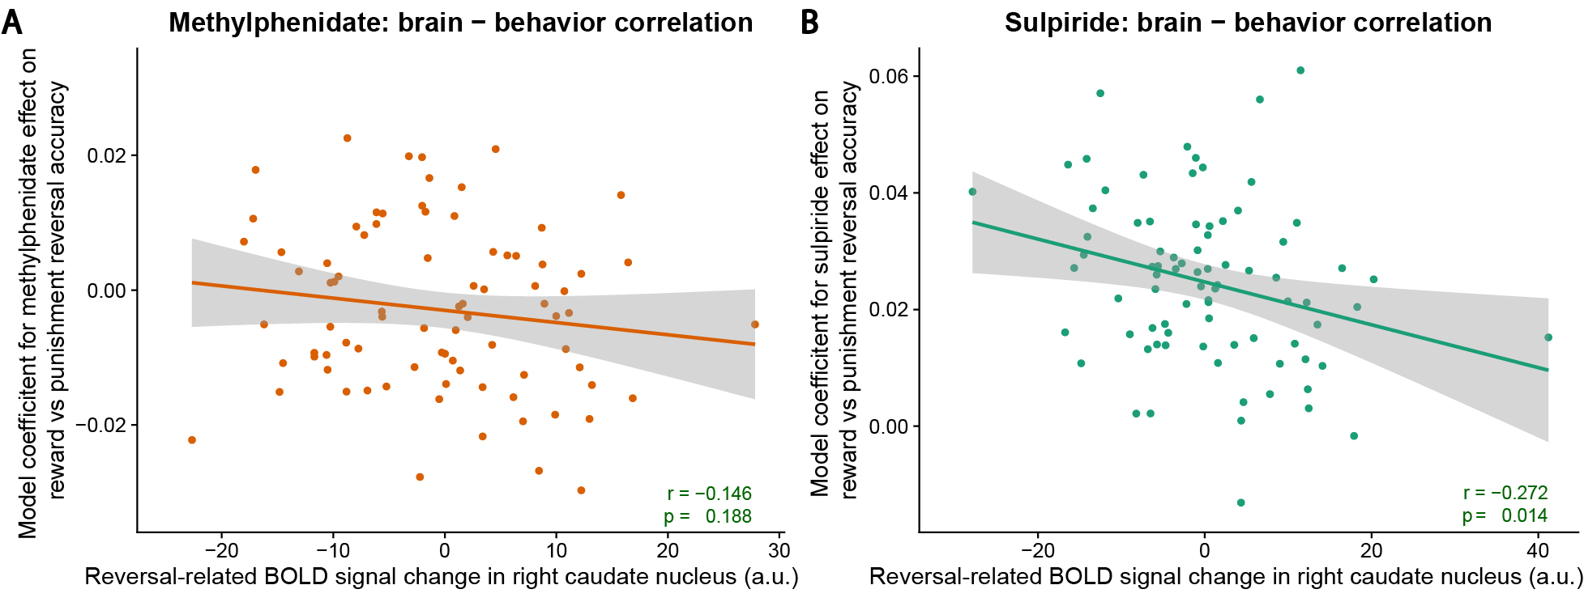
Figure S12. Between-participants brain-behavior correlations. Correlation between the effect of (A) methylphenidate and (B) sulpiride on reversal-related BOLD signal in the right caudate nucleus and the model coefficient for the effect of methylphenidate/sulpiride on reward versus punishment reversal accuracy.

Table S4. Correlations between individual contrast estimates from the statistically significant clusters in group-level contrasts and model coefficients for three behavioral effects on accuracy and response time: main drug effect, drug x reversal (reversal versus regular trials) interaction, drug x reversal x valence (reward versus punishment) interaction. r: Pearson correlation coefficient. p: uncorrected p-value of the correlation coefficient.
fMRI contrast | Model coefficient for accuracy |  |  |  |  |  |  |  | Model coefficient for response time
fMRI contrast | main drug effect |  | drug x reversal |  |  | drug x reversal x valence |  |  | main drug effect |  |  | drug x reversal |  |  | drug x reversal x valence
fMRI contrast | r | p | r | p | r |  | p | r |  | p | r |  | p | r |  | p
Methylphenidate x expectancy x caudate nucleus k_{i}^{cer} in right caudate nucleus | 0.073 | 0.510 | 0.180 | 0.103 | -0.146 |  | 0.188 | -0.061 |  | 0.586 | -0.029 |  | 0.792 | -0.109 |  | 0.329
sulpiride x expectancy x caudate nucleus k_{i}^{cer} in right caudate nucleus | 0.207 | 0.063 | 0.128 | 0.255 | -0.272 |  | 0.014 | -0.140 |  | 0.213 | -0.109 |  | 0.333 | 0.087 |  | 0.440
methylphenidate x expectancy x valence x putamen k_{i}^{cer} in OFC | -0.154 | 0.165 | 0.055 | 0.622 | 0.042 |  | 0.708 | 0.059 |  | 0.599 | 0.002 |  | 0.988 | -0.069 |  | 0.535
methylphenidate x expectancy x caudate nucleus k_{i}^{cer} on stimulus-specificity in FFA/PPA | 0.018 | 0.876 | 0.021 | 0.854 | 0.003 |  | 0.978 | 0.234 |  | 0.039 | 0.250 |  | 0.028 | -0.013 |  | 0.913
sulpiride x expectancy x caudate nucleus k_{i}^{cer} on stimulus-specificity in FFA/PPA | 0.103 | 0.375 | -0.028 | 0.813 | -0.198 |  | 0.087 | 0.077 |  | 0.507 | 0.093 |  | 0.425 | -0.040 |  | 0.730

Analysis of win-stay/lose-shift behavior
The outcome contingencies in this task are counter-intuitive. In most real-life situations, rewards signal correct behavior and punishments signal the need for adjustment of behavior. This results in a tendency to adopt a win-stay/lose-shift response strategy, i.e. to repeat responses after rewards and to switch response after punishments. In the current task such a win-stay/lose-shift strategy is inappropriate, because rewards and punishments are not contingent on the response that participants made preceding the outcome receipt, but rather on which stimulus was highlighted.
We considered the possibility that participants might nevertheless have adopted a task-inappropriate win-stay/lose-shift strategy, and we asked whether the effect of methylphenidate might reflect modulation of such a strategy. Given the fact that in our design both reward and punishment reversal trials always required response shifting, it is possible that the striatal dopamine-dependent boosting of punishment reversal accuracy by methylphenidate reflects a potentiation of a win-stay/lose-shift tendency. To investigate whether adoption of that strategy explains our results, we modeled the probability of staying with the same response to the face/scene stimulus as the previous time that stimulus was highlighted.
We found that methylphenidate boosted the probability of staying with the same response after reward versus punishment outcomes to a greater degree in participants with lower dopamine synthesis capacity in the putamen (methylphenidate x valence x putamen k_{i}^{cer}: B = -0.060, CI = [-0.118, -0.003]). This effect of methylphenidate was driven by striatal dopamine-dependent increase in switch behavior after punishments (methylphenidate x putamen k_{i}^{cer} for punishment trials: B = 0.112, CI = [0.026, 0.201]; methylphenidate x putamen k_{i}^{cer} for reward trials: B = -0.001, CI = [-0.080, 0.076]). Methylphenidate increased lose-shift behavior in participants with lower compared with higher dopamine synthesis capacity. However, the effect was not significant when only considering regular non-reversal trials (Figure S13A; B = -0.008, CI = [-0.031, 0.014]). Thus, there is no evidence that methylphenidate affected non-reversal win-stay/lose-shift behavior.
The effect of sulpiride on the probability of staying with the same response after reward versus punishment outcomes was significantly qualified by the reversal trials. The drug increased the relative win-stay/lose-shift behavior on reversal trials in participants with lower dopamine synthesis capacity in the caudate nucleus and putamen (sulpiride x expectancy x valence x caudate nucleus k_{i}^{cer}: B = -0.061, CI = [-0.113, -0.010]; with putamen k_{i}^{cer}: B = -0.054, CI = [-0.106, -0.004]). Thereby it captures the same effect as the models for reward versus punishment reversal accuracy, since the highlighted stimulus on reversal trials was always the same as on the preceding trial. The effect was not significant when only considering regular non-reversal trials (Figure S13B; sulpiride x valence x caudate nucleus k_{i}^{cer} with only non-reversal trials: B = -0.005, CI = [-0.028, 0.017]; with putamen k_{i}^{cer}: B = 0.012, CI = [-0.011, 0.034]). Thus, there is also no evidence that sulpiride affected non-reversal win-stay/lose-shift behavior.
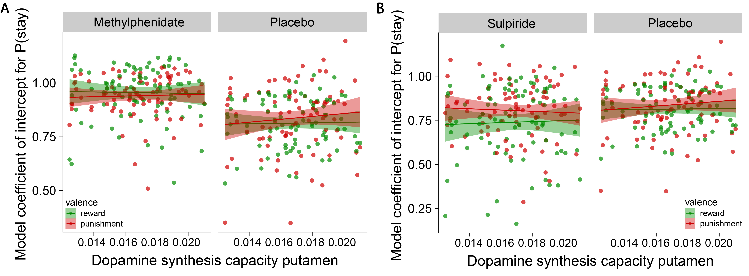
Figure S13. No drug effects on win-stay/lose-shift behavior on non-reversal trials. Correlation between dopamine synthesis capacity in the putamen and the model coefficients for the intercept of reduced models of the probability to stay with the same response that only included non-reversal reward or punishment trials, displayed separately for the methylphenidate (A) or sulpiride (B) and placebo sessions.

Discussion
The current task design ensured that requirements for response shifting were matched between the two types of reversal trials. Participants needed to shift responses to the other button to indicate that their predictions had been updated after both unexpected rewards and punishments. This ensured that any valence-specific reversal comparison was not confounded by differences in processing related to motor preparation or response perseveration. However, an important implication of this design is that a shift towards better punishment versus reward-based reversal might reflect one of two processes. First, it might reflect better punishment surprise coding. Second, it might reflect a greater tendency to adopt a canonical win-stay/lose-shift strategy: in most (instrumental) contexts, where outcomes are contingent on actions, punishments signal the need to shift behavior. Notably, this was not the case in the current stimulus-outcome prediction task. In fact, a win-stay/lose-shift strategy was inappropriate selectively after unexpected rewards.
One possibility is that the pattern of drug effects reflects an effect of striatal dopamine on the reliance on a canonical win-stay/lose-shift strategy. However, we found no evidence for the adoption of such a strategy on the regular non-reversal trials, and no modulation by drugs or synthesis capacity, suggesting that this is unlikely to be the case.
It might be noted that a previous study with the same paradigm had revealed a positive rather than a negative link between striatal BOLD signal and dopamine-related boosting of reward versus punishment learning⁴⁸. We remain puzzled about this, but emphasize that the locus of the drug effect in that previous study was much more ventral than the dorsomedial striatal effect observed here. This raises the possibility that participants adopted different behavioral strategies across the two experiments, relying more readily on a NoGo/switch strategy in the current experiment, but a Go-for-reward strategy in the previous experiment. This hypothesis can be tested in a future study in which Go/NoGo response demands and outcome valence are crossed by design. It is substantiated by the finding that all participants in the current study shifted responses after unexpected punishment much more readily than after unexpected reward compared with the previous study⁴⁸ (Figure S1A).
In addition to the baseline dopamine-dependent drug effects on reward versus punishment learning, we observed a strong main effect of methylphenidate, increasing overall task performance irrespective of trial types, and a smaller main effect of sulpiride, decreasing overall performance (Figure 1). These non-specific performance enhancing effects of methylphenidate were accompanied by task-independent increases in BOLD signal in bilateral dorsal parietal clusters, especially for lower-dopamine participants (Figure S8B-C; Table S3), and might reflect nonspecific increases in general sustained attention and/or cognitive effort^{9,46}, often associated with activation of the dorsal attention network^{17,114}. Conversely, the non-specific performance impairing effects of sulpiride were accompanied by task-nonspecific decreases in putamen signal and increases in motor cortex signal (Figure S8D), possibly in line with an overall presynaptic disinhibition of dopamine release, leading to decreased striatal indirect pathway activity and disinhibition of motor responding, and resulting in a numerical, albeit not significant, overall decrease in response times.

Methods

PET acquisition and preprocessing
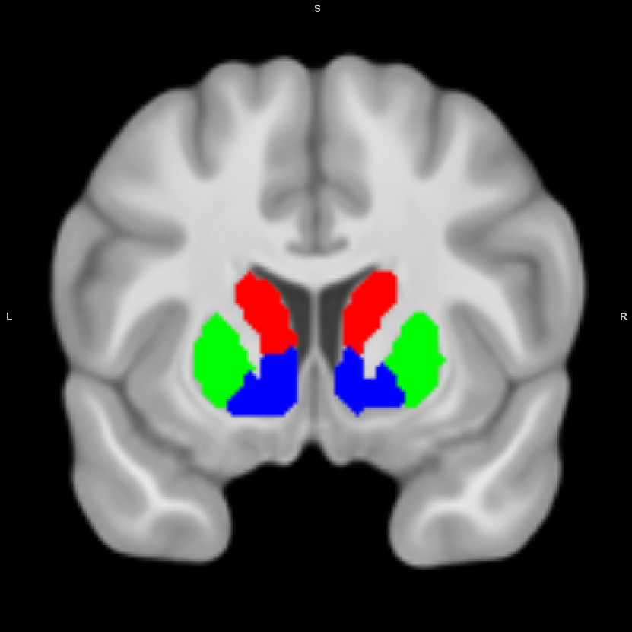
Figure S14. Analysis masks of the striatal regions of interest: caudate nucleus (red), putamen (green), and nucleus accumbens (ventral striatum; blue). The masks are based on an independent, functional connectivity-based parcellation of the striatum (ref 106).

fMRI preprocessing details
All MRI data were preprocessed using fMRIPrep (1.2.6-1; RRID:SCR_016216;^{101,102}), which is based on Nipype (1.1.7; RRID:SCR_002502;^{115,116}). Many internal operations of fMRIPrep use Nilearn (0.5.0; RRID:SCR_001362l;¹¹⁷), mostly within the functional processing workflow. For more details of the pipeline, see the section corresponding to workflows in fMRIPrep's documentation.
Anatomical data preprocessing. The T1-weighted (T1w) image was corrected for intensity non-uniformity (INU) using N4BiasFieldCorrection (ANTs 2.2.0)¹¹⁸, and used as T1w-reference throughout the workflow. The T1w-reference was then skull-stripped using antsBrainExtraction.sh with OASIS as target template. Brain surfaces were reconstructed using recon-all (FreeSurfer 6.0.1, RRID:SCR_001847;¹¹⁹), and the brain mask estimated previously was refined with a custom variation of the method to reconcile ANTs-derived and FreeSurfer-derived segmentations of the cortical gray-matter of Mindboggle (RRID:SCR_002438;¹²⁰). Spatial normalization to the ICBM 152 Nonlinear Asymmetrical template version 2009c (RRID:SCR_008796;¹²¹) was performed through nonlinear registration with antsRegistration (RRID:SCR_004757;¹²²), using brain-extracted versions of both T1w volume and template. Brain tissue segmentation of cerebrospinal fluid (CSF), white-matter (WM) and gray-matter (GM) was performed on the brain-extracted T1w using fast (FSL 5.0.9, RRID:SCR_002823;¹²³).
Functional data preprocessing. Before preprocessing the functional runs with fMRIPrep, we combined the multi-echo data into single time-series per run with the multi-echo toolbox (https://github.com/Donders-Institute/multiecho; commit Nr.: 9356bc51ef) using the TE algorithm, in which the different echoes are weighted by their echo time. The multi-echo combined runs were then preprocessed further with fMRIPrep.
For each of the BOLD runs found per subject, the following preprocessing was performed. First, a reference volume and its skull-stripped version were generated using a custom methodology of fMRIPrep. The BOLD reference was then co-registered to the T1w reference using bbregister (FreeSurfer) which implements boundary-based registration¹²⁴. Co-registration was configured with nine degrees of freedom to account for distortions remaining in the BOLD reference. Head-motion parameters with respect to the BOLD reference (transformation matrices, and six corresponding rotation and translation parameters) were estimated before any spatiotemporal filtering using mcflirt (FSL 5.0.9,¹²⁵). BOLD runs were slice-time corrected using 3dTshift from AFNI 20160207 (RRID:SCR_005927;¹²⁶). The BOLD time-series (including slice-timing correction) were resampled onto their original, native space by applying a single, composite transform to correct for head-motion and susceptibility distortions. First, a reference volume and its skull-stripped version were generated using a custom methodology of fMRIPrep. The BOLD time-series were resampled to MNI152NLin2009cAsym standard space. Automatic removal of motion artifacts using independent component analysis (ICA-AROMA¹²⁷) was performed on the preprocessed BOLD time-series in MNI space after removal of non-steady state volumes and spatial smoothing with an isotropic, Gaussian kernel of 6 mm FWHM (full-width at half-maximum). The motion artifacts were collected as noise-regressors. Several confounding time-series were calculated based on the preprocessed BOLD: framewise displacement (FD), DVARS and three region-wise global signals. FD and DVARS were calculated for each functional run, both using their implementations in Nipype (following the definitions by¹²⁸). The three global signals were extracted within the CSF, the WM, and the whole-brain masks. Additionally, a set of physiological regressors were extracted to allow for component-based noise correction (CompCor¹²⁹). Principal components were estimated after high-pass filtering the preprocessed BOLD time-series (using a discrete cosine filter with 128s cut-off) for the two CompCor variants: temporal (tCompCor) and anatomical (aCompCor). Six tCompCor components were then calculated from the top 5% variable voxels within a mask covering the subcortical regions. This subcortical mask was obtained by heavily eroding the brain mask, which ensured it did not include cortical GM regions. For aCompCor, six components were calculated within the intersection of the aforementioned mask and the union of CSF and WM masks calculated in T1w space, after their projection to the native space of each functional run (using the inverse BOLD-to-T1w transformation). All resamplings could be performed with a single interpolation step by composing all the pertinent transformations (i.e. head-motion transform matrices, susceptibility distortion correction when available, and co-registrations to anatomical and template spaces). Gridded (volumetric) resamplings were performed using antsApplyTransforms (ANTs), configured with Lanczos interpolation to minimize the smoothing effects of other kernels¹³⁰. Non-gridded (surface) resamplings were performed using mri_vol2surf (FreeSurfer).

fMRI quality assurance procedure
We assessed the quality of the individual fMRI datasets before including them in the group analyses, using first-level contrasts of non-interest and quality reports created using custom Matlab code (https://github.com/bramzandbelt/fmri_preprocessing_and_qa_code) with SPM8 in Matlab R2015a. We first judged each drug session's unthresholded contrast map of activity related to button presses. If the activation was deemed sufficient the session was included in the group analyses. If it was not, we checked the contrast map for unexpected versus expected outcomes. If there was not sufficient activation in that contrast either we searched for low tSNR values (<80) or artifacts in the quality reports that might explain the lack of activation. When those were present the session was excluded from the analyses, but the session was included if there was no obvious explanation for the lack of activation in the reports.

References
112. Cools, R., Clark, L., Owen, A. M. & Robbins, T. W. Defining the Neural Mechanisms of Probabilistic Reversal Learning Using Event-Related Functional Magnetic Resonance Imaging. Journal of Neuroscience 22, 4563–4567 (2002).
113. Robinson, O. J., Frank, M. J., Sahakian, B. J. & Cools, R. Dissociable responses to punishment in distinct striatal regions during reversal learning. NeuroImage 51, 1459–1467 (2010).
114. Tomasi, D. et al. Methylphenidate enhances brain activation and deactivation responses to visual attention and working memory tasks in healthy controls. NeuroImage 54, 3101–3110 (2011).
115. Esteban, O. et al. Nipy/nipype: 1.5.0. (2020) doi:10.5281/zenodo.3874968.
116. Gorgolewski, K. et al. Nipype: A Flexible, Lightweight and Extensible Neuroimaging Data Processing Framework in Python. Frontiers in Neuroinformatics 5, (2011).
117. Abraham, A. et al. Machine learning for neuroimaging with scikit-learn. Frontiers in Neuroinformatics 8, (2014).
118. Tustison, N. J. et al. N4ITK: Improved N3 Bias Correction. IEEE Transactions on Medical Imaging 29, 1310–1320 (2010).
119. Dale, A. M., Fischl, B. & Sereno, M. I. Cortical Surface-Based Analysis: I. Segmentation and Surface Reconstruction. NeuroImage 9, 179–194 (1999).
120. Klein, A. et al. Mindboggling morphometry of human brains. PLOS Computational Biology 13, e1005350 (2017).
121. Fonov, V., Evans, A., McKinstry, R., Almli, C. & Collins, D. Unbiased nonlinear average age-appropriate brain templates from birth to adulthood. NeuroImage 47, S102 (2009).
122. Avants, B. B., Epstein, C. L., Grossman, M. & Gee, J. C. Symmetric diffeomorphic image registration with cross-correlation: Evaluating automated labeling of elderly and neurodegenerative brain. Medical Image Analysis 12, 26–41 (2008).
123. Zhang, Y., Brady, M. & Smith, S. Segmentation of brain MR images through a hidden Markov random field model and the expectation-maximization algorithm. IEEE Transactions on Medical Imaging 20, 45–57 (2001).
124. Greve, D. N. & Fischl, B. Accurate and robust brain image alignment using boundary-based registration. NeuroImage 48, 63–72 (2009).
125. Jenkinson, M., Bannister, P., Brady, M. & Smith, S. Improved Optimization for the Robust and Accurate Linear Registration and Motion Correction of Brain Images. NeuroImage 17, 825–841 (2002).
126. Cox, R. W. & Hyde, J. S. Software tools for analysis and visualization of fMRI data. NMR in Biomedicine 10, 171–178 (1997).
127. Pruim, R. H. R. et al. ICA-AROMA: A robust ICA-based strategy for removing motion artifacts from fMRI data. NeuroImage 112, 267–277 (2015).
128. Power, J. D. et al. Methods to detect, characterize, and remove motion artifact in resting state fMRI. NeuroImage 84, 320–341 (2014).
129. Behzadi, Y., Restom, K., Liau, J. & Liu, T. T. A component based noise correction method (CompCor) for BOLD and perfusion based fMRI. NeuroImage 37, 90–101 (2007).
130. Lanczos, C. Evaluation of Noisy Data. Journal of the Society for Industrial and Applied Mathematics: Series B, Numerical Analysis 1, 76–85 (1964).

