Supporting information for
Van der Waals/MCT Heterostructure Enabled High-Performance Uncooled Mid-Infrared Photodetectors via Synergistic Suppression of Dark Current and Interfacial Recombination
Xinlei Zhang^{#1}, Tao Zhou^{#1}, Yueying Cui¹, Ruizhi Li¹, Yuwei Zhang¹, Rui Lin¹, Fang Yang², Kaiyang Liu¹, Jianfeng Wu³, Dongyang Wan*¹, Jialin Zhang*¹, Junpeng Lu^{1,4}, Zhenhua Ni*^{1,4}
¹ Key Laboratory of Quantum Materials and Devices of Ministry of Education, School of Physics, Southeast University, Nanjing 211189, China
² Key Laboratory of State Manipulation and Advanced Materials in Provincial Universities, School of Physics and Technology, Nanjing Normal University, Nanjing 210023, China
³ School of Integrated Circuits, Southeast University, Nanjing 210096, China
⁴ School of Electronic Science and Engineering, Southeast University, Nanjing 210096, China
Authors to whom correspondence should be addressed: wandy@seu.edu.cn, phyzjl@seu.edu.cn, zhni@seu.edu.cn
# Xinlei Zhang and Tao Zhou contributed equally to this work

Supplementary Note 1. Band structure and trap states calculations of HgCdTe
Calculation of component and band structure of HgCdTe
Component 𝑥 of Hg_{1-x}Cd_{x}Te is estimated via the formula proposed by Chu as follows:¹
$E_{g}=-0.295+1.87x-0.28x^{2}+\left(6-14x+3x^{2}\right){10}^{-4}T+0.35x^{4}(eV)$ (1)
where $E_{g}$ is the energy bandgap of Hg_{1-x}Cd_{x}Te, x is the component of cadmium, and T is the temperature. Since the cutoff wavelength ($λ_{c}$) is estimated as ~3.6 μm from Fig. S1a, the$E_{g}=0.35 eV$is extracted via equation $E_{g}=\frac{hc}{λ_{c}}$ at room temperature (300 K), Here, $λ_{c}$ is defined as the wavelength where absorption decreases to 50% of the maximum value. Thus, the component 𝑥 is calculated as around 0.33 according to equation (1).
The conduction band minimum (CBM) of Hg_{1-X}Cd_{X}Te can be extracted from the CBM upward offset ($∆E_{v}$) equation $∆E_{c}=1.21(1-x)$ from CdTe semiconductors.² Since the CBM of CdTe at room temperature is reported as 3.8 eV,³ the CBM of HgCdTe in this work can be calculated as 4.610 eV. Hence, the valance band maximum (VBM) could be estimated via formula $E_{v}=E_{c}+E_{g}$ as 4.960 eV.

The Fermi level according to the following formulas:
$N_{p}=N_{v}exp⁡\left(-\frac{E_{F}-E_{v}}{k_{B}T}\right)$ (2)
$N_{v}=2{\left(-\frac{m_{h}^{*}k_{B}T}{2πh^{2}}\right)}^{3/2}$ (3)
where $N_{P}$ is the free hole volume concentration, $N_{v}$ is the valance band equivalent density of states, $E_{F}-E_{v}$ is the distance from Fermi level to CBM, respectively, $k_{B}$ is the Boltzmann constant, $T$ is the temperature, $m_{h}^{*}$ is the hole effective mass. For the commonly used component of Hg_{1-x}Cd_{x}Te (0.2-0.5), the effective mass of MCT is 0.55$m_{0}$. The doping concentration of MCT ($N_{P}$) is $\sim {10}^{18}$ cm⁻³ at room temperature from Fig. S1b. We substituted $N_{P}$ into formula (3) to figure out ($E_{V}-E_{F}$) to be 10 meV for MCT.
Calculation of shallow and deep trap states within Hg_{1-x}Cd_{x}Te
As a ternary alloy compound, HgCdTe (MCT) has a zinc blende lattice structure. The neutral mercury vacancy (V_{Hg}) has six electrons from its Te neighbors, so it tends to accept one or two more electrons, producing the singly or doubly negatively charged vacancy levels with higher energy than for the neutral state. The neutral V_{Hg} state as a shallow acceptor whose location has been well defined.⁴ The ionization energy for the material composition (x value) from 0.18 to 0.3 can be calculated from the relation:⁵
$E_{1}\left(x\right)=91.1x-6.93 (meV)$ (4)
where x is the component of cadmium. This means that the acceptor level is located near the top of the valence band maximum. For x ~ 0.3, the second level can be treated as a deep defect state located in the mid of the energy gap. The ionization energy of the second defect state which probably originating from the singly negatively charged V_{Hg}:⁵
$E_{2}\left(x\right)=144x+56 (meV)$ (5)
The Shockley-Read-Hall (SRH) recombination, occurring through deep defect levels within the bandgap, is responsible for minority carrier lifetimes in lightly-doped MCT. At high doping concentrations, these deep centers can facilitate SRH current and trap-assisted tunneling of carriers across the junction, which will elevate the dark current and hinder the development of high-operating-temperature (HOT) MCT devices.⁶
According to the shallow and deep trap states calculation formula, the shallow and deep trap states for Hg_{1-x}Cd_{x}Te (x~0.33) are located at 24 meV and 104 meV above the valence band, respectively.

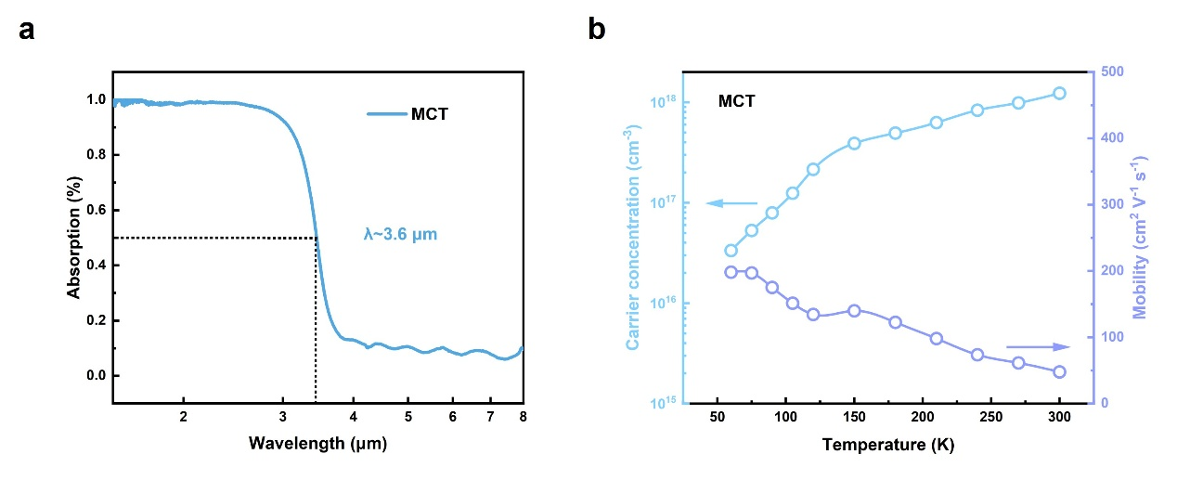
Fig. S1 Optical and electrical characterization of HgCdTe film. a Infrared absorption spectra of HgCdTe film. The cutoff wavelengths $λ_{c}$ of HgCdTe is ~3.6 μm. b Hall measurement results of HgCdTe film. With the decrease of temperature, the carrier mobility of HgCdTe increases, the carrier concentration decreases and conduction type remains p-type.

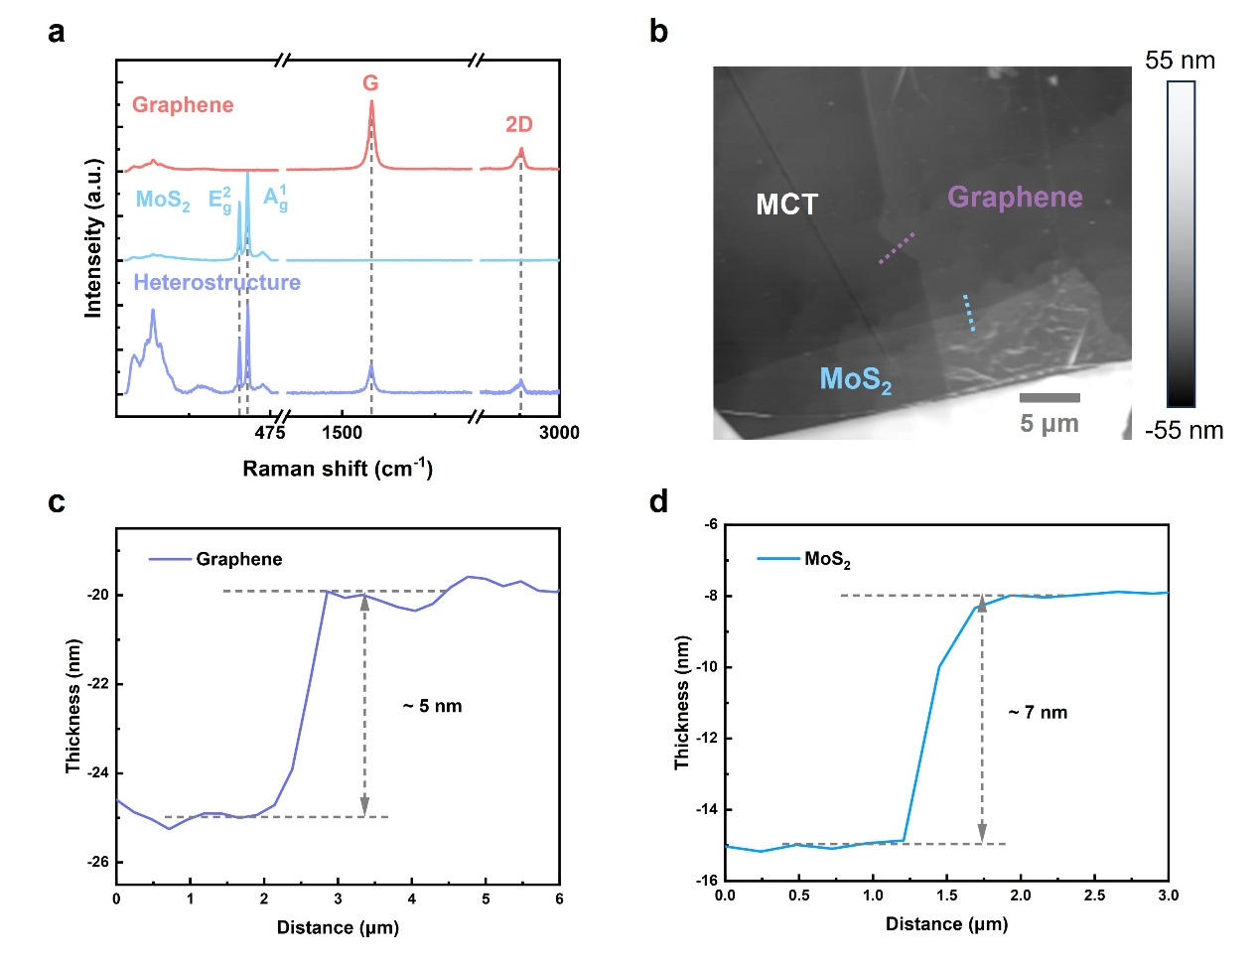
Fig. S2 Raman spectrum and thickness characterization of the tri-layered MoS₂/graphene/MCT vdW heterostructure. a Raman spectrum of the graphene, MoS₂, and overlap of the heterostructure. b AFM mapping image of the heterostructure. The scale bar is 5 μm. The thickness of graphene c and MoS₂ d are extracted from the (b) which are 5 nm and 7 nm respectively.

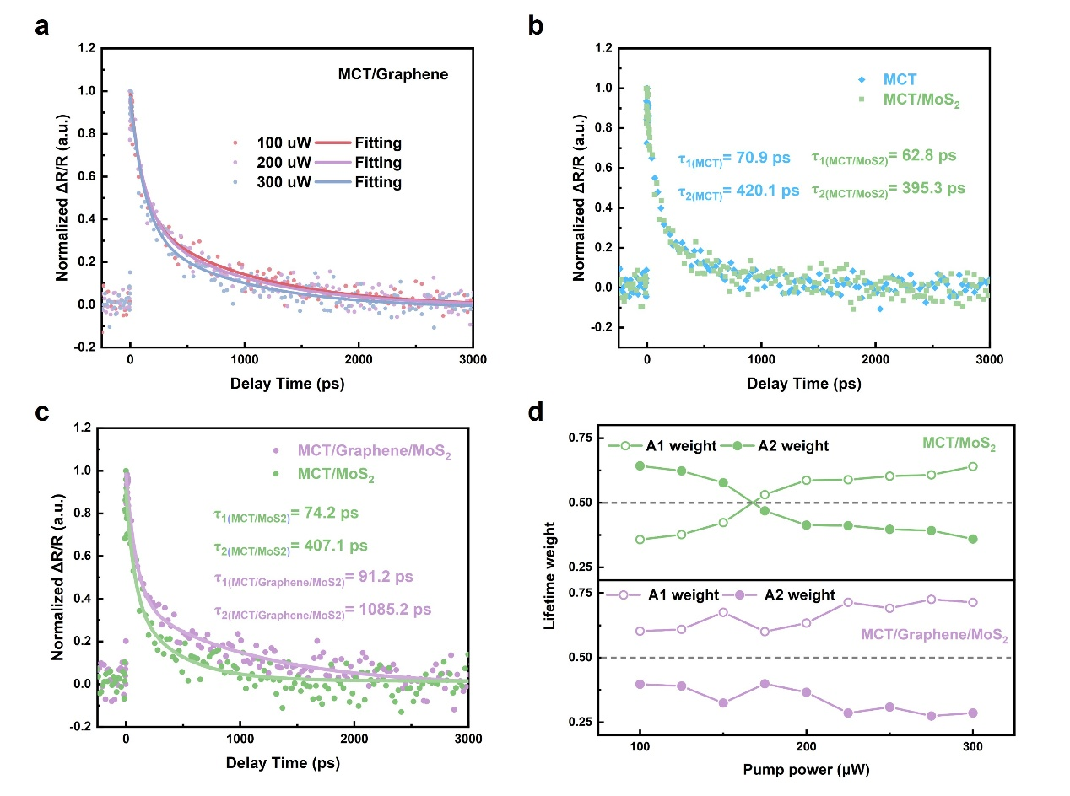
Fig. S3 Pump-probe characterization of graphene/MCT heterostructure, MoS₂/MCT heterostructure, and MoS₂/graphene/MCT vdW structure. a Power-dependent transient reflection spectra and fitting curve of MCT/graphene heterostructure. b Carrier dynamics comparison of the MoS₂/MCT heterostructure and pristine MCT. c Carrier dynamics comparison of the MoS₂/MCT heterostructure and MoS₂/graphene/MCT vdW structure. d Power-dependent lifetime weight comparison of MoS₂/MCT heterostructure and MoS₂/graphene/MCT vdW structure.
The similar decay profiles and power-dependent lifetime weight observed in MoS₂/MCT heterostructure and pristine MCT (Fig. S3b) indicated MoS₂ hardly affect the carrier recombination process within MCT. This can be ascribed to the small work difference between the MCT and MoS₂ and low carrier concertation of MoS₂. The passivation effect of graphene is also reflected in the MoS₂/MCT vdW heterostructure as observed extended lifetime and different power-dependent lifetime weight (Fig.S3c-d).

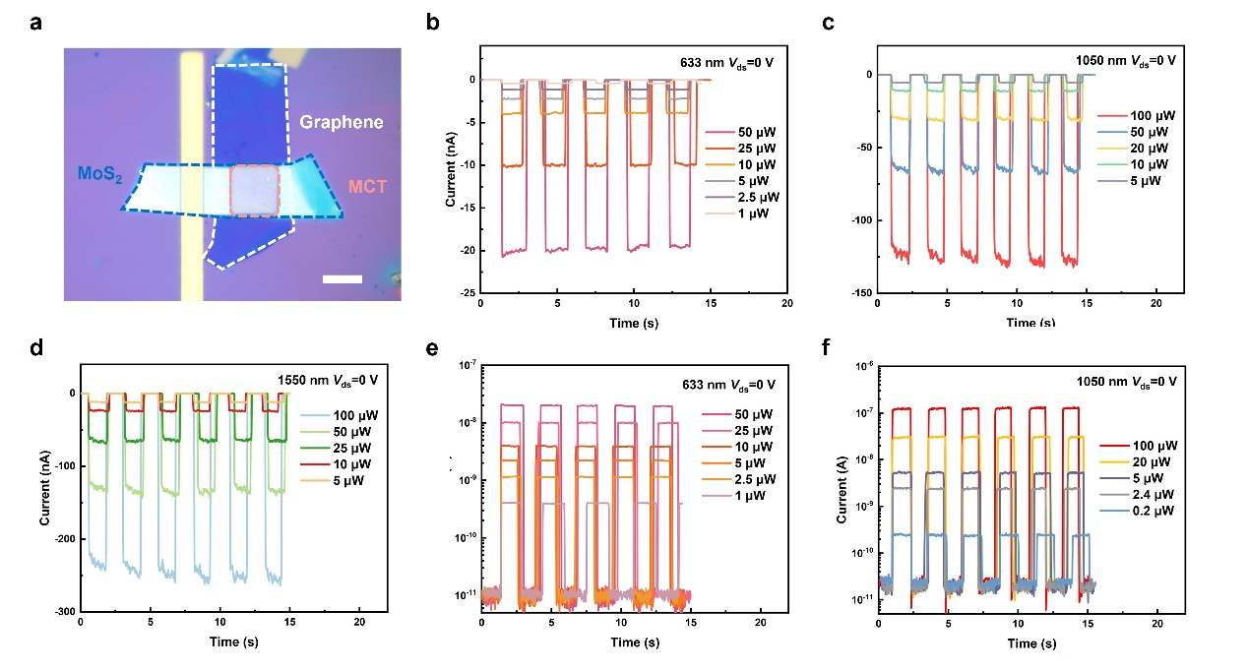
Fig. S4 Photoresponse of the MoS₂/graphene/MCT vdW photodetector under visible and near-infrared laser illumination. The scale bar is 30 μm. a Optical image of the MoS₂/graphene/MCT vdW photodetector. b-d Time-resolved photoresponse of the MoS₂/graphene/MCT vdW photodetector under various power laser illumination with the wavelengths of 633 nm, 1050 nm, 1550 nm in linear scale and e-f in logarithmic scale.

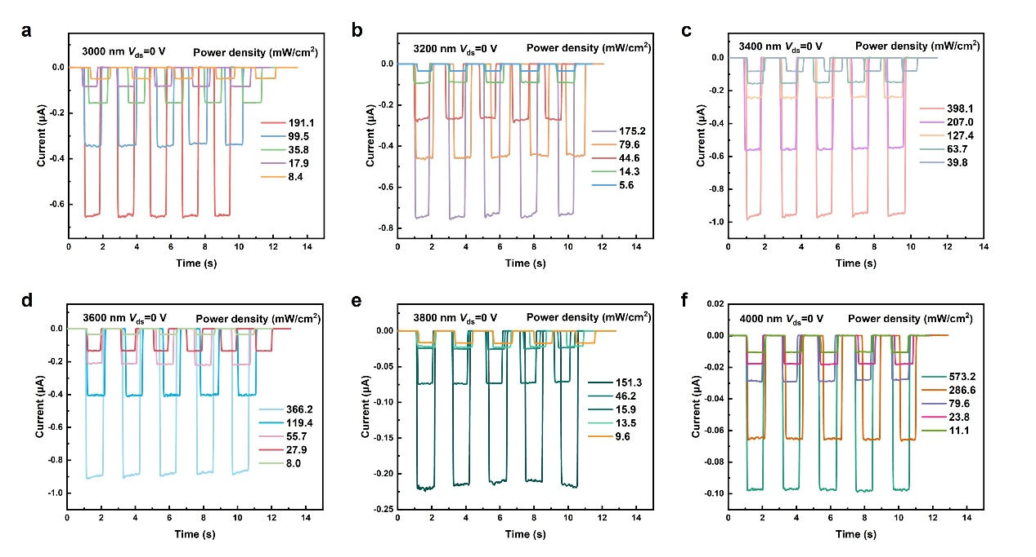
Fig. S5 Photoresponse of the MoS₂/graphene/MCT vdW photodetector under MWIR laser illumination. a-f Time-resolved photoresponse of the MoS₂/graphene/MCT vdW photodetector under various power laser illumination with the wavelengths of 3000 nm, 3200 nm, 3400 nm, 3600 nm, 3800 nm, and 4000 nm.

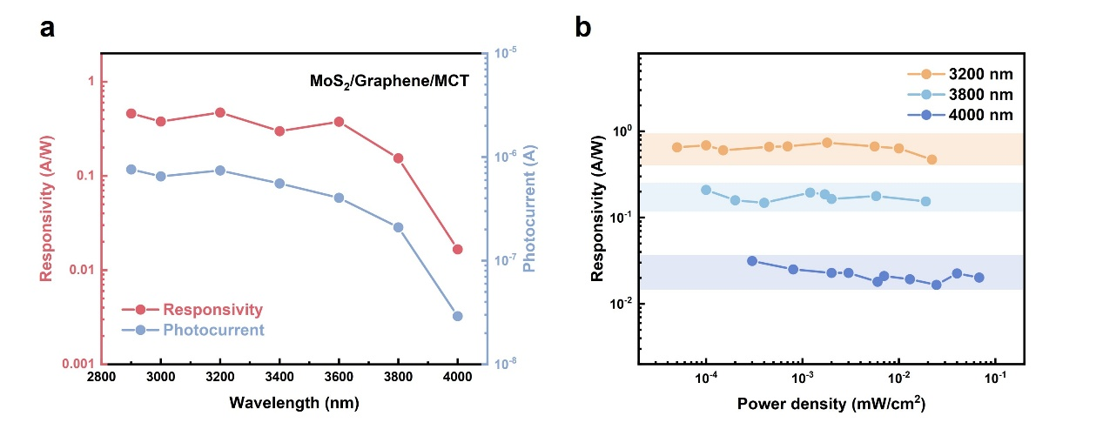
Fig. S6 Photoresponsivity of the MoS₂/graphene/MCT vdW vdW photodetectors under the MWIR laser irradiation at V_{ds}= 0 V. a Wavelength-dependent responsivity and photocurrent of the MoS₂/graphene/MCT vdW photodetector under ~20 mW cm⁻² MWIR illumination. b Power-dependent photoresponsivity of the MoS₂/graphene/MCT vdW photodetector under 3200 nm, 3800nm, and 4000 nm laser irradiation.

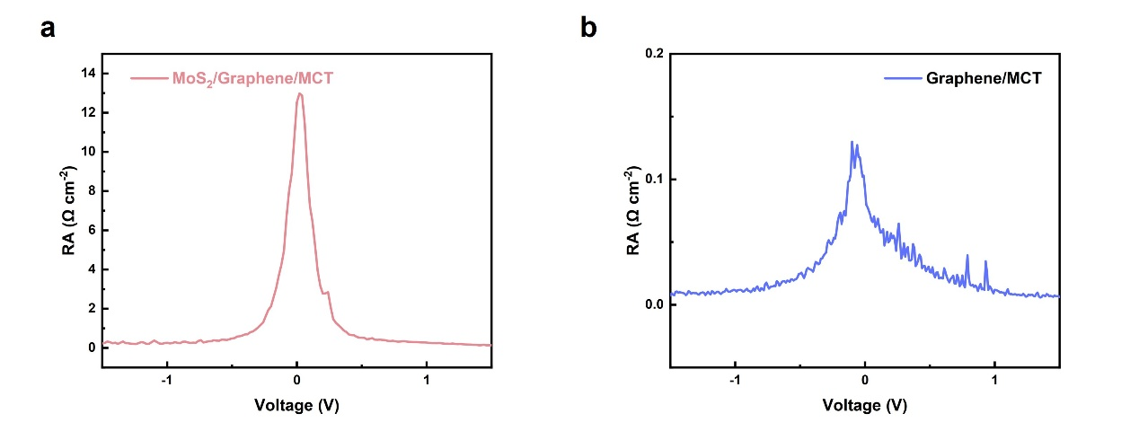
Fig. S7 Resistance-area product measurement of the a MoS₂/graphene/MCT vdW photodetector and b graphene/MCT heterojunction.

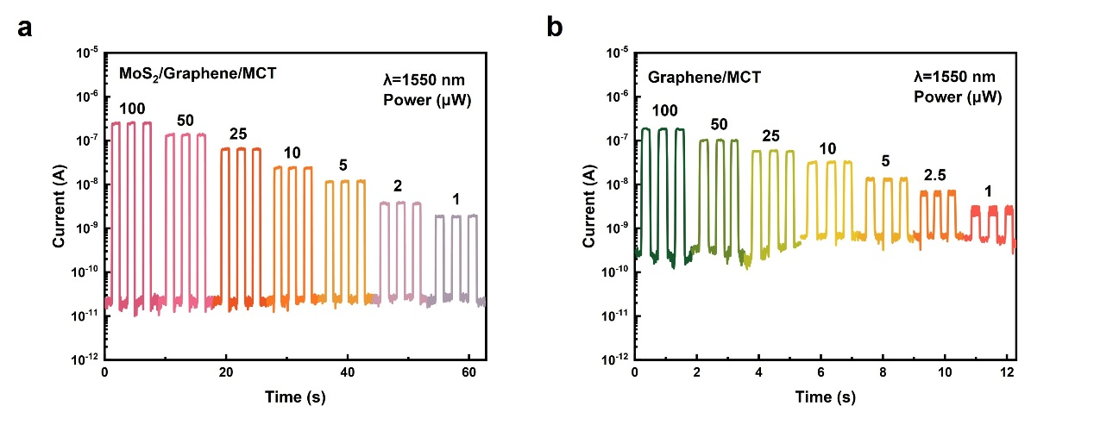
Fig. S8 Power-dependent photoresponse of the a MoS₂/graphene/MCT vdW photodetector and b graphene/MCT heterojunction for 1550 nm in logarithmic scale.

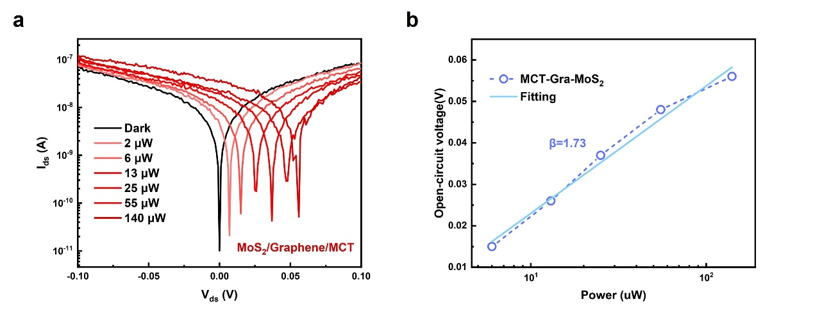
Fig. S9 The open-circuit characterization of the MoS₂/graphene/MCT vdW photodetector under 1550 nm focused laser. a Output characterization curves under various incident light powers of MoS₂/graphene/MCT vdW devices. b The incident light power dependence open-circuit voltage and fitting curve extracted from Fig. S9a.

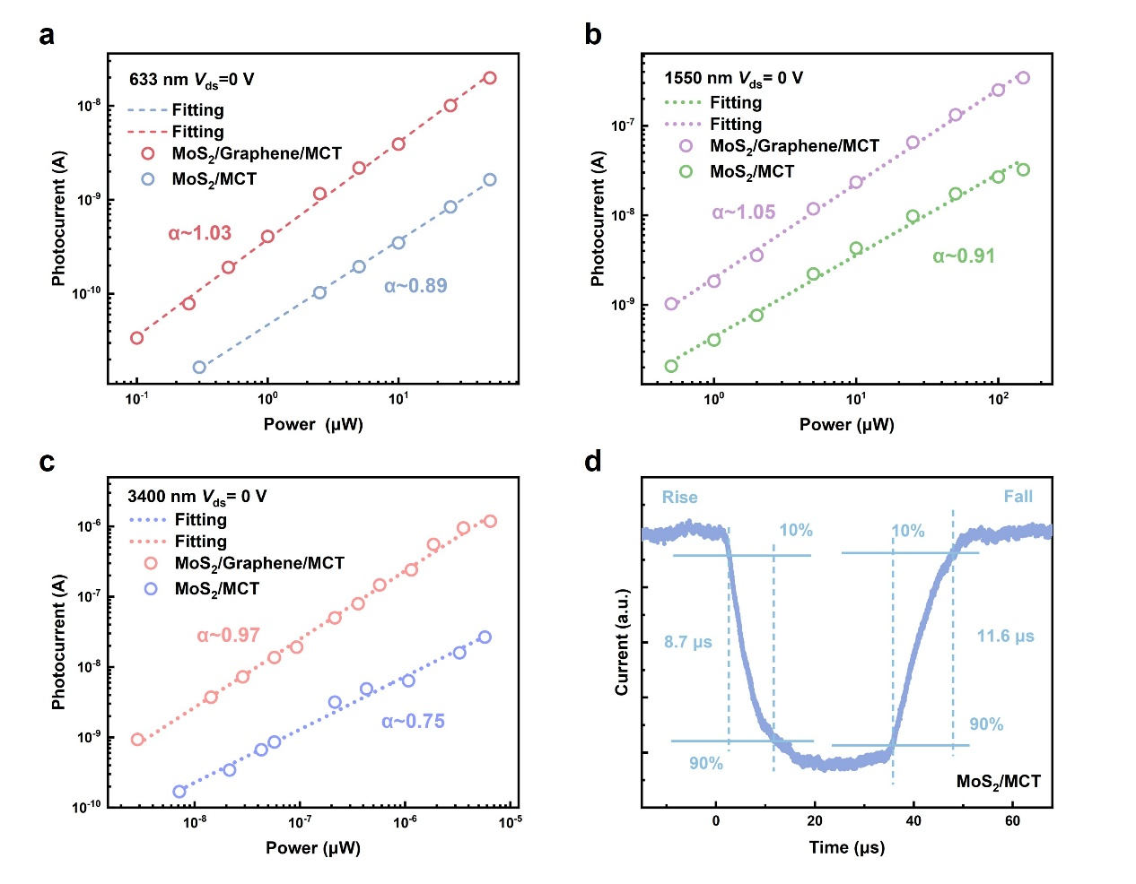
Fig. S10 Power-dependent photocurrent comparison between the MoS₂/MCT heterojunction and MoS₂/graphene/MCT vdW photodetector under a 633 nm, b 1550 nm, and c 3400 nm. d Rise and decay times of the MoS₂/MCT heterojunction at a bias of 0 V under a 633 nm laser.

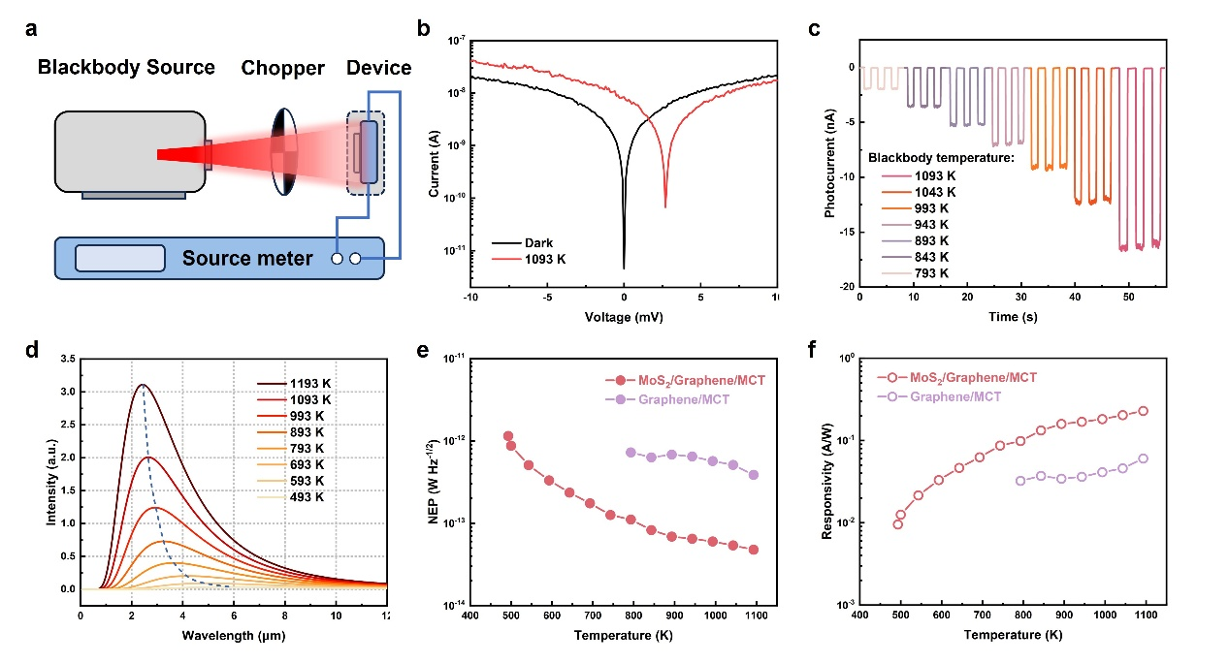
Fig. S11 Blackbody characterization of MoS₂/graphene/MCT vdW photodetector. a Schematic diagram of blackbody response measurement setup. b Output curves with and without 1093 K illumination at 300 K. c Time-resolved photoresponse of MoS₂/graphene/MCT vdW photodetector under diverse blackbody temperature. d Spectra radiance versus wavelength from the 493 to 1193 K blackbody temperatures. e Noise equivalent power (NEP) and f blackbody responsivity comparison between the graphene/MCT heterojunction and MoS₂/graphene/MCT vdW photodetector.

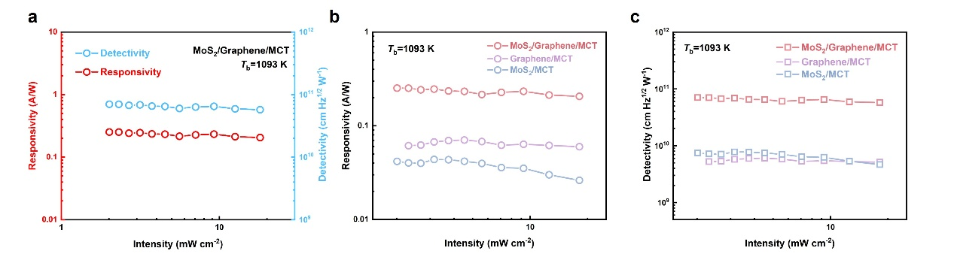
Fig. S12 Blackbody responsivity and detectivity characterization of the MoS₂/graphene/MCT vdW photodetector, graphene/MCT heterojunction, and MoS₂/MCT heterojunction. a Blackbody responsivity and detectivity of MoS₂/graphene/MCT vdW photodetector under diverse blackbody radiation intensity. b Blackbody responsivity and c detectivity comparison of graphene/MCT heterojunction, MoS₂/MCT heterojunction and MoS₂/graphene/MCT vdW photodetector under 1093 K blackbody temperature.

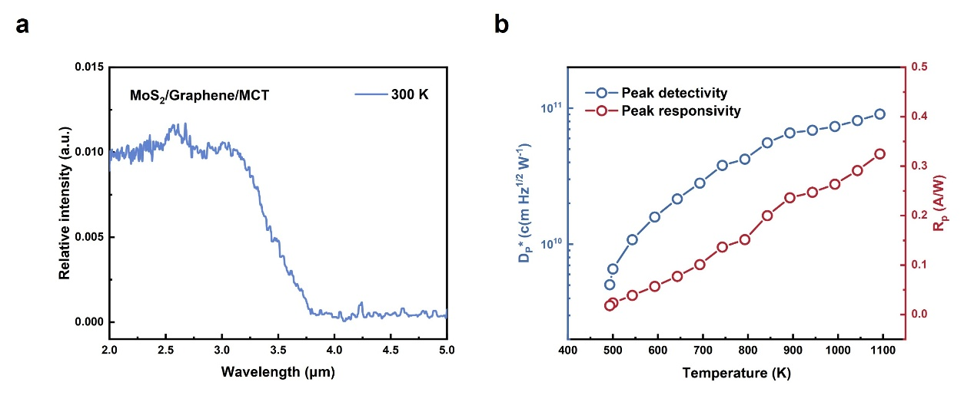
Fig. S13 Spectral response and blackbody detection performance of MoS₂/graphene/MCT vdW photodetector. a Relative response spectrum of the MoS₂/graphene/MCT vdW photodetector. b Peak photoresponsivity and detectivity under various blackbody temperatures radiation from 493 K and 1193 K.

Table 1. Performance comparison of MWIR photodetector⁷⁻¹⁸
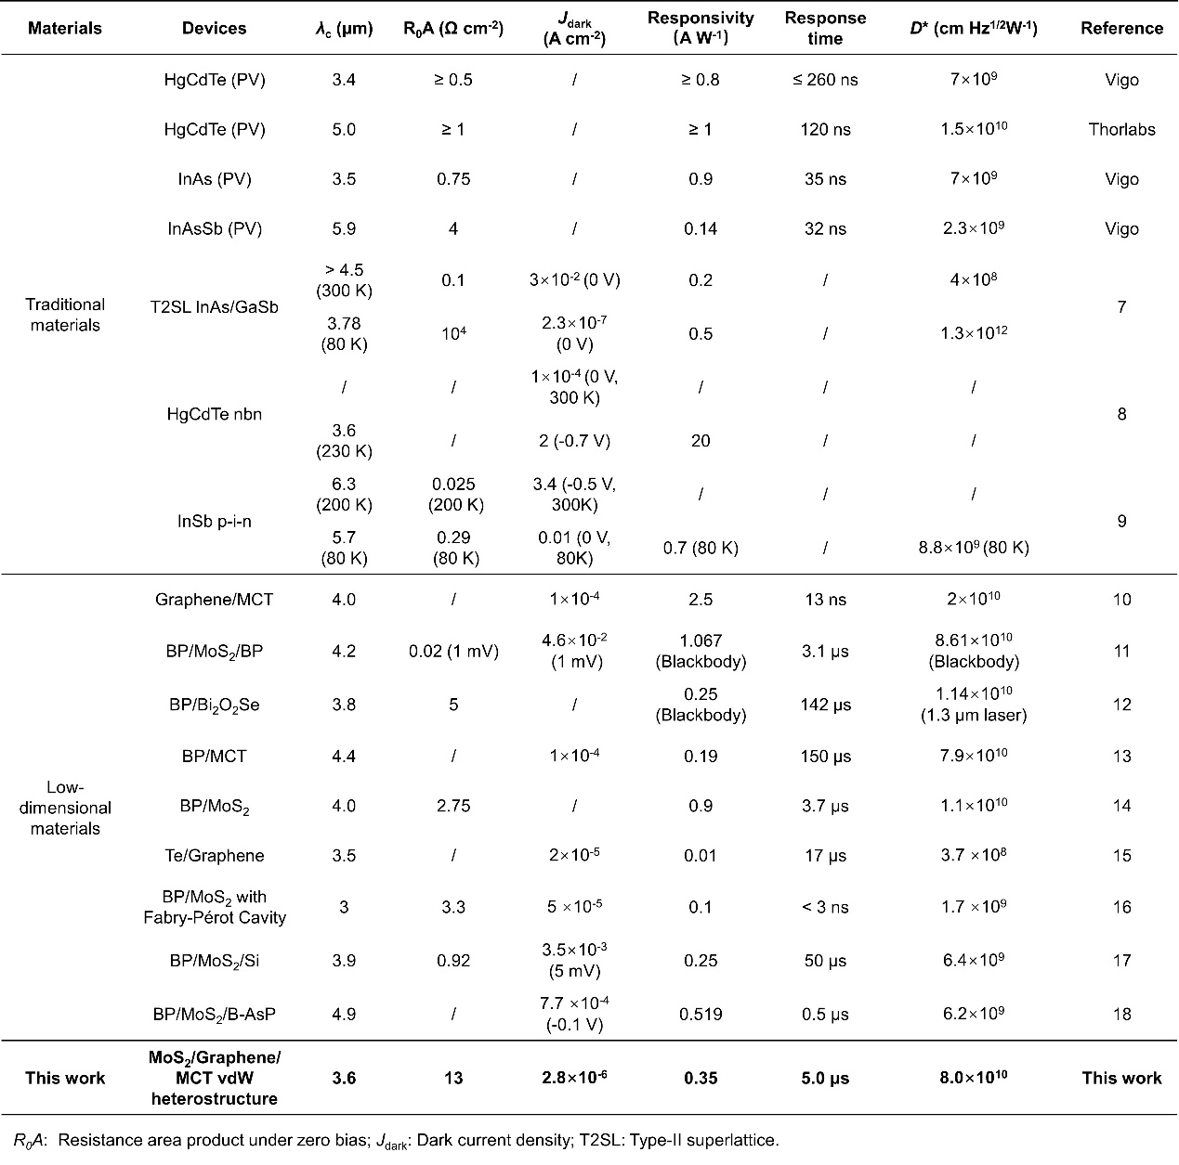

Reference

1 Junhao Chu, A. S. Physics and Properties of Narrow Gap Semiconductors. (2008).
2 C. R. Becker, V. L., A. Pfeuffer-Jeschke, G. Landwehr, and L. W. Molenkamp. Band structure and its temperature dependence for type-III HgTe/Hg1-xCdxTe superlattices and their semimetal constituent. PHYSICAL REVIEW B 62.
3 Isaiah O Oladeji, L. C. & Christos S Ferekides, V. V. b., Zhiyong Zhao. Metal/CdTe/CdS/Cd1−xZnxS/TCO/glass: A new CdTe thin film solar cell structure. Solar Energy Materials and Solar Cells 61, 203-211.
4 H. Nishino, K. O., M. Tanaka, T. Saito, H. Ebe, Y. Miyamoto. Acceptor level related Shockley-Read-Hall centers in p-HgCdTe. Journal of Crystal Growth, 275-279.
5 Majkowycz, K., Murawski, K. & Kopytko, M. New insight into defect energy levels in HgCdTe. Infrared Physics & Technology 137.
6 Chen, W., Rignanese, Gian-Marco, Liu, J. & Hautier, G. Native point defects in HgCdTe infrared detector material: Identifying deep centers from first principles. Journal of Applied Physics 135, 114502.
7 Serincan, U., Arikan, B. & Şenel, O. Direct growth of type II InAs/GaSb superlattice MWIR photodetector on GaAs substrate. Superlattices and Microstructures 120, 15-21.
8 M. Kopytko, A. K., W. Gawron, P. Madejczyk, A. Kowalewski & K. Jóźwikowski High-operating temperature MWIR nBn HgCdTe detector grown
by MOCVD. Opto-Electronics Review 21, 402-405.
9 Jia, B. W. et al. Monolithic Integration of InSb Photodetector on Silicon for Mid-Infrared Silicon Photonics. ACS Photonics 5, 1512-1520.
10 Wang, Y. et al. Fast Uncooled Mid‐Wavelength Infrared Photodetectors with Heterostructures of van der Waals on Epitaxial HgCdTe. Advanced Materials 34.
11 Wang, F. et al. Fully Depleted Self‐Aligned Heterosandwiched Van Der Waals Photodetectors. Advanced Materials 34.
12 Yunfeng Chen et al. Momentum-matching and band-alignment van der Waals heterostructures for high-efficiency infrared photodetection. Science Advances 8.
13 Hanxue Jiao, X. W., Yan Chen, Shuaifei Guo, Shuaiqin Wu, Chaoyu Song, Shenyang Huang, Xinning Huang, Xiaochi Tai, Tie Lin, Hong Shen, Hugen Yan, Weida Hu, Xiangjian Meng, Junhao Chu, Yuanbo Zhang, Jianlu Wang. HgCdTe/black phosphorus van der Waals heterojunction for high-performance polarization-sensitive midwave infrared photodetector. Science Advances 8.
14 Bullock, J. et al. Polarization-resolved black phosphorus/molybdenum disulfide mid-wave infrared photodiodes with high detectivity at room temperature. Nature Photonics 12, 601-607.
15 Peng, M. et al. Room-Temperature Blackbody-Sensitive and Fast Infrared Photodetectors Based on 2D Tellurium/Graphene Van der Waals Heterojunction. ACS Photonics 9, 1775-1782.
16 Yan, W. et al. Spectrally Selective Mid-Wave Infrared Detection Using Fabry-Pérot Cavity Enhanced Black Phosphorus 2D Photodiodes. ACS Nano 14, 13645-13651.
17 Wu, P. et al. Van der Waals two-color infrared photodetector. Light: Science & Applications 11.
18 Zhang, S. et al. Multi-dimensional optical information acquisition based on a misaligned unipolar barrier photodetector. Nat Commun 15, 7071.

