Table 1 Case study overview
Apartment | Pucang | Wonocolo | Ngelom Taman | Pakal Benowo
Blocks | 3 | 4 | 5 | 4
Storey | 5 | 5 | 5 | 5
Units | 297 | 396 | 466 | 96
Site character | Dense 1-2 storey residential area, near factory | Dense 1-2 storey residential area, | Dense 1-2 storey residential area, | Dense 1-2 storey residential area,
Block plan | 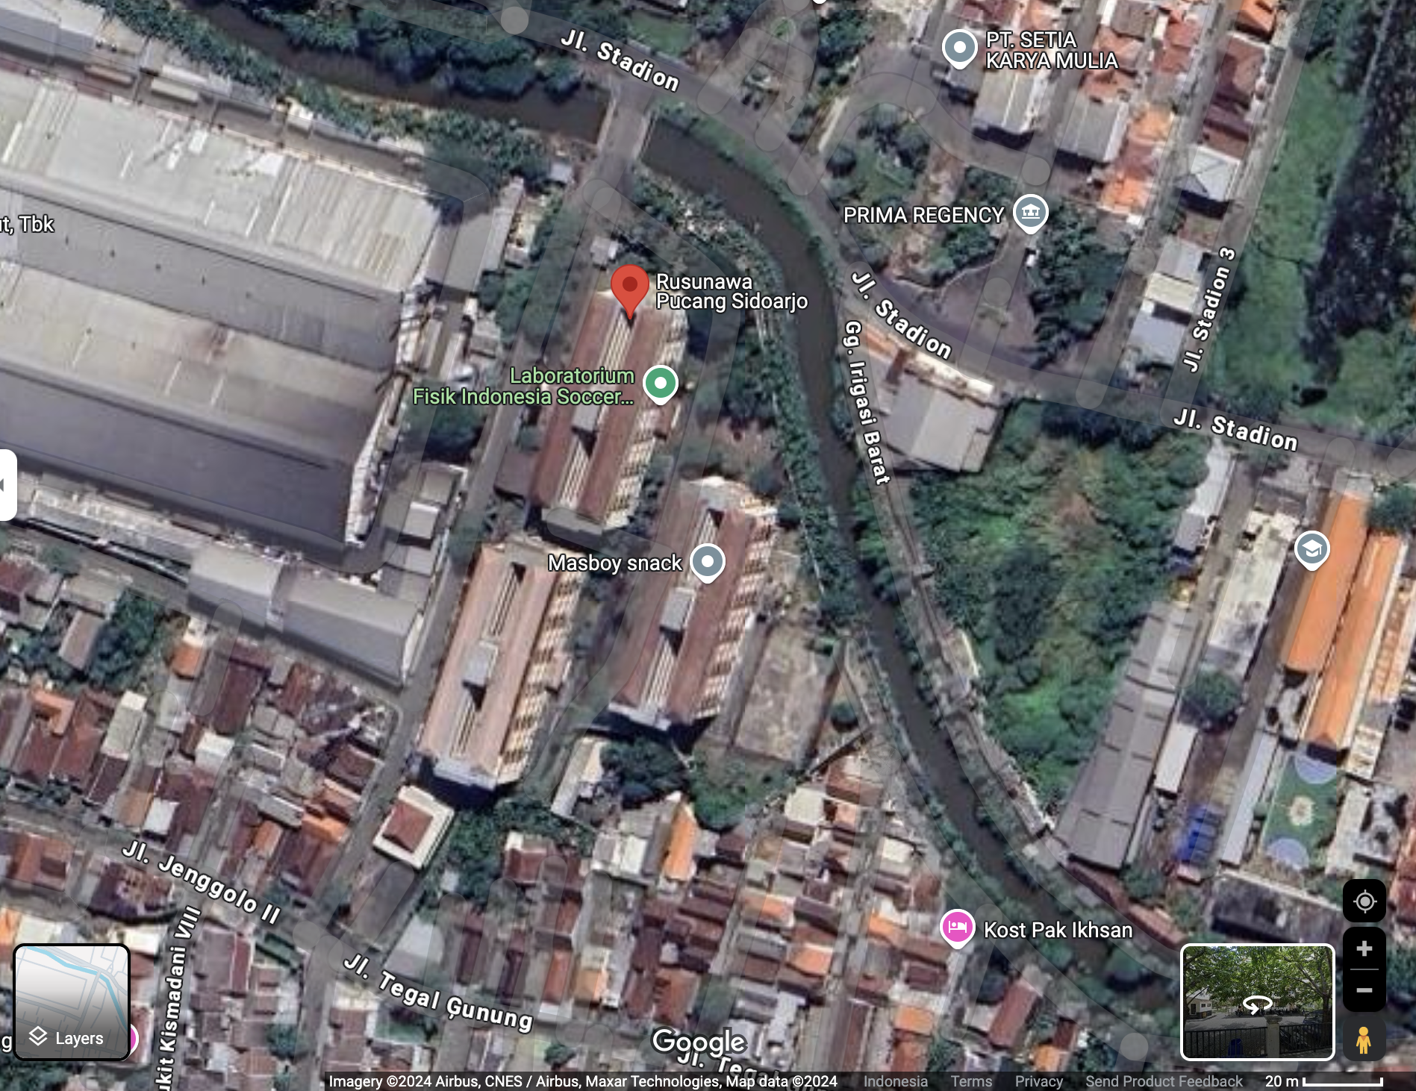 | 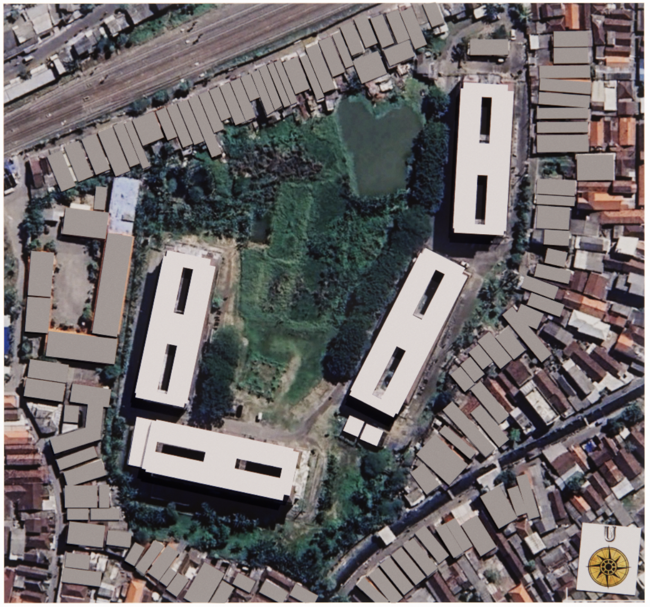  A  B  C  D | 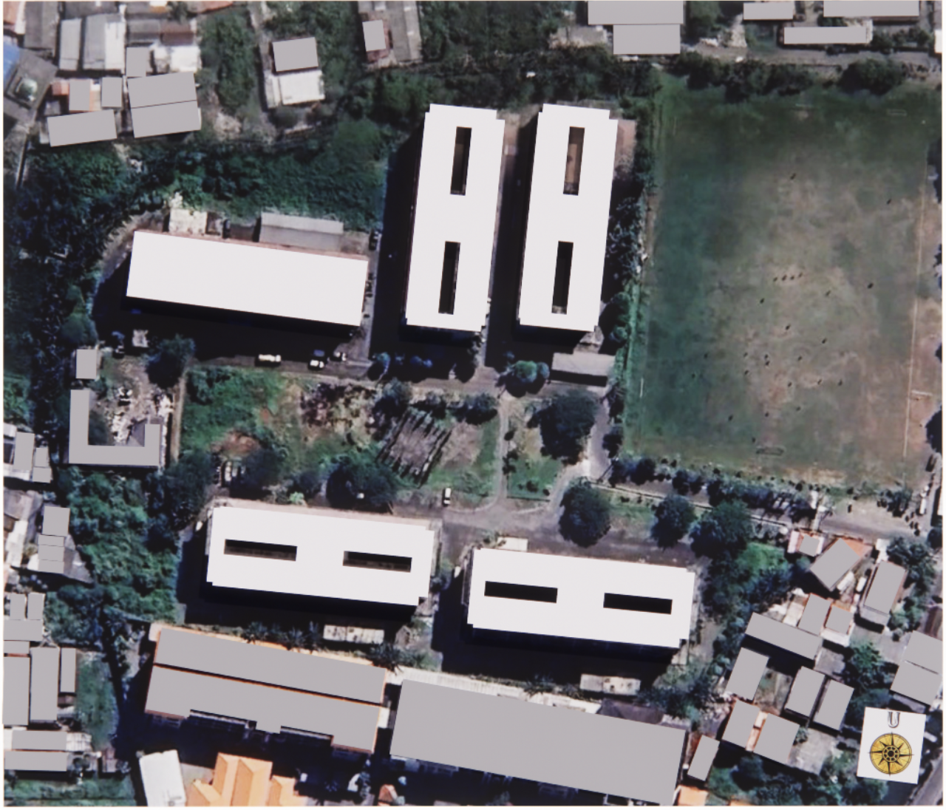  A  B  C  D  E | 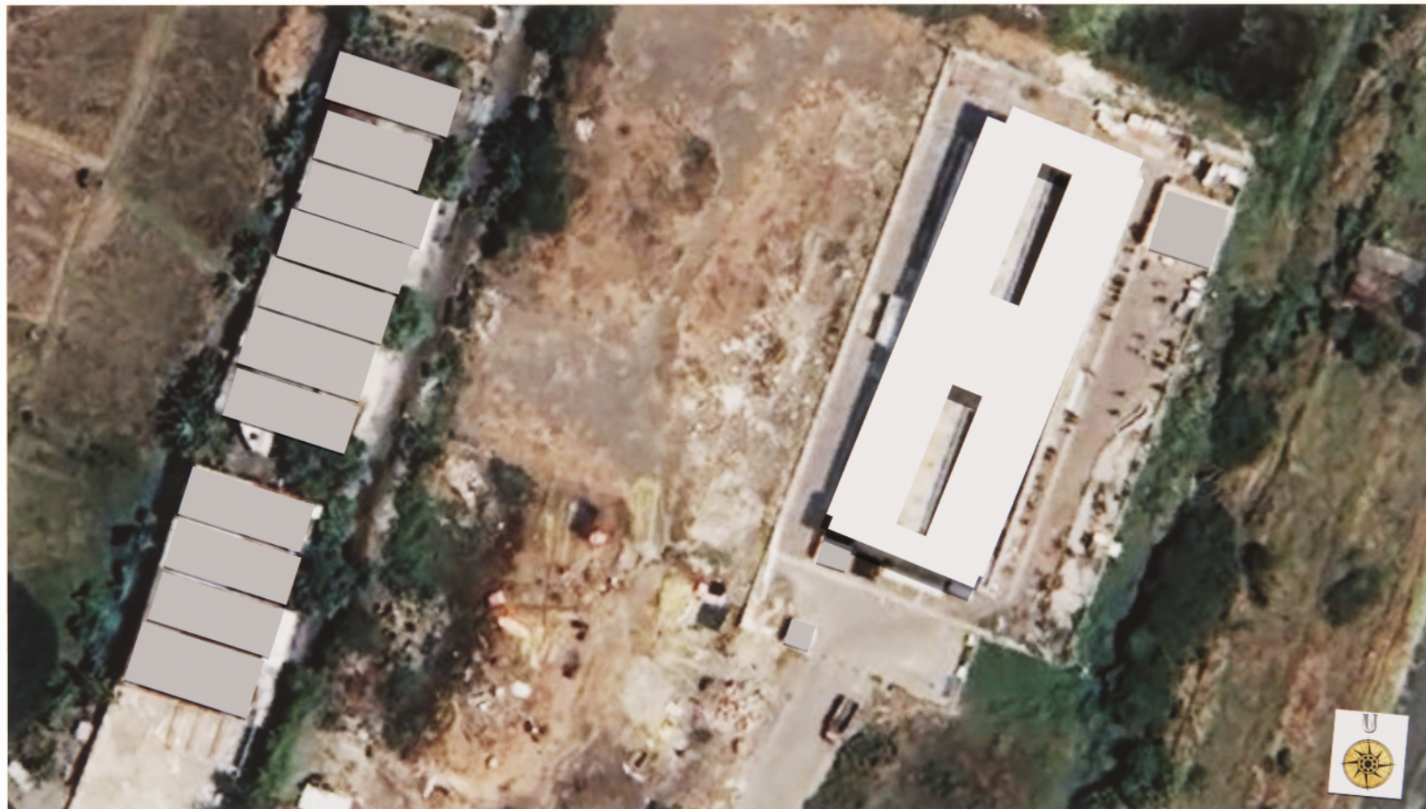

Table 2 Building factor of Case study apartment
Case | Block | Building orienta-tion | Elevation (floor) | ∑ unit | Gross Floor Area (m²) | Communal space (m²) | Nett LetTable Area (m²) | Unit area (m²) | Horizontal roof area (m²) | Tilted roof area `(m²)
Pakal | A | East - West | 1st | 8 | 954,6 | 170,10 | 329,40 | 24,3 | 814,2 | 0
Pakal | A | East - West | 2nd | 22 | 954,6 | 0 | 534,6 | 24,3 | 814,2 | 0
Pakal | A | East - West | 3rd | 22 | 954,6 | 0 | 534,6 | 24,3 | 814,2 | 0
Pakal | A | East - West | 4th | 22 | 954,6 | 0 | 534,6 | 24,3 | 814,2 | 0
Pakal | A | East - West | 5th | 22 | 954,6 | 0 | 534,6 | 24,3 | 814,2 | 0
Ngelom | B | East - West | 1st | 3 | 1152,0 | 199,8 | 145,8 | 24,3 | 698,07 | 442,8 each side
Ngelom | B | East - West | 2nd | 24 | 1152,0 | 88,2 | 583,2 | 24,3 | 698,07 | 442,8 each side
Ngelom | B | East - West | 3rd | 24 | 1152,0 | 88,2 | 583,2 | 24,3 | 698,07 | 442,8 each side
Ngelom | B | East - West | 4th | 24 | 1152,0 | 88,2 | 583,2 | 24,3 | 698,07 | 442,8 each side
Ngelom | B | East - West | 5th | 24 | 1152,0 | 88,2 | 583,2 | 24,3 | 698,07 | 442,8 each side
Ngelom | C | North - South | 1st | 3 | 1152,0 | 199,8 | 145,8 | 24,3 | 698,07 | 442,8 each side
Ngelom | C | North - South | 2nd | 24 | 1152,0 | 88,2 | 583,2 | 24,3 | 698,07 | 442,8 each side
Ngelom | C | North - South | 3rd | 24 | 1152,0 | 88,2 | 583,2 | 24,3 | 698,07 | 442,8 each side
Ngelom | C | North - South | 4th | 24 | 1152,0 | 88,2 | 583,2 | 24,3 | 698,07 | 442,8 each side
Ngelom | C | North - South | 5th | 24 | 1152,0 | 88,2 | 583,2 | 24,3 | 698,07 | 442,8 each side
Ngelom | E | North - South | 1st | 6 | 927,4 | 204,64 | 318,33 | 34,11 | 0 | 314,9 each side
Ngelom | E | North - South | 2nd | 16 | 811,1 | 21,59 | 545,7 | 34,11 | 0 | 314,9 each side
Ngelom | E | North - South | 3rd | 16 | 811,1 | 21,59 | 545,7 | 34,11 | 0 | 314,9 each side
Ngelom | E | North - South | 4th | 16 | 811,1 | 21,59 | 545,7 | 34,11 | 0 | 314,9 each side
Ngelom | E | North - South | 5th | 16 | 811,1 | 21,59 | 545,7 | 34,11 | 0 | 314,9 each side
Wono-colo | A | East - West | 1st | 3 | 1152,0 | 199,8 | 145,8 | 24,3 | 698,07 | 442,8 each side
Wono-colo | A | East - West | 2nd | 24 | 1152,0 | 88,2 | 583,2 | 24,3 | 698,07 | 442,8 each side
Wono-colo | A | East - West | 3rd | 24 | 1152,0 | 88,2 | 583,2 | 24,3 | 698,07 | 442,8 each side
Wono-colo | A | East - West | 4th | 24 | 1152,0 | 88,2 | 583,2 | 24,3 | 698,07 | 442,8 each side
Wono-colo | A | East - West | 5th | 24 | 1152,0 | 88,2 | 583,2 | 24,3 | 698,07 | 442,8 each side
Wono-colo | B | East - West | 1st | 3 | 1152,0 | 199,8 | 145,8 | 24,3 | 698,07 | 442,8 each side
Wono-colo | B | East - West | 2nd | 24 | 1152,0 | 88,2 | 583,2 | 24,3 | 698,07 | 442,8 each side
Wono-colo | B | East - West | 3rd | 24 | 1152,0 | 88,2 | 583,2 | 24,3 | 698,07 | 442,8 each side
Wono-colo | B | East - West | 4th | 24 | 1152,0 | 88,2 | 583,2 | 24,3 | 698,07 | 442,8 each side
Wono-colo | B | East - West | 5th | 24 | 1152,0 | 88,2 | 583,2 | 24,3 | 698,07 | 442,8 each side
Pucang | B | East - West | 1st | 3 | 1152,0 | 199,8 | 145,8 | 24,3 | 698,07 | 442,8 each side
Pucang | B | East - West | 2nd | 24 | 1152,0 | 88,2 | 583,2 | 24,3 | 698,07 | 442,8 each side
Pucang | B | East - West | 3rd | 24 | 1152,0 | 88,2 | 583,2 | 24,3 | 698,07 | 442,8 each side
Pucang | B | East - West | 4th | 24 | 1152,0 | 88,2 | 583,2 | 24,3 | 698,07 | 442,8 each side
Pucang | B | East - West | 5th | 24 | 1152,0 | 88,2 | 583,2 | 24,3 | 698,07 | 442,8 each side
Table 3 Strategi desain pasif dan aktif yang sudah diterapkan pada objek studi
NZEB strategy category | Purpose of strategy | Strategies that can be applied | Evaluation of existing condition strategy
NZEB strategy category | Purpose of strategy | Strategies that can be applied | Rusunawa Pakal | Rusunawa Ngelom, Wonocolo, and Pucang
Passive design strategy | Maximizing natural lighting | Glazing improvement | n.a  (still using clear glass) | n.a  (still using clear glass)
Passive design strategy | Maximizing natural lighting | Natural lighting | The bathroom has minimal natural lighting, the kitchen is dark because the light is blocked by the roster. | Lighting in the kitchen, bathroom and family room can be maximized if there are no obstructions on the windows.
Passive design strategy | Maximizing natural lighting | Light shelf | n.a | n.a
Passive design strategy | Maximizing natural lighting | Skylight | Void in the inner courtyard | Void in the inner courtyard
Passive design strategy | Maximizing natural ventilation | Night Ventilation | n.a | n.a
Passive design strategy | Maximizing natural ventilation | Utilization of natural ventilation | All windows allow to be opened | All windows allow to be opened
Passive design strategy | Minimize heat gain | Double skin facade | Located in the kitchen area in the form of a roster, 1m from the kitchen wall | Located in the kitchen area in the form of galvanized hollow, 1.6m from the kitchen wall
Passive design strategy | Minimize heat gain | Wall insulation | n.a | n.a
Passive design strategy | Minimize heat gain | Shading | n.a | Horizontal shading
Passive design strategy | Minimize heat gain | Thermal bridge control | n.a  The wall material does not use materials with low thermal conductivity. | n.a  The wall material does not use materials with low thermal conductivity.
Passive design strategy | Minimize heat gain | Internal heatgain monitoring | n.a  There is no routine control for measuring temperature / CO₂ levels in each unit. | n.a  There is no routine control for measuring temperature / CO₂ levels in each unit.
Active design strategy | Renewable energy substitution | PV on grid | n.a | n.a
Active design strategy | Renewable energy substitution | PV off- grid | n.a | n.a
Active design strategy | Renewable energy substitution | Migration to electric vehicles | 2 respondents have implemented, most are not interested | 4 respondents have implemented it, most are not interested
Active design strategy | Appliance efficiency | Building system automation | n.a | n.a
Active design strategy | Appliance efficiency | Using efficient equipment | n.a  55.5% of respondents have considered the power size when buying appliances.  There is still electricity leakage from equipment plugged into the wall socket | n.a  69.6% of respondents have considered the power size when buying appliances.  There is still electricity leakage from equipment plugged into the wall socket
Active design strategy | Appliance efficiency | Lighting system efficiency | Use LED lamp | Use LED lamp
Active design strategy | Appliance efficiency | Efficiency of the ventilation system | n.a | n.a

Table 4 Thermal sensation chategory
PMV Skor | Kode warna pada heat map | Estimasi Real feel Temperatur (°C) | Kategori Sensasi Termal | Keterangan
-3 |  | ≤ 23,07 | Cold | Cold, requires heating equipment
-2 |  | 23,08 - 25,07 | Cool | Cool; can be comforTable with heavy clothing or high activity
-1 |  | 25,08 - 27,07 | Slightly Cool | approaching comforTable for those who like low temperatures
0 |  | 29,07 ± 1 (28,07–30,07) | Neutral | The most comforTable temperature in general, not feeling hot or cold
+1 |  | 30,08 - 31,07 | Slightly Warm | Can be considered comforTable, especially in the tropics.
+2 |  | 31,08 - 33,07 | Warm | Feels warm, starting to feel uncomforTable without ventilation
+3 |  | ≥ 33,08 | Hot | Hot, requires active cooling

Table 5 Thermal profile of each case
 | Outdoor thermal profile | Building thermal profile | Mean indoor PET (ᴼC) | ∑ jam tidak nyaman (jam / hari)
Pakal | 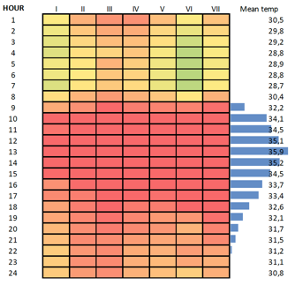 | 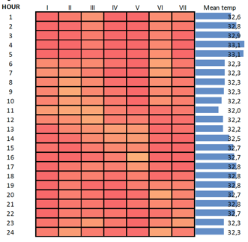 | 32,6 | 24
Ngelom | 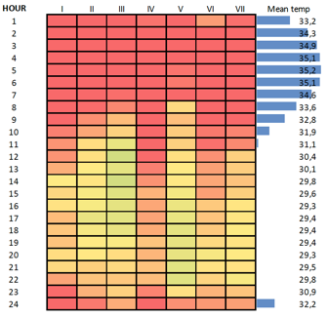 | 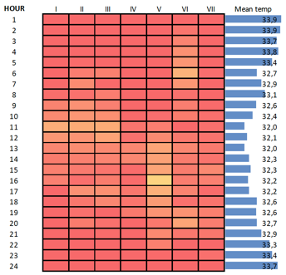 | 32,9 | 24
Wonocolo | 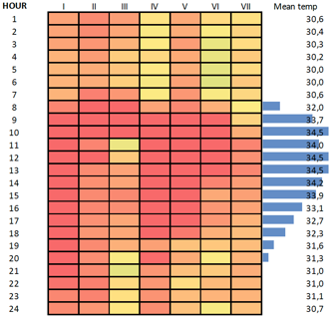 | 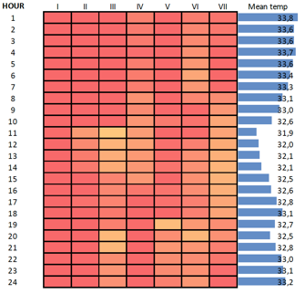 | 32,9 | 24
Pucang | 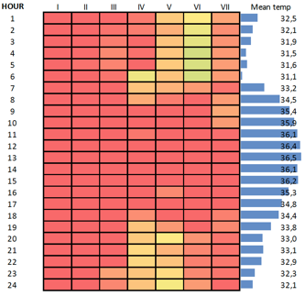 | 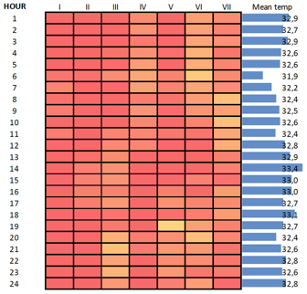 | 32,7 | 24

Table 6 Distribution analysis of household energy demand
Nama rusun | ∑energy demand (kWh/m²/year) | Quartile 1  (kWh/m²/year) | Quartile 2  (kWh/m²/year) | Quartile 3  (kWh/m²/year)
Pakal | 64,46 | 47,33 | 66,43 | 76,60
Ngelom blok A | 73,61 | 58,65 | 71,71 | 87,53
Ngelom blok C | 80,06 | 58,51 | 73,36 | 87,81
Ngelom blok E | 60,86 | 47,17 | 52,92 | 77,59
Wonocolo blok A | 67,42 | 55,95 | 68,22 | 71,96
Wonocolo blok B | 63,64 | 53,47 | 68,63 | 71,43
Pucang | 70,89 | 51,76 | 72,37 | 84,95

Table 7 Comparation of dominant appliance on each case
Appliance | Pakal | Ngelom | Wonocolo | Pucang
Fridge | Dominant, constant 24 hours | Very dominant, largest | Dominant, contributes the largest base load | Dominant, contributes base load
Rice Cooker / Warmer | High in the morning and evening | Very high, peak load | High during peak hours | Very high, peak energy at 5 am
Lamp | Active morning & night | Active all day, increases at night | Morning and evening | STable morning–evening, quite high
Fan | High day to night | Consistently high | STable throughout the day | High at all times, especially at night
Laptop / PC | Used at night | Laptop dominant in the evening-night, PC active in the morning | Laptop active at night | Laptop and PC used almost all day
TV / Set Top Box | Morning & evening | Used intensively in the morning & evening | Appears morning-evening | Consistent afternoon–evening
Washing Machine | Only in the morning | Morning dominant | Moderate-morning | Quite active in the morning
Microwave | Slightly visible | Appears in the morning and evening | Used in the morning | Used morning and evening
Dispenser | Quite active | Active in the morning & evening | Morning | Active morning and evening
Hair Iron / Dryer | A few | Visible in the morning | Visible in the morning | Present in the morning and light afternoon
Speaker | A few | Active at night | A few | Used at night

Table 8 Energy demand of each apartment
Case | block | Building Orienta-tion | Annual household energy consumption (kWh/m²/year) | Annual energy consumption (for communal space)  (kWh/ m²/year) | EEI (kWh/m²/ year)
Pakal | A | East - West | 66,43 | 18,69 | 85,12
Ngelom | A | East - West | 71,71 | 4,39 | 360,8
Ngelom | B | East - West | 71,71 | 4,39 | 360,8
Ngelom | C | North - South | 80,06 | 4,39 | 360,8
Ngelom | D | North - South | 80,06 | 4,39 | 360,8
Ngelom | E | North - South | 52,92 | 4,39 | 360,8
Wonocolo | A | East - West | 68,22 | 10,53 | 147,4
Wonocolo | B | East - West | 68,63 | 10,53 | 147,4
Pucang | A | East - West | 72,37 | 5,91 | 223,02
Pucang | B | East - West | 72,37 | 5,91 | 223,02
Pucang | C | East - West | 72,37 | 5,91 | 223,02

Table 9 Load shifting strategy on each apartment
Case | Main features of the energy profile | Strategy
Pakal | • Morning peak (05.00–08.00) - Moderate evening load  • Dominated by rice cooker, lights, fans | • Use a rice cooker timer to cook earlier/afternoon  • Replace lights/fans with energy-saving versions  • Schedule washing during the day
Ngelom | • Very high morning peak - Many appliances active at the same time  • Evening is also busy | • Spread the schedule for using heavy equipment (rice cooker, iron, washing machine) during the day  • Use energy storage batteries when using PV  • Educate residents not to turn on heavy equipment at the same time
Wonocolo | • High morning & evening, but not extreme  • STable TV, fan, laptop activity | • Reschedule laundry, cooking, to daytime hours  • Use smart plugs or timers  • Encourage non-simultaneous use of heavy equipment at home
Pucang | • Sharp morning peak  • High but even evening  • Many digital appliances active | • Switch digital activities (laptop/charger) to the afternoon  • Schedule rice cooker/microwave to before noon  • Maximize daytime PV usage for digital devices

Table 10 PV installation scenario on 30% of roof area
Apartment | Total roof area (m²) | Scenario 30% of roof area (m²) | ∑ Minimum number of solar panels that can be installed (units) | Solar panel system size (kWp) | Electric power obtained (kWh)
Pakal | 814,2 | 244,26 | 153 | 45,8 | 190,29
Ngelom | 6.964,48 | 2.089,34 | 1.306 | 391,75 | 1.627,73
Wonocolo | 6.334,68 | 1.900,40 | 1.188 | 356,33 | 1.480,53
Pucang | 2.656,80 | 797,04 | 499 | 149,45 | 620,94

Table 11 Calculation of optimal daily energy requirements
Apartment | Daily optimum energy requirement unit (Watt / unit) | ∑ unit | Daily optimum energy requirement communal (kWh) | Total daily optimum energy requirement (kWh) | Energy surplus (kWh/day)
Pakal | 250 | 96 | 6,21 | 30,21 | 160,08
Ngelom | 374 | 466 | 14,11 | 188,394 | 1.439,34
Wonocolo | 289 | 396 | 12,61 | 127,054 | 1.353,48
Pucang | 345 | 297 | 10,28 | 112,745 | 508,20

