Supplementary information

Inter-kingdom networks of canola microbiome reveal Bradyrhizobium as keystone species and underline the importance of bulk soil in microbial studies to enhance canola production.
Jean-Baptiste Floc’h^{1,2}, Chantal Hamel^{1,2}, Mario Laterrière², Breanne Tidemann³, Marc St-Arnaud¹, Mohamed Hijri^{1,4*}
¹Institut de recherche en biologie végétale, Université de Montréal and Jardin Botanique de Montréal, 4101 East, Sherbrooke Street, Montréal QC, Canada H1X 2B2; ²Quebec Research and Development Centre, Agriculture and Agri-Food Canada, Quebec City, QC, Canada. ³Lacombe Research and Development Centre, Agriculture and Agri-Food Canada, Lacombe, AB, Canada; ⁴African Genome Center, Mohammed VI Polytechnic University (UM6P), Lot 660, Hay Moulay Rachid, Ben Guerir 43150, Morocco.

* Corresponding author: Mohamed.Hijri@umontreal.ca

Keywords: sequencing, plant microbiota, soil, rhizosphere, roots

Fig. S1
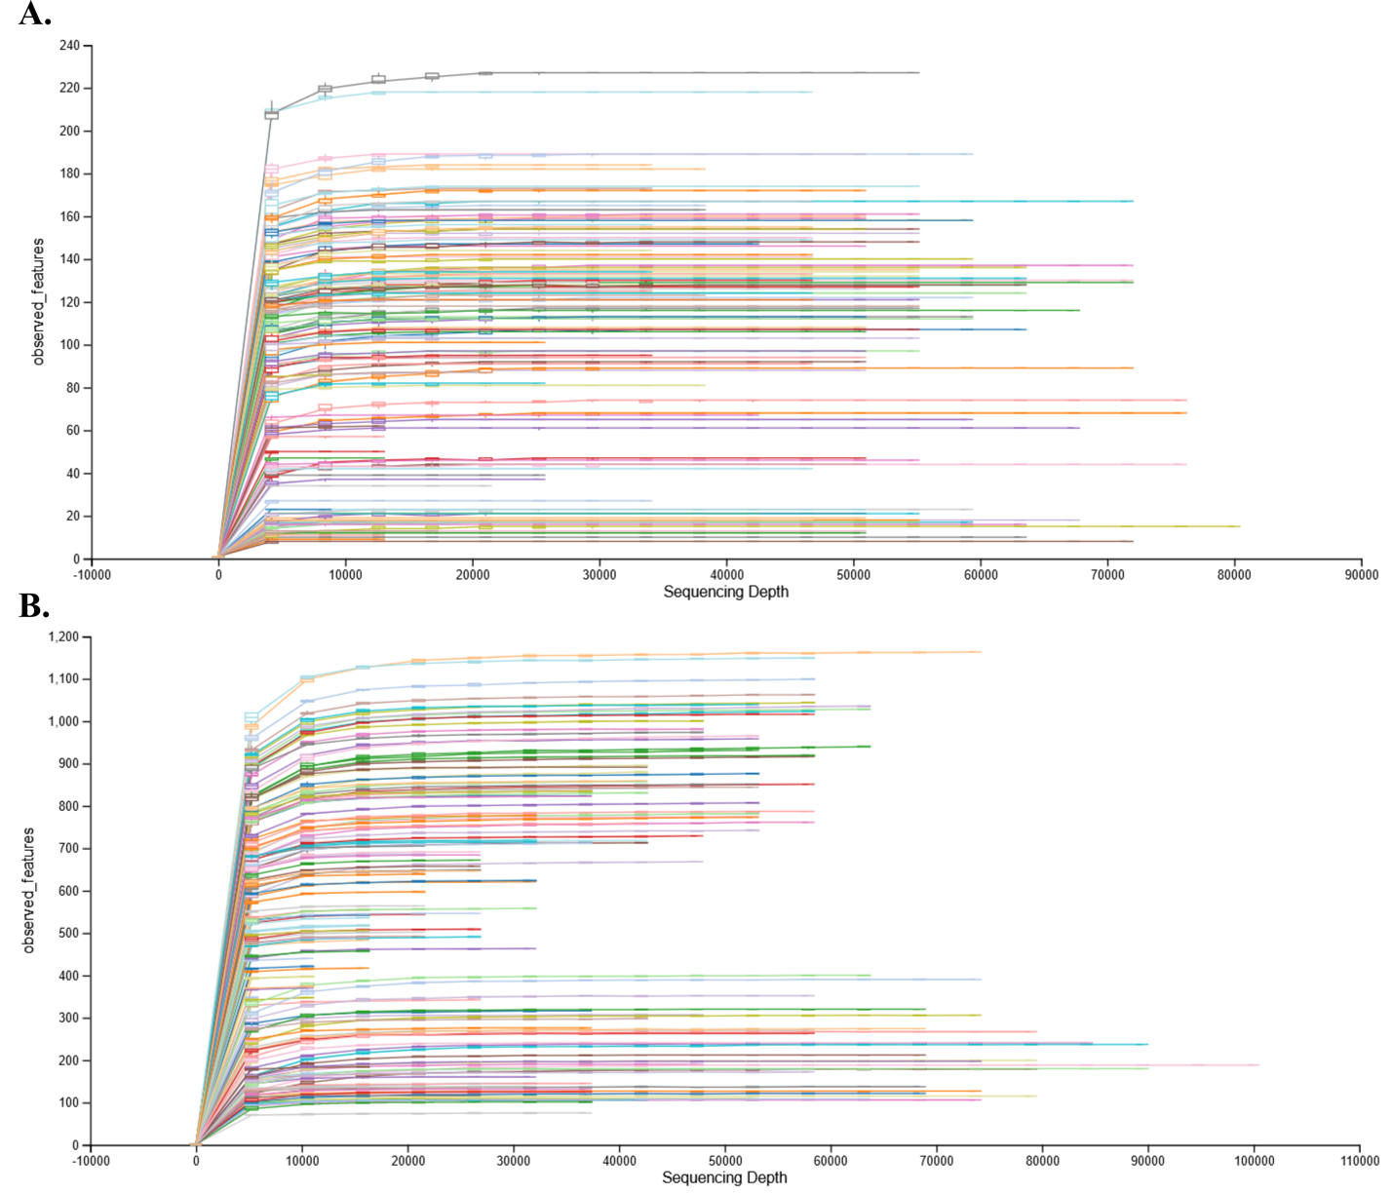
Figure S1. Rarefaction curves for each rhizosphere soil sample, showing the relationship between the number of ASVs and the abundance of (A) ITS DNA gene sequences reads and (B) 16S RNA gene sequences.

Fig. S2
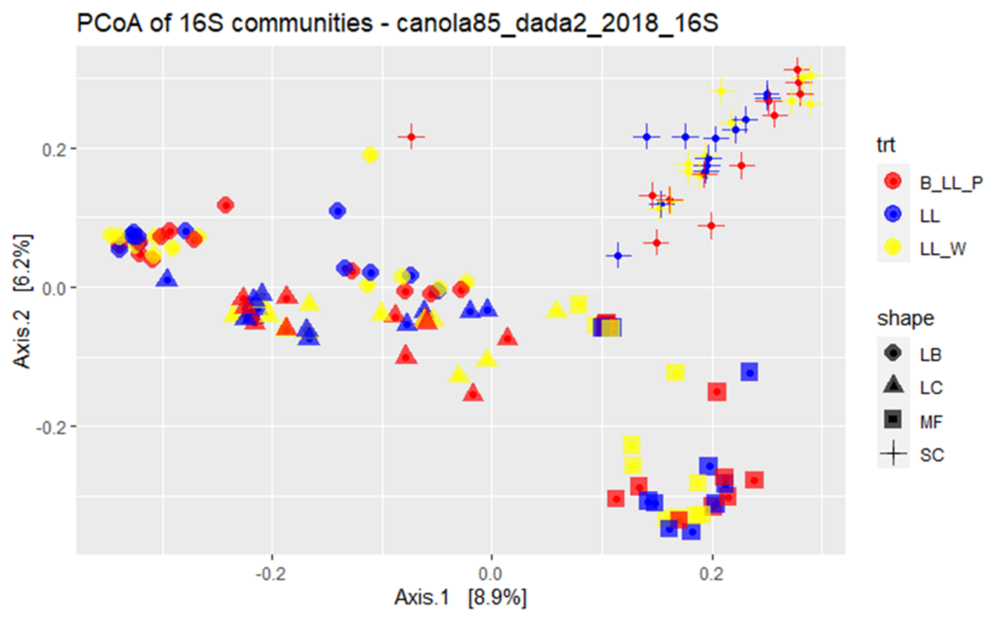
Figure S2. Principal Coordinate Analysis of the bacterial 16S gene community. LL is the cultivar of canola, B is barley, P is pea and W is wheat. LB is the site Lethbridge, LC is Lacombe, MF is Melfort, and SC is Swift Current.

Fig. S3
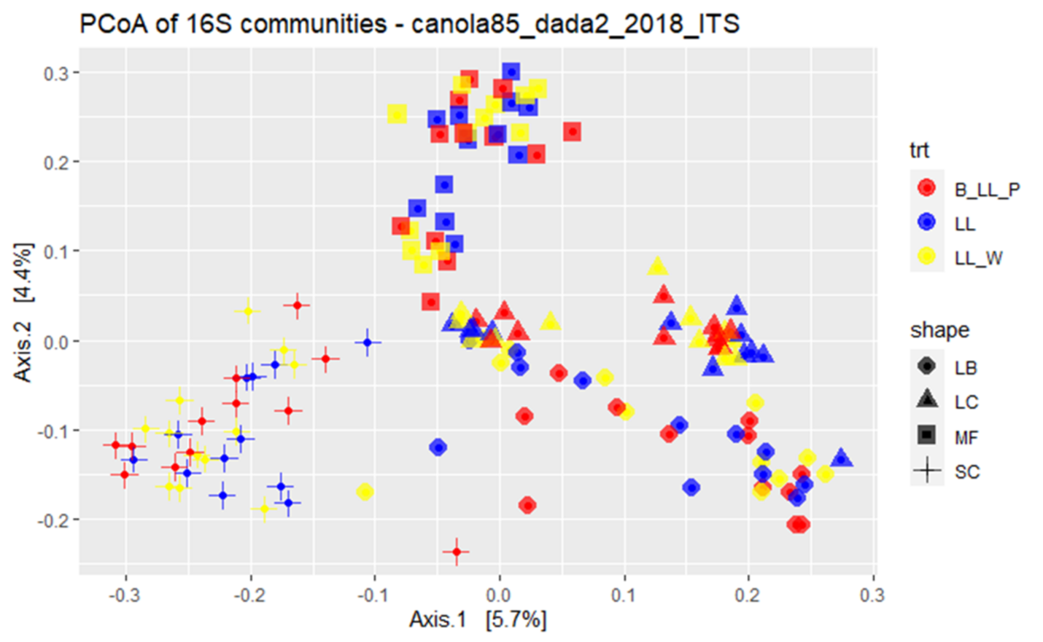
Figure S3. Principal Coordinate Analysis of the fungal ITS gene community. LL is the cultivar of canola, B is barley, P is pea and W is wheat. LB is the site Lethbridge, LC is Lacombe, MF is Melfort, and SC is Swift Current.

Fig. S4
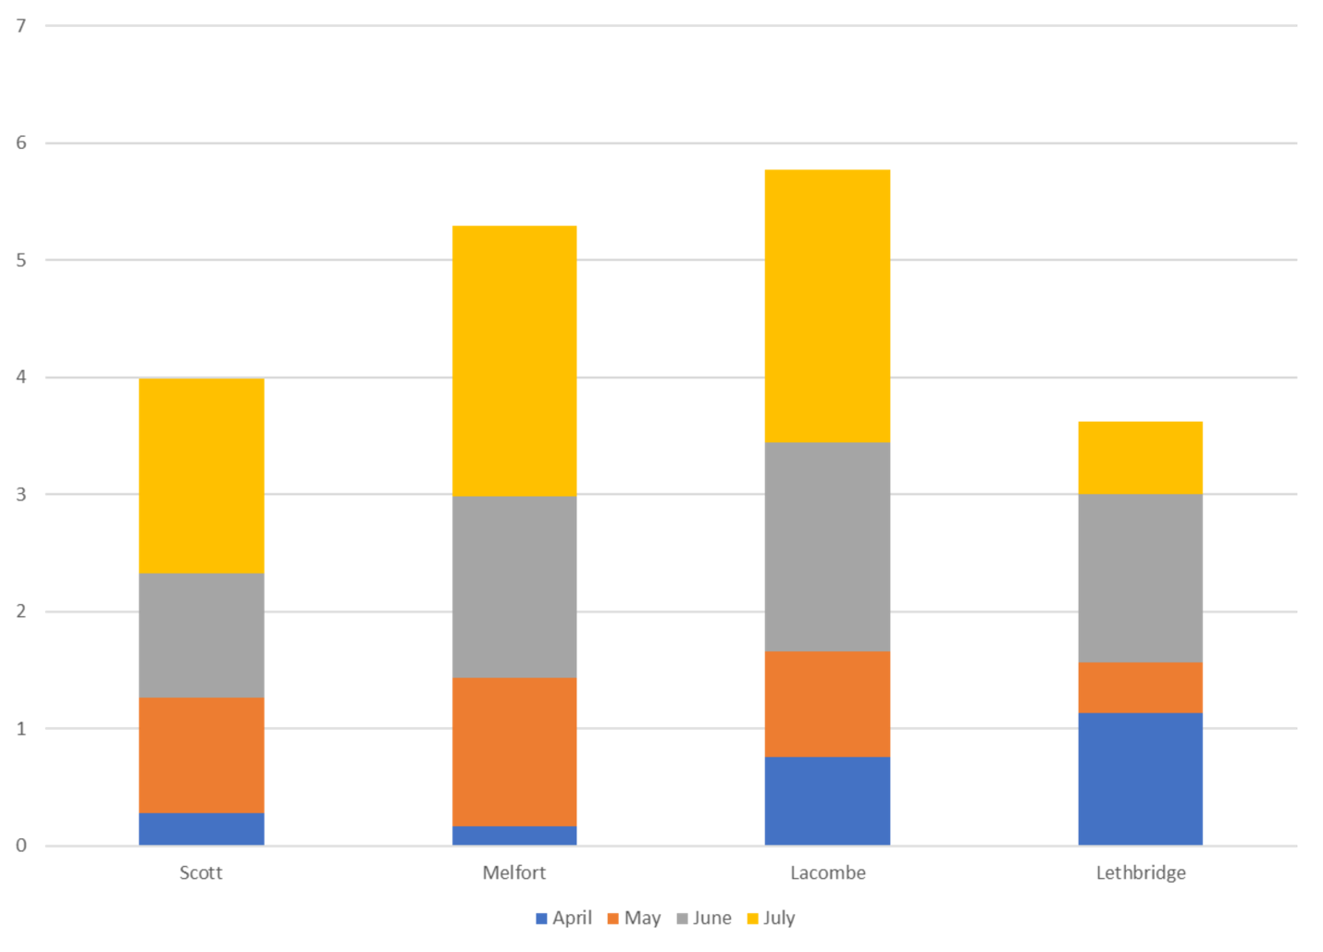
Figure S4. Cumulative precipitations (mm) at each site before sampling in 2018.

