sTable 1

Baseline Assumptions and Guiding Principles of Intervention for Challenging Behavior (originally published on the Open Science Framework [Foster & Deardorff, 2017] as supplemental materials for Lambert, Copeland et al., 2022)

Concept | Description
Baseline Assumptions
1. Behavior patterns are context dependent | Behavior patterns can be understood as a product of an interaction of variables emphasized by operant learning theory (e.g., motivation, discrimination, schedule performance).
2. Persistent patterns of challenging behavior are learned | They are thus the product of experiences with countertherapeutic contingencies prevalent in current or historical contexts (e.g., in the presence of specific people, specific places).
3. Behavior patterns can be changed | Interventionists can influence challenging patterns by transforming countertherapeutic contingencies into therapeutic ones. Specifically, by minimizing reinforcement for challenging behavior and maximizing reinforcement for adaptive and desirable alternatives.
Guiding Principles
1. Be transparent | Interventionists should be transparent with stakeholders about biases, values, and approaches before therapy begins (i.e., Baseline Assumptions).
2. Evidence-based practice (EBP) is a verb | EBP entails conformity to a general algorithm outlined by the APA Presidential Task Force on EBPs. Specifically, EBP depends on a practitioner’s ability to survey client values, environmental constraints, and available resources and match them to techniques most likely to promote effective action for the idiosyncratic circumstances in which it is needed. All variables in this algorithm can and do change frequently. Thus, in addition to matching a potentially effective technique to a function of a client’s behavior, EBP entails communication, coordination, and ongoing formative assessment. Adherence to pre-established protocols should never supersede in-the-moment clinical judgments of supervising BCBAs.
3. Context matters | When engaging in data-based decision making, evidence produced by the client in context should be weighted more heavily than evidence accessed through peer-reviewed publication.
4. Do not treat problems you have not observed | Baseline data, which provide empirical evidence of the prevalence of challenging behavior [and therefore the need for treatment] are non-negotiable. All interventions require data showing the extent to which behavior occurs in the absence of intervention.
5. If challenging behavior is observed, it should be treated | Functional analysis is a required but insufficient component of effective intervention. When functions cannot be confirmed experimentally, data suggestive of functions should be used to design techniques which leverage known operant-learning mechanisms (e.g., motivating operations, discriminative stimuli, reinforcement, extinction, punishment) to promote adaptive response pattens and discourage maladaptive patterns.
6. Prioritize the needs of vulnerable populations | When designing interventions, interventionists should aim to organize contingencies which meet the needs of all relevant stakeholders. However, when needs conflict, the needs of the most vulnerable should be prioritized.
7. Shape desired repertoires | Intensive intervention for challenging behavior is the domain of experiential learning. As clients who require it have been non-responsive to less intensive approaches, instruction should be provided in context. That is, through high-stakes “roleplaying,” clients should have direct and frequent experience contacting therapeutic contingencies which leverage known learning mechanisms in the presence of settings events which have historically occasioned challenging behavior. The organization of systems of reinforcement (e.g., contracts, token systems), without formally arranging direct (and measured) experiences with said systems, is inadequate.
8. Communicate | Unless tolerance of unpredictability is an explicit target of therapy, interventionists should communicate clearly with clients about relevant contingencies so that clients are optimally poised to experience therapeutic systems, as intended, during formal therapy. This can often be accomplished through contingency reviews (e.g., “when you do this, this happens”), and schedule-correlated stimuli (e.g., activity schedules, visual timers).
9. Balance precision with feasibility | The precision with which a technique reduces challenging behavior is often inversely related to the feasibility of the procedure, and not all problems require precision. Treatment options exist along a spectrum and feasibility should only be sacrificed to the extent to which precision is required. These judgments should be based on existing evidence and ongoing assessment (and re-assessment) of stakeholder values & priorities.
10. Reinforcement is not synonymous with ethical practice | The nature (e.g., function-based vs. arbitrary) and the timing of stimulation (and the setting events which establish its value), the potential impact of the collateral effects of its introduction on the ecological integrity of the client’s typical environment(s), and its social acceptability and feasibility should all be weighted as heavily as the directionality of a technique’s impact on behavior (e.g., reinforcement, punishment).
11. Minimize the punishing qualities of EO presentation | When a function-based punisher is naturally at play during therapy (e.g., the presentation of one of challenging behavior’s establishing operations [EO]), interventionists should consider whether lower intensities of the EO might plausibly reduce its punishing qualities without sacrificing the therapeutic objectives it facilitates (e.g., reinforcement of communication). If so, intensity should be reduced.
12. Ensure EOs don’t punish desired repertoires | When a function-based punisher is naturally at play during therapy (e.g., the presentation of one of challenging behavior’s EOs) and cannot be avoided, care should be taken to ensure it follows undesirable behavior more frequently than it follows desirable behavior through intentional programming.
13. Attend to ratios | When function-based punishers are programmed into therapy, care should be taken to ensure substantially more reinforcement is delivered in context than is punishment.
14. Don’t poison the therapeutic context | If a procedure (reinforcement, punishment, or both) risks conditioning the therapeutic context as an aversive experience, it should be changed. The evidence to support these changes may extend beyond data obtained through formalized data systems and can include parent affect, child affect, approach responses to therapists and therapy rooms between sessions and at the onset of appointments, chronic cancellations, and other collateral indicators. Temporary child frustration at focused and critical points of therapy (e.g., FA, initial stages of EO tolerance) are expected. However, persistent negative reactions to therapy serve as justification for treatment modification.
15. Ethical practice is calculus | Treatment plans are least likely to cross ethical boundaries when every member of a team (including caregivers and other interventionists) has had an opportunity to learn about a prescribed course of action, has learned of its associated cost/benefit analysis, and has had an opportunity to provide input about their comfort with its execution. Although consensus is not required and disagreements should be addressed hierarchically (i.e., caregivers, supervising BCBA, then interventionists, in that order), the ethical integrity of a course of action should be more thoroughly scrutinized whenever consensus amongst stakeholders is not achieved.

sTable 2

Assumptions, principles, and frameworks which informed clinical decision making at critical junctures of the consultation process

Decision | Guiding Assumptions, Principles, & Frameworks
Conduct functional analysis | sTable 1 (BLA: 1, 2; GP: 3, 4)
Conduct experience-based intervention based in operant-learning theory | sTable 1 (BLA: 3; GP: 5, 7)
Conduct FCT + Ext to achieve initial response elimination | sFigure 1 (mechanism 3)
Incorporate chained-schedules arrangement to achieve EO tolerance | sFigure 2
Introduce function-based punishment through an individualized levels system that capitalizes on the naturally punishing properties of EO presentations for multiply controlled challenging behavior. | sTable 1 (GP: 2,3,5,6,10,11,12,13)  sFigure 1 (mechanism 6)  sFigure 3
Massed practice opportunities prior to parent use. | sTable 1 (GP: 7)
Parent practice at the times and in the locations in which challenging behavior typically contacted. | sFigure 4
Prepare parent for escalations in behavior following introduction of function-based punishment. | sTable 1 (BLA: 1; GP: 1)  sFigure 1 (mechanism 6)
Ask parent to practice in absence of researcher (following training) | sTable 1 (GP: 3)
Seek ongoing feedback from parent about alignment of intervention with Jared’s and family’s needs, perceived effectiveness, intervention difficulties, and continued desire for change. | sTable 1 (GP: 2, 3, 6, 14, 15)
Parametric changes to reinforcer provision (longer, less frequent access) | sTable 1 (GP: 10)
Troubleshoot attention via siblings | sTable 1 (GP: 9, 10, 12, 13, 14)
Incorporate sibling needs into intervention activities | sTable 1 (GP: 9)
Note: BLA = baseline assumption GP = guiding principle

sFigure 1

Mechanisms-Based Precision Hierarchy for Addressing Challenging Behavior (originally published on the Open Science Framework [Foster & Deardorff, 2017] as supplemental materials for Lambert, Copeland et al., 2022)

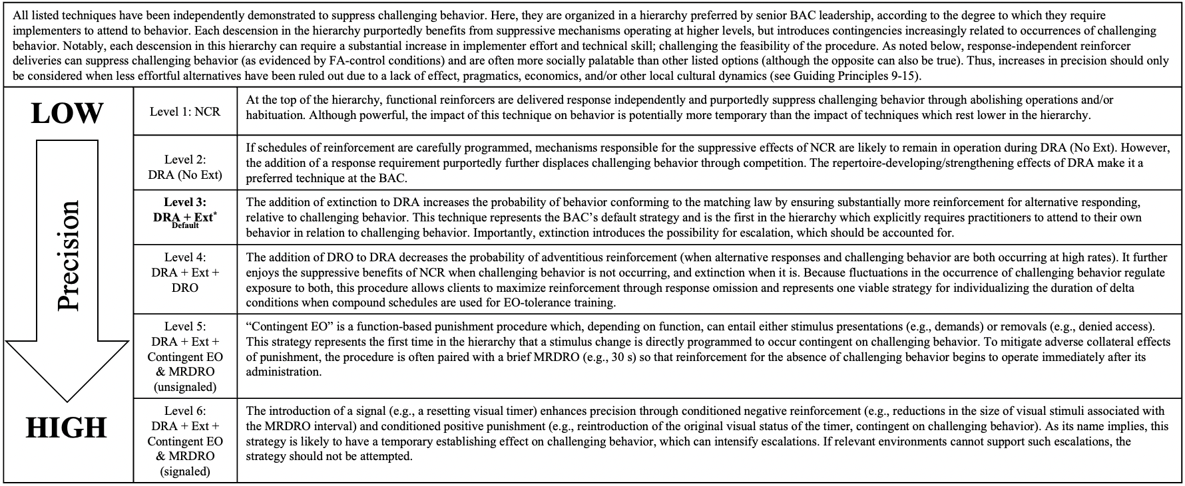

Note: NCR = noncontingent reinforcement; Ext = extinction; DRA = differential reinforcement of alternative behavior; DRO = differential reinforcement of other behavior; EO = (challenging behavior’s) establishing operation; MRDRO = momentary resetting DRO.

sFigure 2

Functions of Compound Schedules at the BAC (originally published on the Open Science Framework [Foster & Deardorff, 2017] as supplemental materials for Lambert, Copeland et al., 2022)

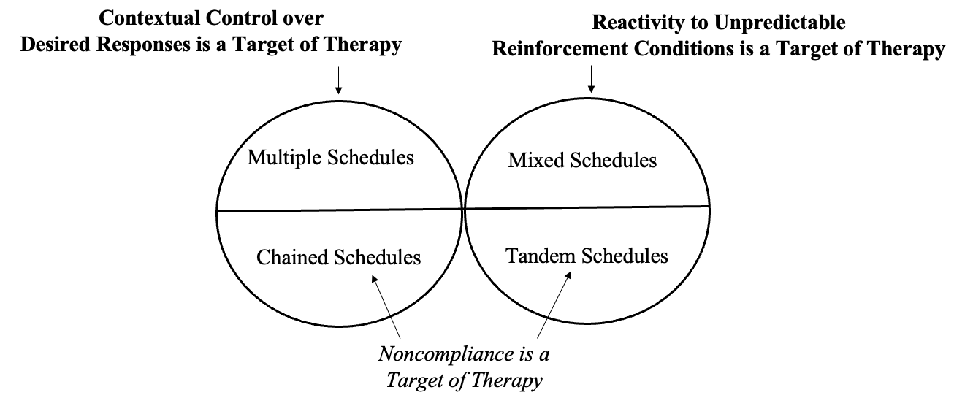
Note: Transitions between two or more simple-schedule arrangements are time based in multiple (signaled) and mixed (unsignaled) schedules. Transitions between simple-schedule arrangements are performance based (e.g., contingent on compliance) in chained (signal) and tandem (unsignaled) schedules. Often, 3-5 tandem schedules can be randomized during EO-Tolerance Training to suppress adverse participant reactions to unpredictability (Hanley et al., 2014). Importantly, compound-schedules arrangements can be used for many different purposes and readers should not feel constrained to functions identified here.

sFigure 3

Individualized Levels System for Multiply Controlled Challenging Behavior (originally published on the Open Science Framework [Foster & Deardorff, 2017] as supplemental materials for Lambert, Copeland et al., 2022)

Note: Function-based individualized levels systems are helpful for addressing challenging behavior for which extinction is procedurally difficult, due to multiple control (see Hagopian et a.., 2002, Randall et al., 2018; Lambert et al., 2021; 2022). This system ensures that no arbitrary aversive stimuli are introduced into the system, that the duration of punishment elements are palatable and individualized (i.e., the conjunctive schedule for levels ascension ensures absence of problem behavior and can be as brief as 30 s when participants demonstrate responsiveness to caregiver requests), and ensures that considerably more reinforcement than punishment is programmed into the intervention by imbedding levels descension into pre-existing reinforcement-based compound schedules arrangements.

sFigure 4

Extent to Which Generalization Programming Has Occurred for a Given Participant (originally published on the Open Science Framework [Foster & Deardorff, 2017] as supplemental materials for Lambert, Copeland et al., 2022)

sFigure 5

Problem-Solving Framework (originally published on the Open Science Framework [Foster & Deardorff, 2017] as supplemental materials for Lambert, Copeland et al., 2022)

Note. Tx = treatment.

sFigure 6
Jared’s FA Results

Note. Results of the FA of Jared’s aggression confirmed escape and tangible functions, and suggested an attention function.

