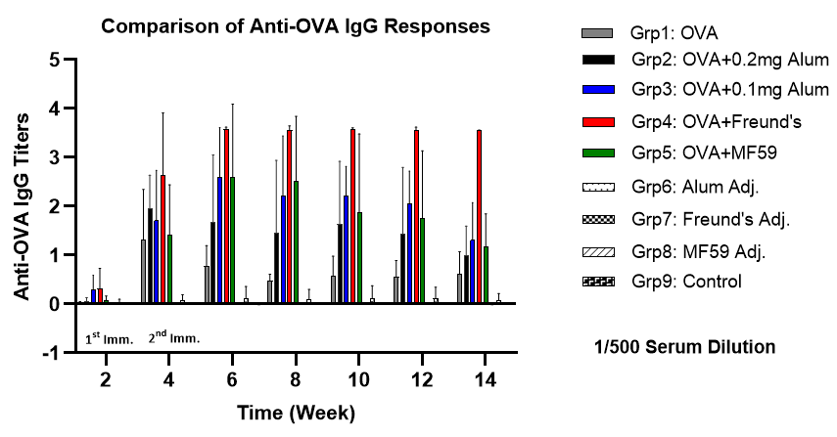

Fig. 1 Serum OVA-specific IgG levels in mice groups immunised with different adjuvant formulations. A one-way ANOVA was used for statistical analysis. The contrasted results were statistically significant (P<0.0001).

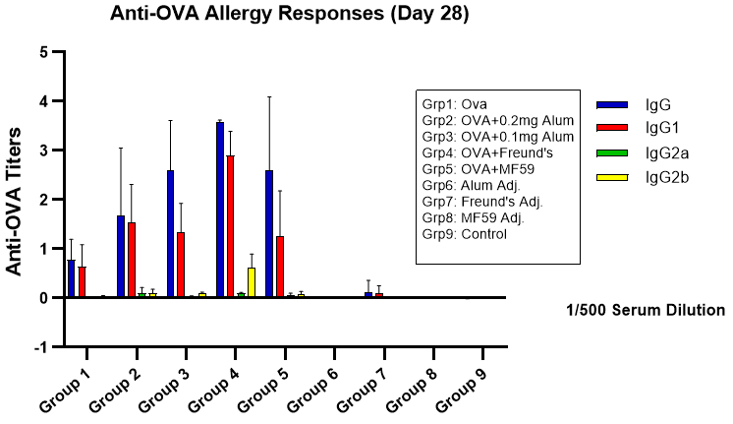

Fig. 2 Comparison of allergic responses on day 28. A one-way ANOVA was used for statistical analysis. The contrasted results were statistically significant (P<0.0001).

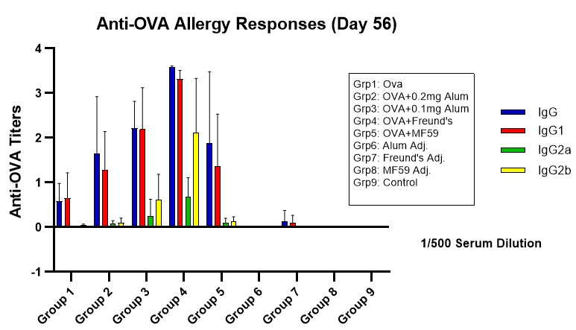

Fig. 3 Comparison of allergic responses on day 56. A one-way ANOVA was used for statistical analysis. The contrasted results were statistically significant (P<0.0001).

