TITLE PAGE

Title:
hmmibd-rs: An enhanced hmmIBD implementation for parallelizable identity-by-descent detection from large-scale Plasmodium genomic data

Authors:

Bing Guo ^{1, 2}, Stephen F. Schaffner ^{3,4}, Aimee R. Taylor ⁵, Timothy D. O’Connor ^{2, *}, Shannon Takala-Harrison ^{1, *}

Affiliations:

¹ Center for Vaccine Development and Global Health, University of Maryland School of Medicine, Baltimore, MD, USA
² Institute for Genome Sciences, University of Maryland School of Medicine, Baltimore, MD, USA
³ Infectious Disease and Microbiome Program, Broad Institute of MIT and Harvard, Cambridge, MA, USA
⁴ Department of Immunology and Infectious Diseases, Harvard T. H. Chan School of Public Health, Boston, MA, USA
⁵ Institut Pasteur, Universit´e Paris Cit´e, Paris, France

* These authors jointly supervised this work

Corresponding authors:

Timothy D. O'Connor, timothydoconnor@gmail.com , https://orcid.org/0000-0002-0276-1896
Shannon Takala-Harrison, STakala@som.umaryland.edu, https://orcid.org/0000-0003-4674-8500

SUPPLEMENTARY INFORMATION

SUPPLEMENTARY NOTES

Where a non-uniform recombination rate map is misspecified by a single average rate, there are a few reasons leading to underestimation of IBD breakpoints in recombination hotspots: (i) The HMM underlying both hmmIBD and hmmibd-rs assumes that the switch rate parameter (k) is constant across all sites for a given haploid genome pair. Consequently, adjacent short true IBD segments from the most recent common ancestors of different ages are likely reported as a single longer IBD segment, leading to an underestimation of the number of IBD breakpoints. This IBD-merging bias is more pronounced in recombination hot spots (Supplementary Figure 2c). (ii) In recombination hotspots, the marker density per unit of genetic distance is extremely low, resulting in higher error rates in IBD inference compared to cold spots (Figure 2e and see [5]). (iii) Misspecifying the recombination rate with a single average rate results in using a lower-than-actual average rate in hotspots, during HMM inference. This leads to a reduced hidden state switching rate and the chance of generating breakpoints. (iv) Misspecification of the recombination rate with a single average rate also results in the underestimation of IBD length in genetic units within recombination hotspots, leading to more aggressive removal of IBD segments during length filtration (Figure 2c).

SUPPLEMENTARY METHODS

Simulations
We used the coalescent simulator msprime [1] to simulate haploid genotype data and genealogical trees for downstream IBD detection and analysis. We simulated chromosomes of 1.5 million base pairs; each genome consists of 14 independently simulated chromosomes, with the full genome size similar to that of P. falciparum. For simulating smaller sample sizes (n≤1000), we used a single-population demographic model with an exponentially shrinking effective population size from 10,000, 200 generations ago to 1,000 at present, similar to those used in our previous work [2]. When larger sample sizes (n ranging from 1,000 to 30,000) were needed to benchmark hmmibd-rs, we modified the demographic model to grow exponentially from 10,000 individuals 200 generations ago to 100,000 at present. We used a constant mutation rate of 1×10⁻⁸ per base pair per sexual generation (i.e. per meiosis). For analyses related to computational efficiency, we used a constant recombination rate of r = 6.667×10⁻⁷ per base pair per sexual generation (i.e., per meiosis). For analyses evaluating the impact of recombination rate misspecification on IBD detection, we used a non-uniform recombination rate map instead of a constant rate.

The non-uniform recombination map was built by dividing the chromosome into 20 windows (each 75,000 bp) and randomly designating h of them as hot spots, with the remaining 20-h as cold spots. Hot spot and cold spot regions were assigned recombination rates of 200r/(20-9h) and 20r/(20-9h), respectively, so that hot spots recombine 10 times faster than cold spots, and the chromosome-wide average rate is still r. For instance, the non-uniform recombination rates shown in Figure 2 and Supplementary Figures 1 and 2 were simulated with h = 7.

IBD detection and length filtration
Simulated genotype data were used as input for hmmIBD and hmmibd-rs for IBD inference. Genealogical trees were utilized to find true IBD segments via tskibd [2]. For data simulated with non-uniform recombination rates, the same recombination rate is used in hmmibd-rs and tskibd, while hmmIBD uses the average (constant) rate. For analysis involving long IBD segments, we used a criterion of minimum length of 2 cM. Both the true rate map and average rate could be used for IBD length filtering, as indicated in individual figure legends.

IBD segments inferred using hmmIBD are filtered outside the software in a downstream analysis step. For hmmibd-rs, IBD segment length filtering can be done using the optional, built-in functionalities via options such as ‘--filt-ibd-only’ and ‘--filt-min-seg-cm’, where IBD length in cM is calculated based on the provided recombination rate or rate map that is also used in the HMM inference step. Of note, this built-in length filtering step in hmmibd-rs is done after the HMM inference step and is independent from the HMM options ‘-n’ (max N generation): ‘-n’ sets a cap on the fitted HMM parameter k [3] that are shared across all sites for a pair of haploid genomes; ‘--filt-ibd-only’ acts on individual IBD segments.

Computation runtime
We utilized the GNU utility time to measure the computation time for IBD detection or data processing (hmmIBD and hmmibd-rs), genotype data prefiltering (bcftools [4]), and IBD coverage analysis (ishare/ibdutils). When comparing hmmIBD and hmmibd-rs, hmmIBD may not complete in a timely manner for larger sample sizes due to its single-threaded nature. Therefore, we used computation time from runs with smaller sample sizes to extrapolate for larger samples, and this extrapolation is indicated in the related figure captions.

IBD segment overlapping analysis.
We updated our previously reported tool, ishare/ibdutils [5], which now allows the calculation of false positive and false negative error rates of detected IBD segments over short windows rather than the entire genome. For a given genome window W (15,000 bp in length, for instance) and a pair of haploid genomes, the false positive rate is defined as the ratio a/b, where b is the fraction of genome window W covered by any inferred segments (from hmmibd-rs or hmmIBD), and a is the fraction of W covered by inferred segments but not by any true segments (determined by tskibd [2]). The false negative rate is defined as the ratio c/d, where d is the fraction of W covered by true segments, and c is the fraction of W covered by true segments but not by positive segments. These rates were then aggregated over genome pairs for each window. We used these window-specific metrics to evaluate how local variations in recombination rates affect the accuracy of IBD detection and filtration.

IBD coverage analysis.
Based on IBD segments detected from a population sample, the IBD coverage for a given site in the genome is calculated as the total number of IBD segments (from any genome pair in the population sample) that contain the site. We sampled evenly spaced sites (one site per 150 bp) across the genome and calculated the IBD coverage over these sites.

Empirical data processing and analysis.
Raw, unfiltered variant call data (in VCF format) and meta information (including F_{ws}) of MalariaGEN Pf7 samples were downloaded from the official website (see link in the Availability of Data and Materials section). These VCF files of 14 nuclear chromosomes were concatenated and piped to bcftools for initial filtering and encoding into BCF format: (1) sites with PASS in the FILTER column; (2) sites with a genotype call missing rate < 0.7; (3) SNP variants with a minor allele frequency greater than 0.01. The single prefiltered BCF file, containing sites from all 14 nuclear chromosomes, was used as input for hmmibd-rs, which further iteratively filters samples and sites by missingness, removes samples (such as polyclonal samples in this work), and constructs haploid genomes based on the dominant alleles. Detailed processing steps are provided in Supplementary Table 1, and the processing parameter values are available at https://github.com/bguo068/hmmibd-rs-bench-empirical/blob/main/input/bcf_filter_config.toml. The filtered data were split into a condensed data file for each chromosome to allow IBD inference and IBD filtering independently for each chromosome. The full pipeline, including downstream IBD coverage analysis, is provided in a GitHub repository (see the Availability of Data and Materials section).

SUPPLEMENTARY FIGURES

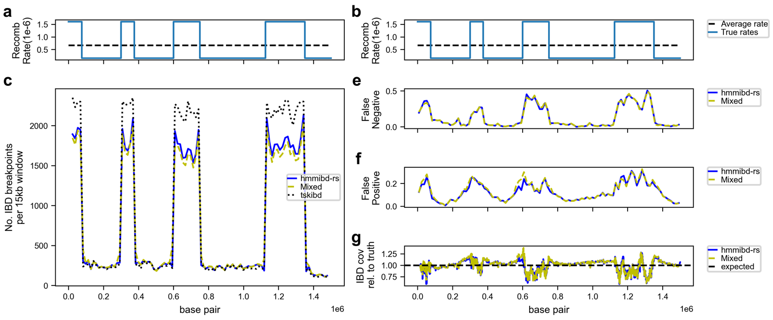

Supplementary Figure 1. Recombination rate misspecification has minimal impact on the inference of IBD segments over 2 centimorgans (cM) when IBD length calculation and filtration use the true recombination rate (extending Fig. 2; note that the main difference from Fig. 2 is that hmmIBD uses true rates instead of average rate for the length filtration step, which is labeled as “Mixed” (yellow dotted line) since both true and average rates are used). a-b, the true, non-uniform recombination rate map (blue line) and the constant chromosome-wide average rates (black dotted line). c, number of detected IBD breakpoints (two ends of IBD segments over 2 centimorgans, cM) in 15 kb windows along the simulated P. falciparum-like genomes. e-f, False negative rate (e) and false positive rate (f) of detected IBD segments (over 2 cM) using IBD segment overlapping analysis (see Methods). g, Coverage of detected IBD segments (over 2 cM) normalized to the coverage of true IBD segments (over 2 cM, determined by tskibd [2]).

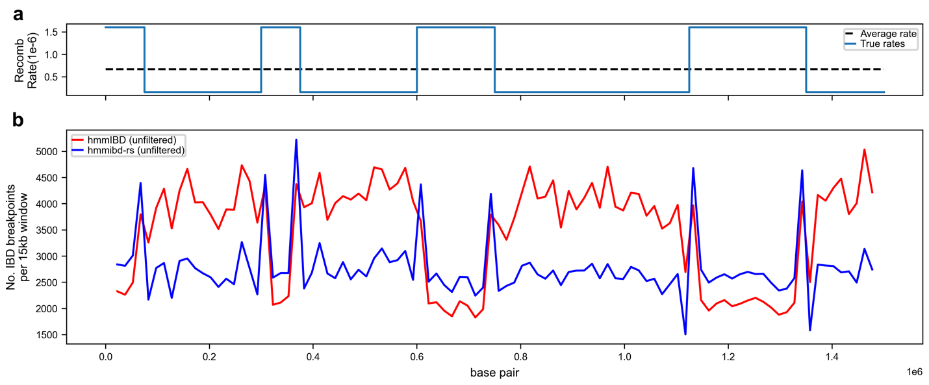

Supplementary Figure 2. Patterns of IBD breakpoints when IBD segments are not filtered by length (extending Fig. 2c and Supplementary Figure 1c). Note that the main difference is that here all IBD segments (< 2 cM and ≥ 2 cM, that is, unfiltered) are included. a, the true, non-uniform recombination rate map (blue line) and the constant chromosome-wide average rates (black dotted line). b, number of detected IBD breakpoints (for all IBD segments) in 15 kb windows along the simulated P. falciparum-like genomes. Of note, when using unfiltered IBD segments for IBD breakpoint analysis, neither hmmibd-rs nor hmmIBD capture the expected enrichment of breakpoints in recombination hot spots, possibly due to that the HMM algorithm cannot reliably capture short segments in regions of high recombination rates, consistent with our previous findings [5].

SUPPLEMENTARY TABLES

Supplementary Table 1. In-memory, multi-step input data preprocessing built into hmmibd-rs. hmmibd-rs can optionally use raw genotype data in binary variant call format (BCF) as input and preprocess the data for IBD inference. When a BCF file is used as input (–from-bcf flag is set), the file should contain the FORMAT/GT and FORMAT/AD fields. The processing steps, options, and details are listed below. These options can be provided by the user via the –bcf-filter-config config.toml option. See https://github.com/bguo068/hmmibd-rs/blob/main/testdata/pf7_data/dom_gt_config.toml for an example.

Step | Options | Description
subset samples | target_samples = samples.txt | This option specifies targeted samples. For example, users may choose to use only monoclonal samples instead of all samples. If target_samples is not specified, all samples in the BCF file will be included.
define dominant alleles | min_depth = 5 | Minimum total AD for the sample. To be dominant, the major allele must have total-AD $≥$ min_depth
 | min_ratio = 0.7 | Minimum value for the ratio of major-allele-AD to total-AD. To be dominant, major-allele-AD / total-AD must be $≥$ min_ratio.
 | min_r1_r2 = 3.0 | Minimum ratio of major allele AD to minor allele AD. To be dominant, minor-allele-AD / major-allele-AD must be $≤$ 1.0 / min_r1_r2.
 |  | If any of these conditions are false, the sample is treated as having a missing genotype for this site. Otherwise, the major allele is designated as the dominant allele representing the genotype for this sample at the current site.
filter sites | filter_column_pass_only = true | If set to true, a site that does not have PASS or ‘.’ in the FILTER column of the BCF record will be removed.
 | min_site_nonmissing | Calculate the non_missing_rate as the fraction of samples with dominant alleles. If the site has non_missing_rate $<$ min_site_nonmissing, the site will be filtered out.
 | min_maf = 0.7 | Calculate the minor allele frequency maf for the site using dominant allele genotypes. If maf $<$ min_maf, the site will be filtered out.
 | major_minor_alleles_must_be_snps = true | Calculate the allele counts across samples for the site and determine the major and minor alleles (for a site) as the alleles with the largest and second largest sample counts. If major_minor_alleles_must_be_snps is set to true in the configuration, the site will be filtered out if either the major or minor allele is not a SNP.
Iterative missingness filtering | nonmissing_rates = [  [0.31, 0.155],  [0.35, 0.175],  …  [0.85, 0.85],  ] | Threshold for iteratively removing sites and samples with the highest genotype missing rates (or lowest non-missing rates) defined in the two-element arrays in nonmissing_rates. Each two-element item corresponds to one round of filtering where first sites are filtering according to min_site_nonmiss_rate, and then samples are filtered by min_sample_nonmiss_rate. The iterative filtering process is used to avoid aggressively removing sites or samples by an abrupt stringent threshold.

Supplementary Table 2. In-memory filtration of IBD output (including IBD segments and fraction of sites IBD) reduces disk usage. The table shows the number of records and disk space occupied for the two main outputs of hmmIBD and hmmibd-rs: the segments (files ending with .hmm.txt) and the statistics for genome pairs (files ending with hmm_fract.txt). The figures, presented as mean ± standard deviation, are based on data from three independent simulation experiments. Each experiment simulates a chromosome of 100 cM (1.5 million base pairs) using an effective population size of 100,000 and a sample size of 10,000. The second column lists the filtering options provided by hmmibd-rs.

Result Type | hmmibd-rs filter options | Number of Records |  | Disk usage (Mb) |  | Percentage (%)
 |  | mean | std | mean | std
Segments | All (non-IBD + IBD, default) | 64151396 | 1074588 | 1912.5 | 58.5 | 100.00
Segments | IBD only, any length | 7195155 | 546998 | 214.6 | 19.3 | 11.21
Segments | IBD only, long(e.g.)$≥$2cM | 820728 | 9041 | 24.5 | 0.3 | 1.28
Fract File | Printed (default) | 49995000 | 0 | 3148.0 | 0.7 | 100.00
Fract File | Suppressed | 0 | 0 | 0.0 | 0.0 | 0.00

REFERENCES:

1. Baumdicker F, Bisschop G, Goldstein D, Gower G, Ragsdale AP, Tsambos G, et al. Efficient ancestry and mutation simulation with msprime 1.0. Genetics. 2022;220:iyab229.
2. Guo B, Borda V, Laboulaye R, Spring MD, Wojnarski M, Vesely BA, et al. Strong positive selection biases identity-by-descent-based inferences of recent demography and population structure in Plasmodium falciparum. Nat Commun. 2024;15:2499.
3. Taylor AR, Jacob PE, Neafsey DE, Buckee CO. Estimating relatedness between malaria parasites. Genetics. 2019;212:1337–51.
4. Danecek P, Bonfield JK, Liddle J, Marshall J, Ohan V, Pollard MO, et al. Twelve years of SAMtools and BCFtools. Gigascience. 2021;10:giab008.
5. Guo B, Takala-Harrison S, O’Connor TD. Benchmarking and Optimization of Methods for the Detection of Identity-By-Descent in High-Recombining Plasmodium falciparum Genomes. eLife [Internet]. 2025 [cited 2025 Jan 22];14. Available from: https://elifesciences.org/reviewed-preprints/101924

