Electronic Supporting Information

Preparation of magnetic decorated polyacrylonitrile grafted chitosan as a new bio-inspired nanocatalyst for the synthesis of dihydropyrano [2,3-c]pyrazoles and 2-amino-3-cyano-4H-pyran derivatives
Niloufar Nashibi¹, Mohammad G. Dekamin¹, Ali Maleki¹
¹Pharmaceutical and Biologically-Active Compounds Research Laboratory, Department of Chemistry, Iran University of Science and Technology, Tehran 16846-13114, Iran
Tel: +98-21-77240640-50; fax: +98-21-73021584; e-mail: mdekamin@iust.ac.ir

Page | Contents
S1 | Title page
S3 | Fig. S1. Structure of selected examples of biologically- and pharmacologically-active dihydropyrano [2,3-c] pyrazole and 4H-pyrans.derivatives
S3 | Fig. S2. Schematic representation for the preparation of CS-g-PAN/Fe₃O₄ nanoparticles (1)
S4 | Fig. S3. One-pot three-component synthesis of highly substituted dihydropyrano [2,3-c] pyrazole (DHPPs) and 4H-pyrans derivatives catalyzed by the magnetic CS-g-PAN/Fe₃O₄ nanoparticles.
S4 | Fig. S4. FTIR spectra of (a) PAN, (b) CS, (c) CS-g-PAN and (d) the CS-g-PAN/Fe₃O₄
S5 | Fig. S5. FESEM images of the CS-g-PAN nanoparticles (1).
S5 | Fig. S6. XRD patterns of the CS-g-PAN/Fe₃O₄ nanoparticles (1), CS-g-PAN and CS
S6 | Fig. S7. EDX spectra of the CS-g-PAN/Fe₃O₄ nanoparticles (1), along with its elemental mapping for a fresh sample.
S6 | Fig. S8. Hysteresis diagram of the CS-g-PAN/Fe₃O₄ nanoparticles (1)
S7 | Fig. S9. (a) The N₂ adsorption–desorption isotherm of CS-g-PAN catalyst (1) and (b) its pore width.
S7 | Fig. S10. TGA patterns of the CS-g-PAN/Fe₃O₄ nanoparticles (1)
S8 | Fig. S11. FTIR spectra of the recycled CS-g-PAN/Fe₃O₄ MNPs (1) after the first run (Down, blue curve); and five run (Top, red curve) in the model reaction for the synthesis of 6k.
S9 | Fig. S12. ¹H NMR spectrum of compound (6a)
S10 | Fig. S13. ¹H NMR spectrum of compound (6k)
S11 | Fig. S14. ¹H NMR spectroscopy of the 4H-Pyran (7a)
S12 | Fig. S15. ¹H NMR spectroscopy of the 4H-Pyran (7j)
S13 | Fig. S16. ¹H NMR spectroscopy of the 4H-Pyran (7i)

(Anticancer activity) A
(Inhibitor of human CHK1 kinase) C
(Antibacterial) B
(Antifungal) E
(Anti-tumor agent) D
Fig. S1. Structure of selected examples of biologically- and pharmacologically-active dihydropyrano [2,3-c] pyrazole and 4H-pyran derivatives.
(Tumor vascular-disrupting agent) F
(Antiproliferative agent) G
(Anticancer agent) H

Fig. S2. Schematic representation for the preparation of CS-g-PAN/Fe₃O₄ nanoparticles (1).

Fig. S3. One-pot three-component synthesis of highly substituted dihydropyrano [2,3-c] pyrazole (DHPPs) and 4H-pyrans derivatives catalyzed by the magnetic CS-g-PAN/Fe₃O₄ nanoparticles.
a)
b)

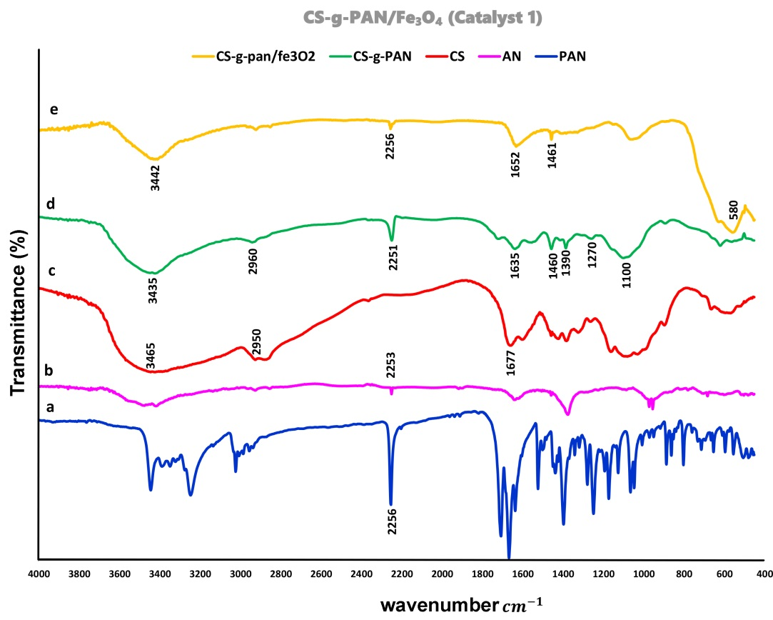
Fig. S4. FTIR spectra of (a) PAN, (b) CS, (c) CS-g-PAN and (d) the CS-g-PAN/Fe₃O₄.

 | (a) |  | (b)
 | (c) |  | (d)
Fig. S5. FESEM images of the CS-g-PAN (a-b) and CS-g-PAN/Fe₃O₄ (c-d) nanoparticles (1).

Fig. S6. XRD patterns of the CS-g-PAN/Fe₃O₄ nanoparticles (1), CS-g-PAN and CS.
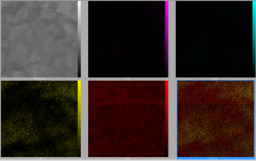
Fig. S7. EDX spectra of the CS-g-PAN/Fe₃O₄ nanoparticles (1), along with its elemental mapping for a fresh sample.
a
b

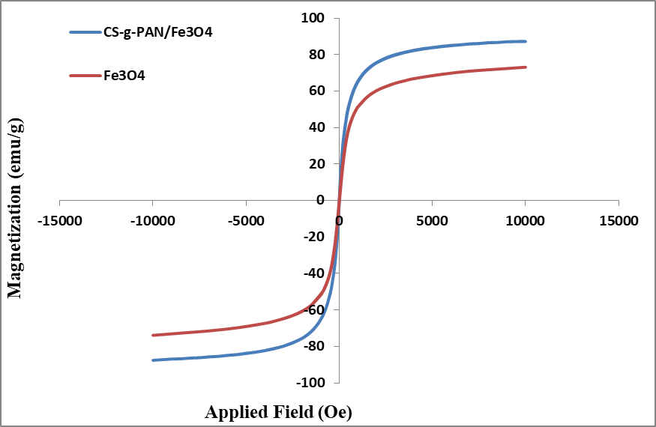
Fig. S8. Hysteresis diagram of the CS-g-PAN/Fe₃O₄ nanoparticles (1).

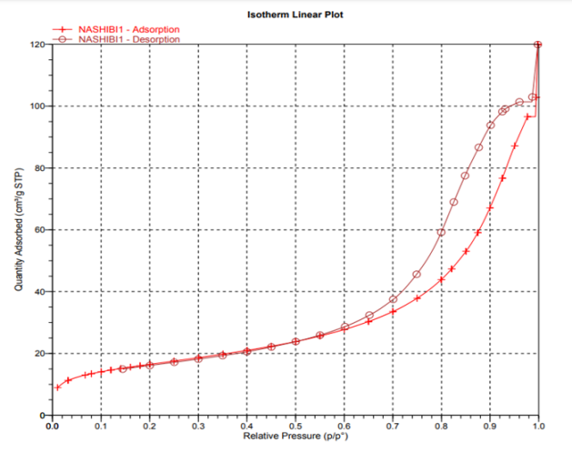
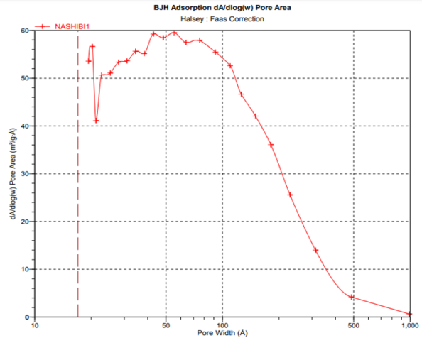
Fig. S10. TGA patterns of the CS-g-PAN/Fe₃O₄ nanoparticles (1).
Fig. S9. (a) The N₂ adsorption–desorption isotherm of CS-g-PAN catalyst (1) and (b) its pore width.
a
b

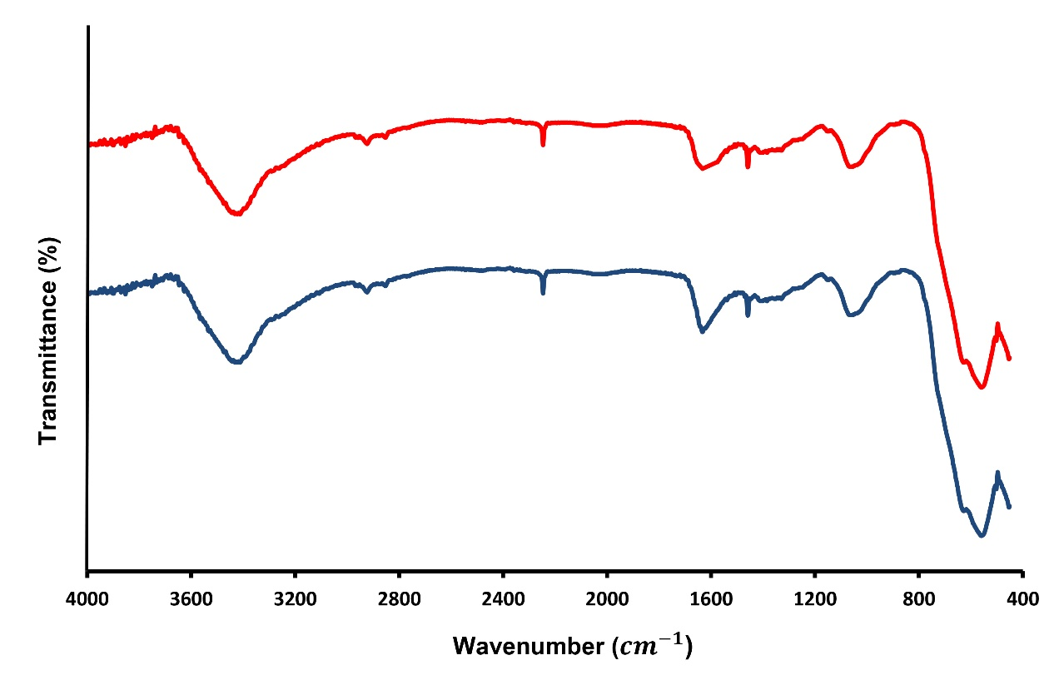
Fig. S11. FTIR spectra of the recycled CS-g-PAN/Fe₃O₄ MNPs (1) after the first run (Down, blue curve); and five run (Top, red curve) in the model reaction for the synthesis of 6k.

Fig. S12. ¹H NMR spectrum of compound (6a).

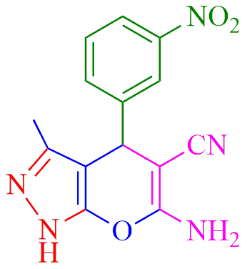

Fig. S13. ¹H NMR spectrum of compound (6k).

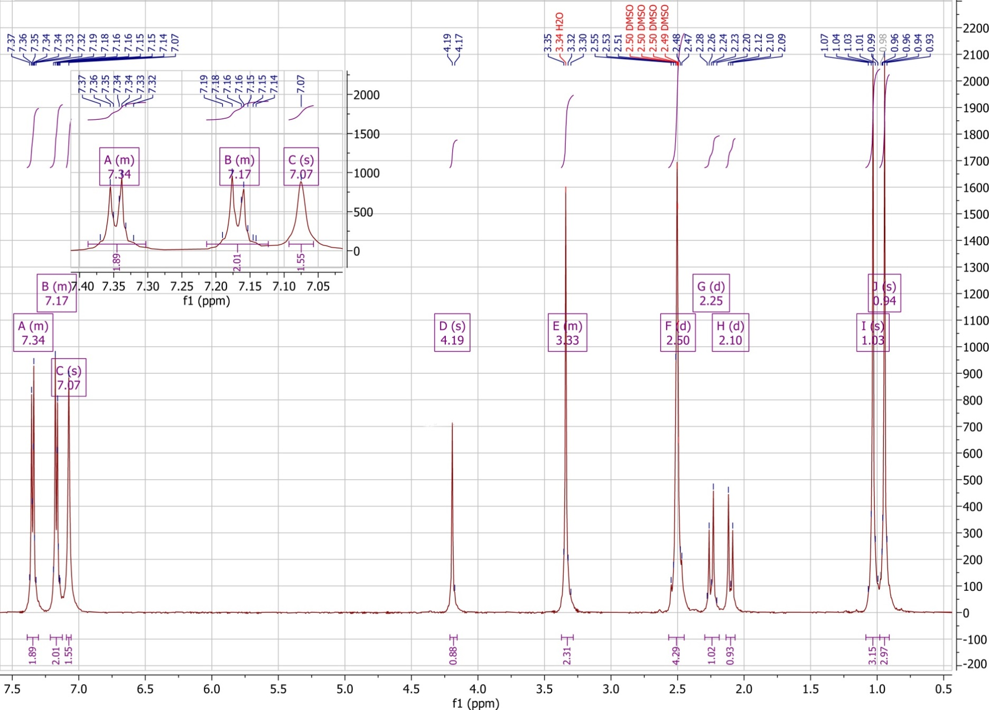

Fig. S14. ¹H NMR spectroscopy of the 4H-pyran (7a).

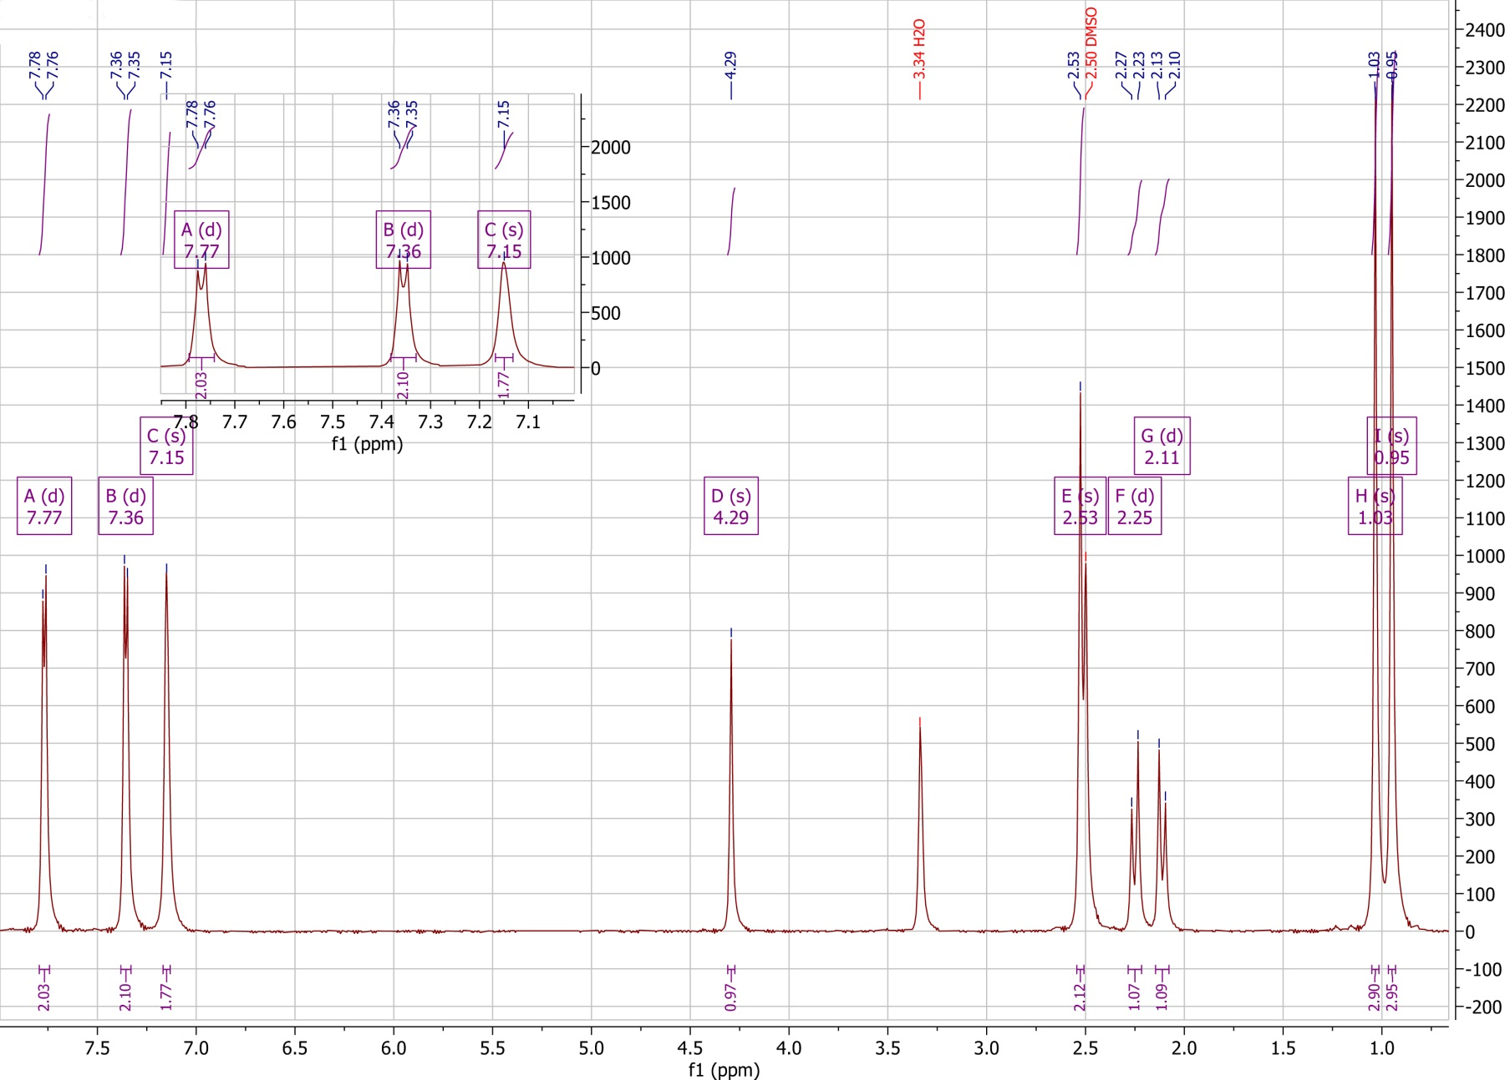

Fig. S15. ¹H NMR spectroscopy of the 4H-pyran (7j).
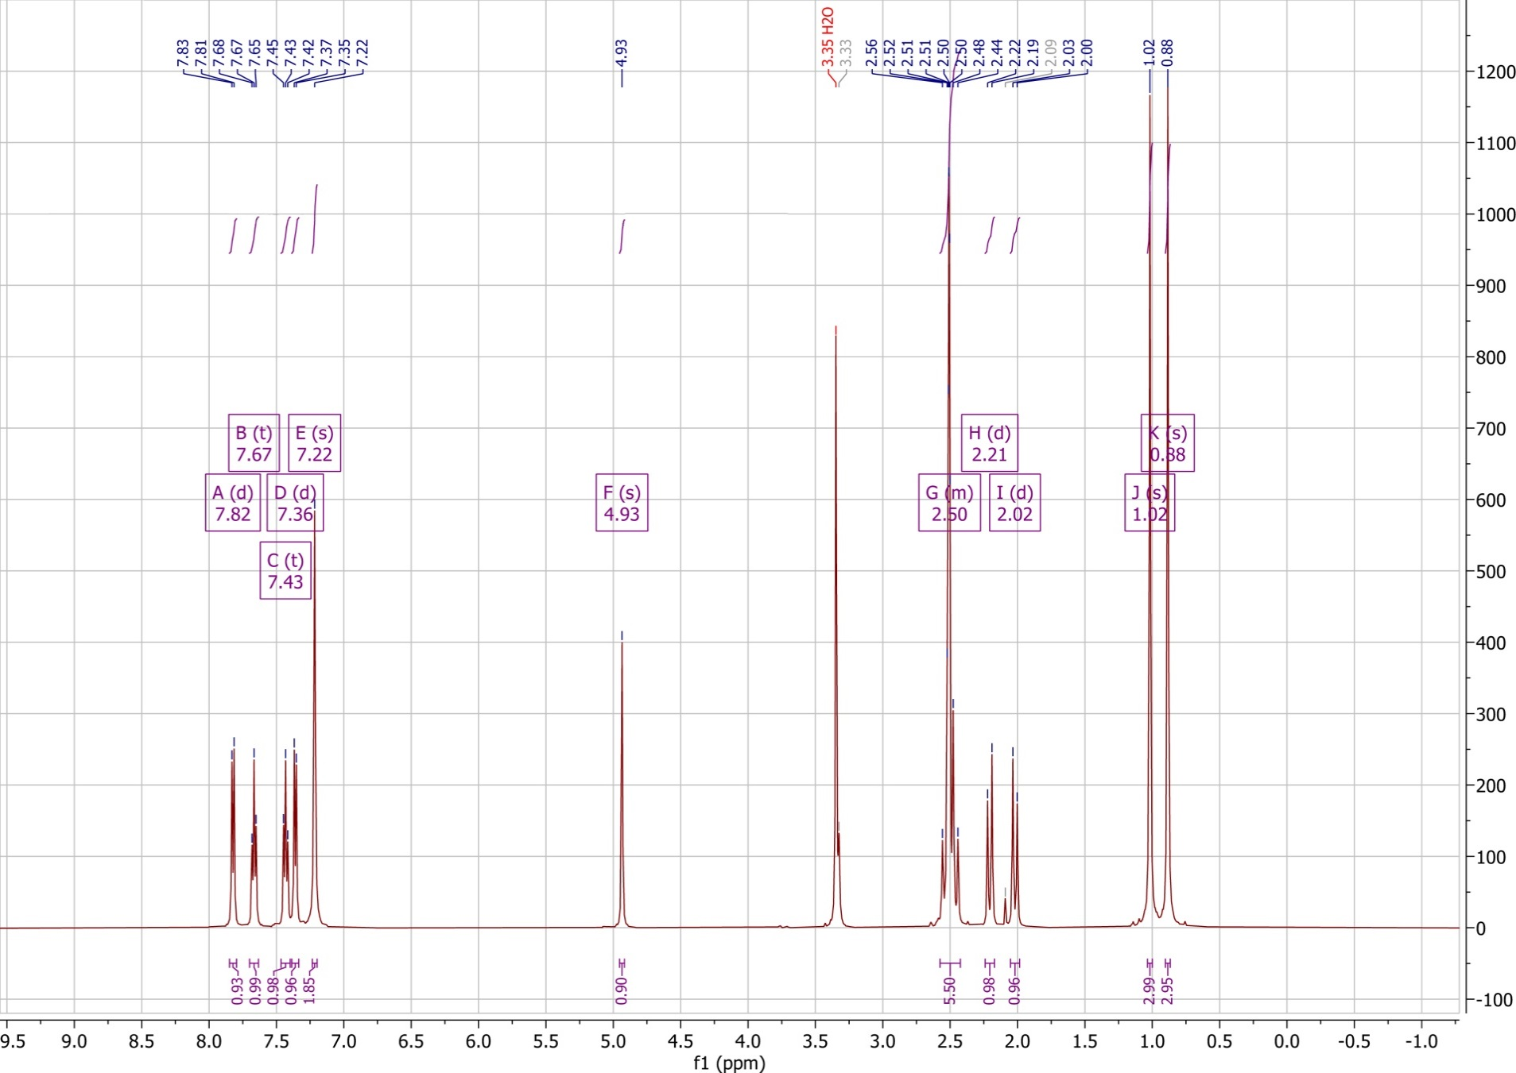
Fig. S16. ¹H NMR spectroscopy of the 4H-pyran (7i).

