Versatile Lithium Niobate Platform for Photoacoustic/Thermoelastic Gas Sensing and Photodetection
Haoyang Lin¹, Huadan Zheng^{1,}*, Wenguo Zhu¹, Yongchun Zhong¹, Jianhui Yu¹, Hongpeng Wu², Zhiwei Jia³, Jinchuan Zhang³, Angelo Sampaolo^{2,4}, Pietro Patimisco^{2,4}, Huihui Lu¹, Xiaojun Jia², Vincenzo Spagnolo^{2,4}, and Lei Dong^{2,}*
¹Key Laboratory of Optoelectronic Information and Sensing Technologies of Guangdong Higher Education Institutes, Department of Optoelectronic Engineering, Jinan University, Guangzhou, 510632, China
²State Key Laboratory of Quantum Optics and Quantum Optics Devices, Institute of Laser Spectroscopy, Shanxi University, Taiyuan, 030006, China
³Laboratory of Solid-State Optoelectronics Information Technology, Institute of Semiconductors, Chinese Academy of Sciences, Beijing, China.
⁴PolySense Lab—Dipartimento Interateneo di Fisica, University and Politecnico of Bari, Bari, Italy
*Corresponding author: zhenghuadan@jnu.edu.cn and donglei@sxu.edu.cn

Design and manufacture of the LN-MFP
Each side of the LN-MFP is divided into three distinct regions: a central region where negative charges accumulate and two side regions where positive charges are concentrated. Due to the piezoelectric properties of lithium niobate, the charge distribution on the back of the LN-MFP mirrors that on the front side, with opposite polarities. To optimize signal extraction, the central electrode on the front side is electrically connected to the side electrodes on the back, forming one output terminal of the MFP. Conversely, the side electrodes on the front are linked to the central electrode on the back, creating the second output terminal. This electrode configuration effectively captures the differential charge distribution generated during device operation.
The LN-MFP’s resonance characteristics were measured to evaluate its performance as a piezoelectric resonator. The device was electrically excited to induce mechanical vibration, generating an output charge proportional to the vibration amplitude. Fig. 1s presents the recorded vibration amplitude of the LN-MFP. The resonance curve exhibits a distinct peak at the fundamental resonance frequency, confirming an efficient vibrational response. An electrical excitation signal of 40 mVpp was used to excite the LN-MFP. The LN-MFP has a frequency of 10,485 Hz and a Q factor of 1,621. This remarkable enhancement underscores the superior piezoelectric performance of lithium niobate in the proposed device configuration.
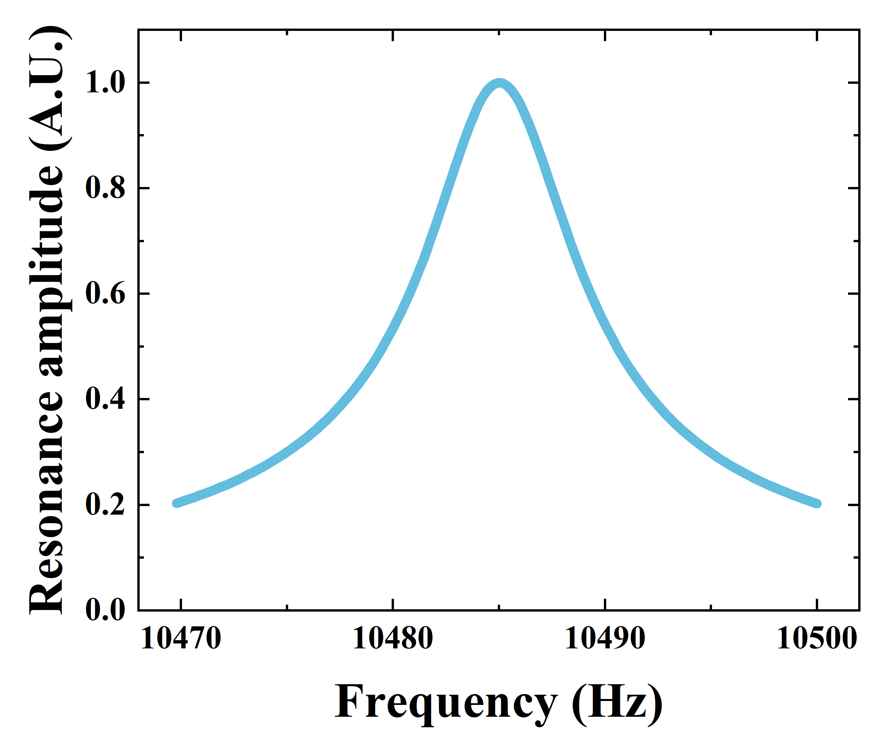
Fig. 1s | Resonance profile of the LN-MFP as a function of excitation frequency.
Optimization of photoacoustic detection
To optimize the LN-MFP for lithium niobate-enhanced photoacoustic spectroscopy detection, the effect of laser beam positioning between the tines and along their length was systematically studied. The laser spot was incrementally shifted from the top opening to the base of the tines, and the corresponding PAS signal amplitude was retrieved and modeled using finite element modeling (FEM) with COMSOL Multiphysics®. The results, shown in Fig. 2s(a), indicate that when the laser beam was positioned approximately 2 mm from the top of the tines, the LN-MFP output reached its peak.
An acoustic resonator was incorporated at the 2 mm position to construct a spectrophone. The acoustic resonator consisted of two independent stainless steel capillary tubes, mounted perpendicular to the LN-MFP plane and aligned coaxially with the laser beam, as illustrated in Fig. 2s(b). The gap between the capillaries ends and the LN-MFP plane was fixed at ~20 µm to ensure optimal coupling. We systematically tested various capillary lengths and measured the corresponding signal amplitude, identifying 13 mm as the optimal length. Through resonant amplification of acoustic waves, the acoustic resonator enhanced the LN-MFP signal by 79 times, enabling detection of ultraweak acoustic signals.

(a)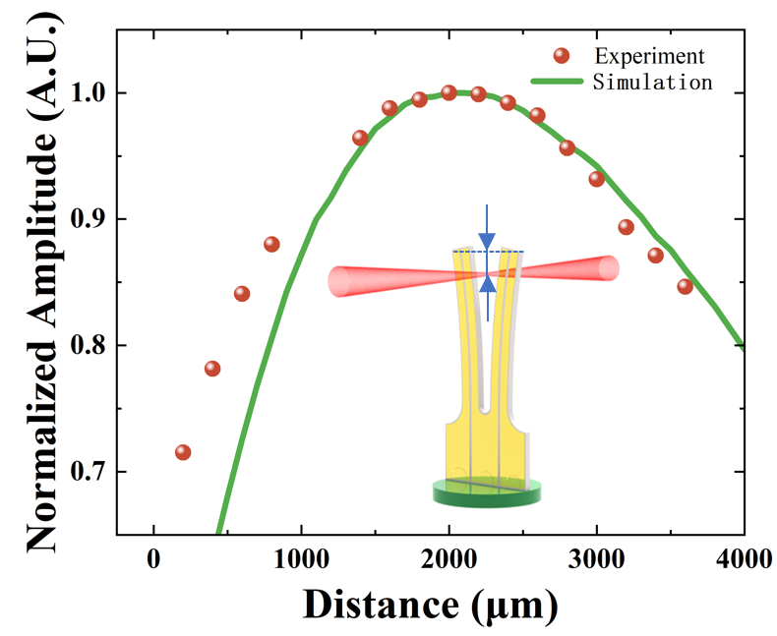(b)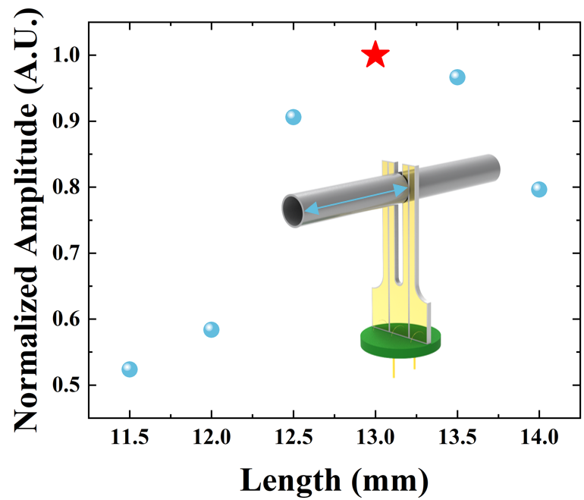
Fig. 2s | (a) Simulated and measured PAS signals as a function of the laser beam position along the LN-MFP tines. (b) PAS signal amplitude as the function of an acoustic resonator’s length.
Optimization of thermoelastic detection
The 1.3 µm NIR DFB laser, previously described, was used to target the water absorption line at 7185.6 cm⁻¹. The position of light incidence on the tuning fork is a crucial parameter, as the thermal deformation effect varies along the tines, directly influencing the LN-MFP’s output response. To optimize sensitivity, we systematically investigated the impact of thermal excitation position on the LITES signal of the LN-MFP. Fig. 3s presents the signal amplitude as a function of the laser beam position along the left tine. For symmetry, the same results are expected when exciting the right tuning fork prong. The results indicate that the optimal position for maximizing the thermoelastic effect is 10.5 mm from the top of the tine. This location aligns with the region where thermal-induced deformation most effectively couples with the mechanical resonance of the device.
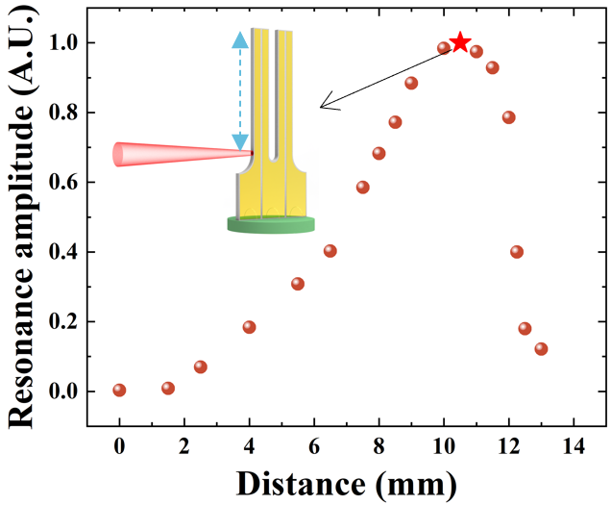
Fig. 3s | LITES signal of the LN-MFP as a function of the laser beam position along the left tuning fork tine.
Determination of minimum detection level for light
The correlation between laser modulation depth and LN-MFP vibration amplitude was systematically analyzed. The modulation depth was progressively reduced toward zero, allowing for an accurate assessment of the device’s photodetection capabilities. The photodetection sensitivity S of the LN-MFP was calculated using the following equation:
$S=\frac{P_{i}}{A_{i}}∙A_{0}$ (1)
where P_{i} represents the laser power at modulation depth i, and A_{i} and A₀ represent the vibration amplitudes at modulation depth i and zero, respectively.
Data availability
The datasets generated and analysed during this study are available from the corresponding author upon reasonable request.
Acknowledgments
This work is supported by the National Key Research and Development Program of China (2021YFB2800801), National Natural Science Foundation of China (62375111, 62005105, 12174156, 12174155, 62105125, 62175137), the Ministry of Education of China (8091B03012309), Natural Science Foundation of Guangdong Province (2023B1515020027), the Science and Technology Projects of Guangzhou (202102020445), Special Project in Key Fields of the Higher Education Institutions of Guangdong Province (2020ZDZX3022), Open foundation of CEPREI (NO. 19D09), the Fundamental Research Funds for the Central Universities (21619402, 11618413, 21624113) ), Special Funds for the Cultivation of Guangdong College Students' Scientific and Technological Innovation (NO. pdjh2023a0052, NO. pdjh2024a051, NO. pdjh2024a048), National Innovation and Entrepreneurship Training Program for Undergraduate (NO. 202310559088, NO. 202410559001). Authors from PolySensSe Lab acknowledge funding from PNRR MUR project PE0000023-NQSTI and MUR-Dipartimenti di Eccellenza 2023−2027 project “Quantum Sensing and Modeling for One-Health” (QuaSiModO).
Author contributions
Huadan Zheng, Angelo Sampaolo, Pietro Patimisco and Vincenzo Spagnolo conceived the idea. Haoyang Lin, Huihui Lu, Jianhui Yu and Huadan Zheng designed the experiment. Haoyang Lin conducted the experiment. Wenguo Zhu, Yongchun Zhong and Hongpeng Wu analyzed the data. Haoyang Lin, Angelo Sampaolo, and Pietro Patimisco finished the manuscript. Jinchuan Zhang, Xiaojun Jia, Vincenzo Spagnolo, and Lei Dong supervised the project.
Competing interests
The authors declare no competing interests.
Additional information
Supplementary information The online version contains supplementary material available at https://doi.org/****/
Correspondence and requests for materials should be addressed to H. Zheng.
Reprints and permissions information is available at www.nature.com/reprints.

